|  |  |
| --- | --- |
|  | **NAme :- sahil pravin thakur**  **prn : - 2020btecs00042**  **batch : - s3**  **sub :- Data base enginnering lab Assignment 3** |

**Title :- Study of relational module (music company database)**

**Diagram on software**

-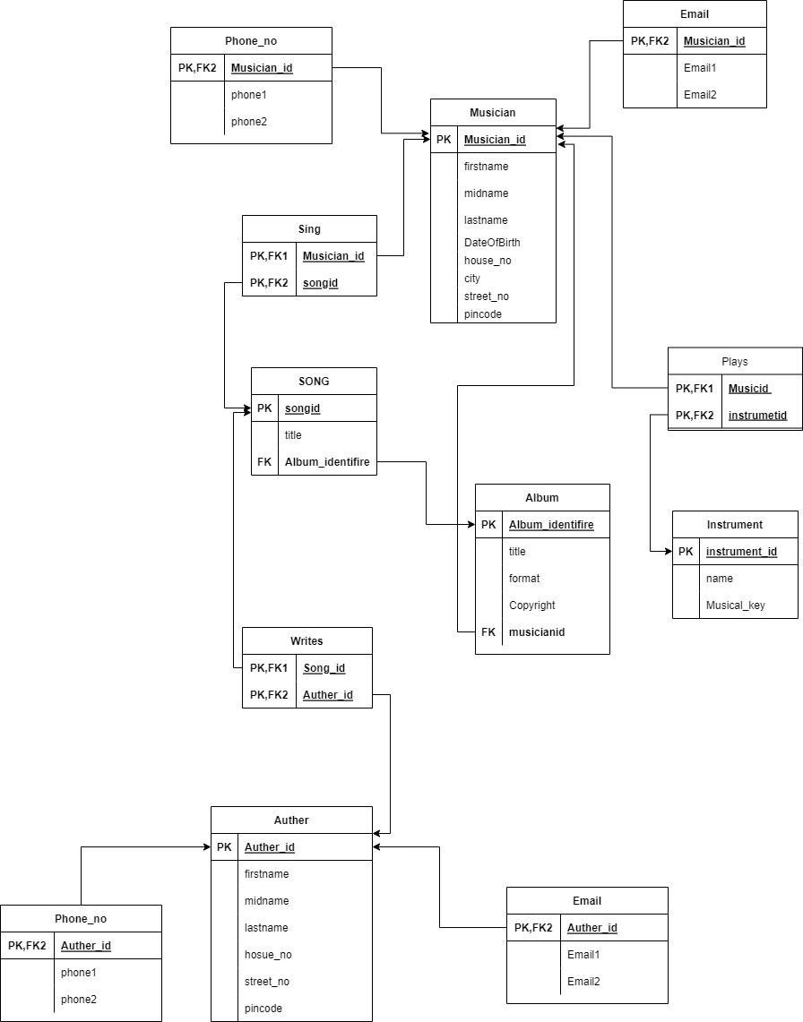

Diagram on paper

