Walchand College of Engineering, Sangli

Computer Science & Engineering

Third Year

Course: Design and analysis of algorithm Lab

Lab course coordinator:

Dr. B. F. Momin- Batch: - T6, T7, T8

Mr. Kiran P. Kamble- Batch: - T1, T2, T3, T4, T5

**Week 5 Assignment**

Part: 3

**Divide and conquer strategy**

Farmer has planted only mango trees in his farm as shown in figure (indicates position of each tree with *x, y* coordinates) It is not a fixed size farm. He wants to protect those mango trees from a thief, for that he decided to round up a tree with electric wire. But as the farm is not of fixed size, he decided to find all set of mango trees which will cover all the remaining mango trees and then he will wind all tree with electric wire.

Implement an algorithm to find set of mango trees which cover all remaining mango trees. Also find perimeter of rounded wire. 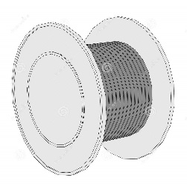 

(1, 4) 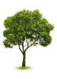  (4,4) (7,4)

(1, 3) (3, 3) (6, 3) (8, 3)

 (1, 2) (3, 2)  (5, 2) (7, 2) (9, 2)

 (2, 1)  (4, 1)  (6, 1) (8, 1)