**Let’s build something!**

**Setting up**

Before implementing the code, make sure you have set up the following:

Hugging Face account setup

1. To create a Hugging Face account, you can go to this link: <https://huggingface.co/join> and sign up.

2. After signing up, go to Your Profile page, click on Edit Profile, and go to Access Tokens.

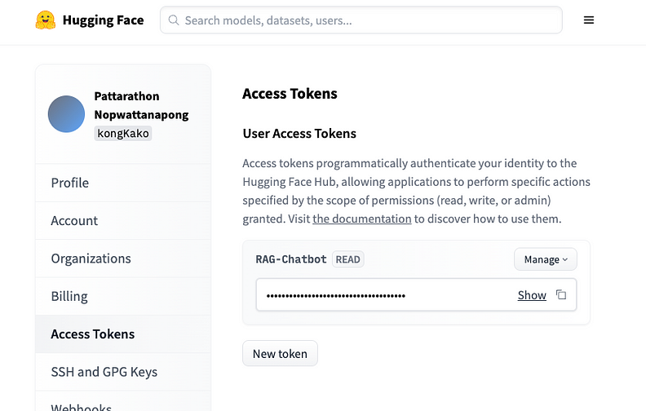

Getting HuggingFace Access Token

3. On the Access Tokens page, create a new token called “*RAG-Chatbot”*, or similar. Make sure no one has access to this token except you.

Pinecone account setup

1. To create a PineCone account, sign up via this link: <https://www.pinecone.io/>

2. After registering with the free tier, go into the project, and click on Create a Project.

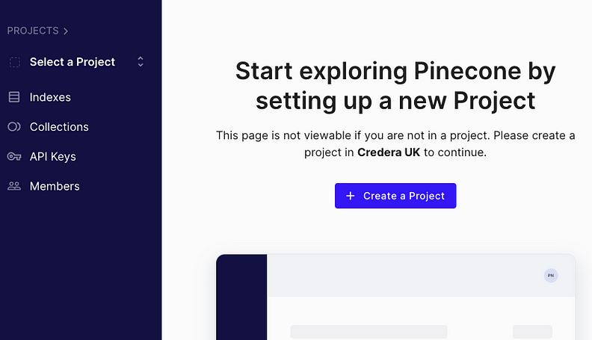

Create Project

3. Fill in the Project Name, Cloud Provider, and Environment. In this case, I have used “Chatbot Application” as a Project Name, GCP as Cloud Provider, and Iowa (gcp-starter) as an Environment.

4. After the project is created, go into the API Keys section, and make sure you have an API key available. Do not share this API key.

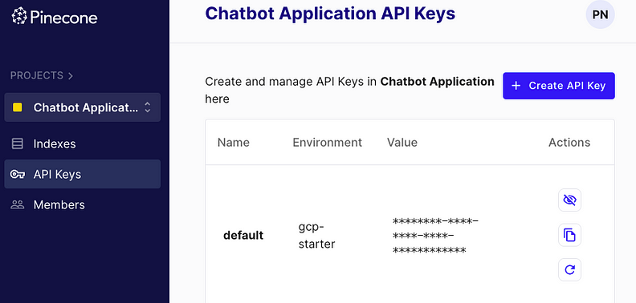

Create API Key

Project structure and environment

After completing the account setup, you can create a directory called “Chatbot”. Inside the Chatbot directory, create a file called .env. The context inside .env should look like the image below (replace xxx with your Hugging Face access tokens and Pinecone API Keys). We will be using this .env file in later steps.

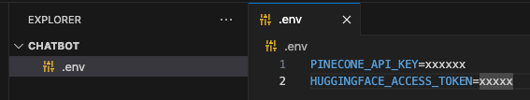

.env

# .env file  
PINECONE_API_KEY=xxxxxx  
HUGGINGFACE_API_KEY=xxxxx

Finally, create a file called main.py, and create an empty class called Chatbot inside it. This class is going to be called when we implement the frontend UI. For now, just create the class without adding any more code to it.

