AUGMENTED REALITY EXPERIENCE APPLICATION- AREA
Almiro Agnelo Gonsalves
Information Technology
Padre Conceicao College Of
Engineering
Verna, India
gonsalvesalmiro@gmail.com
Dylan Julier Lobo
Information Technology
Padre Conceicao College Of
Engineering
Verna, India
dylanlobo7375@gmail.com
Dattaraj Alias Sarthak Poi Anglo
Information Technology
Padre Conceicao College Of
Engineering
Verna, India
sarthakanglo@gmail.com
Sahil Rajesh Walawalkar
Information Technology
Padre Conceicao College Of
Engineering
Verna, India
walawalkarsahil25@gmail.com
Dr. Sufola Das Chagas Silva E Araujo
Information Technology
Padre Conceicao College Of
Engineering
Verna, India
sufolachagas100@rediffmail.com

Abstract— Home decor plays a crucial role in creating comfortable and aesthetically pleasing living spaces. With the increasing popularity of digital technologies, home decor applications have emerged as valuable tools. This paper focuses on emphasizing the elements of interior designing but allowing customization of products for the user, improving the dimensionality of the AR based applications, and improving the user experience. The application allows users to explore various decor styles, experiment with different furniture items, and preview how different design elements would look in their own spaces through augmented reality (AR) technology. Overall, this research contributes to the growing body of knowledge on the integration of digital technologies in home decor practices and highlights the potential of AR-based applications in enhancing the user experience in interior design.
Keywords – Home Decor, comfortable, aesthetically pleasing, Interior Design, visualization, planning, augmented reality technology.

Introduction
Augmented reality (AR) is a technology that computer graphics in the real world and has applications in engineering and architecture to solve real-life problems. There are various existing AR systems used in clothing, gaming, and navigation, providing an interactive experience in reality. The primary role of augmented reality is to bring digital components into the real world, making them appear as natural parts of the environment rather than just a display of data.
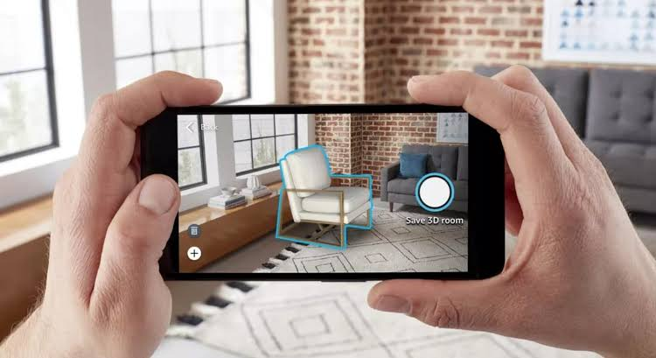
Fig 1 : AR view of Chair

AR in Home Décor

AR furniture arrangement systems are a cutting-edge technology that allows users to virtually place furniture in their real-world space. By superimposing 3D virtual furniture models onto the user's actual room, these systems enable individuals to visualize and interact with different furniture arrangements, facilitating the home decoration process. This innovative technology offers a convenient way for users to experiment with various furniture options and decor, ultimately helping them create their ideal living space without the need to physically move or purchase real furniture.

The commercial value of AR furniture arrangement systems is significant, as they streamline the home decoration process and make it more accessible to a wider audience. By providing a virtual platform for users to experiment with different furniture layouts and styles, these systems empower individuals to make informed decisions about their home decor. Ultimately, AR furniture arrangement systems offer a convenient and practical solution for those seeking to enhance their living spaces, making the process of home decoration more efficient and enjoyable.

Markerless AR
Marker-less AR, also known as location-based or position-based AR, utilizes the device's camera and sensors to identify and track real-world objects and surfaces without relying on specific markers or codes. This enables virtual objects to be seamlessly integrated into the actual environment, resulting in a more immersive and natural experience for users.

Marker-less AR is considered better than other types of AR, such as marker-based AR because it offers greater flexibility and freedom in terms of object placement and interaction. It also enables a more realistic and intuitive user experience as virtual objects can interact with the real world more seamlessly. Additionally, marker-less AR can be used in a wider range of environments and scenarios, making it a more versatile and practical choice for many applications.

Gaps in Existing System
The limitations of time, ineffective printed catalogues, wastage of catalogues, and reliance on staff advice reveal the gaps that exist within the conventional furniture shopping system. Limited Time for Furniture Shopping: In today's fast-paced world, many customers have limited time to visit physical furniture showrooms and explore various options. This creates a gap in the system as it restricts customers' ability to make well-informed decisions and may lead to rushed purchases. When customers are unable to visualize how furniture will look in their own space, it creates a significant barrier in the decision-making process. This gap in the system can lead to uncertainty and dissatisfaction with furniture choices.

Ineffective Printed Catalogs and Wastage: Printed catalogs are often static and do not provide an engaging or interactive experience for customers. This leads to wastage of resources and environmental impact due to the production and disposal of physical materials. Dependence on Staff Advice: Relying solely on staff advice can be limiting for customers, as they may not always receive personalized guidance or have the opportunity to explore different options independently. This gap in the system can result in a lack of empowerment for customers to make decisions based on their preferences and needs.

The functionality and user experience of an AR app suffers significantly from the lack of a customization feature, creating a gap within the system. Personalization and interaction with digital objects are vital components of virtual product experiences, enabling users to align their preferences and needs with the technology. When an AR app fails to offer this capability, there emerges a disconnection between user expectations and the application's actual capabilities.

Objective

The goals are to create a space that is not only visually appealing but also practical and welcoming. The aim is to design a living area that reflects the homeowner's unique style and preferences. To ensure the project's success, it's important to set clear and achievable objectives that are specific, measurable, attainable, realistic, and time-bound.

The main objective of the project is to enable users to customize virtual products by changing their size, colour, and other attributes to match their preferences. This feature will allow users to experiment with different combinations and configurations of the product, giving them a better idea of how it would look in their home.

Reduce the number of product returns by giving customers a more accurate representation of how furniture and home decor items would look in their homes.

Advantage of using AR in Home Décor
AR allows you to visualize how a piece of furniture or decor will look in your home before you buy it, saving you from the hassle of returning items that don’t fit your space.
It can also save you money by reducing the need for physical prototypes, help interior designers communicate more effectively with clients, and make the home decoration process more convenient by allowing you to measure rooms, plan and visualize your space, and take virtual tours of properties.

Literature Review

Augmented Reality (AR) has seen a surge in popularity, not only in science and medicine but also in engineering and architecture, leading to numerous studies in the field. This growth is attributed to advancements in computer vision algorithms and the increasing affordability of AR technology.

AR technology has the potential to address this challenge by enabling the development of user-friendly applications for interior design. Consequently, numerous companies and developers have endeavoured to create applications that integrate AR for interior design and infrastructure planning. While many of these systems have shown promise, they also exhibit several limitations. One significant drawback is their focus on a limited set of furniture items and their restriction to trying out items live using a mobile camera. As a result, users do not have the complete creative freedom to design an entire room according to their preferences. Various approaches for interior design using AR have been presented in the literature, highlighting the need for further development in this area.

Study | Research Paper | Tools and Focus | Conclusion
G Tejo Lakshmi  et al  [1],  2022 | ROOM ARRANGEMENT USING AR AND 360-DEGREE CONVERSION | Vuforia SDK –  This system visualizes the furniture and tracking. | Simplifies furniture layout visualization, encourages multi-user collaboration, and proposes future enhancements.
Nandita Nandakumar  et al  [2],  2023 | An In-Depth Evaluation of AR-Based Interior Design and Decoration Applications | AR Core React Native Firebase –  allows for a cross platform 3D modelling app. | App offers creative freedom and convenience. With upcoming HCI features and brand collaborations, it's poised to redefine interior decorating.
Sashank Sridhar  et al  [3],  2020 | Instant Tracking-Based approach for interior decor planning with marker less AR | Unity, Vuforia SDK –  Choose, track, update and manipulate model. | The app developed has an increased ease of use, independent of external hardware and is highly accessible.
Samriddhi  Dongre  et al  [4],  2016 | Home Decor Shopping Using Augmented Reality | Vuforia SDK Unity SDK Blender –  Online shopping and electronic commerce access | AR-powered interior design app offers creative freedom and convenience. With upcoming HCI features and brand collaborations, it's poised to redefine interior decorating.
- Comparison Tabel
The comparison between the above 4 Research Papers has led to the conclusion that using AR Core with React Native Firebase is better for the development of our project than Unity with Vuforia.
We have come about this conclusion by comparing the development capabilities of each. AR Core with react native is easier to learn as it only requires us to know JavaScript and react, platform compatibility of AR Core with react native is slightly better than that of Unity with Vuforia. Although the points to be considered are that Unity with Vuforia has a much larger community than AR Core with react native firebase, which in turn will make it easier to solve problems in case any discrepancies are found while working on any project. Since both the Software development kit are good it would be better to say that using Unity with AR Core might just be the solution to everything.

Study | Research Paper | Tools and Focus | Conclusion
C.V. Pravin  et al  [5],  2020 | AR Decor | Android Studio AR Core –  Interior Design and movement tracking | Integration of AR in online home decor shopping enabling customers to visualize products in their own spaces, offers immersive experience.
Prof. S.M. Satre  et al  [6],  2020 | FURNITURE ORGANIZER APPLICATION USING AUGMENTED REALITY | AR Core AutoCAD –  Easy furniture arrangement and planning | The research paper concludes that the proposed AR system simplifies furniture placement, enhances UX, and benefits both consumers and real estate professionals.
Rohan Moaresa  et al  [7],  2019 | Interior Decor App using Augmented Reality Technology | AR SDK Toolkit. Unity Software Compatible Android Device –  Workings, limitations and future scope of AR | It presents an AR application for interior design and discusses its potential benefits and limitations.
Syamantak N.  et al  [8],  2021 | Furnished: An Augmented Reality-based Approach Towards Furniture Shopping | Android SDK Scene form SDK AR Core –  Better E commerce furniture shopping and realistic experience. | Harnesses AR's potential to revolutionize e-commerce furniture shopping for enhanced UX.
- Comparison Tabel

The comparison between the above four research papers has led to the conclusion that the choice for a better Software Development Kit depends on the type of application that is being built.
If building an application for specific android phones then Android SDK with scene form SDK and AR Core is a better choice, whereas if the focus is on building Auto CAD models, then AR Core for Auto CAD is more specialized for the same; But in general, the software that shows the best results for platform compatibility, ease of implementation and great 3D modeling features, Unity with AR Core is the best choice.

Ref. No. | Research Paper | Tools and Focus | Conclusion
Sun Wenxin  et al  [9],  2018 | AR technology-based home decoration management system | Does not mention any specific tools –  Visualizes décor effects using scanned images. | Introduces AR-based home decoration system that enables users to visualize decor effects and access detailed information about household items.
Sebastian Gottschalk1  Et al  [10],  2020 | Model-Based Product Configuration in Augmented Reality Applications | Android and Unity Angular AR Core –  Easy furniture arrangement and home planning. | Presents a model-based approach for AR-assisted product configuration in mobile shopping apps, focusing on positioning of 3D objects in the physical environment.
Hainan University  et al  [11],  2021 | Personalized customization system solution using augmented reality technology | Azure Kinect, OpenGL 3D –  Enhances clothing customization and merges digital and physical aspects. | Paper introduces an AR-based clothing customization system for tailor designers, aiming to enhance user experience, reduce costs, and contribute to industry development through real-time interactive tools.
Santosh Sharma  et al  [12],  2018 | Marker less Augmented Reality Application for Interior Designing | Does not mention any specific tools –  Web based AR for 3D furniture visualization. | Marker less AR apps for interior designing that utilizes web-based augmented reality technology, The advantages of web-based AR, such as low bandwidth, accessibility, and speed, are highlighted.
- Comparison Tabel

The comparison of the above research papers has led us to the conclusion that Unity with AR Core is a must better option than Azure Kinect with OpenGL 3D.Firstly there are two research papers that have not clearly mentioned what type of software development kit they have used for their research purpose; Thus we have to compare the two papers that have used a SDK and those are 'Model-Based Product Configuration in Augmented Reality Applications' and 'personalized customization system solution using augmented reality technology' who have used 'Android and Unity Angular AR Core' and 'Azure Kinect, OpenGL 3D' respectively. Android and Unity Angular AR Core is mostly used for desktop applications and also requires some good amount of knowledge for using the same. Whereas for Angular AR Core is an extension from google for web-based applications.

Description Table:

Study | Application Name | Features | Gaps
Nandita N.  et al  [9],  2023 | IKEA Place (2023) | IKEA Place leads the way in AR interior design, letting users place virtual furniture in their rooms and shop seamlessly, though purchases are finalized via a separate IKEA app. It's available on AR Core-supported phones, making it a go-to for immersive home decor planning. | This application is currently unavailable in India and is limited to IKEA products only. The live demo of objects is only feasible but in order to purchase any product, the user has to install another application which is time-consuming.
Nipun Manjhi  et al  [9],  2023 | Dulux Visualizer (2023) | Dulux Visualizer helps find the perfect shade for the wall with the help of AR technology. It provides a huge variety of colors to choose from and also helps filter them based on the user requirement. | Based on user reviews on the play store, it was found that the colors on the app look unrealistic and often prove to be different from the one ordered. There are a lot of bugs in the UI that haven’t been solved and thus makes it difficult for the users to navigate.
3 | WAYFAIR (2022) | Wayfair’s I-phone and I-pad app lets you view the furniture in 3D, the AI will adjust the size accordingly so it is easier to manage. It also offers a wide variety of furniture shopping options for you to choose from. | Wayfair does not allow for 3D viewing of objects, also it doesn’t let you select the sizes in which you would like the furniture to be, the changing of colors is also not available for the furniture. It is an application that is very similar to Amazon.com as it offers that same interface but also with the option to view the products in the room.
4 | TARGET (2024) | It is a all-in-one home décor application that allows for users to place their selected furniture in their own homes using AR, which helps in understanding how the furniture will look like. | They have a very unstable placement point which means that the user has to be very stable while placing the object otherwise the scanning of the surface does not take place properly.
- Other similar Apps Description Tabel

Metric | AREA  (proposed) | Wayfair  (2022) | Dulux Visualizer  (2023) | TARGET  (2024) | IKEA Place  (2023)
Cross-Platform |  |  |  | _  ------ | __  ------
360-degree rotation of model |  | _  ------_ | __  ------ |  | __  ------
Technical Performance (Loading Speed, stability) |  | 78% | 56% | 67% | 88%
User Experience  (Positive Customer Ratings) |  | 80% | 65% | 70% | 80%
Color Change for items |  | __  ------ | __  ------ | __  ------ | __  ------
Length Change for items |  | __  ------ | __  ------ | __  ------ | __  ------
Object Placement |  | (Only view the model) | __  ------
- Comparison Tabel

Study | Research Paper | Tools and Focus | Conclusion
Jason Orlosky  Et al  [13],  2019 | A Transitional AR Furniture Arrangement System with Automatic View Recommendation | Conventional AR systems  Virtual reality (VR) modes  View recommendation algorithm  Transitional mode  Secondary scene –  Aids furniture arrangement perception with quick and effortless virtual transitions. | The Transitional AR furniture arrangement system enhances user comprehension of room layout, with future work focusing on automatic furniture recognition and integration of real and virtual furniture.
Sakshi Patil  et al  [14],  2023 | ARtistic Furniture Research paper | Android 8.0  Android Studio  Flutter  AR core –  AR enables accurate placement and customization, enhancing the furniture experience. | The Furniture Layout Application utilizes simultaneous localization and mapping technology to efficiently locate and map devices within a specific space.
Shinde Somesh Ajit  et al  [15],  2023 | Furnitureal-Home Furniture Décor Application  using AR | Unity 3d  Google AR Core –  Virtual stores replace physical ones, enhancing customer shopping experiences. | Google AR Core and Unity 3D software are utilized in the creation of AR models for various applications, enhancing customer connections and enhancing furniture layouts.
Fairuz Iqbal Maulana  et al  [16],  2023 | FunAR-furniture augmented reality application to support practical laboratory experiments in interior design education | Vuforia target management system (VTMS)  Unity Software  3D design software (such as Blender) –  ADDIE app enhances student learning, offers active lab experience anytime. | FunAR significantly supports smartphones in enhancing reality by adjusting camera marker reading for 3D objects, a feature that is particularly beneficial for devices with superior hardware specifications.
- Comparison Tabel

The Comparison between the above four research papers has led us to believe that Unity with AR Core is the best option by far in all the options that have been provided. Thus, we have decided to continue using Unity with AR Core software development kit to perform our project.

Proposed Methods

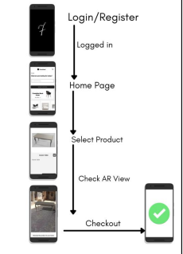
Fig 2 : User Flow.

Sign In/Sign Up: Users must register on the application with their cellphone number in order to enjoy a safe and secure buying experience. Following a successful registration process, users can access their user ID and password via the login page

Home Page: Following a successful login, users are greeted warmly on the home page with a personalized message, merging their name with the amicable salutation "Hi" The central focus of the home page highlights either the top-selling product or a featured item, with the current emphasis on the black leather chair. To keep users updated on the latest additions, an automated recycler view UI component is integrated into the home page, ensuring real-time updates whenever a new product is introduced.
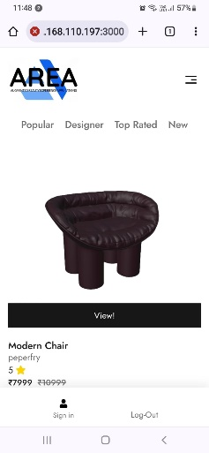
Fig 3: Home page

Categories Page: Elevating user exploration, the categories page serves as a gateway for users to navigate through diverse product classifications. Selecting a category causes a special recycler view to open, which then quickly pulls and displays products from the database associated with that particular category name. This user-centric design fosters a smooth and enjoyable browsing experience, empowering users to uncover products tailored to their distinct preferences.

Select Product: The application launches the product details activity, which is especially made for showing product information, when a product is chosen from the recycler view on the home page or from any category. Receiving the distinct product ID as an intent string extra from the previous action starts this one. Product details class: this class effectively obtains the following product details: name, description, price, image, and link to the AR object that is kept in Firebase storage.
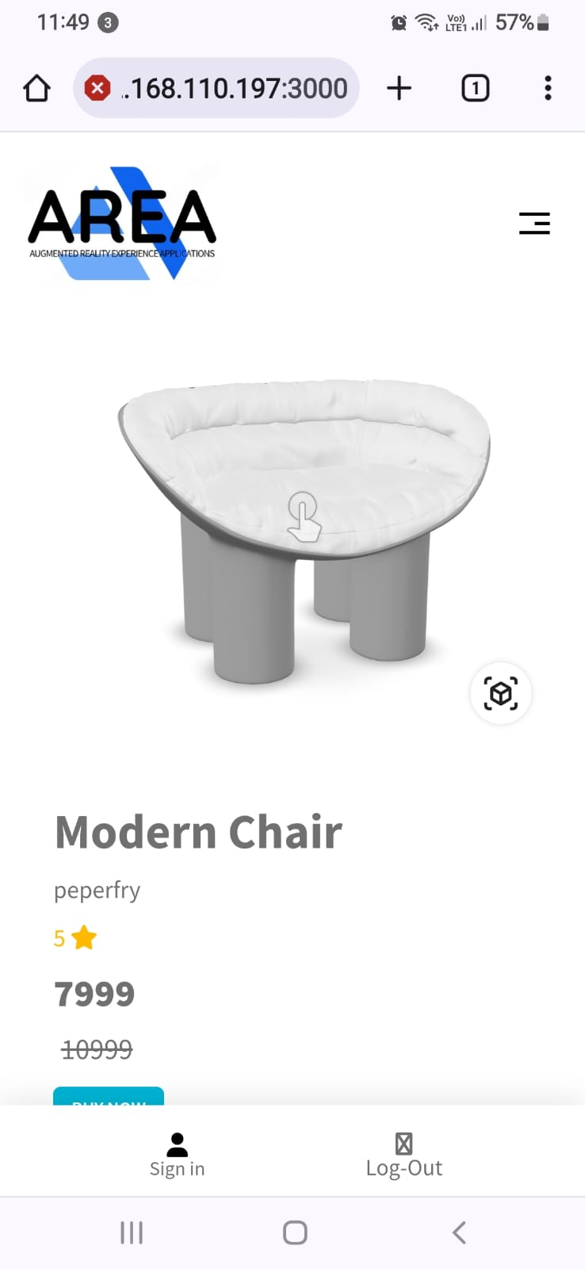
Fig 3: View Product

AR View: The process of presenting the AR object in the view follows the outlined steps. The AR item can be recognised by its special product key. (timestamp stating the product's addition date to the database), is fetched from the database. Upon opening the AR Fragment, the user is greeted with a toast message confirming the model's successful retrieval. Using the ARCore plugin, horizontal points suitable for placing the model are identified. Users can interact by tapping these points to showcase the scalable and transformable model, ensuring a personalized fit within any desired area of the customer's home.

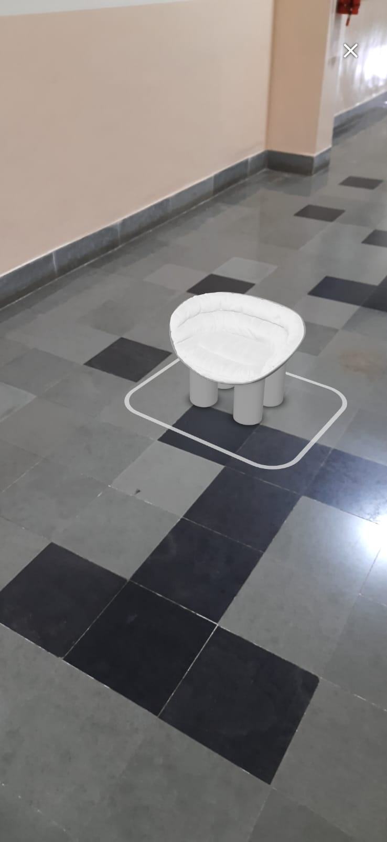
Fig 4: AR view

Checkout: Upon thorough examination of the product, customers have the option to add it to their cart. Initiating this action triggers the addition of the product to a dedicated database for cart lists, complete with user-specific details of the individual adding it to their cart. The cart page prominently displays the overall price, providing users with a transparent overview, if satisfied with their choice, users can proceed to the checkout seamlessly.

Conceptualization and Design: Identify the features and functionalities you want in the AR home furniture app. Create a user interface (UI) for the application's design, considering easy navigation and a visually appealing layout.3D Modeling with Blender: Use Blender to create detailed and realistic 3D models of furniture items. Ensure that the models are optimized for AR performance and consider textures, materials, and lighting for a lifelike appearance

Integration of ARCore in Unity: Set up a Unity project and import the ARCore SDK to enable AR functionalities. Implement the AR features such as plane detection, object tracking, and interaction using ARCore APIs.Integrate the 3D furniture models into the Unity project, placing them in the real world using AR.

User Interaction: Implement intuitive gestures for users to interact with the AR furniture, like tapping to select or dragging to move items. Add features like rotating, resizing, and preview options for a comprehensive AR experience.

E-Commerce Integration: Develop a backend system for handling product data, pricing, and inventory. Implement an e-commerce frontend within the Unity app, allowing users to browse, view details and make purchases seamlessly.

Payment Integration: Integrate a secure payment gateway to facilitate transactions within the app. Ensure the payment process is user-friendly and complies with security standards.

System Architecture

Model

Tracking
Manupulation
Output
Rendering
UI

Fig 5 : System Architecture.

UI
The UI layer includes the graphical interface through which users interact with the AR app. This may involve menus, buttons, gestures and other interactive elements that allow users to navigate through the app, select virtual products, and access customization options.

Tracking
The tracking component is responsible for detecting and tracking the physical environment using sensors such as cameras, gyroscopes, and accelerometers. It utilizes computer vision algorithms to identify and track features in the environment, enabling the app to overlay virtual objects onto the real-world scene accurately.

Rendering
The Rendering Module has 2 inputs consisting of a calculated pose from the Tracking Module and a Virtual Object to be augmented. This module combines the original as well as the virtual components and displays the augmented view on the screen.

The rendering module handles the visualization of virtual objects within the AR environment. It leverages 3D graphics rendering techniques to display virtual products realistically and seamlessly integrate them with real-world surroundings. This involves rendering textures, lighting, and shadows to create a convincing augmented reality experience.

Model Manipulation
The model manipulation component allows users to customize and interact with virtual products. It enables functionalities such as scaling, rotating, and positioning virtual items within the AR space. Additionally, it provides tools for modifying colors, textures, and other attributes of virtual objects to support user customization.

Output
The output layer is responsible for presenting the augmented reality experience to users. This includes rendering the final composite view of the real-world environment with overlaid virtual objects and providing visual feedback based on user interactions and customizations.

Software Requirements

Unity Hub

User Interface: Unity is a popular game development platform that offers robust tools for creating UI elements within AR applications. Unity's built-in UI system allows you to design and implement UI components directly within the Unity development environment.

Access to Additional Features and Add-ons: Unity Hub provides access to additional features, add-ons, and modules that can enhance the capabilities of the Unity development environment for AR. This includes tools for AR development, such as AR Foundation, which enables the creation of AR experiences across both iOS and Android devices.

Unity Hub: Installation and Management of Unity Versions: Unity Hub allows developers to easily install and manage different versions of the Unity game development platform. This is essential for AR development as it ensures compatibility with specific AR-related features and updates.

ARcore

Motion Tracking and Environmental Understanding: ARCore offers APIs for motion tracking, which is crucial for AR apps to understand and track the position and orientation of the device in the real world. It also provides environmental understanding capabilities, allowing apps to detect and interact with physical surfaces and objects, forming the foundation for realistic AR experiences.

Light Estimation: ARCore includes features for light estimation, enabling AR apps to dynamically adjust virtual object lighting to match real-world lighting conditions. This is vital for creating visually convincing AR scenes that seamlessly integrate virtual objects with real-world environments.

Blender

3D Modeling and Texturing: Blender is a powerful tool for creating 3D models and textures that can be used in AR applications. For AR development, Blender's 3D modelling and texturing capabilities are essential for creating

lifelike virtual objects and environments that can be seamlessly integrated into the real world.

Visual Studio or Visual Studio Code

For scripting and coding within Unity, developers may use Microsoft's Visual Studio or Visual Studio Code as their preferred integrated development environment (IDE). These tools provide robust support for C# scripting, which is used in Unity development.

CONCLUSION
In conclusion, the review of augmented reality (AR) applications in interior design demonstrates the significant potential of AR technology to revolutionize the industry. The components of model manipulation and output play a crucial role in enabling users to customize and interact with virtual products while presenting the augmented reality experience. The identified software requirements, including Unity Hub for user interface and additional features, AR Core for motion tracking and environmental understanding, Blender for 3D modelling and texturing, and Visual Studio or Visual Studio Code for scripting and coding, provide a comprehensive toolkit for AR development in interior design. Future research and development should focus on refining accuracy, expanding product catalogues, and integrating social and collaborative features to further enhance the capabilities of AR applications for interior design. As the field continues to advance, leveraging AR technology in home decor and interior design holds the promise of delivering immersive experiences, personalized customization, and enhanced visualization, ultimately benefiting both consumers and professionals in the industry.

Future Improvements

- Seamless cloud integration for effortless access, storage, and sharing of personalized designs across devices.
- E-commerce integration facilitates direct purchasing of visualized products with secure transactions and order processing.
- Implementation of a customer support chat feature for real-time assistance, personalized recommendations, and addressing user queries during the virtual design and shopping journey.
- These future enhancements aim to elevate the AR home decor experience, offering convenience, accessibility, and interactive support, thereby enhancing user satisfaction and engagement.

Acknowledgements
We want to express our sincere gratitude to our project mentor, Dr. Sufola Das Chagas Silva E Araujo, for her invaluable guidance, assistance, and helpful suggestions. Her support played a crucial role in helping us meet our deadlines. Special thanks to our Head of Department, Dr. Shailendra Aswale, for the continuous support. We also appreciate the Department of Information Technology at PCCE, Verna, for their unwavering support throughout the project. Thanks to the entire faculty for their valuable input and timely assistance.

References
- G TejoLakshmi, Chatragadda Balaji, Chilaka Mikky, Addanka, Babburi Venkata Sasi Kiran, Bollepalli Prudhvi Kumar, “Room arrangement using ar and 360degree conversion”, 2022.
- Nandita Nandakumar1, Nipun Manghi2, Saahith Shetty3, Dr. Deepti Reddy4 “An In-Depth Evaluation of AR-Based Interior Design and Decoration Applications”, 11 Feb 2023
- Sashank Sridhar, Sowmya Sanagavarapur, Instant Tracking-Based approach for interior decor planning with markerless AR, Aug 2020.
- Samriddhi Dongre, Saurabh Dube & Prita Patel “Home Decor Shopping Using Augmented Reality” -2016,
- C.V. Pravin , M. Raja Ganapathi and Dr. T. Guhan G TejoLakshmi, Chatragadda Balaji, Chilaka Mikky, Addanka, Babburi Venkata Sasi Kiran, Bollepalli Prudhvi Kumar “Decor AR”, July 2020.
- Prof. S. M. Satre, Hardik Mangla, Shreesh Sambhare, and Shrey Kshatriya published a furniture organizer application using augmented reality, in April 2020.
- Rohan Moaresa, Vaishnavi Jadhavb, Rushikesh Bagulc, RejiJacbo d, Shagufta Rajgurue, Rakhi K f published Interior Decor App using Augmented Reality Technology, 2019.
- Syamantak N. Dhavle Prof. Bhavna Arora Chaudhary Mohammed Qais Khan Mohd Saif Tabarakallah published Furnished, May 2021
- Sun Wenxin AR Technology Based Home Decoration Management System”.2018.
- Sebastian Gottschalk1, Enes Yigitbas1, Eugen Schmidt2, and Gregor Engels1” Model-based Product Configuration in Augmented Reality Applications” 2020.
- 1Hainan Vocational University of Science and Technology, Hainan, China ,2Faculty of Art and Design, University of Hainan, Hainan, China, 3Faculty of Computing and Informatics, University Malaysia Sabah, Malaysia . “Personalized customization system solution using augmented reality technology” 2021.
- Santosh Sharma, Yash Kaikini, Parth Bhodia, Sonali Vaidya,” Markerless Augmented Reality Based Interior Designing Sytem”.2018
- Jason Orlosky, Haruo Takemura, Kiyoshi Kiyokawa, “ A Tranitinal AR Furniture Arrangement Syatem with Automatic View Recommendation”2019.
- Sakshi Patil, P. S. .Deore “ Artistic Furniture” .2023
- Shinde Somesh Ajit, Patil Disha Pandit, Shetty Bradula Balachandra, Wani Pranjal Dipak, Prof. Anita D. Mhatre, “ Furnitureal-Home Furniture Décor Application using AR”. 2023.
- Fairuz Iqbal Maulana, Baskoro Azis, Tiara Ika Widia Primadani, Pangeran Rasyach Artha Hasibuan, “ FunAR-furniture augmented reality application to support practical laboratory experiments in interior design education”. 2023.

