**APPENDIX 1**

**System for Family Tree**

END TERM REPORT

*By*

*1)Rupesh Gaur*

*2)Imsanger Jamir*

*3) Walke Sahil Sanjay*

*4)Ashish Kumar*

Section:K18PA

Roll Number(s): B52,B65,B66,B67



**Department of Intelligent Systems**

**School of Computer Science Engineering**

**Lovely Professional University, Jalandhar**

April-2020

**APPENDIX 2**

Student Declaration

This is to declare that this report has been written by me/us. No part of the report is copied from other sources. All information included from other sources have been duly acknowledged. I/We aver that if any part of the report is found to be copied, I/we are shall take full responsibility for it.

IMSANGER

Imsanger Jamir

B65

SAHIL

Walke Sahil Sanjay

B66

ASHISH

Ashish Kumar

B67

RUPESH

Rupesh Gaur

B52

Place: Lovely Professional University,Phagwara

Date:06/04/2020

**TITLE** **PAGE NO.**

1. **Background and objectives of project assigned ................** **1**

* + 1. **Background 6**
    2. **Outcome** **6**
  1. **Concrete Goal** 7
     1. **Outcome** **7**

1. **Description of Project ... ........................................................** **8**
   1. **Output Screen and Explanation** **8**
   2. **Project Work done by group mates. 13**
   3. **Technologies and Framework Used. 14**
   4. **Implementation of Scheduled Work. 15**
   5. **SWOT analysis achieved by project. 16**

APPENDIX 4

BONAFIDE CERTIFICATE

Certified that this project report “**SYSTEM FOR FAMILY TREE ”** is the bonafide work of “1)Imsanger Jamir 2)Walke Sahil Sanjay 3)Ashish Kumar” who carried out the project work under my supervision.

Signature of the Supervisor

Name of supervisor

Academic Designation

ID of Supervisor

Department of Supervisor

**Background:**

The Project “System for Family Tree” is one of the best projects we have done. IN this project we have shown the relationship between two peoples of same family with their relations given when user enters both of the names. Firstly we have stored the data of whole family in background and then we are able to show the relationship between them. The relationship between Grandfather and their till their Great Grandson is shown in this project.

**Outcome:**

I got the motivation for our Artificial Intelligence Teacher Ms.Jasleen Kaur Mam.She helped us a lot in making of our project. Outcome of project was to show the relation between two names entered by the user. To show the relation between family is only the main moto of our project to be done.

**Concrete Goal:**

Concrete goal of our project was to show the correct output of relation to be shown of our project. There shouldn’t be single error while running of the program. User should get the proper output of behalf the names entered by him or her of the family. We have shown the family tree at the start of the output screen so user gets proper understanding of the project. But due to output screen showing all the names in same format we have used different format for understanding of project in which we are able to identify the blood relations at first and then the relations which are added after marrying to a person of the that family and to become part of that family afterwards. So we have mentioned some points at the end of family tree shown in output screen to get exact information about the family. So it will be easy to know the family and user will be able get proper output he wanted to know the relations of.

**Objective**:

Objective of our project is only to give the relationship name between two names entered by the use. It should be proper and accurate while user is entering the names given in family tree.

**Description of Project:**

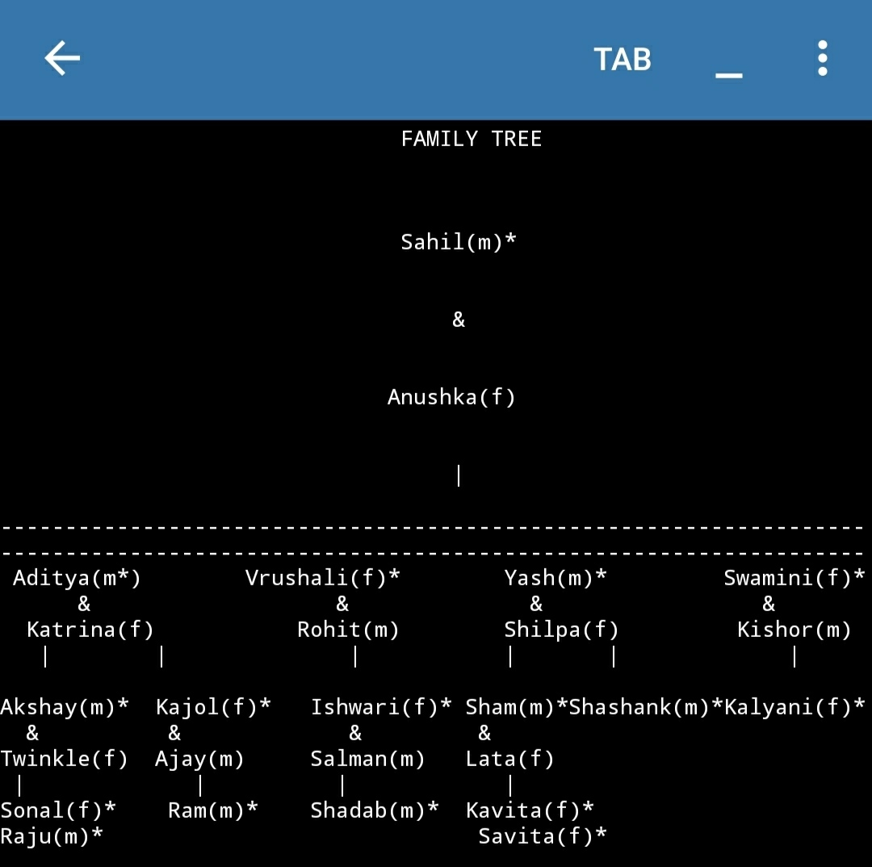

This is the flow chart of Family Tree System.

The symbol * indicates the close blood relations of the family.

And the names without symbol are persons added to family after marriage.

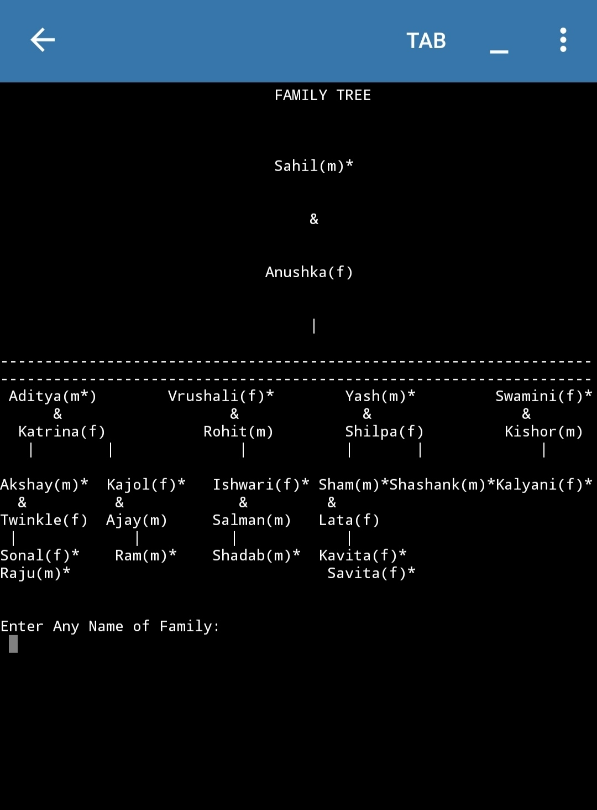In this flowchart:

The name is asked to enter to user by the System.

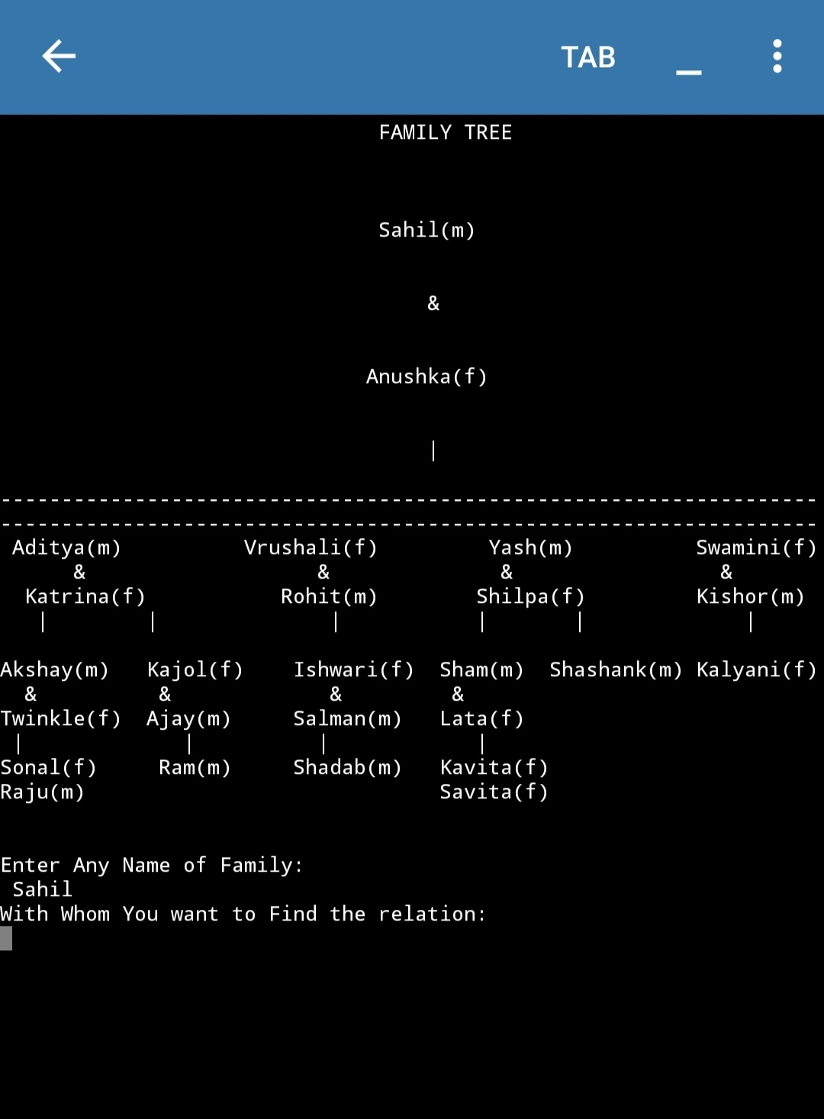

In this flowchart:

Second name is asked to enter to the user by the system.

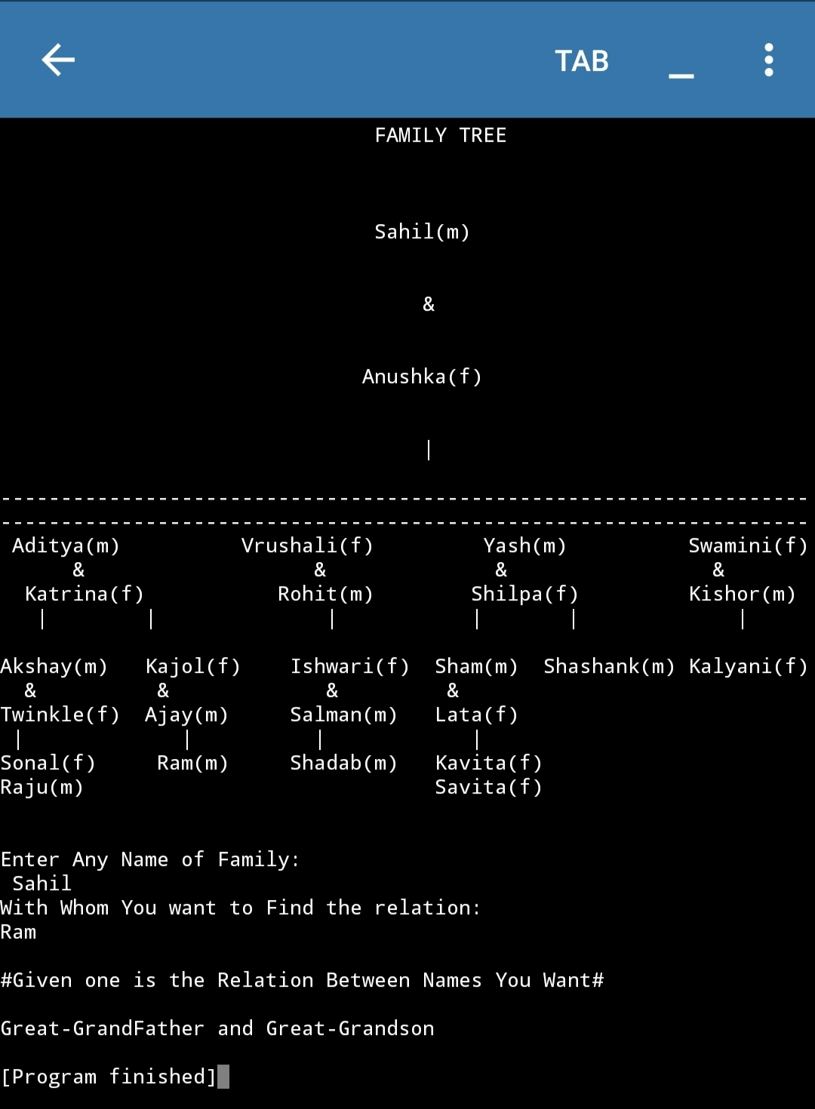

In this flowchart:

The relationship name is shown by the system to the user when he or she enters the name of two persons in a family tree.

**Project work done by Group Mates:**

1)Rupesh

Testing and Report part of Project is made by me.

1)Imsanger

I had done all the outline of project. Means to create all the Family Tree and allocating them the relations.

2)Sahil

I had done the coding part of project.And the testing part of system and error detection is also done by us.

3)Ashish

Helping the Report making part of the project and also made the loom video.

**Technologies and Framework to be used:**

1)We have used PYDROID3 Mobile App for making of the project.

2)It was made on Android 10.

3) Version of Pydroid3 app was 3.11_arm64.

4)Apk to this file is ru.iiec.pydroid3.

5) Installation source was from Google Play Store.

**Implementation of Scheduled Work:**

Date:14/02/2020. Start of Project

Date:29/02/2020. Collection of all logics needed for project

Date:22/03/2020. Finish with coding part of project

Date:03/04/2020. Done with report of project

Date:06/04/2020. Submitted the project

**SWOT analysis achieved in project:**

1)This project has capability of finding relationship names between two names entered by the user. This is the strength.

2)Weakness of project is that the complexity of project is much more than required. Because lines of code are so much.

3) Opportunities are that it can used in daily life for calculating the family relationship names and can be used on great extent. Can have application on sites used for arranging marriages.

4)There are no Threats of this project.