

Worksheet No- 2
Name - Sahil Gupta UID – 25MCI10266
Branch – MCA Section – MAM-1(A)
Semester – 2nd Date of performance – 12th Jan,2026
Subject - Technical Training Subject Code -

Aim / Overview of the Practical
To understand and implement the CASE statement in PostgreSQL for conditional data aggregation and analysis.

Theory
The CASE statement in PostgreSQL is used to perform conditional logic similar to if-else conditions. It is commonly used in SELECT queries to apply conditions while retrieving or aggregating data.

Tools Used
● PostgreSQL
- PostgreSQL (Database Server)
- pgAdmin (Graphical User Interface)
- SQL Queries (DDL, DML, DCL commands)
Objectives
  - To retrieve specific data using filtering conditions
  - To sort query results using single and multiple attributes
  - To perform aggregation using grouping techniques
  - To apply conditions on aggregated data
  - To understand real-world analytical queries commonly asked in placement interviews

Practical / Experiment Steps

CREATE TABLE Students (

student_id INT PRIMARY KEY,

student_name VARCHAR(50),

city VARCHAR(30),

percentage DECIMAL(5,2)

);

INSERT INTO Students VALUES

(1, 'Aman', 'Delhi', 96.5),

(2, 'Riya', 'Delhi', 97.0),

(3, 'Kunal', 'Delhi', 92.0),

(4, 'Neha', 'Mumbai', 98.0),

(5, 'Rohit', 'Mumbai', 96.5),

(6, 'Sneha', 'Mumbai', 94.0);

select * from students;
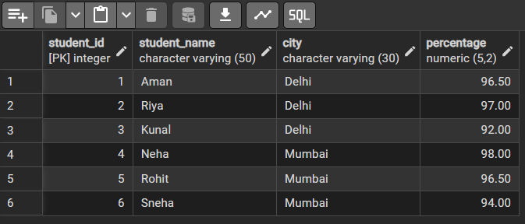

-- Without CASE statement

SELECT city, COUNT(*) AS above_95

FROM Students

WHERE percentage > 95

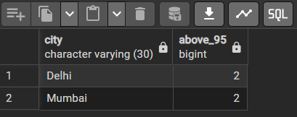
GROUP BY city;

-- With CASE statement

SELECT city,

SUM(CASE

WHEN percentage > 95 THEN 1

ELSE 0

END) AS above_95

FROM Students

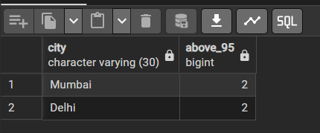
GROUP BY city;

-- II: Average percentage of students scoring above 95

SELECT city,

AVG(CASE

WHEN percentage > 95 THEN percentage

ELSE NULL

END) AS average

FROM Students

GROUP BY city

ORDER BY average DESC;
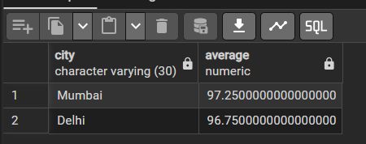

5. Learning Outcome
- Apply the CASE statement in PostgreSQL to perform conditional logic within SELECT queries for data analysis.
- Differentiate between conditional filtering using WHERE clause and conditional aggregation using CASE in GROUP BY queries.
- Compute conditional counts and averages by combining CASE statements with aggregate functions such as COUNT() and AVG().
- Analyse student performance data city-wise, improving understanding of real-world data summarization techniques in PostgreSQL.
- Implement efficient SQL queries for decision-based reporting, which is useful in academic and industry-level database applications.

