

Worksheet No- 4
Name - Sahil Gupta UID – 25MCI10266
Branch – MCA Section – MAM-1(A)
Semester – 2nd Date of performance – 3rd feb,2026
Subject - Technical Training Subject Code – 25CAP-652_25MAM_KAR-1_A

Aim / Overview of the Practical

To understand and implement iterative control structures in PostgreSQL conceptually, including FOR loops, WHILE loops, and basic LOOP constructs, for repeated execution of database logic.

Software Requirements
● PostgreSQL
Objectives

To understand why iteration is required in database programming

To learn the purpose and behavior of FOR, WHILE, and LOOP constructs

To understand how repeated data processing is handled in databases

To relate loop concepts to real-world batch processing scenarios

To strengthen conceptual knowledge of procedural SQL used in enterprise systems

Theory
In real-world database applications, tasks often need to be repeated multiple times. Examples include processing employee records, generating reports, validating data, applying salary increments, and running batch jobs. Standard SQL is declarative and works well for single operations, but repeated logic requires procedural control.
PostgreSQL provides PL/pgSQL, a procedural extension that supports iteration using loop structures. These loops allow SQL statements to execute repeatedly until a specific condition is met.
Iteration in PostgreSQL is commonly used inside:
- Stored procedures
- Functions
- Anonymous execution blocks
Large organizations such as Amazon, SAP, Oracle, and Rippling use loop-based logic for payroll processing, billing cycles, analytics, and automation workflows.
Types of Loops in PostgreSQL
1. FOR Loop (Range-Based)
- Executes a fixed number of times
- Useful when the number of iterations is known in advance
- Commonly used for counters, testing, and batch execution
2. FOR Loop (Query-Based)
- Iterates over rows returned by a query
- Processes one row at a time
- Frequently used for reporting, audits, and row-wise calculations
3. WHILE Loop
- Executes repeatedly as long as a condition remains true
- Suitable for condition-controlled execution
- Often used in retry logic or threshold-based processing
4. LOOP with EXIT Condition
- Executes indefinitely until explicitly stopped
- Provides maximum control over execution flow
- Used in complex workflows where exit conditions are custom-defined
Experiment Steps
Example 1: FOR Loop – Simple Iteration
- The loop runs a fixed number of times
- Each iteration represents one execution cycle
- Useful for understanding basic loop behavior
Application: Counters, repeated tasks, batch execution

Example 2: FOR Loop with Query (Row-by-Row Processing)
- The loop processes database records one at a time
- Each iteration handles a single row
- Simulates cursor-based processing
Application: Employee reports, audits, data verification

Example 3: WHILE Loop – Conditional Iteration
- The loop runs until a condition becomes false
- Execution depends entirely on the condition
- The condition is checked before every iteration
Application: Retry mechanisms, validation loops

Example 4: LOOP with EXIT WHEN
- The loop does not stop automatically
- An explicit exit condition controls termination
- Gives flexibility in complex logic
Application: Workflow engines, complex decision cycles

Example 5: Salary Increment Using FOR Loop
- Employee records are processed one by one
- Salary values are updated iteratively
- Represents real-world payroll processing
Application: Payroll systems, bulk updates

Example 6: Combining LOOP with IF Condition
- Loop processes each record
- Conditional logic classifies data during iteration
- Demonstrates decision-making inside loops
Application: Employee grading, alerts, categorization logic
RESULT:
This experiment helps students understand how iterative control structures work in PostgreSQL at a conceptual level. Students learn where and why loops are used in database systems and gain foundational knowledge required for writing procedural logic in enterprise-grade applications.

Coding and Output :

CREATE TABLE employee (

emp_id INT PRIMARY KEY,

emp_name VARCHAR(50),

salary INT,

score INT

);

INSERT INTO employee VALUES

(1, 'Sahil', 80000, 85),

(2, 'Rahul', 35000, 72),

(3, 'Bunty', 40000, 60),

(4, 'Krishna', 45000, 48),

(5, 'Radha', 38000, 55

select * from employee;
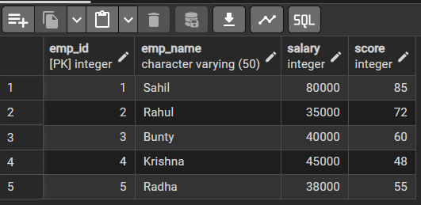

-- EXAMPLE 1 : For loop (Simple Iteration)
Do $$
Declare
i INT;
Begin
For i in 1..5 LOOP
Raise notice 'Execution cycle number: %',i;
end LOOP;
END $$;
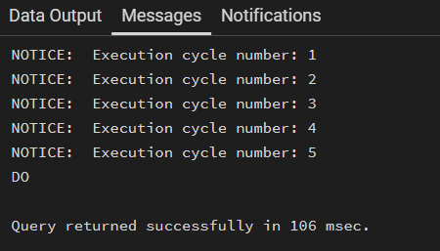

-- Example 2: For loop with query(Row-by-Row processing)
Do $$
Declare
rec RECORD;
Begin
For rec in select emp_id, emp_name from employee LOOP
Raise notice 'Employee ID: %, Name: %',rec.emp_id,rec.emp_name;
End LOOP;
End $$;
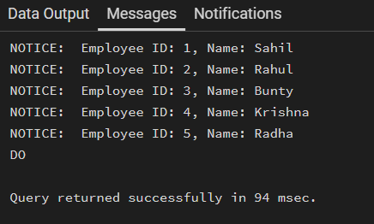

-- Example 3 : While LOOP - Conditional Iteration
Do $$
Declare
counter INT := 1;
Begin
WHILE counter <= 3 LOOP
Raise Notice 'While loop execution: %',counter;
counter := counter + 1 ;
End LOOP;
End $$;

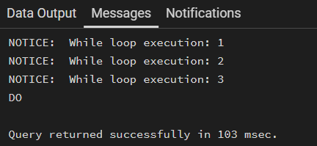

-- Example 4 : LOOP with EXIT WHEN
Do $$
Declare
i INT := 1;
Begin
LOOP
Raise notice 'LOOP execution number: %',i;
i := i+1;

Exit WHEN i > 4;
END LOOP;
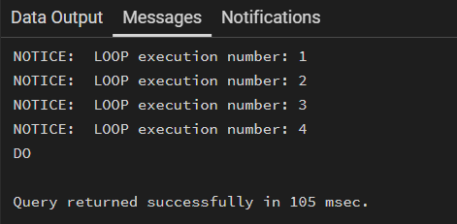
END $$;

-- Example 5: Salary increment Using For LOOP
Do $$
Declare
rec RECORD;
Begin
For rec in select emp_id FROM employee LOOP
UPDATE employee
SET salary = salary + 5000
WHERE emp_id = rec.emp_id;

Raise notice 'Salary incremented for Employee ID %', rec.emp_id;
END LOOP;
END $$;
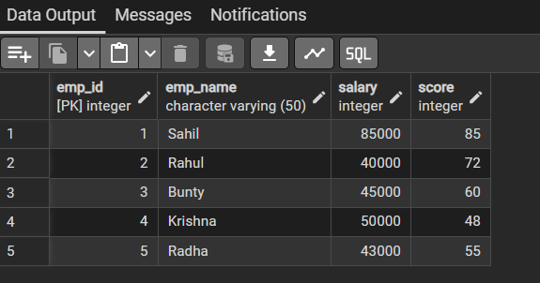
This table shows the updated value of salary by 5000

-- Example 6: Combining LOOP and IF Condition
Do $$
Declare
rec RECORD;
Begin
For rec in select emp_name, score From employee LOOP

IF rec.score >= 75 THEN
Raise NOTICE '% -> Grade: Distinction', rec.emp_name;
ELSIF rec.score >= 60 THEN
Raise NOTICE '% -> Grade: First Class', rec.emp_name;
ELSE
Raise NOTICE '% -> Grade: Pass', rec.emp_name;
End if;
End LOOP;
End $$;
