Student Name: Sahil Gupta UID: 25MCI10266
Branch: M.C.A(A.l & M.L) Section/Group: MAM-1 A
Semester: 2nd Sem Date of Performance:12/01/2026
Subject Name: TECHINCAL SKILLS Subject Code:

WORKSHEET 1.1
AIM: To design and implement a sample database system using DDL, DML, and DCL commands, including database creation, data manipulation, schema modification, and role-based access control to ensure data integrity and secure, read-only access for authorized users.
S/W Requirement: Oracle Database Express Edition and pgAdmin
OBJECTIVES:
To gain practical experience in implementing Data Definition Language (DDL), Data Manipulation Language (DML), and Data Control Language (DCL) operations in a real database environment. This will also include implementing role-based privileges to secure data.
Given:
An organization wants to design a sample database system to manage Departments, Employees, and Projects. The database must ensure data integrity, controlled access, and proper privilege management for different users.

- Database Design
- Create multiple tables such as Department, Employee, and Project.
- Define appropriate PRIMARY KEY and FOREIGN KEY constraints.
- Enforce NOT NULL, UNIQUE, and CHECK constraints where necessary.

Code:
-- 1. Create Department table
CREATE TABLE Department (
dept_id INT PRIMARY KEY,
dept_name VARCHAR(30) UNIQUE NOT NULL
);

-- 2. Create Employee table
CREATE TABLE Employee (
emp_id INT PRIMARY KEY,
emp_name VARCHAR(30) NOT NULL,
emp_email VARCHAR(40) UNIQUE NOT NULL,
emp_phone VARCHAR(15) UNIQUE NOT NULL,
emp_address VARCHAR(50),
dept_id INT,
FOREIGN KEY (dept_id) REFERENCES Department(dept_id)
ON UPDATE CASCADE
ON DELETE SET NULL
);

-- 3. Create Project table
CREATE TABLE Project (
project_id INT PRIMARY KEY,
project_name VARCHAR(40) NOT NULL,
start_date DATE NOT NULL,
end_date DATE NOT NULL,
assigned_emp INT,
FOREIGN KEY (assigned_emp) REFERENCES Employee(emp_id)
ON UPDATE CASCADE
ON DELETE SET NULL
);

-- 4. Insert values into Department
INSERT INTO Department VALUES
(11, 'AI Research'),
(22, 'Software Development'),
(33, 'Marketing'),
(44, 'Administration');

-- 5. Insert values into Employee
INSERT INTO Employee VALUES
(301, 'Sahil Gupta', 'sahil.gupta@gmail.com', '9811111111', 'Chandigarh', 22),
(302, 'Aman Verma', 'aman@gmail.com', '9822222222', 'Delhi', 22),
(303, 'Riya Sharma', 'riya@gmail.com', '9833333333', 'Jaipur', 33),
(304, 'Neha Singh', 'neha@gmail.com', '9844444444', 'Bhopal', 11),
(305, 'Karan Malhotra', 'karan@gmail.com', '9855555555', 'Noida', 44);

-- 6. Insert values into Project
INSERT INTO Project VALUES
(101, 'AI Chatbot System', '2026-01-10', '2026-06-30', 301),
(102, 'Online Learning Platform', '2026-02-15', '2026-07-20', 302),
(103, 'Marketing Analytics Tool', '2026-03-01', '2026-05-31', 303),
(104, 'Research Data Portal', '2026-01-25', '2026-04-30', 304),
(105, 'Office Automation System', '2026-02-05', '2026-08-10', 305);

-- 7. Display tables
SELECT * FROM Department;
SELECT * FROM Employee;
SELECT * FROM Project;

-- 8. Update employee department
UPDATE Employee
SET dept_id = 44
WHERE emp_id = 303;

-- 9. Delete an employee
DELETE FROM Employee WHERE emp_id = 305;

-- 10. Create role and grant permissions
CREATE ROLE HR LOGIN PASSWORD 'HR';

GRANT SELECT, INSERT, UPDATE ON Employee TO HR;
GRANT SELECT ON Department TO HR;
GRANT SELECT, INSERT, UPDATE ON Project TO HR;

-- 11. Revoke permissions
REVOKE SELECT ON Employee FROM HR;
REVOKE UPDATE ON Employee FROM HR;

OUTPUT:
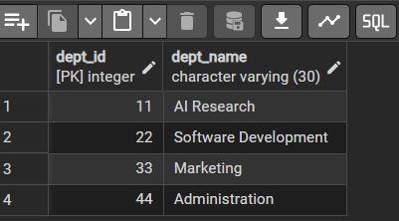
Dept. table
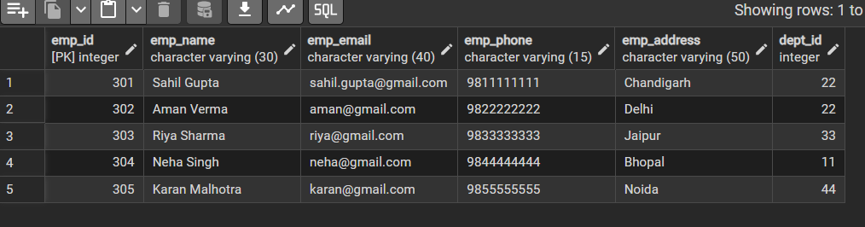

EMPLOYEE Table

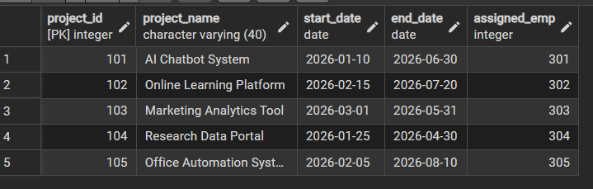
Project table
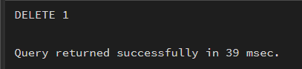
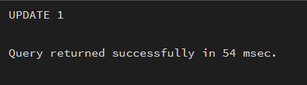
DML Commands
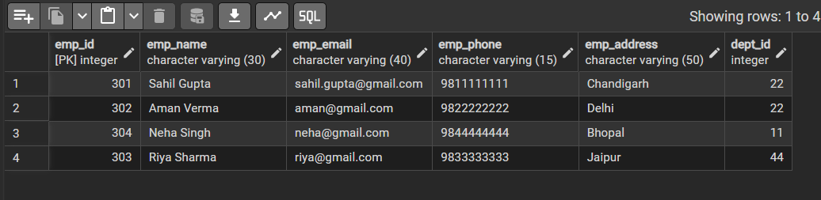
After DML Operations (Employee table)
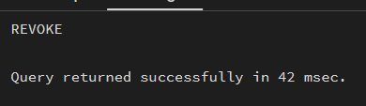
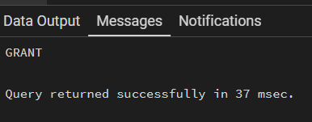
DCL commands for providing permissions to the role

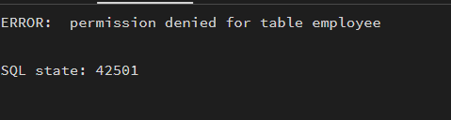
Role(user) tries to access data from employee table after revoke

Learning Outcomes:
- Understood the basics of relational database design using tables, keys, and relationships.
- Learned to apply primary key and foreign key constraints to maintain data integrity.
- Gained hands-on experience with INSERT, UPDATE, and DELETE operations safely.
- Understood how roles and privileges control access to database objects.
- Learned to use GRANT and REVOKE for implementing read-only users.
- Practiced ALTER TABLE and DROP TABLE for managing database changes.

