3) Understanding the Production
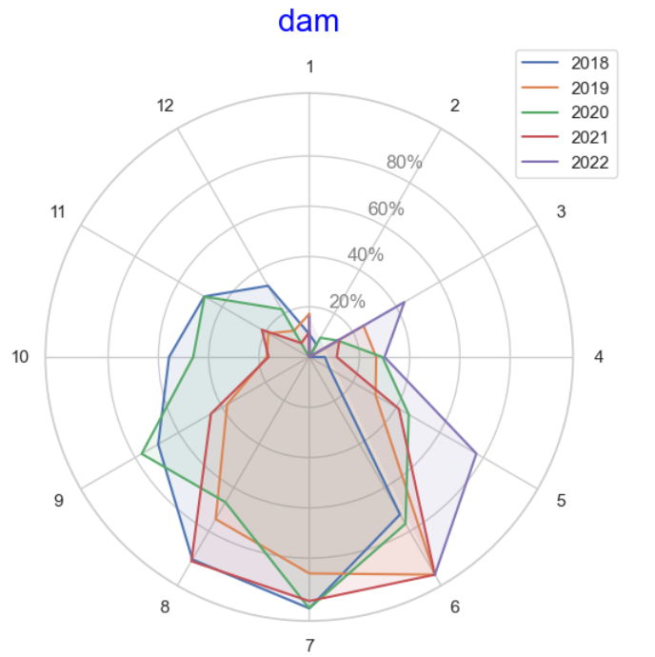
Picture reveals the production trend of dam. It seems that during summer dam’s production increase. If we consider the consumption decrease during summer, that may couses the lower prices.
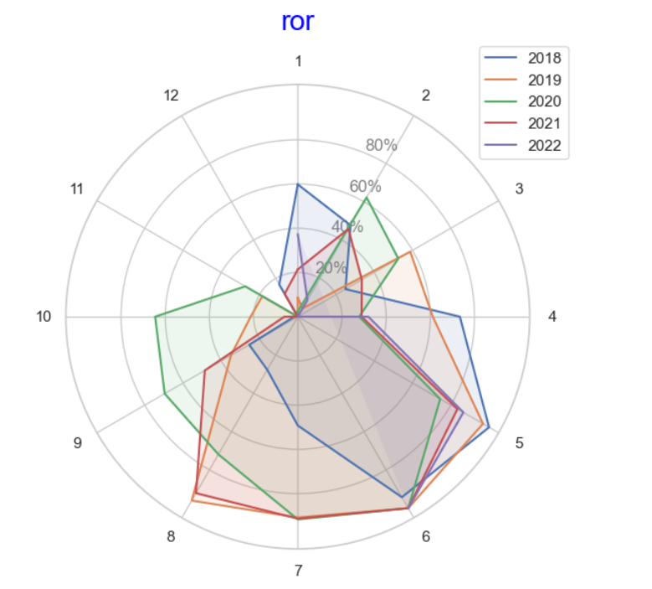
Similar trend observed for Ror’s.
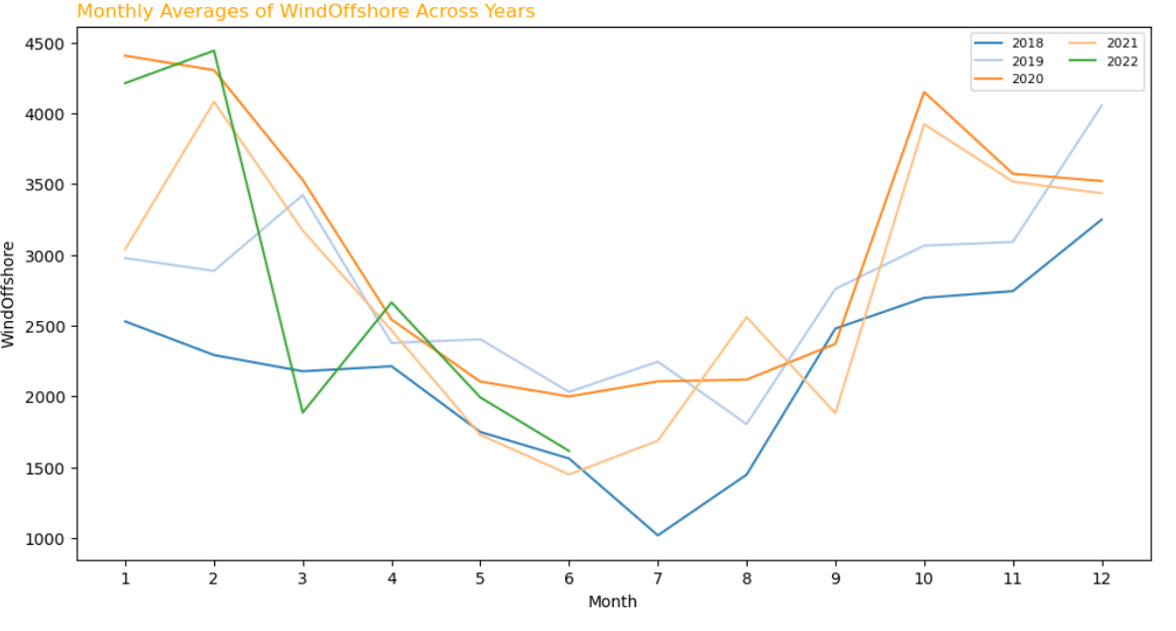
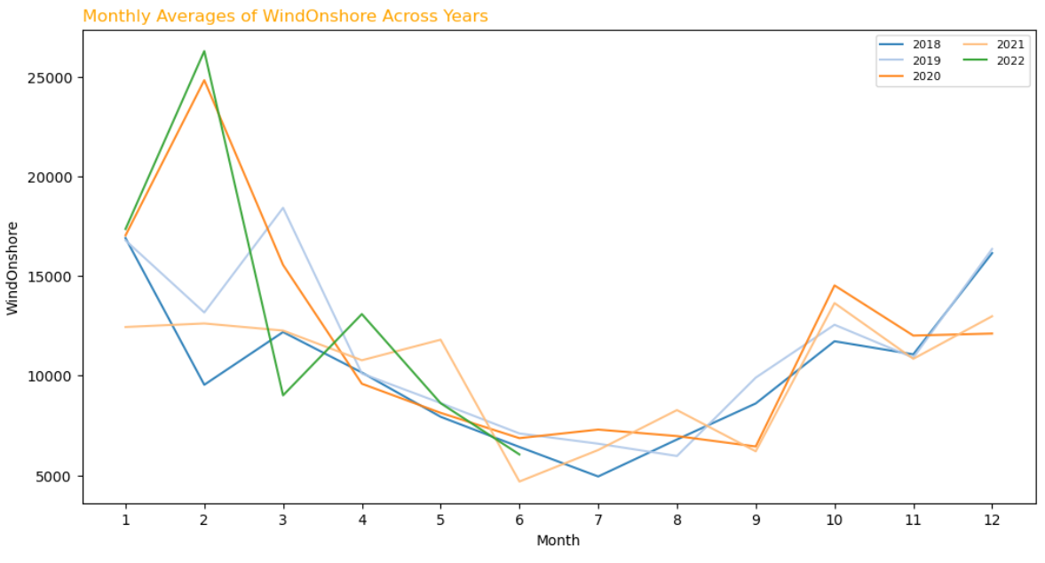
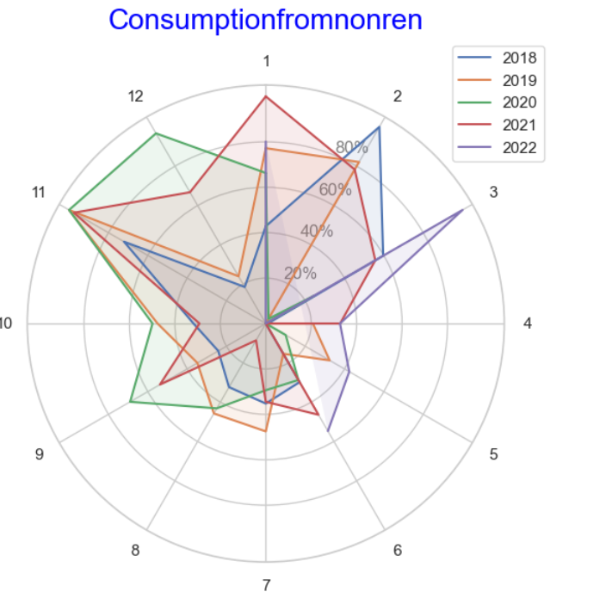
The above picture reveals the trend of production of power from non renewable sources.(Residual demand) Especially during winter, when consumption increases and production from water decreases, residual demand increases and that may couse price increase. However power generation from wind increases during the winter. Because of that, heating demand and generation from wind are crucial for price during winter.

4) Price
Corelation of price in 2019
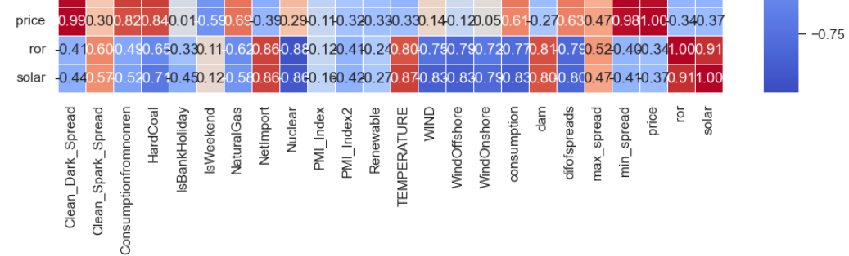
Corelation of price in 2020
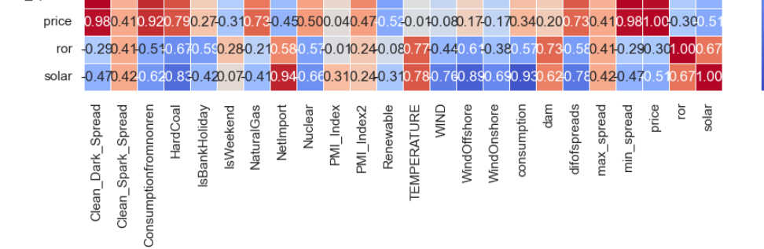
Corelation of price in 2021
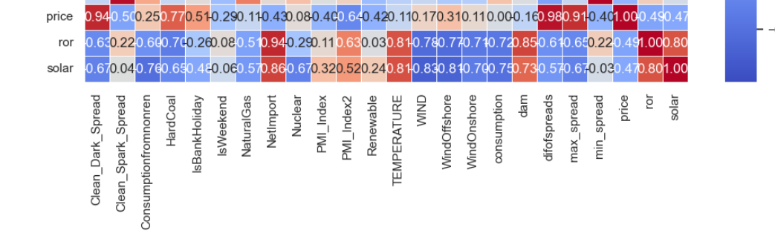
Corelation of price in 2022

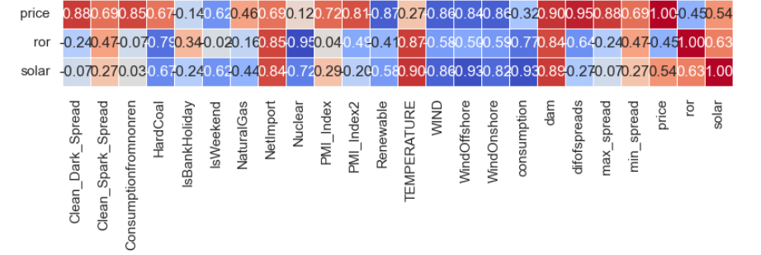

The correlation heatmap indicates that prices are largely influenced by factors such as Clean Dark Spread, consumption from non-renewable sources (residual demand), and the disparity between dark and spark spreads. Particularly noteworthy is the increased sensitivity of prices when the difference between spark and dark spreads widens. This suggests that issues such as coal or natural gas availability could be driving price hikes.
This trend appears to be particularly significant for 2022. Consequently, I opted to construct a new simplified regression model specifically tailored to address this scenario. To achieve this, I utilized data spanning from September 2021 to June 2022. Omitting earlier data was intentional, as it's unlikely that an ML model could effectively discern supply shortages from historical data alone. I used %85 of data for training, and %15 for test. Results can be seen in regression.csv file attached to mail. Also detailed analysis codes attached to email.
Evaluation Metrics :
RMSE: 47.89256867337023
MAE: 36.830512726260544

