SOLUTION STEPS
- Creating Dataset
- Csv files imported the MS SQL database
- A new time table created, bank holidays and weekends were determined
- Based on new time table, following sql quary executed and dataset prepared for analysis

SELECT
tm.*,
YEAR(C.datetime) AS 'Year',
MONTH(C.datetime) AS 'Month',
DAY(C.datetime) AS 'Day',
DATEPART(HOUR, C.datetime) AS 'Hour',
c.datetime,
C.consumption,
pr.dam,pr.solar,pr.ror,pr.WindOffshore,pr.WindOnshore,pr.HardCoal,pr.Nuclear,pr.NaturalGas,
C.consumption-pr.solar-pr.ror-pr.WindOffshore-pr.WindOnshore-pr.dam as 'Consumptionfromnonren',
pr.solar+pr.ror+pr.WindOffshore+pr.WindOnshore+pr.dam as 'Renewable',
co.Clean_Dark_Spread-co.Clean_Spark_Spread as difofspreads,
CASE
WHEN co.Clean_Dark_Spread >= Clean_Spark_Spread THEN Clean_Dark_Spread
ELSE Clean_Spark_Spread
END AS max_spread,

CASE
WHEN co.Clean_Dark_Spread <= Clean_Spark_Spread THEN Clean_Dark_Spread
ELSE Clean_Spark_Spread
END AS min_spread,
Co.*,
NI.*,
P.*,
W.*,
pmı.PMI_Index

from [dbo].[hourly_data_with_bank_holidays] tm
left join
[dbo].[consumption] AS C on YEAR(C.datetime) = tm.[Year] AND MONTH(C.datetime) = tm.[Month] AND DAY(C.datetime) = tm.[Day] AND DATEPART(HOUR, C.datetime) =tm.[Hour]
LEFT JOIN
[dbo].[costs] AS Co ON tm.[Year] = YEAR(Co.date) AND tm.[month] = MONTH(Co.date) AND tm.[Day] = DAY(Co.date)
LEFT JOIN
[dbo].[net_imports] AS NI ON tm.[Year] = YEAR(NI.date) AND tm.[month] = MONTH(NI.date) AND tm.[Day] = DAY(NI.date) AND DATEPART(HOUR, C.datetime) = DATEPART(HOUR, NI.date)
LEFT JOIN
[dbo].[price] AS P ON YEAR(C.datetime) = YEAR(P.datetime) AND MONTH(C.datetime) = MONTH(P.datetime) AND DAY(C.datetime) = DAY(P.datetime) AND tm.Hour = DATEPART(HOUR, P.datetime)
LEFT JOIN
[dbo].[production] AS Pr ON tm.Year = YEAR(Pr.datetime) AND tm.Month = MONTH(Pr.datetime) AND tm.Day = DAY(Pr.datetime) AND tm.Hour = DATEPART(HOUR, Pr.datetime)
LEFT JOIN
[dbo].[weather] AS W ON tm.Year = YEAR(W.datetime) AND tm.Month = MONTH(W.datetime) AND tm.dAY = DAY(W.datetime) AND TM.Hour = DATEPART(HOUR, W.datetime)
Left join [dbo].[germany_pmi_index_2018_2023] pmı on tm.Year=pmı.Year and tm.Month=pmı.Month
ORDER BY tm.Year,tm.Month,tm.Day,tm.Hour

- New columns were added the dataset, like max of dark and spark spred and difference of spreads, also pmi index.
2) Understanding the Consumption
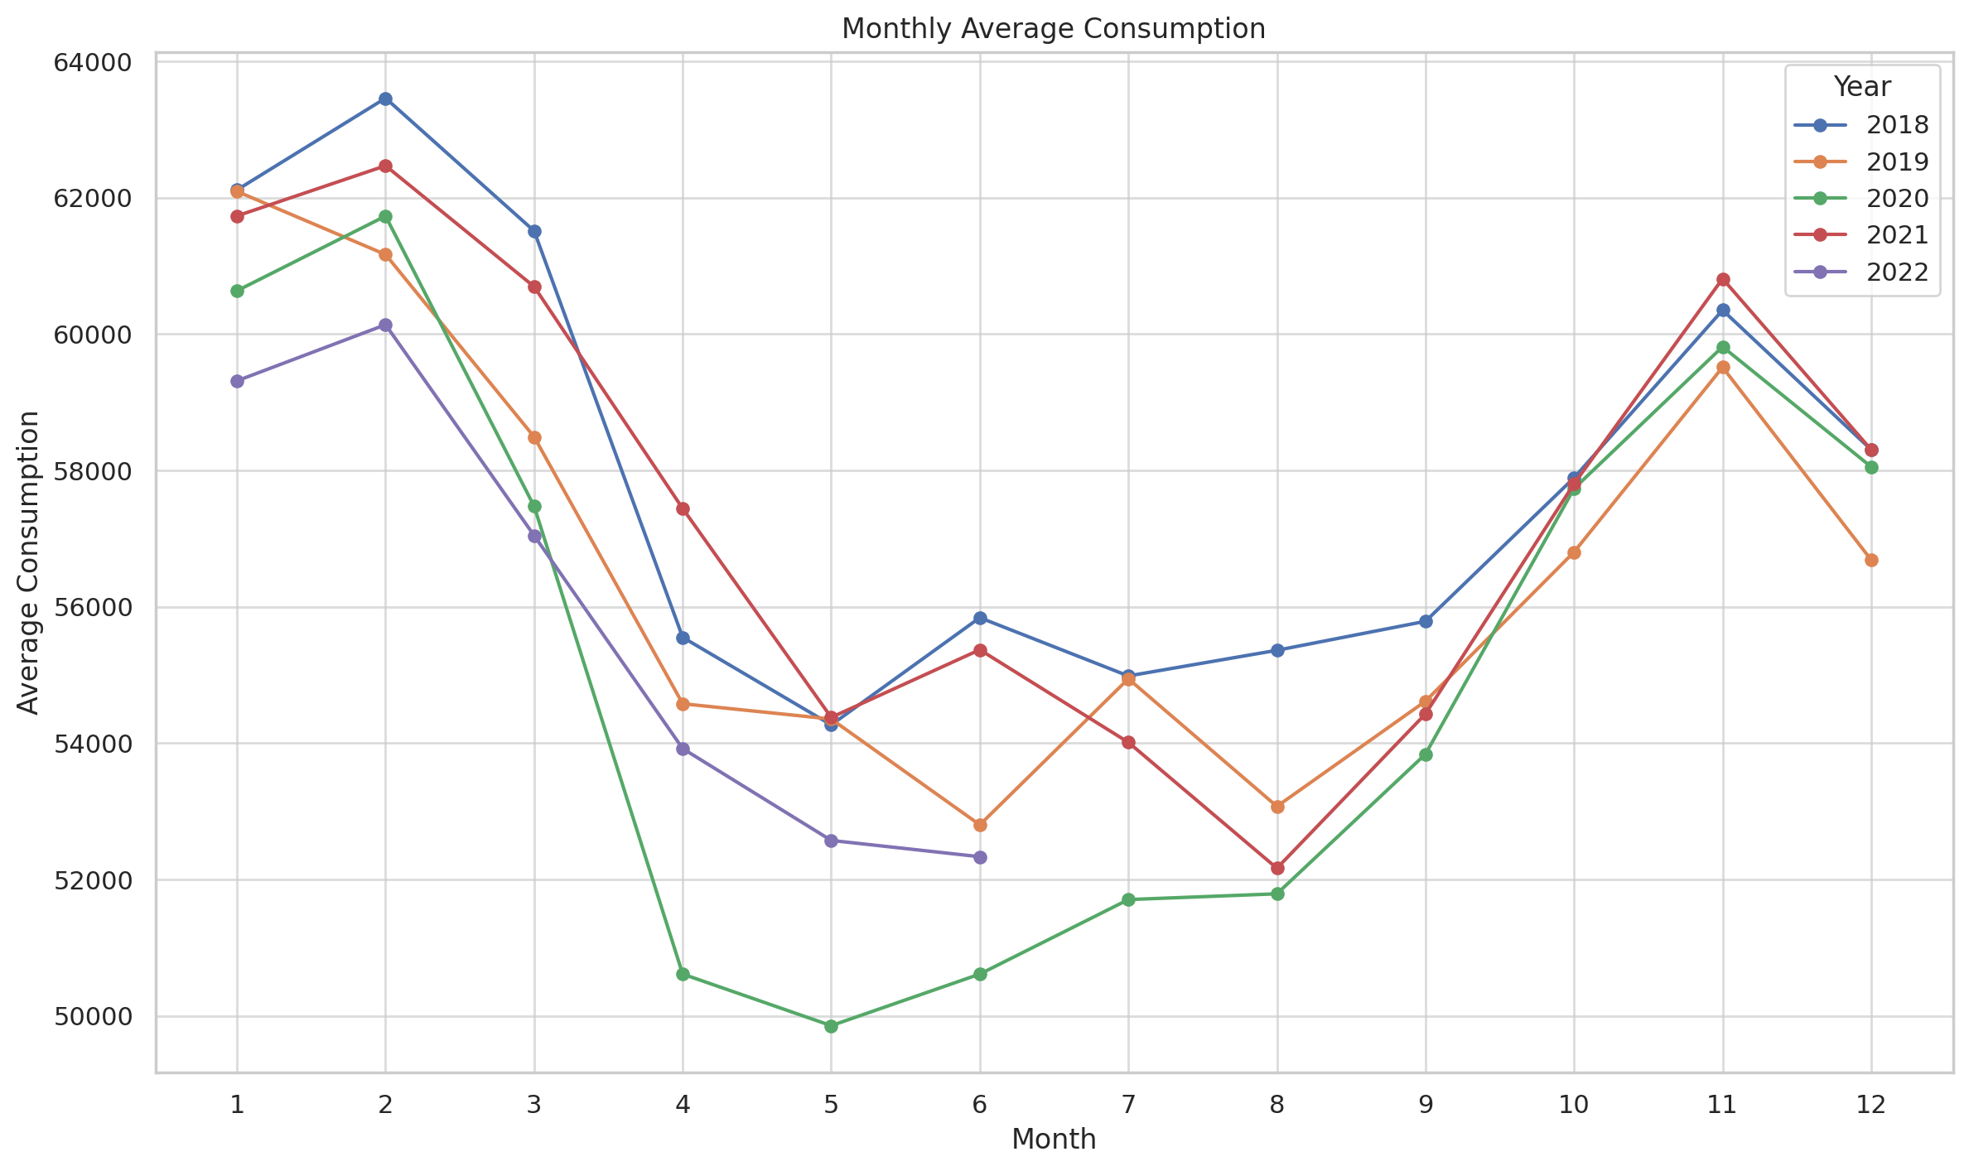
From the picture above, it seems that there is a seasonality in power demand. Especially during winter and autumn, heating demand increases.
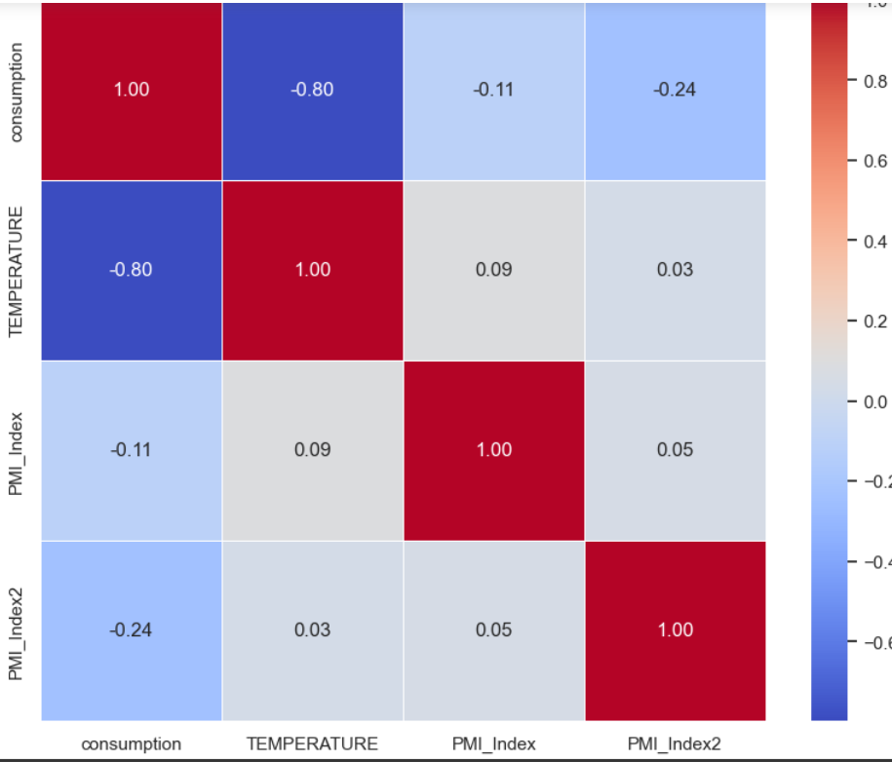
The picture above shows that there is a strong negative corelation between consumption and average temperature.
Abo
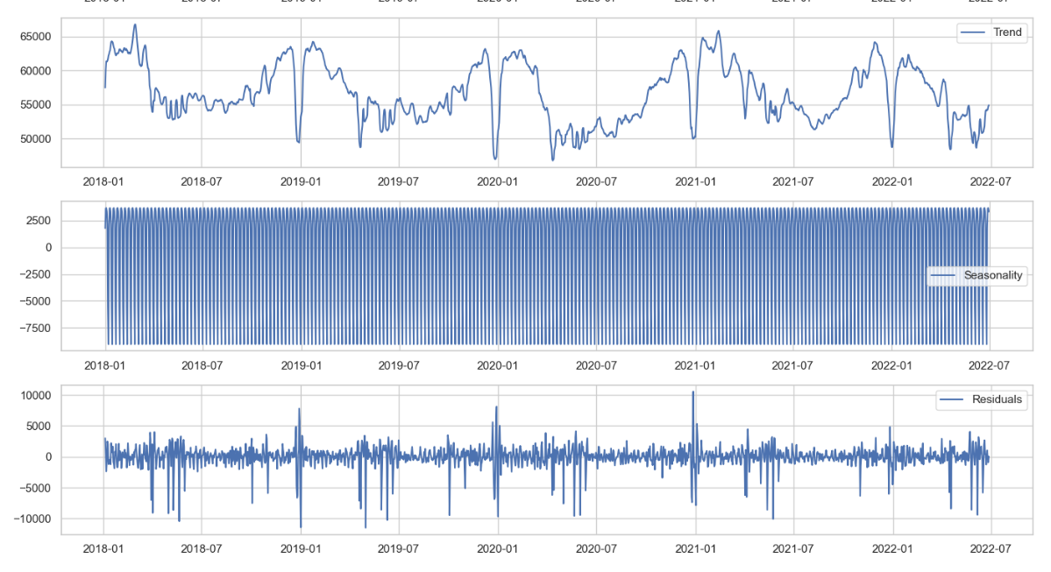
First picture depicts the trend of power demand.It seems that there is a decrease during new years eve.Also trend of consumption reveals that during winter and autumn, trend tend to be increased.

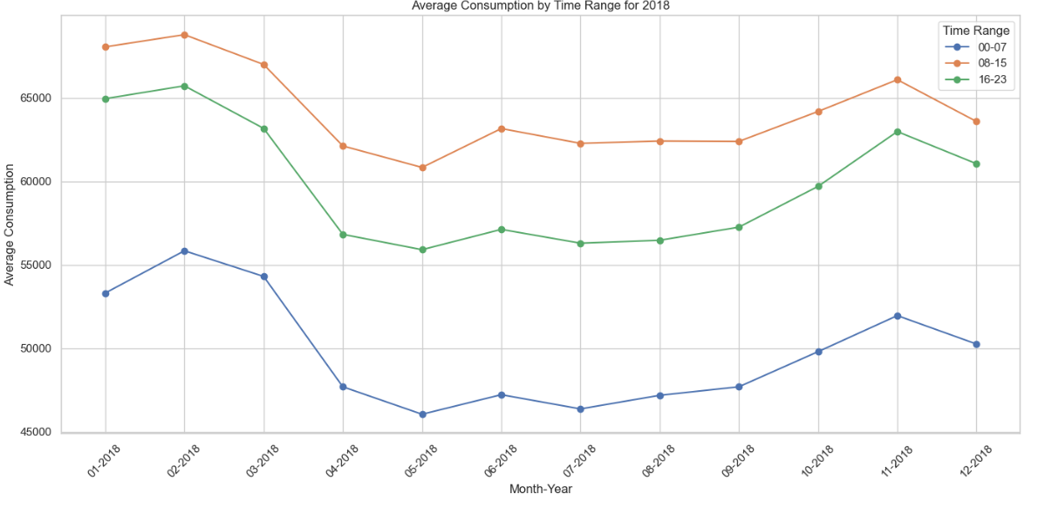
Above picture reveals that peak hours are 08-15.
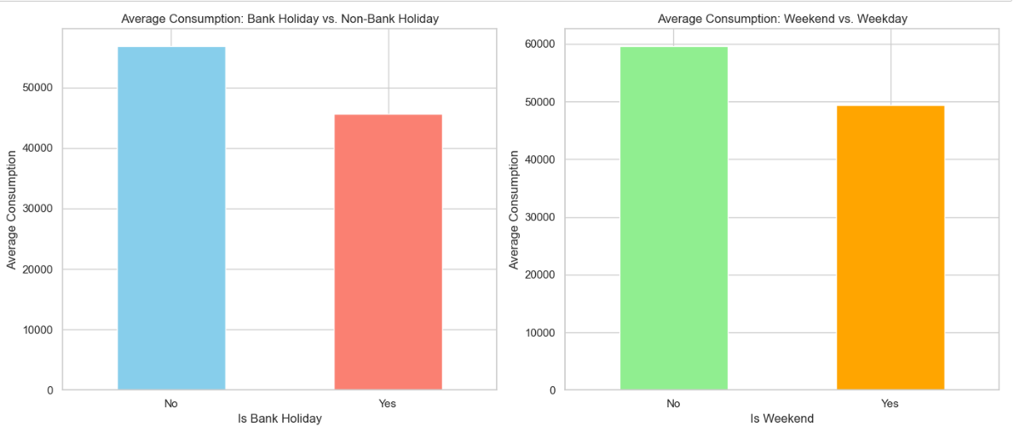
Consumption tend to decrease during holidays and weekends.

