

DATA STRUCTURES AND ALGORITHMS
23CSE203
LAB MANUAL
SUBMITTED BY
NAME | M.SAHINI
ROLL NO | AV.SC.U4CSE25217
YEAR/SEM/SECTION | 2ND YEAR/SEM-3/CSE-C
CREDITS | 05

SUBMITTED TO | Dr Gayathri Parasa
DESIGNATION | Asst. Professor (Sr. Gr)
DEPARTMENT | SCHOOL OF COMPUTING

S.NO | TITLE | PAGE NO
1. | WEEK 1:  1(A). A rocket launch system displays a countdown before launch. Instead of using a loop, implement the countdown using recursion. Write a recursive python program to display a countdown from n to 1, followed by “Launch!”.  1(B). Banks calculate the growth of an investment using compound interest. The formula requires calculating powers, which can be implemented recursively. Write a recursive program to calculate P^{n}(power) where: P= principal growth factor, n= number of years.  1(C). A HR department stores employee ID’s in a list. Develop a recursive program to search for a given employee ID. Write a recursive function to search for an employee ID in a list.  1(D). In a logistics company, the number of possible ways to arrange n different parcels are calculated using the factorial formula (n!). Develop a recursive program to calculate the factorial of a given number.  1(E). Write a recursive python program to print the first n terms of the Fibonacci series.
2. | WEEK 2:  2(A). Write a python program to implement linear search.  2(B). Write a python program to implement binary search with and without sorted array as an input.
3. | WEEK-3:  3(A). Write a python program to implement bubble sort.  3(B). Write a python program to implement insertion sort.  3(C). Write a python program to implement selection sort.
4. | WEEK-4:  4(A). Write a python program to implement quick sort.  4(B). Write a python program to implement merge sort.

5. | WEEK-5:  5(A). Write a python program to implement a Singly Linked List with the below operations.  - Create Linked List  - Insert Beginning  - Insert End  - Insert at Index  - Delete by Value  - Delete First Node  - Delete Last Node  - Count number of nodes  - Sort the data of SLL  - Search data in SLL  - Display or Traverse  - Exit
6. | WEEK-6:  Write a python program to implement a Double Linked List with the below operations.  - Create Linked List  - Insert Beginning  - Insert End  - Insert at Index  - Delete by Value  - Delete First Node  - Delete Last Node  - Count number of nodes  - Display or Traverse  - Exit
7. | WEEK-7:  7(A). Write a python program to implement stack operations such as push, pop, peek, display using an array.  7(B). Write a python program to implement stack operations such as push, pop, peek, display using a linked list.
8. | WEEK-8:  8(A). Write a python program to implement Queue and its operations such as enqueue, dequeue, peek, display with a menu driven approach. Implement using array, and linked list data structures.  8(B). Write a python program to implement Circular Queue and its operations such as enqueue, dequeue, peek, display with a menu driven approach. Implement using array, and linked list data structures.
9. | WEEK-9:  Write a python program to implement a Binary Search Tree (BST) and perform the following operations.  1. Insertion  2. Deletion  3. Tree Traversals – in-order, pre-order and post-order  4. Count Leaf Nodes  5. Count Internal Nodes  6. Height of the Tree
10. | WEEK-10:  Write a menu driven python program to implement an AVL Tree and perform the following operations.  1. Insertion  2. Deletion  3. Tree Traversals  4. Count Leaf Nodes  5. Count Internal Nodes  6. Height of the Tree
11. | WEEK-11:  Write a menu-driven Python program to implement a Binary Heap (Max Heap and Min Heap) and perform the following operations:  - Insertion of an element into the Heap.  - Deletion of the root element from the Heap.  - Display the array representation of the Heap.  - Exit the program.
12. | WEEK-12:  Write a program to implement the following three collision resolution techniques in a Hash Table:  - Separate Chaining  - Linear Probing  - Quadratic Probing

WEEK 1:
1(A). A rocket launch system displays a countdown before launch. Instead of using a loop, implement the countdown using recursion. Write a recursive python program to display a countdown from n to 1, followed by “Launch!”.

PROGRAM:
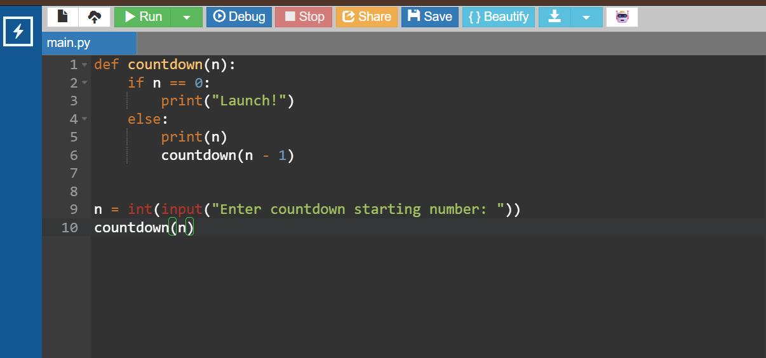

OUTPUT:
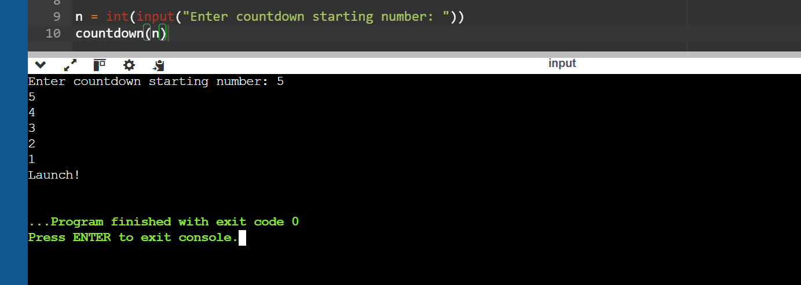

1(B). Banks calculate the growth of an investment using compound interest. The formula requires calculating powers, which can be implemented recursively. Write a recursive program to calculate P^{n}(power) where: P= principal growth factor, n= number of years.

PROGRAM:
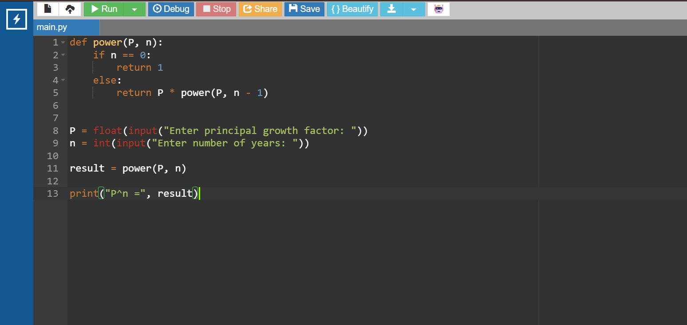

OUTPUT:
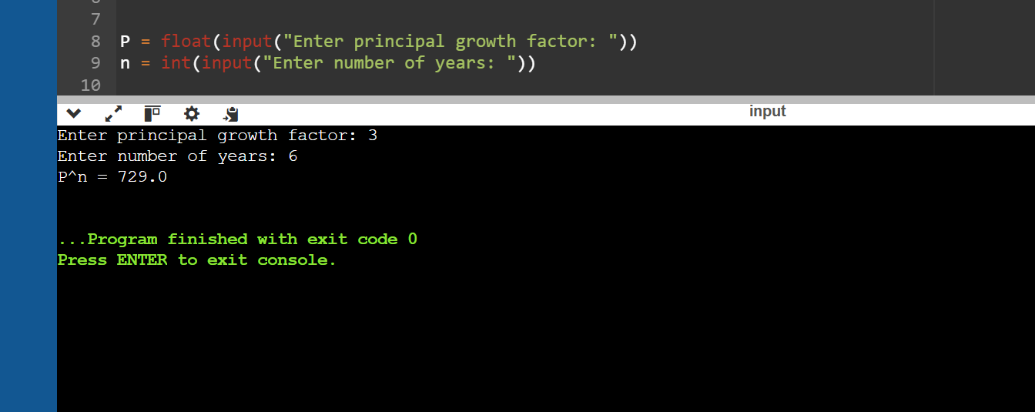

1(C). A HR department stores employee ID’s in a list. Develop a recursive program to search for a given employee ID. Write a recursive function to search for an employee ID in a list.

PROGRAM:
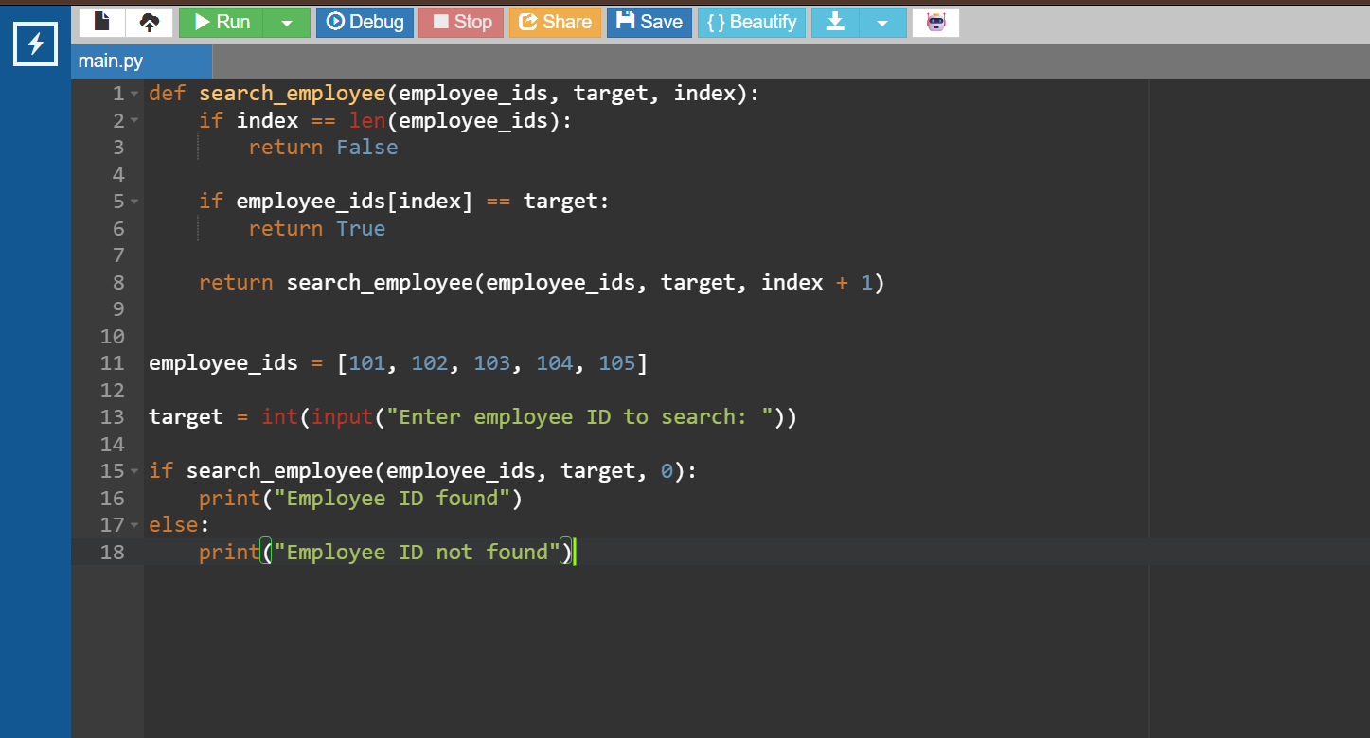

OUTPUT:
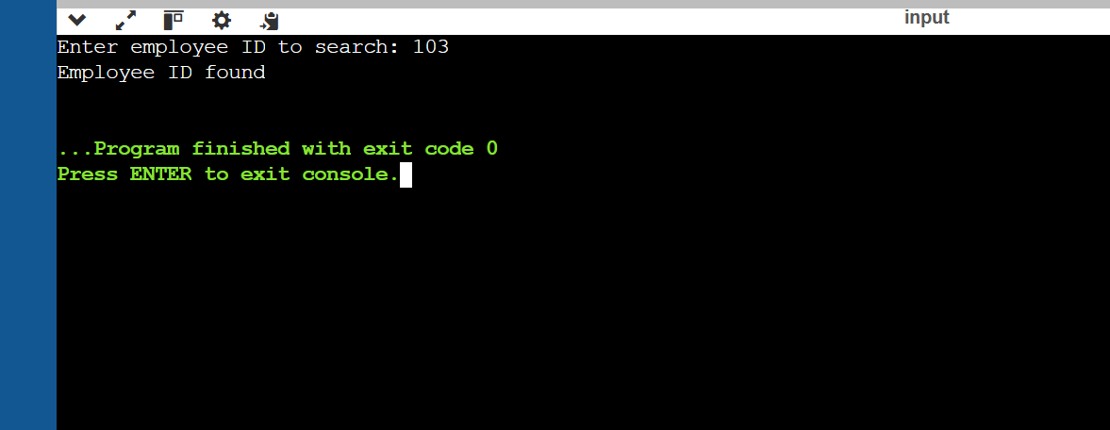

1(D). In a logistics company, the number of possible ways to arrange n different parcels are calculated using the factorial formula (n!). Develop a recursive program to calculate the factorial of a given number.

PROGRAM:
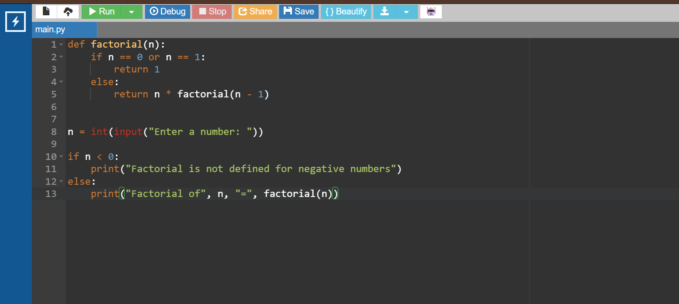

OUTPUT:
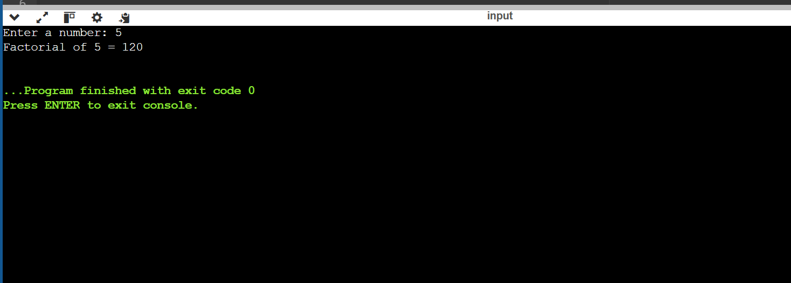

1(E). Write a recursive python program to print the first n terms of the Fibonacci series

PROGRAM:
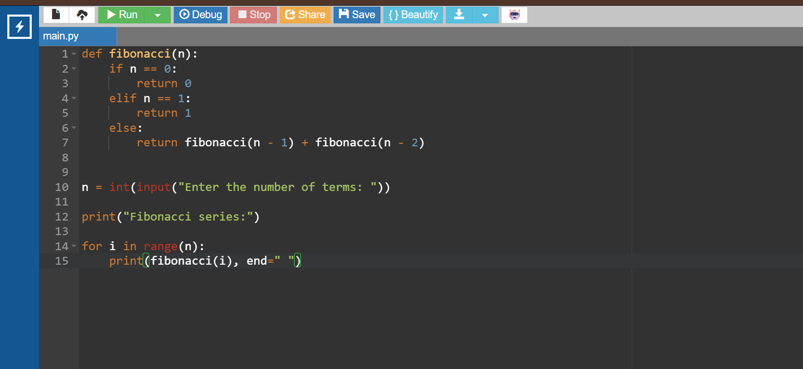

OUTPUT:
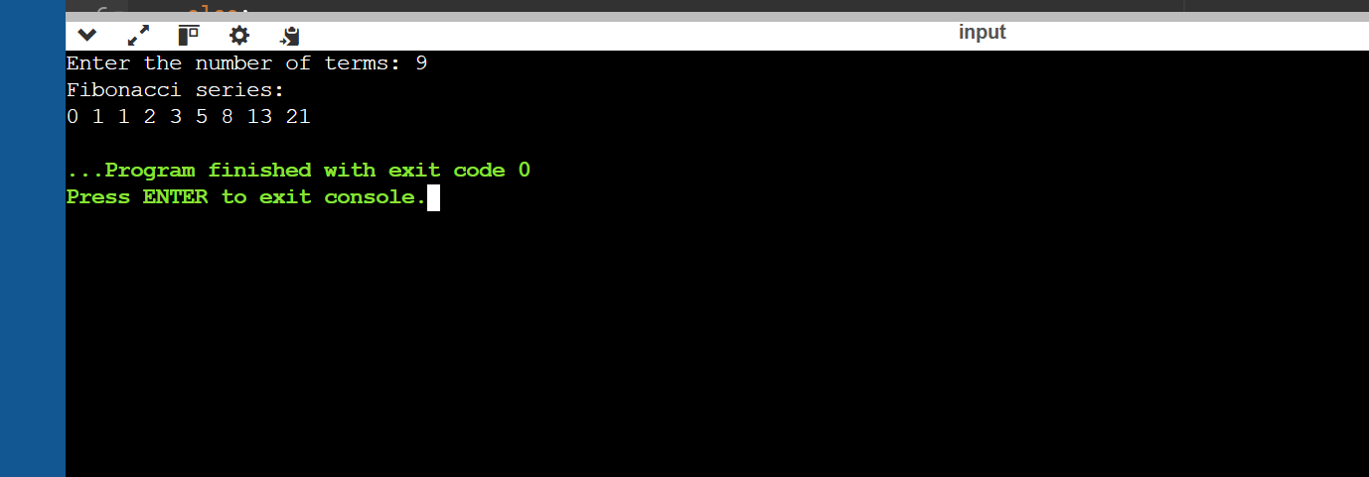

WEEK 2:

2(A). Write a python program to implement linear search.

PROGRAM:
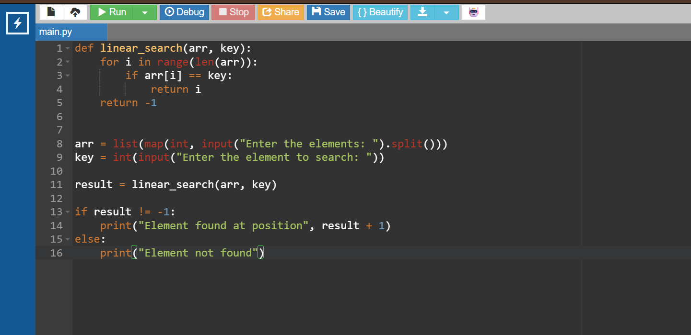

OUTPUT:
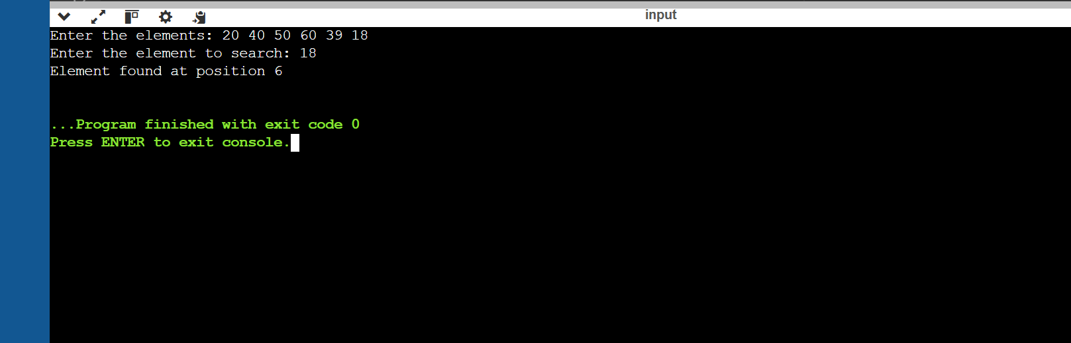

2(B). Write a python program to implement binary search with and without sorted array as an input

PROGRAM:
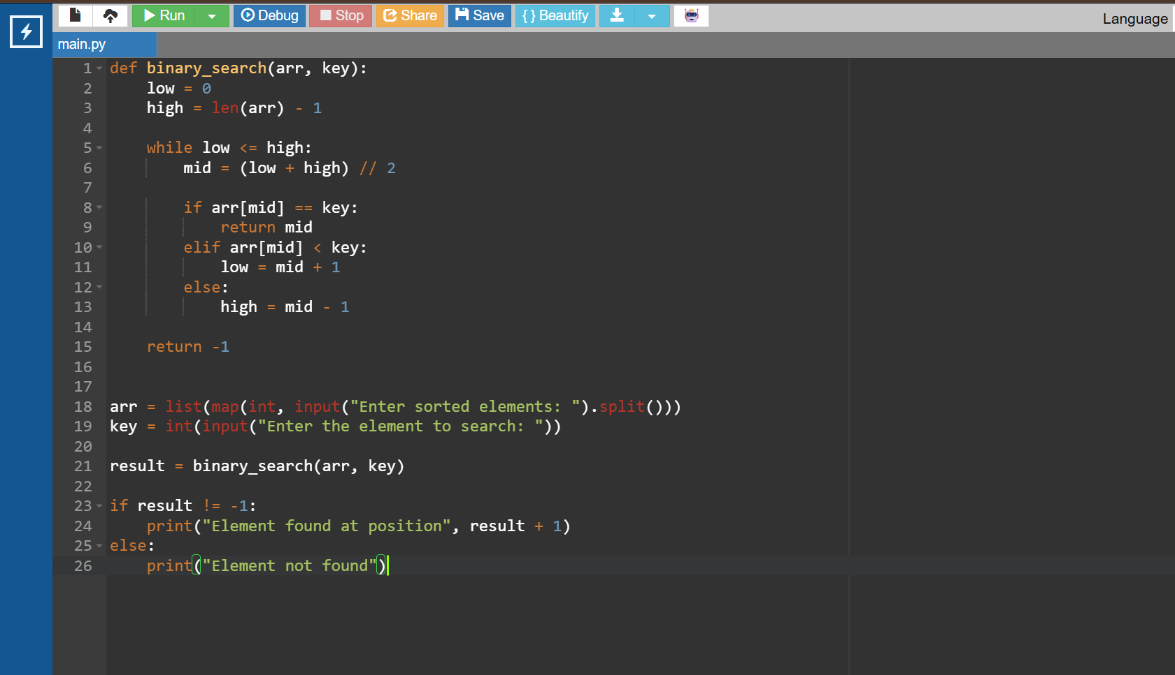

OUTPUT:
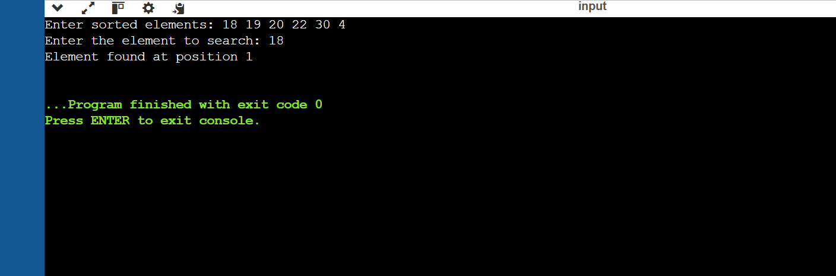

WEEK-3:
3(A). Write a python program to implement bubble sort.

PROGRAM:
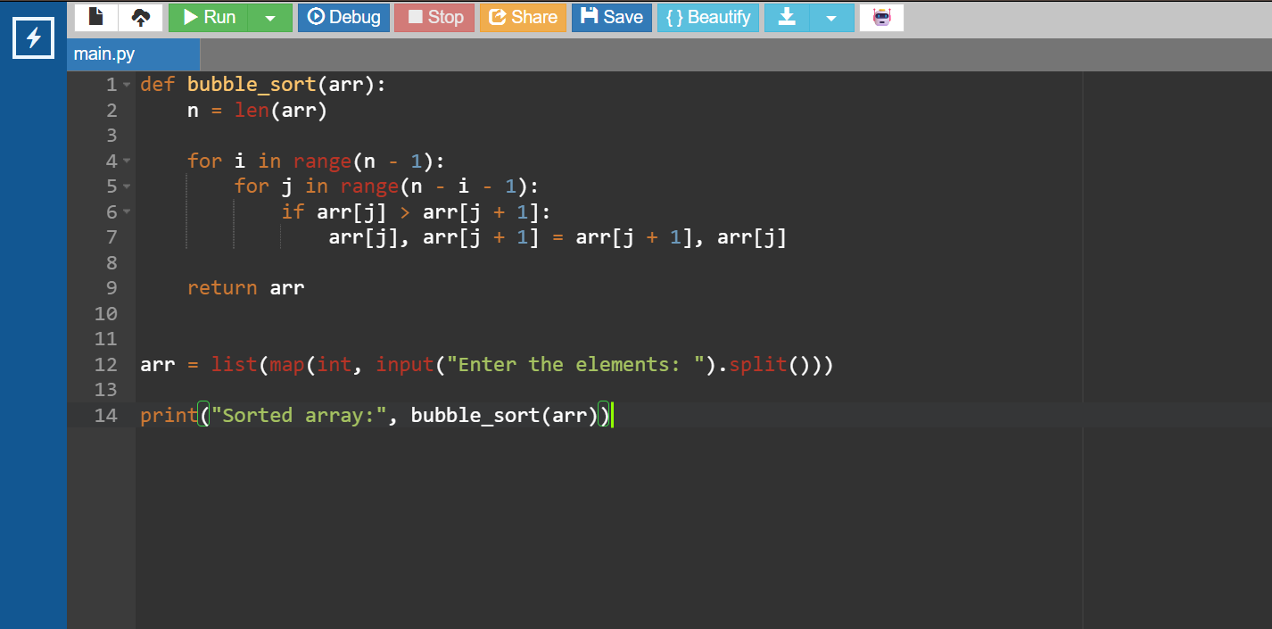

OUTPUT:
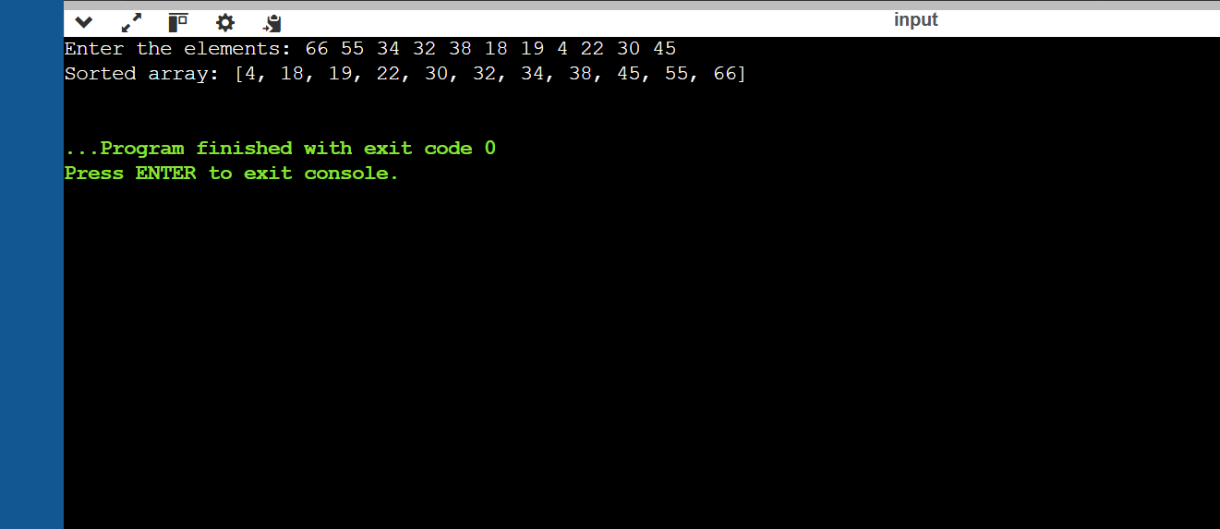

3(B). Write a python program to implement insertion sort.
PROGRAM:
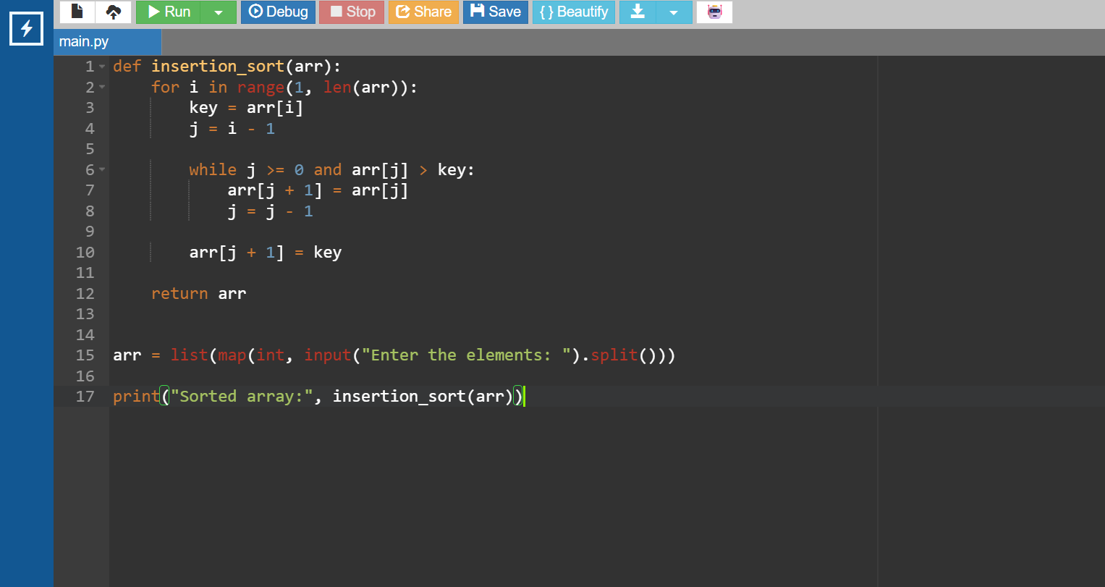

OUTPUT:
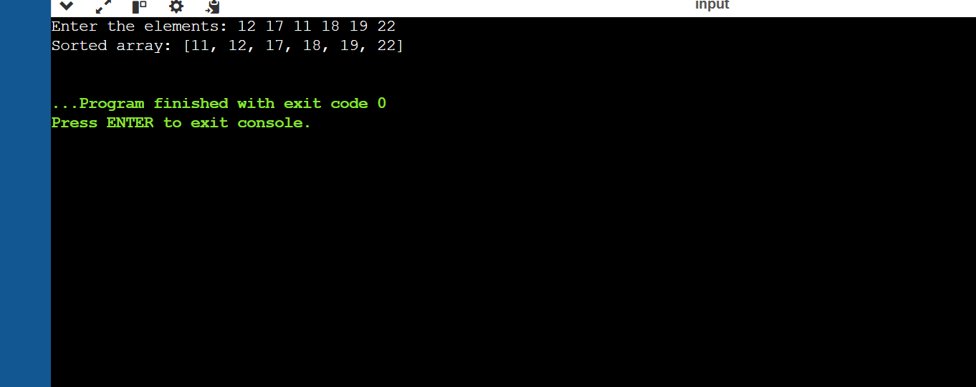

3(C). Write a python program to implement selection sort.
PROGRAM:
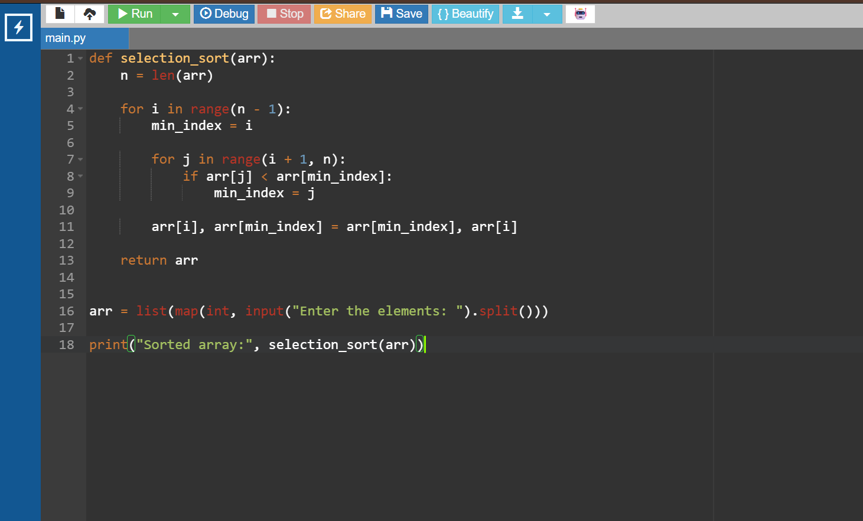

OUTPUT:
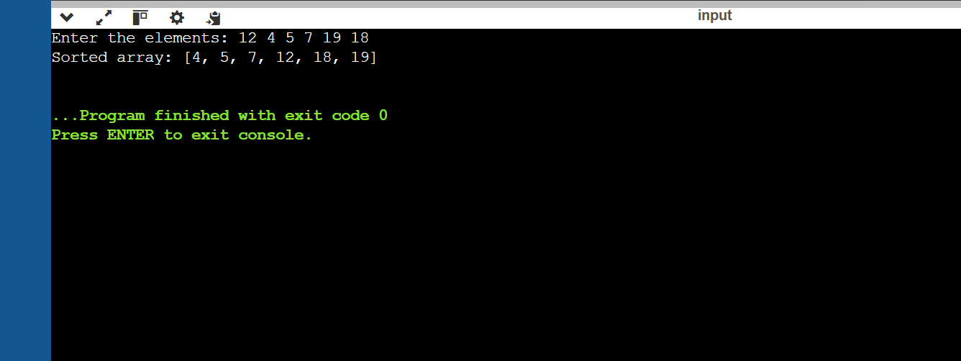

WEEK-4:
4(A). Write a python program to implement quick sort.

PROGRAM:
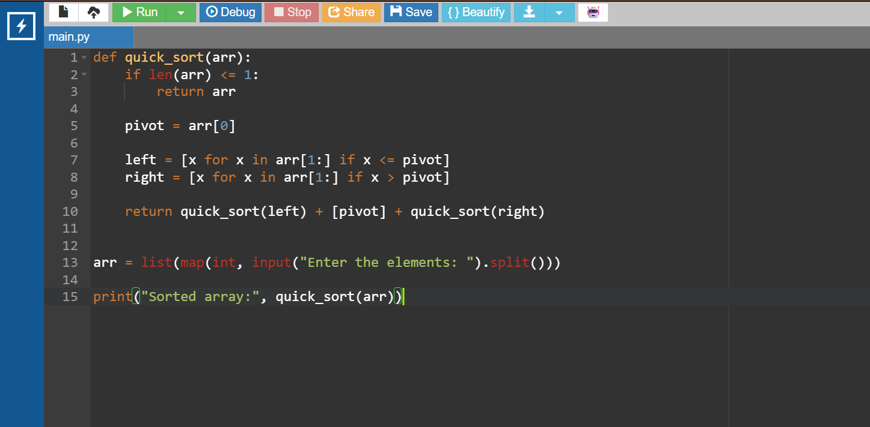

OUTPUT:
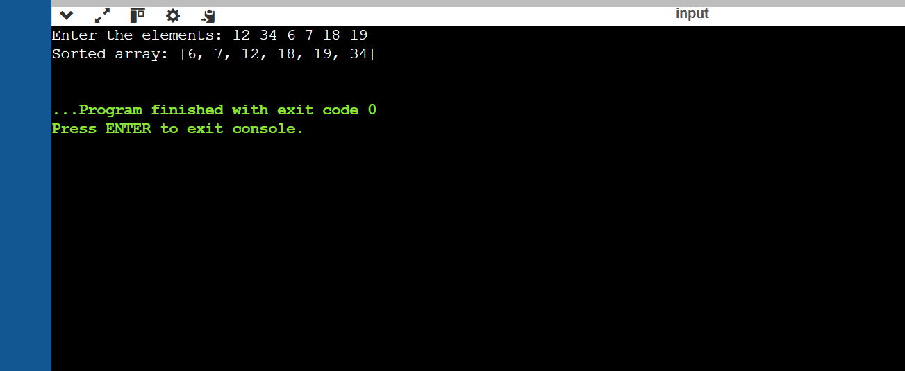

4(B). Write a python program to implement merge sort.

PROGRAM:
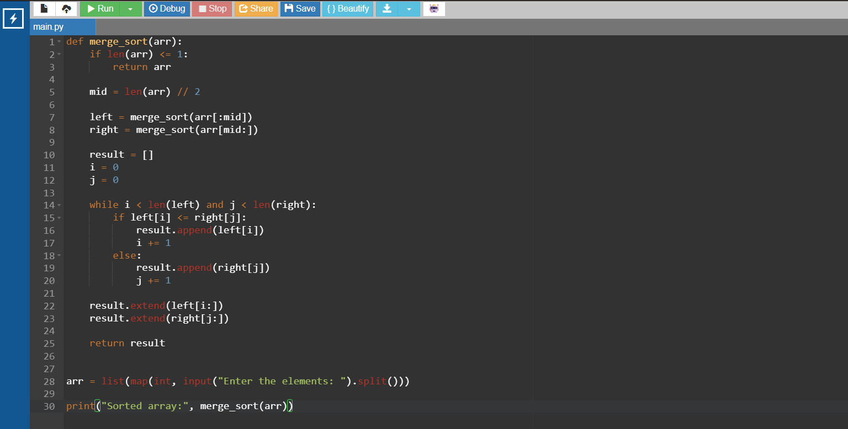

OUTPUT:
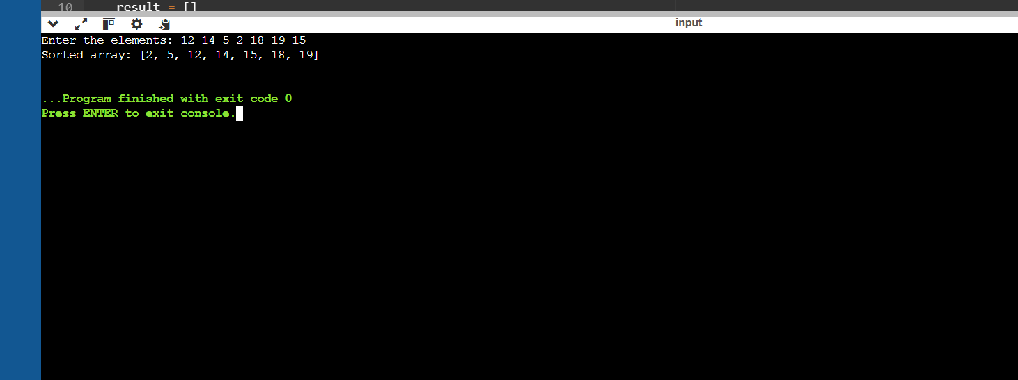

WEEK-5:

5(A). Write a python program to implement a Singly Linked List with the below operations.
- Create Linked List
- Insert Beginning
- Insert End
- Insert at Index
- Delete by Value
- Delete First Node
- Delete Last Node
- Count number of nodes
- Sort the data of SLL
- Search data in SLL
- Display or Traverse
- Exit

PROGRAM:
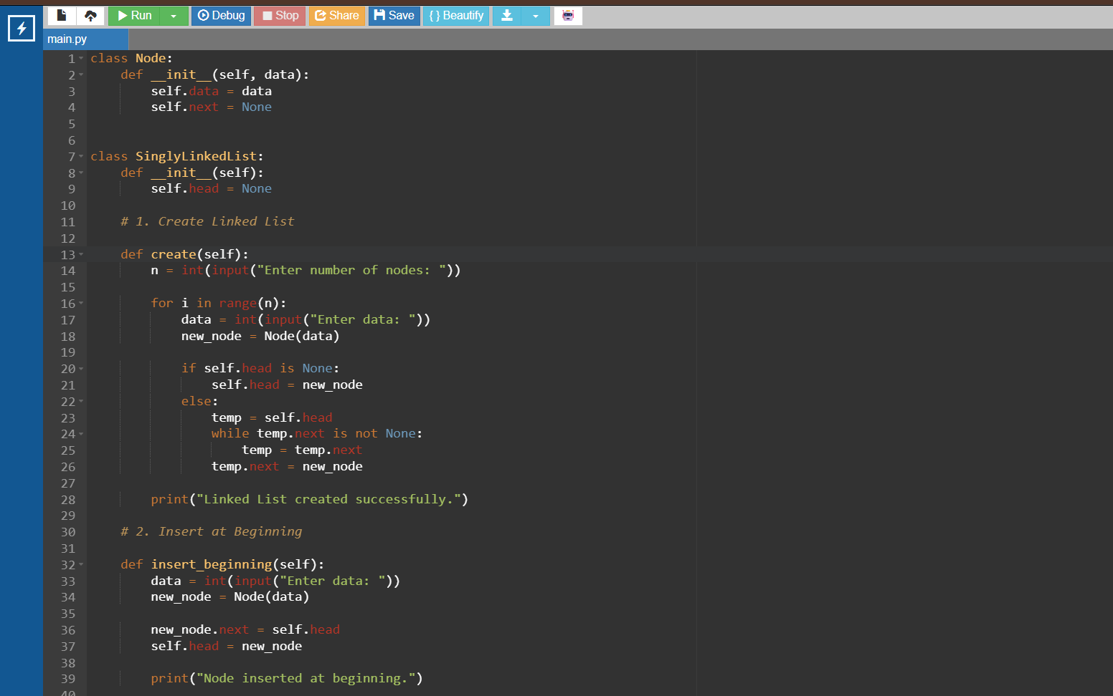
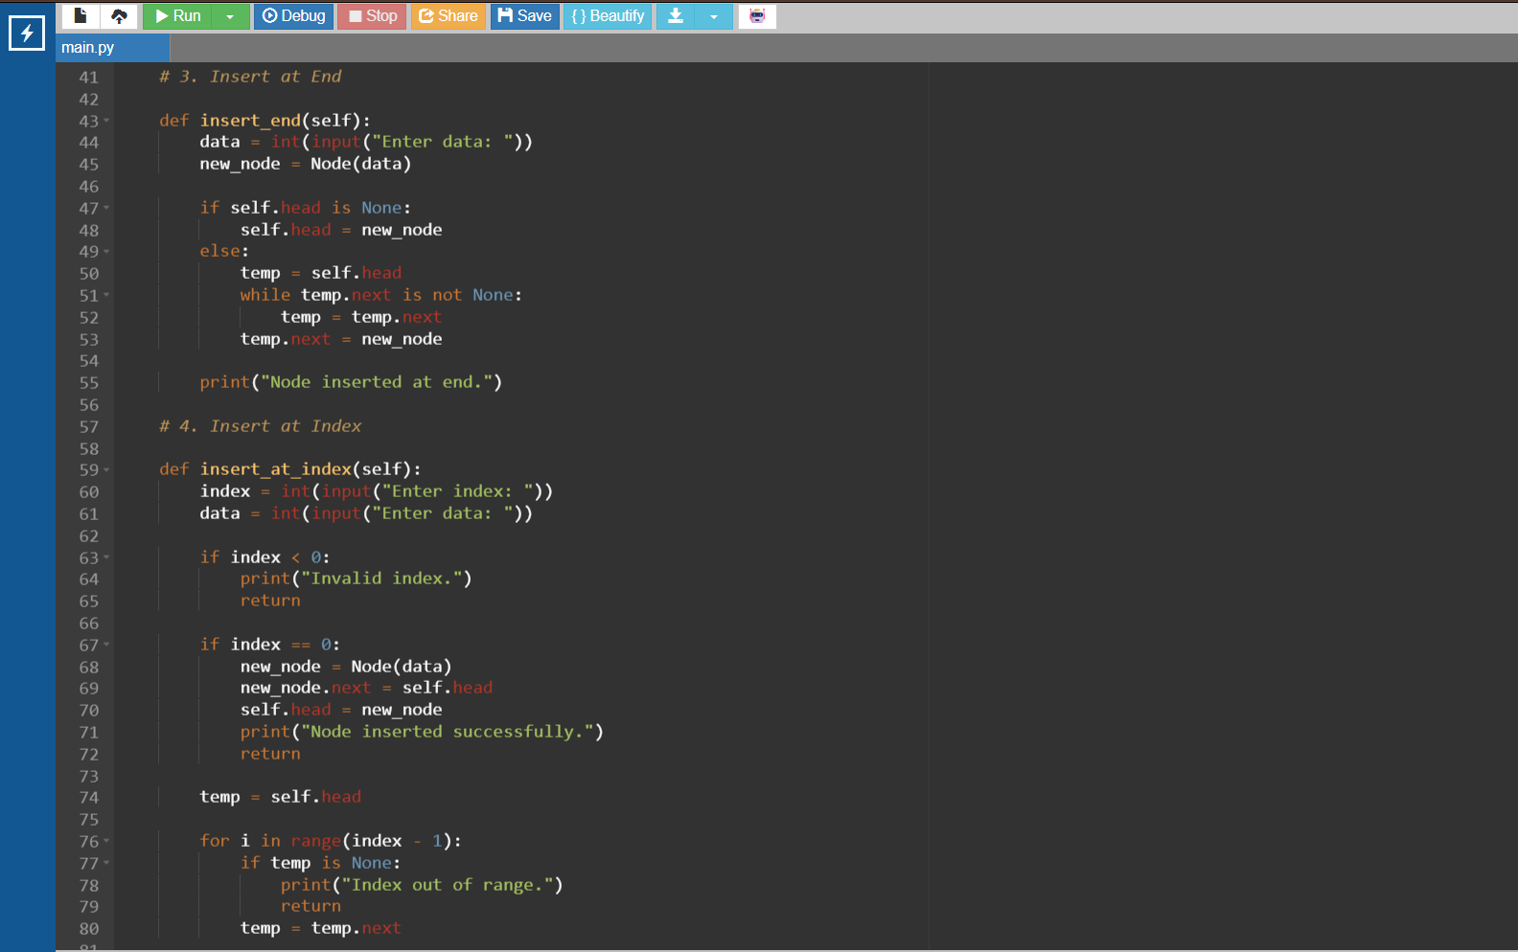

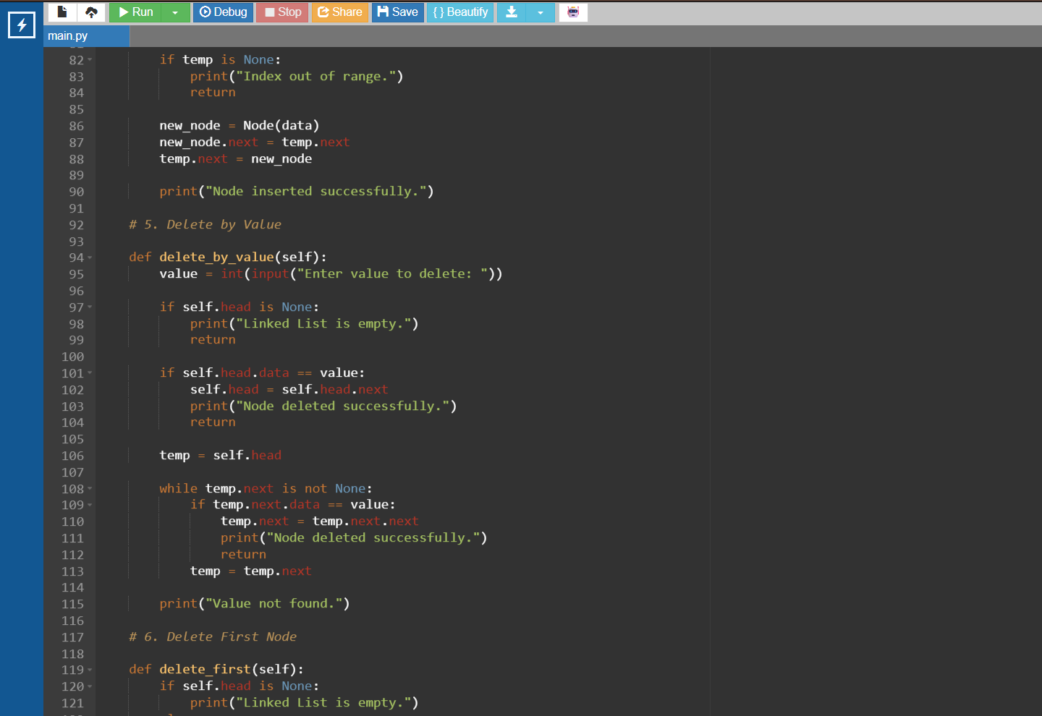
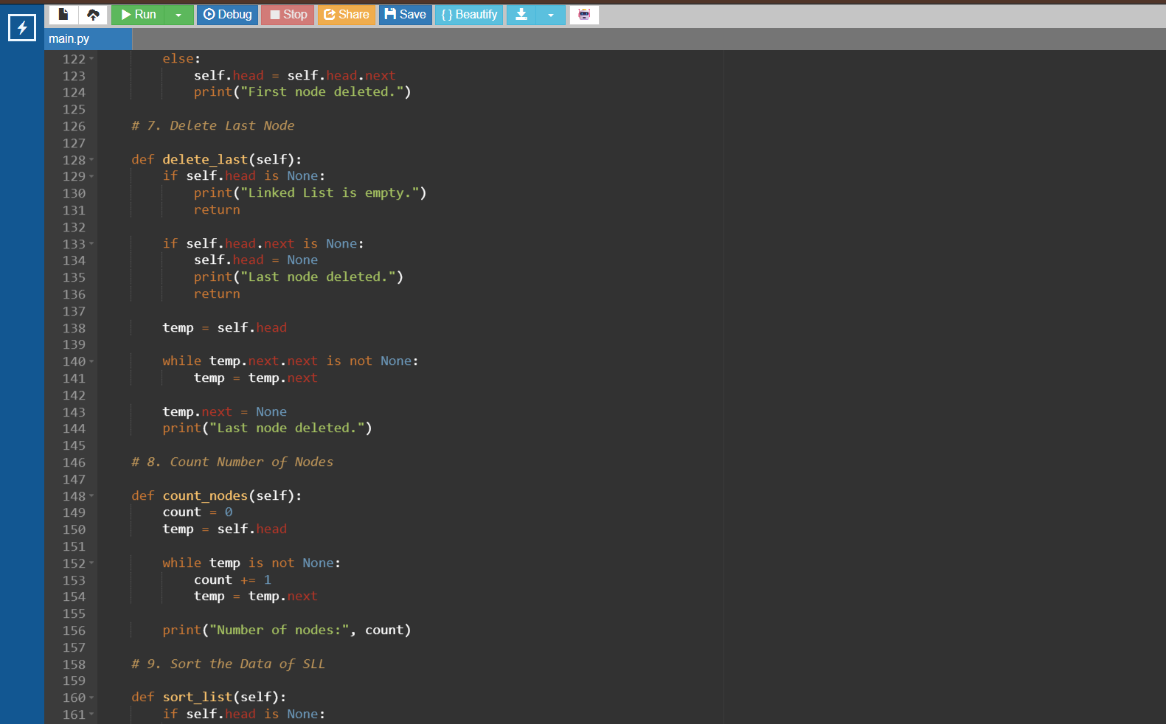

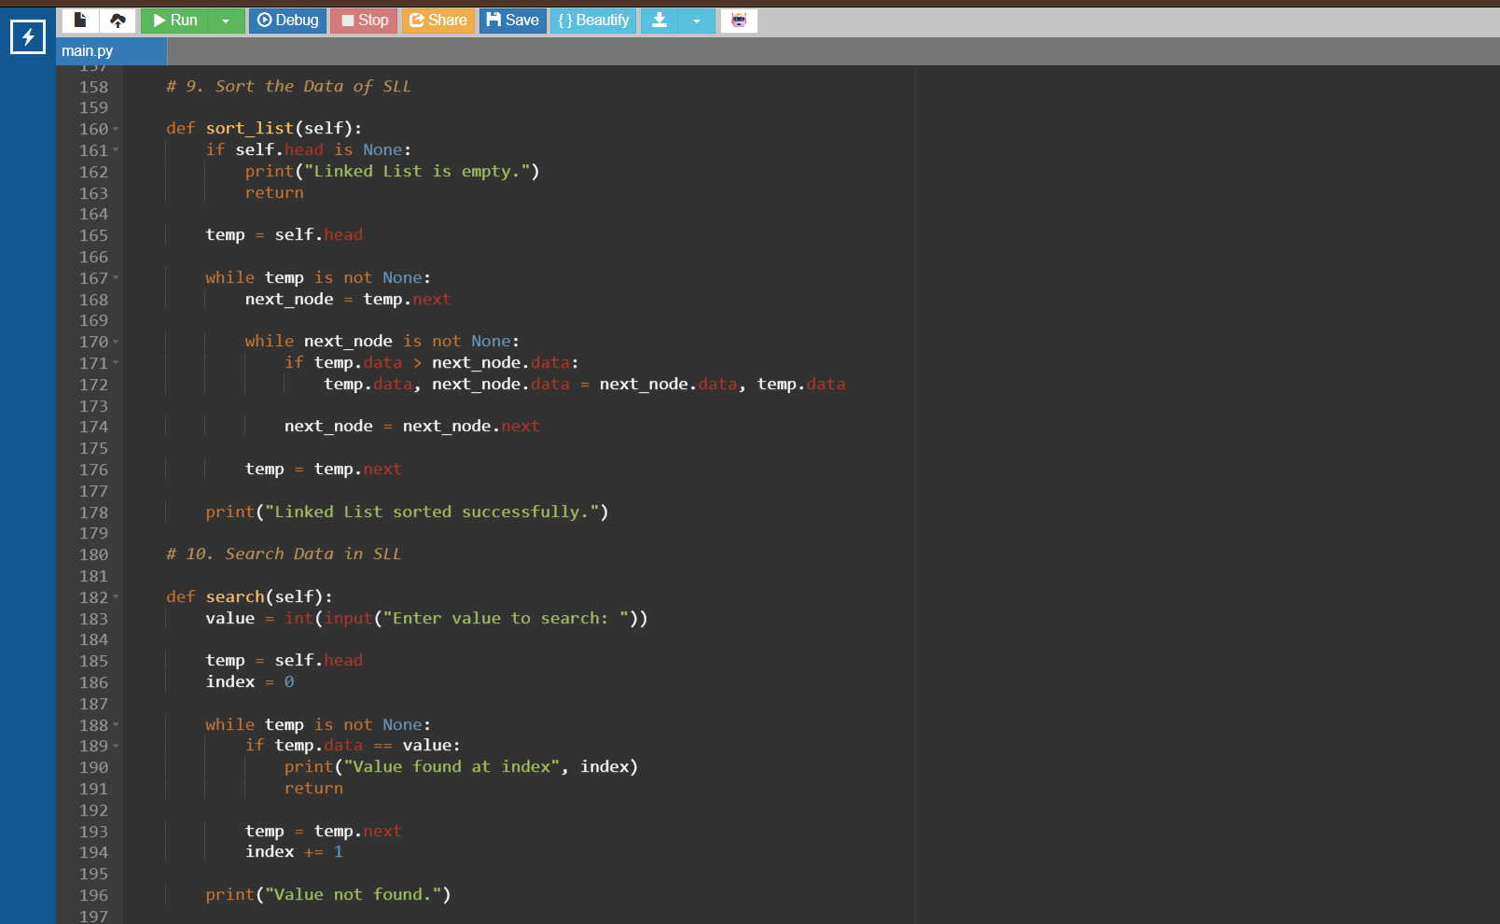
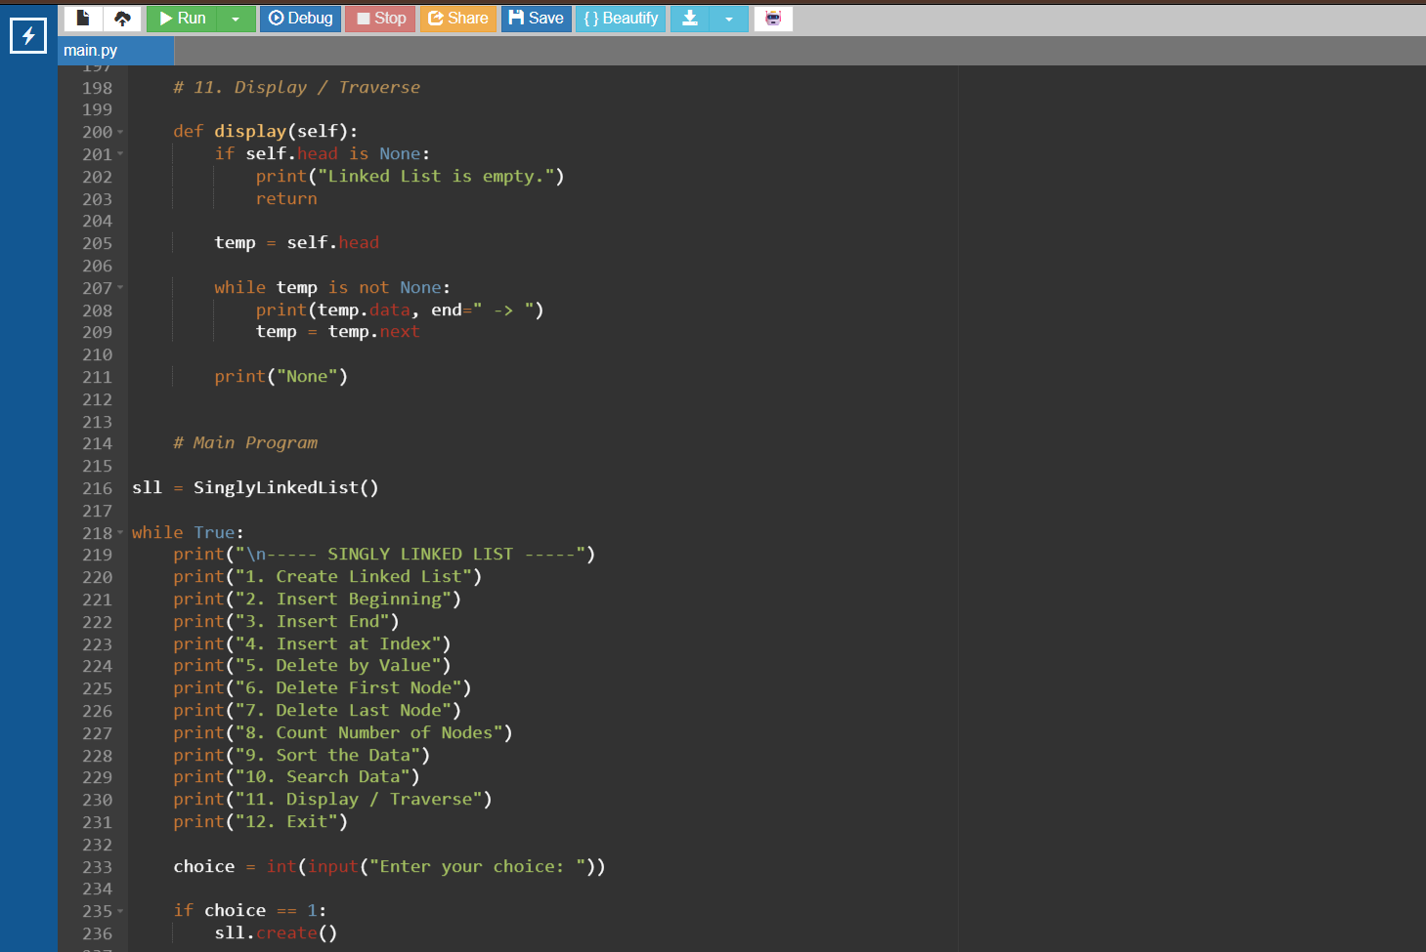

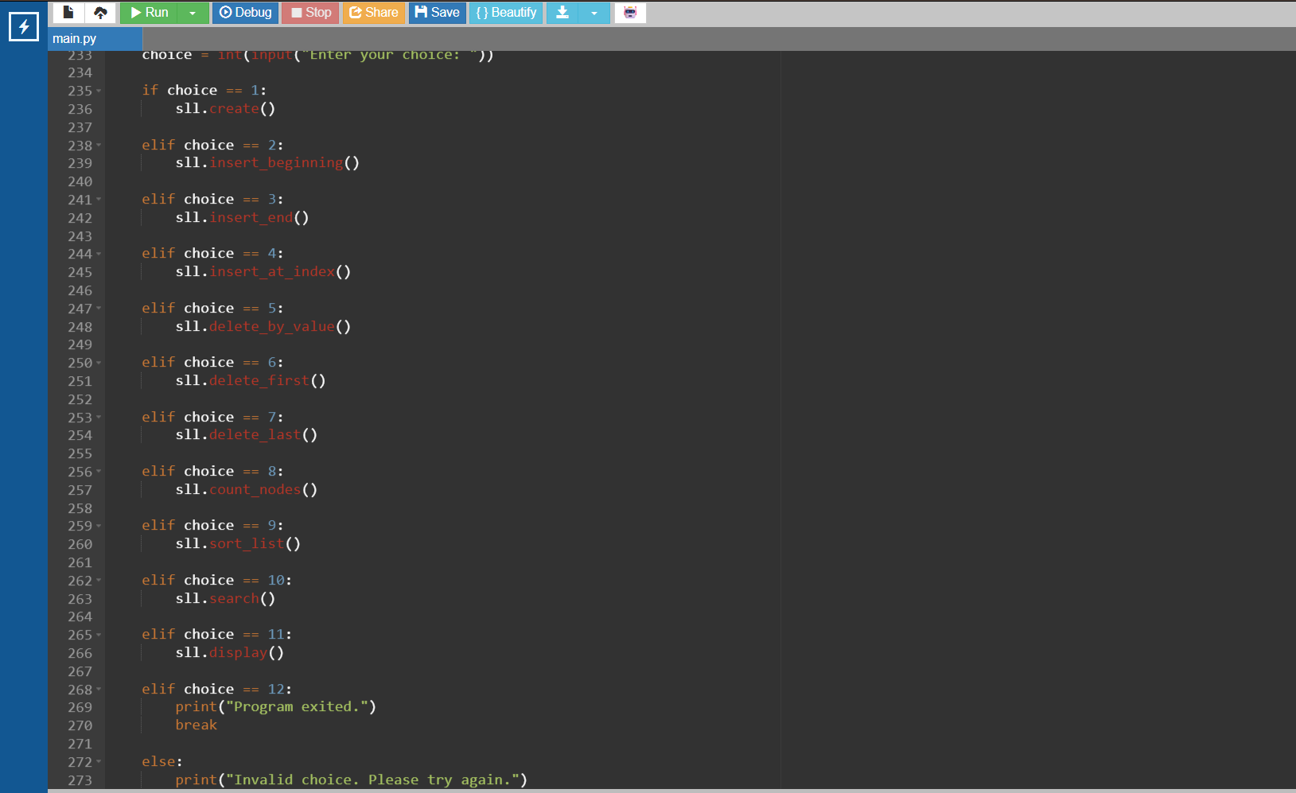

OUTPUT:
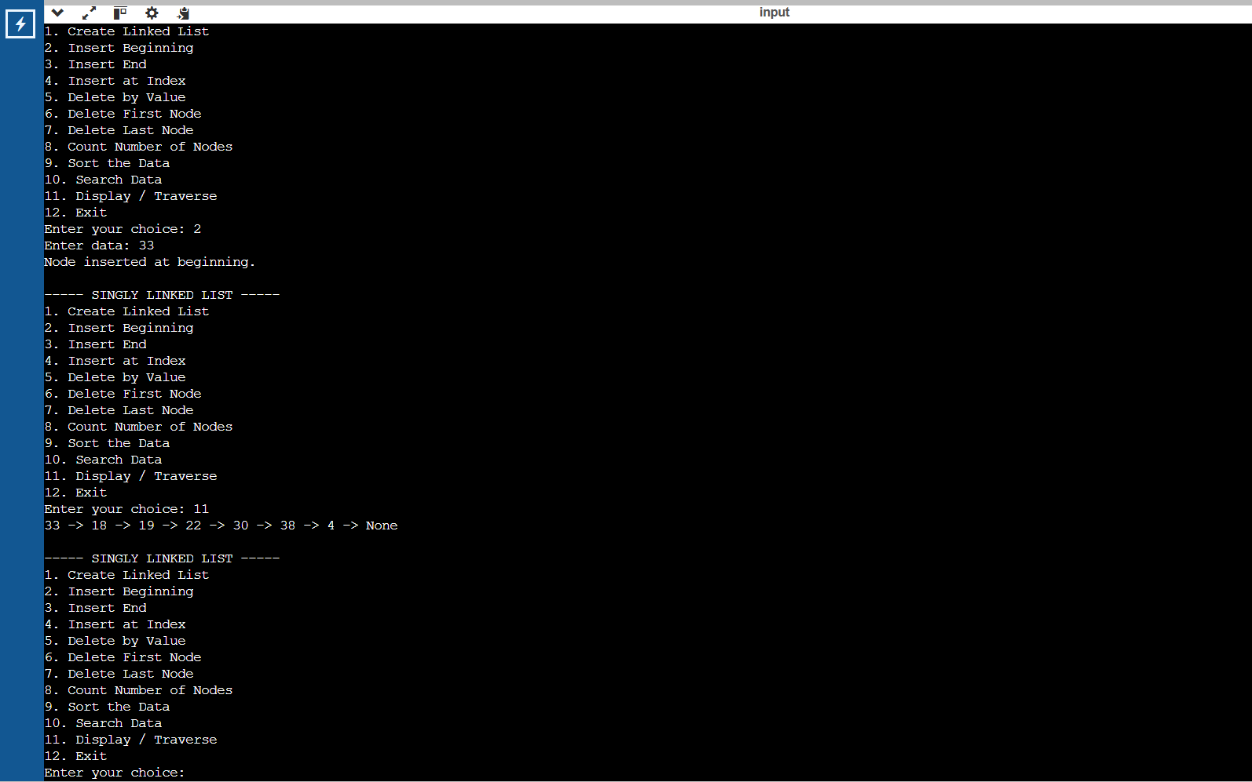

WEEK-6:
Write a python program to implement a Double Linked List with the below operations.
- Create Linked List
- Insert Beginning
- Insert End
- Insert at Index
- Delete by Value
- Delete First Node
- Delete Last Node
- Count number of nodes
- Display or Traverse
10)Exit

PROGRAM:
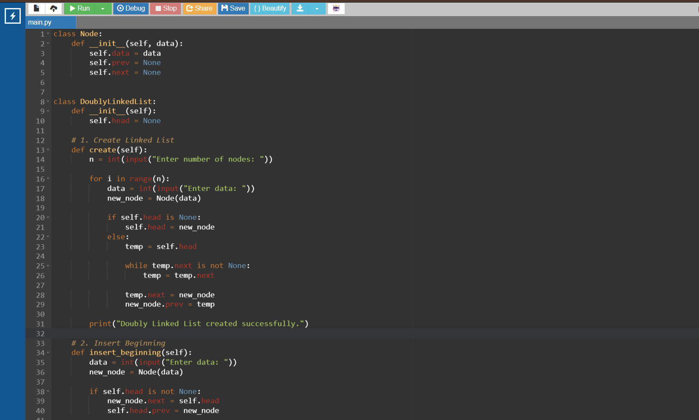

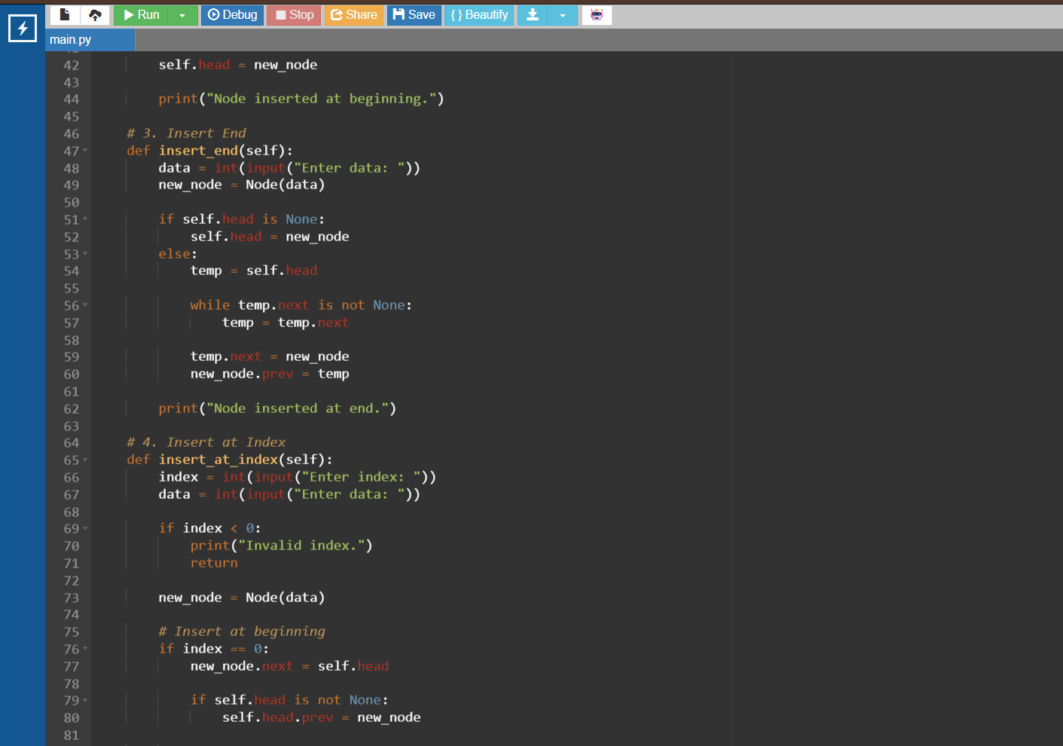

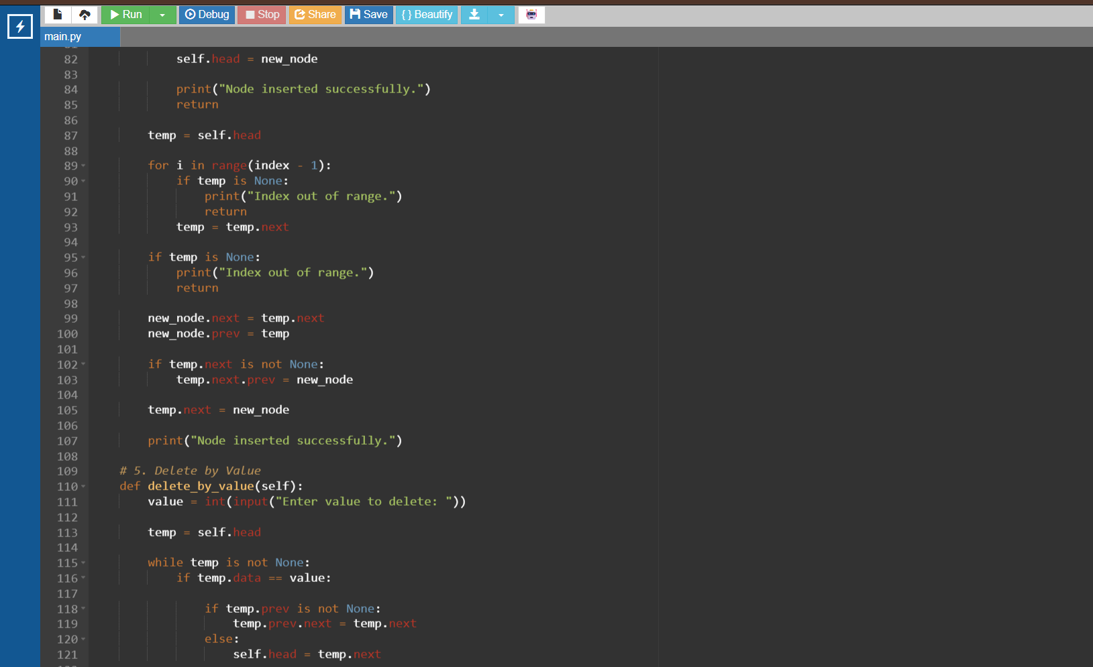

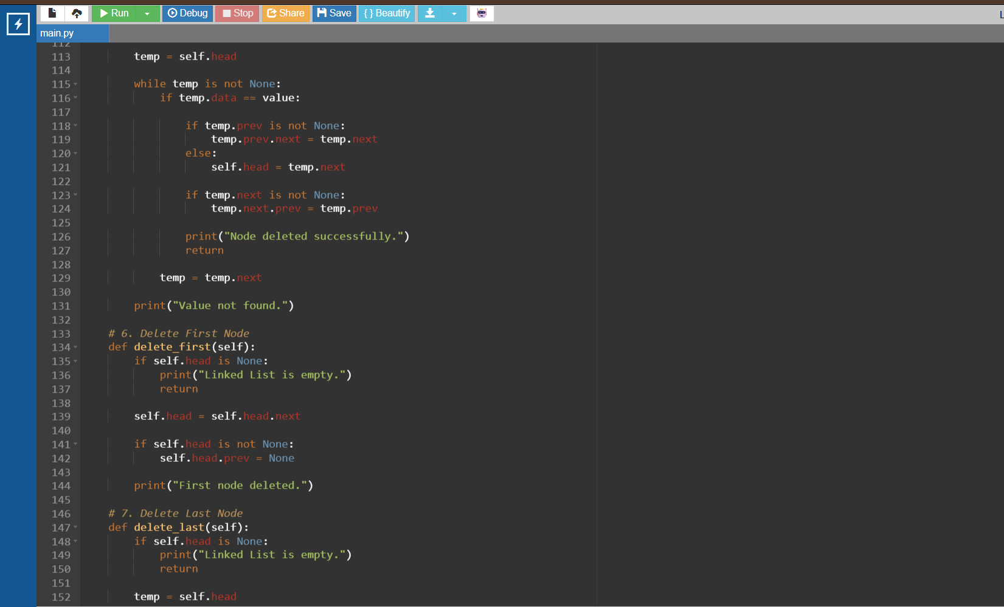
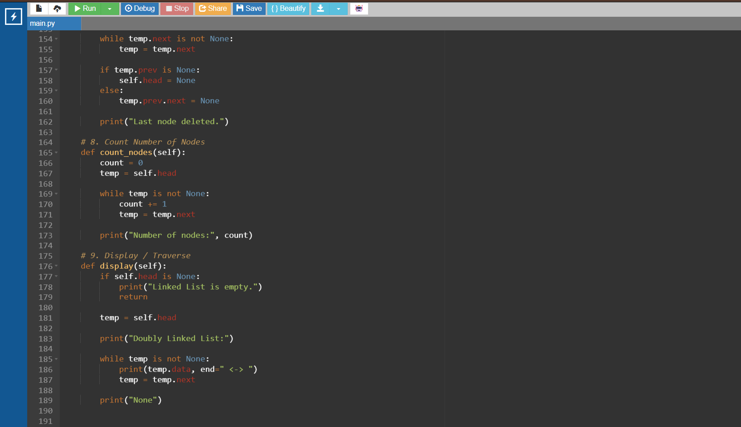
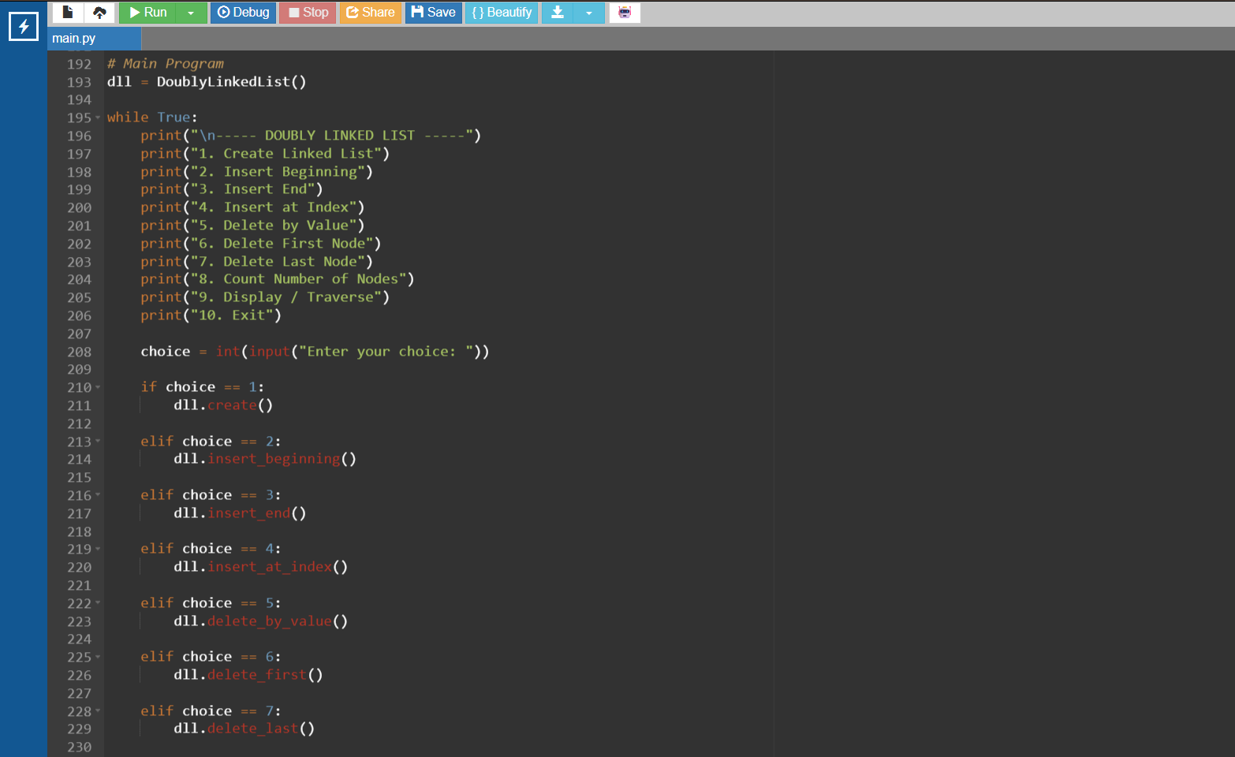
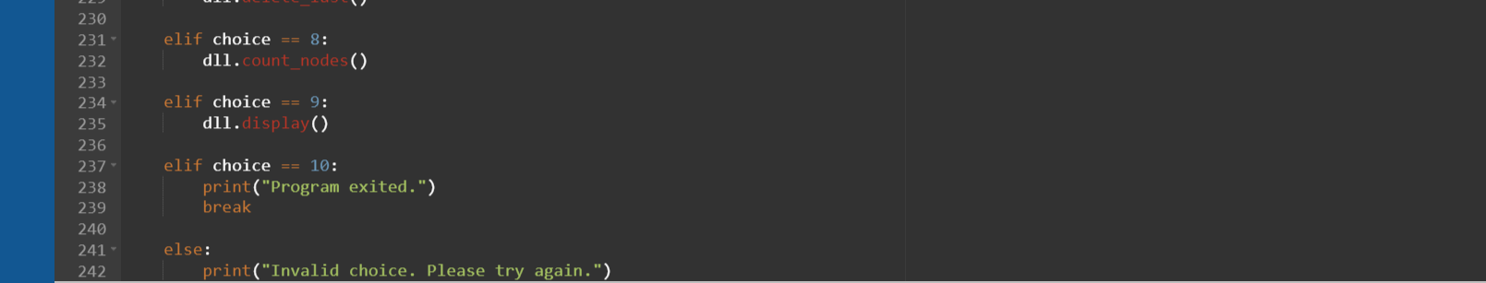

OUTPUT:
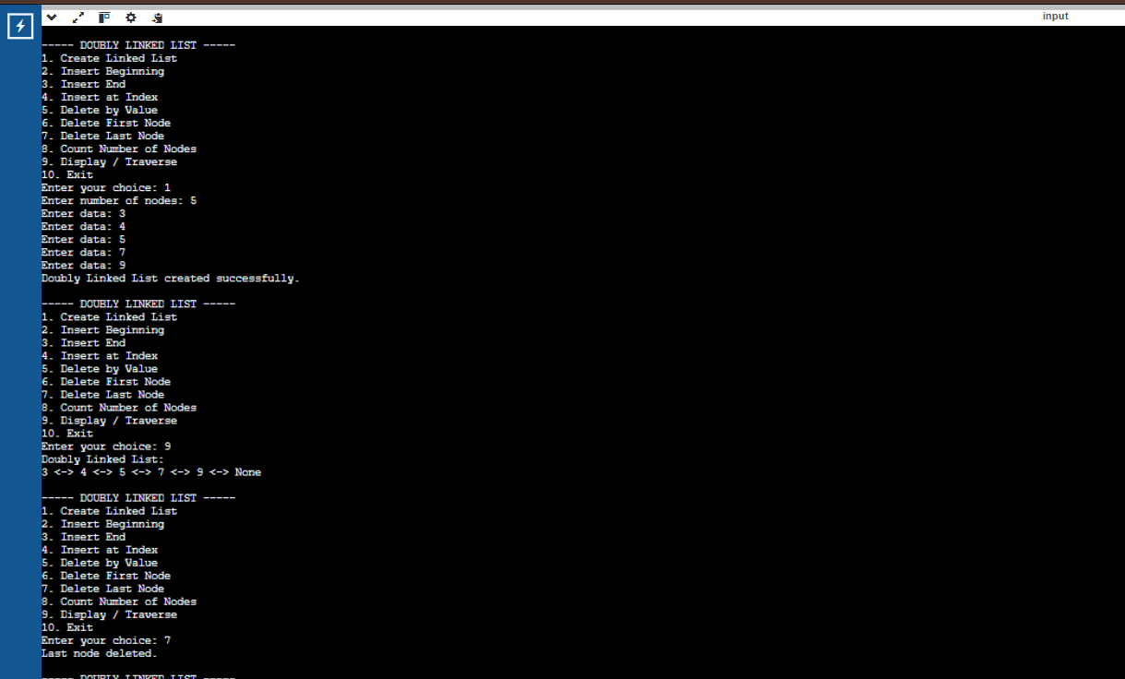

WEEK-7:
7(A). Write a python program to implement stack operations such as push, pop, peek, display using an array.
PROGRAM:
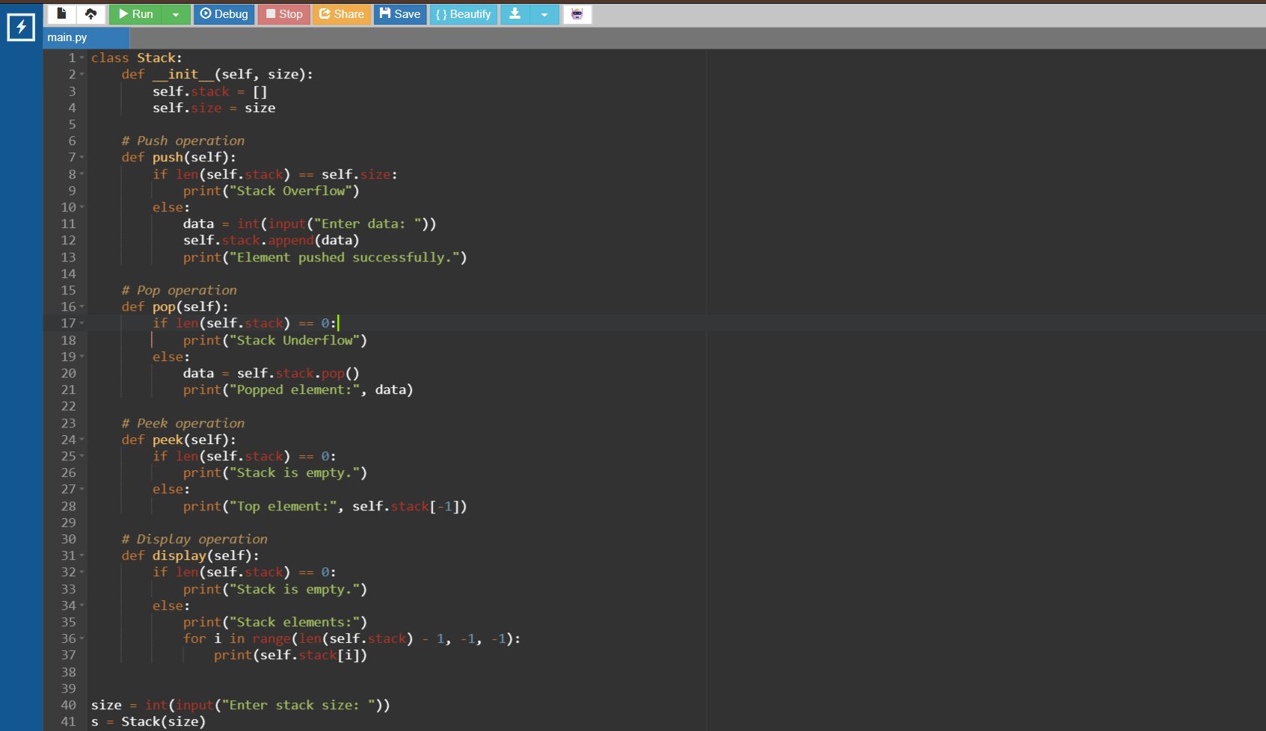

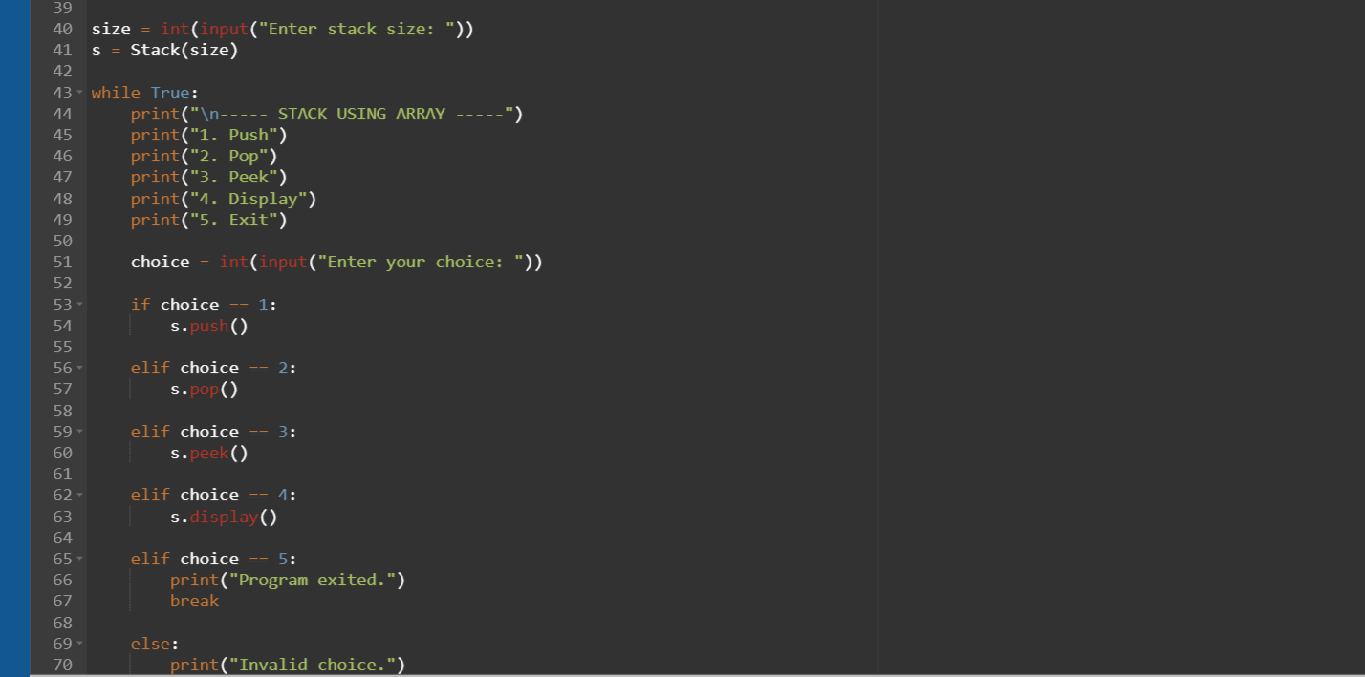

OUTPUT:
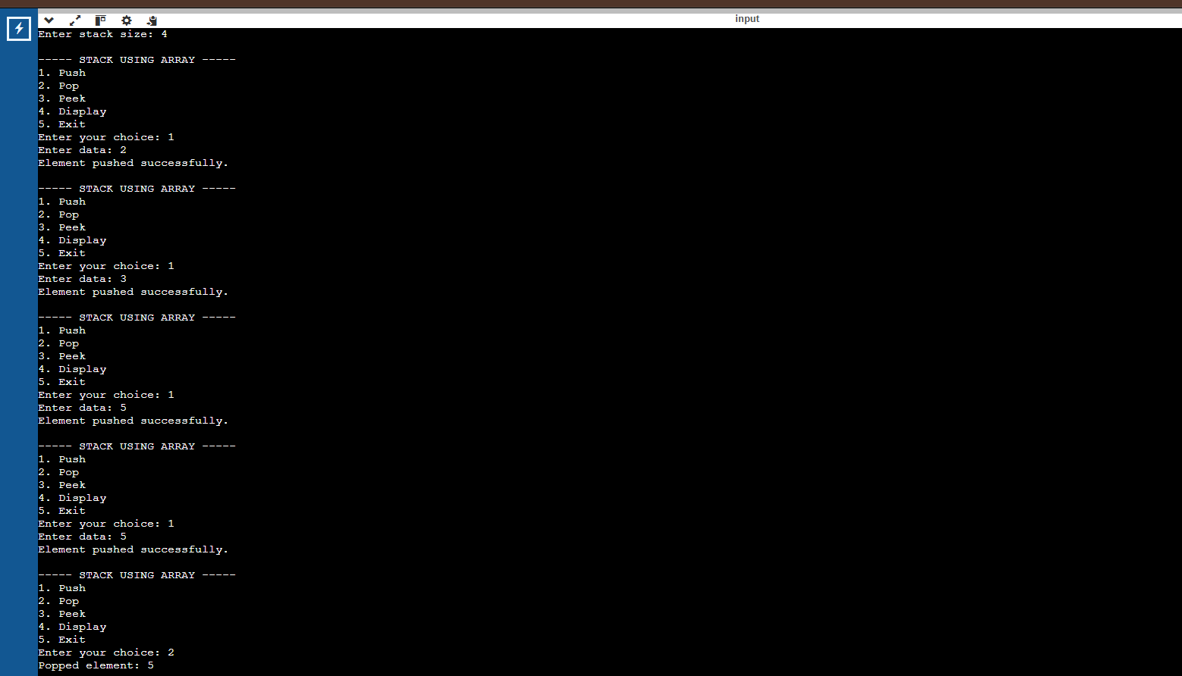

7(B). Write a python program to implement stack operations such as push, pop, peek, display using a linked list.
PROGRAM:
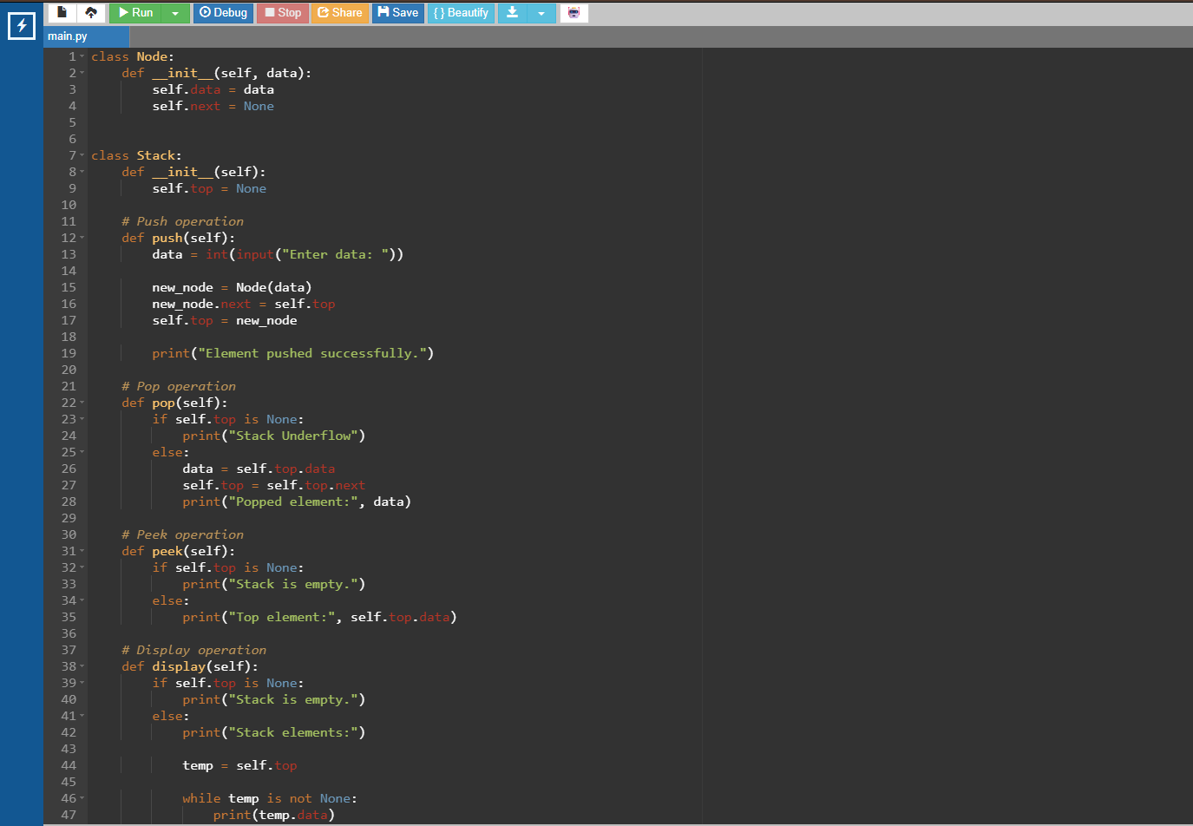
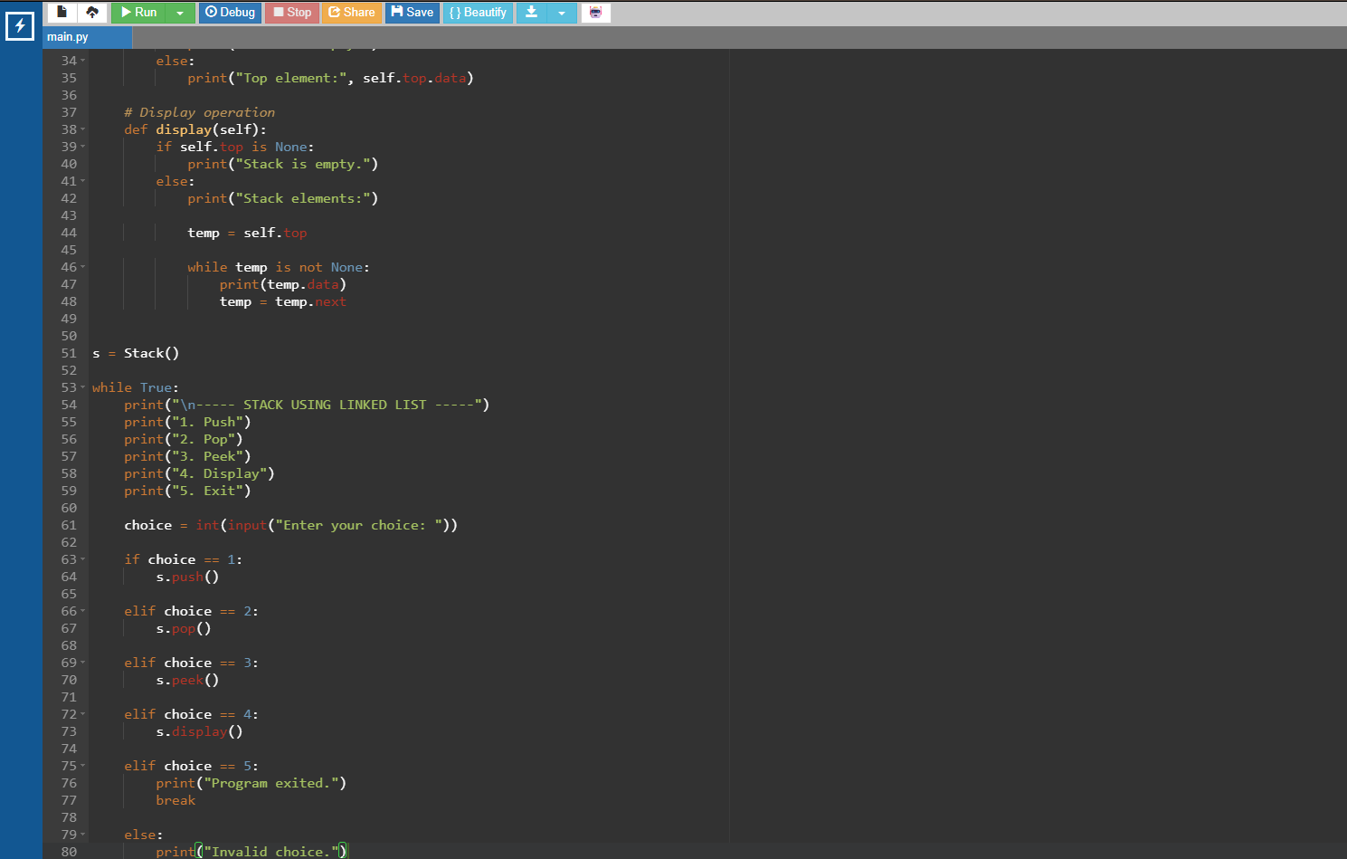
OUTPUT:
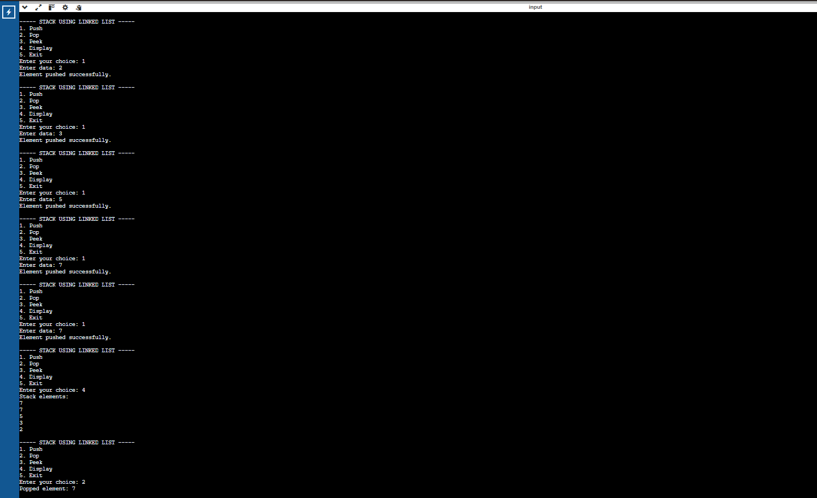

WEEK-8:
8(A). Write a python program to implement Queue and its operations such as enqueue, dequeue, peek, display with a menu driven approach. Implement using array, and linked list data structures.
PROGRAM:
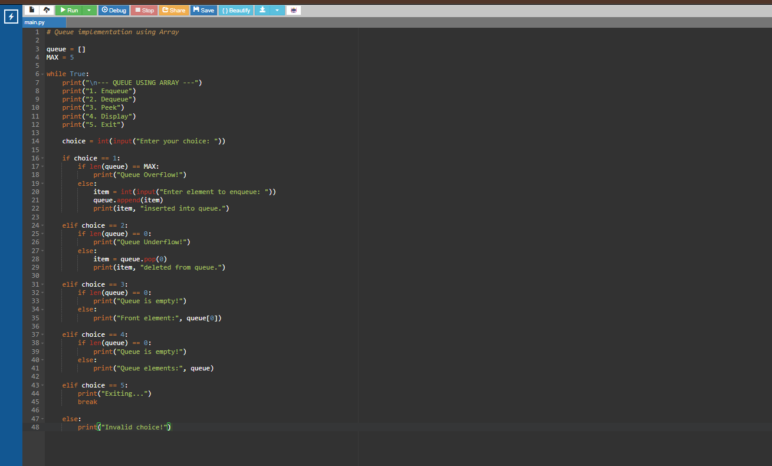
OUTPUT:
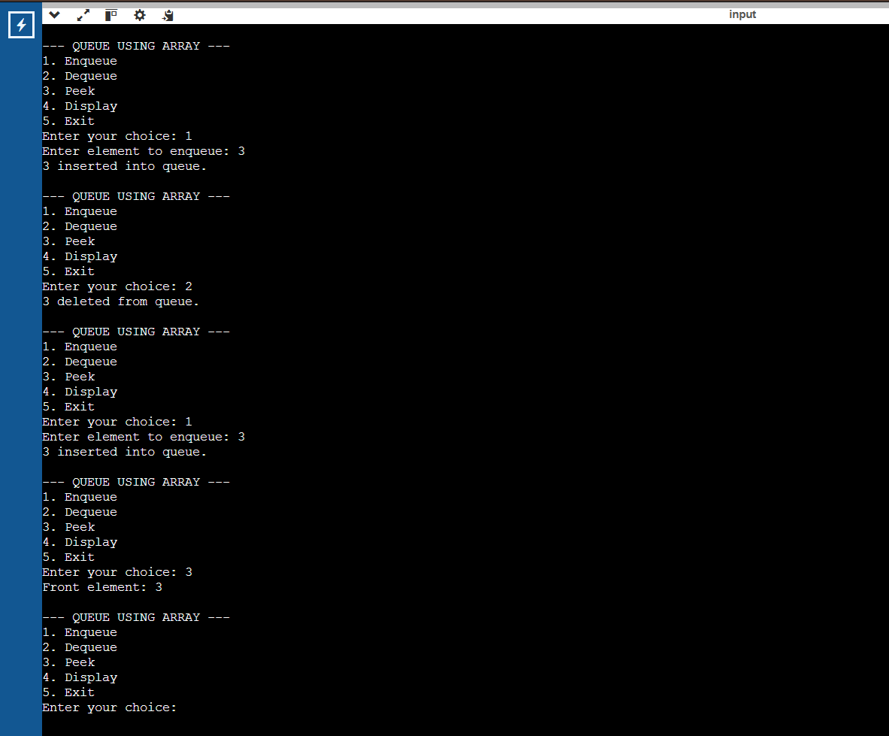

LINKED LIST:
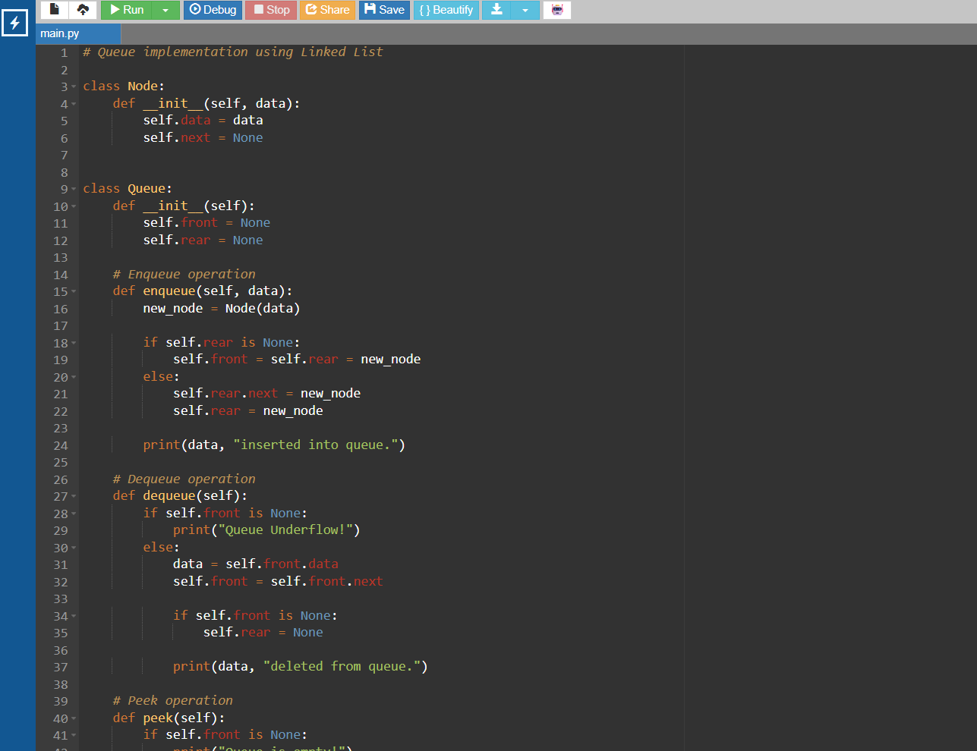

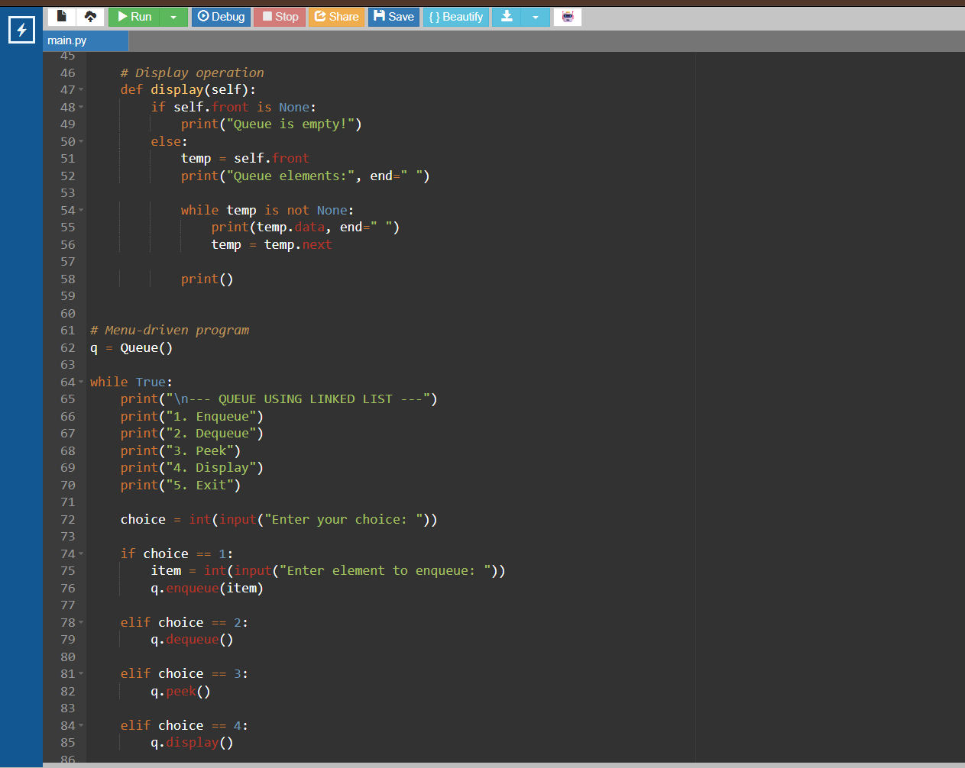

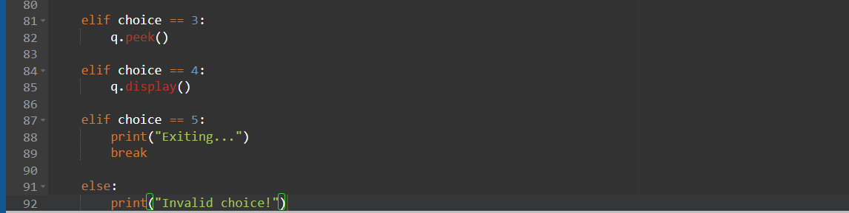

OUTPUT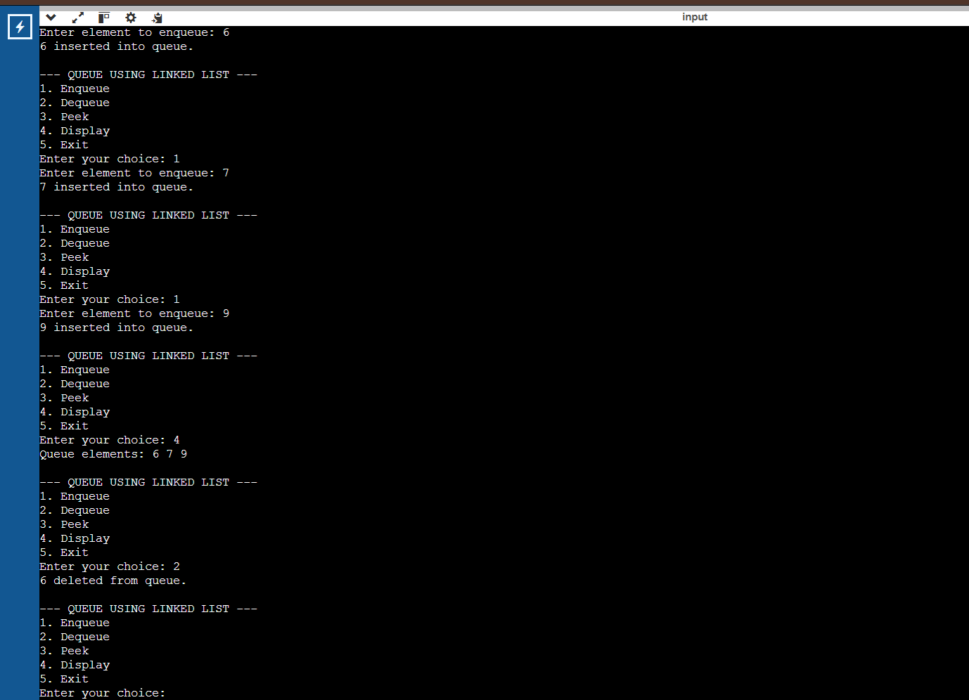

8(B). Write a python program to implement Circular Queue and its operations such as enqueue, dequeue, peek, display with a menu driven approach. Implement using array, and linked list data structures.
PROGRAM:
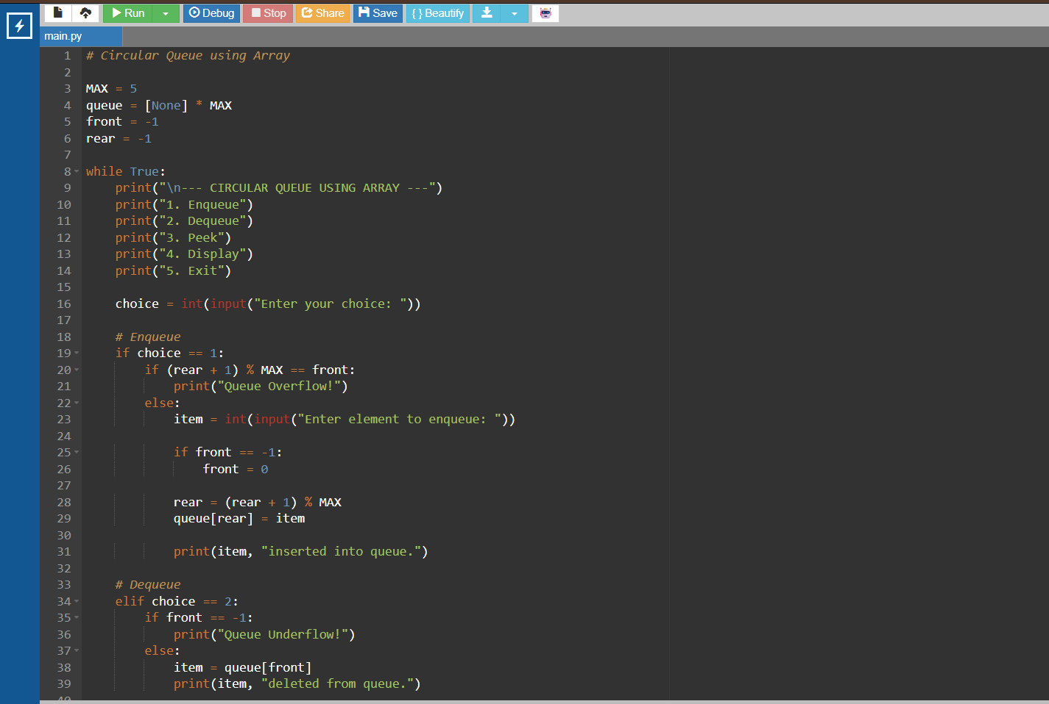
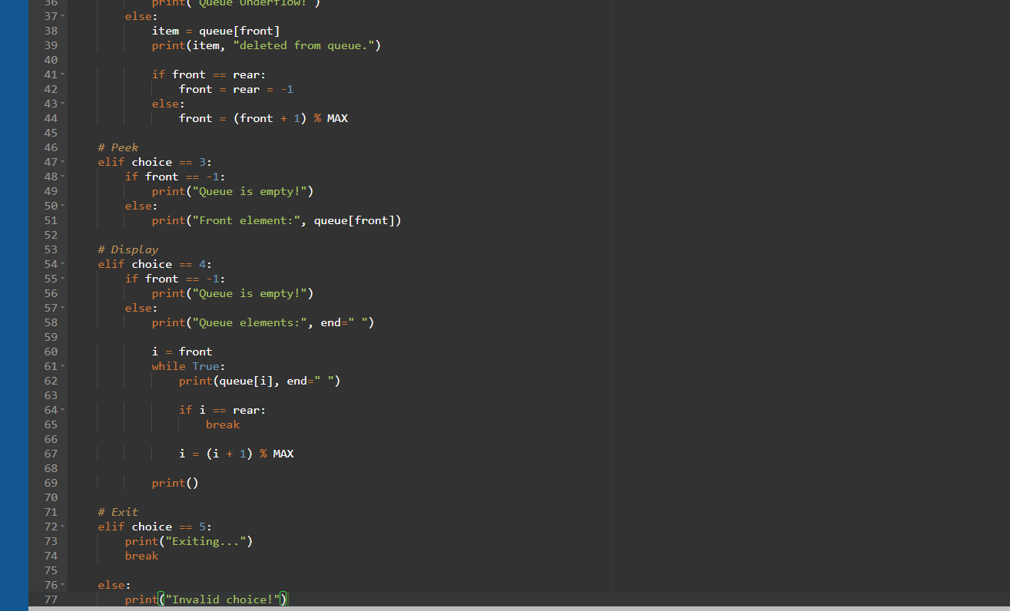

OUTPUT:
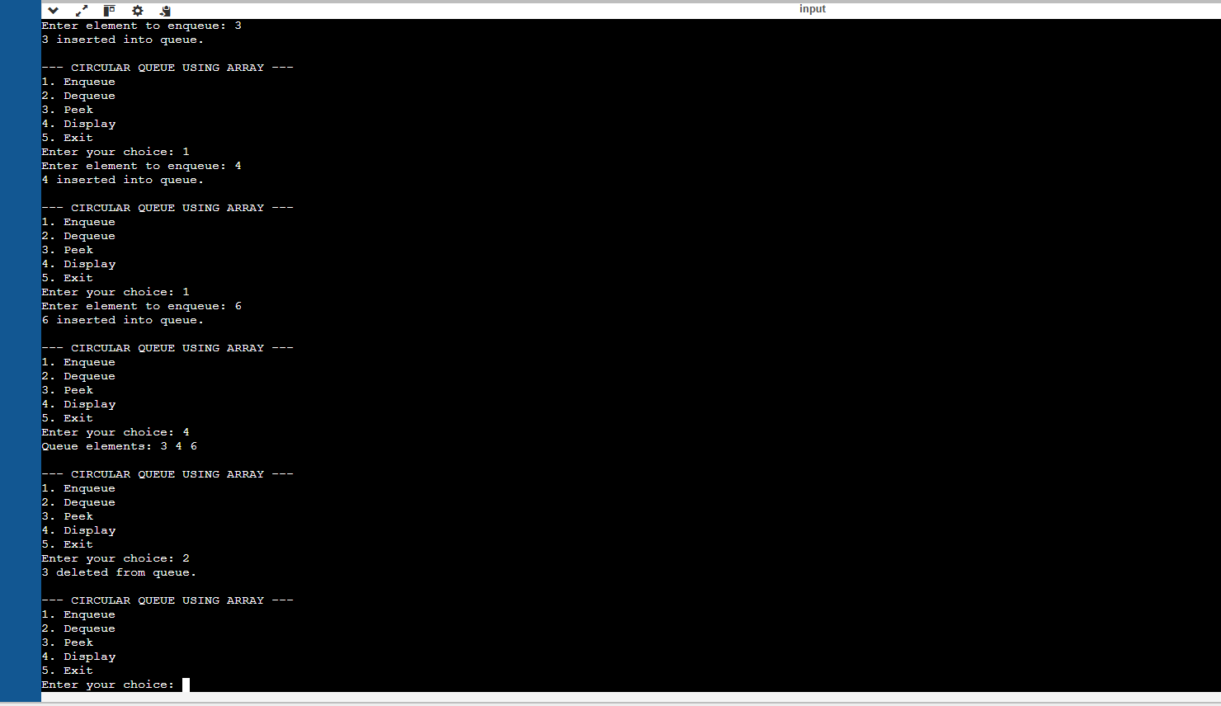

LINKED LIST:
PROGRAM:
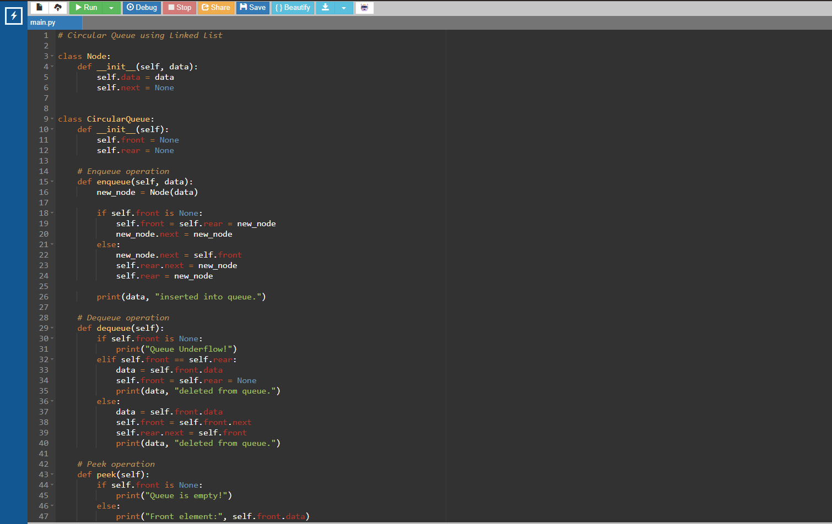

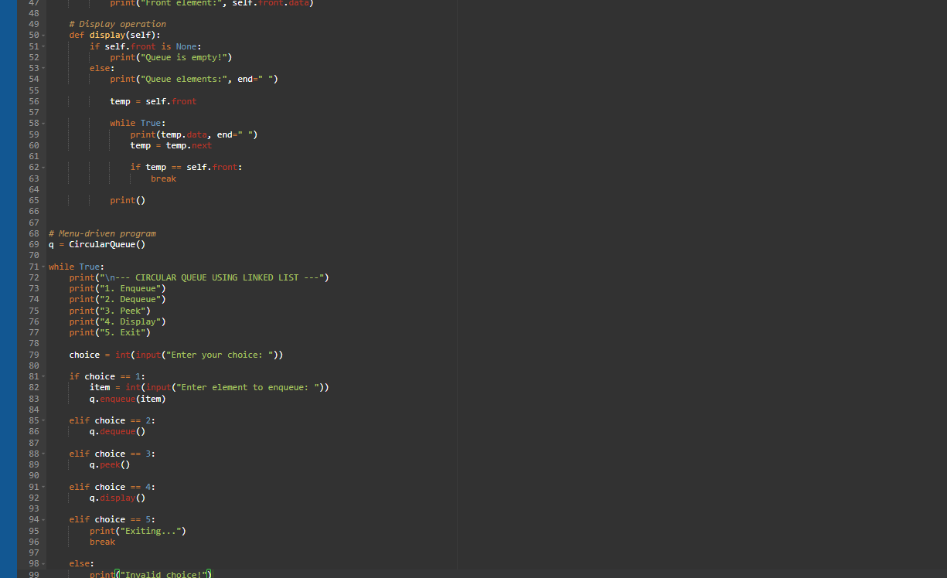
OUTPUT:
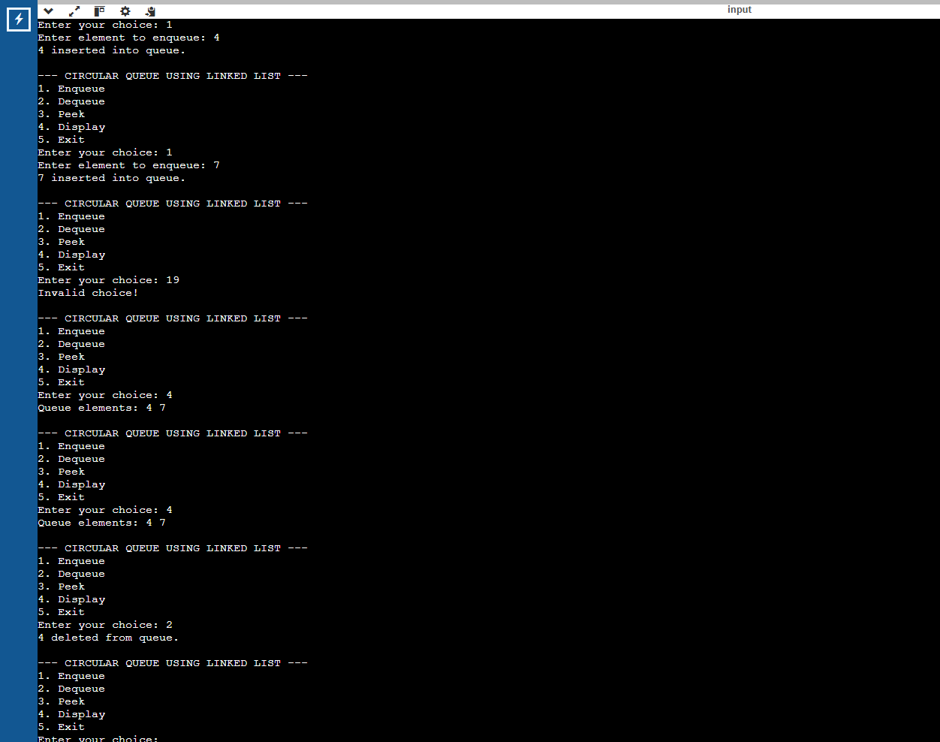

WEEK-9:
Write a python program to implement a Binary Search Tree (BST) and perform the following operations.
1. Insertion
2. Deletion
3. Tree Traversals – in-order, pre-order and post-order
4. Count Leaf Nodes
5. Count Internal Nodes
6. Height of the Tree

PROGRAM:
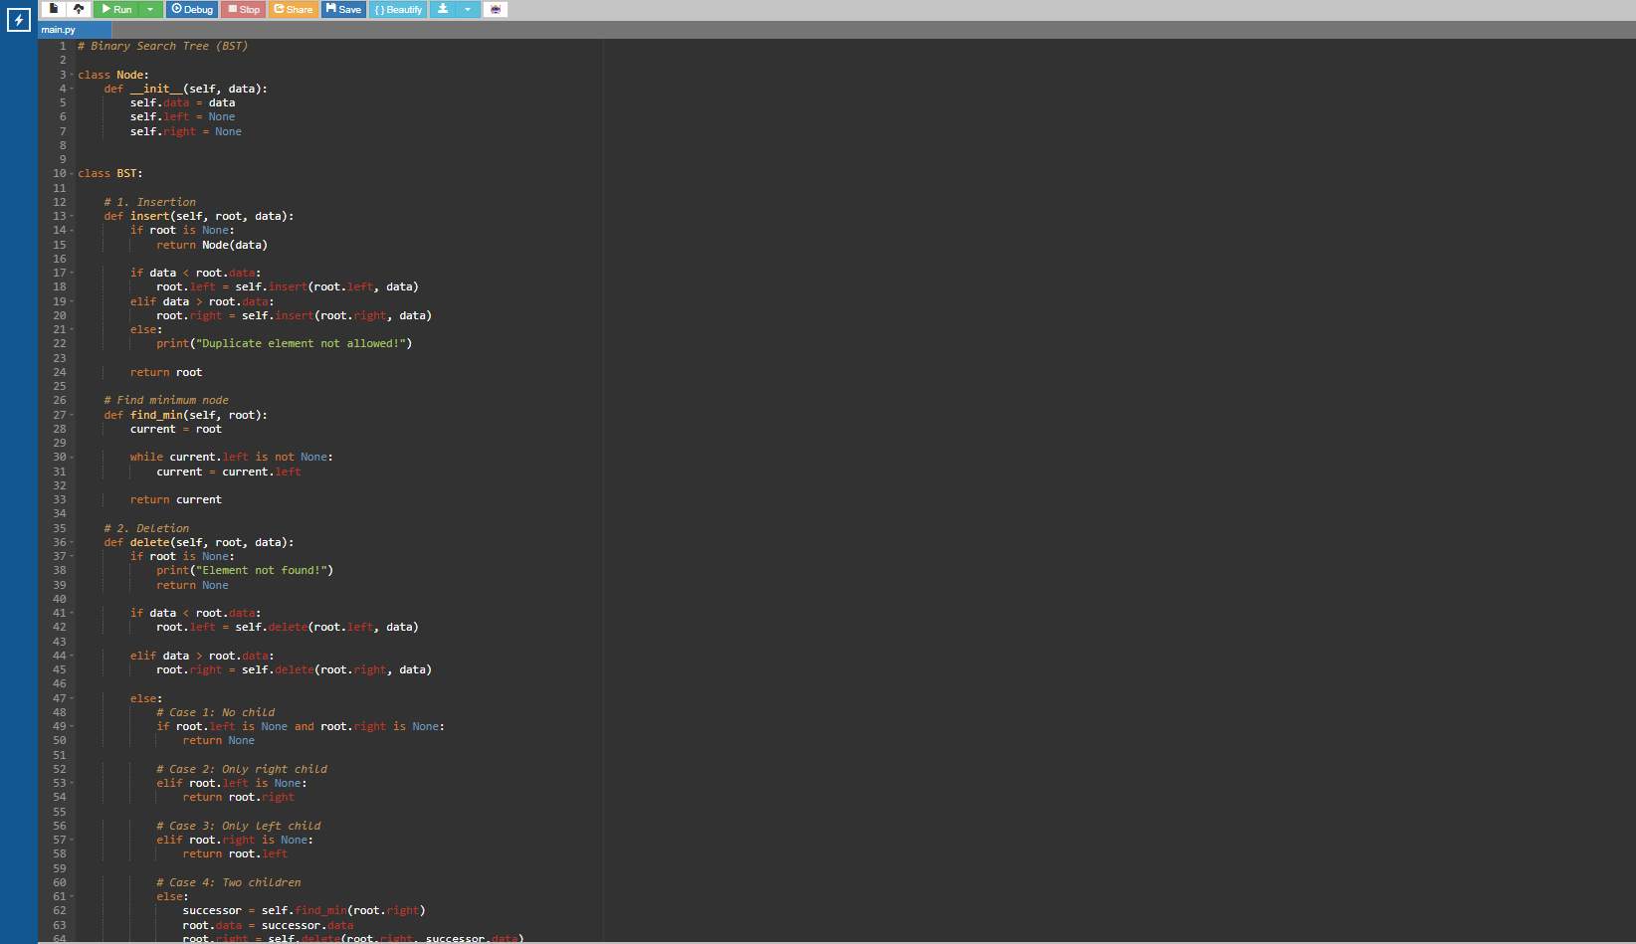
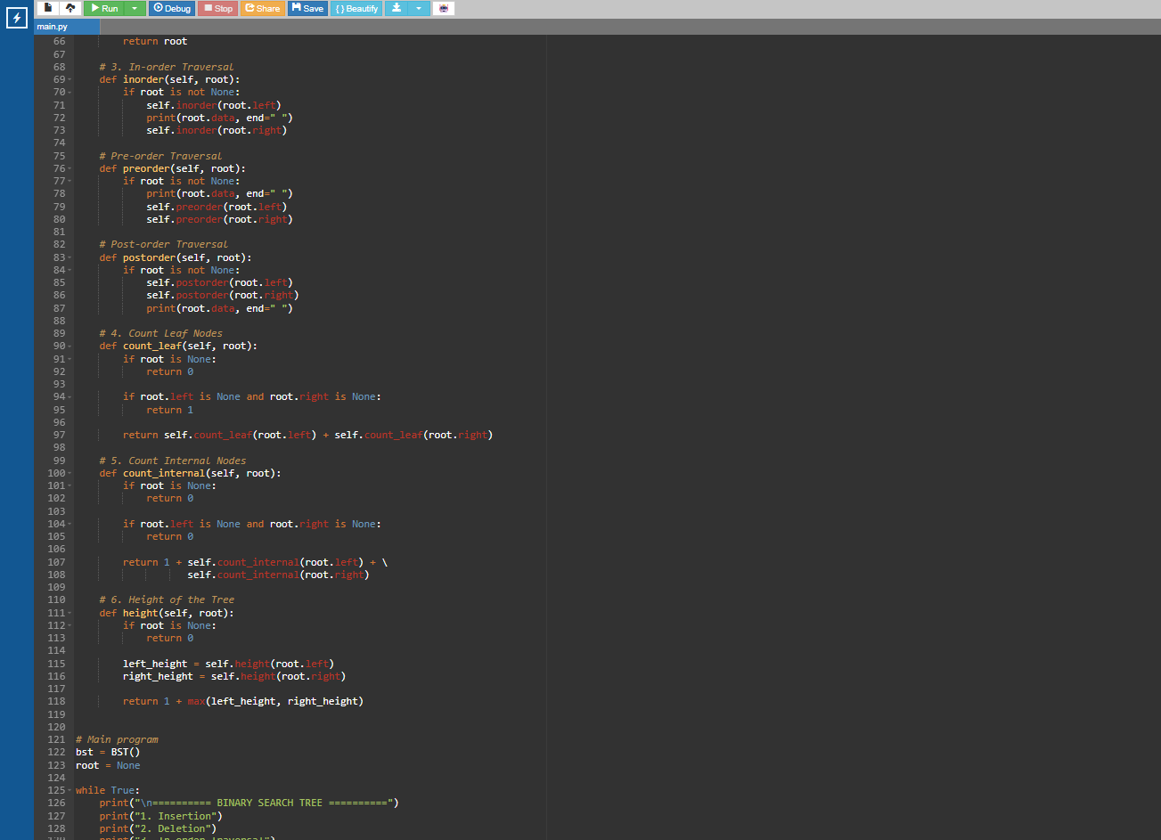

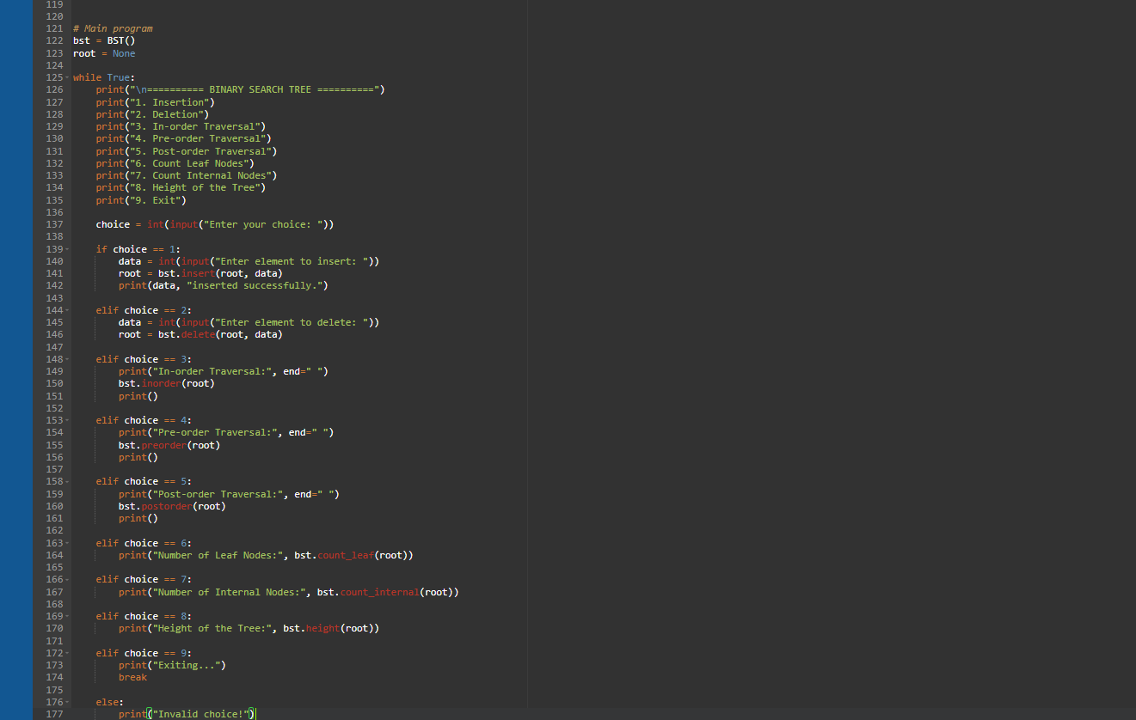

OUTPUT:
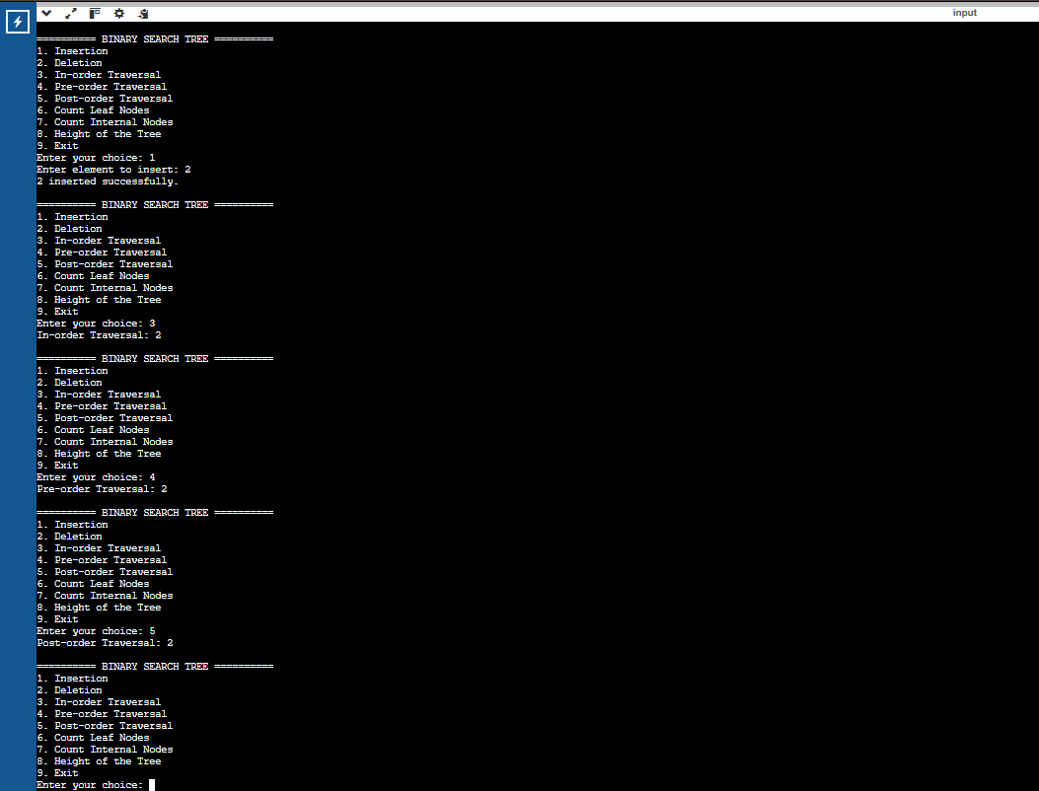

WEEK-10:
Write a menu driven python program to implement an AVL Tree and perform the following operations.
1. Insertion
2. Deletion
3. Tree Traversals
4. Count Leaf Nodes
5. Count Internal Nodes
6. Height of the Tree

PROGRAM:
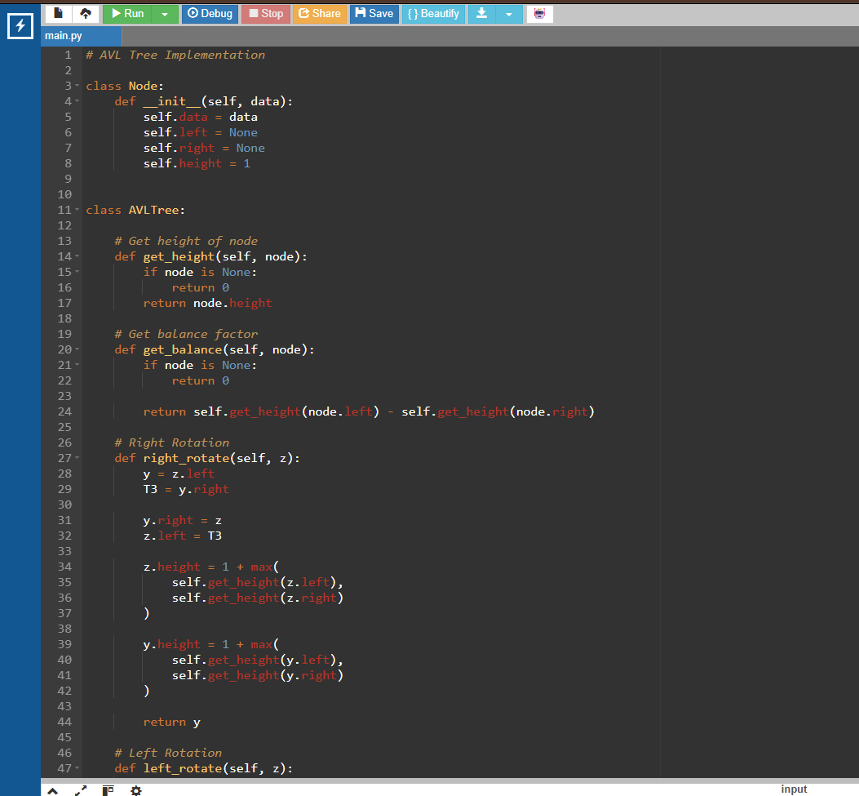

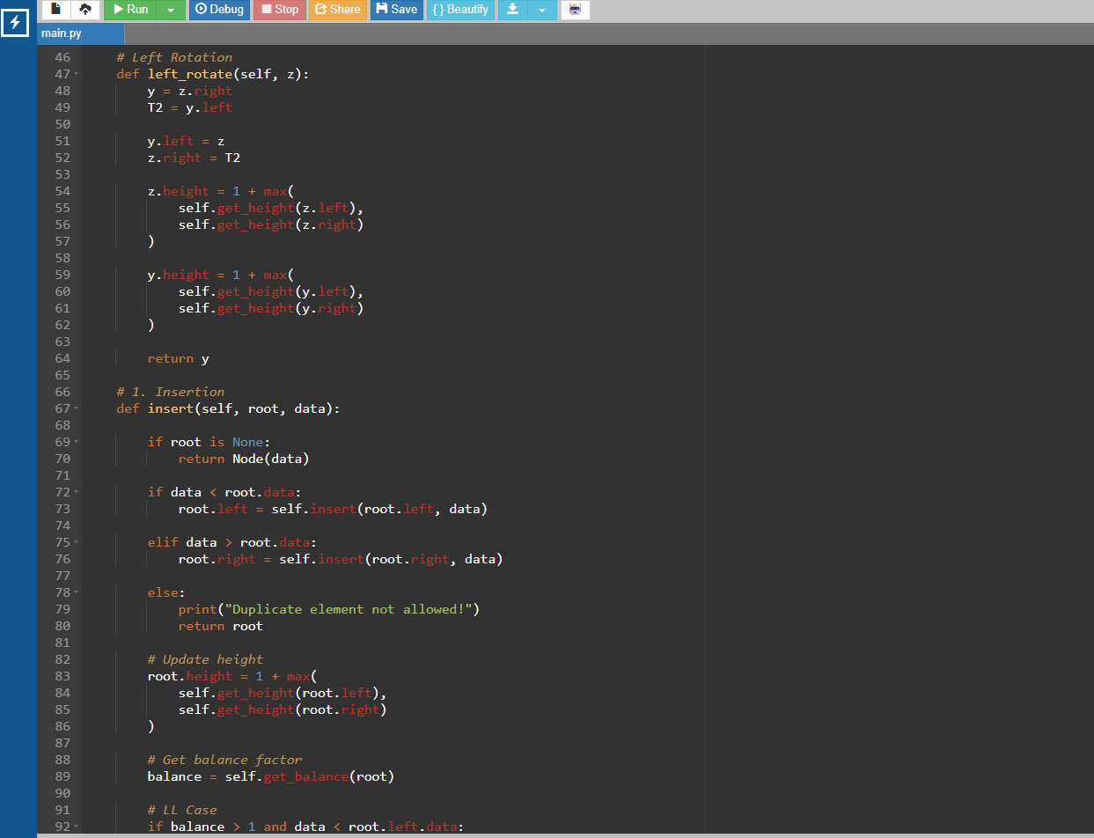
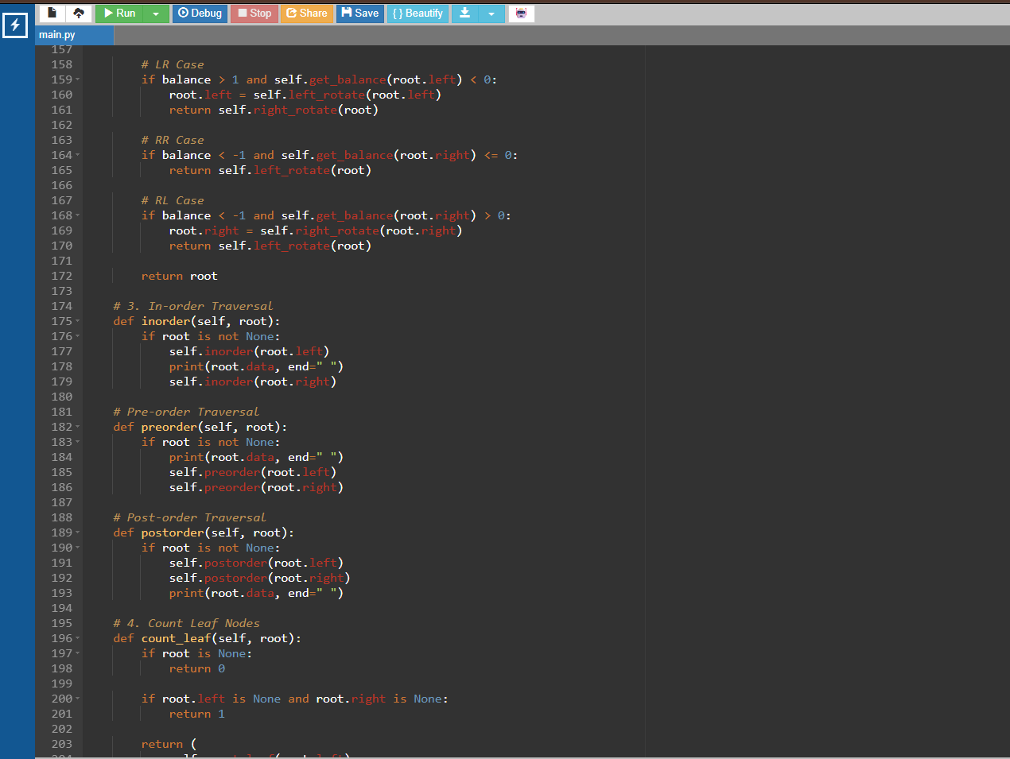
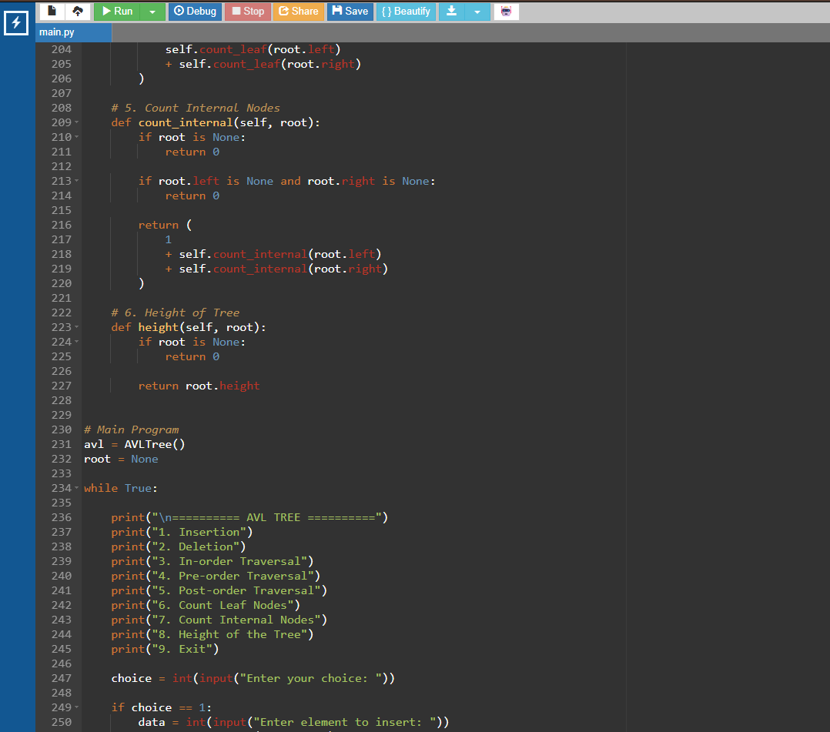
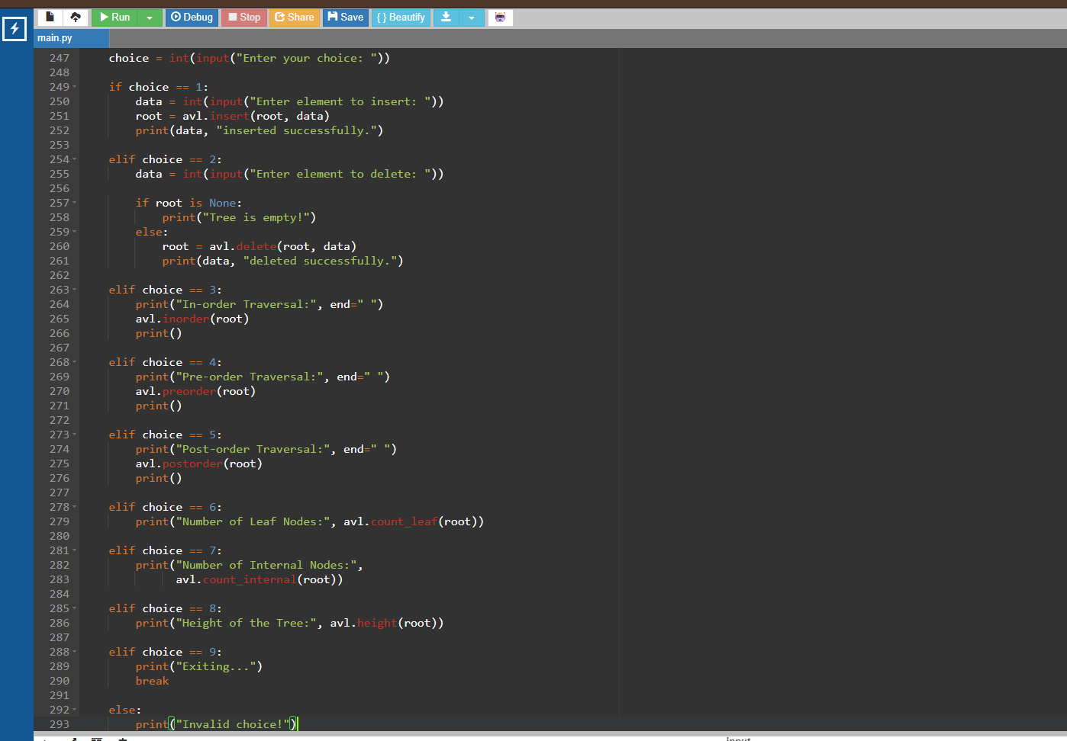

OUTPUT:
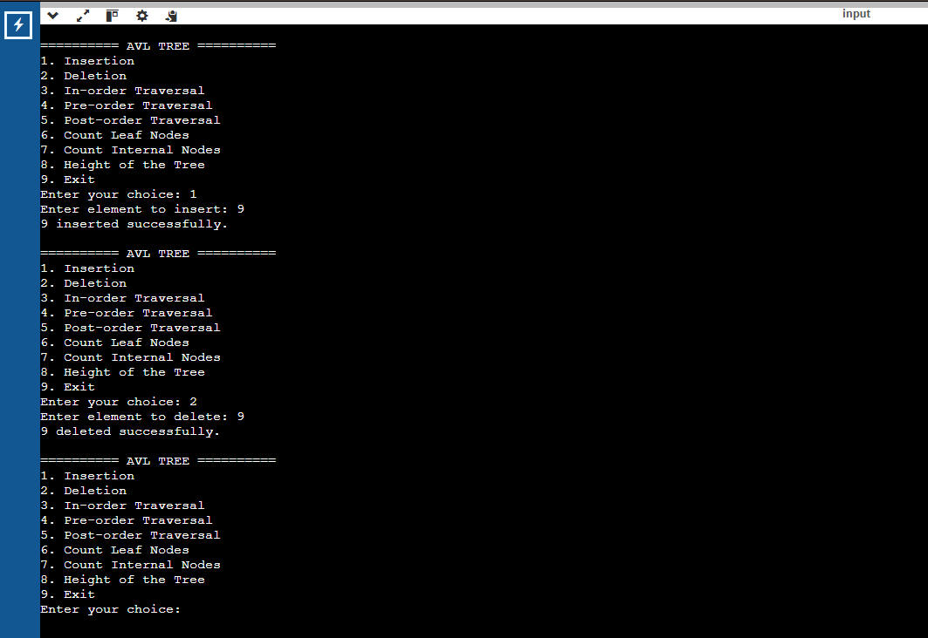

WEEK-11:
Write a menu-driven Python program to implement a Binary Heap (Max Heap and Min Heap) and perform the following operations:
- Insertion of an element into the Heap.
- Deletion of the root element from the Heap.
- Display the array representation of the Heap.
- Exit the program.

PROGRAM:
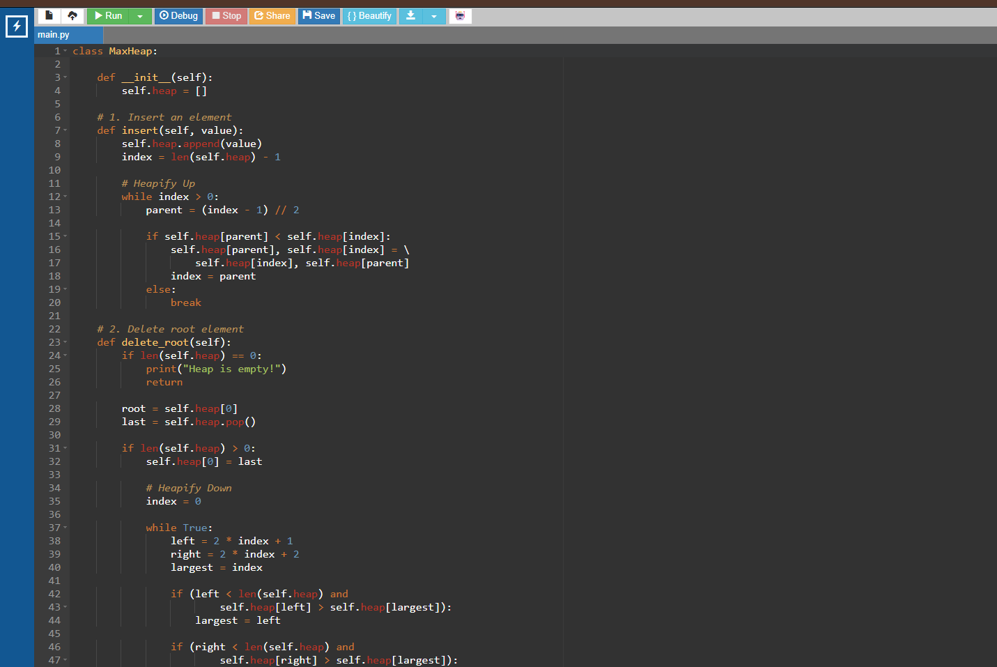

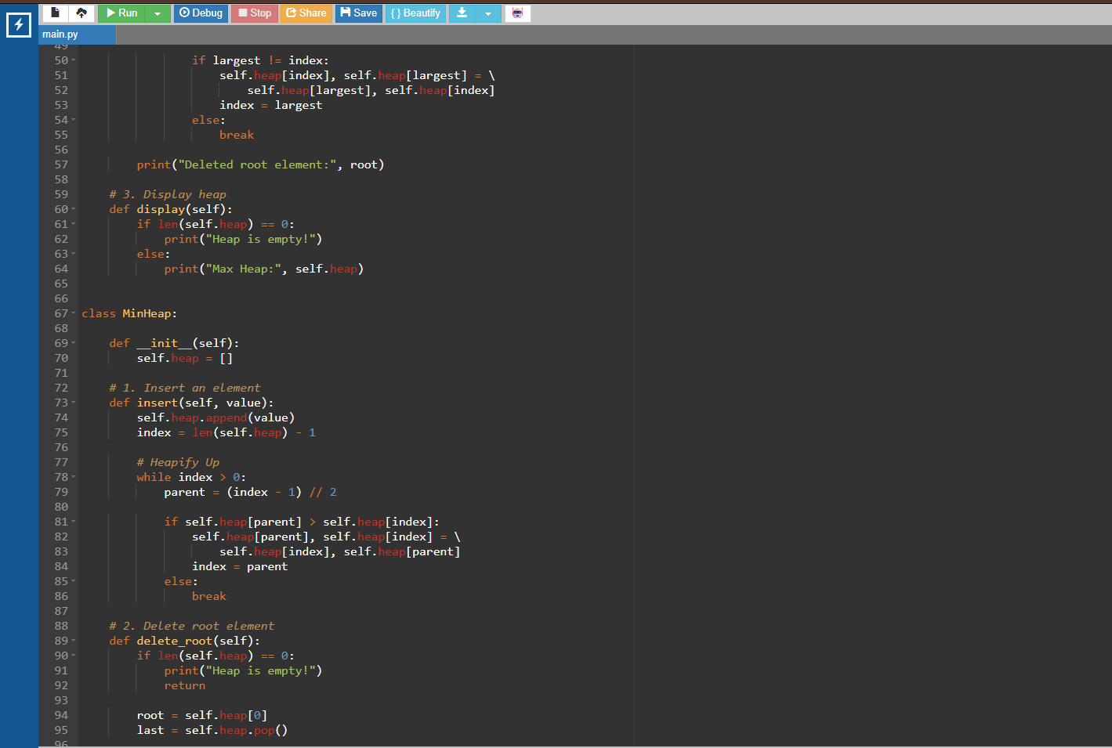
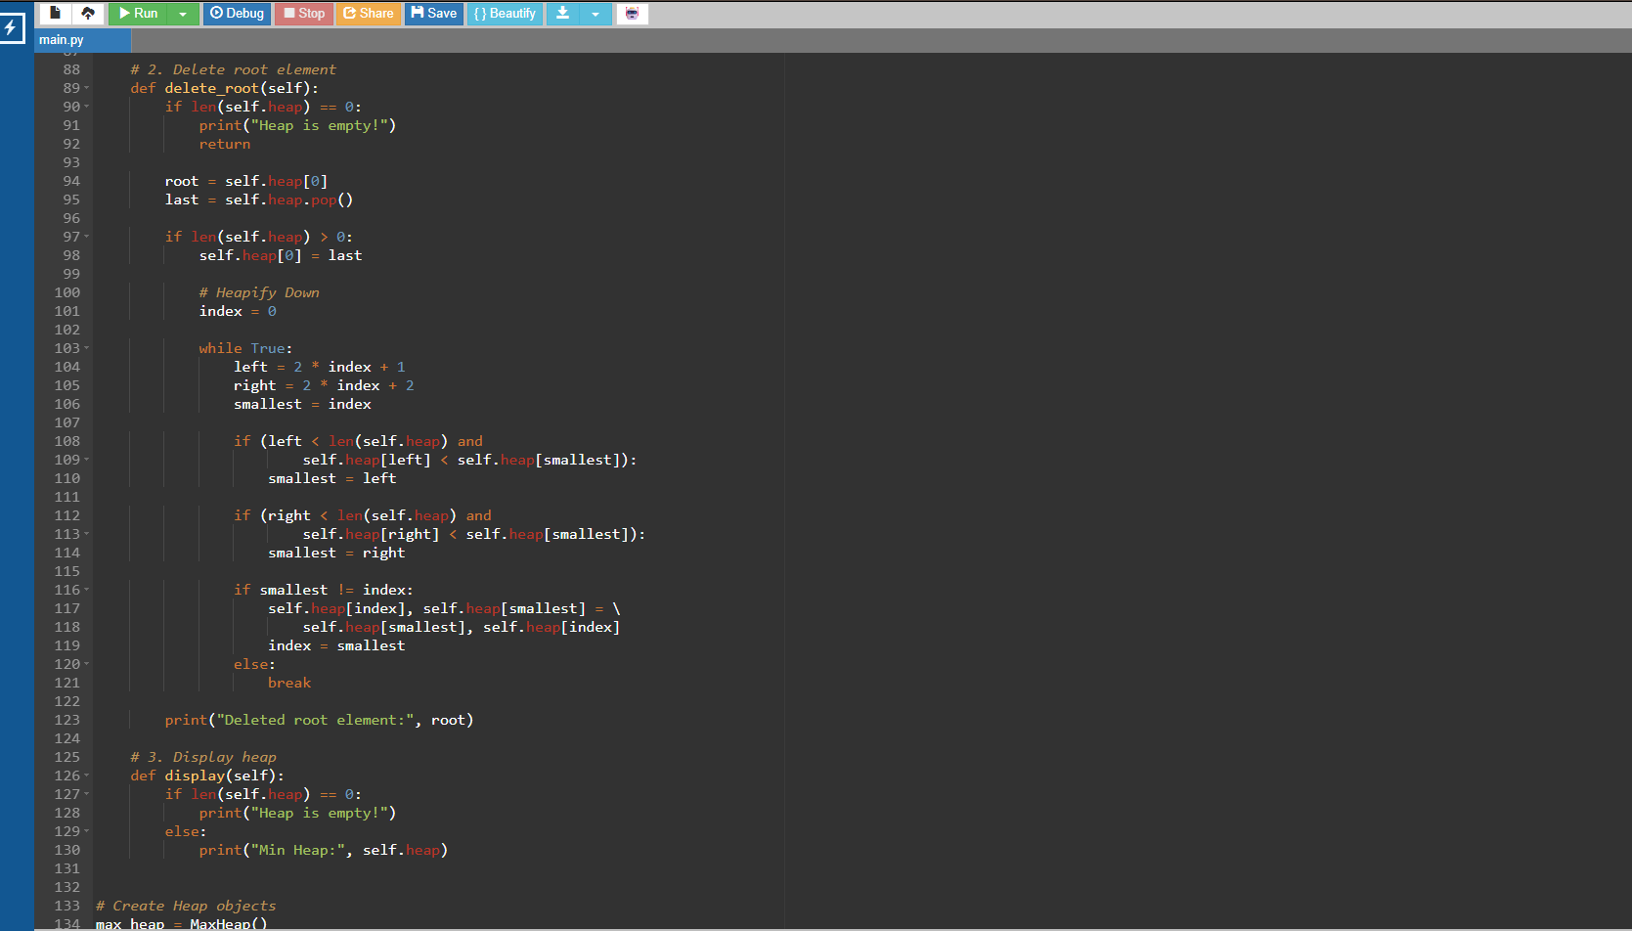

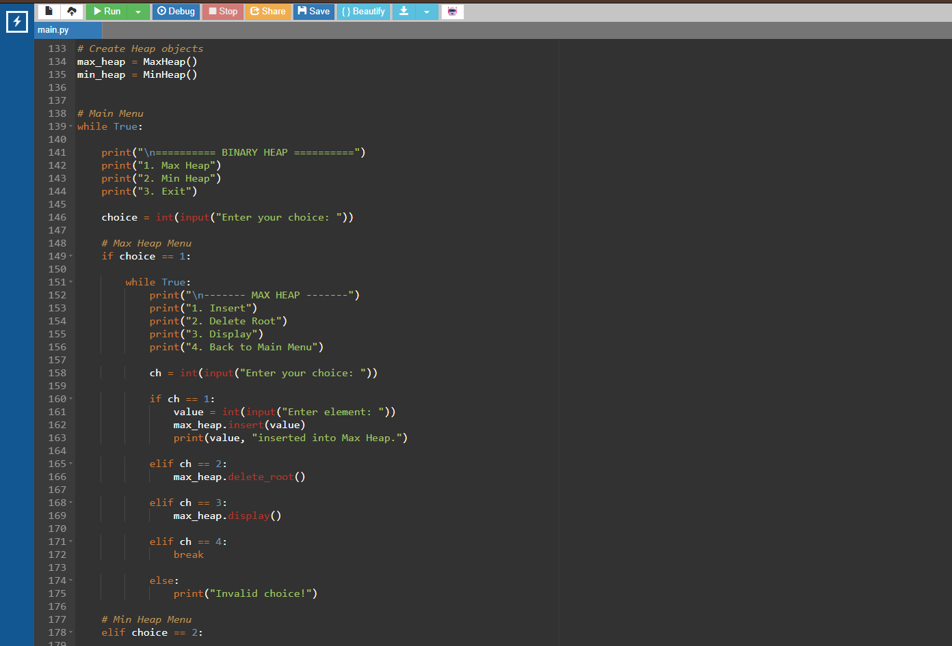
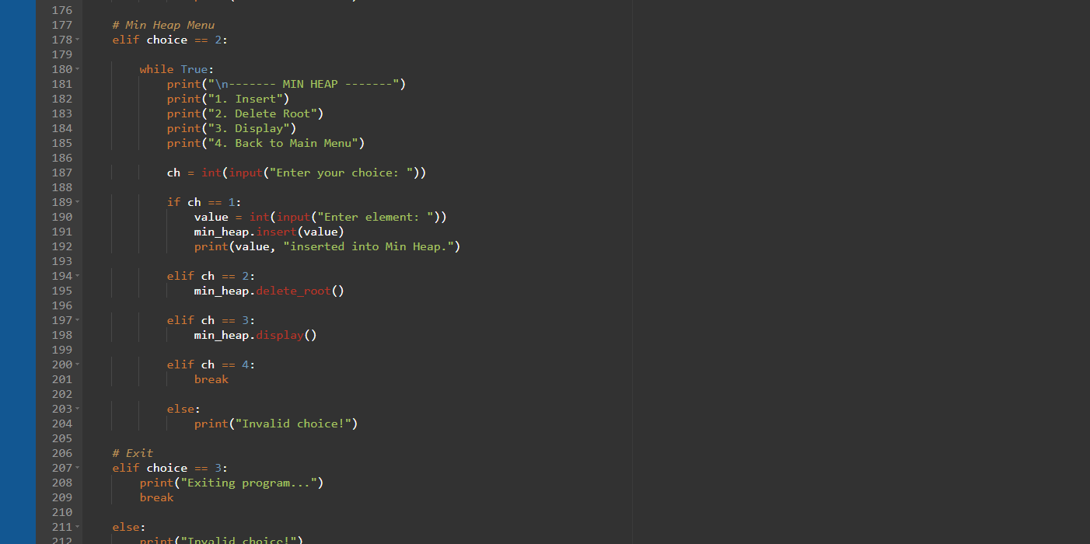

OUTPUT:
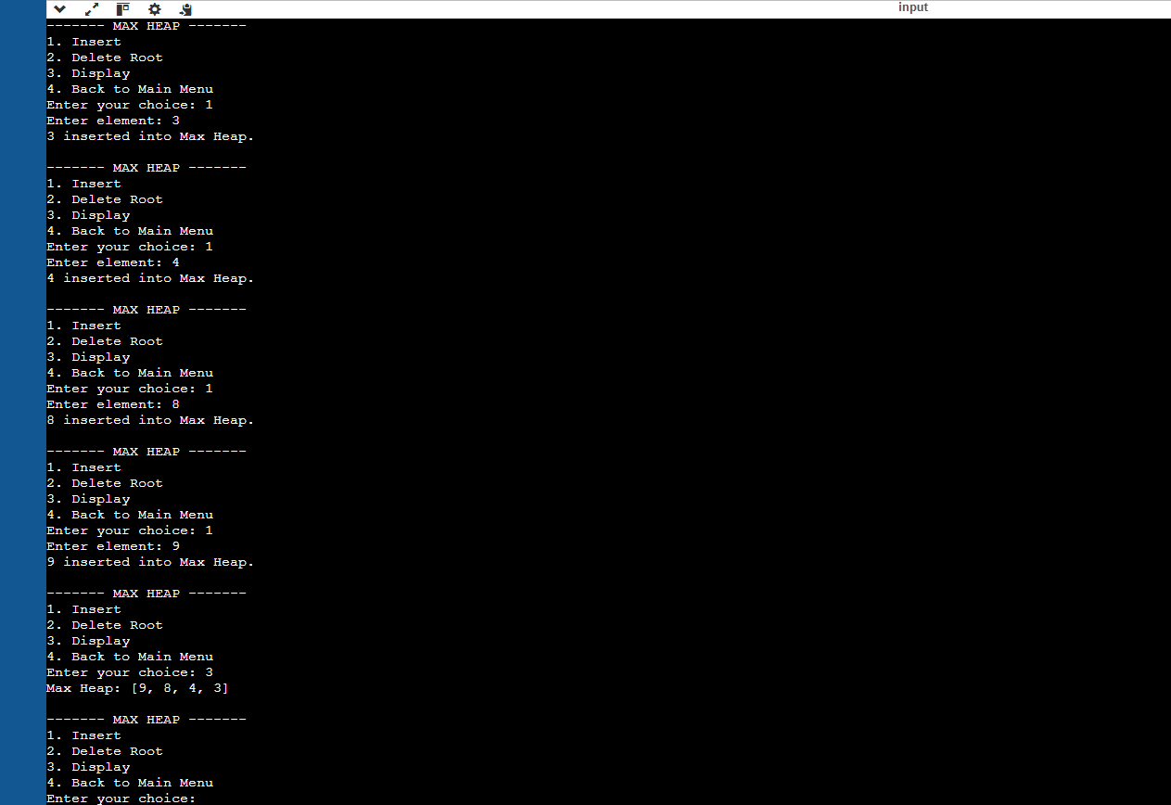

WEEK-12:
Write a program to implement the following three collision resolutiontechniques in a hash table :
1.separate chaining
2. linear probing
3. quadratic probing

PROGRAM:
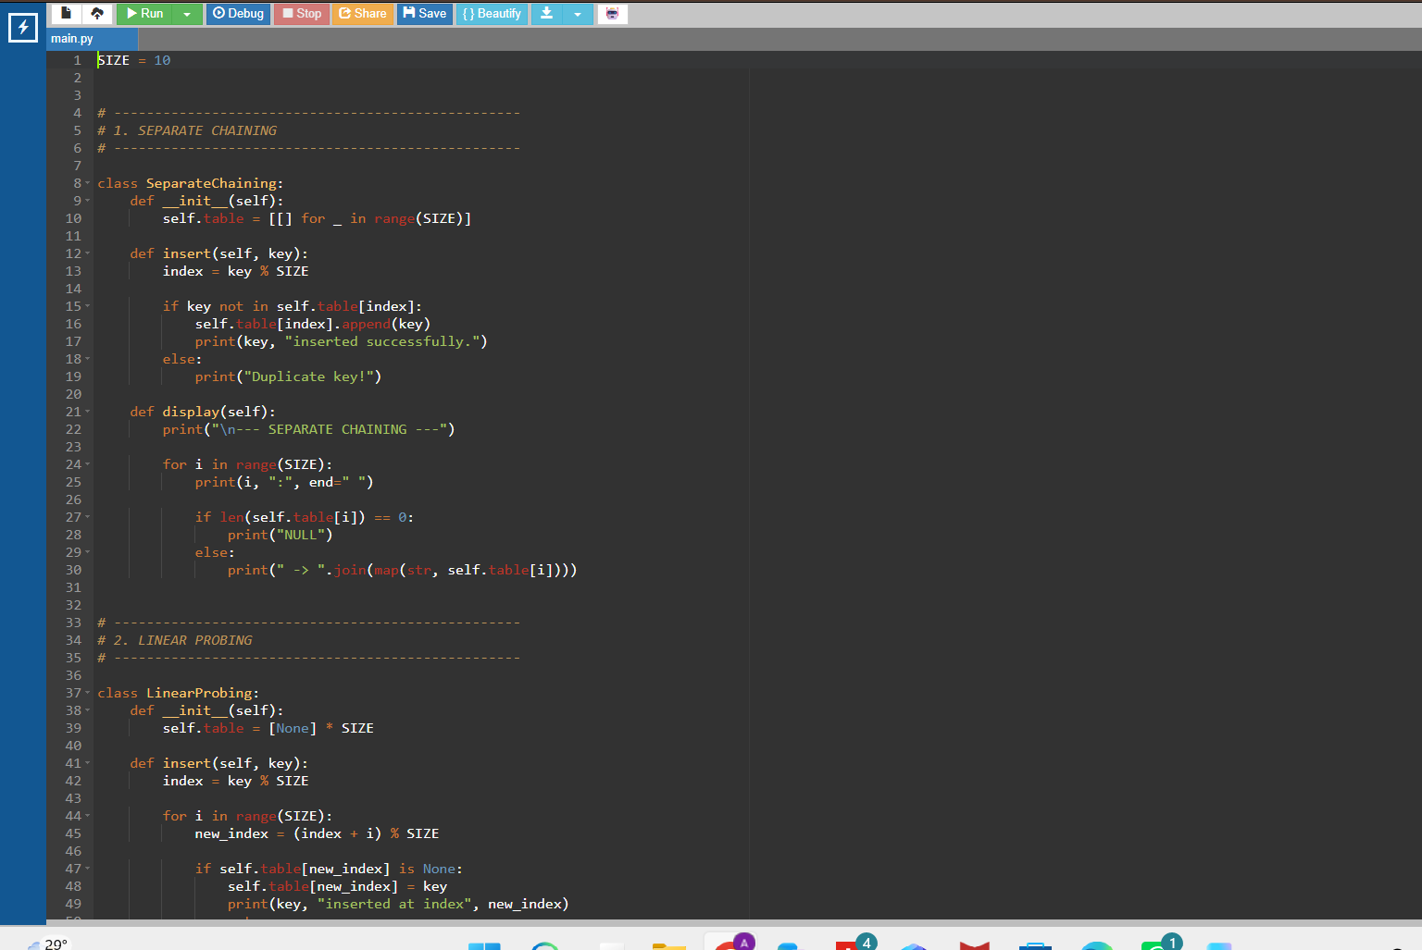
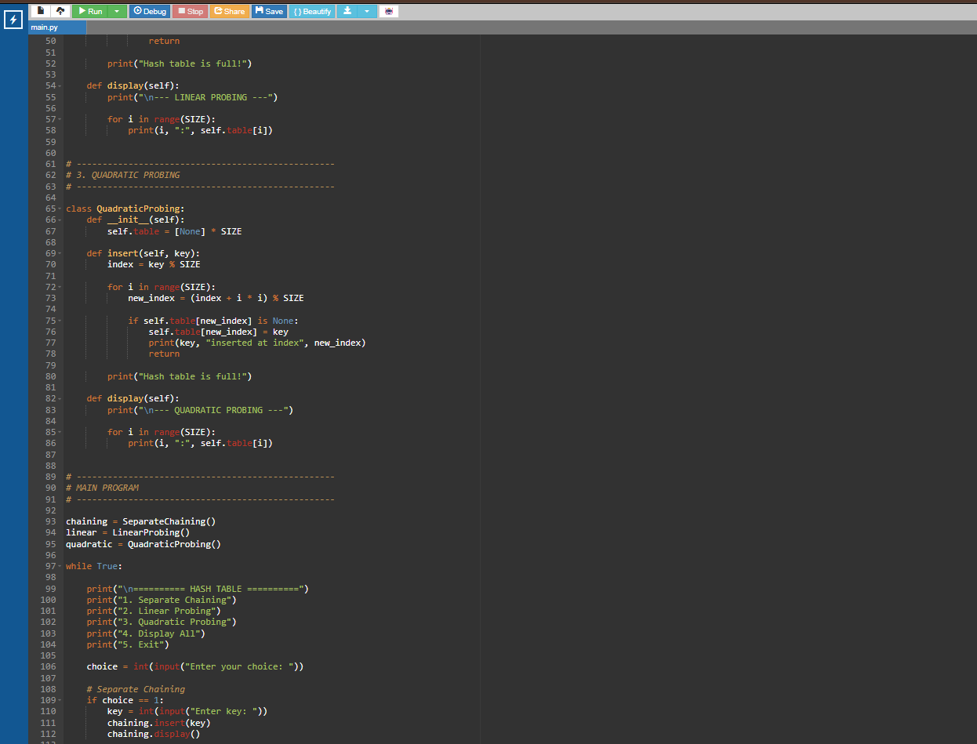

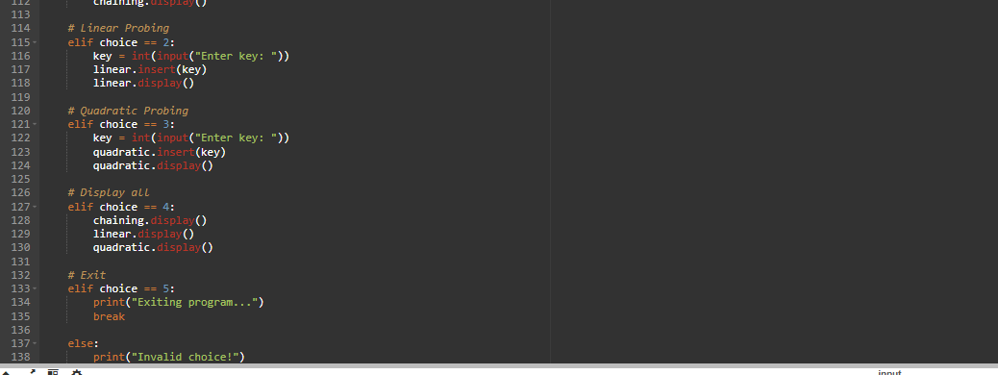

OUTPUT:


