A survey on different CNN approaches for Image Recognition
CS2IS2 Final Project (2018-19)
Sahir Sharma, Swastik Sahu
sharmas5@tcd.ie, sahus@tcd.ie
Abstract. The abstract should summarize the contents of the report and should contain at least 70 and at most 150 words. It should be set in 9-point font size and should be inset 1.0 cm from the right and left margins. There should be two blank (10-point) lines before and after the abstract. This document is in the required format. The abstract should give a concise overview of the main points of the report: the motivation behind the work, a very high-level description of the problem and how it was solved by the proposed algorithms. The abstract must not include any figures or table.
1 Introduction
Image recognition is a challenging problem for the computer. Even recognising simple objects, for example - digits or letters, can be an exceedingly complex task for the computer. An average human can correctly recognise almost all the digits in figure 1 as the digit ‘eight’ with just a glance. This is a very challenging problem for a computer, and a simple logic may not even achieve an accuracy of 50%. Perhaps one of the few things humans can do more efficiently than computers!

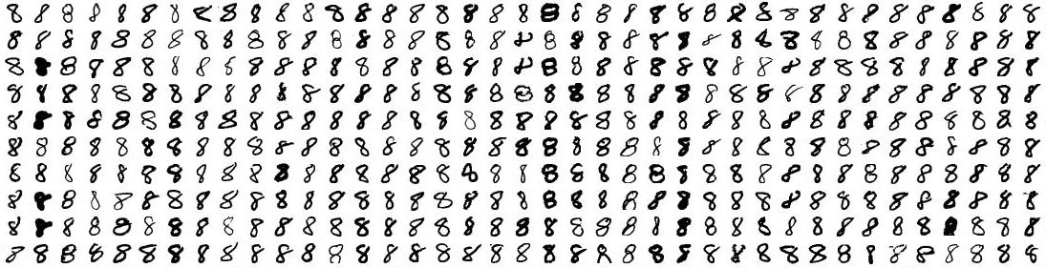
Figure 1

Unlike humans, the computers do not perceive and classify the input as a certain type of shapes or figure. The input received by the computer is in form of a series of pixel values, which may look the example in figure 2. The slightest of change in the input, in form of colour, hue, saturation, etc., can completely change the input. The complexity only adds up when this must be done for high resolution images and/or in real-time situations like for autonomous vehicles.

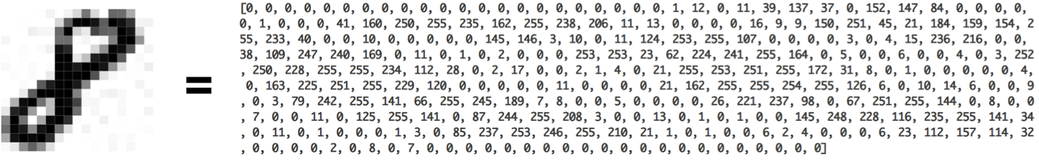
Figure 2

Till 2011, researchers have tried to solve this problem using various machine learning algorithms like Support Vector Machine, k-Nearest Neighbour and other classification algorithms, and were able to bring down to error rate to around 26%. The year 2012 marked the beginning of a new era, when researchers Krizhevsky et al. 2012 [1] from the University of Toronto, Canada used Deep Neural Networks to solve this challenge and were able to bring down the error rate to around 15%, a significant improvement over the previous best. Since then, the use of Deep Neural Networks in image recognition has been very popular and the current state of art is as good as a human.
Deep Convolutional Neural Networks (DNN/CNN) came into existence around 1980 when researchers were trying to model the way human brain works. But its popularity faded away as it was not able to produce promising results. At that time, we did not have enough computing resources because of which researchers could not use it for practical purposes. In the last decade, the availability of computing resources has facilitated the used of DNN and it has regained its popularity. The architectural differences and performance analysis of state of art DNNs for image recognition, as they have evolved, have been discussed in this paper.

2 Literature Review
Krizhevsky et al. 2012 [1] from the University of Toronto, Canada developed a DNN (called AlexNet) which had 60 x 10⁶ parameters, 6.5 x 10² neurons, with 5 convolutional layers followed by max-pooling layers, and 3 fully-connected layers with 1000-way softmax for image classification. Their model won the ImageNet competition by a huge margin and drew attention of others researcher for using DNNs in image classification tasks.
In 2014, Zisserman and Simonyan from the Visual Geometry Group(VGG), University of Oxford, modified the AlexNet to build an even deeper CNN called VGGNet. VGGNet

ImageNet is the most popular image classifying competition since 2010. It consists of over 1 Million labelled training data which are categorized into 1000 groups. Before

In 2015, C. Szegedy et al. created the Inception V2 model, predominantly an extension to the first version. Although they have changed the 5x5 filter to two 3x3 filters, a 3x3 convolution and a 3x1 fully-connected slide over the first one. This method called convolution factorization lessens the parameters in each inception module, thus lowering the computing resources. This model reached a top-5 error rate of 5.6% on the 2012 ImageNet challenge.

Using the above research, B. Zoph et al. in 2017 have created a model with an architecture above NAS on the CIFRA-10 dataset to perform the ImageNet challenge. These blocks are replicated and stacked-up with their own parameters to create the “NASNet” model. The ImageNet data-source is too big to be used for the NAS method, but the authors have successfully created a lighter and speeder block architecture than C. Szegedy et al. The parameter matrix of the NASNet model is trained using the ImageNet. The model achieved a top-5 error rate of 3.8% over the ImageNet 2012 challenge. A lighter version of less than 50 MB is also released with a lower error rate than any other similar model.

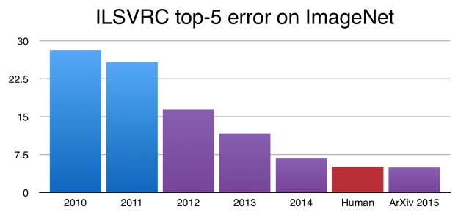
Figure 3
3 Problem Definition and Algorithm
This section formalises the problem you are addressing, and the models used to solve it. This section should provide a technical discussion of the chosen/implemented algorithms. A pseudocode description of the algorithm(s) can also be beneficial to a clear explanation. It is also possible to provide one example that clarifies the way an algorithm works. It is important to highlight in this section the possible parameters involved in the model and their impact, as well as all the implementation choices that can impact the algorithm.
4 Experimental Results
4.1 Top-k Accuracy

A comparison of algorithms was performed, and Top-k Accuracy was measured. The interpretation was visualized and can be seen in Fig 5. The trend is clearly visible, and the graph represents a curve.

Methodology
Data from Figure 4 was used. A simple 2D Scatter Plot was made between different technologies and different Top(s). A visual color encoding (Column 1 of Table in Figure 4) was adopted to represent different technologies. Y-Axis depicts different Top-k (Top-1, Top-2 and so on). X-Axis depicts the accuracy. The graph is plotted between ranges 65% to 100% to optimize space.

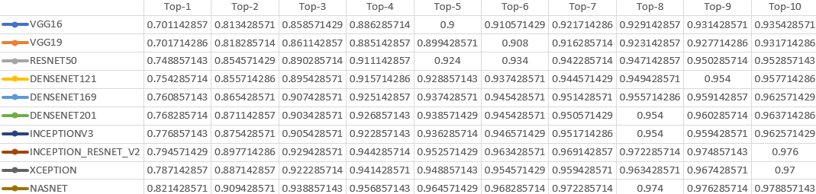
Figure 4

Results

Figure 5 illustrates the curve-like trend in accuracy among different algorithms.
The lowest accuracy observed is of VGG16 (70.11%) in Top-1. The highest observed is of NASNET (97.89%) in Top-10. This also means that we observed an increasing trend in subsequent Top-k’s and later a level of saturation, Top-6 onwards.

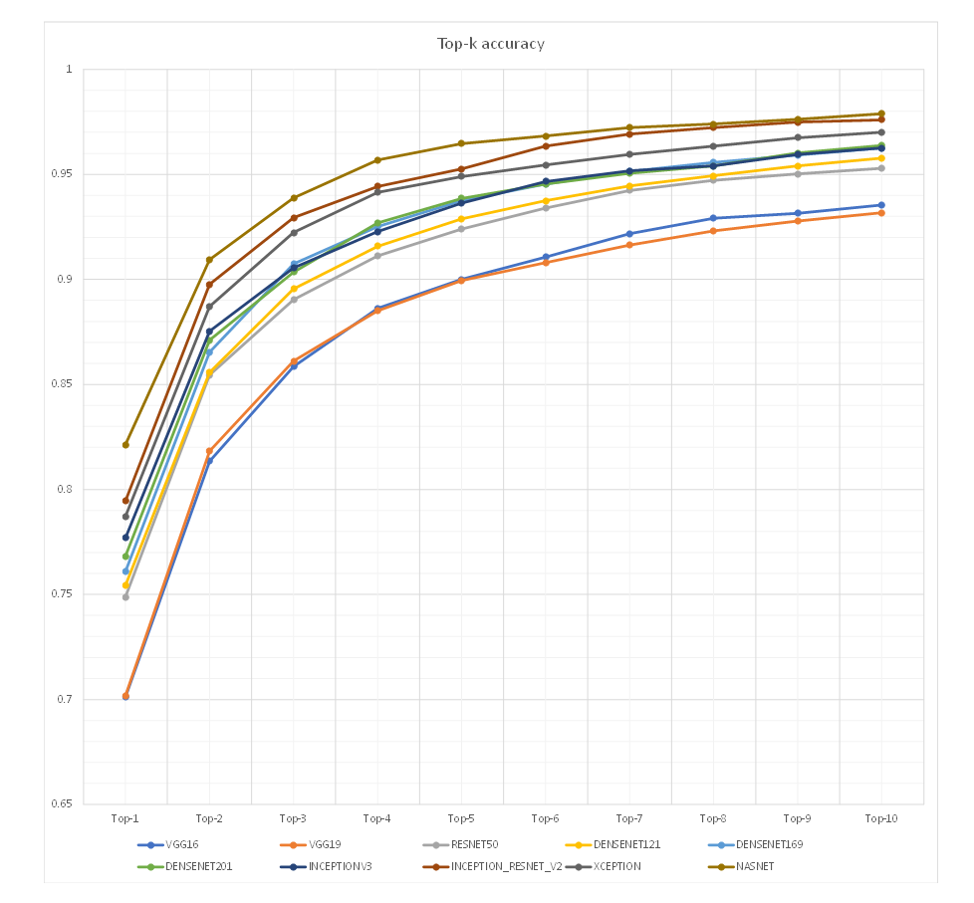
Figure 5
Discussion
Lorem Ipsum
5 Conclusions and Future Work
Provide a final discussion of the main results and conclusions of the report. Comment on the lesson learnt and possible improvements.
Despite the advances made in CNNs, they are still not ready to be deployed on mobile devices and real-time applications. Since Lavin and Gray [12] in 2015, there has been some research done in exploring the use of Winograd transformation and other pruning techniques. My research will further explore the possibilities of using Winograd transformation and pruning methods.

Liu and Turakhia [17], 2016, were able to prune 90% of the original parameters of the original parameters using Winograd-based convolution on LeNet-5 and prune 75% of those using FFT-based convolution.

Research by Li et al. [14], October 2017, shows that they were able to ‘natively’ prune Winograd coefficients to obtain more than 90% sparsity with just 0.1% accuracy loss using AlextNet on ImageNet dataset.

Liu et al. [15], Feb 2018, proposed to move ReLU operation into the Winograd domain to improve sparsity of the transformed activations and pruned the weight in Winograd domain to exploit static weight sparsity. They were able to outperform previous baselines by keeping the loss in accuracy to less than 0.1%.

Barabasz et al. [13], March 2018, propose a canonical evaluation ordering that reduces FP error and the size of the search space, based on Huffman coding. They propose a modified Toom-Cook convolution method which reduces the FP error by 20% - 70%.

Zlateski et al. [16], September 2018, in their paper titled - “FFT Convolutions are Faster than Winograd on Modern CPUs, Here’s Why”, use optimized implementations of regular FFT, Gaus-FFT and Winograd-based convolutions on modern CPUs. They conclude that FFT-based implementations outperform Winograd-based implementation on modern CPUs.

Recently, Lin et al. [18], November 2018, proposed a data-driven method to prune connections between input and output feature maps with their proposed class of parameter called ‘Synaptic Strength’. They claim their approach is a better indicator for kernel pruning when compared with previous approaches in empirical result and theoretical analysis.

Sparse methods and transformation techniques are orthogonal approaches. Each one can optimize the convolution computations in CNNs independently. Merging the two approaches by creating a sparse Winograd model can offer combined performance benefit. I will explore this possibility through my research.

References
- Alex Krizhevsky, Ilya Sutskever, and Geoffrey E Hinton. Imagenet classification with deep convolutional neural networks. In Advances in neural information processing systems (NIPS), 2012.
- Karen Simonyan and Andrew Zisserman. Very deep convolutional networks for large-scale image recognition. In Proceedings of International Conference on Learning Representations (ICLR), 2015

- Christian Szegedy, Wei Liu, Yangqing Jia, Pierre Sermanet, Scott Reed, Dragomir Anguelov, Dumitru Erhan, Vincent Vanhoucke, and Andrew Rabinovich. Going deeper with convolutions. CoRR, abs/1409.4842, 2014.
- Kaiming He, Xiangyu Zhang, Shaoqing Ren, and Jian Sun. Deep residual learning for image recognition. CoRR, abs/1512.03385, 2015.
- Shmuel Winograd. Arithmetic complexity of computations, volume 33. Siam, 1980.
- Andrew Lavin and Scott Gray. Fast Algorithms for Convolutional Neural Networks. In Proceedings of the IEEE Conference on Computer Vision and Pattern Recognition, pp. 4013–4021, 2016.
- Vasilache, Nicolas, Johnson, Jeff, Mathieu, Michael, Chintala, Soumith, Piantino, Serkan, and LeCun, Yann. Fast Convolutional Nets with fbfft: A GPU Performance Evaluation. In International Conference on Learning Representations (ICLR), 2015.
- Mathieu, Michael, Henaff, Mikael, and LeCun, Yann. Fast training of convolutional networks through ffts. CoRR, abs/1312.5851, 2013.
- Yann LeCun, Léon Bottou, Yoshua Bengio, and Patrick Haffner. Gradient-based learning applied to document recognition. Proceedings of the IEEE, 86(11):2278–2324, 1998.
- Christian Szegedy, Wei Liu, Yangqing Jia, Pierre Sermanet, Scott E. Reed, Dragomir Anguelov, Dumitru Erhan, Vincent Vanhoucke, and Andrew Rabinovich. Going deeper with convolutions. In 2015 IEEE Conference on Computer Vision and Pattern Recognition (CVPR), pp. 1–9, June 2015.
- Karen Simonyan and Andrew Zisserman. Very deep convolutional networks for large-scale image recognition. In Proceedings of International Conference on Learning Representations (ICLR), 2015.
- Shmuel Winograd. Signal processing and complexity of computation. In IEEE International Conference on Acoustics, Speech, and Signal Processing, ICASSP ’80, Denver, Colorado, April 9-11, 1980, pages 94–101, 1980.
- Andrew Lavin and Scott Gray. Fast algorithms for convolutional neural networks. CoRR, abs/1509.09308, 2015.
- Barbara Barabasz, Andrew Anderson, David Gregg. Error analysis and improving the accuracy of Winograd Convolution for deep neural networks. CoRR, abs/1803.10986, 2018.
- Sheng Li, Jongsoo Park, Ping Tak Peter Tang. Enabling Sparse Winograd Convolution by Native Pruning. CoRR, abs/1702.08597, 2017.
- Xingyu Liu, Jeff Pool, Song Han, William J. Dally. Efficient Sparse-Winograd Convolutional Neural Networks. CoRR, abs/1802.06367, 2018.
- Aleksandar Zlateski, Zhen Jia, Kai Li, Fredo Durand. FFT Convolutions are Faster than Winograd on Modern CPUs, Here is Why. CoRR, abs/1809.07851, 2018.
- Xingyu Liu, Yatish Turakhia. Pruning of Winograd and FFT Based Convolution Algorithm. Stanford edu, 2016. http://cs231n.stanford.edu/reports/2016/pdfs/117_Report.pdf
- Chen Lin, Zhao Zhong, Wei Wu, Junjie Yan. Synaptic Strength for Convolutional Neural Network. CoRR, abs/1811.02454, 2018

