Disease Diagnosis using Chatbot

In this project you ask us to develop Chatbot which can analyse input symptoms and then predict disease and then display diet and doctor appointment booking. It’s not real time application to make booking with the doctor but we will display predicted disease, diet information along with doctor and hospital details.

To identify disease we need to train Chatbot with machine learning so it can take symptoms as input and then predict disease and to train Chatbot we have use CNN algorithm and this algorithm get trained on below dataset

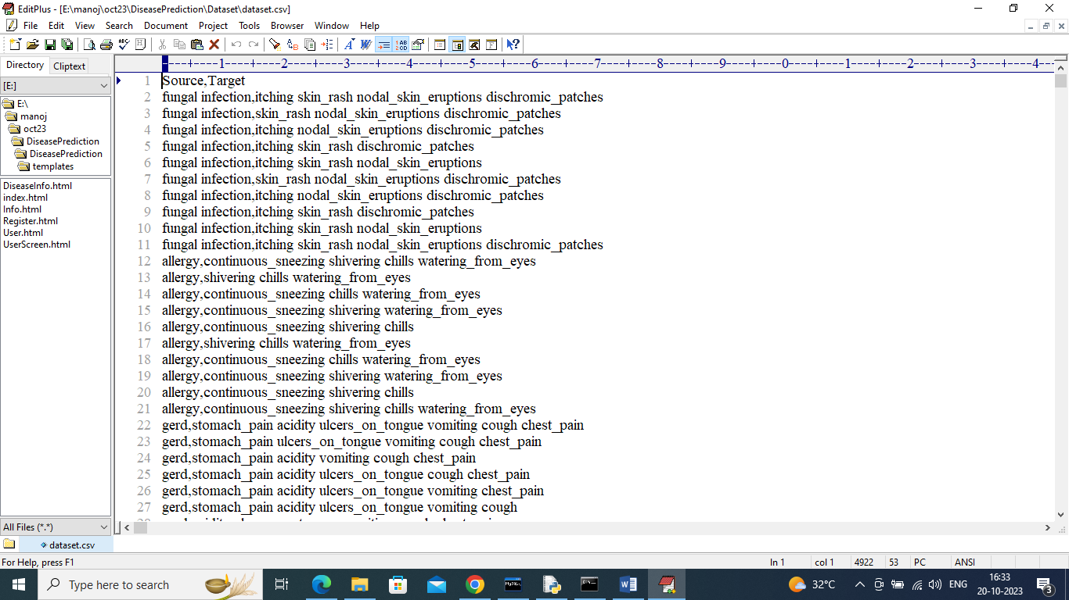

In above dataset ‘Source’ column refers to disease name and ‘Target’ column refers to all possible symptoms of that disease and by analysing those symptoms CNN will predict disease and suggest diets with home remedies

To implement this project we have designed following modules

1. Register: using this module users can sign up with the application along with email ID and contact no so email can be sent along with predicted disease and diet details
2. User: using this module user can login to application
3. Chatbot: using this module user can enter symptoms and then Chatbot will predict disease, diet, doctor details and then display output as well as send email to registered email ID
4. Lifestyle & Disease Information: using this module use can select disease name and then system will suggest foods to take, avoid along with doctor details.

SCREEN SHOTS

To run project copy content from DB.txt file and then paste in MYSQL console to create database and then double click on ‘run.bat’ file to start python server and get below page

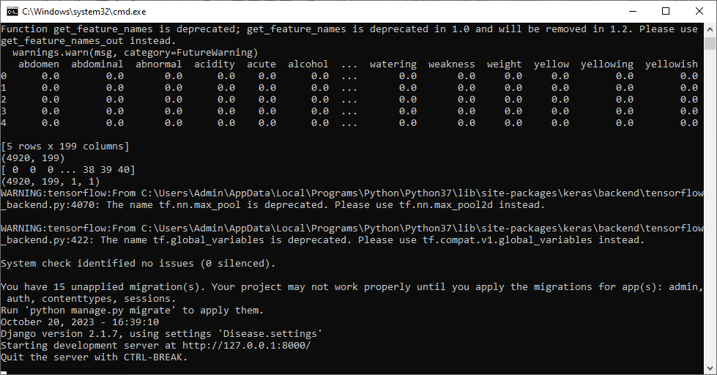

In above screen python server started and now open browser and entre URL as <http://127.0.0.1:8000/index.html> and then press enter key to get below page

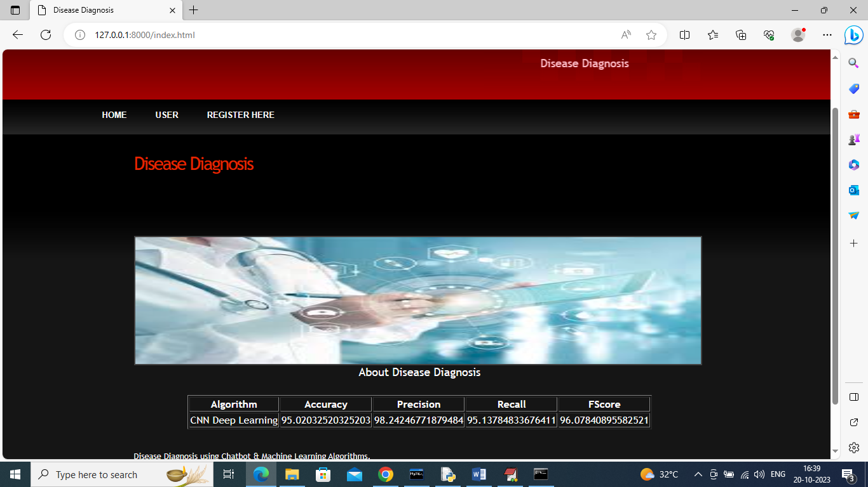

In above screen we can see application home page and then in table we can see CNN algorithm disease prediction accuracy and now click on ‘Register Here’ link to sign up with the application

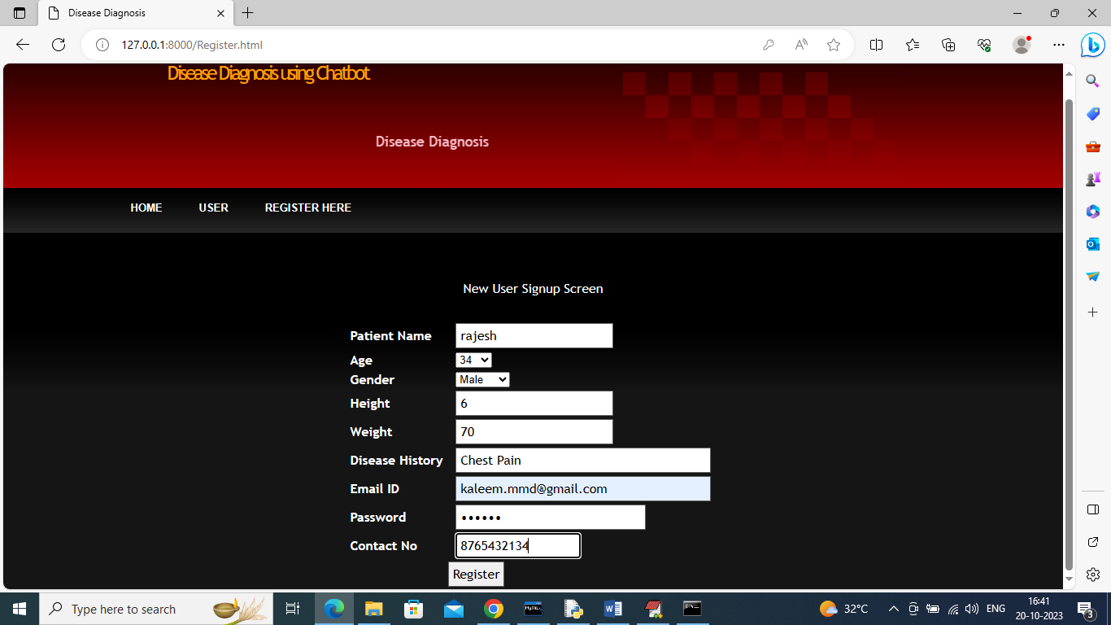

In above screen user is entering signup detail and give valid MAIL ID so you can receive mails and press button to get below page

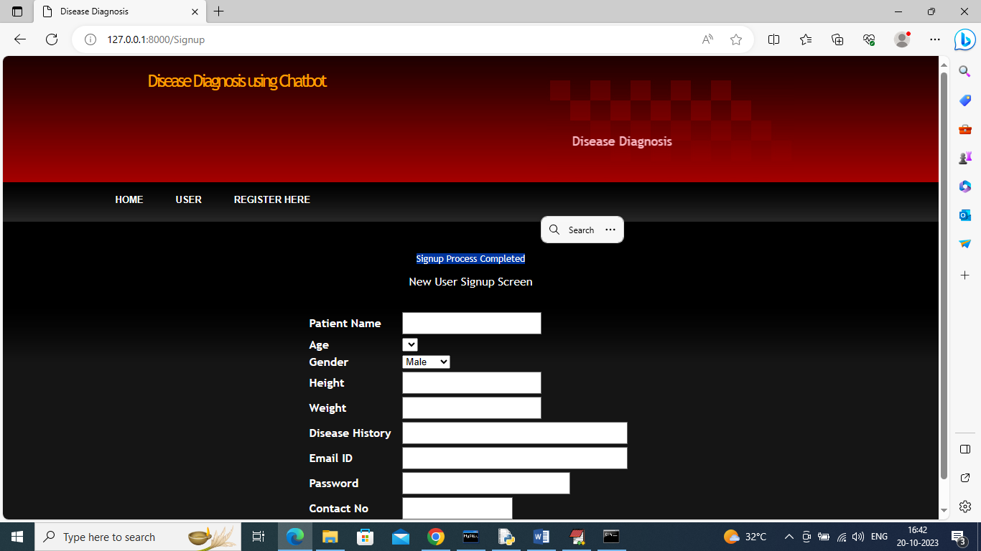

In above screen in blue colour text we can see sign up completed and now click on ‘User’ link to login as user

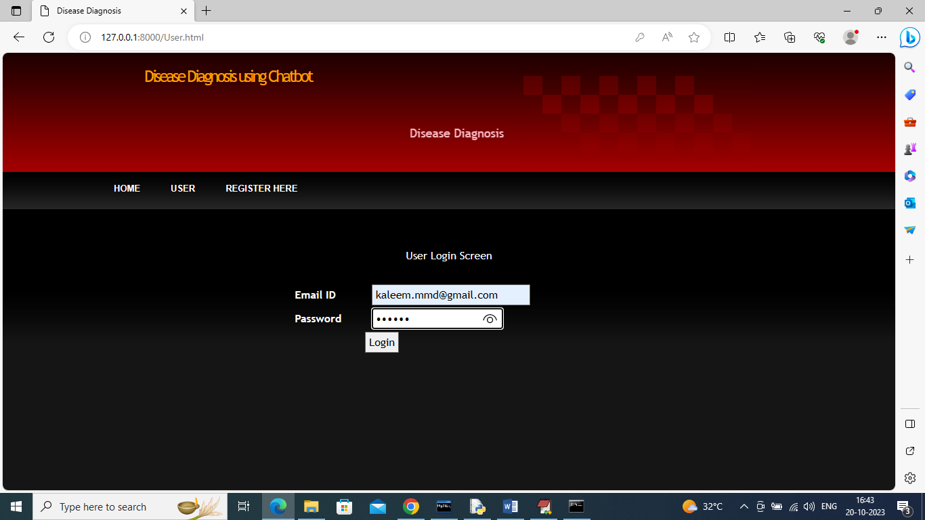

In above screen user is login and after login will get below page

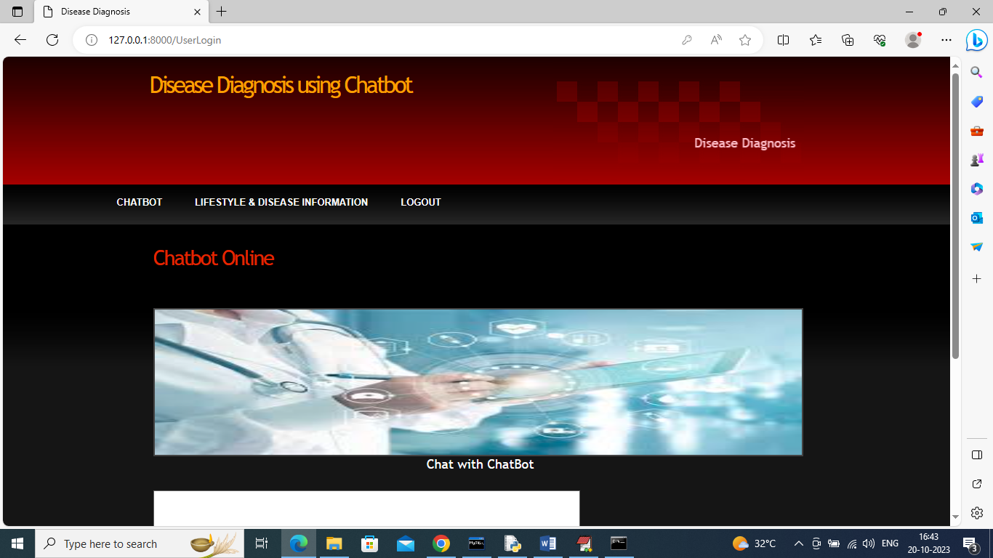

In above screen click on ‘Chatbot’ link to get below page

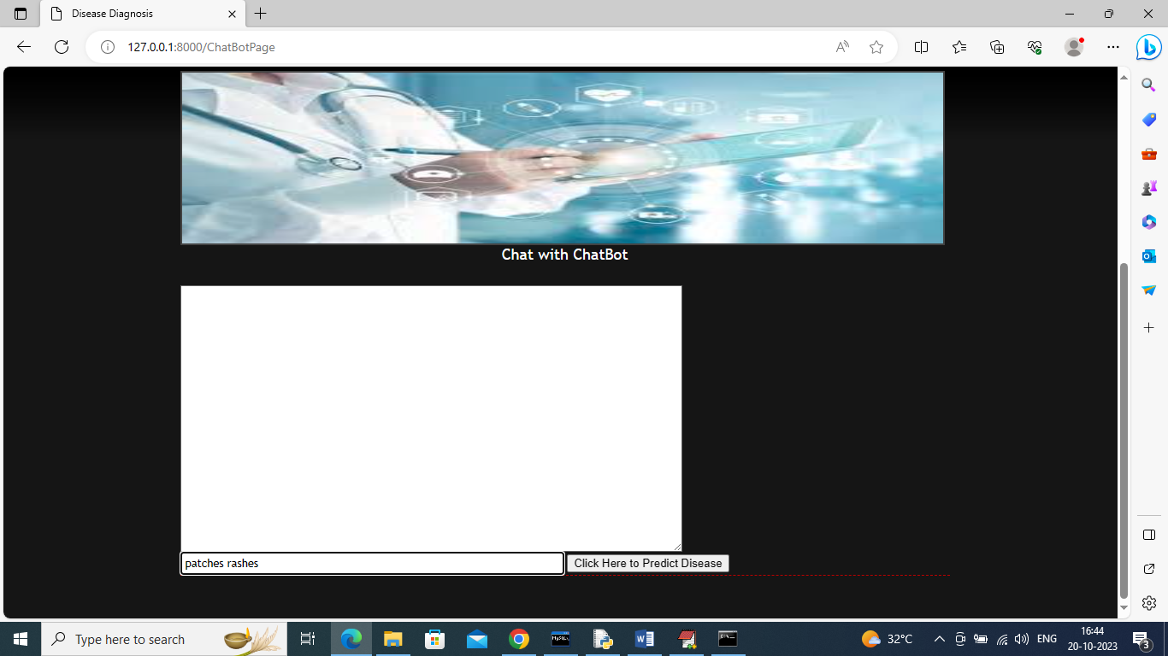

In above Chatbot page just type some symptoms and in above page I gave symptoms as ‘patches rashes’ and then press button to get reply from Chatbot like below screen

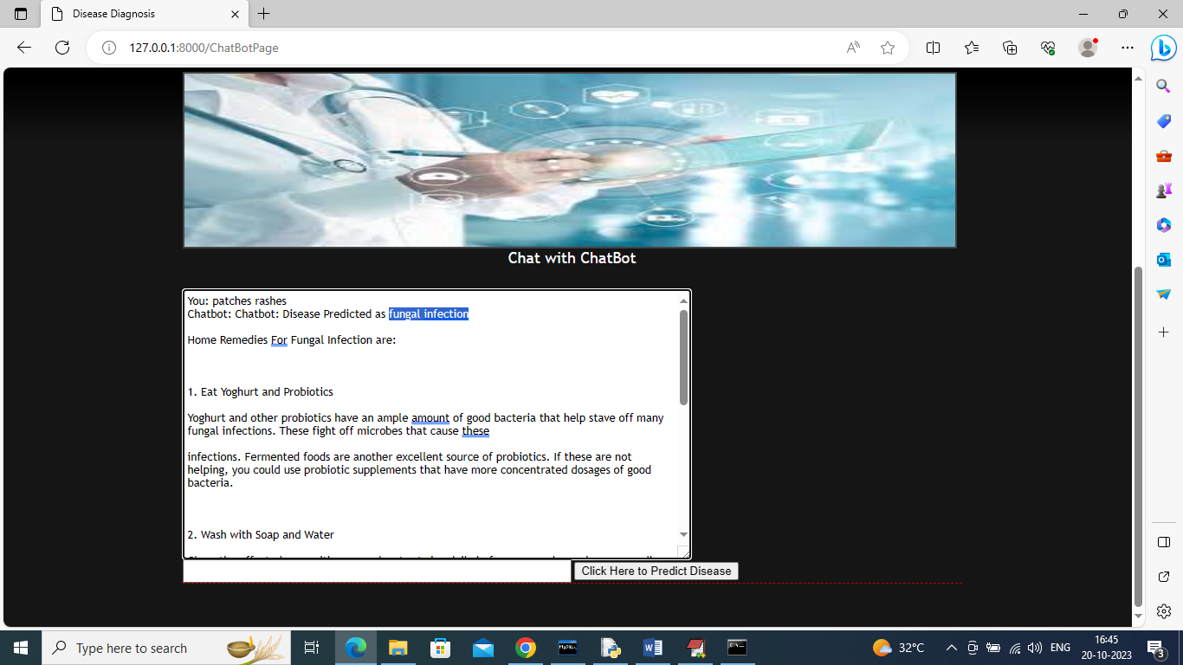

In above screen in blue colour text disease predicted as ‘Fungal Infection’ and then in below lines we can see home remedies along with diet details and scroll down above page to view complete details

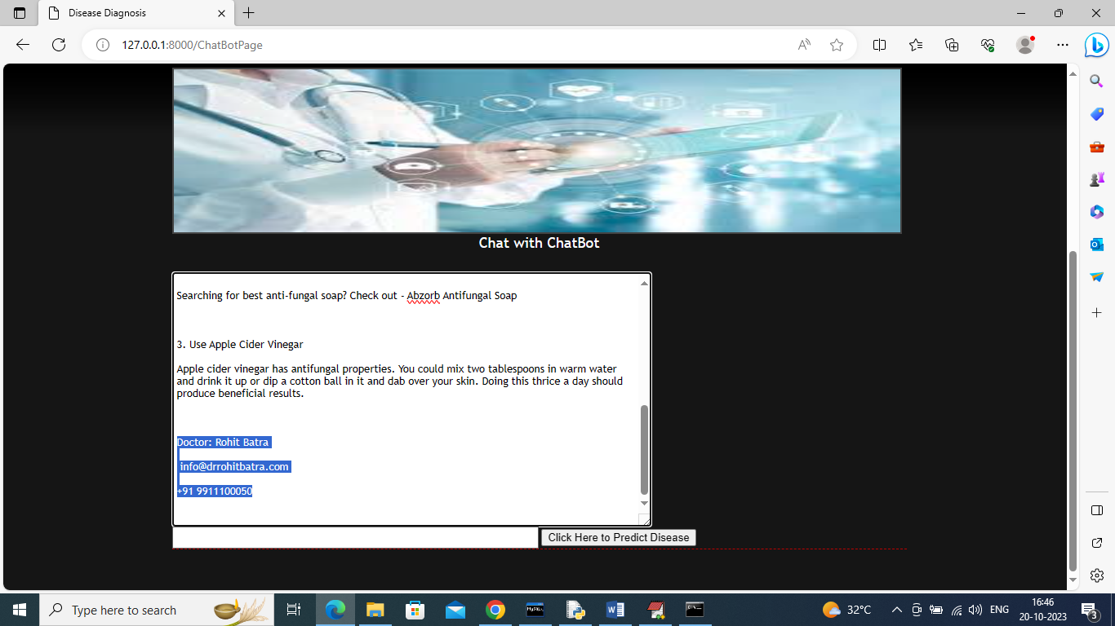

In above screen we can see doctor details and then same information will be sent to mail also like below screen

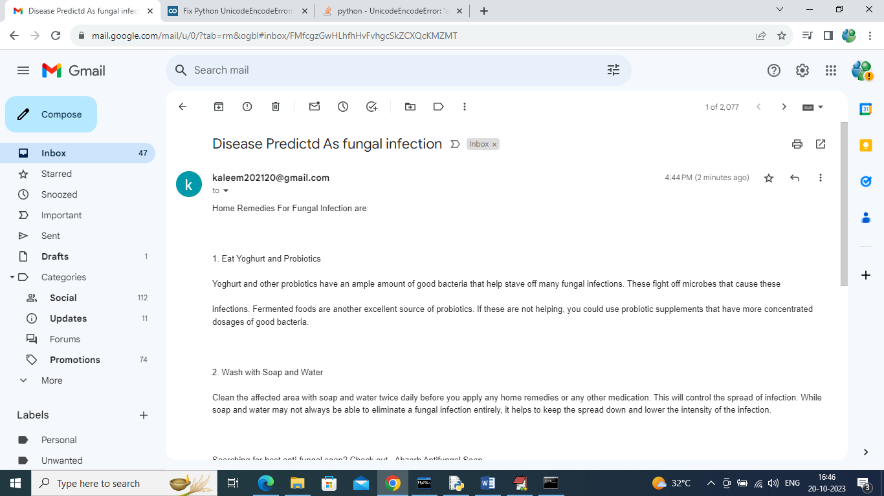

In above email we can see disease details with diet and remedies and similarly you can search for any symptoms and below is another example

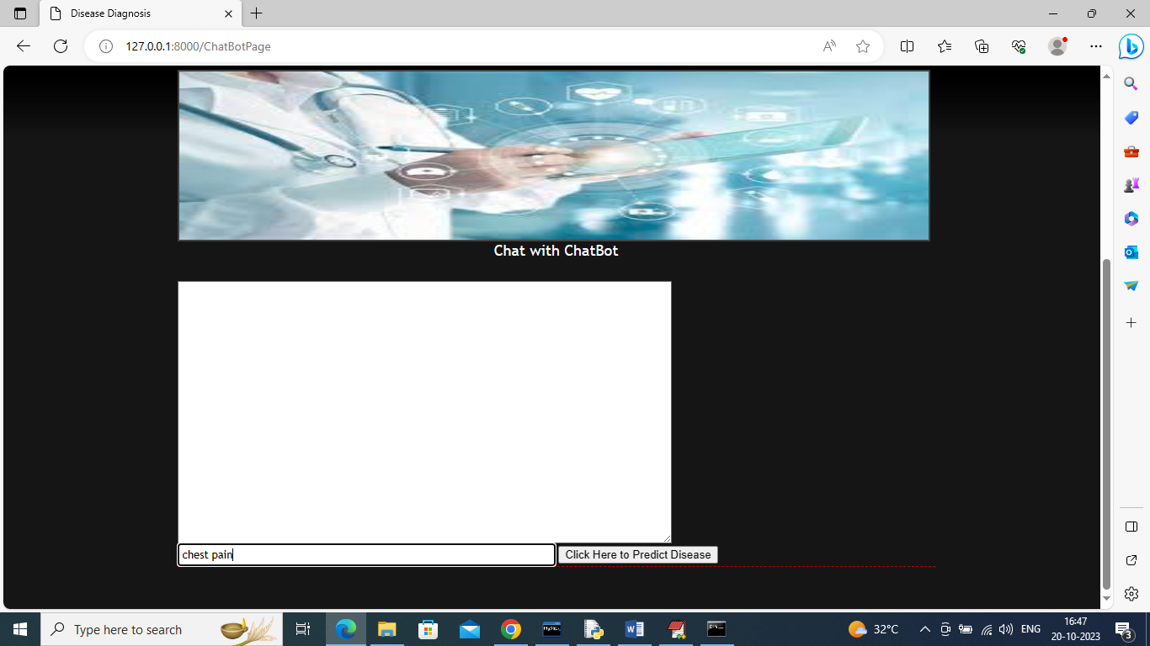

In above screen I gave symptoms as ‘Chest Pain’ and below is the output

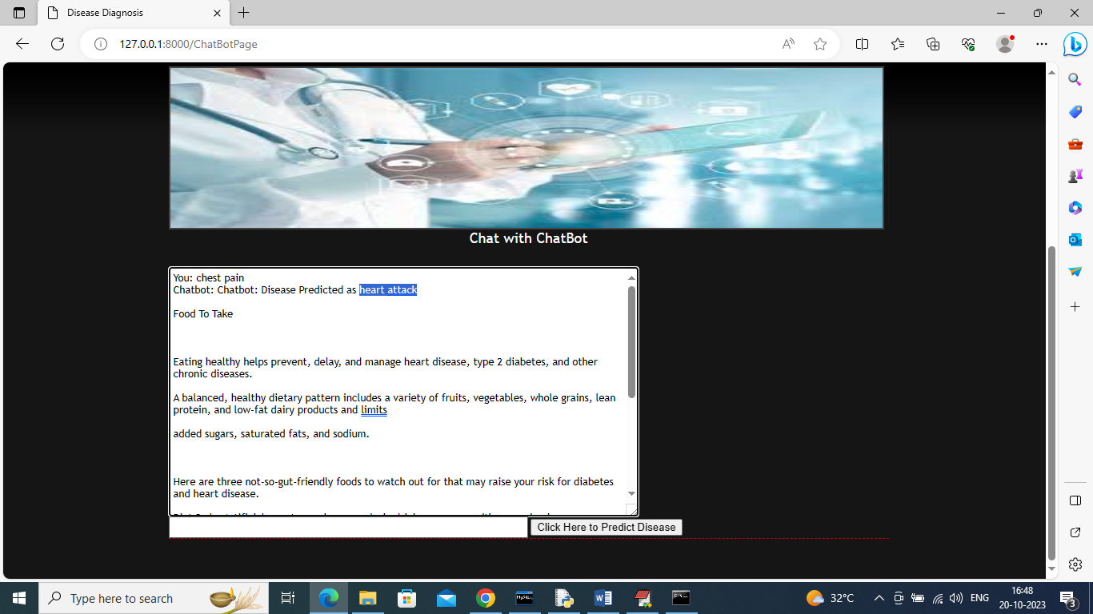

In above screen in blue colour text Chatbot predicted disease as ‘Heart Attack’ for symptom ‘Chest Pain’. Similarly you can search for any symptoms and now click on ‘Lifestyle & Disease Information’ link to view static information about disease

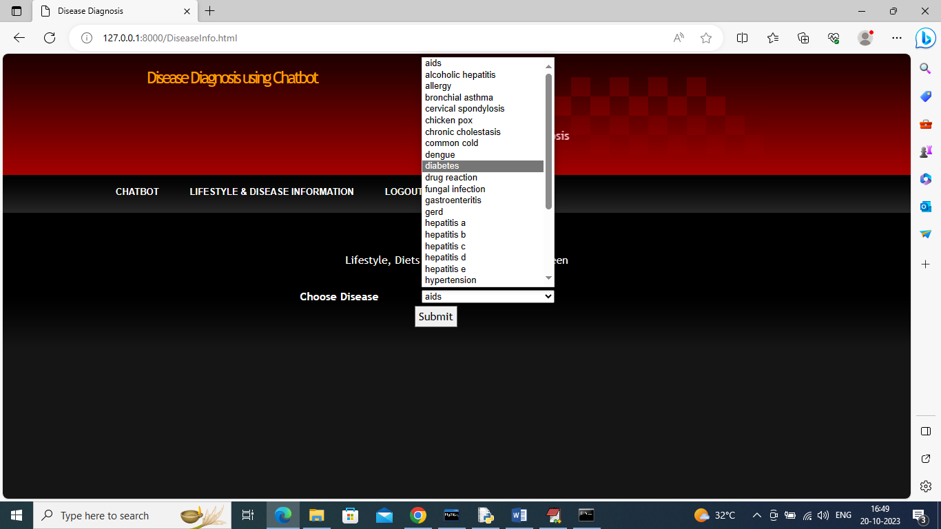

In above screen user can select specific disease and then press button to get disease, diet information like below screen

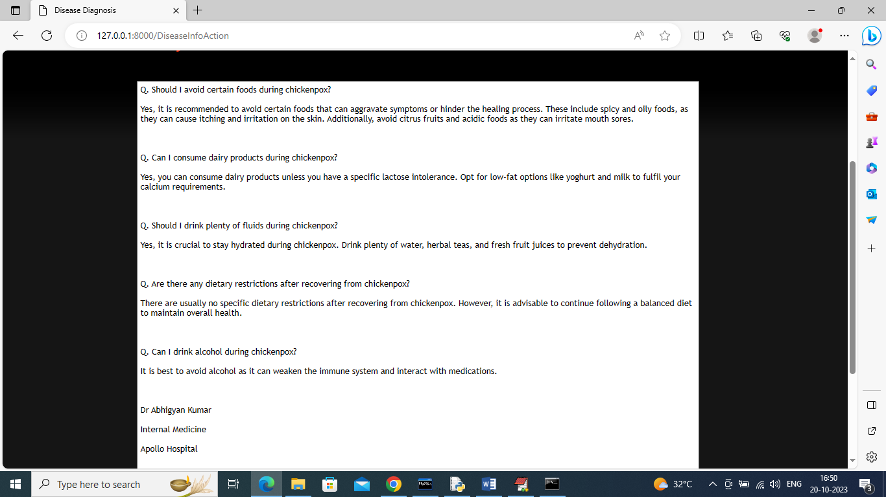

In above screen user can see some answers about selected disease along with doctor details.

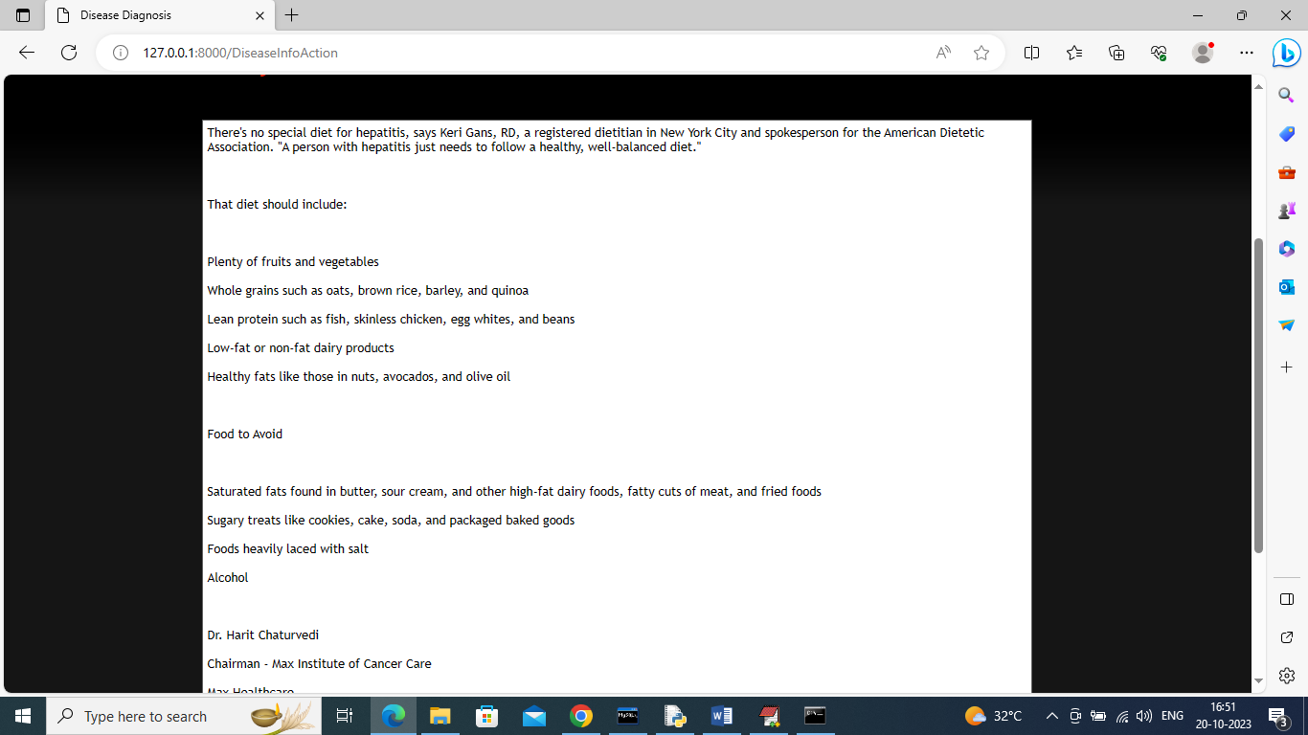

In above screen for some disease we can see information about Food to take and avoid