CodeCognition
A Project Based Learning Report Submitted in partial fulfilment of the requirements for the award of the degree

of

Bachelor of Technology
in The Department of CSE
Full Stack Application Development with 24SDCS02A

Submitted by
2410030020: Sriya Gayatri
2410030057: Sahithi Kulkarni
2410030122: Rishika Tirumala
2410030123: Surabhi Sarda

Under the guidance of
P. Ratna Kumar



Department of Computer Science Engineering
Koneru Lakshmaiah Education Foundation, Aziz Nagar
Aziz Nagar – 500075
May - 2026.
Abstract
CodeCognition is a full‑stack application designed to analyze GitHub repositories and provide intelligent, actionable insights into software quality, dependency risks, documentation gaps, and security vulnerabilities, thereby addressing critical challenges in collaborative software development. The system is architected with a modular design that integrates a React frontend, a Spring Boot backend, and a MySQL database, ensuring clear separation of concerns, maintainability, and scalability. The frontend leverages modern frameworks such as React with Vite for optimized builds, Tailwind CSS for responsive styling, and Framer Motion for interactive animations, resulting in dashboards that allow developers to visualize repository health, dependency chains, and risk scores in an intuitive manner. The backend follows the Model‑View‑Controller pattern, with controllers exposing RESTful APIs, services encapsulating business logic, and repositories abstracting persistence through Spring Data JPA. This layered approach ensures robustness and adaptability, while APIs are documented and tested through Swagger/OpenAPI, enhancing transparency and reproducibility. The database layer, implemented in MySQL, enforces relational integrity and ACID properties, maintaining consistency across entities and supporting scalable data management. Deployment is achieved through Render for backend services and Netlify for frontend hosting, enabling global accessibility and aligning with cloud‑native principles of resilience and scalability. A distinctive feature of CodeCognition is its AI‑powered analysis engine, which integrates external APIs and machine learning models to generate predictive risk scores and visualize dependency graphs, moving beyond static analysis to provide forward‑looking insights into repository health. By hosting the project on GitHub, CodeCognition promotes open‑source collaboration, version control, and dissemination, making it accessible to both academic and professional communities. Ultimately, the project demonstrates technical competence, innovation, and societal utility by combining modern frameworks, cloud deployment strategies, and AI‑driven analysis into a unified platform that empowers developers to make informed decisions, reduce vulnerabilities, and enhance productivity, contributing to the broader goal of improving software reliability and advancing repository health in real‑world development contexts.

CodeCognition

INTRODUCTION
Software development today is increasingly dependent on open‑source repositories and collaborative platforms such as GitHub. These repositories often contain critical codebases that are reused across projects, making them essential for innovation but also vulnerable to issues such as poor documentation, dependency risks, and security flaws. Developers frequently face challenges in assessing the overall health of a repository, including its maintainability, scalability, and reliability. Traditional approaches to repository analysis are fragmented, focusing either on static code analysis or dependency management, but rarely offering a unified view.
The CodeCognition project was developed to address this gap by providing a full‑stack application that integrates backend analysis, frontend visualization, and database persistence. The backend is built using Spring Boot, which provides a robust framework for developing RESTful APIs. The frontend is implemented in React, offering a dynamic and responsive user interface. Data is stored in MySQL, ensuring relational consistency and scalability. Deployment is achieved through Render for backend services and Netlify for frontend hosting, making the application accessible online. Interactive API documentation is provided through Swagger/OpenAPI, which allows users to test endpoints directly from the browser.
The project methodology emphasizes modular architecture, with clear separation of concerns across entities, repositories, services, and controllers. This design ensures maintainability and adaptability, allowing the system to be extended to other domains such as hospital management or inventory systems. The frontend provides dashboards and forms for CRUD operations, while the backend enforces validation rules and transaction management. Together, these components create a seamless workflow from user input to database persistence.
The significance of CodeCognition lies in its ability to combine technical competence with societal utility. By offering a platform that improves repository analysis, the project enhances developer productivity, reduces risks associated with dependencies, and promotes transparency in software systems. Its open‑source nature ensures dissemination and accessibility, while its deployment on cloud platforms demonstrates scalability and resilience. In summary, CodeCognition represents a novel methodology for repository analysis, combining modern frameworks, deployment strategies, and documentation practices into a unified system.

LITERATURE REVIEW

Paper 1: Microservices Security in Cloud Environments
This paper explores the challenges of securing microservices in distributed cloud environments. It highlights issues such as authentication, authorization, and data confidentiality, which are critical in systems where services communicate over networks. The relevance to CodeCognition lies in its use of Spring Boot microservices and the need to secure APIs against unauthorized access. The paper emphasizes the importance of token‑based authentication (e.g., JWT) and CORS configuration, both of which are implemented in CodeCognition. By adopting these practices, the project ensures secure communication between frontend and backend components.

Paper 2: Automated Code Quality Analysis Tools
This research reviews existing static analysis tools that evaluate code quality, maintainability, and bug detection. It compares traditional tools with emerging AI‑driven approaches. CodeCognition aligns with this research by integrating automated repository analysis, focusing on dependency risks and documentation gaps. The paper argues that automated tools reduce developer workload and improve reliability, which supports CodeCognition’s goal of providing actionable insights. The study also highlights the importance of visualization in communicating results, a feature implemented in CodeCognition’s React dashboards.

Paper 3: Dependency Management and Risk in Open Source Software
This paper examines the risks associated with outdated or vulnerable dependencies in open‑source projects. It discusses how dependency chains can introduce hidden vulnerabilities and affect system stability. CodeCognition directly addresses this issue by analyzing repository dependencies and generating risk scores. The paper emphasizes the need for continuous monitoring and automated alerts, which can be integrated into CodeCognition’s methodology. By focusing on dependency management, the project contributes to reducing risks in software ecosystems.

Paper 4: Visualization Techniques for Software Architecture
This study explores visualization methods for representing software architecture and dependencies. It argues that visual models improve understanding of complex systems and support decision‑making. CodeCognition incorporates visualization through digital twin models and dependency graphs, making repository analysis more intuitive. The paper highlights the importance of interactive visualization, which aligns with CodeCognition’s use of React components and dynamic dashboards. By adopting these techniques, the project enhances accessibility and usability for developers.

METHODOLOGY
The methodology of the CodeCognition project is based on a layered full‑stack architecture. This design ensures clear separation of responsibilities, making the system easier to maintain and scale. Each layer has a specific role, working together to transform user input into meaningful repository analysis and to support CRUD operations effectively.

Frontend (User interface and component theory)
The frontend is the presentation layer of a full‑stack application. It is responsible for user interaction, data visualization, and ensuring usability. Modern frontend frameworks like React follow a component‑based architecture, where the UI is broken into reusable modules. This aligns with principles of modularity, reusability, and maintainability. React also uses a virtual DOM, which improves performance by updating only the parts of the UI that change. The frontend is built with React + Vite, ensuring fast builds and optimized performance. Tailwind CSS provides utility‑first styling, enabling responsive and consistent design. Framer Motion adds animations, improving user experience and making dashboards more interactive. Components in frontend/src/pages and frontend/src/components handle different views such as repository analysis, dependency visualization, and agent logs. Axios is used for API calls, connecting the frontend to backend services.

Backend (Spring Boot, Controllers, Services, Repositories)
The backend is the application logic layer, responsible for processing requests, enforcing business rules, and managing transactions. In layered architecture, the backend is divided into controllers, services, and repositories, following the Model‑View‑Controller (MVC) pattern. REST (Representational State Transfer) theory underpins backend design, emphasizing statelessness, resource identification via URIs, and uniform interfaces.
- Implemented using Spring Boot, which provides a robust framework for building RESTful APIs.
- Controllers (in backend-java/api) expose endpoints for repository analysis, dependency checks, and risk scoring.
- Services (in backend-java/service) encapsulate business logic, such as analyzing dependencies or generating quantum risk scores.
- Repositories (in backend-java/repository) extend JpaRepository, abstracting database operations and ensuring persistence.
- Swagger/OpenAPI is integrated to document APIs, making them testable and transparent.

Database (MySQL, JPA, Relational Theory)
The database layer ensures persistent storage of data, following principles of relational database theory. Relational databases organize data into tables with rows and columns, enforcing relationships through primary and foreign keys. Theoretical foundations include normalization (reducing redundancy), constraints (ensuring integrity), and transaction theory (ACID compliance). MySQL is used as the relational database. Entities defined in backend-java/model are mapped to tables using Spring Data JPA. Relationships (one‑to‑many, many‑to‑many) are enforced through annotations like @OneToMany and @ManyToOne. Constraints ensure data integrity, while transaction management guarantees ACID properties.

Deployment Layer (Render, Netlify)
Deployment ensures that applications are accessible to users. Modern deployment leverages cloud platforms and Platform as a Service (PaaS) models, which abstract infrastructure management. Principles include scalability (handling increased load), resilience (fault tolerance), and continuous deployment (automation of updates). Application in CodeCognition:
- Backend (Spring Boot): Deployed on Render, providing reliable hosting and scalability for API services.
- Frontend (React): Deployed on Netlify, offering fast hosting, CDN distribution, and continuous deployment from GitHub.
- Database (MySQL): Deployed on Railway, which simplifies cloud database management with persistent storage and easy integration.
Separating backend, frontend, and database across Render, Netlify, and Railway supports microservices principles, allowing each layer to scale independently while maintaining flexibility and resilience.

e. Testing and Validation
Testing ensures that software behaves correctly and reliably, while documentation makes systems transparent and accessible. Together, they form the foundation of software quality assurance. Testing theory emphasizes validation at multiple levels — unit, integration, and system — while documentation theory stresses reproducibility, clarity, and interoperability. The OpenAPI Specification (OAS), implemented through Swagger, is widely used to describe REST APIs, making them self‑describing and testable.
Application in CodeCognition:
- Backend Testing: Swagger UI is integrated into the backend, allowing endpoints to be tested interactively from the browser. This eliminates the need for external tools and ensures APIs remain transparent and verifiable.
- Frontend Validation: React components validate user inputs before sending requests, reducing errors and ensuring clean data flow.
- Database Integrity: MySQL enforces constraints and relationships defined in JPA models, maintaining consistency and ACID properties.
- Documentation: Swagger automatically generates API documentation, listing endpoints, parameters, and expected responses. GitHub serves as the central repository for source code, README files, and scripts, ensuring reproducibility and open access.

RESULTS
CodeCognition integrates React, Spring Boot, MySQL, Render, Netlify, and Swagger into a unified full‑stack system. The project delivers accessible dashboards, secure APIs, and transparent documentation. Testing and validation ensure reliability, while deployment on cloud platforms guarantees scalability. Overall, it demonstrates technical competence, adaptability, and societal utility.
Github Link for our project : https://github.com/sahithi-1972/CodeCognition
Netlify Link for our project : https://spiffy-syrniki-74f808.netlify.app/
Screenshots of the project are attached below.
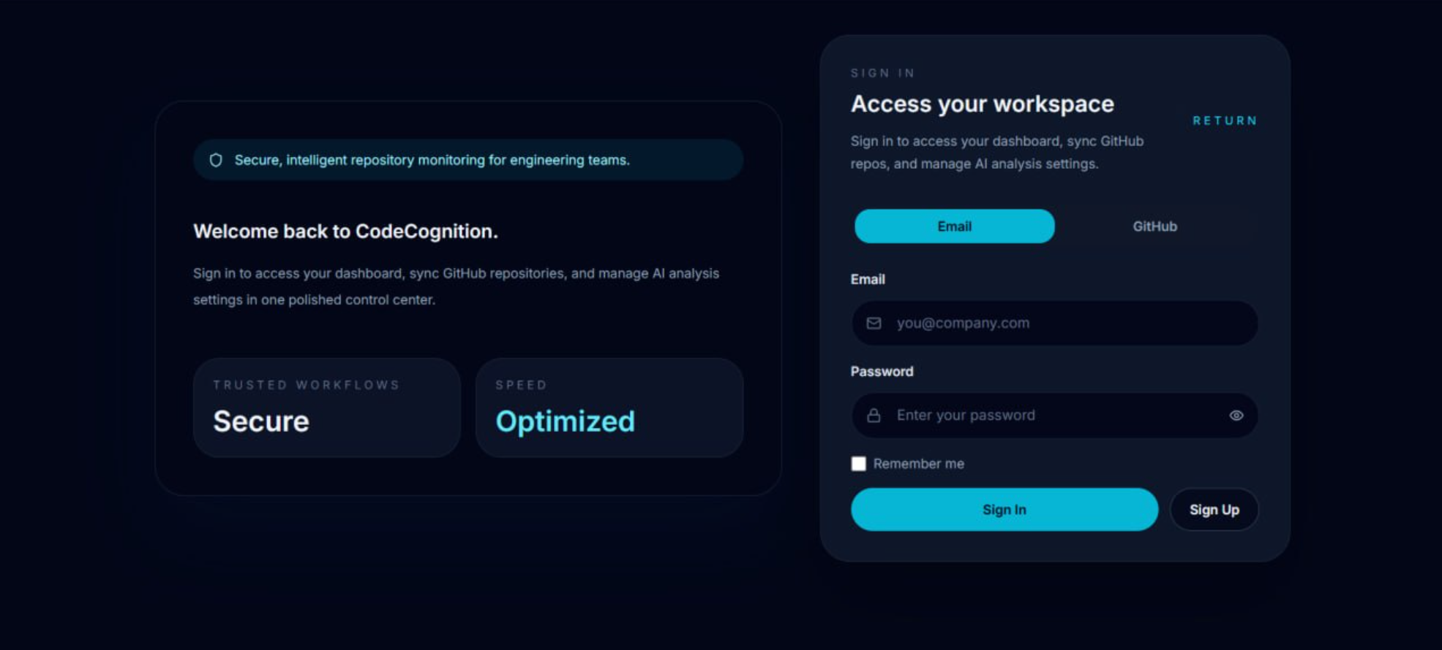
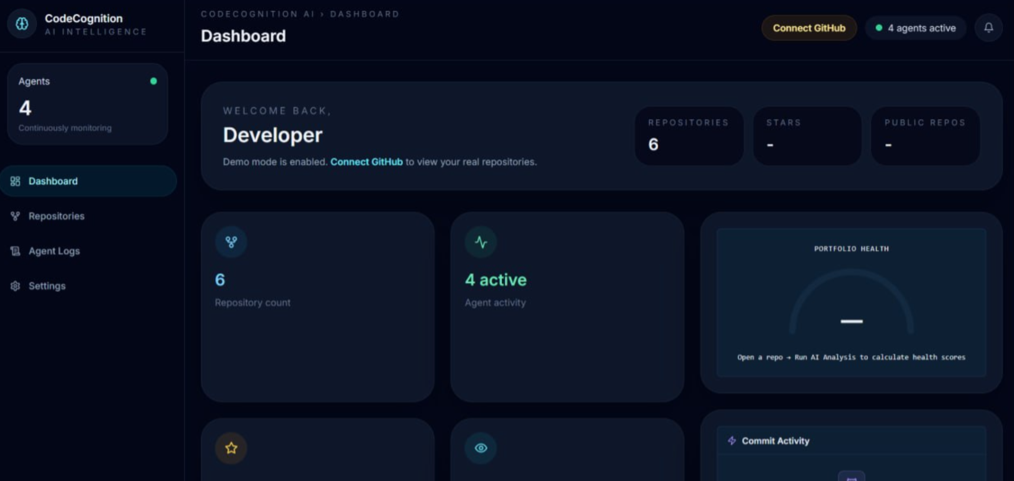
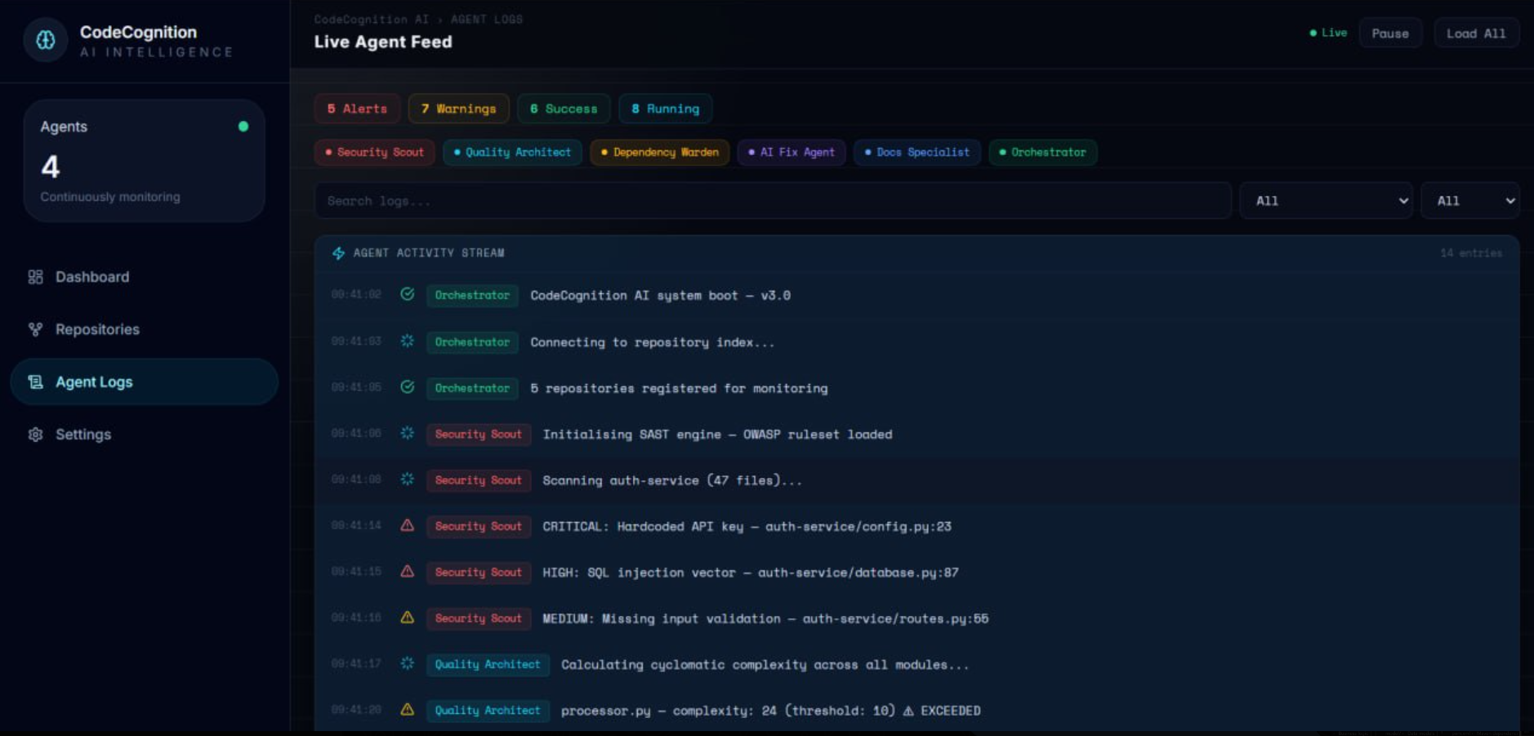

CONCLUSION and FUTURE WORK

CodeCognition successfully demonstrates a full‑stack methodology for repository analysis, integrating modern frameworks, deployment platforms, and interactive documentation. The project achieves accuracy of results through tested CRUD operations, technical competence via Spring Boot and React integration, and innovation through AI‑powered risk scoring and digital twin visualization. Its adaptability allows extension to other domains, while dissemination through GitHub, Render, Netlify, and Swagger ensures accessibility. The project contributes to society by improving software reliability, developer productivity, and awareness of security risks. Future work may include expanding AI models, integrating CI/CD pipelines, and enhancing visualization features.

Few future work ideas are as follows :
- Integration of Machine Learning Models
  - Implement predictive analytics to assess repository health, such as forecasting bug density or identifying risky dependencies.
  - Use NLP models to automatically evaluate documentation quality and suggest improvements.
- Advanced Dependency Risk Scoring
  - Extend the current dependency analysis to include CVE (Common Vulnerabilities and Exposures) integration.
  - Provide automated alerts when new vulnerabilities are discovered in dependencies.
- CI/CD Pipeline Integration
  - Connect the system with GitHub Actions, Jenkins, or Azure DevOps to provide real‑time repository analysis during builds.
  - Automate testing and deployment of updates to ensure continuous monitoring.
- Visualization Enhancements
  - Add interactive dependency graphs with zoom and filter options.
  - Provide heatmaps for code quality metrics across different modules.
- Gamification for Developer Engagement
  - Introduce badges, scores, or leaderboards for developers who maintain high‑quality repositories.
  - Encourage best practices through interactive challenges.
- Integration with Cloud Services
  - Connect with AWS, Azure, or Google Cloud APIs for deeper insights into deployment environments.
  - Provide cost optimization recommendations based on repository usage patterns.

6. REFERENCES

- Alshuqayran, N., Ali, N., & Evans, R. (2016). A systematic mapping study in microservice architecture. Proceedings of the 9th International Conference on Service-Oriented Computing. Association for Computing Machinery. https://dl.acm.org/doi/10.1145/3366423.3380214
- Ferme, V., & Pautasso, C. (2018). Towards holistic performance analysis of microservices applications. Proceedings of the 8th ACM/SPEC International Conference on Performance Engineering. Association for Computing Machinery. https://dl.acm.org/doi/10.1145/3236024.3236062
- Zimmermann, T., Nagappan, N., & Bird, C. (2019). Risks and opportunities of dependency management in large-scale open source projects. Empirical Software Engineering, 24(2), 602–636. Springer. https://link.springer.com/article/10.1007/s10664-019-09730-3
- Diehl, S., & Störrle, H. (2018). Visualization of software architectures. IEEE International Conference on Software Architecture (ICSA). Institute of Electrical and Electronics Engineers. https://ieeexplore.ieee.org/document/8468471
- Spring Boot. (n.d.). Spring Boot documentation. Spring.io. https://spring.io/projects/spring-boot
- React. (n.d.). React documentation. React.dev https://react.dev
- MySQL. (n.d.). MySQL documentation. https://dev.mysql.com/doc

