Viswa Sahithi Kalakonda ( vaultwave.online )

**CMPE-281 Sec 48 - Cloud Technologies Project#1**

**Introduction :**

DropBox is an AWS cloud-hosted web application provides authorized users with a safe environment for managing their files online. It makes it easier to upload, download, update, and delete files from any location. This three-tier application uses a variety of AWS resources to guarantee high availability, scalability, and a reasonably priced way to back up data on Amazon S3 and CloudFront. By employing AWS auto-scaling technology, the application effortlessly manages the load during periods of peak demand. Additionally, it makes use of CloudWatch, AWS Lambda, and SNS to track the health of EC2 instances linked to the auto-scale group.

**Tech Stack :**

Front end- **ReactJS**

File storage - **S3, RDS**

User registration and authentication – **Amplify**

**Website Link :** http://vaultwave.online

**Git Repository :** <https://github.com/sahithi-kalakonda/dropbox/tree/dropbox_v1>

**Architecture Diagram :**

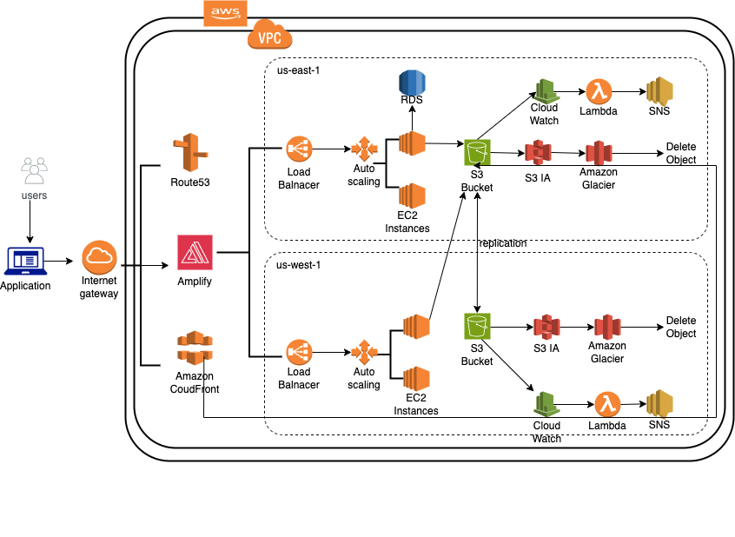

**User Registration :**

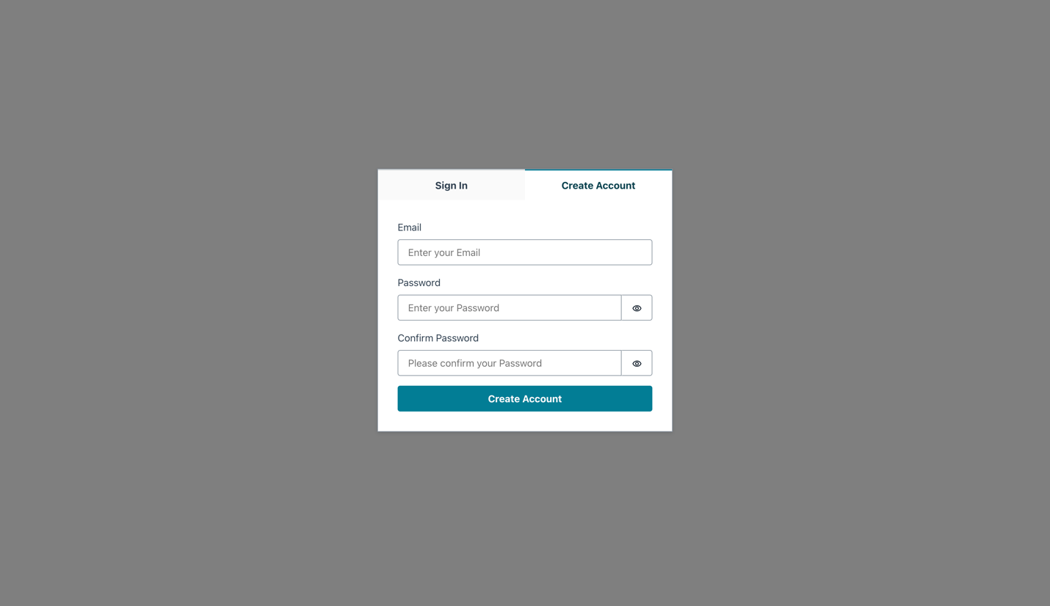

**Custom Login :**

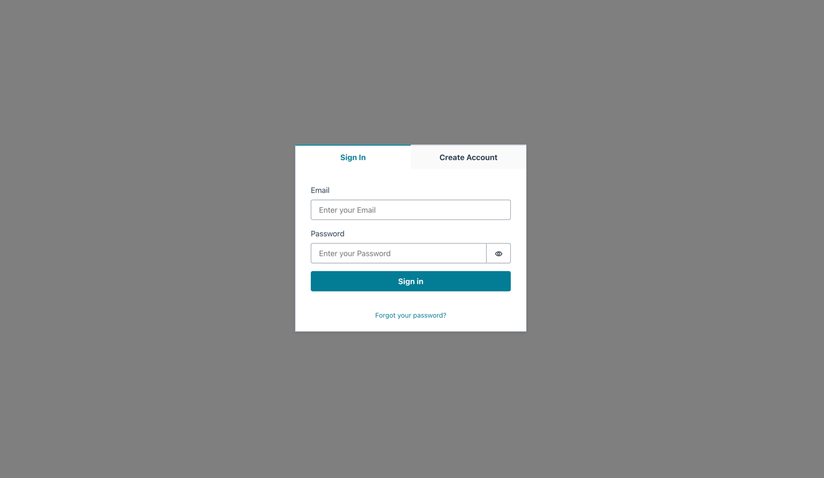

**File Upload :**

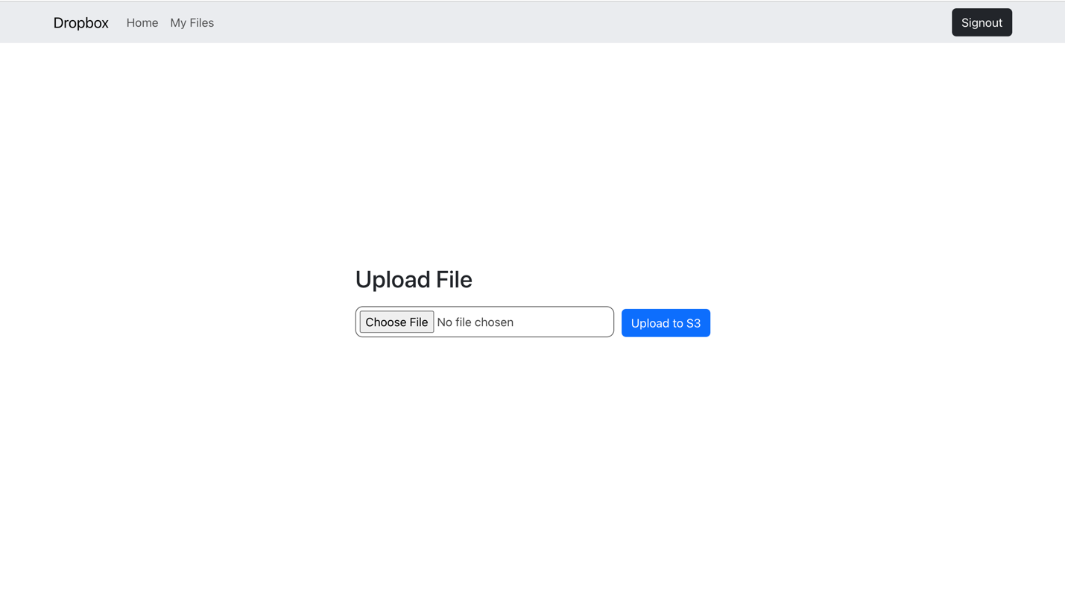

**File Download :**

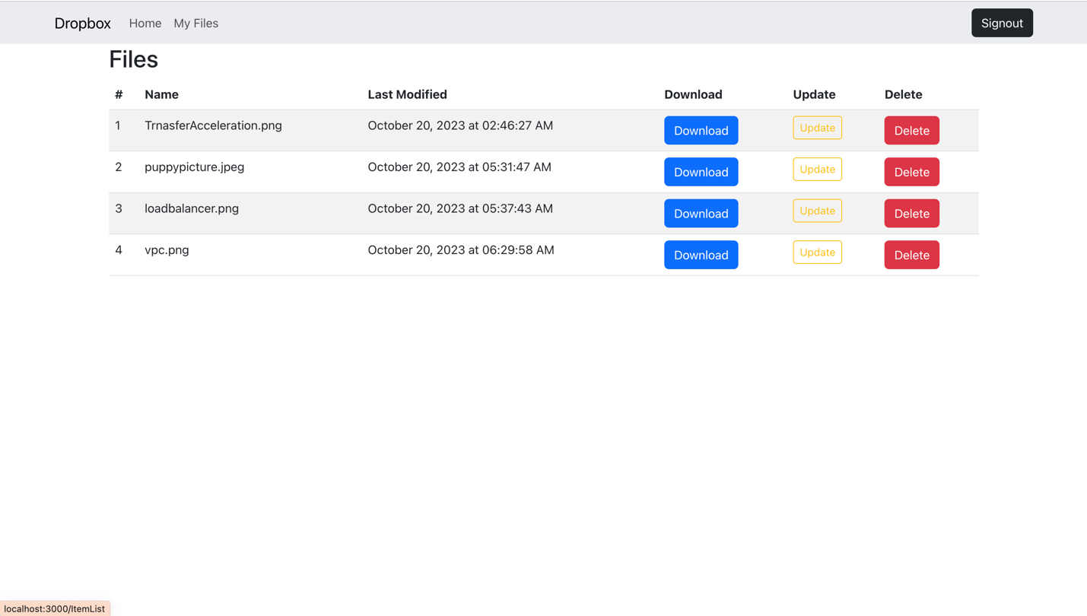

**Admin Panel :**

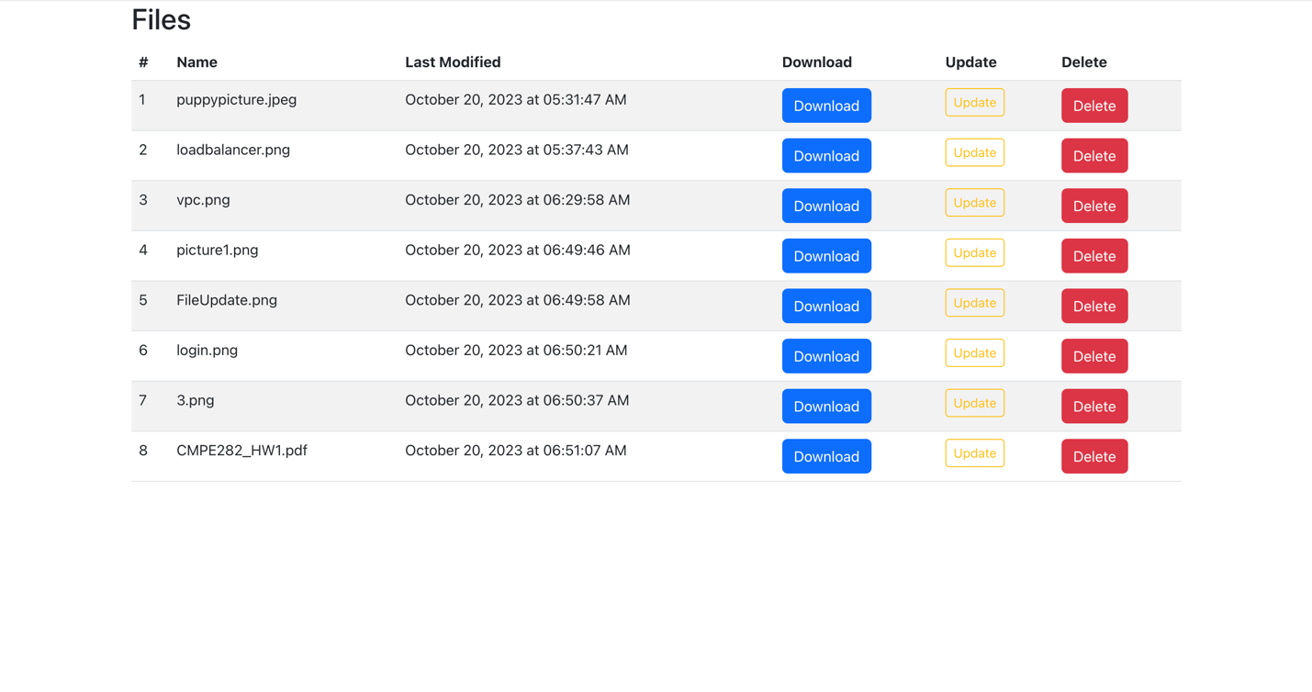

**Database Updates :**

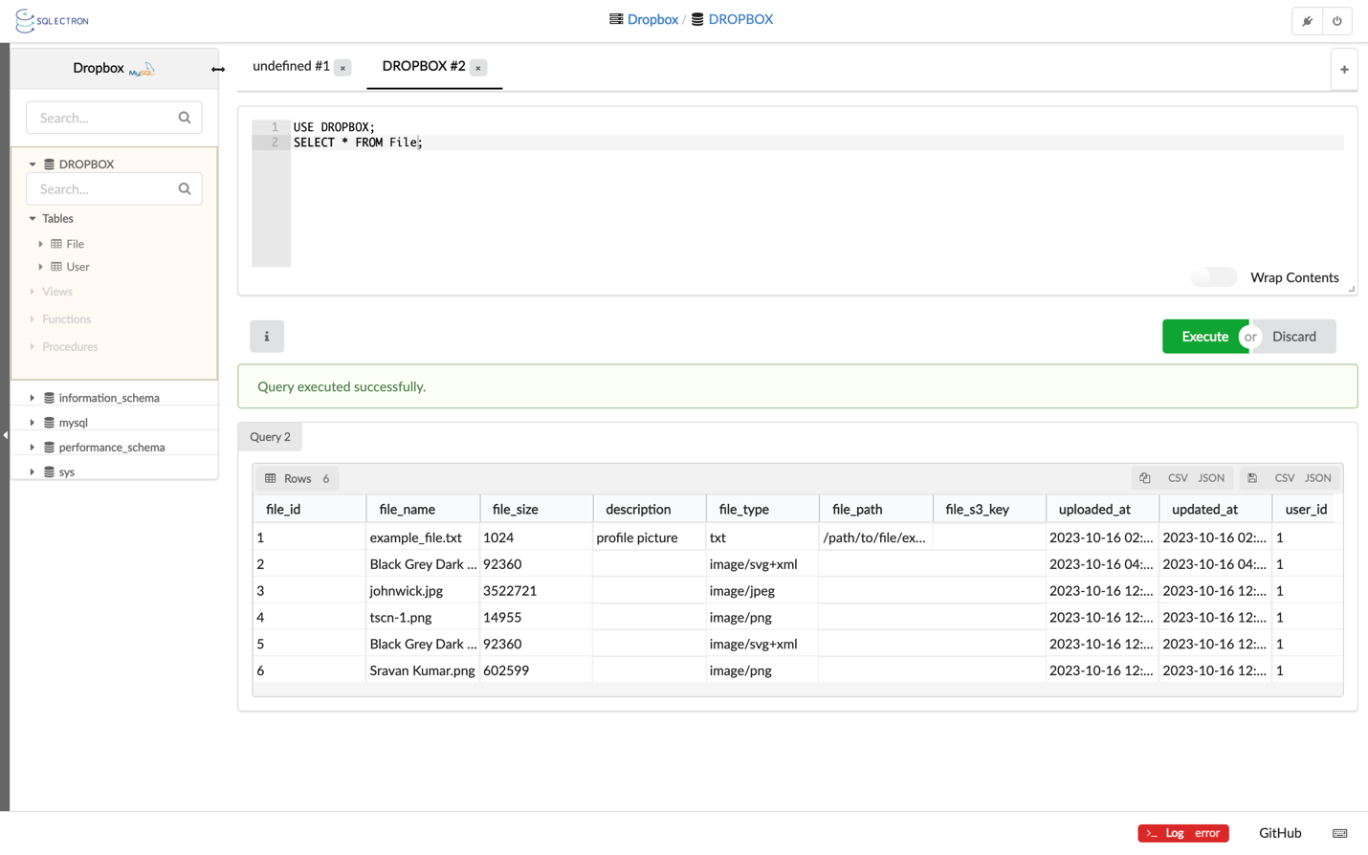

**File Delete :**

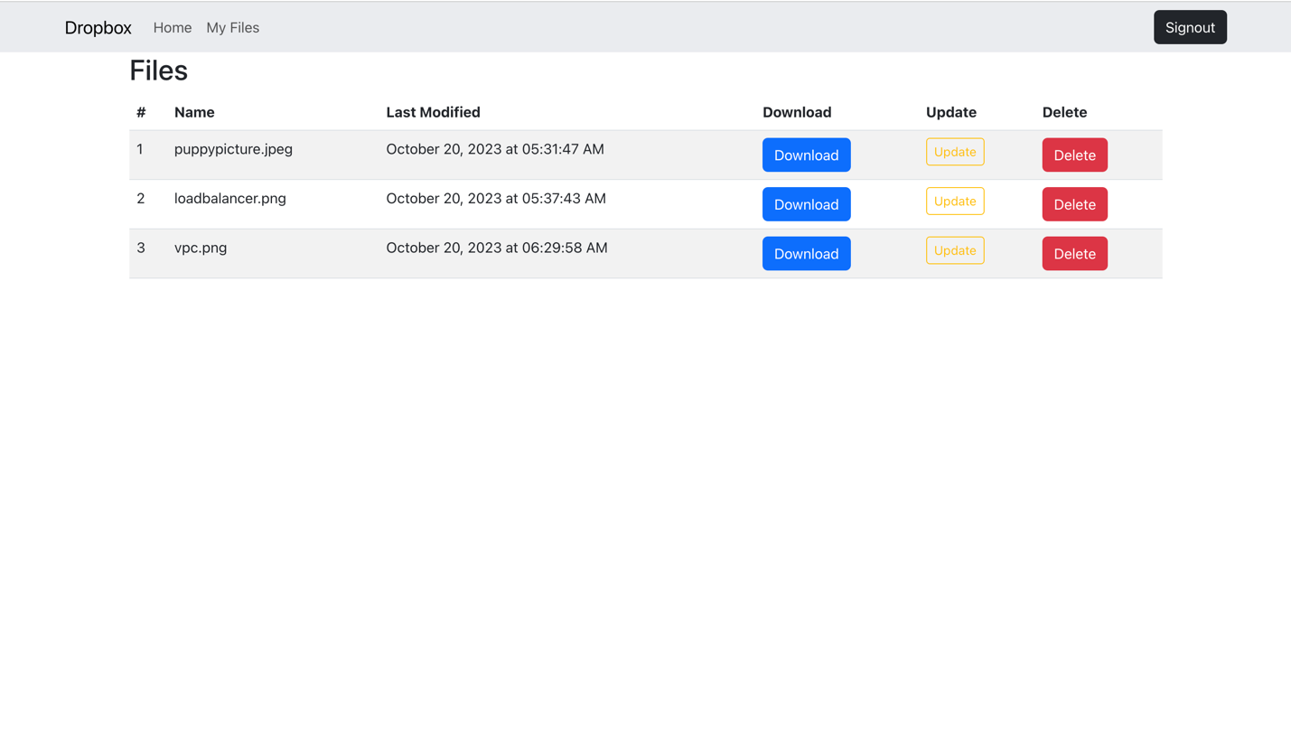

**AWS Amplify:** It is used for authentication.an authentication code will be send while registering for the user.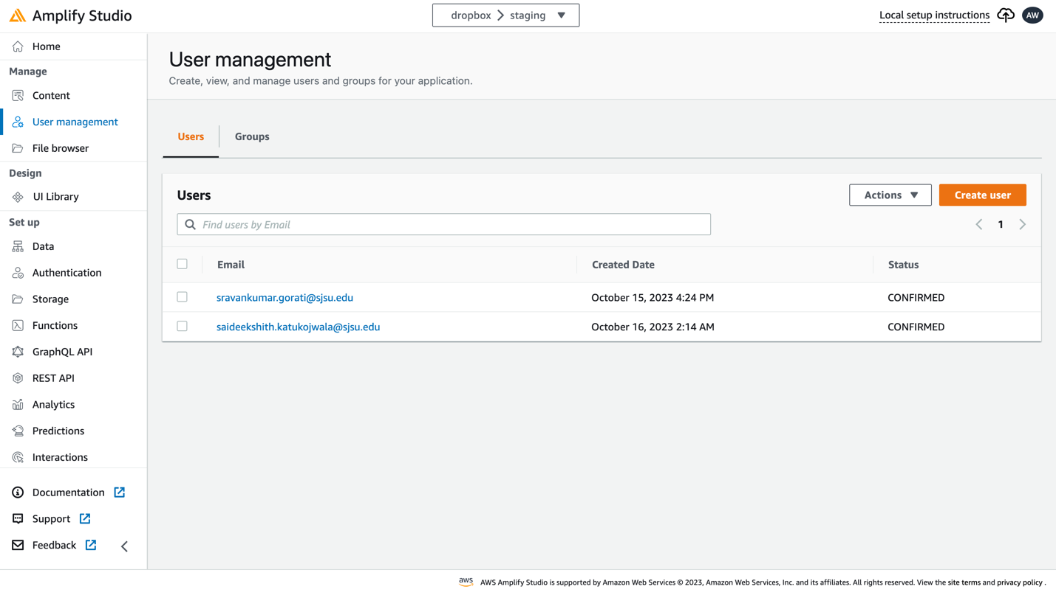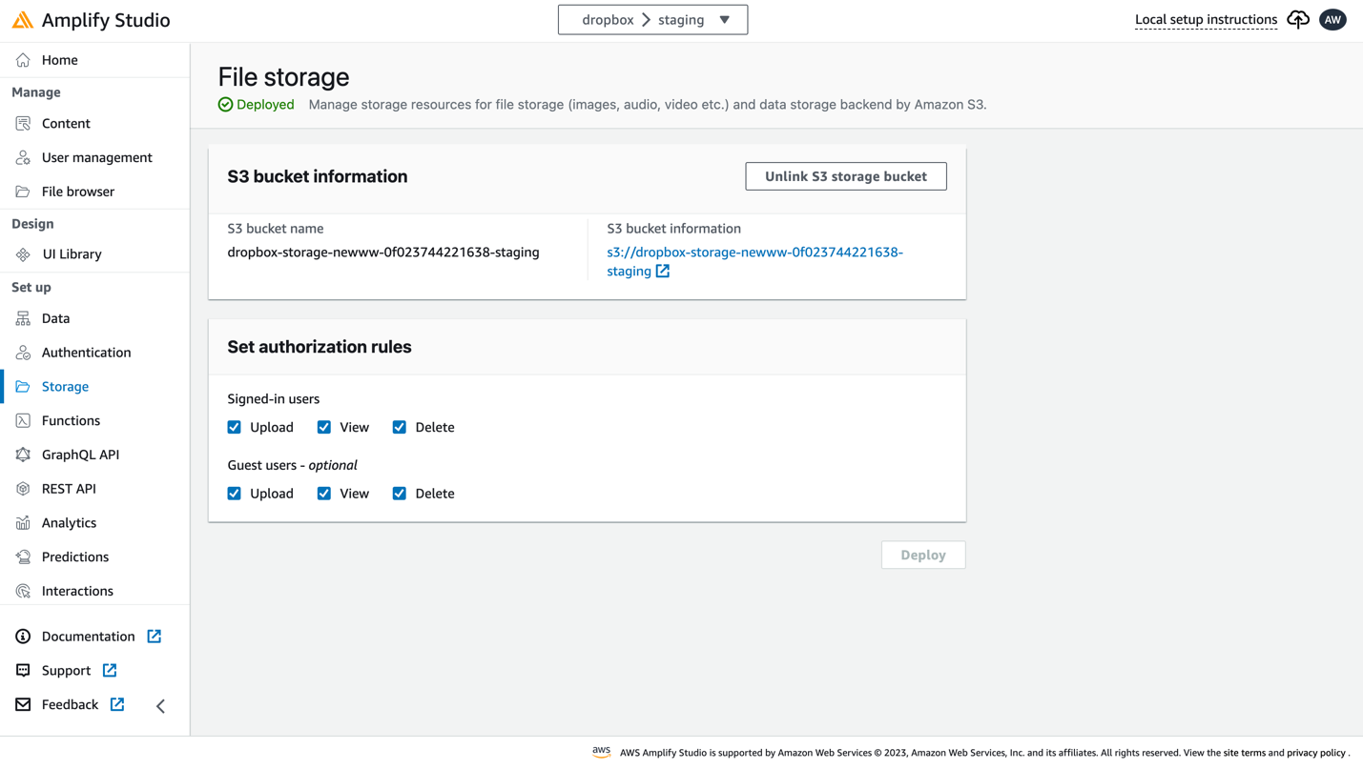

**S3:** S3 is used for the purpose of managing and storing the data, and a lifetime policy is also added to this so that, after 75 days, the files are stored in S3 Infrequent Access, migrated to Glacier after a year, and erased two years later.

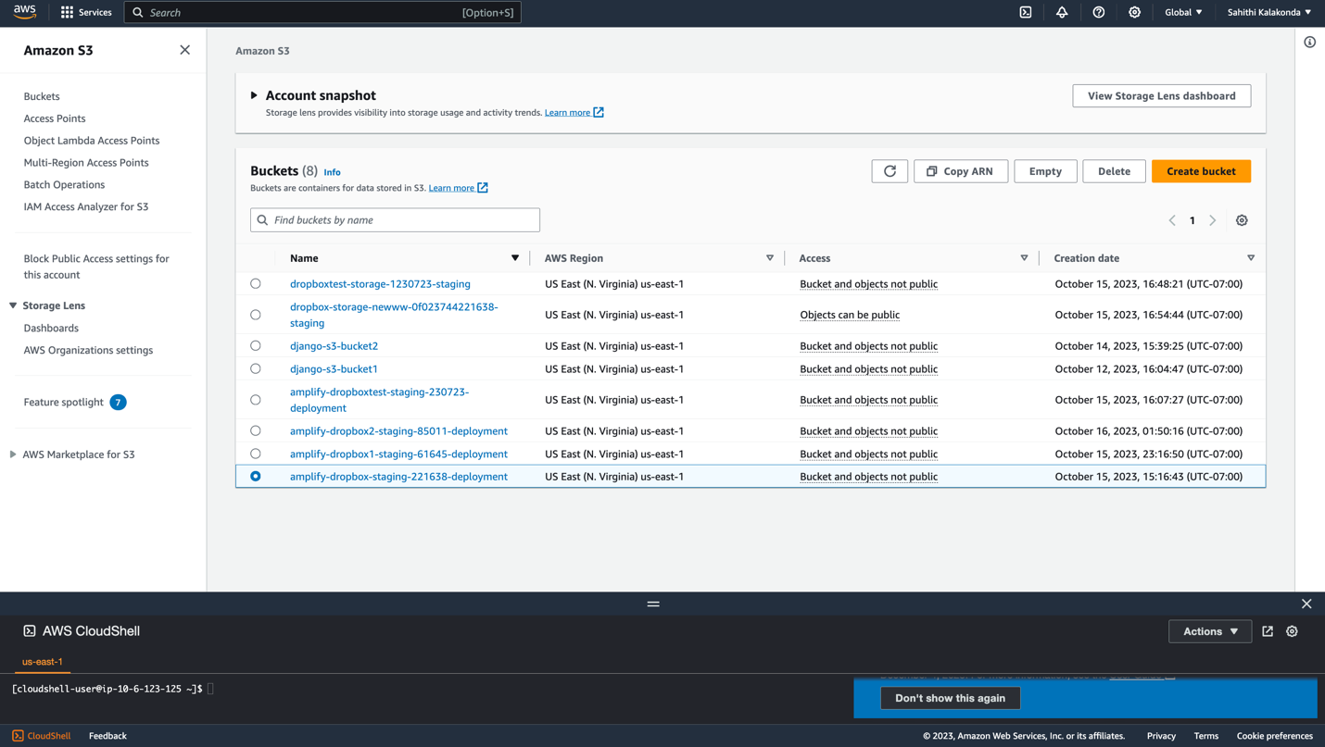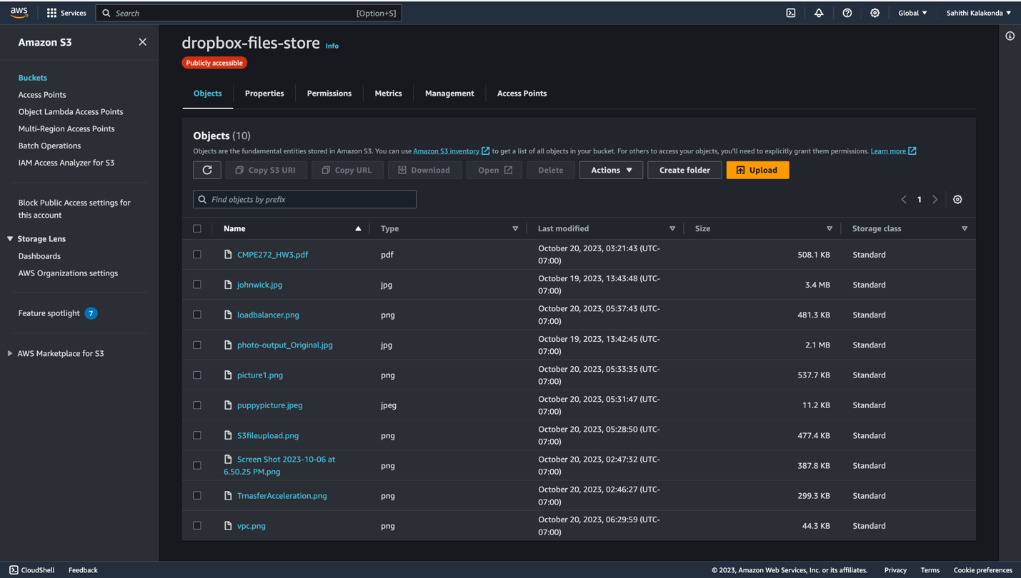

**CloudFront:** Something has been introduced in front of the S3 to enable users to download files more quickly.

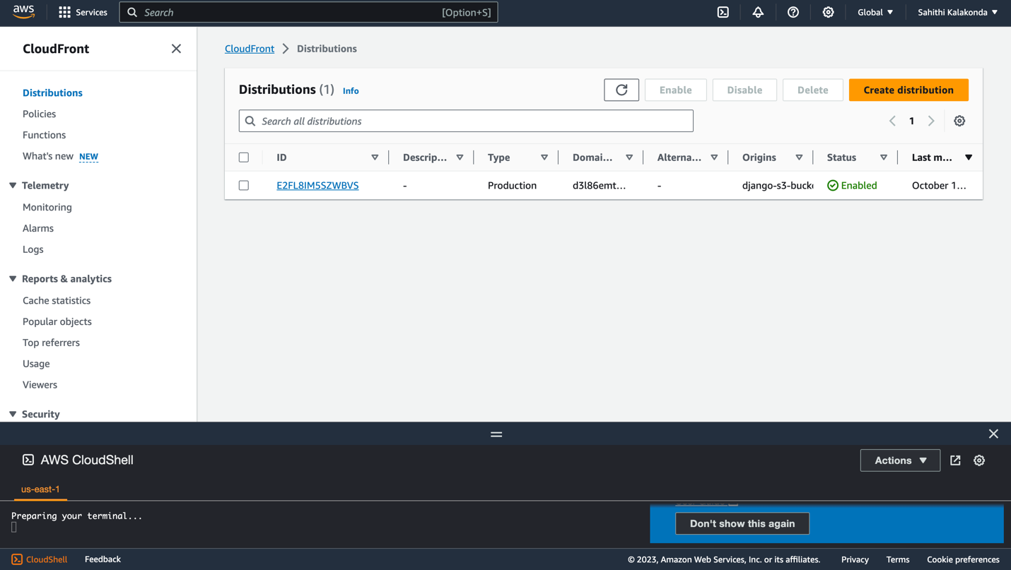

**EC2:** EC2 instance is created to deploy website on AWS.

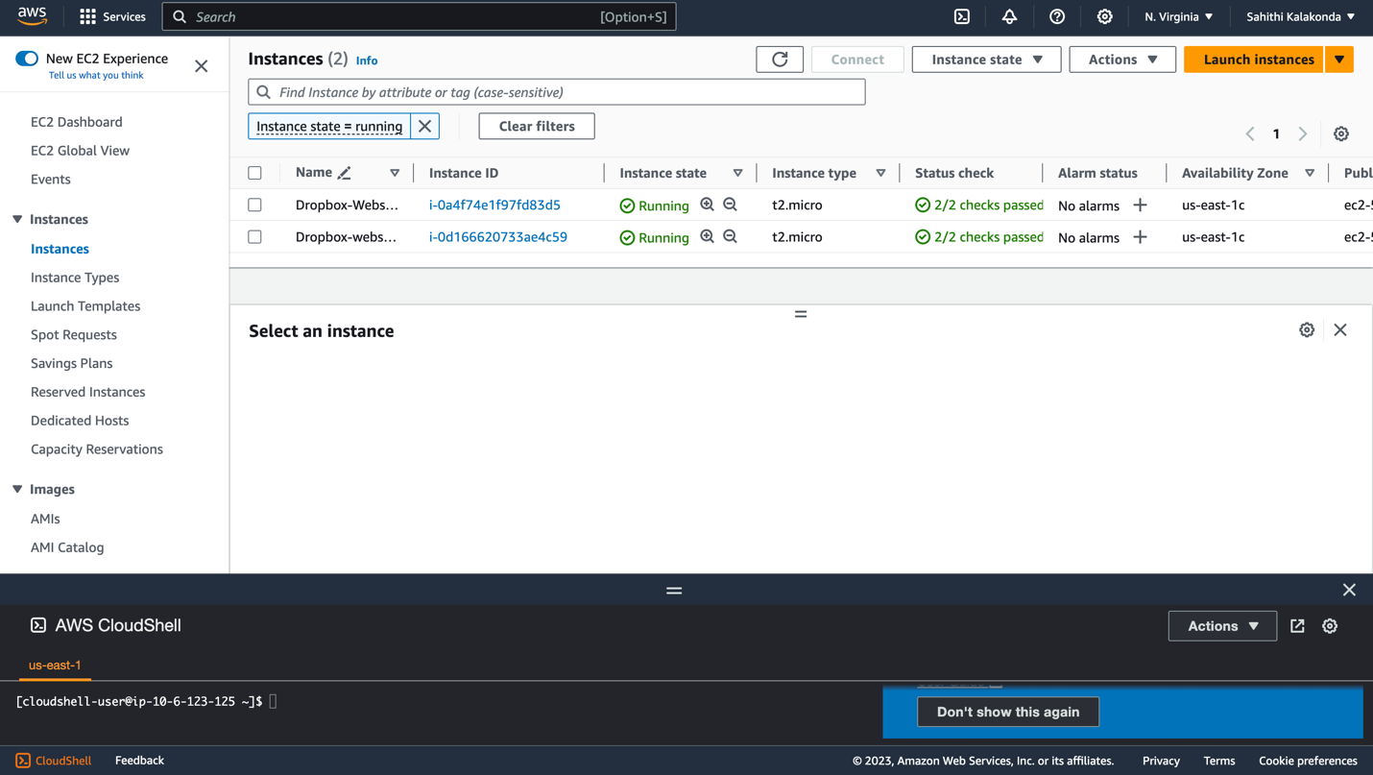

**RDS :** Any new user is registered through RDS, and their files and the timestamp of when they were edited are stored inside the MySQL database.

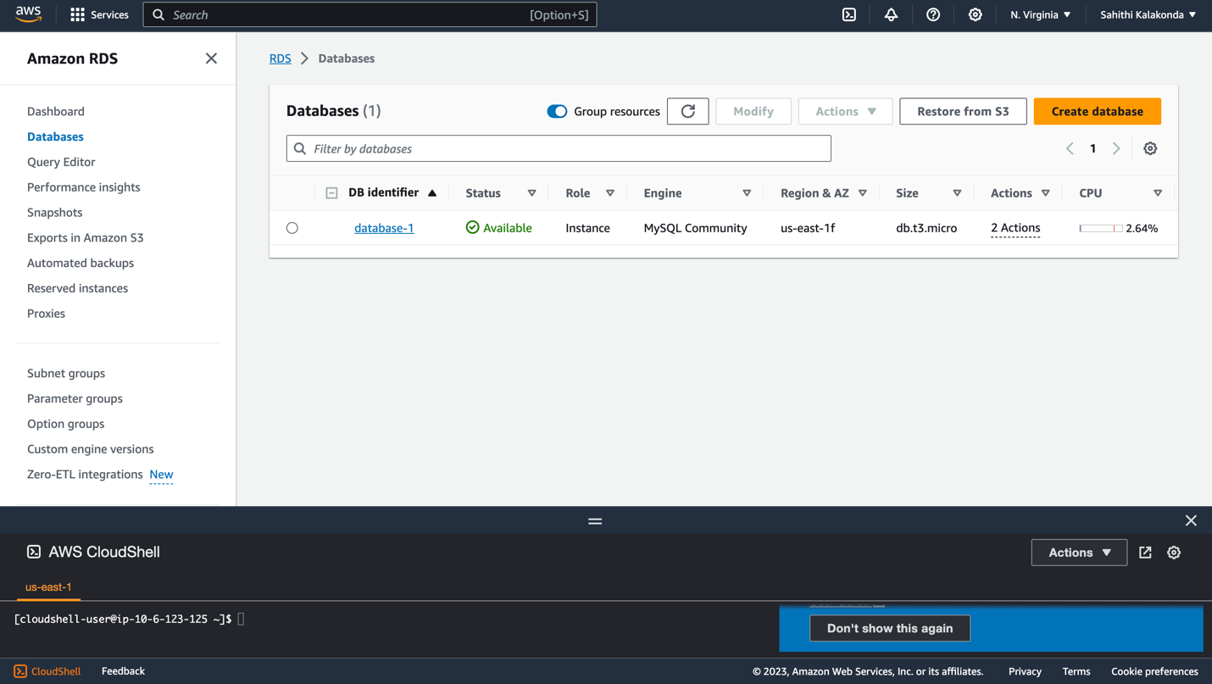

**ELB:** The vaultwave.online is load balanced using an application load balancer.

Auto scaling group - For the instances that include the application, an auto scaling group is configured.

Load balancer in the region - **us-east-1**

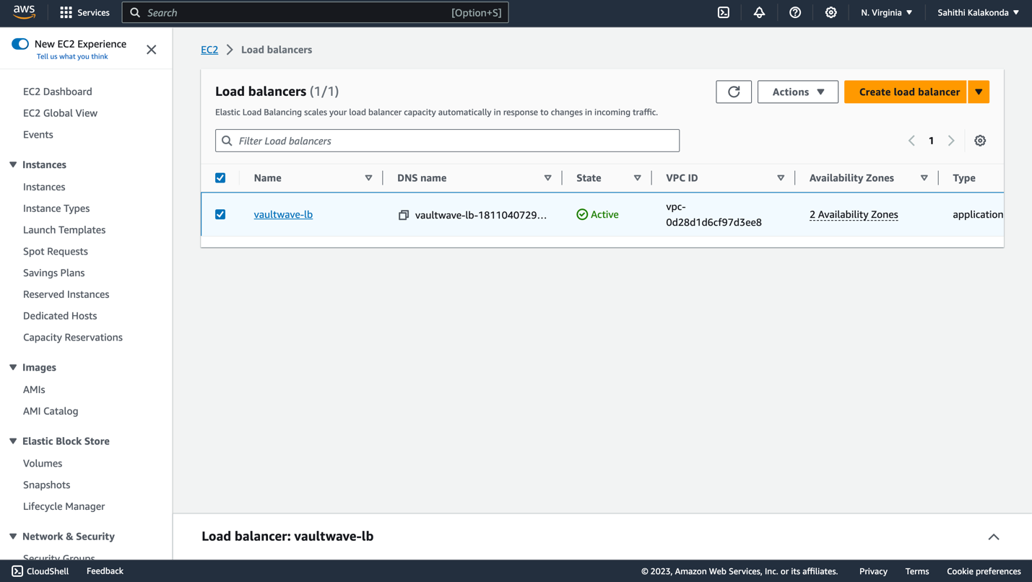

**CloudWatch :** This is configured to send users notifications whenever a new registration is established. This will notify the recipient that the user has signed in.

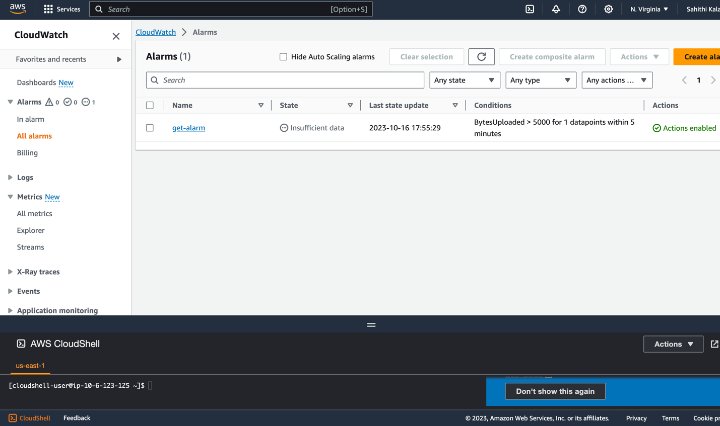

**Admin Panel :** Using the account "admin," we are currently able to enter the admin panel.

Any files published by users may be seen, changed, or deleted by the administrator.

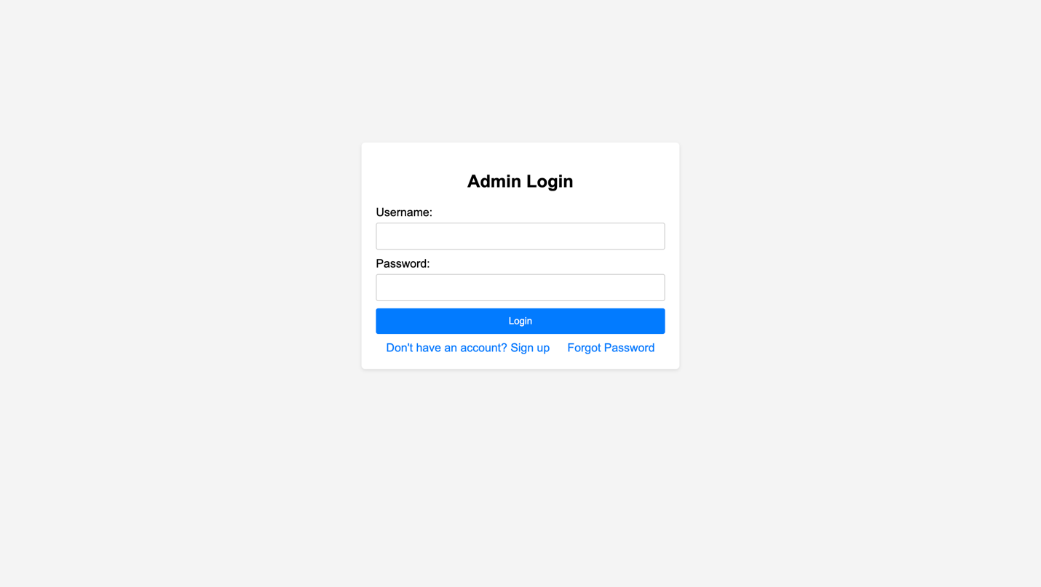

**AWS Cost :**

| **Services Utilized** | **Cost** |
| --- | --- |
| S3 standard | **$0.005 (per 1,000 requests)** |
| EC2 instances( t2 micro) | **$0.0116 (per hour) for 1 instance** |
| Load Balancer | **$0.0225 per hour for 1 LB** |
| RDS | **$14.75 per month** |
| Lambda | **$0.0000166667 for every GB-second** |
| AWS Cognito | **free tier of 50,000 MAUs per account** |
| Route 53 | **$0.50* per health check / month** |
| Domain setup (hostinger) | **$0.99 per year** |
| CloudWatch | **$0.30 per month** |
| SNS | **$2.00 per 100,000 notifications for email** |