**CMPE282: Virtual Technologies**

**Assignment 1 : Discovering VMX Features**

**Sahithi Kalakonda(017478786), Lekhana Gadde(017461236)**

**Contribution of Team Members:**

We distributed the assignment uniformly ensuring that each person contributed by writing two MSR's Linux kernel code. To maintain consistency, we followed a standardized process for setting up, building, and configuring the environment. Throughout the assignment, we collaborated closely to document the procedures we followed.

**Environment Setup :**

1.Created VM instance on Google cloud platform using the command

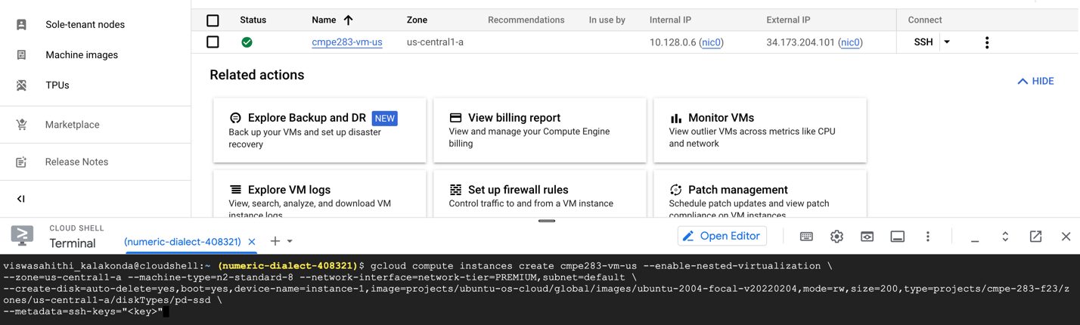

**Build and Development :**

1. CMPE283-1.c and Makefile are downloaded from Canvas.

2. New Directory named ‘linux’ is created which contains the cloned repository

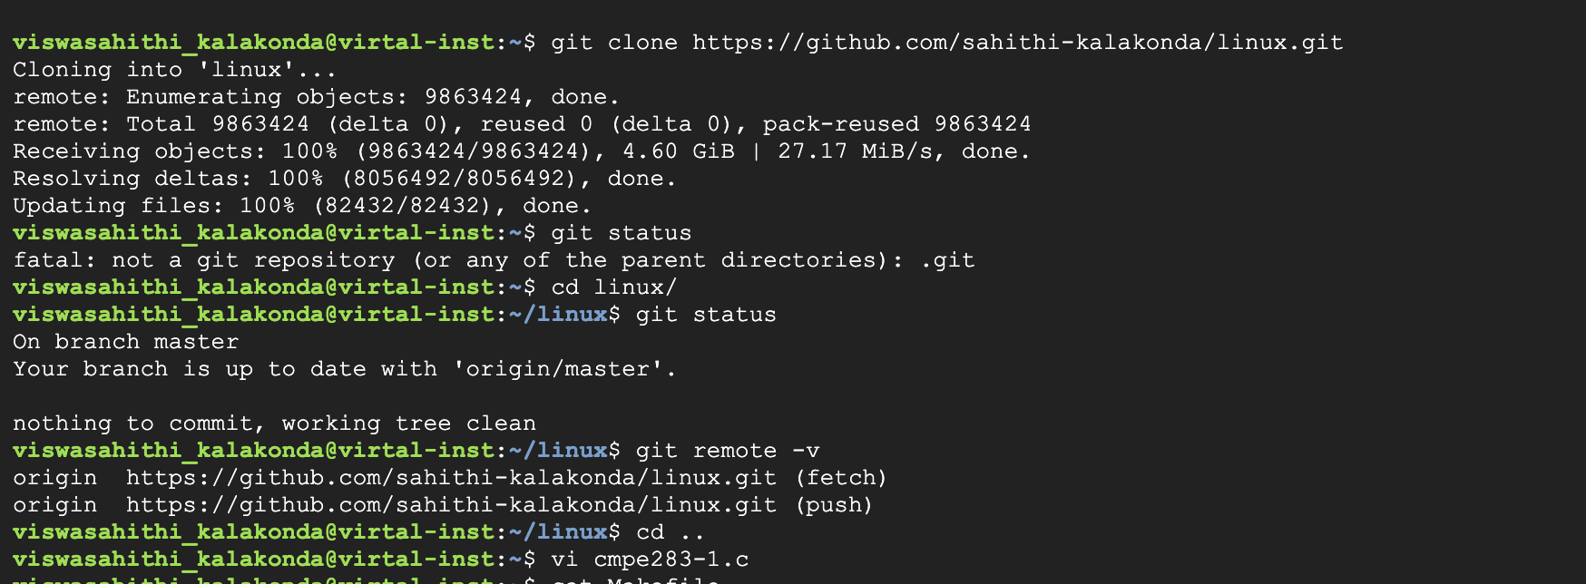

3. Check whether Makefile is uploaded using – “Cat Makefile”

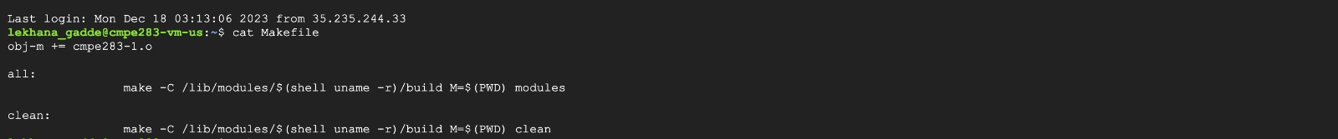

4. Installed all the required libraries -

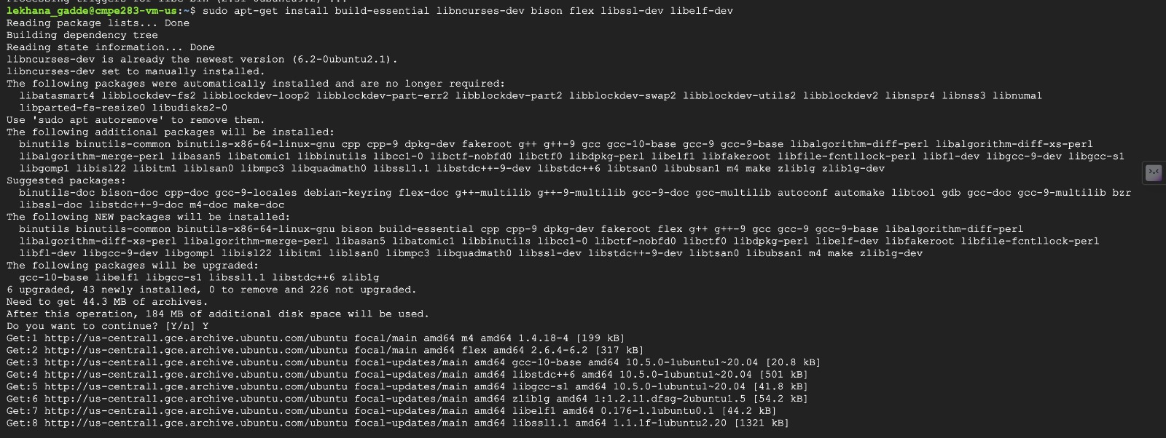

5.Built the file using Make command -

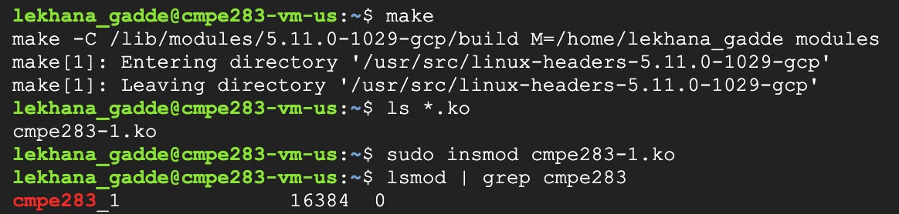

6. After Building the file, check whether cmpe283-1.ko(Kernel Object) file is created -



7. View Kernel related messages using -

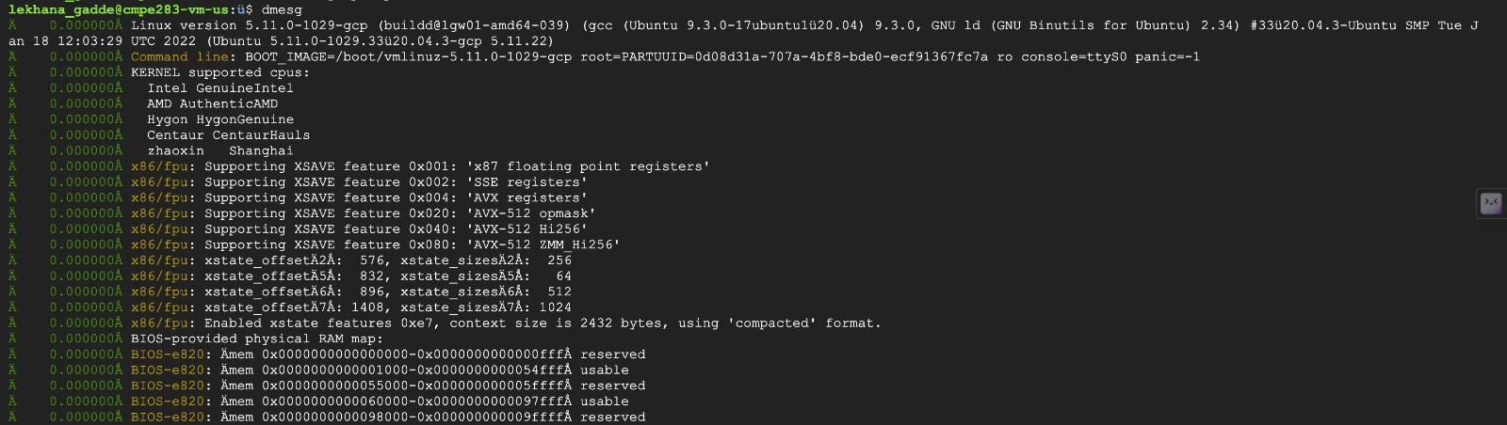

8.Inserted the above built Kernel module cmpe283-1.ko into the running kernel using

sudo insmod cmpe283.ko

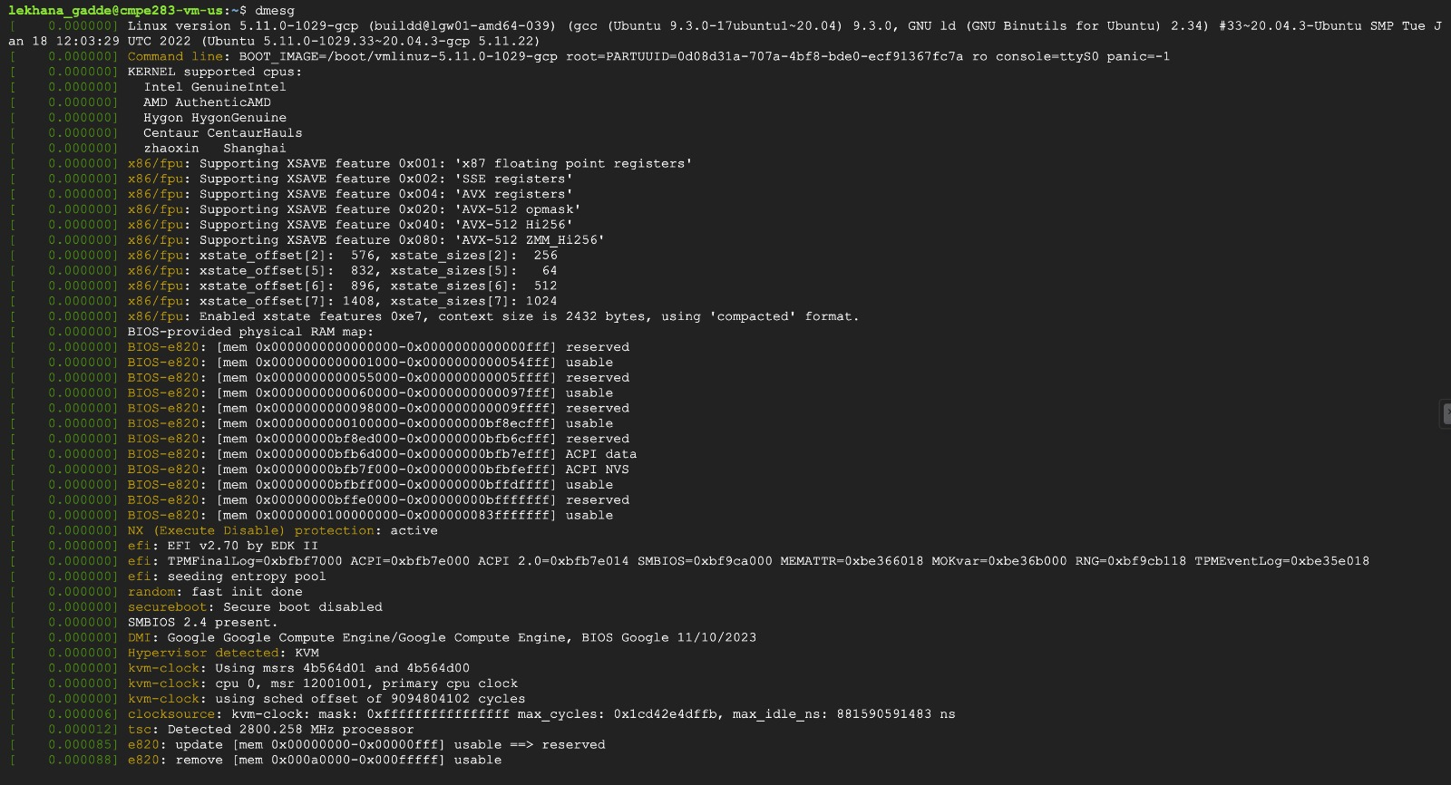

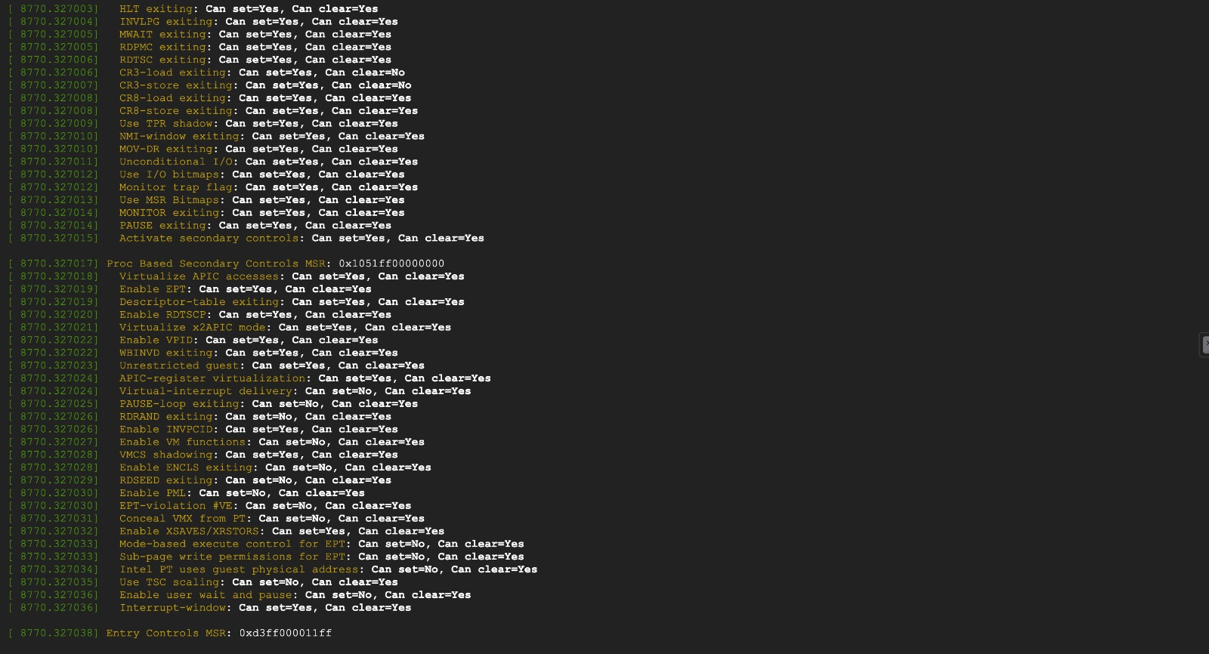

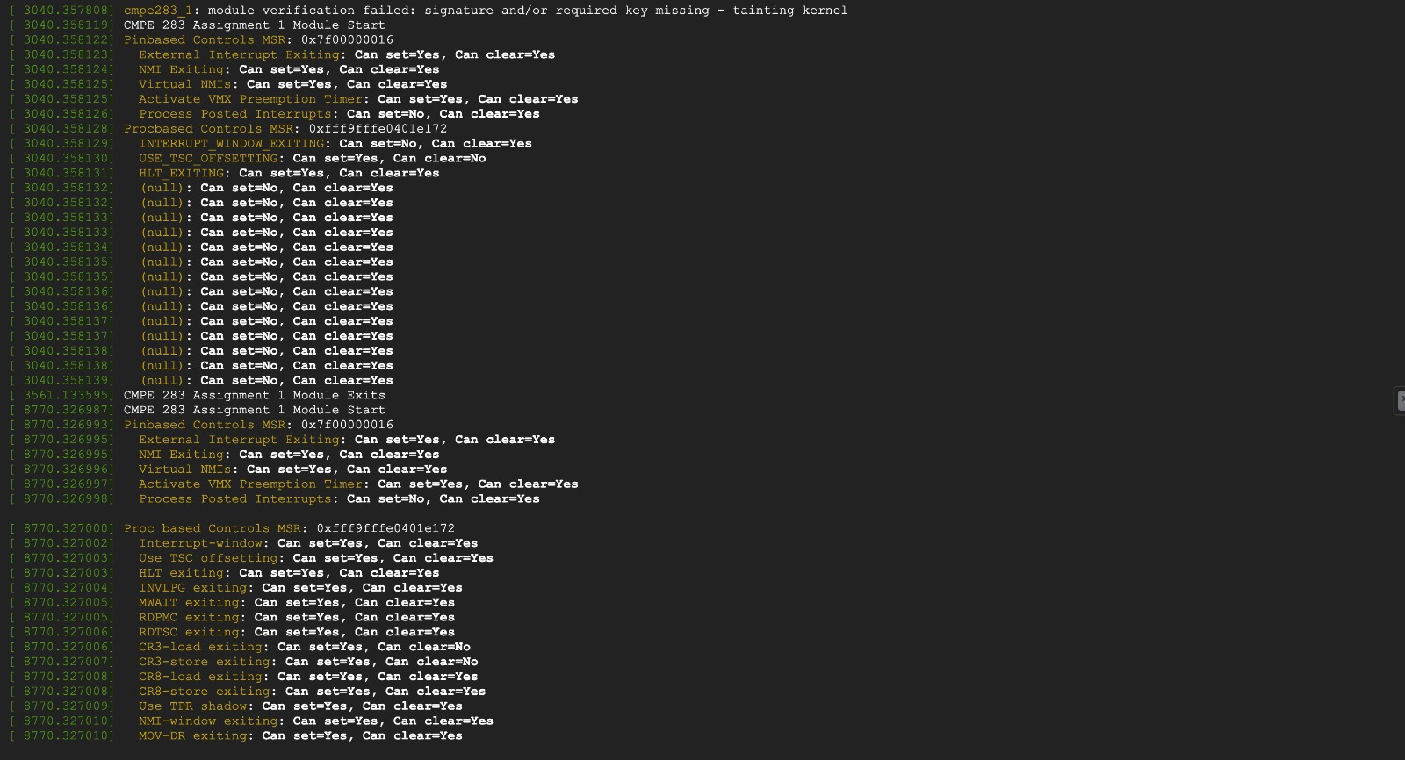

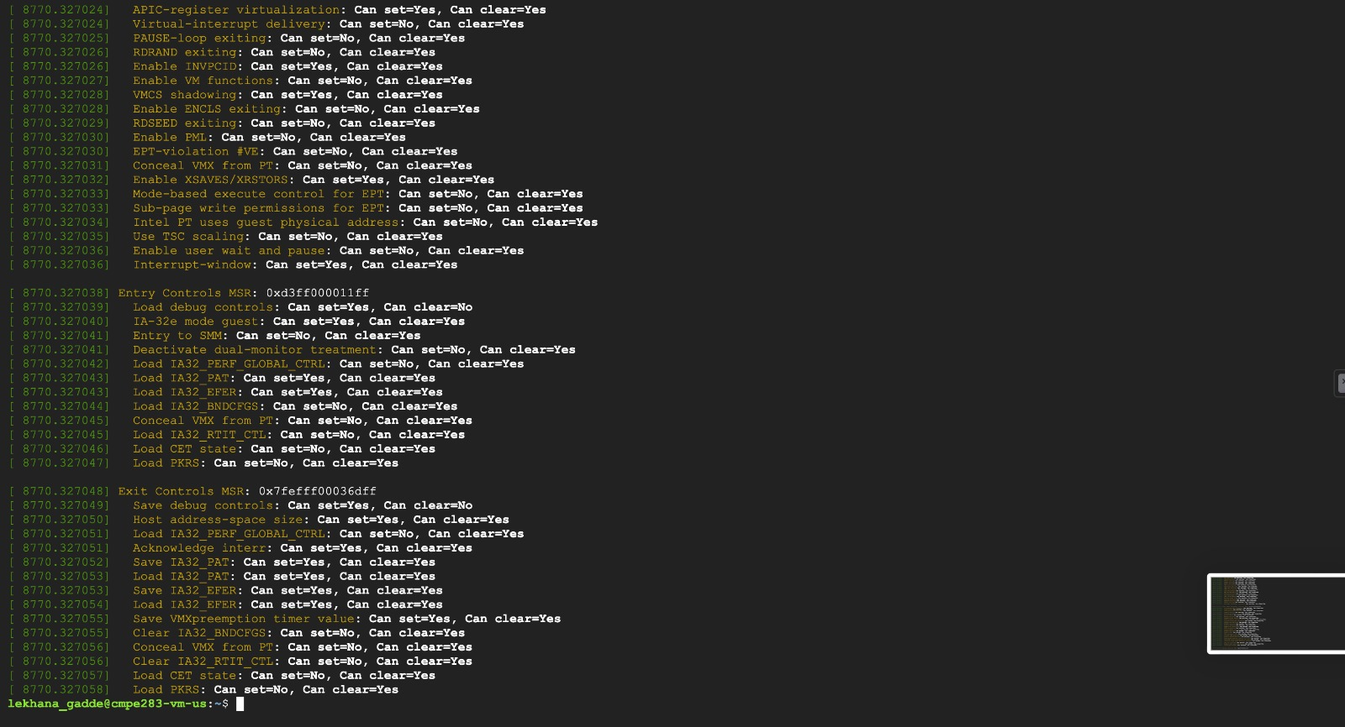

9. Executed the below command to remove cmpe283-1.c module

sudo rmmod cmpe283-1

10. dmesg command After removing the module cmpe283-1.c

