Product Design
Team | 22 , Students World, R V Sahithi, Animesh Chandra Pathak, Pratyusha Musunuru , Satyam Pandey.

Design Model
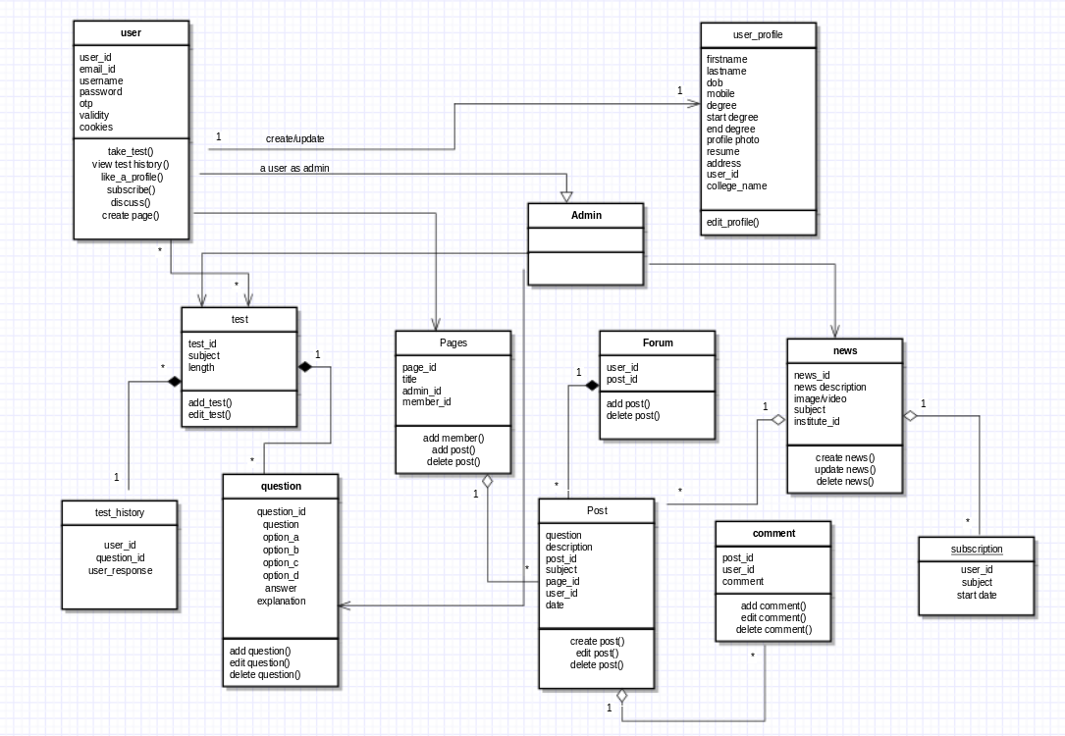

user | Class state  - holds the minimum required login details of the user.  Class behavior  - a logged in user can take a test  - he can analyse the tests in test history  - discuss on forums  - subscribe to news from various institutes or companies
test | Class state  - the test topic and duration of test  Class behavior  - admin can add / edit tests
test_history | Class state  - user response for each question.
question | Class state  - question  - options  - answer  - explanation  Class behavior  - admin can add or edit questions
pages | Class State  - created by  - members  Class behavior  - page admin can add members  - members of the group can create or edit posts
Post | Class state  - title  - description  - created by  - date of creationg  - tags  Class behavior  - user can post in forum or a page he is member of.  - He can edit or delete his posts  - he can search for posts by tags
Comment | Class State  - on_post  - created by  Class behavior  - add/edit comment
News | Class state  - news description  - created by  - tags  Class behavior  - create/update/delete news
User profile | Class state  - user details like address, contact details  - resume  Class behavior  - user can edit his profile
.

Sequence Diagram(s)
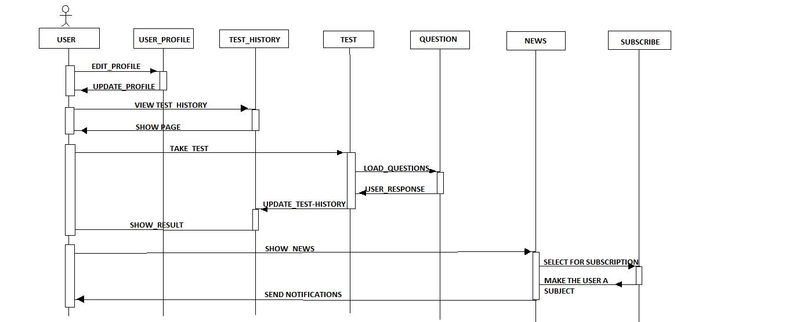
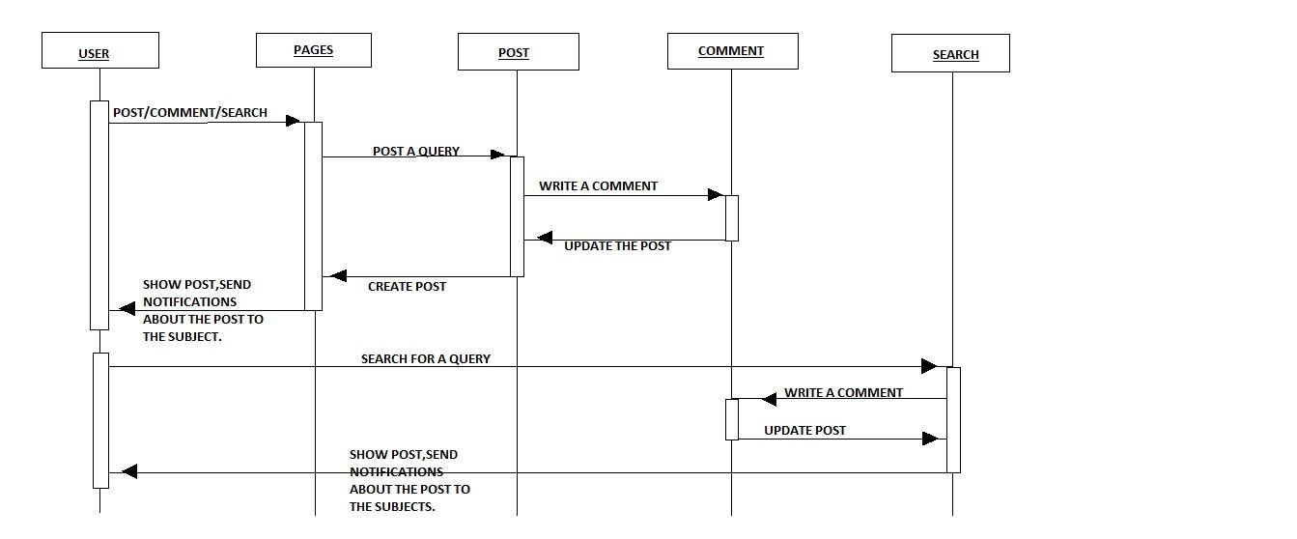

Design Rationale
This is a running list of issues that arise as your design process proceeds. This is an important section of the design document as it captures the thought process of the product's designers. It includes why or why not (rejected solutions) a design decision was made and supports future changes to the product. It should be updated whenever a design change occurs.

It is RARELY the case that the first design you consider is the best one that you can come up with that meets the requirements and that can be implemented, tested, and delivered on schedule. Your instructor will be looking for signs that you considered at least a few approaches, and that you had a coherent rationale for preferring the design your team eventually adopts.
This is the place to record such thoughts – what alternatives did you consider? What are the strengths (and deficiencies) of the final design compared to the other alternatives considered? Why did you select the approach you finally chose? This last question should be answered with an eye to the tradeoffs inevitably involved in creating an appropriate design.

