Question 3:
Number of integers n

n is 10000
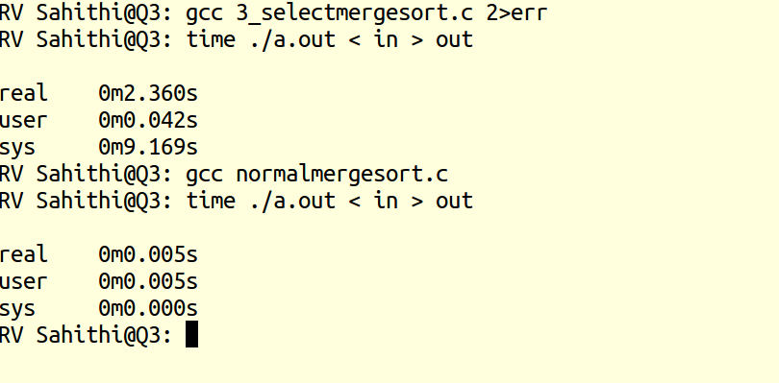

n is 1000
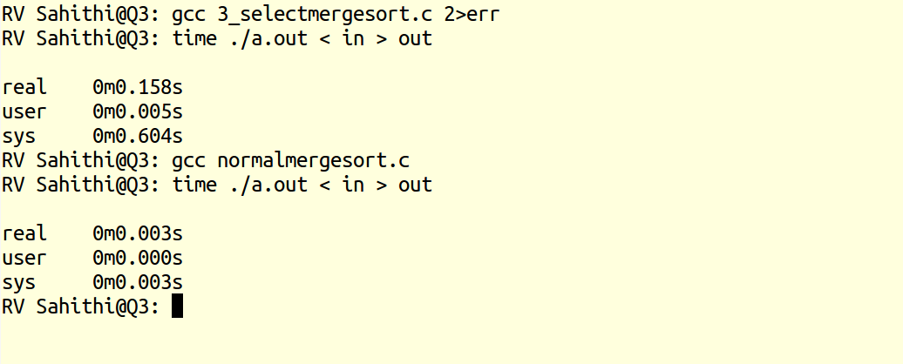

n is 100
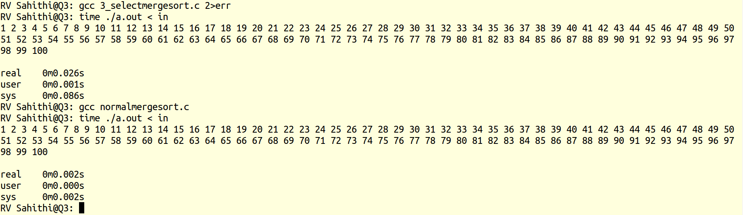

The time taken for concurrent merge sort is higher than time taken for normal merge sort.
This is because fork() system call is quite expensive and creating too many processes increases number of context switches.

My system crashes when n is of the order of 10^5 for concurrent merge sort as it cannot fork large number of times.

