Bonus Question:

A 1.2GB file was sorted by splitting into 3 files at each divide step.
When threshold is 500MB
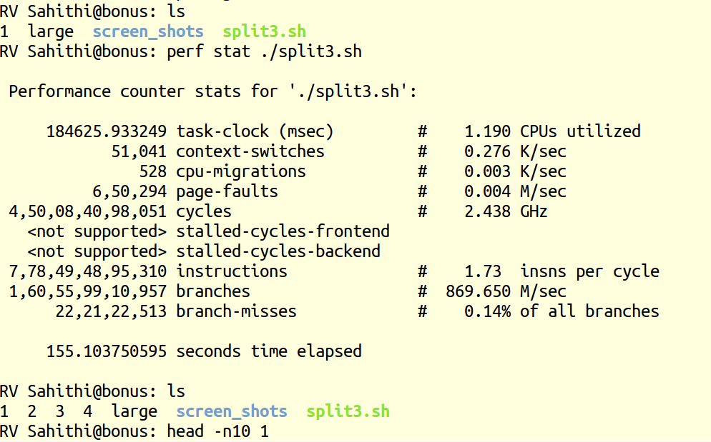

When threshold is 10MB;
