Question 4a

Context switches:
When performing perf test on dtella , I ran large applications like android studio, eclipse , Xchat, Okular etc. This increased number of context switches to the order of 10^5. Generally number of context switches when there are no applications running is 150.

Context switches vs Time
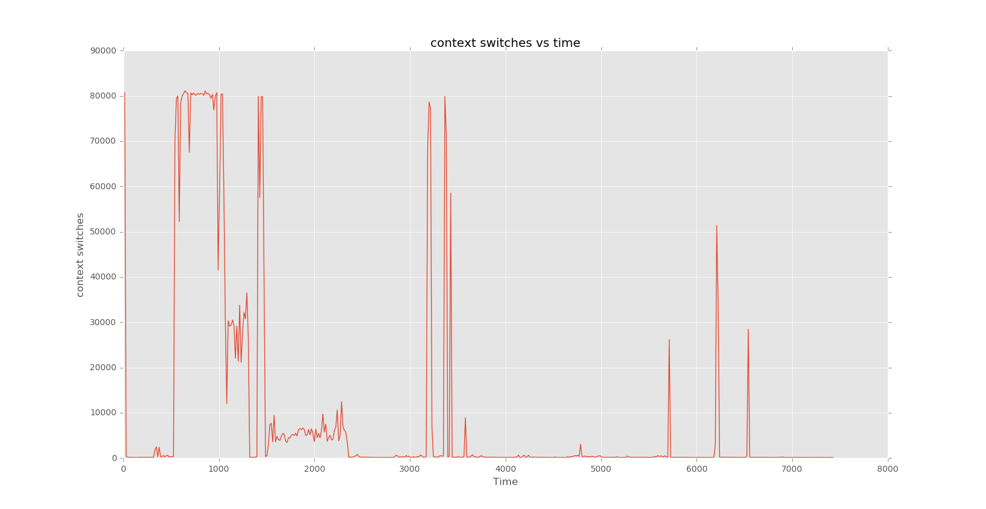

CPU Usage:

Usually the CPU Usage is around 0.005 when running dtella. On runnig CPU intense processes as mentioned above CPU usage increased to 0.300 .

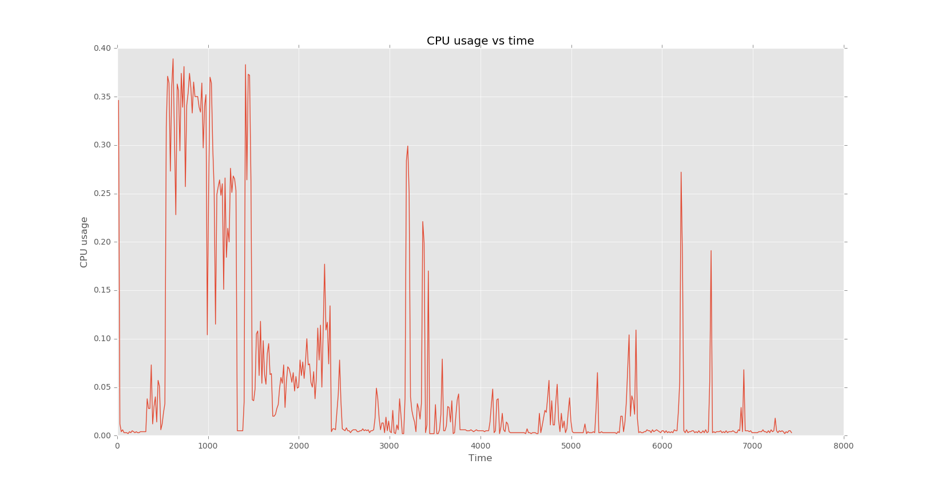
CPU Usage vs Time

