Question 4b

The threshold values chosen are 10MB , 100MB ,500MB

When threshold is 10MB – time taken to sort 150000000 integers is 233.5 sec.

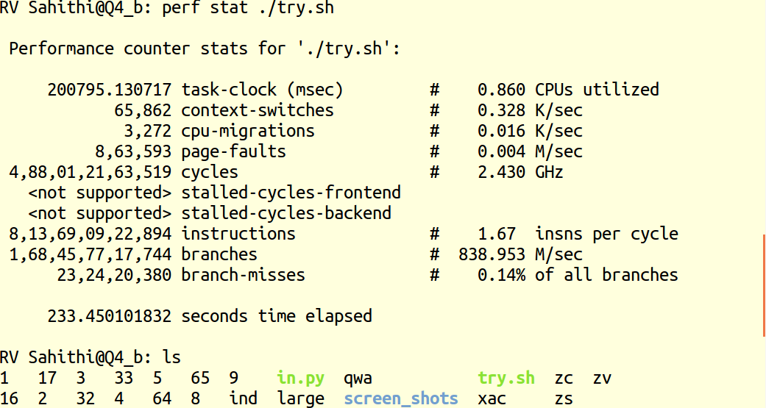
When threshold is 100MB time elapsed is 222.4 sec
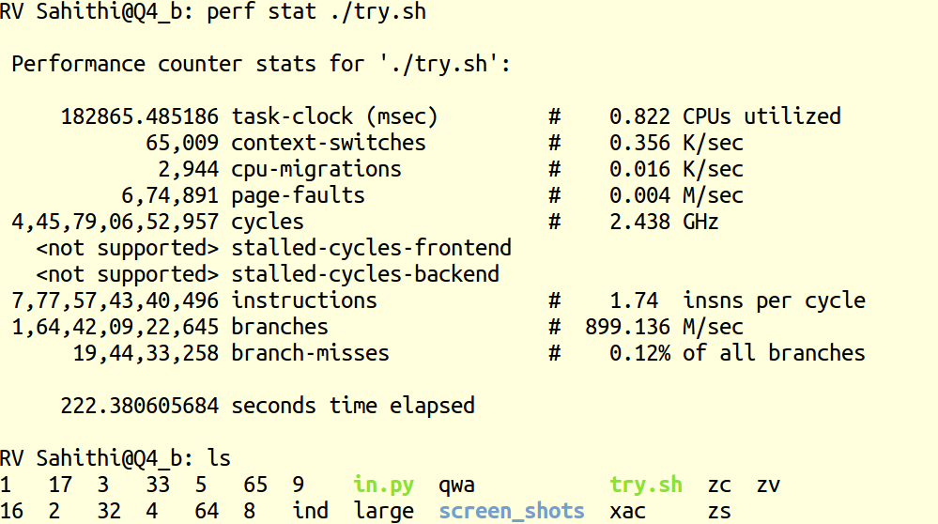

When threshold is 500MB, time elapsed is 182.45sec

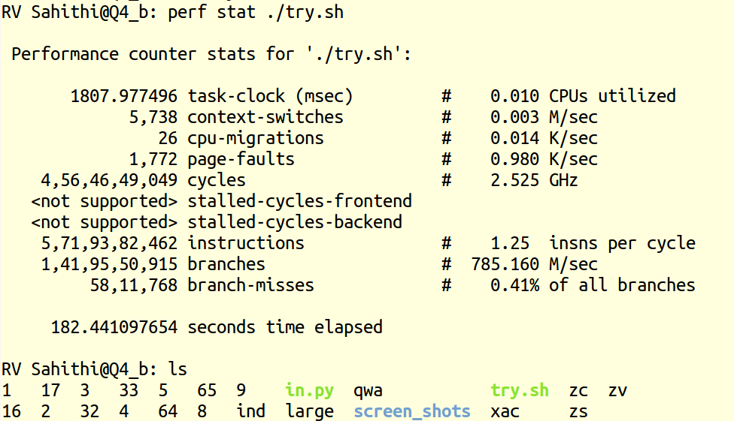
The sort command in bash is highly optimised and split command is more expensive

As the threshold value increases number of splits to be performed decreases and hence time elapsed decreases.

