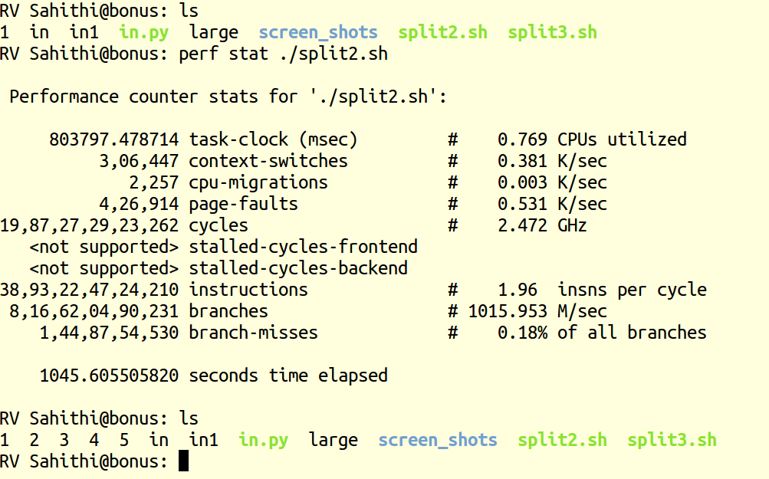
Bonus Question:

given 5gb file as input to the program, the time elapsed is 1045.6s .
The threshold size is 1000MB and at each divide step, the file splits into 2 files.

