**(CLA – 04)**

**Code:**

<!DOCTYPE html>

<html lang="en">

<head>

<meta charset="UTF-8">

<meta http-equiv="X-UA-Compatible" content="IE=edge">

<meta name="viewport" content="width=device-width, initial-scale=1.0">

<title>Document</title>

</head>

<body>

<script>

var population= window. prompt("Enter the population of country: "); var country= window. prompt("Enter the country name: ");

if (population > 33) {

console.log( `${country}'s population is above average`);

} else {console.log(`${country}'s population is ${33 - population} million below average`, ); }

</script>

</body>

</html>

# Output:-

**After compilation of this source code :-**

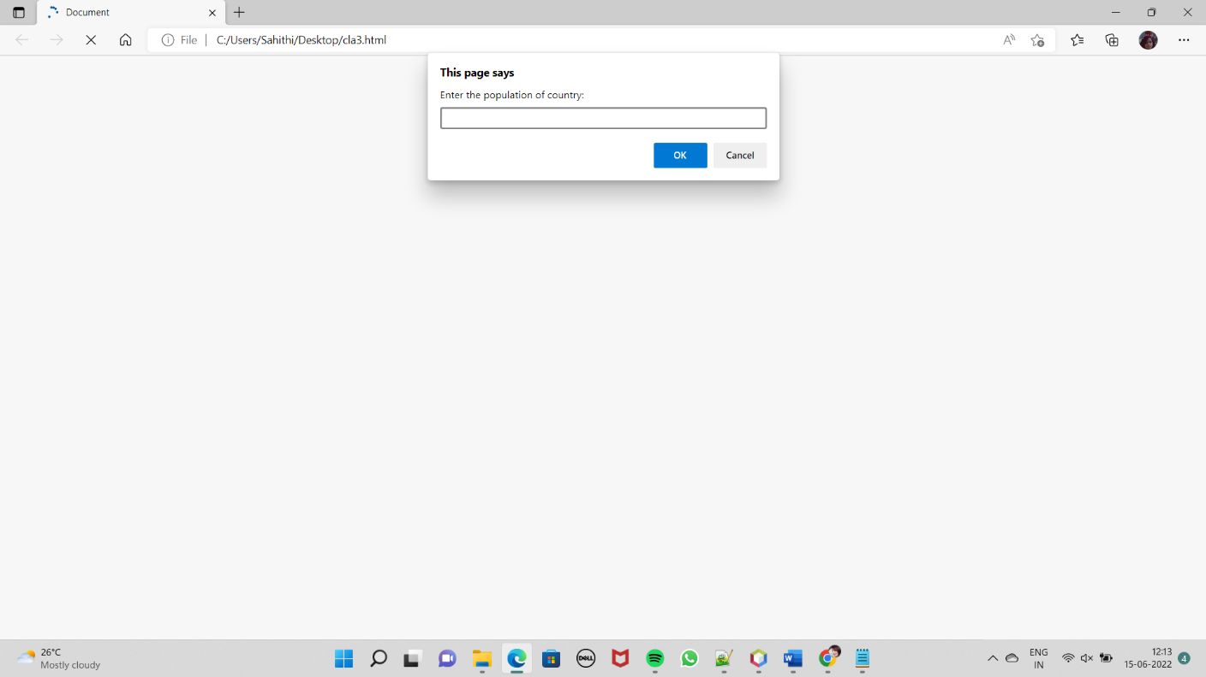

Enter the poupulation of country :-220

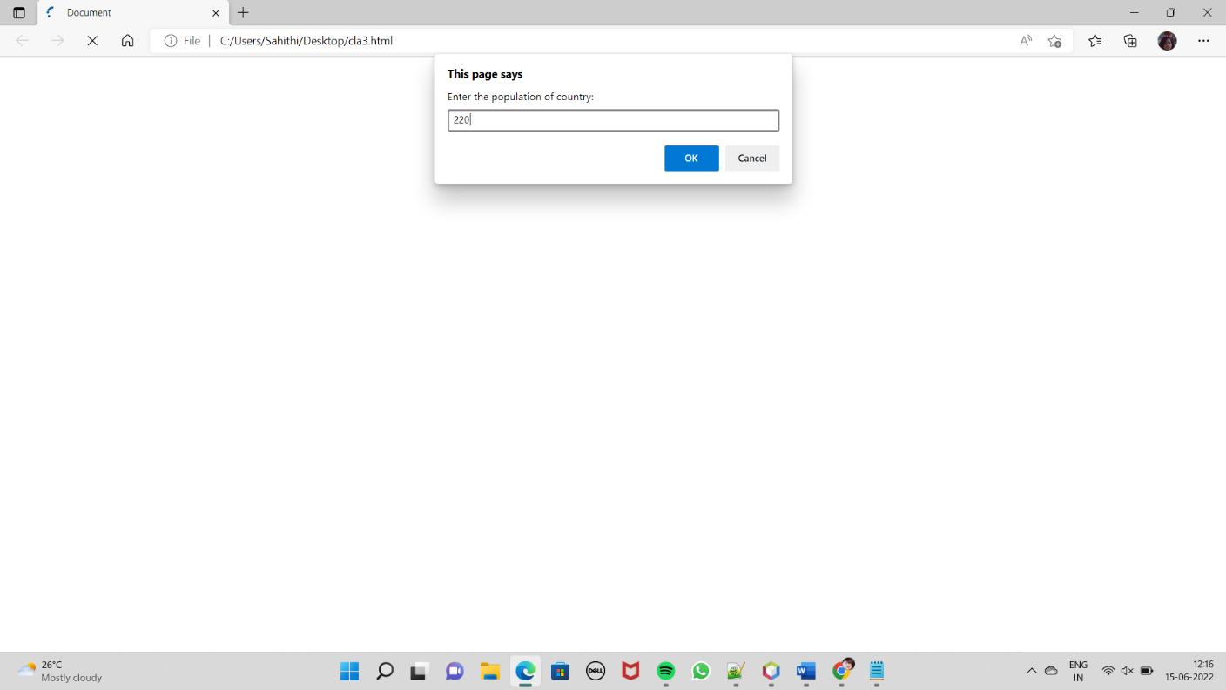

Click on ok button

Then next step:

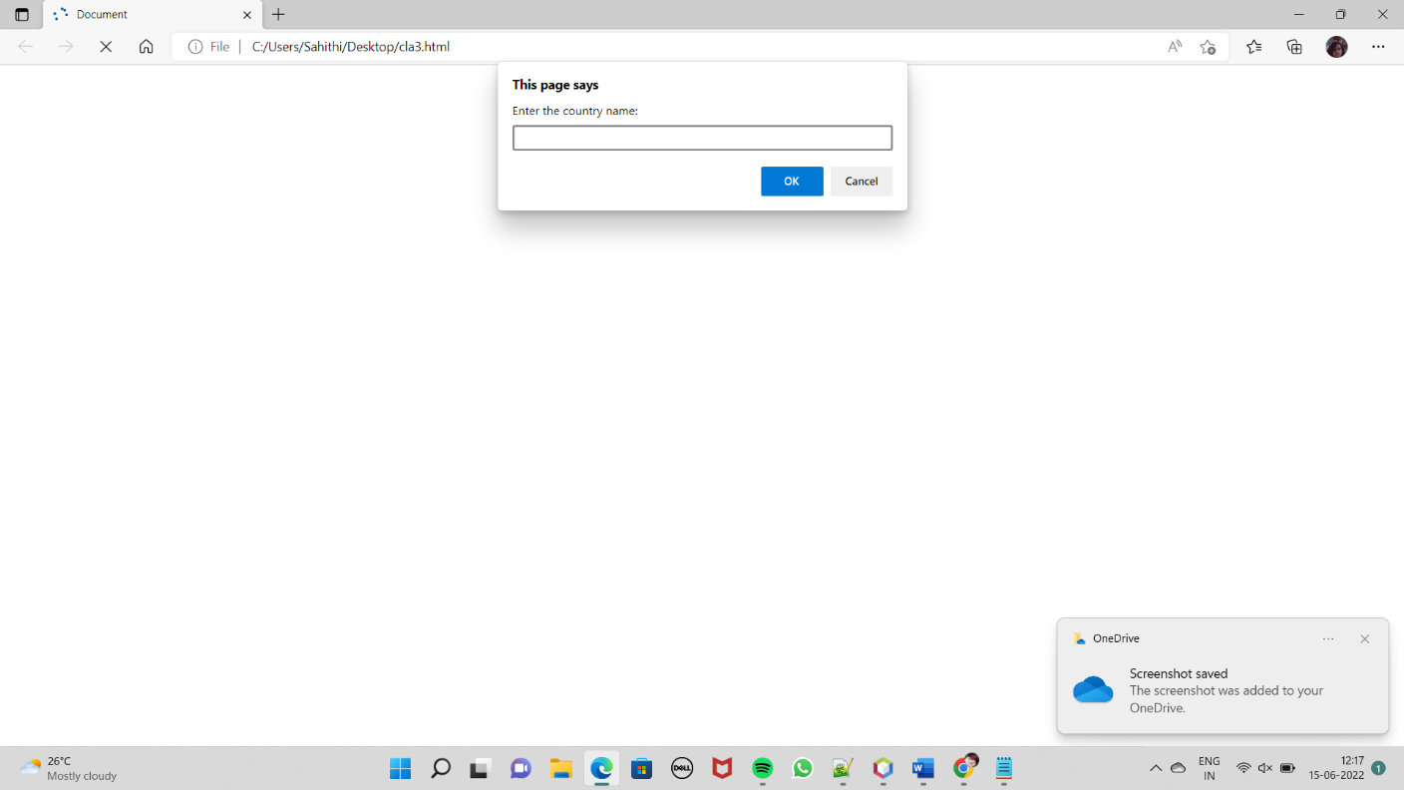

Enter the name of country:- India

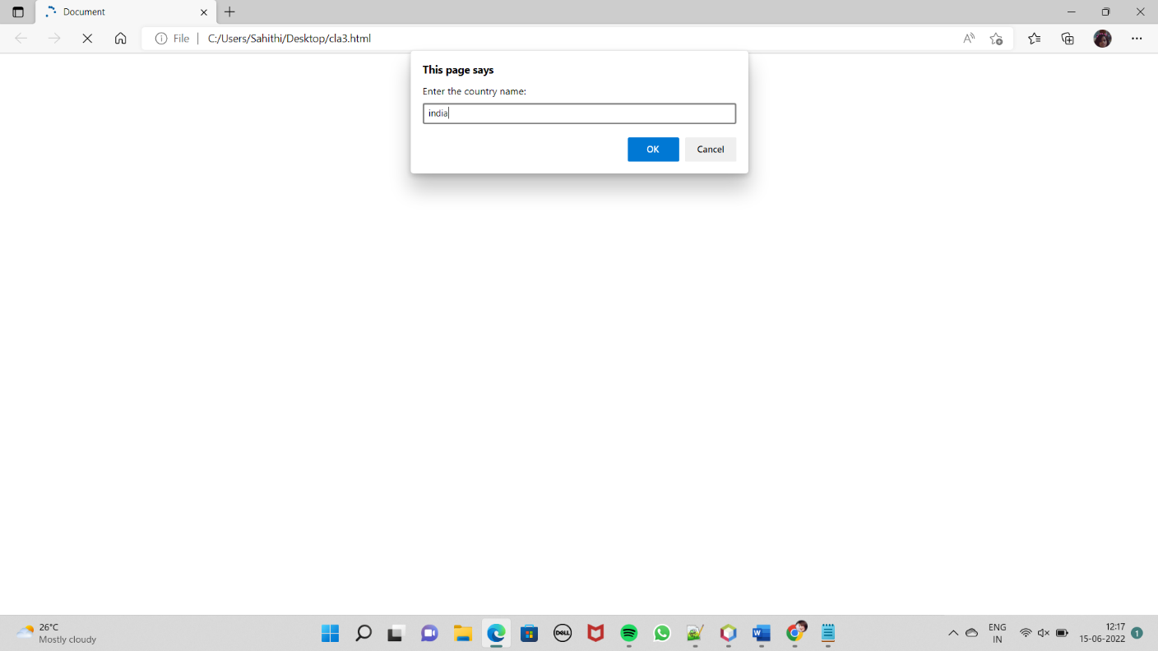

After the that press the ok button and go to console to see the RESULT:

Finally result :-

