CSA1554-CLOUD COMPUTING AND BIG DATA ANALYTICS FOR HADOOP APPLICATIONS
CO-3
ASSESSMENT TOOL-1(EXPERIMENTS)
NAME: E.LOHITHA
REG NUMBER: 192411103
Experiment 1: Create a simple cloud software application for educational institutions to manage fee collection and payment tracking using any Cloud Service Provider to demonstrate SaaS.
Aim:
To create a simple cloud-based SaaS application for educational institutions using zoho creator to manage student fee collection and payment tracking.
Software Used:
Zoho creator
Algorithm:
- Create Student Details form and enter student data.
- Create Fee Payment form and enter payment details.
- Calculate balance amount from total fee and paid amount.
- Update payment status as Paid or Pending.
- Store records in cloud and generate reports using zoho creator.
Output:
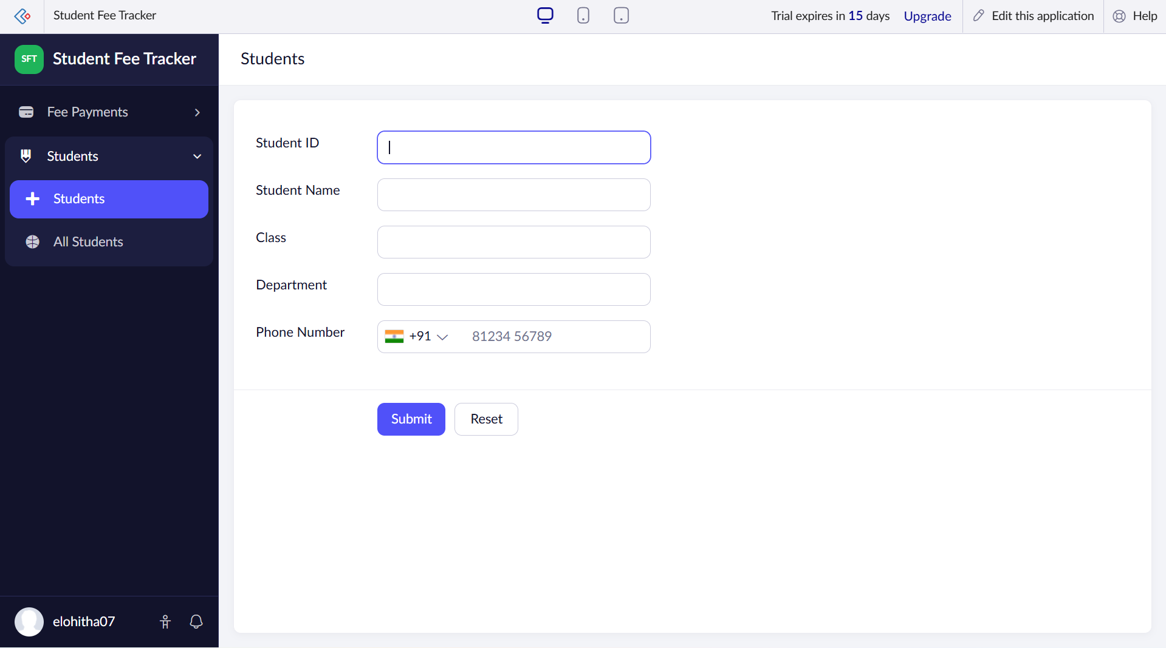
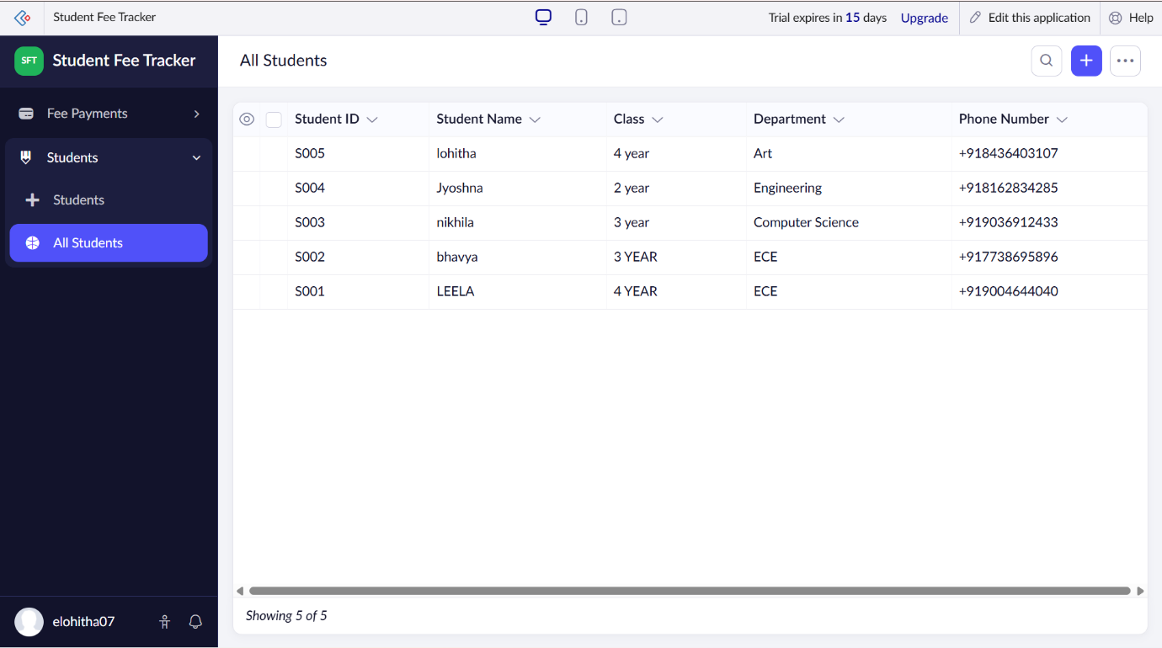
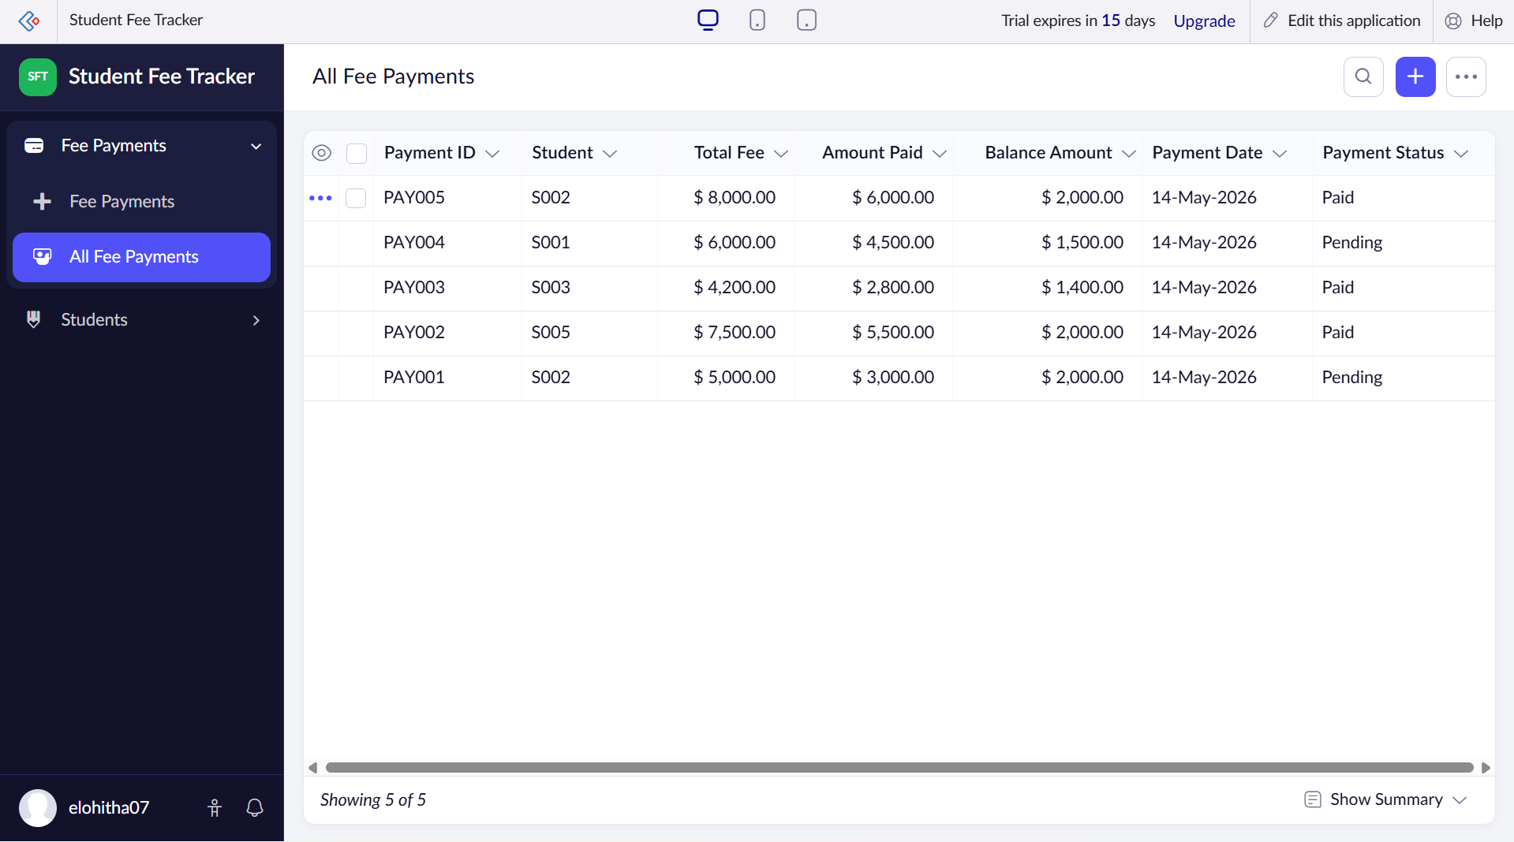

Result:
The cloud-based SaaS application for student fee collection and payment tracking was created successfully using zoho creator.

Experiment 2: Create a simple cloud software application for racking inventory, stock updates, and sales management using any Cloud Service Provider to demonstrate SaaS.
Aim:
To create a simple cloud-based SaaS application for inventory tracking, stock updates, and sales management using Zoho creator.
Software used:
Zoho creator
Algorithm:
- Create a Product Details form and enter product information.
- Create a Sales Management form and enter sales details.
- Update stock after each sale.
- Store inventory and sales data in the cloud.
- Generate stock and sales reports using zoho creator.
Output :
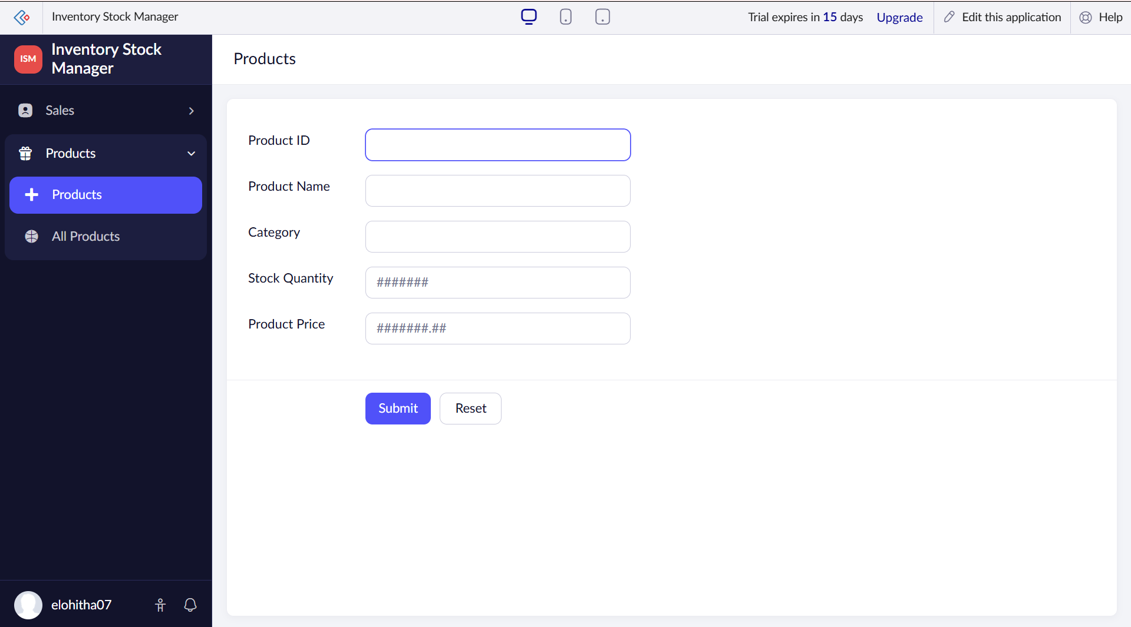
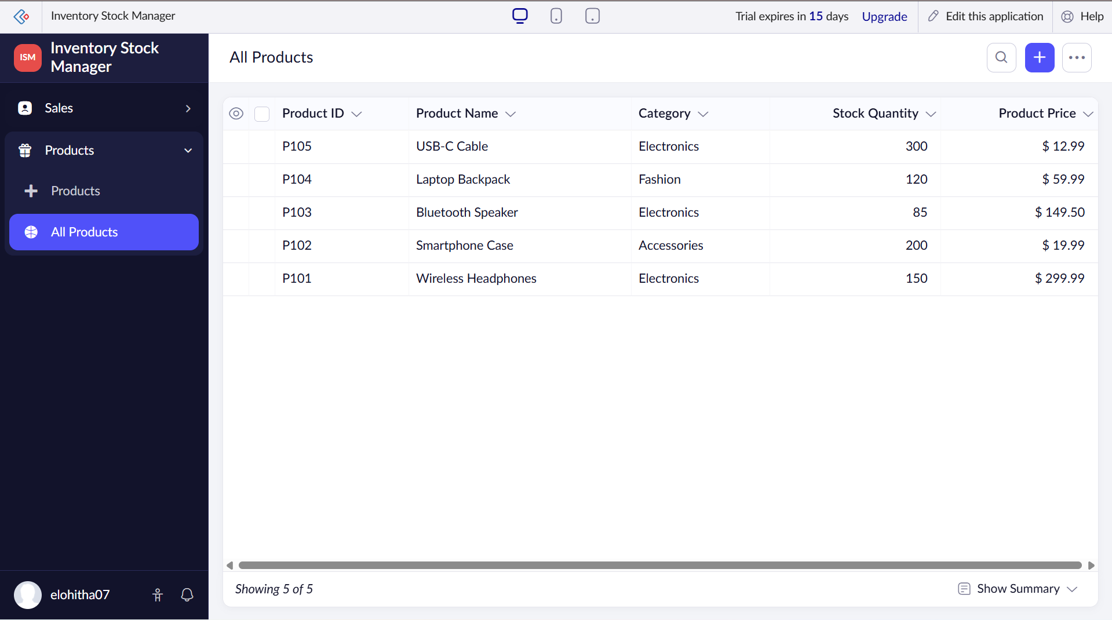
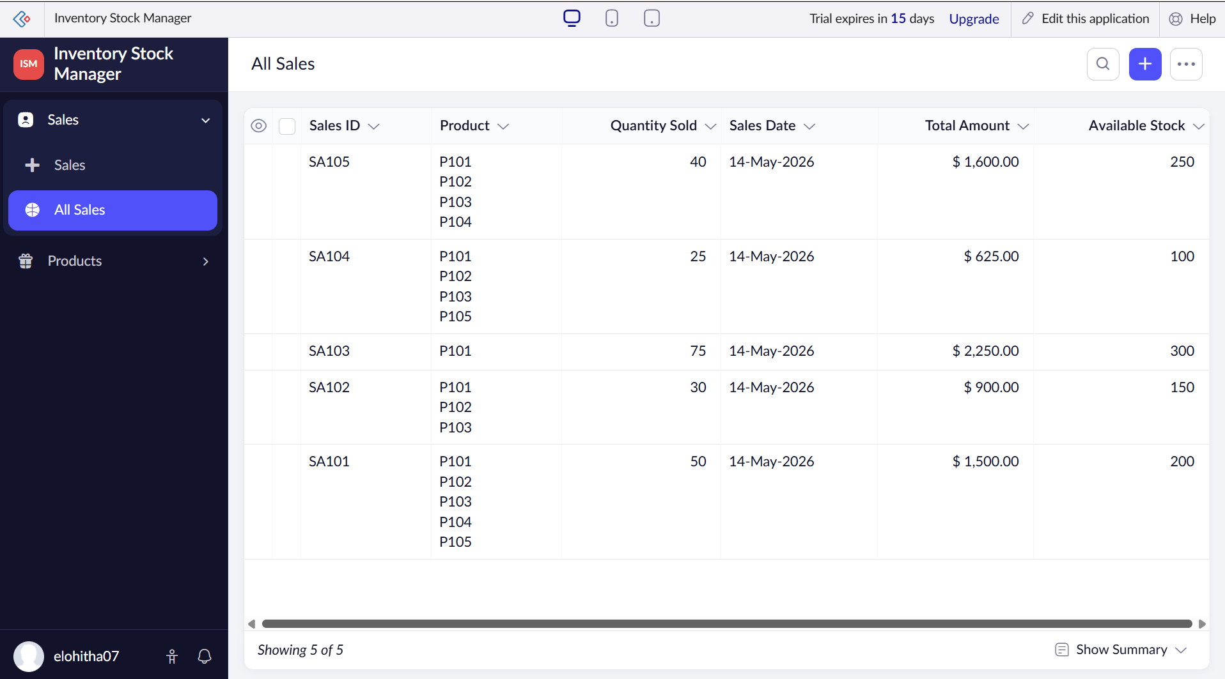

Result:
The cloud-based SaaS inventory management application was successfully developed using zoho creator.

