**Q1**

1. Created a list called ages to store the numbers
2. Used sort method to sort the numbers in the list
3. Calculated minimum and maximum values of the list using min , max functions and again added them to the list
4. Calculated median, mean using median and mean methods by using statistics library
5. Calculated Range by subtracting maximum and minimum values and printed it as in the below image

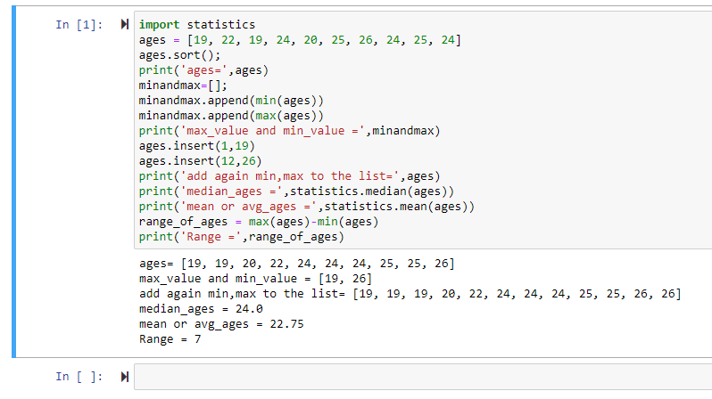

**Q2**

1. Created a empty dictionary called dog
2. Added keys and values to the dog dictionary
3. Created student dictionary with given keys and printed length of the dictionary
4. Printed the values of skills and converted it to list type
5. Added two values to skills
6. Printed the keys, values as a list

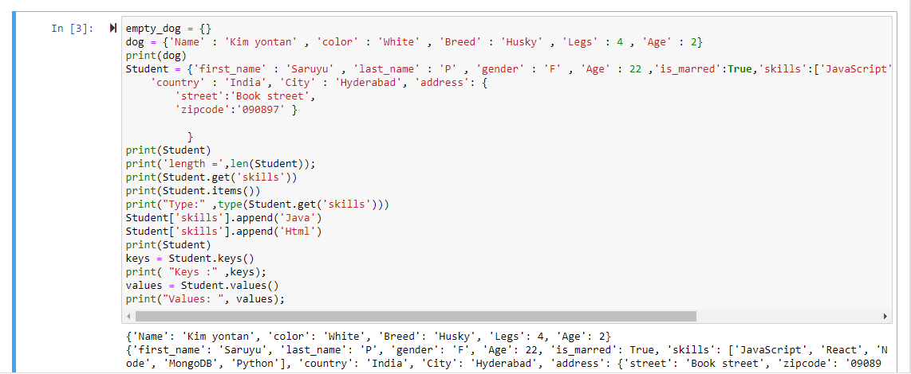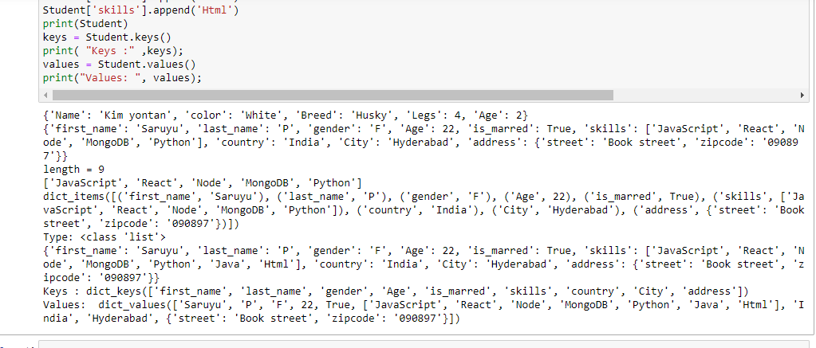

**Q3**

1. Created two tuples, performed addition operation on them
2. Calculated the length of the tuple
3. Added family members variables to siblings tuple

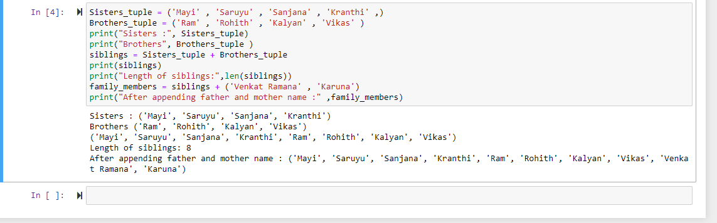

**Q4**

1. Created a set and calculated its length
2. Performed add, update, remove operations on the set
3. Performed union, intersection, subset ,disjoint, and symmetric operation on sets “A”and’’B”
4. Deleted the sets completely and converted the ages to a set and compare the length of the list and the set.

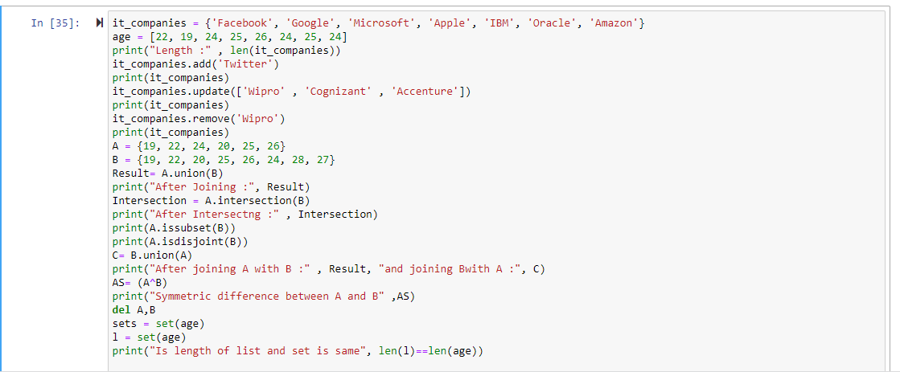

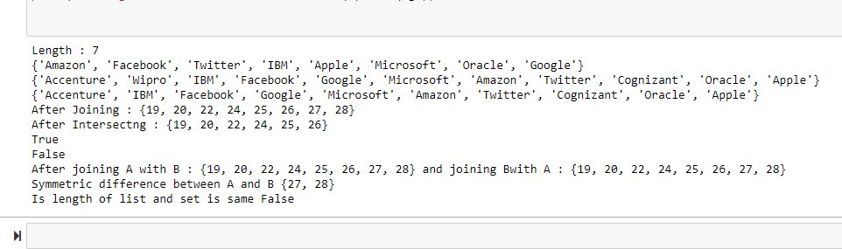

**Q5**

1. Calculated area, circumference of circle by taking radius as input.
2. Calculated area, circumference of circle by taking radius as input from the console.

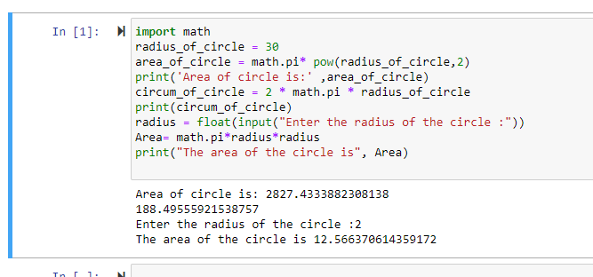

**Q6**

1. Given a string as input
2. Created a set named ‘ Unique’ and used split method to get each word of the above string and stored into Unique set
3. Printed the set to see the unique values

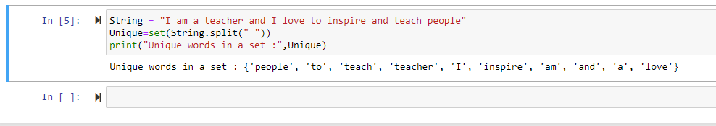

**Q7**

1. Used “ \t” and “\n” to create a table view as given in the question.

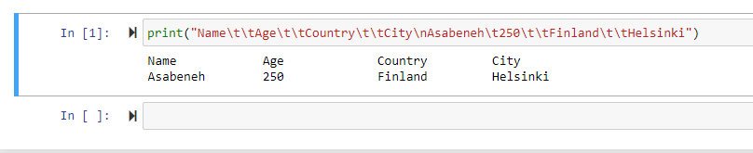

**Q8**

1. Calculated area of circle by taking radius as input .
2. Printed the area and radius using string format method

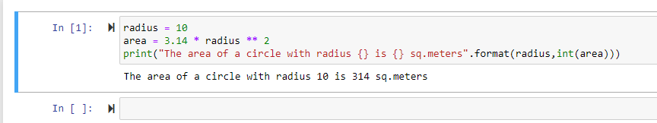

**Q9**

1. Taken weights of N students as input and added them to the list ‘H’
2. Used for loop to take each element of list H, converted them into kilograms and added them to a new list ‘kilogram’
3. Printed the kilogram list

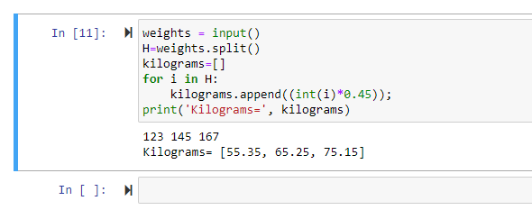

**Q10**

