**PIZZA ORDER PAGE DEFECTS**

**Defect Id**: 1

**Defect Title**: Pizza type should be selected for placing an order

**Defect Description:**

Even if the pizza type is not selected the order is getting placed

**Steps To Reproduce:**

* Launch application
* Fill in all the fields except the pizza type
* Click on place order

**Test Data**

* Pizza Toppings 1: Olives
* Pizza Toppings 2: Mushrooms
* Quantity: 2
* Name: user1
* Phone Number: 12345
* Payment Option: Credit Card

**Expected Result**

Order should not be placed without selecting the pizza type

**Actual Result**

Order is getting placed successfully

**Priority**: High

**Severity**: Critical

**Requirement**: Fill in the Pizza Order Details

**Environment**: local

**Evidence**:

**Defect Id**: 2

**Defect Title**: Topping 1 and Toppings 2 Drop down should be disabled

**Defect Description**

When pizza type with no toppings is selected both the drop downs pizza toppings 1 and pizza toppings 2 should be disabled and user should not be able to select any options from these drop downs.

**Steps to Reproduce**

* Launch application
* Fill in the pizza type as pizza with no toppings
* Try to select an option from the toppings 1 and toppings 2 drop down
* Fill in other details such as name, phone number, payment information
* Click on place order

**Test Data**

* Pizza Type: SMALL_NOTOPPINGS
* Quantity: 2
* Name: user1
* Phone Number: 12345
* Payment Option: Credit Card

**Expected Result**

User is not able to select any option from the toppings 1 and toppings 2 drop down. Order should not be placed in this scenario

**Actual Result**

User can select any option from the toppings 1 and toppings 2 drop down. Order is getting placed successfully

**Priority**: High

**Severity**: Medium

**Requirement**: Enable the toppings drop down as per the selection of the pizza type

**Environment**: local

**Evidence**

**Defect Id**: 3

**Defect Title**: Pizza Toppings 1 Enabled and Pizza Toppings 2 Disabled According to Pizza Type Selected

**Defect Description**

When user selects the pizza type with toppings 1 then the toppings 1 drop down should be enabled and toppings 2 drop down should be disabled

**Steps to Reproduce**

* Launch application
* Fill in the pizza type as pizza with 1 topping
* Try to select an option from the toppings 2 drop down
* Fill in other details such as name, phone number, payment information
* Click on place order

**Test Data**

* Pizza Type: SMALL_ONETOPPINGS
* Pizza Toppings1: Olives
* Quantity: 2
* Name: user1
* Phone Number: 12345
* Payment Option: Credit Card

**Expected Result**

User should be able to select the toppings from toppings 1 drop and toppings 2 drop down should be disabled.

**Actual Result**

User can select the toppings from both toppings 1 and toppings 2 drop down, both the drop downs are enabled

**Priority**: High

**Severity**: Medium

**Requirement**: Enable the toppings drop down as per the selection of the pizza type

**Environment**: local

**Evidence**:

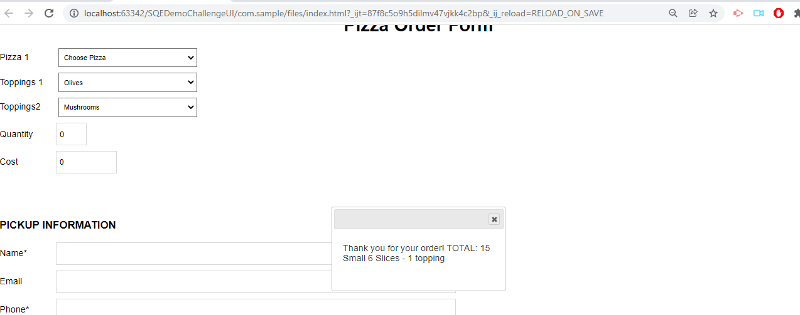

**Defect Id**: 4

**Defect Title**: Quantity Field Must Be Mandatory for Placing the Order

**Defect Description**

When user does not fill in the quantity field, the user should not be able to place the order

**Steps to Reproduce**

* Launch application
* Fill in the pizza type and the toppings as per the pizza type
* Fill in other details such as name, phone number, payment information
* Click on place order

**Test Data**

* Pizza Type: SMALL_ONETOPPINGS
* Pizza Toppings1: Olives
* Name: user1
* Phone Number: 12345
* Payment Option: Cash on Pickup

**Expected Result**

User should not be able to place the order with zero quantity

**Actual Result**

Even the quantity field is not filled the order is getting placed

**Priority**: High

**Severity**: Critical

**Requirement**: Quantity should not be zero

**Environment**: local

**Evidence**:

**Defect Id**: 5

**Defect Title**: Quantity Field Present on The Pizza Order Form Should not accept negative values

**Defect Description:**

When user fills negative value in the quantity field, the user should not be able to place the order and the user should get an error message displaying that the negative values should not be filled in the quantity field

**Steps to Reproduce**

* Launch application
* Fill in the pizza type and the toppings as per the pizza type
* Fill in the quantity value a negative number
* Fill in other details such as name, phone number, payment information
* Click on place order

**Test Data**

* Pizza Type: LARGE_TWOTOPPINGS
* Pizza Toppings1: Olives
* PizzaToppings2: Mushrooms
* Quantity: -538
* Name: user1
* Phone Number: 12345
* Payment Option: Cash on Pickup

**Expected Result**

user should not be able to place the order and the user should get an error message displaying that the negative values should not be filled in the quantity field

**Actual Result**

user can place the order and the user does not get any error message displaying that the negative values should not be filled in the quantity field

**Priority**: High

**Severity**: High

**Requirement**: Quantity Field Boundary Values

**Environment**: local

**Evidence**

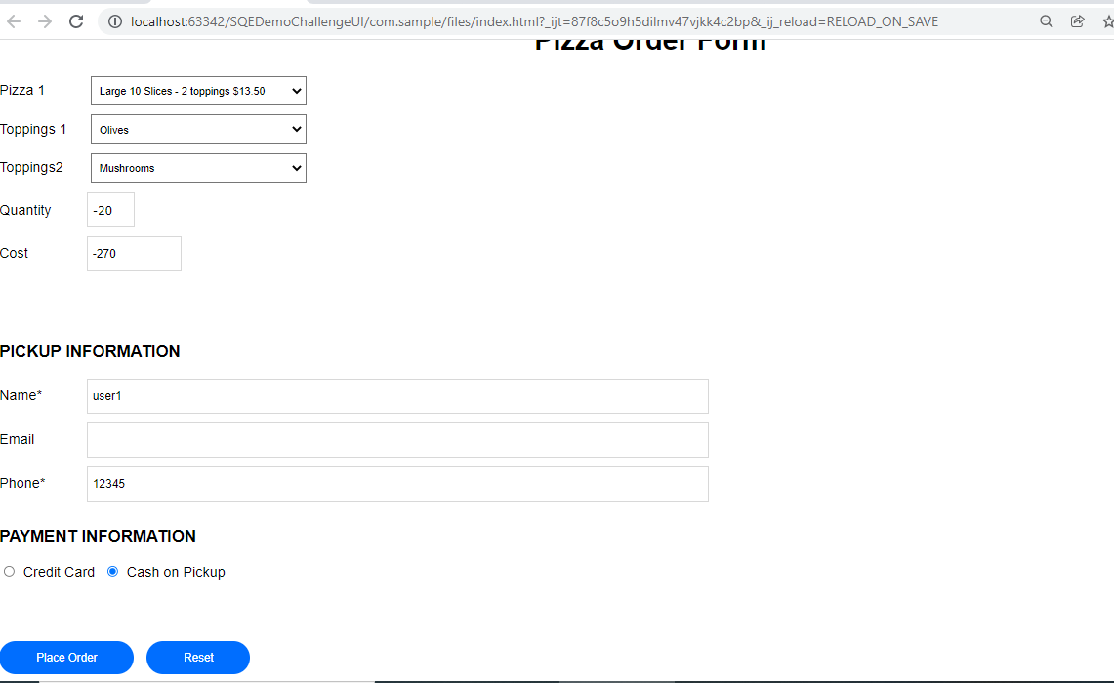

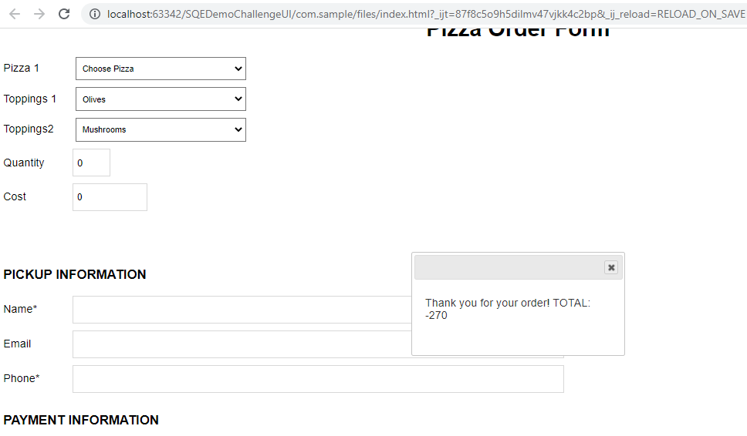

**Defect Id**: 6

**Defect Title**: Quantity Field Present on The Pizza Order Form Should not accept floating numbers and fractions

**Defect Description**:

When user fills a fractional value in the quantity field, the user should not be able to place the order and the user should get an error message displaying that these values are not accepted

**Steps to Reproduce**

* Launch application
* Fill in the pizza type and the toppings as per the pizza type
* Fill in the quantity value a negative number
* Fill in other details such as name, phone number, payment information
* Click on place order

**Test Data**

* Pizza Type: SMALL_ONETOPPINGS
* Pizza Toppings1: Olives
* Quantity: 0.3
* Name: user1
* Phone Number: 12345
* Payment Option: Cash on Pickup

**Expected Result**

user should not be able to place the order and the user should get an error message displaying that the fractional values should not be filled in the quantity field

**Actual Result**

user can place the order and the user does not get any error message displaying that the fractional values should not be filled in the quantity field

**Priority**: High

**Severity**: High

**Requirement**: Quantity Field Boundary Values

**Environment**: local

**Evidence**

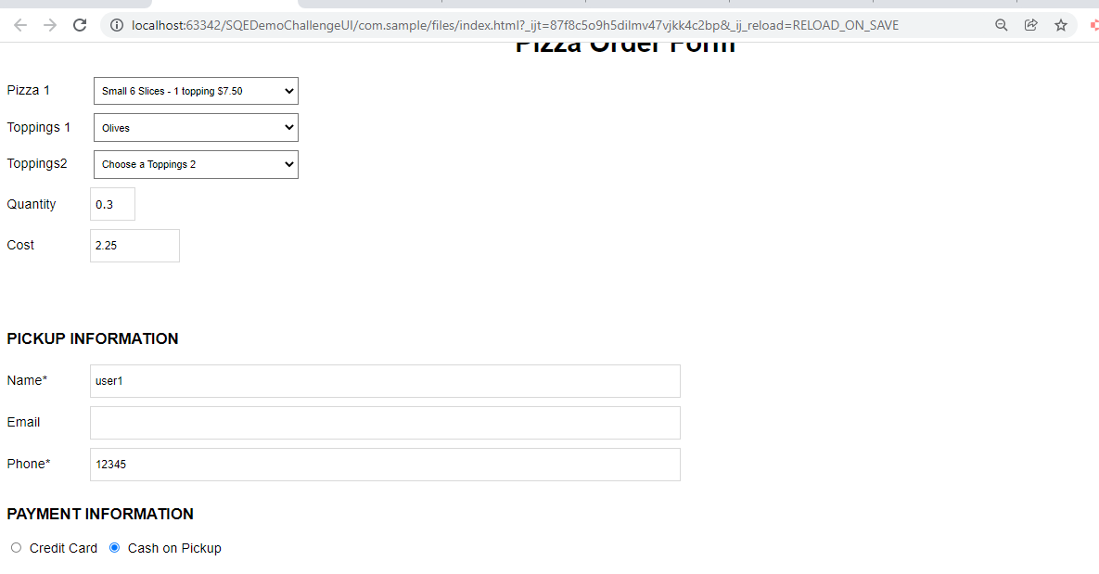

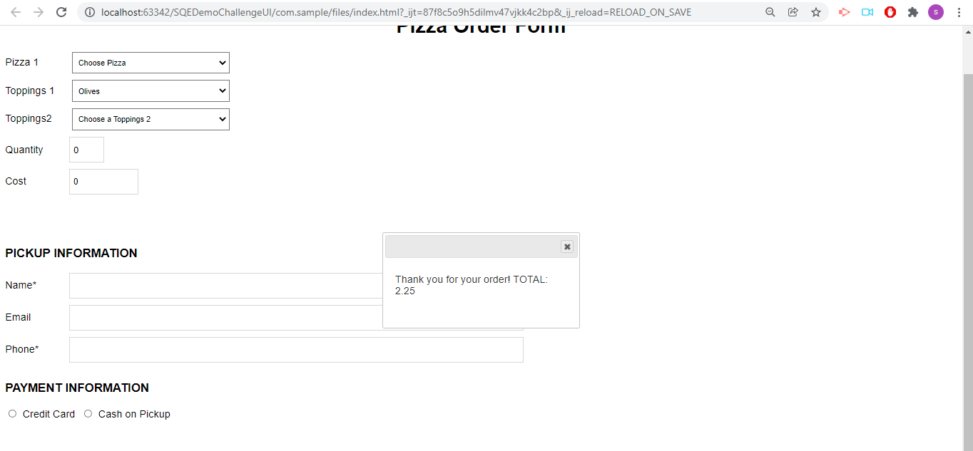

**Defect Id**: 7

**Defect Title**: Cost is not getting reflected as soon as quantity is getting filled as a result user might be confused with the cost information

**Defect Description**:

When user selects the pizza type and fills in the quantity unless the click happens on other element the cost is not getting reflected, consider a situation where user fills in all the details and at last decides to change quantity and cost remains same as the previous one on the cost input field clicks on the place order button, on the success dialog box the actual changed cost occurs.

**Steps to Reproduce**

* Launch application
* Fill in the pizza type and the toppings as per the pizza type
* Fill in the quantity value and observe the cost value
* Fill in other details such as name, phone number, payment information
* Edit the quantity value to another value
* Click on place order

**Test Data**

* Pizza Type: SMALL_ONETOPPINGS
* Pizza Toppings1: Olives
* Quantity 1: 3
* Name: user1
* Phone Number: 12345
* Quantity 2: 5
* Payment Option: Cash on Pickup

**Expected Result**

user should be able to see the updated cost value as soon as the quantity changes.

**Actual Result**

Cost field value is not getting reflected automatically as soon as the quantity is filled in, upon clicking on other web element or any where on the page the quantity value is getting updated

**Priority**: Medium

**Severity**: Medium

**Requirement**: Cost Field Value Verification

**Environment**: local

**Evidence**

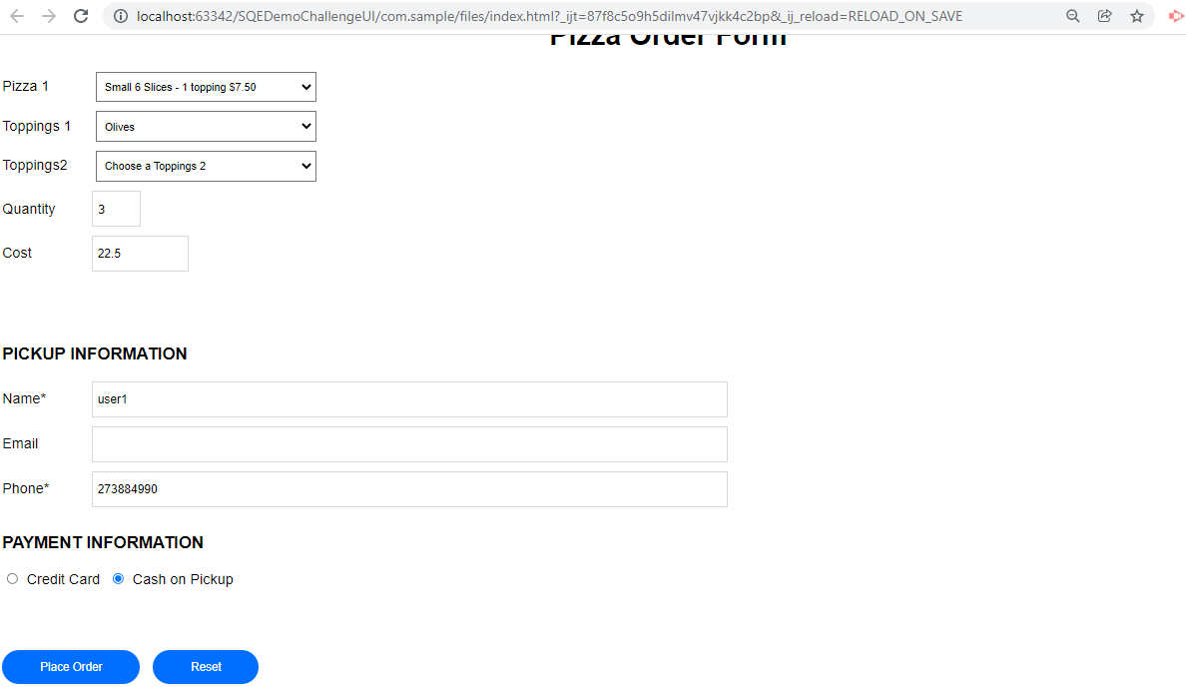

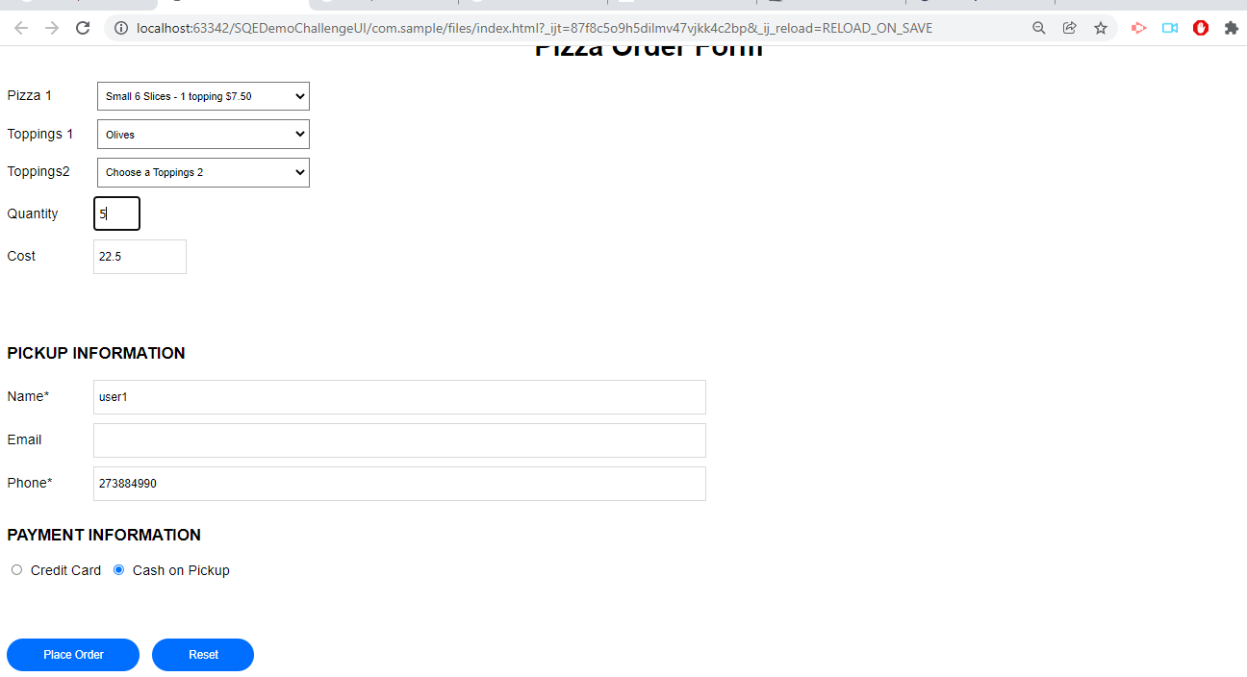

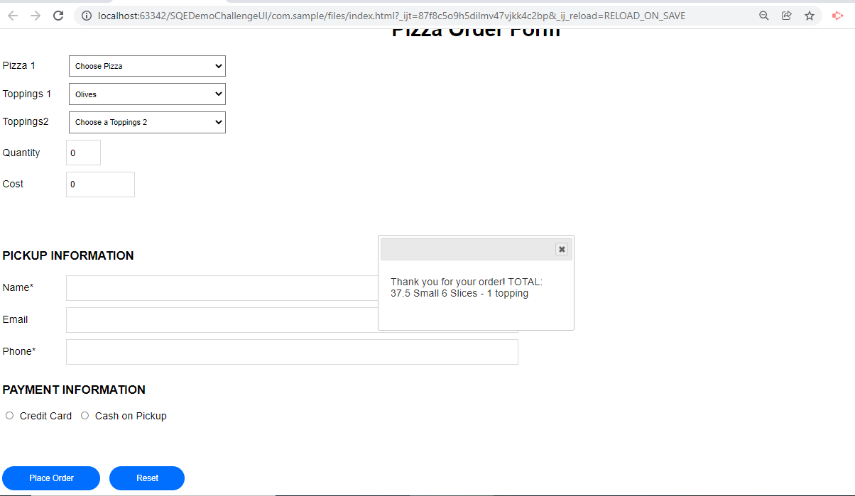

**Defect Id**: 8

**Defect Title**: Email address validation is not done

**Defect Description**:

The application accepts any kind of characters for email address and there is no validation done.

**Steps to Reproduce**

* Launch application
* Fill in the pizza type and the toppings as per the pizza type
* Fill in the quantity value
* Fill in other details such as name, invalid email value, phone number, payment information
* Click on place order

**Test Data**

* Pizza Type: SMALL_ONETOPPINGS
* Pizza Toppings1: Olives
* Quantity: 2
* Name: user1
* Phone Number: 12345
* email: 12344dnd
* Payment Option: Cash on Pickup

**Expected Result**

user should be able to see the error message that the email address in not correct and user should not be able to place the order

**Actual Result**

User does not get any error message displayed when incorrect email address is entered and also the order gets placed successfully.

**Priority**: Medium

**Severity**: Medium

**Requirement**: Email Field Validation

**Environment**: local

**Evidence**

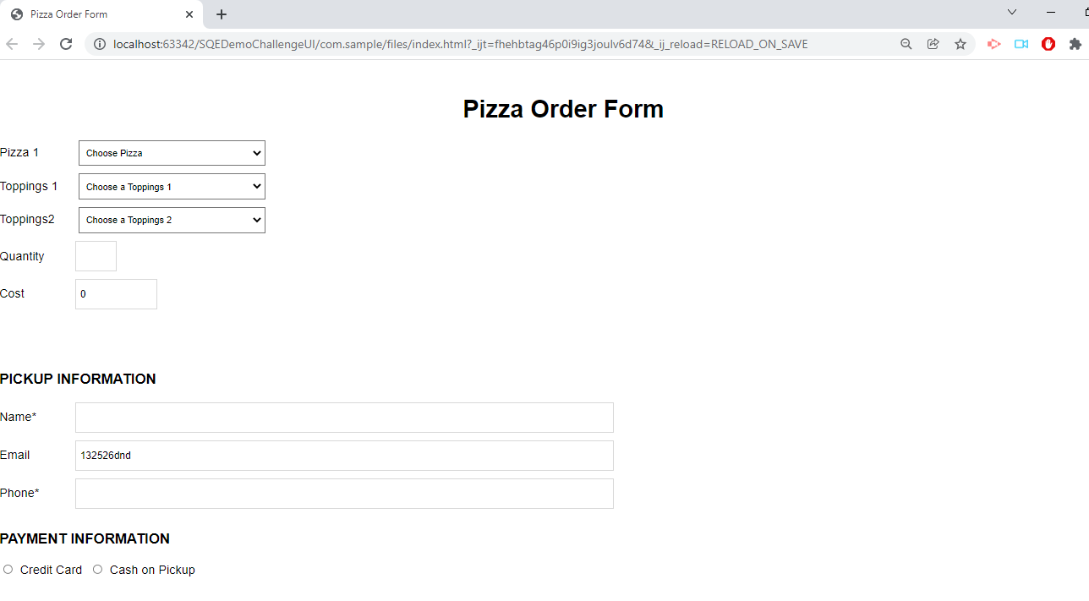

**Defect Id**: 9

**Defect Title**: Phone number field validation

**Defect Description**:

The application accepts any kind of characters for phone number and there is no validation done on pattern as well as on length

**Steps to Reproduce**

* Launch application
* Fill in the pizza type and the toppings as per the pizza type
* Fill in the quantity value
* Fill in other details such as name, email value, invalid phone number, payment information
* Click on place order

**Test Data**

* Pizza Type: SMALL_ONETOPPINGS
* Pizza Toppings1: Olives
* Quantity: 2
* Name: user1
* Phone Number: abcd#h
* email: user@gmail.com
* Payment Option: Cash on Pickup

**Expected Result**

user should be able to see the error message that the phone is incorrect, only digits are allowed and user should not be able to place the order

**Actual Result**

User does not get any error message displayed when incorrect phone number is entered and also the order gets placed successfully.

**Priority**: High

**Severity**: High

**Requirement**: Email Field Validation

**Environment**: local

**Evidence**:

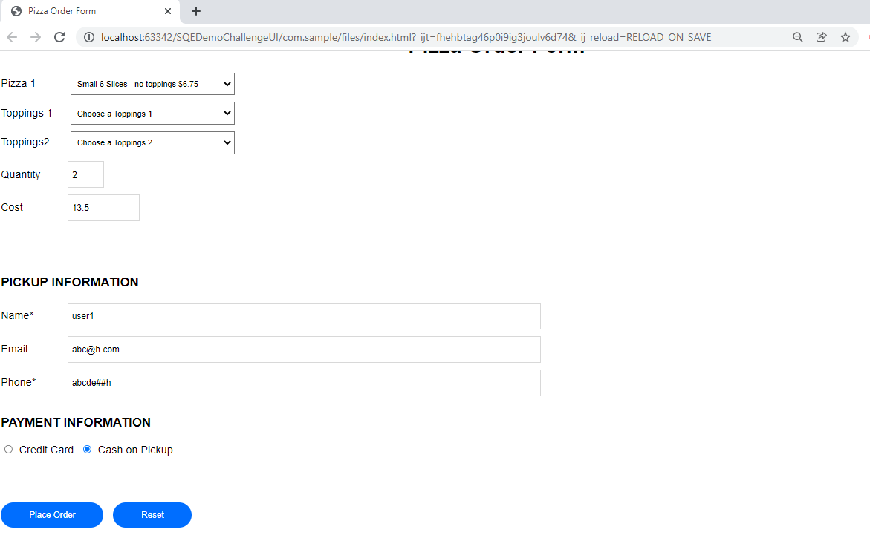

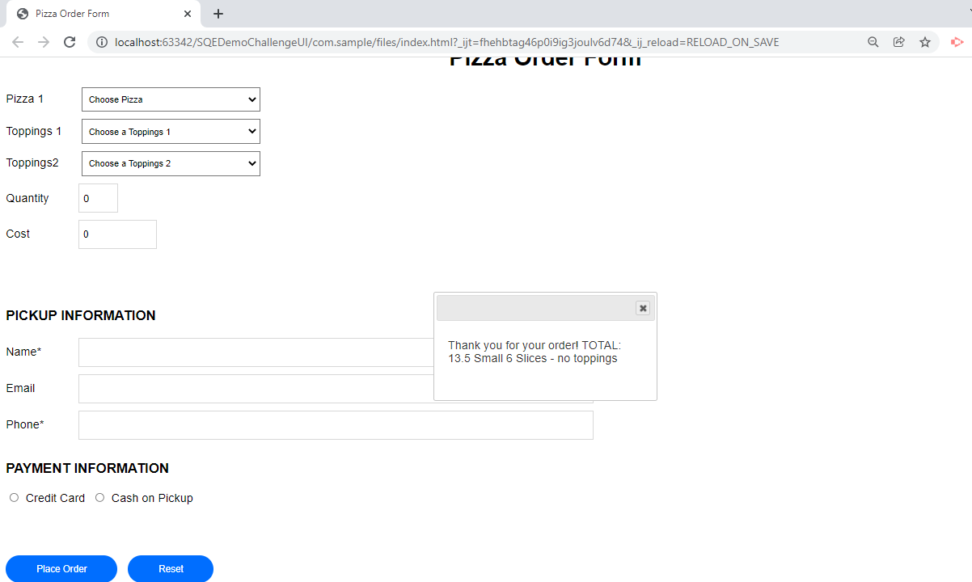

**Defect Id**: 10

**Defect Title**: Phone number field validation

**Defect Description:**

The application accepts phone number of any length and there is no validation done on maximum length and phone number should not cross 10 digits maximum length

**Steps to Reproduce**

* Launch application
* Fill in the pizza type and the toppings as per the pizza type
* Fill in the quantity value
* Fill in other details such as name, email value, invalid phone number, payment information
* Click on place order

**Test Data**

* Pizza Type: SMALL_ONETOPPINGS
* Pizza Toppings1: Olives
* Quantity: 2
* Name: user1
* Phone Number: absgdjjdjjdddddddddd########12338enbcdcccccccccccccc
* email: user@gmail.com
* Payment Option: Cash on Pickup

**Expected Result**

user should be able to see the error message that the phone is incorrect, only digits are allowed and user should not be able to place the order

**Actual Result**

User does not get any error message displayed when incorrect phone number is entered and also the order gets placed successfully.

**Priority**: High

**Severity**: High

**Requirement**: Email Field Validation

**Environment**: local

**Evidence**:

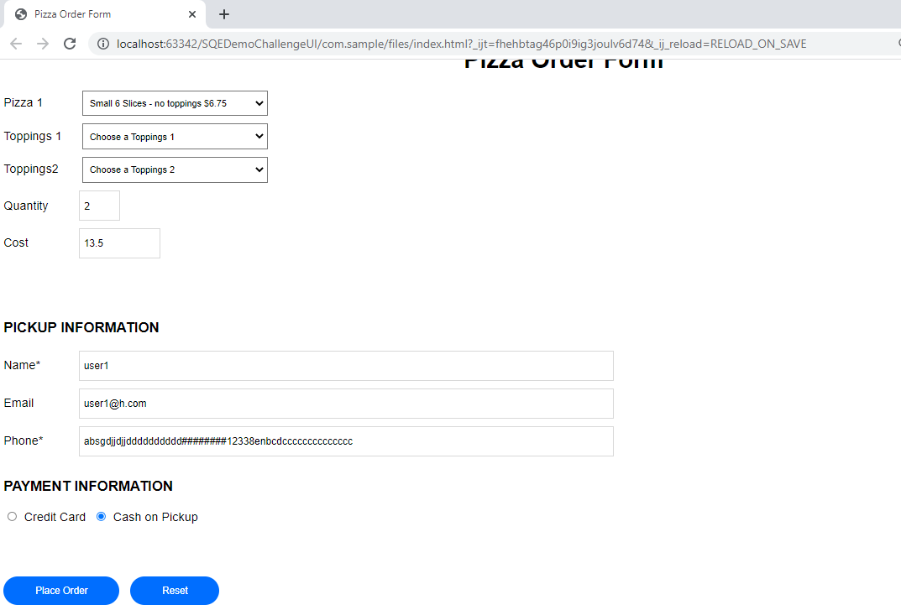

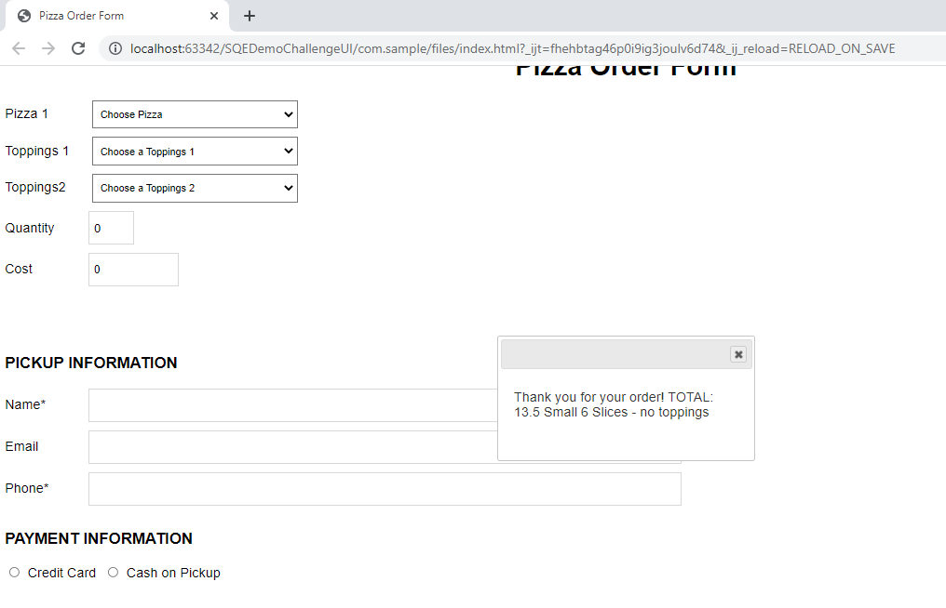

**Defect Id**: 11

**Defect Title**: Only one type of Payment Mode should be selectable

**Defect Description**:

The application accepts selection of all the payment modes ideally a radio button should select only 1 type and only one type of payment mode should be selected for an order

**Steps to Reproduce**

* Launch application
* Fill in the pizza type and the toppings as per the pizza type
* Fill in the quantity value
* Fill in other details such as name, email value, phone number
* Select all types of payment mode
* Click on place order

**Test Data**

* Pizza Type: SMALL_ONETOPPINGS
* Pizza Toppings1: Olives
* Quantity: 3
* Name: user1
* Phone Number: 1243771819
* email: user@gmail.com
* Payment Option: Credit Card, Cash on Pickup

**Expected Result**

User should be able to select only one type of payment mode and user should not be able to place the order

**Actual Result**

User can select multiple payment modes and the order gets placed successfully.

**Priority**: High

**Severity**: Critical

**Requirement**: Payment Mode Validation

**Environment**: local

**Evidence**:

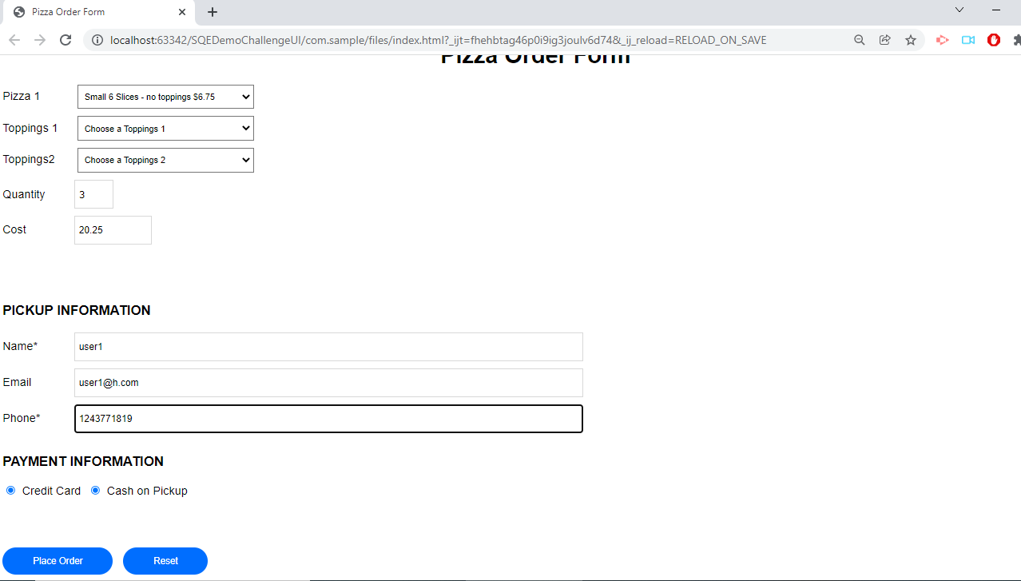

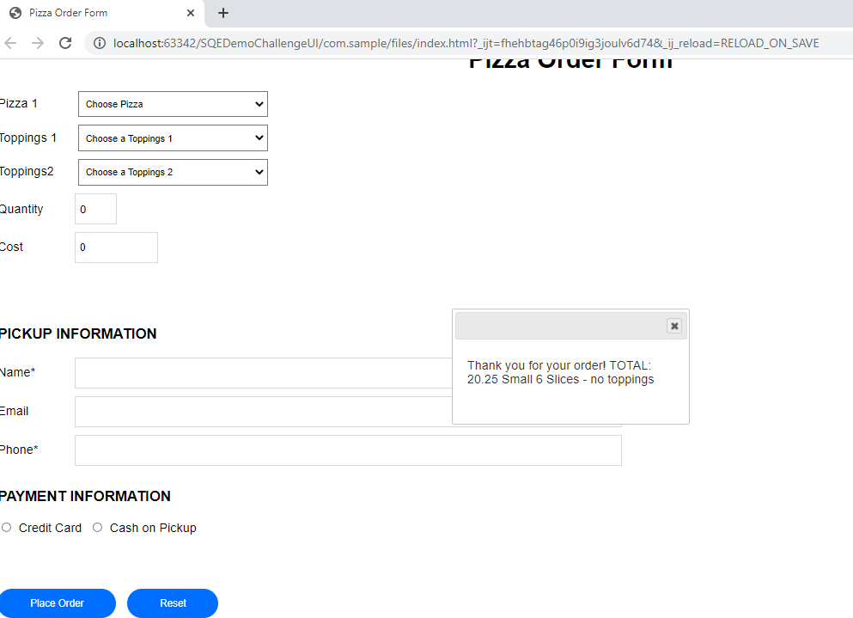

**Defect Id**: 12

**Defect Title**: Credit Card Payment Mode Not Working as Expected

**Defect Description**:

When user selects the credit card payment mode, the credit card details form does not appear and user is able to place the order without any error message

**Steps to Reproduce**

* Launch application
* Fill in the pizza type and the toppings as per the pizza type
* Fill in the quantity value
* Fill in other details such as name, email value, phone number
* Select credit card payment mode
* Click on place order

**Test Data**

* Pizza Type: SMALL_ONETOPPINGS
* Pizza Toppings1: Olives
* Quantity: 3
* Name: user1
* Phone Number: 1243771819
* email: user@gmail.com
* Payment Option: Credit Card

**Expected Result**

User should be able to see the credit card details form when the credit card is selected as the payment option

**Actual Result**

User does not see the credit card details form when the credit card is selected as the payment option and the order gets placed successfully.

**Priority**: High

**Severity**: Critical

**Requirement**: Payment Mode Validation

**Environment**: local

**Evidence**:

**Defect Id**: 13

**Defect Title**: Reset button is not working as expected

**Defect Description**:

When user fills in all the fields and then clicks on the reset button then all the fields are reset to initial values except the toppings 1 and toppings 2.

**Steps to Reproduce**

* Launch application
* Fill in the pizza type and the toppings as per the pizza type
* Fill in the quantity value
* Fill in other details such as name, email value, phone number
* Select credit card payment mode
* Click on reset button

**Test Data**

* Pizza Type: SMALL_ONETOPPINGS
* Pizza Toppings1: Olives
* Quantity: 3
* Name: user1
* Phone Number: 1243771819
* email: user@gmail.com
* Payment Option: Credit Card

**Expected Result**

User should be able to see all the values reset and a new form with all the fields again.

**Actual Result**

Toppings 1 and Toppings 2 drop down values are not getting reset

**Priority**: High

**Severity**: Critical

**Requirement**: Reset Button Validation

**Environment**: local

**Evidence**:

**Defect Id**: 14

**Defect Title**: After Clicking on Close button of the success or error dialog box the values are not getting reset

**Defect Description**:

When user fills in all the fields and then clicks on place order button, success or error dialog box appears. After clicking on the close button of the dialog box all the fields are reset except the toppings 1 and toppings 2 drop down

**Steps to Reproduce**

* Launch application
* Fill in the pizza type and the toppings as per the pizza type
* Fill in the quantity value
* Fill in other details such as name, email value, phone number
* Select credit card payment mode
* Click on place order button
* Click on close button of the success or error dialog box

**Test Data**

* Pizza Type: SMALL_ONETOPPINGS
* Pizza Toppings1: Olives
* Quantity: 3
* Name: user1
* Phone Number: 1243771819
* email: user@gmail.com
* Payment Option: Credit Card

**Expected Result**

User should be able to see all the values reset and a new form with all the fields again.

**Actual Result**

Toppings 1 and Toppings 2 drop down values are not getting reset

**Priority**: High

**Severity**: High

**Requirement**: Reset Button Validation

**Environment**: local

**Evidence**:

**Defect Id**: 15

**Defect Title**: Upon filling the name and phone number order is getting placed without filling payment details.

**Defect Description**:

When user fills in all the fields except payment field and then clicks on place order button, success dialog box appears.

**Steps to Reproduce**

* Launch application
* Fill in the pizza type and the toppings as per the pizza type
* Fill in the quantity value
* Fill in other details such as name, email value, phone number
* Click on place order button

**Test Data**

* Pizza Type: SMALL_ONETOPPINGS
* Pizza Toppings1: Olives
* Quantity: 3
* Name: user1
* Phone Number: 1243771819
* email: user@gmail.com

**Expected Result**

User should not be able to place the order when the payment details are not filled.

**Actual Result**

User can place the order as well as success dialog box appears

**Priority**: High

**Severity**: High

**Requirement**: Payment Details Should Be Mandatory

**Environment**: local

