Phishing Email Analysis Report (Task-02)

Intern Details
Name: J. Sahithi
Track: Cyber Security
Date: April 2026

Objective
The objective of this task is to analyze suspicious email messages and identify phishing indicators that may pose security risks. The task focuses on understanding how attackers craft fake emails to deceive users and steal sensitive information. By analyzing email headers and content, it becomes possible to detect spoofing attempts and malicious intent.
- Analyze phishing emails and identify security risks
- Understand attacker techniques and social engineering
- Check email authenticity using header analysis
- Detect SPF, DKIM, DMARC failures

Email Samples Analyzed
In this task, two phishing email samples were analyzed using professional tools and manual inspection techniques. The first email impersonates PayPal and attempts to trick users into verifying their account using a fake link. The second email mimics a security alert message and creates urgency to force the user to take immediate action. Both emails were designed to appear legitimate but contained multiple phishing indicators. These samples were selected to represent common real-world phishing scenarios. The analysis was performed using header analysis tools and manual observation. Each email was evaluated based on authenticity, content, and security indicators.

Tools Used
- Google Admin Toolbox – Header Analysis
- MXToolbox – Email Header Analyzer
- Used to check SPF, DKIM, DMARC
- Identify sender IP and blacklist status
- Analyze email routing path
- Manual inspection of links and domains

Header Analysis
The email headers were analyzed to understand the origin and authenticity of the messages. The results show that the emails were sent from suspicious domains that do not match official service providers. The sending server IP addresses were found to be untrusted and even listed in blacklists, indicating potential malicious activity. Authentication checks revealed that SPF validation failed, meaning the sender is not authorized to send emails on behalf of the domain. DKIM signatures were missing, and DMARC policies also failed, confirming the emails are not legitimate. These findings clearly indicate that the emails are spoofed and cannot be trusted.

Phishing Indicators Identified
- Fake sender domain (fakepaypal.com)
- Urgent subject line creates panic
- Impersonation of trusted brands
- Blacklisted mail server
- Fake sender domain (fakepaypal.com)
- Urgent subject line creates panic
- Impersonation of trusted brands
- Blacklisted mail server

Risk Classification
Risk classification is an important step in phishing email analysis, where emails are categorized based on their level of threat. It helps in determining how dangerous an email is and what action should be taken. The classification is done by analyzing various factors such as sender authenticity, email content, presence of suspicious links, and authentication results like SPF, DKIM, and DMARC. By evaluating these elements, security analysts can identify whether an email is safe, suspicious, or malicious. This process helps organizations respond quickly to potential threats and protect users from cyber attacks.
🟢 Safe (No Risk)
Safe emails are legitimate and come from trusted sources with proper authentication. SPF, DKIM, and DMARC checks pass successfully, confirming the sender’s identity. These emails do not contain suspicious links or misleading content. The domain matches the official organization, and there are no urgency or fear tactics used. Such emails follow standard communication patterns and are safe for users to interact with. However, users should still remain cautious and verify important information when needed.

🟡 Low Risk (Slightly Suspicious)
Low-risk emails may contain minor issues but are not clearly malicious. For example, the email might have slight formatting issues or unfamiliar wording. Authentication may partially pass, but some checks could be missing. The email content does not strongly indicate phishing but may still raise doubts. These emails do not aggressively ask for sensitive information. Users should verify the sender before taking any action. While not dangerous immediately, caution is still required.

🟠 Medium Risk (Suspicious)
Medium-risk emails show clear warning signs of phishing. The sender domain may look similar to a trusted domain but contains slight variations. The email may include suspicious links or attachments. Authentication checks like SPF or DKIM may fail or be missing. The message often creates urgency or asks the user to perform an action quickly. These emails can trick users if they are not careful. It is recommended to avoid interacting with such emails and verify through official channels.

🔴 High Risk (Phishing Email)
High-risk emails are confirmed phishing attempts with multiple strong indicators. The sender domain is fake or spoofed, and authentication checks such as SPF, DKIM, and DMARC fail completely. The email often contains urgent or threatening language to create panic. Links provided in the email usually lead to fake websites designed to steal user credentials. The sending server may also be blacklisted, indicating known malicious activity. These emails pose a serious threat and should be immediately reported and deleted. Users must never interact with such emails.

Prevention Tips
Users should always verify the sender’s email address before taking any action. It is important to avoid clicking on links from unknown or suspicious emails. Instead, users should visit official websites directly to check any alerts or notifications. Enabling Two-Factor Authentication (2FA) adds an extra layer of security to accounts. Email security tools and spam filters should be used to block phishing emails. Users should also be trained to recognize phishing attempts and report suspicious emails immediately. Following these practices can significantly reduce the risk of cyber attacks.

Do’s and Don’ts
- Verify email authenticity
- Report suspicious emails
- Do not share passwords
- Avoid urgent email traps
- Do not download unknown attachments
- Stay alert while checking emails

Evidence
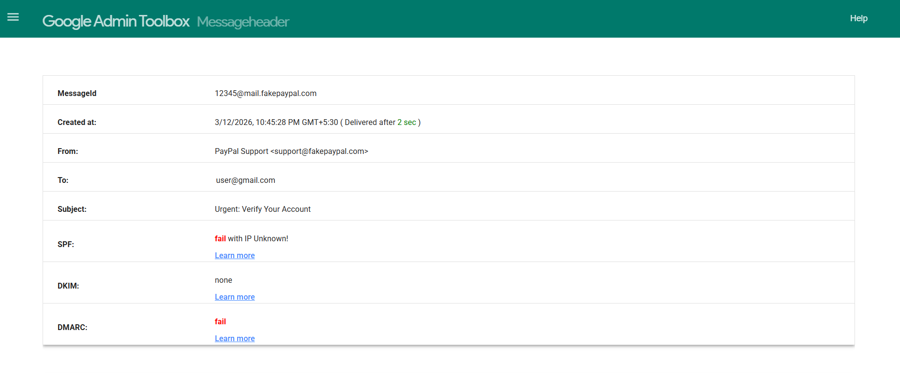
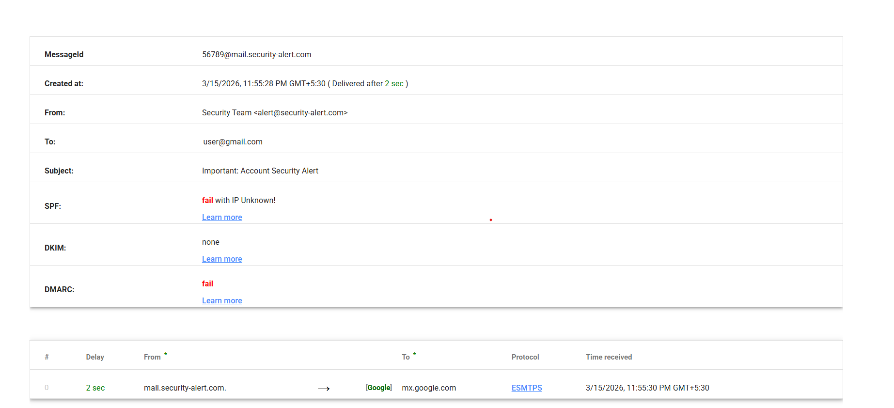
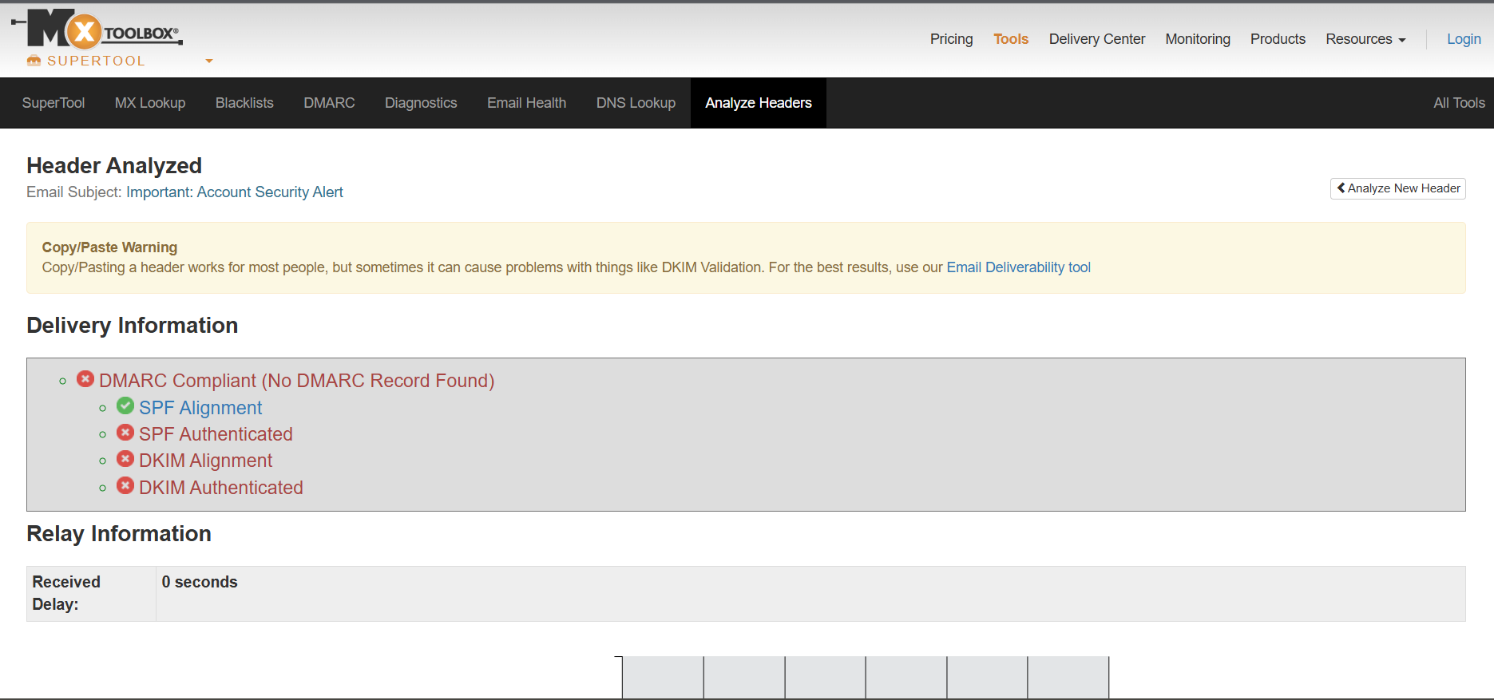
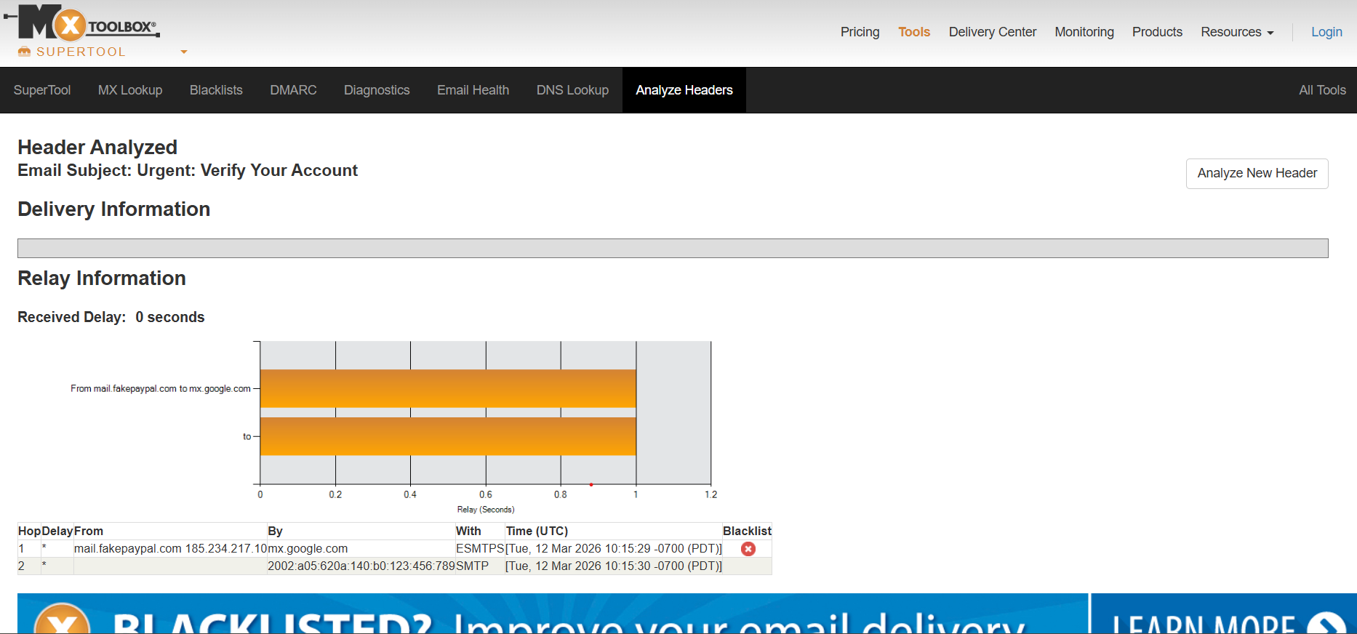
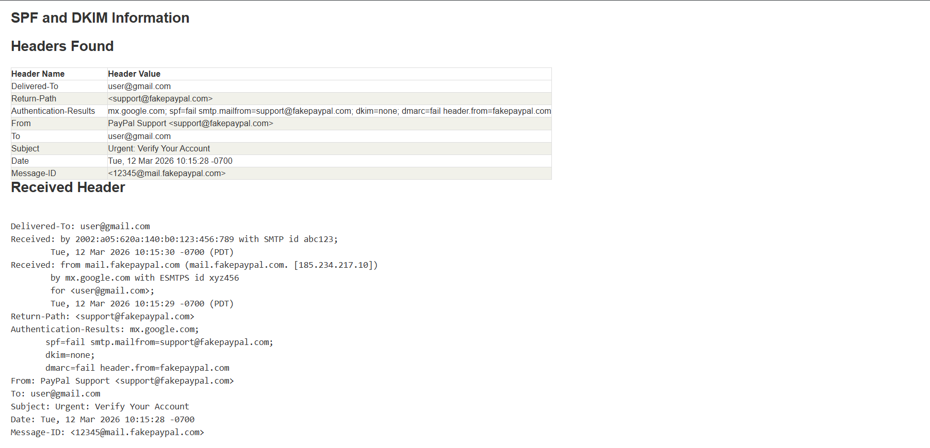

Conclusion
Phishing attacks are one of the most common cyber threats faced by individuals and organizations today. This analysis demonstrates how attackers use fake domains, authentication failures, and social engineering techniques to deceive users. By analyzing email headers and content, it becomes easier to identify malicious emails. The use of tools like Google Header Analyzer and MXToolbox helps in detecting spoofed emails effectively. Awareness and proper security practices are essential to prevent such attacks. Overall, this task highlights the importance of vigilance and cybersecurity knowledge in protecting digital assets.

