API Security Risk Analysis Report

Intern Details
- Name: J. Sahithi
- Role: Cyber Security Intern
- Organization: Future Interns
- Task: Task-03 – API Security Risk Analysis

Project Overview
Modern applications rely heavily on APIs (Application Programming Interfaces) to exchange data between systems such as mobile apps, web applications, and SaaS platforms. While APIs improve functionality and integration, insecure APIs can expose sensitive information and allow unauthorized access.
This project focuses on performing a security risk analysis on a public API to identify common vulnerabilities and provide appropriate remediation strategies.

Objective
- To analyze API endpoints using testing tools
- To identify common API security risks
- To evaluate authentication and authorization mechanisms
- To assess data exposure and response behavior
- To provide practical remediation recommendations

API Tested
- API Name: JSONPlaceholder
- Base URL: https://jsonplaceholder.typicode.com
- Type: Public REST API (Testing & Prototyping)

Tools Used
- Postman – API testing and request execution
- Web Browser – Reviewing API behavior
- Screenshot Tool – Capturing evidence

Methodology
The API was tested using a read-only and ethical approach. Various endpoints such as /users, /posts, and /comments were accessed using GET requests in Postman.
The responses were analyzed to check:
- Authentication requirements
- Authorization controls
- Data exposure
- API response structure
- Security headers
No exploitation or harmful actions were performed during this assessment.

Evidence (Screenshots)
GET /users

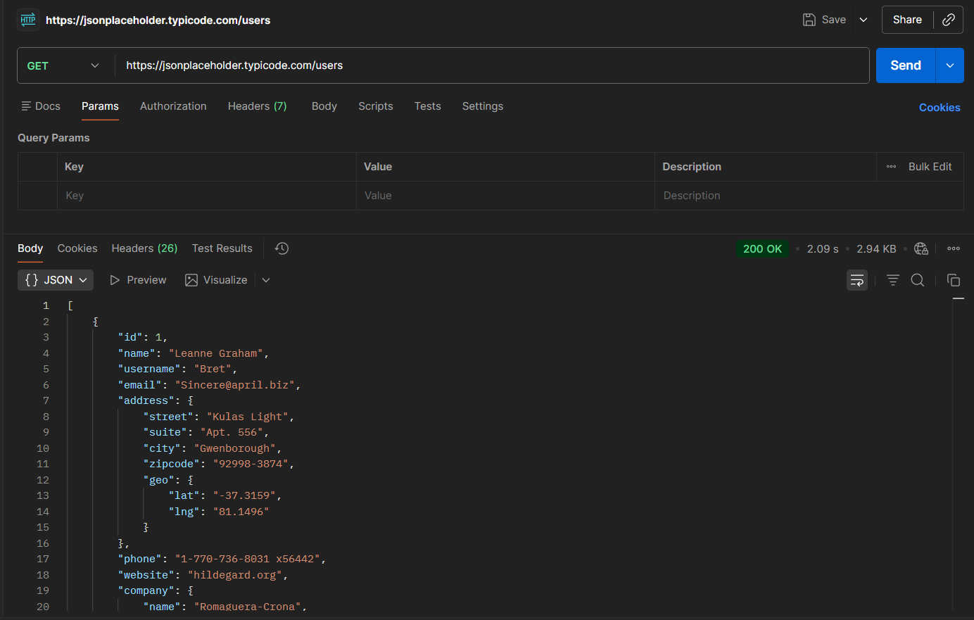

GET /users/1
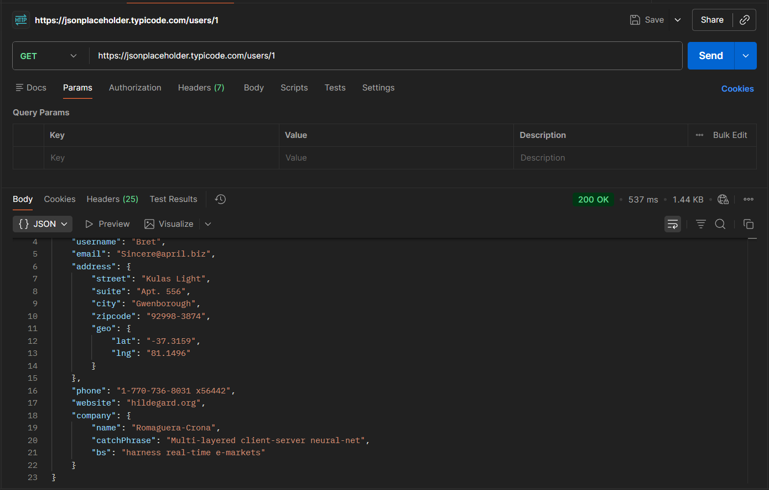

GET /posts
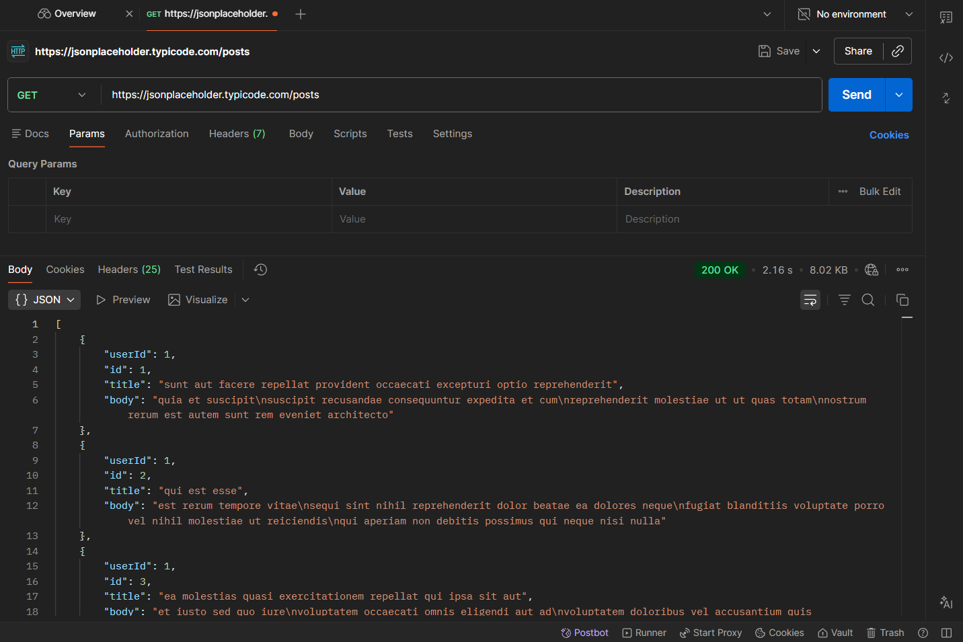

GET /comments
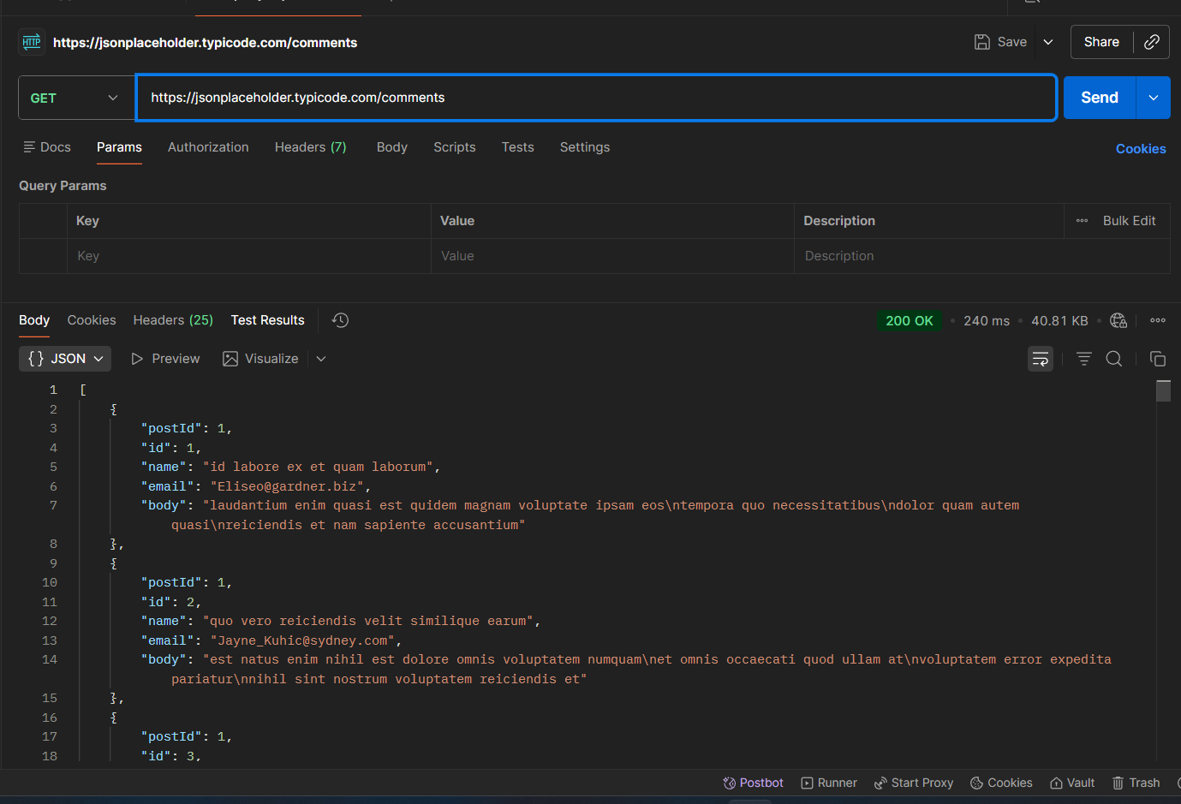

Identified Security Risks
1. No Authentication Mechanism
Description:
The API allows access to all endpoints without requiring authentication such as login credentials, API keys, or tokens.
Impact:
This allows any user to access data without verification, increasing the risk of unauthorized data usage and scraping.
Severity: High
Recommendation:
Implement authentication mechanisms such as JWT tokens, API keys, or OAuth to restrict access.

2. Broken Authorization
Description:
The API does not validate whether a user is authorized to access specific resources. By modifying endpoint IDs, users can access data belonging to others.
Impact:
This leads to unauthorized access to user data and potential privacy violations.
Severity: High
Recommendation:
Implement role-based or user-specific access control to ensure users can only access their own data.

3. Excessive Data Exposure
Description:
The API returns detailed user information including email, address, phone number, and company details, even when not required.
Impact:
Unnecessary data exposure increases the risk of sensitive information misuse.
Severity: Medium
Recommendation:
Limit API responses to only required fields and apply data filtering techniques.

4. No Rate Limiting
Description:
The API does not restrict the number of requests a client can make within a given time.
Impact:
Attackers can overload the API with repeated requests, potentially causing service disruption.
Severity: Medium
Recommendation:
Implement rate limiting and throttling to control API usage.

5. Missing Security Headers
Description:
The API responses lack important security headers that protect against common web vulnerabilities.
Impact:
This increases the risk of attacks such as cross-site scripting (XSS) and data interception.
Severity: Low
Recommendation:
Add security headers like Content-Security-Policy, X-Content-Type-Options, and Strict-Transport-Security.

Risk Summary
Risk | Severity
No Authentication | High
Broken Authorization | High
Excessive Data Exposure | Medium
No Rate Limiting | Medium
Missing Security Headers | Low

Recommendations
- Implement secure authentication methods
- Enforce proper authorization checks
- Reduce unnecessary data exposure
- Apply rate limiting to prevent abuse
- Include essential security headers

Conclusion
The security analysis of the JSONPlaceholder API revealed several common vulnerabilities such as lack of authentication, improper access control, and excessive data exposure.
Although the API is designed for testing purposes, these issues represent real-world risks when present in production systems. Addressing these vulnerabilities is essential to ensure data security, system reliability, and user trust.

Final Note
This project demonstrates practical understanding of API security concepts and the ability to analyze risks from a real-world security consultant perspective.

