**Design Thinking Project Workbook**

# Team Name: Diet Recommendation System

**Team Members:**

* Akshita kiran, ID: 2320030374
* Sriya Sahithi , ID: 2320090074
* Ravada Rajitha, ID: 2320030466

**1. Problem/Opportunity Domain**

* **Domain of Interest:** Personalized Diet Recommendation System
* **Description:** NutriGuide is an AI-driven system using NLP, machine learning, and user health profiling to provide tailored diet recommendations in real-time, promoting healthy lifestyles and preventing diet-related illnesses.
* **Why Chosen:** Poor dietary habits lead to serious health issues, and AI offers personalized, scalable solutions where traditional dietary advice may lack accessibility or customization.

**2. Problem/Opportunity Statement**

* **Problem Statement:** Inadequate access to personalized dietary advice contributes to poor health outcomes and diet-related diseases. Traditional methods are often expensive, unscalable, or lack customization. A real-time, automated solution is needed to provide accurate, individualized recommendations.
* **Problem Description:**
  + Manual consultations with dietitians are costly and time-consuming.
  + Generic diet plans may not suit individual health needs.
  + Poor dietary habits lead to long-term health issues.
* **Context:**Occurs when individuals aim to improve their health, manage medical conditions, or achieve fitness goals.
* **Alternatives:** Consulting dietitians, searching for information online, or using generic diet apps.
* **Customers:** Individuals with health goals, diet-conscious users, healthcare providers, and fitness enthusiasts..
* **Emotional Impact:** Customers feel overwhelmed, uninformed, or frustrated by generic advice.
* **Quantifiable Impact:** Poor diets contribute to obesity, diabetes, cardiovascular diseases, and other health issues.
* **Alternative Shortcomings:** Dietitians may be expensive, online information can be unreliable, and generic apps lack personalization.

**3. Addressing SDGs**

* **Relevant SDGs:** SDG 3 (Good Health and Well-Being): Promotes healthy diets, reducing diet-related diseases.SDG 9 (Industry, Innovation, Infrastructure): Fosters innovation in health tech through AI systems.SDG 17 (Partnerships for Goals): Encourages collaborations between healthcare providers, developers, and nutrition experts
* **How Addressed:** Encourages well-being through personalized health management, advances AI-driven healthcare solutions, and integrates partnerships for better outcomes.

**4. Stakeholders**

* **Key Stakeholders:** End-users (individuals and patients), Healthcare providers (dietitians, doctors),AI developers and data scientists, Fitness centres and wellness organizations, Policymakers and regulatory bodies, Nutrition researchers.
* **Roles:** Users provide feedback and input data, Healthcare providers contribute expertise, Developers build and refine the system, Fitness and wellness centers promote adoption, Policymakers regulate data privacy and healthcare compliance, educators use in teaching, Researchers ensure evidence-based recommendations.
* **Interests/Concerns:** Users: Easy-to-use and accurate recommendations,Providers: Maintain ethical standards and accuracy,Developers: Ensure system reliability and scalability,Fitness centers: Seamless integration with programs,Policymakers: Data privacy and healthcare regulations,Researchers: Ensure scientific validity of recommendations.
* **Influence:** Users drive adoption and provide data quality, Providers validate content credibility, ,Developers shape system capabilities, Policymakers ensure compliance,Researchers contribute to improvements.
* **Engagement:** Users access the system and give feedback, Providers validate dietary guidelines, Developers implement feedback and enhance features, Fitness centers advocate for its use, Policymakers oversee regulation, Researchers provide insights for updates.
* **Communication:** User feedback loops, Collaboration with dietitians and researchers, Data agreements with healthcare providers, API integrations with fitness platforms, Advocacy with policymakers on compliance, Educational workshops for user adoption.

**5. Power Interest Matrix of Stakeholders**

### High Power, High Interest (Manage Closely — Red Quadrant)

* Healthcare Providers (Dietitians, Doctors): Authority to validate and promote the system. Highly invested in ensuring personalized diet recommendations improve patient health outcomes.
* Developers/AI Engineers: — Responsible for designing, implementing, and optimizing the system. Highly involved in ensuring accuracy, scalability, and integration of the platform.

### High Power, Low Interest (Keep Satisfied — Yellow Quadrant)

* Investors/Funders: — Provide critical financial resources to develop and launch the system. Interested in returns but may not actively engage in the system's detailed functionalities.
* Regulatory Bodies (Health Authorities, Data Privacy Authorities): — Ensure compliance with health standards and data protection laws. May not have an ongoing operational interest in the system itself.

### Low Power, High Interest (Keep Informed — Blue Quadrant)

* End Users (Health-Conscious Individuals, Patients): — Actively use the system for personalized recommendations to meet dietary or health goals. Highly interested but have limited influence on development.
* Fitness Centers and Wellness Organizations: — Engage with the system for member benefits and enhanced fitness programs. Interested in the system's success but lack direct control.

### Low Power, Low Interest (Monitor — Green Quadrant)

* General Public — Indirectly benefits from widespread adoption of the system, improving public health awareness. Has limited interaction or interest unless directly impacted.

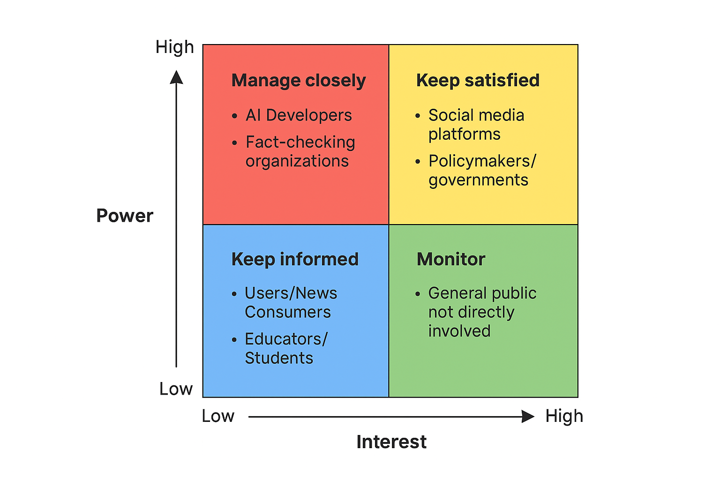

|  |  |  |
| --- | --- | --- |
| **User** | **Questions Asked** | **Insights Gained** |
| Naveen | What features do you expect in a health app? | Needs clarity and visual tracking of goals. |
| Deepthi | What diet changes have you tried? What works/doesn’t? | Wants guidance for healthy eating but feels confused with online advice. |
| Anvitha | How do you feel about your current eating habits? | Wishes for easy meal plans that match her fitness goals. |
| Karthik | What challenges do you face in sticking to a diet | Finds it hard to maintain motivation and track what he eats. |

**6. Empathetic Interviews**

**Empathy Map**

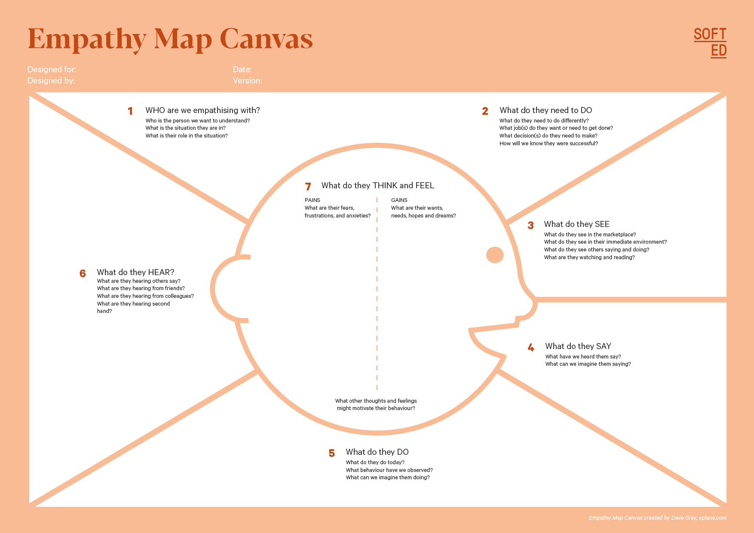

Your Answer:Insights from other on how AI-driven Task Management system improve their productive.

Industry experts emphasizing data-driven time management.

Feedback from customers about Task managing in time issues.

Your Answer:Students,Shop keepers and House wives looking to management time and complete their tasks in time.

Who is your Customer Segment:

Students,

Shop keepers,  
House wives

Idea/Innovation Title: AI-Powered Task Management System

Designed By:Nandini

Date of Submission: 25/03/25

Your Answer:Uncertainty in not knowing how to actually use it for their use. Fear of not able to still complete the Task in time

Your Answer:AI-driven insights for better management of time and planning tasks.

Reduced stress because of in time completions.

Your Answer:Difficulty in managing time across multiple Tasks.

Your Answer: Manage time and help you to complete the task before the deadline

Your Answer:Fluctuating in time due to missing the completion of task and external factors.,Increasing use of AI-driven analytics tools in competitive companies.

Your Answer:"We need an AI model that improves productivity to help us plan manage our time .",

"Managing time without proper insights leads to stress later and less productivity."

"If we could manage time better, we could make better future and be productive."

Your Answer:Analyze past Datasets manually ,adjust timing and working strategies based on intuition rather than data,seek AI-driven solutions but find implementation challenging.

**7. Empathy Map**

**a. Who is your customer?  
 Description: Sravani, 20 y/o student**

* Busy schedule, forgets meals, struggles with fitness goals.
* Found Nutri Guide helpful to maintain energy and consistency.

**b. Who are we empathizing with?**

1. Students juggling classes and fitness.
2. Professionals lacking time for meal planning.
3. Users needing motivation to stick to a plan.

**8. Persona of Stakeholders**

**Name:** Sravani  
**Demographics:** 20 y/o, urban student  
**Goals:** Maintain energy, lose weight, save time on planning  
**Challenges:** Academic stress, poor eating routine  
**Aspiration:** Achieve a balanced lifestyle  
**Needs:** Quick, reliable diet guidance  
**Pain Points:** Generic app advice, time-consuming planning

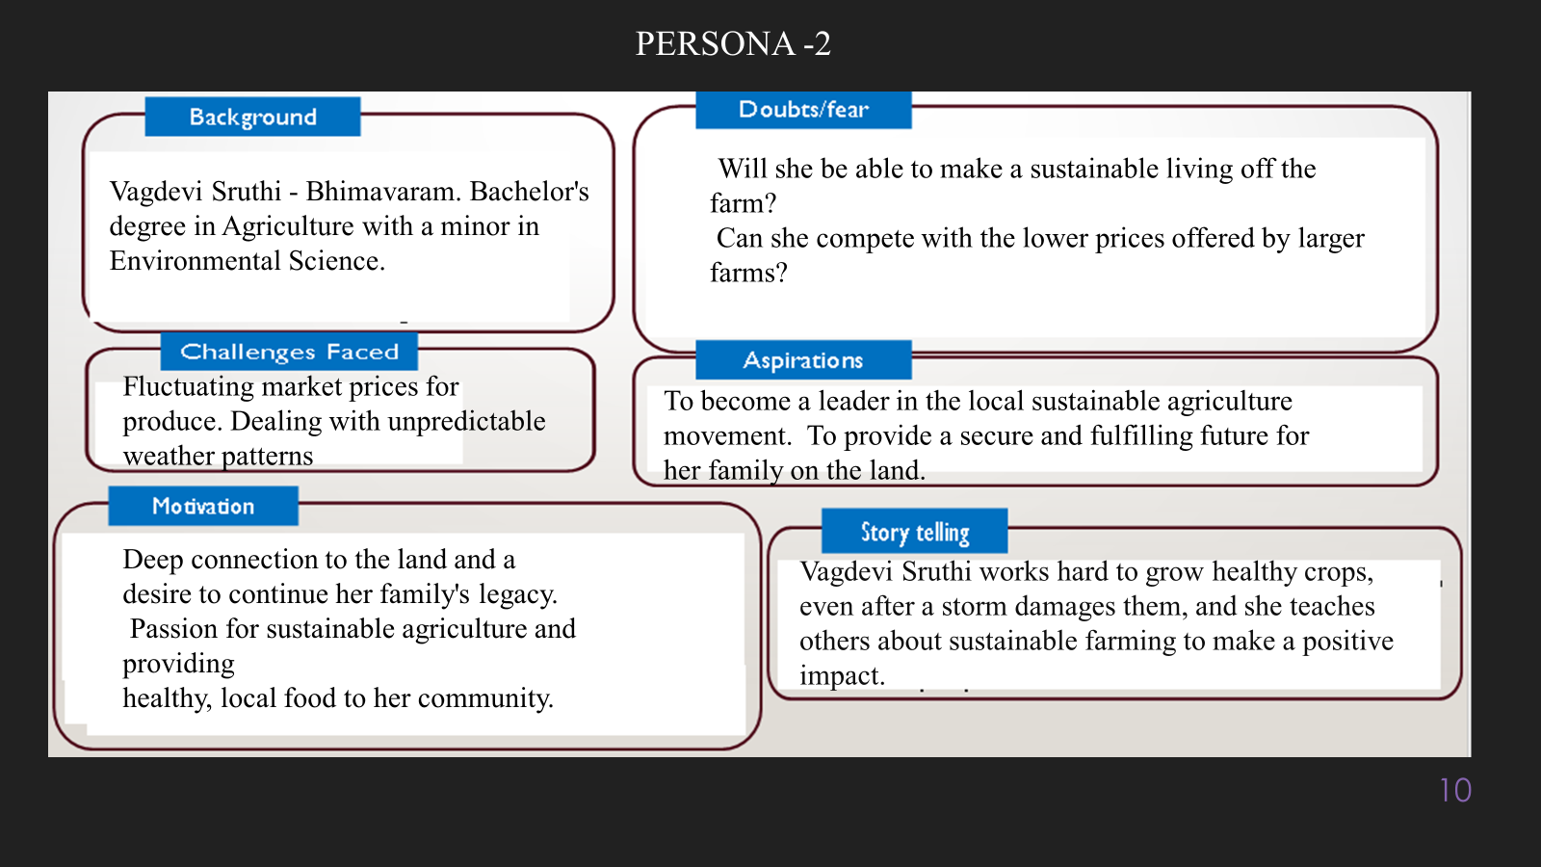

**10. Common Themes, Behaviours, Needs, and Pain Points**

**Themes:** Users want personalized, goal-based diet recommendations. Simplicity, trust in AI, and real-time help are key desires.

**Behaviours:** Most users try various diets, often switch between apps, and rely on social media or unverified sources.

**Needs:** Customized diet plans, reminders, progress tracking, and integration with lifestyle (like work schedule or food habits).

**Pain Points:** Generic diet apps, lack of motivation, difficulty sticking to plans, confusing interfaces, and overwhelming food options.

**12. Define Needs and Insights of Your Users**

**User Needs:**

* Personalized and adaptive recommendations
* Simple interface
* Accurate, data-backed suggestions

**User Insights:**

* Prefer automation
* Want integration with wearables/fitness apps
* Seek clarity and education about their choices

**13. POV Statements:**

|  |  |  |  |
| --- | --- | --- | --- |
| PoV Statements | Role-based or Situation-Based | Benefit, Way to Benefit, Job TBD, Need (more/less) | PoV Questions |
| A student managing fitness | **Personalized meals** | **Health improvement** | **How might we adapt diets to changing routines?** |
| A diabetic user | Sugar control | Prevent spikes | How might we suggest meals based on real-time glucose levels? |
| A fitness coach | Diet plans for clients | Improve outcomes | How might we support client goals using our system? |
| A busy mom | Easy meal planning | Save time | How might we automate healthy meal plans for families? |
| A dietitian | Track user adherence | Better care | How might we connect dietitians with user progress? |
| An office worker | Snack suggestions | Boost energy | How might we recommend healthy snacks based on time of day? |
| An elderly person | **Balanced nutrition** | Maintain wellness | How might we simplify nutrition guidance for older users? |
| A vegan | Avoid allergens | Ensure dietary needs | How might we customize plans by dietary restrictions? |

**14. Develop POV/How Might We (HMW)**

* How might we ensure diet recommendations adapt to real-time health data?
* How might we simplify the process of healthy grocery shopping?
* How might we help users build consistent healthy eating habits?
* How might we provide offline access to essential features?
* How might we improve user trust in AI recommendations?

**16. Crafting a Balanced and Actionable Design Challenge**

Design an AI-powered diet recommendation system that enhances healthy lifestyle choices, automates meal planning, adapts to personal needs, and integrates with health data—improving nutrition and wellness for diverse user groups.

**17. Validating the Problem Statement**

**Validation Plan:**

|  |  |  |  |
| --- | --- | --- | --- |
| **Stakeholder/User** | **Role** | **Feedback on Problem Statement** | **Suggestions for Improvement** |
| Working Women | End Users | Found diet planning stressful | Add quick meal ideas for busy days |
| Fitness Coach | Professional   |  | | --- | |  |  |  | | --- | |  | | Wants integration with wearables | Include step and calorie tracking |
| Dietitian | Expert | Appreciated AI recommendations | Wants a way to customize templates |
| Developers | Tech Team | System needs scalability | Focus on modular backend design |

**18. Ideation**

**Ideation Process:**

|  |  |  |  |
| --- | --- | --- | --- |
| Idea Number | Proposed Solution | Key Features/Benefits | Challenges/Concerns |
| Idea 1 | **AI Personalized Meal Plans** | **Tailored to health data** | **Ensuring data privacy** |
| Idea 2 | **Real-Time Data Integration** | **Real-time diet feedback** | **Compatibility issues** |
| Idea 3 | **Smart Grocery Planner** | **Auto-generate list** | **Sync** |
| Idea 4 | **Dynamic Plan Adjustments** | **Update based on user feedback** | **Real-time data handling** |
| Idea 5 | **Recipe Suggestions by Goal** | **Based on weight, BMI** | **Localization of content** |

**Solution Concept Form**

**1. Problem Statement:**

* **Poor dietary habits and lack of personalized advice lead to health challenges, creating a need for an AI-powered diet recommendation system.**

**2. Target Audience:**

* **Health-conscious individuals, dietitians, healthcare providers, fitness enthusiasts, and families.**

**3. Solution Overview:**

* **An AI-driven personalized diet recommendation platform that integrates health data for customized and actionable advice.**

**4. Key Features:**

| **Feature** | **Description** |
| --- | --- |
| **Feature 1** | **Personalization through health profiles and goals.** |
| **Feature 2** | **Automated meal planning and grocery list creation.** |
| **Feature 3** | **Integration with fitness trackers and health apps.** |

**5. Benefits:**

| **Benefit** | **Description** |
| --- | --- |
| **Benefit 1** | **Simplifies dietary planning for users with busy lifestyles.** |
| **Benefit 2** | **Educates users on nutritional impacts for healthier choices.** |
| **Benefit 3** | **Adapts plans based on evolving health needs and metrics.** |

**6. Unique Value Proposition (UVP):**

* **Combines scientific accuracy and real-time adaptability to meet individual dietary needs.**

**7. Key Metrics:**

**Adoption rate, user satisfaction, health improvements, ease of use, retention rate, and system reliability.**

**8. Feasibility Assessment:**

**Uses existing AI tools, scalable to broad demographics, integrates with APIs for health data.**

**9. Next Steps:**

* **Research user preferences and dietary habits.**
* **Develop the system architecture and core features.**
* **Test prototypes with target groups for feedback.**
* **Launch and refine based on real-world use.**