*A Project Report on*

**“WAR FIELD RF CONTROLLED BASED SPY ROBOT”**

*Submitted in the partial fulfillment of the requirements for the award of degree*

**BACHELOR OF TECHNOLOGY**

**IN**

**ELECTRONICS AND COMMUNICATION ENGINEERING**

***Submitted By***

**G. SAHITHI K.IMMANIUEL DAS**

**K. ANIL KUMAR A.MAHESH**

*Under the esteemed guidance of*

**Mrs.P.Radhika Lakshmi, M.Tech**

**Assistant Professor, Dept. of ECE**



**DEPARTMENT OF**

**ELECTRONICS AND COMMUNICATION ENGINEERING**

**TIRUMALA ENGINEERING COLLEGE**

**(AFFILIATED TO JNTU, KAKINADA)**

**NARASARAOPET – 522601**

**ANDHRA PRADESH**

**2013-2014**

**TIRUMALA ENGINEERING COLLEGE**

**(AFFILIATED TO JNTU, KAKINADA)**

**DEPARTMENT OF**

**ELECTRONICS AND COMMUNICATION ENGINEERING**

**NARASARAOPET – 522601**



**CERTIFICATE**

This is to certify that the Project work entitled ***“*WAR FIELD RF CONTROLLED SPY ROBOT”** is a bonafide work done by **G.SAHITHI (10NE1A0428), K.IMMANIUEL DAS (10NE1A0464), K.ANIL KUMAR(10NE1A0458), A.MAHESH(10NE1A401)**submitted in partial fulfillment for the award of the degree of Bachelor of Technology in Electronics and Communication Engineering from Jawaharlal Nehru Technological University Kakinada during the academic year 2013-2014 under our guidance and supervision.

**Project Guide Head of the Department**

Mrs.P.RADHIKA LAKSHMI, M.Tech

Assistant Professor,

Department of ECE.

**External Examiner**

**DECLARATION**

We are the students of Tirumala Engineering College hereby declare that this project work entitled **“WAR FIELD RF CONTROLLED SPY ROBOT”** being submitted to the Department of ECE, TMLN affiliated to JNTU, Kakinada for the award of BACHELOR OF TECHNOLOGY in Electronics and Communication Engineering is a record of bona fide work done by me and it has not been submitted to any other Institute or University for the award of any other degree or prize.

**Project Associates**

**G. SAHITHI**

**K. IMMANIUEL DAS**

**K. ANIL KUMAR**

**A. MAHESH**

**ACKNOWLEDGEMENT**

A successful project is a fruitful culmination of efforts by many people, some were directly involved and some others quickly encouraged and supported from the background. We owe a great many thanks to a great many people who helped and supported us during the accomplishment of the project.

We would like to gratefully acknowledge our project Guide, **Mrs.P.RADHIKA LAKSHMI, M.Tech, Assistant Professor,** has been abundantly helpful and has assisted us in numerous ways. We specially thank her for infinite patience. The discussions we had with him were invaluable.

We take immense pleasure in thanking of our beloved Head of the Department, **Mr.M.H.H.Sastry,M.Tech** Electronics and Communication Engineering, Tirumala engineering college for having permitted us to carry out this project work.

We take immense pleasure in thanking of our beloved Principal, **Dr**. **Y.V.NARAYANA, B.Tech, M.E, Ph.D., FIETE,** Tirumala engineering college for having permitted us to carry out this project work.

We are grateful to our college management for providing us excellent lab facilities and inspiring us through their valuable messages.

Finally we would like to thank all of our friends and family members for their continuous help and encouragement.

**Project Associates**

**G. SAHITHI**

**K. IMMANIUEL DAS**

**K. ANIL KUMAR**

**A. MAHESH**

**ABSTRACT**

This is a robotic application used in Intelligence department and Military application. The physical structure of these robots looks like some house hold equipment or a simple toy nobody will suspect that these are robotic equipment. For example, a simple ball. These are complete wireless controlled robots which can be navigated remotely will contain a wireless camera. By seeing the visual data, we can navigate these robots. These robots will send secret information to the base station so that we can be prepared for facing it.

Out new robot is pc operated, it has got two-barrel turret through bullet can be fired, pc camera in synchronization with the turret can rotate up and down, left and right up to a safe firing limit. turret and camera mechanism has been installed on my spy robot vehicle, which has all the function like tank, Turing to any angle on its axis, moving forward and the reverse directions.   
 This robot is radio operated self-powered, and has all the controls like a normal car. A pair of laser gun has been installed on it, so that it can fire on enemy remotely when required this is not possible until a wireless camera is installed. Wireless camera will send real time video and audio signals which could be seen on a remote monitor and action can be taken accordingly. It can silently enter into enemy area and send us all the information through its’ tiny camera eyes.

***TABEL OF CONTENTS Pg.no***

LIST OF FIGURES vii

LIST OF TABLES viii

ABSTRACT ix

CHAPTER-1 1

**1. INTRODUCTION**

1.1 OBJECTIVE OF THE PROJECT 1

1.2 ORGANIZATION OF THE PROJECT 2

CHAPTER-2

**2.OVERVIEW OF THE TECHNOLOGIES USED**  3

2.1 EMBEDDED SYSTEMS 3

2.2 RF TECHNOLOGY 4

CHAPTER-3

**3.HARDWARE IMPLEMENTATION OF THE PROJECT** 6

3.1 PROJECT DESIGN 6

3.1.1 BLOCK DIAGRAM OF THE PROJECT AND ITS DESCRIPTION 7

3.2 POWER SUPPLY 8

3.3 MICROCONTROLLERS 10

3.4 RF TECHNOLOGY 25

3.5 SWITCHES AND PUSH BUTTONS 29

3.6 L293D-CURRENT DRIVER 31

3.7 ELECTRIC MOTORS 32

CHAPTER-4

4**.FIRMWARE IMPLEMENTATION OF THE PROJECT DESIGN** 43

4.1 SOFTWARE TOOLS REQUIRED 43

4.1.1 PROGRAMMING MICRO CONTROLLER 43

CHAPTER-5

**5. RESULTS** 51

**CONCLUSION** 53

**SPR ROBOT IN FUTURE**  54

**REFERENCES** 55

***LIST OF FIGURES***

**FIGURES Pg No**

3.1Block Diagram of Section 7

3.2 Block Diagram of RPS 8

3.3 Flow chart of PIC 13

3.4: Pre-scaler and Post-scaler 23

3.5.1: RF Transmitter 27

3.5.2: RF Receiver 28

3.6: Switches Structure 28

3.7: Switches interfacing to controller 29

3.8: Magnetic field effect 32

3.9: DC Motors 32

3.10: Commutator 33

3.11: Magnetic Pole Directions 34

3.12: Single Phase 36

3.13: Three Phase 36

5.1 Implementing stage of Spy robot 46

5.2 Hardware implementation of Spy robot 47

***LIST OF TABLES***

**TABELS**  **Pg No**

2.1 Frequency range of RF 5

3.1 STATUS Register 11

3.2 Interrupts in PIC 14

3.3 STATUS Register (16FX) 17

3.4 Program Memory 18

3.5 EECON1 Structure 19

3.6.1 T1CON Register 22

3.6.2 T2CON Register 23

3.7.1 Postscaler data 24

3.7.2 Prescaler data 24

3.8 Movement of Motor 30

3.9 Motor Ratings 35

3.10 Operational Specifications of Motors 38

**CHAPTER 1**

1. **INTRODUCTION**

War field spy robot is an exclusive project where the direction of the movement of Robot can be changed using wireless technologies. The Robot will be placed different from that of from where it is controlled. This project can also be carried out using wiring processes. But the main disadvantage when we go for wiring is that, data transmission and reception may not be perfect and the data may be lost if the wiring is not done properly. Thus, the Robot movement is controlled using wireless concept in this project. In this project, the controlling of the Robot is done from the transmitter and this information will be passed to the Robot in a wireless fashion.

To control the direction of the Robot, predefined keys has to give as commands from the transmitter section. The data from the transmitter section is transmitted and will be received by microcontroller at the receiver section. The data, while before being transmitted, will be converted into a format suitable for transmission. i.e., data will be encoded.

* 1. **OBJECTIVE OF THE PROJECT**

The project aims at making the robot to move in a particular direction, connected at the receiver side, specified by the user at the transmitter side using RF technology. The project uses the Microcontroller, Dc Motors, Ir Transmitter and Receiver Circuit, Drivers, Regulators, Power supply andEmbedded Systems to design this application. The main objective of this project is to design a system that continuously checks for the data received from the transmitter section and also monitor video captured by the and transmit the same to remotely placed TV or a PC and we can even attack by firing the gun attached to this robot if the target is confirmed.

This project is a device that collects data from the transmitting section, codes the data into a format that can be understood by the controlling section. This receiving section controls the direction of the robot as per the command received from the transmitter section.

The objective of the project is to develop a microcontroller based control system. It gives the secret information about the intruders. It resembles the shape of a ball. So, no one can identify it.

**BACK GROUND OF THE PROJECT**

The software application and the hardware implementation help the microcontroller read the data received from the transmitter section and accordingly change the direction of the robot. The performance of the design is maintained by controlling unit.

**1.2 ORGANIZATION OF THE PROJECT**

In view of the proposed thesis work explanation of theoretical aspects and algorithms used in this work are presented as per the sequence described below.

Chapter 1 describes a brief review of the objectives and goals of the work.

Chapter 2 describes the existing technologies and the study of various technologies in detail.

Chapter 3 describes the Block diagram, Circuit diagram of the project and its description. The construction and description of various modules used for the application are described in detail.

Chapter 4 explains the Software tools required for the project, the Code developed for the design.

Chapter 5 presents the results, overall conclusions of the study and proposes possible improvements and directions of future research work.

**CHAPTER 2**

**2.OVERVIEW OF THE TECHNOLOGIES USED**

**2.1 EMBEDDED SYSTEMS:**

An embedded system can be defined as a computing device that does a specific focused job. Appliances such as the air-conditioner, VCD player, DVD player, printer, fax machine, mobile phone etc. are examples of embedded systems. Each of these appliances will have a processor and special hardware to meet the specific requirement of the application along with the embedded software that is executed by the processor for meeting that specific requirement.

The embedded software is also called “firm ware”. The desktop/laptop computer is a general purpose computer. You can use it for a variety of applications such as playing games, *word* processing, accounting, software development and so on.

In contrast, the software in the embedded systems is always fixed listed below: Embedded systems do a very specific task, they cannot be programmed to do different things. Embedded systems have very limited resources, particularly the memory. Generally, they do not have secondary storage devices such as the CDROM or the floppy disk. Embedded systems have to work against some deadlines. A specific job has to be completed within a specific time. In some embedded systems, called real-time systems, the deadlines are stringent. Missing a deadline may cause a catastrophe-loss of life or damage to property. Embedded systems are constrained for power. As many embedded systems operate through a battery, the power consumption has to be very low.

Some embedded systems have to operate in extreme environmental conditions such as very high temperatures and humidity.

Following are the advantages of Embedded Systems:

1. They are designed to do a specific task and have real time performance constraints which must be met.
2. They allow the system hardware to be simplified so costs are reduced.
3. They are usually in the form of small computerized parts in larger devices which serve a general purpose.

The program instructions for embedded systems run with limited computer hardware resources, little memory and small or even non-existent keyboard or screen.

**2.2 RF TECHNOLOGY:**

**RF** refers to **radio frequency**, the mode of communication for wireless technologies of all kinds, including cordless phones, radar, ham radio, GPS and radio and television broadcasts. RF technology is so much a part of our lives we scarcely notice it for its ubiquity. From baby monitors to cell phones, Bluetooth to remote control toys, RF waves are all around us. RF waves are electromagnetic waves which propagate at the speed of light, or 186,000 miles per second (300,000 km/s). The *frequencies* of RF waves, however, are slower than those of visible light, making RF waves invisible to the human eye.

The frequency of a wave is determined by its oscillations or cycles per second. One cycle is one hertz (Hz), 1,000 cycles is 1 kilohertz (KHz). A station on the AM dial at 980, for example, broadcasts using a signal that oscillates 980,000 times per second or has a frequency of 980 KHz. A station a little further down the dial at 710 broadcasts using a signal that oscillates 710,000 times a second, or has a frequency of 710 KHz. With a slice of the RF pie licensed to each broadcaster, the RF range can be neatly divided and utilized by multiple parties.

Every device in the United States that uses RF waves must conform to the Federal Communications Commission's ([FCC](http://www.wisegeek.com/what-is-the-fcc.htm)) regulations. A baby monitor, for example, must operate using the designated frequency of 49 MHz. Cordless phones and other devices have their own designated frequencies.

The FCC shares responsibility for RF assignment with the National Telecommunications and Information Administration (NTIA), which is responsible for regulating *federal* uses of the RF spectrum. At present, according to the FCC, frequencies from 9 KHz — 275 GHz have been allocated, with the highest bands reserved for satellite and radio astronomy.

The sample chart below lists some of the major categories with approximate RF ranges. In actuality, there are no gaps between categories, as hundreds of other uses are also assigned, from [garage](http://www.wisegeek.com/what-is-a-garage.htm) door openers and alarm systems to amateur radio and emergency broadcasting.

**Table 2.1 Frequency range of RF**

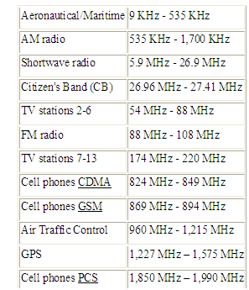

The RF table is divided and labeled according to frequency, with *extremely low frequency* (ELF) occupying one end at just 3-30 Hz, and *extremely high frequency* (EHF) at the other, representing 30-300 GHz. The RF bands most of us are familiar with are VHF (very high frequency), used by radio and television stations 2-13, and [UHF](http://www.wisegeek.com/what-is-uhf.htm) (ultra high frequency), used by other television stations, mobile phones and two-way radios. Microwave ovens even use RF waves to cook food, but these waves are in the *super high frequency band* or SHF. Following the electromagnetic spectrum into even higher frequencies, one finds [infrared](http://www.wisegeek.com/how-does-infrared-work.htm) waves, and finally visible light.

**CHAPTER 3**

**3. HARDWARE IMPLEMENTATION OF THE PROJECT**

This chapter briefly explains about the Hardware Implementation of the project. It discusses the design and working of the design with the help of block diagram and circuit diagram and explanation of circuit diagram in detail. It explains the features, timer programming, serial communication, interrupts of AT89S52 microcontroller. It also explains the various modules used in this project.

**3.1 PROJECT DESIGN**

The implementation of the project design can be divided in two parts.

* Hardware implementation
* Firmware implementation

Hardware implementation deals in drawing the schematic on the plane paper according to the application, testing the schematic design over the breadboard using the various IC’s to find if the design meets the objective, carrying out the PCB layout of the schematic tested on breadboard, finally preparing the board and testing the designed hardware.

The firmware part deals in programming the microcontroller so that it can control the operation of the IC’s used in the implementation. In the present work, we have used the MPLAB 8.60 software development tool to write and compile the source code, which has been written in the C language. The Proload programmer has been used to write this compile code into the microcontroller. The firmware implementation is explained in the next chapter.

The project design and principle are explained in this chapter using the block diagram and circuit diagram. The block diagram discusses about the required components of the design and working condition is explained using circuit diagram and system wiring diagram.

**3.1.1 BLOCK DIAGRAM OF THE PROJECT AND ITS DESCRIPTION**

The block diagram of the design is as shown in Fig 3.1. It consists of power supply unit, microcontroller,RF transmitter and receiver section and the robot arrangement. The brief description of each unit is explained as follows.

**Transmitter section**

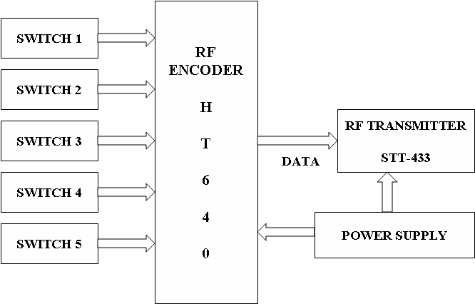

**Receiver section**

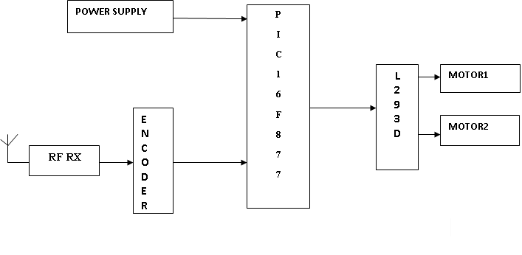

**Figure 3.1 Block Diagram of Section**

**3.2 POWER SUPPLY:**

The input to the circuit is applied from the regulated power supply. The a.c. input i.e., 230V from the mains supply is step down by the transformer to 12V and is fed to a rectifier. The output obtained from the rectifier is a pulsating d.c voltage. So in order to get a pure d.c voltage, the output voltage from the rectifier is fed to a filter to remove any a.c components present even after rectification. Now, this voltage is given to a voltage regulator to obtain a pure constant dc voltage.

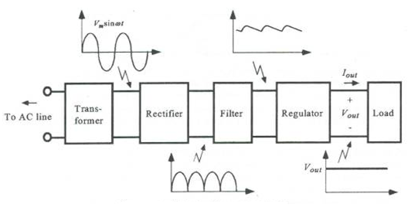

**Figure 3.2 Block Diagram of RPS**

**Transformer:**

Usually, DC voltages are required to operate various electronic equipment and these voltages are 5V, 9V or 12V. But these voltages cannot be obtained directly. Thus the a.c input available at the mains supply i.e., 230V is to be brought down to the required voltage level. This is done by a transformer. Thus, a step down transformer is employed to decrease the voltage to a required level.

**Rectifier:**

The output from the transformer is fed to the rectifier. It converts A.C. into pulsating D.C. The rectifier may be a half wave or a full wave rectifier. In this project, a bridge rectifier is used because of its merits like good stability and full wave rectification.

**Filter:**

Capacitive filter is used in this project. It removes the ripples from the output of rectifier and smoothens the D.C. Output received from this filter is constant until the mains voltage and load is maintained constant. However, if either of the two is varied, D.C. voltage received at this point changes. Therefore a regulator is applied at the output stage.

**Voltage regulator:**

As the name itself implies, it regulates the input applied to it. A voltage regulator is an electrical regulator designed to automatically maintain a constant voltage level. In this project, power supply of 5V and 12V are required. In order to obtain these voltage levels, 7805 and 7812 voltage regulators are to be used. The first number 78 represents positive supply and the numbers 05, 12 represent the required output voltage levels.

**3.3 MICROCONTROLLERS:**

**PIC:**

* It stands for Peripheral Interface Controller.
* It is developed by Microchip Technology in 1975
* It is available in Variety of choices (8-bit to 32-bit) microcontrollers.
* It is of reasonable cost, consumes less power, convenient in packing.

**Applications:**

1) Mini-robots.

2) Temperature sensor.

**Overview and Features:**

* PIC Microcontrollers are RISC Processors and use Harvard architecture
* It is available in 16C6X,16C7X
* In 16C6X series there will be 16C61,16C66
* In 16C7X series there will be 16C71,16C74
* 16C7X series have the additional functionality of ADC.
* Data memory of PIC is 8-bit wide.(00 to FF)
* Program memory is 12, 14, or 16-bit wide.
* It is usually 14-bit wide.
* Fewer instructions (35)
* So, it is easier for programmer to remember.
* An interesting thing about PIC is that its machine cycle consists of 4 clock cycles.
* PIC Instruction set is highly orthogonal.

**Functions:**

1) analog-to-digital converter (ADC).

2) Built-in-**power** reset.

3) brown-out-reset feature.

4) Watchdog timer.

5) SLEEP mode.

**Brown-out-reset:** when the power supply drops below a certain voltage (4V) , it causes PIC to reset.

**Built-in-power reset:** It clears all the internal registers once the power is on.

**Watchdog timer:** It continuously monitors the processor from hanging condition.

**Register Section (PIC 16C6X/7X):**

**CPU Registers:**

1) W or Working Register (8bits)

2) STATUS Register (8bits)

3) FSR (File selection Register) [Indirect Memory address pointer] (8bits)

4) PCLATH (Program counter Latch) (5bits)

5) PCL (Program Counter Low Byte) (8bits)

* Usually Program counter is 13-bit for PIC

**W Register:** The working register is 8-bit wide.

* It contains one of the source operands during execution.
* It may serve as the destination for the result of operation.
* It is only for ALU operations.
* It is not an addressable register.

**STATUS Register:**

**Table 3.1 STATUS Register**

|  |  |  |  |  |  |  |  |
| --- | --- | --- | --- | --- | --- | --- | --- |
| **0** | 0 | RP0 | PD | T0 | Z | DC | C |

C - Carry flag

DC - Digit carry/Borrow flag

Z - Zero flag

TO - Time out bit

PD - Power down bit

RP0 - Register bank select

**Note:** In PIC 2 banks are available. So one bit RP0 is sufficient.

**FSR (FILE SELECTION REGISTER):**

* FSR is the pointer used for indirect memory addressing in the whole register file.
* It must be noted that, in PIC, every instruction that can be used for direct addressing may also be used for indirect addressing.
* The only difference is that one has to write the address byte in FSR and then use INDF in the instruction.
* Thus, FSR points to the desired memory location.

**Direct addressing mode:**

* Direct addressing mode uses 7 bits of the instruction and the 8th bit from RP0 bit.

Bank 0 - if it is 0

Bank 1 - if it is 1

* The lower 7 bits of the instruction code along with RP0 forms the 8-bit address.

**PCLATH (Program Counter Latch):**

* PCLATH is different from the program counter.
* It is a separate entity.
* Any write to PCL will cause the contents of PCLATH to be transferred to the 13-bit program counter higher locations.

**PCL:**

* PCL is the lower byte of the program counter.
* The PIC program counter is 13-bit wide.

As seen earlier any write to PCL causes PCLATH contents to be transferred to higher bit locations of program counter.

**PIC 16F877A PIN DIAGRAM:**

* In this project we are using PIC 16F877A controller.
* Each pin is only shared between two or three functions so its easier to decide what the pin function (other devices have up to 5 functions for a pin).
* A disadvantage of the device is that it has no internal oscillator so you will need an external crystal of other clock source.
* The 40 pins make it easier to use the peripherals as the functions are spread out over the pins.
* Low power high speed cmos technology is used
* Wide operating of 2.2 v to 5v in PIC.
* Industrial temperature range (-40° to +85°C)
* 15 Interrupt Sources
* 35 single-word instructions
* All single-cycle instructions except for program branches (two-cycle)

The PIC16F877A CMOS FLASH-based 8-bit microcontroller is upward compatible with the PIC16C5x, PIC12Cxxx and PIC16C7x devices. It features 200 ns instruction execution, 256 bytes of EEPROM data memory, self programming, an ICD, 2 Comparators, 8 channels of 10-bit Analog-to-Digital (A/D) converter, 2 capture/compare/PWM functions, a synchronous serial port that can be configured as either 3-wire SPI or 2-wire I2C bus, a USART, and a Parallel Slave Port.

This makes it easier to decide what external devices to attach without worrying too much if there are enough pins to do the job.

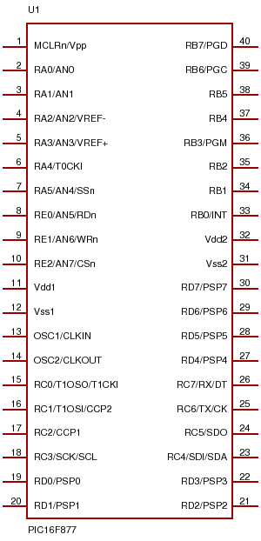

**Figure 3.3 pin diagram of PIC**

**PIC Memory Organization:**

* PIC 16C6X/7X program memory is **2K or 4K.**
* To address **2K**-program memory, **11-bit address is sufficient.**
* As we know Program counter is 13 bits wide upper 2 bits are ignored.
* For **4K**-program **memory, 12 bit address is needed.** So, the uppermost bit is ignored.

**Data Memory Register File Structure:**

* Data memory is categorized as

1) General-purpose register file.

2) special-purpose register file.

* The address in register file is from 00 to FFH

The **lower bytes** of the register bank are identified as special function registers (SFRs)

* However in case of direct addressing mode 7 bits are used to address the register files.
* Therefore, the register bank selects (RP0) in the **STATUS** register is used to select one of the register banks.
* With this 8-bit address, total 256 locations are possible.

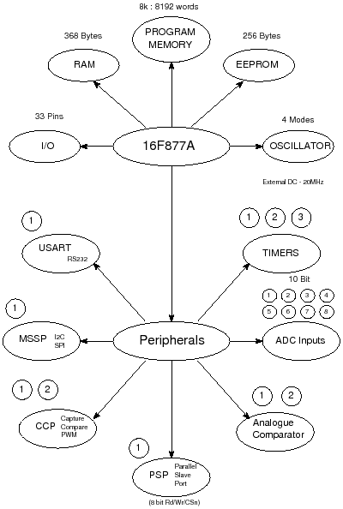

**Figure 3.4 Flow chart of PIC**

**Interrupts in PIC 16C61/71**

* PIC 16C61 supports 3 interrupts

1) External interrupt (RB0 pin)

2) Timer 0 interrupt.

3) PORTB change interrupt.

* PIC 16C71 has one more interrupt associated with the ADC operation.
* For accepting any interrupt we need to initialize INTCON register.

**Table 3.2 Interrupts in PIC**

|  |  |  |  |  |  |  |  |
| --- | --- | --- | --- | --- | --- | --- | --- |
| GIE | ADIE | TOIE | INTE | RBIE | TOIF | INTF | RBIF |

**GIE:** global interrupt enable

**ADIE:** A/D conversion interrupt enable

**TOIE:** Timer 0 interrupt enable.

**INTE:** Interrupt enable bit.

**RBIE:** PORTB change interrupt enable.

**TOIF:** Timer 0 interrupt flag.

**INTF:** Interrupt enable flag.

**RBIF:** PORTB change interrupt flag.

* Two different bits from INTCON are required for any interrupt operation.

1) Enabling the interrupt

2) Detection of occurrence.

* Apart from these there is a common bit in INTCON called GIE to enable or disable all interrupts simultaneously.
* So, GIE must be enable for detecting the interrupt along with that corresponding interrupt bit is enable.
* GIE must be cleared when an interrupt is serviced.
* GIE is set automatically when “retfie” is issued.
* So, programmer has to initialize the INTCON register before using an interrupt.

**External Interrupt:**

* A Transition at pin RB0/INT causes this interrupt.
* When a valid interrupt signal appears at INT pin, INTF bit is set in INTCON.
* Further, this interrupt can wake the processor from SLEEP mode
* When an interrupt occurs, the return address is pushed onto the stack.
* The program counter is loaded with 004H.
* At this location, a goto instruction is written to direct it to ISR.

**Timer 0 Interrupt:**

* Timer 0 overflow interrupt is generated when counter/timer 0 overflows i.e. (OFFH to OOH)
* This will set TOIF flag in INTCON.
* For this purpose, TOIE bit in INTCON is set along with GIE bit.

**PORTB Change Interrupt:**

* A change from high to low or low to high on PORTB pins RB4 to RB7 causes this interrupt.
* It is possible to have PORTB change interrupt, if pins RB4 to RB7 are configured as inputs.
* Interrupt on change function compares the current pin status with the last one.
* If there is any mismatch, the PORTB change interrupt is generated by setting the RBIF.
* RBIE and GIE must be set to enable the interrupt.
* A change on one of the port pins can wake the CPU from SLEEP mode.

**PIC 16F8XX Flash Microcontrollers**

* PIC 16C61/71 microcontrollers are simple and has limited features.
* However as the need grows, the designer must have micro controllers that have maximum features.
* PIC 16F8XX meets the requirements.
* It belongs to the family of CMOS 8-bit Flash microcontrollers
* PIC 16F877 belongs to the family of 16F8XX.
* PIC 16F877 is a flash microcontroller.

**Flash Memory:**

* Now a days all embedded systems are utilizing this flash memory.
* It is a read/write memory.
* The main reason of choosing flash memory is ‘ERASING FACILITY’
* It can be done by chip-level.
* It combines the features of EPROM and EEPROM.

**Features of 16F8XX:**

1. It is having flash program memory.
2. It is having data EEPROM.
3. It is having three timers plus WDT.

* Timer 0: (8-bit timer/counter with prescaler)
* Timer 1: (16-bit wide and with prescaler)
* Timer 2: (8-bit timer/counter , with 8-bit period register, prescaler and postscaler)

4) 10- bit ADC is an interesting feature.

5) Universal synchronous receiver transmitter USART is supported.

6) A parallel 8-bit wide slave port (PSP) is supported.

7) There is a synchronous serial port (SSP)

**Status Register (16F8XX):**

* It is almost the same as that of 16CXX.
* Here additional bits are IRP, RP1 and RP0
* RP0 and RP1 are present because there are four memory banks each of 128 bytes in size.
* So, for bank selection, 2 bits are needed, making the effective address 9-bit wide.

**Table 3.3 STATUS Register (16FX)**

|  |  |  |  |  |  |  |  |
| --- | --- | --- | --- | --- | --- | --- | --- |
| **IRP** | **RP1** | **RP0** |  |  | **Z** | **DC** | **C** |

**PIC 16F8XX PROGRAM MEMORY:**

* PIC microcontrollers have separate program memory and data memory.
* The flash program memory of 16F877 is 8K and is 14-bit wide.
* To access 8k memory, 13-bit address is needed and hence program counter is 13-bit wide.

**Table 3.4 Program Memory**

|  |
| --- |
| RESET VECTOR (0000H) |
| ---- |
| INTERRUPT VECTOR (0004H) |
| PAGE 0 (0005H to 07FFH) |
| PAGE 1 (0008H to 0FFFH) |
| PAGE 2 (1000H to 17FFH) |
| PAGE 3 (1800H to 1FFFH) |

* After reset, the program counter points to 0000H.
* 0004H is loaded into program counter automatically if interrupts are enabled.
* For protecting against unwanted write operations to flash program memory, bit WRT may be programmed to ‘0’.
* Further, to erase WRT bit in the configuration word, the device has to be erased fully.

**PIC 16F8XX DATA MEMORY:**

* Data memory of 16F877 is of two types.

1) RAM data memory

2) EEPROM data memory

**Data RAM:**

* Data memory 0f PIC 16F877 is divided into four banks.
* STATUS register bits IRP, RP1, RP0 are used to select any of the banks.
* Size of the each bank is 128 bytes.
* The lower locations in every bank is reserved for SFRs.
* There are SFRs PORTA, PORTB, PORTC, PORTD, and PORTE in bank 0 corresponding to five I/O ports.
* Associated registers for these 5 I/O ports are present in bank 1.TRISA, TRISB, TRISC, TRISD, TRISE.
* They are used as direction registers.TRIS-0 (It acts as an output) TRIS-1 (It acts as an input)
* File selection register (FSR), PCL, PCLATH, INTCON are common for each bank.

**DATA EEPROM:**

* Data EEPROM allows to read and write.
* There are 256 bytes of EEPROM data memory in 16F877.
* This EEPROM is not located in the register files.
* There is also a protect mechanism to disable external read or write.
* The microcontroller can however read or write inspite of the protect mechanism.

**DATA EEPROM AND FLASH PROGRAM MEMORY**

* Data EEPROM and flash EEPROM are readable and writable.
* There are six FSRs used for read/write operation of data EEPROM and the flash program memory.
* EECON1, EECON2, EEDATA, EEDATH, EEADR, and EEADRH
* A write operation automatically erases the location.
* The program memory cannot be addressed during the write operation.

**EECON1:**

* EECON1 is the control register for accessing the program or data EPROM memory.

**Table 3.5 EECON1 Structure.**

|  |  |  |  |  |  |  |  |
| --- | --- | --- | --- | --- | --- | --- | --- |
| EEPGD | ----- | ------- | ------ | WRERR | WREN | WR | RD |

**EEPGD:** Access Program/Data EEPROM

1 = Program memory

0 = Data EEPROM

**WRERR:** EEPROM error flag bit

1 = Write operation terminated

0 = Write operation completed

**WREN:** EEPROM write enable bit

1 = Allows write cycles

0 = Inhibit write to the EEPROM

**WR:** Write control bit.

**RD:** Read control bit.

* Bits 4, 5, 6 are unimplemented.

**EECON2, EEDATA, EEADR:**

* EECON2 is not a physical register and if tried to read, it will read all ‘0’s.
* This is used in the write to data EEPROM operation.

EEDATA: EEPROM data register

EEADR: EEPROM address register

**Reading and Writing Data EEPROM:**

**Reading Data EEPROM:**

1) The address of the location to be read is written in EEADR

2) We need to clear the EEPGD bit.

EEPGD = 0 (Data EEPROM)

3) Set the bit RD in EECON1.

4) The data from addressed location will be in EEDATA register

**Writing Data EEPROM:**

1. The address of the location to be written is loaded in to the EEADR register.
2. We need to clear the EEPGD bit.
3. Set the WREN bit in EECON1.
4. Then the data is written into the EEDATA register by means of EECON2
5. During writing process all the interrupts should be disabled.

**TIMERS**

* 16F877 supports three timers

1) Timer 0

2) Timer 1

3) Timer 2

**Timer 0:**

* It is an 8-bit timer that can be read and written.
* It has assigned a prescaler value in between 0 and 256
* The clock to timer can be either internal or external.
* An interrupt is generated after it overflows from FFH to 00H.
* Timer 0 operation in 16F877 will be similar to 16C71.

**Timer 1:**

* Timer 1 is a 16-bit timer/counter consists of two timer bytes, TMR1H and TMRIL.
* The pair forming 16-bit register is incremented from 0000h to FFFFH.
* And after overflow from FFFFH to 0000H, interrupt flag TMRIF is set if the interrupt is enabled by TMR1IE.

**T1CON Register:**

**Table 3.6 T1CON Register**

|  |  |  |  |  |  |  |  |
| --- | --- | --- | --- | --- | --- | --- | --- |
| ----- | ----- | T1CKPS1 | T1CKPS0 | T1OSCEN | T1SYNC | TMR1CS | TMR1ON |

**TMR1CS:** (Timer1 clock source select bit)

1 = External clock (counter)

0 = Internal clock (timer)

**TMR1ON:**

1 = Enable timer1

0 = Stop timer1

**T1OSCEN:** Timer 1 oscillator enable.

1 = Oscillator enabled

0 = Oscillator off

**T1SYNC:** Timer 1 external clock input synchronization bit

0 = External clock input is synchronized.

1 = ignore.

* This condition will be applicable for external clock (counter)

**TIMER 2:**

* It is an 8-bit timer with prescaling and postscaling.
* Timer 2 is also useful in PWM generation.

**T2CON Register:**

**Table 3.6 T2CON Register**

|  |  |  |  |  |  |  |
| --- | --- | --- | --- | --- | --- | --- |
| TOUTPS3 | TOUTPS2 | TOUTPS1 | TOUTPS0 | TMR1ON | T2CKPS1 | T2CKPS0 |

* The input clock is prescaled from 1:1 to 1:16 by T2CKPS1 and T2CKPS0
* Timer 2 has an 8-bit period register PR2.
* Timer 2 increments from 00H until it matches PR2 value.
* After that it resets to 00H during the next cycle
* The match output of TMR2 again has a postscaler of 1:1 to 1:16.
* Any match generates an interrupt TMR2IF in PIR1 if it is enabled.
* Postscaler counts the number of times the TMR2 register matches with the PR2 register.
* This postscaling and prescaling makes the capacity of timer 2equal to that of any 16-bit timer/counter.

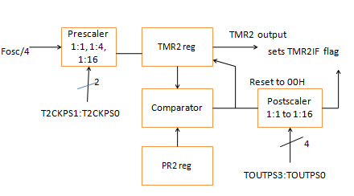

**Figure 3.5: Pre-scaler and Post-scaler.**

**Postscaler:**

**Table 3.7 Postscaler data**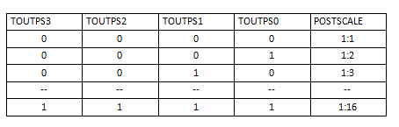

**Prescaler:**

**Table 3.7 Prescaler data**

|  |  |  |
| --- | --- | --- |
| T2CKPS1 | T2CKPS0 | PRESCALER |
| 0 | 0 | 1:1 |
| 0 | 1 | 1:4 |
| 1 | X | 1:16 |

**3.4 RF TECHNOLOGY:**

**WHAT IS RF?**

**Radio frequency** (**RF**) is a frequency or rate of oscillation within the range of about 3 Hz to 300 GHz. This range corresponds to frequency of alternating current electrical signals used to produce and detect radio waves. Since most of this range is beyond the vibration rate that most mechanical systems can respond to, RF usually refers to oscillations in electrical circuits or electromagnetic radiation.

**Properties of RF:**

Electrical currents that oscillate at RF have special properties not shared by direct current signals. One such property is the ease with which it can ionize air to create a conductive path through air. This property is exploited by 'high frequency' units used in electric arc welding. Another special property is an electromagnetic force that drives the RF current to the surface of conductors, known as the skin effect. Another property is the ability to appear to flow through paths that contain insulating material, like the dielectric insulator of a capacitor. The degree of effect of these properties depends on the frequency of the signals.

**Brief description of RF:**

Radio frequency (abbreviated RF) is a term that refers to alternating current (AC) having characteristics such that, if the current is input to an antenna, an electromagnetic (EM) field is generated suitable for wireless broadcasting and/or communications. These frequencies cover a significant portion of the electromagnetic radiation spectrum, extending from nine kilohertz (9 kHz),the lowest allocated wireless communications frequency (it's within the range of human hearing), to thousands of gigahertz(GHz).

When an RF current is supplied to an antenna, it gives rise to an electromagnetic field that propagates through space. This field is sometimes called an RF field; in less technical jargon it is a "radio wave." Any RF field has a wavelength that is inversely proportional to the frequency. In the atmosphere or in outer space, if f is the frequency in megahertz and sis the wavelength in meters, then

**s = 300/f**

The frequency of an RF signal is inversely proportional to the wavelength of the EM field to which it corresponds. At 9 kHz, the free-space wavelength is approximately 33 kilometers (km) or 21 miles (mi). At the highest radio frequencies, the EM wavelengths measure approximately one millimeter (1 mm). As the frequency is increased beyond that of the RF spectrum, EM energy takes the form of infrared (IR), visible, ultraviolet (UV), X rays, and gamma rays.

Many types of wireless devices make use of RF fields. Cordless and cellular telephone, radio and television broadcast stations, satellite communications systems, and two-way radio services all operate in the RF spectrum. Some wireless devices operate at IR or visible-light frequencies, whose electromagnetic wavelengths are shorter than those of RF fields. Examples include most television-set remote-control boxes Some cordless computer keyboards and mice and a few wireless hi-fi stereo headsets.

The RF spectrum is divided into several ranges, or bands. With the exception of the lowest-frequency segment, each band represents an increase of frequency corresponding to an order of magnitude (power of 10). The table depicts the eight bands in the RF spectrum, showing frequency and bandwidth ranges. The SHF and EHF bands are often referred to as the microwave spectrum.

### WHY DO WE GO FOR RF COMMUNICATION?

### RF Advantages:

1. No line of sight is needed.
2. Not blocked by common materials: It can penetrate most solids and pass through walls.
3. Longer range.
4. It is not sensitive to the light;.
5. It is not much sensitive to the environmental changes and weather conditions.

**WHAT CARE SHOULD BE TAKEN IN RF COMMUNICATION?**

### RF Disadvantages:

1. Interference: communication devices using similar frequencies - wireless phones, scanners, wrist radios and personal locators can interfere with transmission
2. Lack of security: easier to "eavesdrop" on transmissions since signals are spread out in space rather than confined to a wire
3. Higher cost than infrared
4. Federal Communications Commission(FCC) licenses required for some products
5. Lower speed: data rate transmission is lower than wired and infrared transmission

**WHAT ARE THE MAIN REQUIREMENTS FOR THE COMMUNICATION USING RF?**

* + RF Transmitter
  + RF Receiver
  + **RF TRANSMITTER STT-433MHz:**

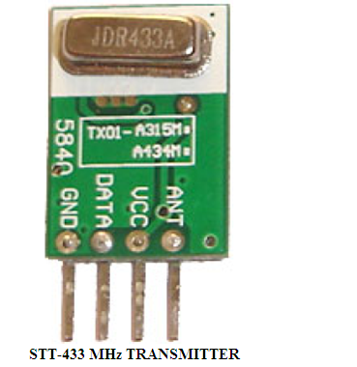

**Figure 3.6: RF Transmitter**

**FACTORS INFLUENCED TO CHOOSE ABOUT THE TRANSMITTER:**

* The STT-433 is ideal for remote control applications where low cost and longer range is required.
* The transmitter operates from a1.5-12V supply, making it ideal for battery-powered applications.
* The transmitter employs a SAW-stabilized oscillator, ensuring accurate frequency control for best range performance.
* The manufacturing-friendly SIP style package and low-cost make the STT-433 suitable for high volume applications.

**Features**

* 433.92 MHz Frequency
* Low Cost
* 1.5-12V operation
* Small size

**FACTOR INFLUENCED TO CHOOSE RF RECEIVER STR-433 MHz:**



**Figure 3.7: RF Receiver**

The data is received by the RF receiver from the antenna pin and this data is available on the data pins. Two Data pins are provided in the receiver module. Thus, this data can be used for further applications.

#### **3.5 SWITCHES AND PUSH BUTTONS**

This is the simplest way of controlling appearance of some voltage on microcontroller’s input pin. There is also no need for additional explanation of how these components operate.

This is about something commonly unnoticeable when using these components in everyday life. It is about contact bounce, a common problem with mechanical switches. If contact switching does not happen so quickly, several consecutive bounces can be noticed prior to maintain stable state. The reasons for this are: vibrations, slight rough spots and dirt. Anyway, this whole process does not last long (a few micro- or milliseconds), but long enough to be registered by the microcontroller. Concerning the pulse counter, error occurs in almost 100% of cases.

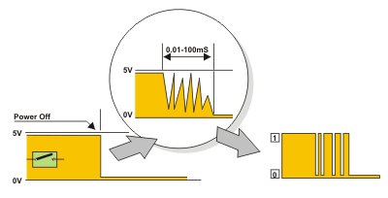

**Figure 3.8: Switches Structure**

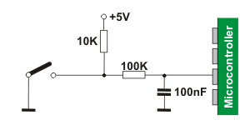

**Figure 3.9: Switches interfacing to controller**

The simplest solution is to connect simple RC circuit which will suppress each quick voltage change. Since the bouncing time is not defined, the values of elements are not strictly determined. In the most cases, the values shown on figure are sufficient.

If complete safety is needed, radical measures should be taken. The circuit (RS flip-flop) changes logic state on its output with the first pulse triggered by contact bounce. Even though this is more expensive solution (SPDT switch), the problem is definitely resolved. Besides, since the condensator is not used, very short pulses can be also registered in this way. In addition to these hardware solutions, a simple software solution is also commonly applied. When a program tests the state of some input pin and finds changes, the check should be done one more time after certain time delay. If the change is confirmed, it means that switch (or pushbutton) has changed its position. The advantages of such solution are: it is free of charge, effects of disturbances are eliminated and it can be adjusted to the worst-quality contacts.

**3.6 L293D- CURRENT DRIVER**

**Features:**

* Wide Supply-Voltage Range: 4.5 V to 36 V
* Separate Input-Logic Supply
* Internal ESD Protection
* Thermal Shutdown
* High-Noise-Immunity Inputs
* Functionally Similar to SGS L293 and SGS L293D
* Output Current 1 A Per Channel (600 mA for L293D)
* Peak Output Current 2 A Per Channel (1.2 A for L293D)
* Output Clamp Diodes for Inductive Transient Suppression (L293D)

**Description:**

The L293 and L293D are quadruple high-current half-H drivers. The L293 is designed to provide bidirectional drive currents of up to 1 A at voltages from 4.5 V to 36 V. The L293D is designed to provide bidirectional drive currents of up to 600-mA at voltages from 4.5 V to 36 V. Both devices are designed to drive inductive loads such as relays, solenoids, dc and bipolar stepping motors, as well as other high-current/high-voltage loads in positive-supply applications.

All inputs are TTL compatible. Each output is a complete totem-pole drive circuit, with a Darlington transistor sink and a pseudo- Darlington source. Drivers are enabled in pairs, with drivers 1 and 2 enabled by 1,2EN and drivers 3 and 4 enabled by 3,4EN. When an enable input is high, the associated drivers are enabled and their outputs are active and in phase with their inputs. When the enable input is low, those drivers are disabled and their outputs are off and in the high-impedance state. With the proper data inputs, each pair of drivers forms a full-H (or bridge) reversible drive suitable for solenoid or motor applications. On the L293, external high-speed output clamp diodes should be used for inductive transient suppression.

A VCC1 terminal, separate from VCC2, is provided for the logic inputs to minimize device power dissipation. The L293 and L293D are characterized for operation from 0 to 70 degree Celsius.

**How to control the Robot to obtain the desired direction of movement**

**Table 3.8 Movement of Motor**

|  |  |  |  |
| --- | --- | --- | --- |
|  | **Left Wheel** | **Right Wheel** | **Movement** |
| 1 | Forward | Forward | Forward |
| 2 | Backward | Backward | Backward |
| 3 | Forward | Stop | Right Turn |
| 4 | Stop | Forward | Left Turn |
| 5 | Forward | Backward | Sharp Right Turn |
| 6 | Backward | Forward | Sharp Left Turn |

DC motors are used as the wheels for the Robot since the DC motors can provide continuous rotations when once given the input. The next section gives the brief description of the motors.

**3.7 ELECTRIC MOTORS**

Electric motors are used to efficiently convert electrical energy into mechanical energy. Magnetism is the basis of their principles of operation. They use permanent magnets, electromagnets, and exploit the magnetic properties of materials in order to create these amazing machines.

There are several types of electric motors available today. The following outline gives an overview of several popular ones. There are two main classes of motors: AC and DC. AC motors require an alternating current or voltage source (like the power coming out of the wall outlets in your house) to make them work. DC motors require a direct current or voltage source (like the voltage coming out of batteries) to make them work. Universal motors can work on either type of power. Not only is the construction of the motors different, but the means used to control the speed and torque created by each of these motors also varies, although the principles of power conversion are common to both.

Motors are used just about everywhere. In our house, there is a motor in the furnace for the blower, for the intake air, in the sump well, dehumidifier, in the kitchen in the exhaust hood above the stove, microwave fan, refrigerator compressor and cooling fan, can opener, garbage disposer, dish washer pump, clocks, computer fans, ceiling fans, and many more items.

In industry, motors are used to move, lift, rotate, accelerate, brake, lower and spin material in order to coat, paint, punch, plate, make or form steel, film, paper, tissue, aluminum, plastic and other raw materials.

They range in power ratings from less than 1/100 hp to over 100,000 hp.  The rotate as slowly as 0.001 rpm to over 100,000 rpm.  They range in physical size from as small as the head of a pin to the size of a locomotive engine.

**What happens when a wire carrying current is within a magnetic field?**



**Figure 3.10: Magnetic field effect**

* This is the **Left Hand Rule** for motors.
* The **first finger** points in the direction of the **magnetic field** (first - field), which goes from the North pole to the South pole.
* The **second finger** points in the direction of the **current** in the wire (second - current).
* The **thumb** then points in the direction the wire is **thrust** or pushed while in the magnetic field (thumb - torque or thrust).

So, when a wire carrying current is perpendicular to a magnetic field, a force is created on the wire causing it to move perpendicular to the field and direction of current.  The greater the current in the wire, or the greater the magnetic field, the faster the wire moves because of the greater force created.  If the current in the wire is parallel to the magnetic field, there will be no force on the wire.

**DC Motors**

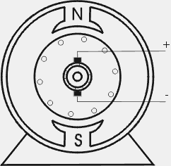

**Figure 3.11: DC Motors**

DC motors are fairly simple to understand.  They are also simple to make and only require a battery or dc supply to make them run.

A simple motor has six parts, as shown in the diagram below:

* **Armature or rotor**
* **Commutator**
* **Brushes**
* **Axle**
* **Field magnet**
* **DC power supply** of some sort

An el­ectric motor is all about magnets and magnetism: A motor uses **magnets** to create motion. If you have ever played with magnets you know about the fundamental law of all magnets: Opposites attract and likes repel. So if you have two bar magnets with their ends marked "north" and "south," then the north end of one magnet will attract the south end of the other. On the other hand, the north end of one magnet will repel the north end of the other (and similarly, south will repel south). Inside an electric motor, these attracting and repelling forces create **rotational motion**. ­

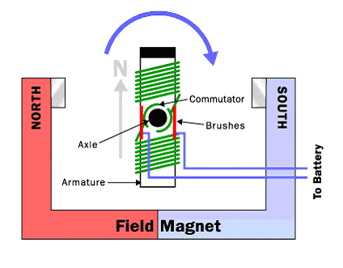

**Figure 3.12: Commutator**

The armature (or rotor) is an electromagnet, while the field magnet is a permanent magnet (the field magnet could be an electromagnet as well, but in most small motors it is not in order to save power).When you put all of these parts together, here is a complete electric motor:

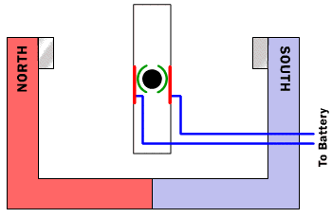

**Figure 3.13: Magnetic Pole Directions**

In the above figure, the armature winding has been left out so that it is easier to see the commutator in action. The key thing to notice is that as the armature passes through the horizontal position, the poles of the electromagnet flip. Because of the flip, the north pole of the electromagnet is always above the axle so it can repel the field magnet's north pole and attract the field magnet's south pole.

Even a small electric motor contains the same pieces described above: two small permanent magnets, a commutator, two brushes, and an electromagnet made by winding wire around a piece of metal. Almost always, however, the rotor will have **three poles** rather than the two poles as shown in this article.

There are two good reasons for a motor to have three poles:

* It causes the motor to have better dynamics. In a two-pole motor, if the electromagnet is at the balance point, perfectly horizontal between the two poles of the field magnet when the motor starts, one can imagine the armature getting "stuck" there. This never happens in a three-pole motor.
* Each time the commutator hits the point where it flips the field in a two-pole motor, the commutator shorts out the battery (directly connects the positive and negative terminals) for a moment. This shorting wastes energy and drains the battery needlessly. A three-pole motor solves this problem as well.

It is possible to have any number of poles, depending on the size of the motor and the specific application it is being used in.

**Types of Motors**

**Split Phase**

The split phase motor is mostly used for "medium starting" applications. It has start and run windings, both are energized when the motor is started. When the motor reaches about 75% of its rated full load speed, the starting winding is disconnected by an automatic switch.

**Uses:** This motor is used where stops and starts are somewhat frequent. Common applications of split phase motors include: fans, blowers, office machines and tools such as small saws or drill presses where the load is applied after the motor has obtained its operating speed.

**Horsepower & RPM**

**Horsepower**

Electric motors are rated by horsepower, the home shop will probably utilize motors from 1/4 HP for small tools and up to 5 HP on air compressors. Not all motors are rated the same, some are rated under load, others as peak horsepower and hence we have 5 HP compressors with huge motors and 5 Hp shopvacs with tiny little motors. Unfortunately all 5 HP compressor motors are not equal in actual power either, to judge the true horsepower the easiest way is to look at the amperage of the motor. Electric motors are not efficient, most have a rating of about 50% due to factors such as heat and friction and some may be as high as 70%.

**Table 3.9 Motor Ratings**

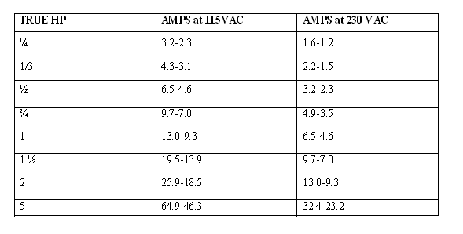

A quick general calculation when looking at a motor is 1 HP = 10 amps on 110 volts and 1 HP = 5 amps on 220 volts.

**RPM**

The shaft on a typical shop motor will rotate at either 1725 or 3450 RPM (revolutions per minute).

The speed of the driven machine will be determined by the size of pulleys used, for example a 3450 RPM motor can be replaced by a 1750 RPM motor if the diameter of the pulley on the motor is doubled. The opposite is true as well but if the pulley on the 1750 RPM motor is small it is not always possible to replace it with one half the size. It may be possible to double the pulley size on the driven machine if it uses a standard type of pulley, (not easily done on air compressors for example).

Electronic speed reducers such as the ones sold for routers will not work on induction type motors.

**Phase, Voltage & Rotation**

Whether or not you can use a motor will likely depend on these factors.

**Single Phase**

Ordinary household wiring is single phase, alternating current. Each cycle peaks and dips as shown. To run a three phase motor a phase converter must be used, usually this is not practical, it is often less expensive to change the motor on a machine to a single phase style.

singlephase

**Figure 3.14: Single Phase**

**Three Phase**

This is used in industrial shops, rather than peaks and valleys the current supply is more even because of the other two cycles each offset by 120 degrees.

3phase

**Figure 3.15: Three Phase**

**Voltage**

Many motors are dual voltage i.e., by simply changing the wiring configuration, they can be run on 110 volts or 220 volts. Motors usually run better on 220 volts, especially if there is any line loss because of having to use a long wire to reach the power supply.Motors are available for both AC and DC current, our typical home wiring will be AC. There are DC converters available which are used in applications where the speed of the motor is controlled.

**Rotation**

The direction the shaft rotates can be changed on most motors by switching the right wires. The direction of rotation is usually determined by viewing the motor from the shaft end and is designated as CW (clockwise) or CCW (counter-clockwise).

**Inside the Wipers**

The wipers combine two mechanical technologies to perform their task

1. A combination [electric motor](http://auto.howstuffworks.com/motor.htm) and [worm gear](http://auto.howstuffworks.com/gear5.htm) reduction provides power to the wipers.
2. A neat linkage converts the rotational output of the motor into the back-and-forth motion of the wipers.

On any gear, the [ratio](http://www.howstuffworks.com/gear-ratio.htm) is determined by the distances from the center of the gear to the point of contact. For instance, in a device with two gears, if one gear is twice the diameter of the other, the ratio would be 2:1.

One of the most primitive types of gears we could look at would be a wheel with wooden pegs sticking out of it.

The problem with this type of gear is that the distance from the center of each gear to the point of contact changes as the gears rotate. This means that the gear ratio changes as the gear turns, meaning that the output speed also changes. If you used a gear like this in your car, it would be impossible to maintain a constant speed you would be accelerating and decelerating constantly.

**Worm gears**

These are used when large gear reductions are needed. It is common for worm gears to have reductions of 20:1, and even up to 300:1 or greater.

Many worm gears have an interesting property that no other gear set has: the worm can easily turn the gear, but the gear cannot turn the worm. This is because the angle on the worm is so shallow that when the gear tries to spin it, the friction between the gear and the worm holds the worm in place.

**Motor and Gear Reduction**

It takes a lot of force to accelerate the wiper blades back and forth across the windshield so quickly. In order to generate this type of force, a worm gear is used on the output of a small electric motor.

The worm gear reduction can multiply the torque of the motor by about 50 times, while slowing the output speed of the electric motor by 50 times as well. The output of the gear reduction operates a linkage that moves the wipers back and forth.

Inside the motor/gear assembly is an **electronic circuit** that senses when the wipers are in their down position. The circuit maintains power to the wipers until they are parked at the bottom of the windshield, and then cuts the power to the motor. This circuit also parks the wipers between wipes when they are on their intermittent setting.

**Linkage**

A short cam is attached to the output shaft of the gear reduction. This cam spins around as the wiper motor turns. The cam is connected to a long rod; as the cam spins, it moves the rod back and forth. The long rod is connected to a short rod that actuates the wiper blade on the driver's side. Another long rod transmits the force from the driver-side to the passenger-side wiper blade.

**Table 3.10 Operational Specifications of Motors**

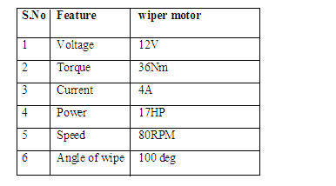

**Description of the wiper motors selected**

The motor is two pole design having high energy permanent magnets, together with a gear box housing, having two stages of gear reduction .power from the motor is a transferred by a three start worm on a extension of the armature shaft through a two stage gear system.

A ball bearing system is provided on the commutator end of the armature to minimize the friction losses and thereby increase torque of the wiper motor. Power from the final gear arm spindles .A special inbuilt limit switch ensures in applying regenerative braking to the OFF position.

Thermal protector is connected in series with armature to avoid burning of armature under locked position. Consistent parking of the wiper arms and blades in the correct position is there by ensured. The side on which the arms come to rest is preset to requirements.

Electrical connections are made to the motor via a non-reversible in line plug and socket assembly .This type of connections ensures that the correct motor polarity is maintained when the motor is connected to the vehicle wiring. The wiper motor incorporates radio interference capacitor.

**CHAPTER 4**

**4. FIRMWARE IMPLEMENTATION OF THE PROJECT DESIGN**

This chapter briefly explains about the firmware implementation of the project. The required software tools are discussed in section 4.2. Section 4.3 shows the flow diagram of the project design. Section 4.4 presents the firmware implementation of the project design.

**4.1 SOFTWARE TOOLS REQUIRED**

* **MPLAB® C COMPILER FOR PIC24 MCUs.**

The working of each software tool is explained below in detail.

**4.1.1 PROGRAMMING MICROCONTROLLER**

A compiler for a high level language helps to reduce production time. To program the PIC 16F877 microcontroller the MPLAB 8.60is used. The programming is done strictly in the embedded C language. MPLAB 8.60is a suite of executable, open source software development tools for the microcontrollers hosted on the Windows platform.

The compilation of the C program converts it into machine language file (.hex). This is the only language the microcontroller will understand, because it contains the original program code converted into a hexadecimal format. During this step there are some warnings about eventual errors in the program. If there are no errors and warnings then run the program, the system performs all the required tasks and behaves as expected the software developed. If not, the whole procedure will have to be repeated again.

One of the difficulties of programming microcontrollers is the limited amount of resources the programmer has to deal with. In personal computers resources such as RAM and processing speed are basically limitless when compared to microcontrollers. In contrast, the code on microcontrollers should be as low on resources as possible.

**SOURCE CODE:**

#include <pic.h>

__CONFIG(0x3F39);

#define _XTAL_FREQ 4e6

#define m1_in1 RD1

#define m1_in2 RC3

#define m1_en RD0

#define m2_in1 RC2

#define m2_in2 RD2

#define m2_en RD3

#define m3_in1 RC5

#define m3_in2 RC6

#define m3_en RC4

#define DATAIN PORTB

#define in_break RC7

#define out_break RD4

#define open_pin RB5

#define close_pin RB6

#define forward_pin RB2

#define backword_pin RB7

#define right_pin RB4

#define left_pin RB3

bit in_breakflag = 0;

bit out_breakflag = 0;

void open(void);

void close(void);

void forward(void);

void backword(void);

void right(void);

void left(void);

void all_stop(void);

void pulse_init(void);

void pulse_init(void)

{

TRISB = 0XFF;

PORTB = 0XFF;

TRISD = 0x10;

PORTD = 0x10;

TRISC = 0X80 ; // set PORTC as output

PORTC = 0x80 ; // clear PORTC

GIE = 0;

}

void open(void)

{

if(out_break == 1)

{

out_breakflag = 1;

m3_en = 1;

m3_in2 = 0;

m3_in1 = 1;

m1_en = 0;

m2_en = 0;

m1_in1 = 0;

m1_in2 = 0;

m2_in1 = 0;

m2_in2 = 0;

}

}

void close(void)

{

if(in_break == 1)

{

in_breakflag = 1;

m3_en = 1;

m3_in2 = 1;

m3_in1 = 0;

m1_en = 0;

m2_en = 0;

m1_in1 = 0;

m1_in2 = 0;

m2_in1 = 0;

m2_in2 = 0;

}

}

void forward(void)

{

m1_en = 1;

m2_en = 1;

m1_in1 = 1;

m1_in2 = 0;

m2_in1 = 1;

m2_in2 = 0;

}

void backword(void)

{

m1_en = 1;

m2_en = 1;

m1_in1 = 0;

m1_in2 = 1;

m2_in1 = 0;

m2_in2 = 1;

}

void right(void)

{

m1_en = 1;

m2_en = 1;

m1_in1 = 0;

m1_in2 = 1;

m2_in1 = 1;

m2_in2 = 0;

}

void left(void)

{

m1_en = 1;

m2_en = 1;

m1_in1 = 1;

m1_in2 = 0;

m2_in1 = 0;

m2_in2 = 1;

}

void all_stop(void)

{

m1_en = 0;

m2_en = 0;

m3_en = 0;

m1_in1 = 0;

m1_in2 = 0;

m2_in1 = 0;

m2_in2 = 0;

m3_in1 = 0;

m3_in2 = 0;

}

void main(void)

{

pulse_init();

CLRWDT();

while(1)

{

if((in_break == 0) && (in_breakflag == 1))

{

all_stop();

in_breakflag = 0;

}

if((out_break == 0) && (out_breakflag == 1))

{

all_stop();

out_breakflag = 0;

}

if(open_pin == 1)

{

open();

}

if(close_pin == 1)

{

close();

}

if(forward_pin == 1)

{

forward();

}

if(backword_pin == 1)

{

backword();

}

if(right_pin == 1)

{

right();

}

if(left_pin == 1)

{

left();

}

if(DATAIN == 0x00)

{all_stop();}

}

}

**CHAPTER 5**

**5.** **RESULTS**

Assemble the circuit on the PCB as shown in Fig 5.1(a) and fig 5.1(b). After assembling the circuit on the PCB, check it for proper connections before switching on the power supply.

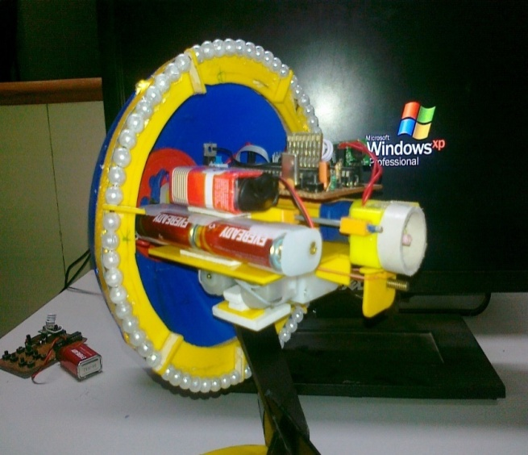

**Figure 5.1 Implementing stage of Spy robot**

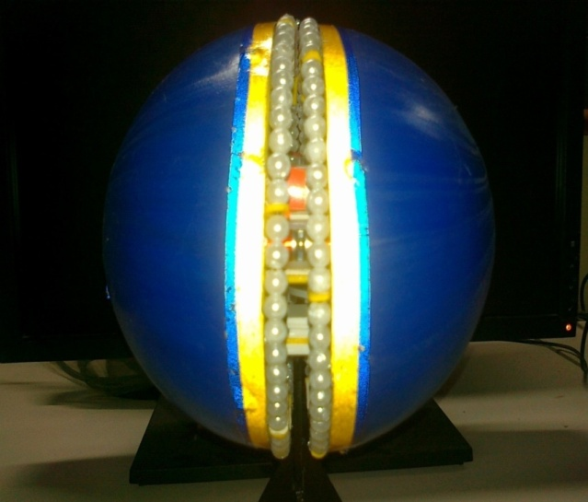

**Figure 5.2 Hardware implementation of Spy robot**

**CONCLUSION**

The implementation of war field based spy robot is done successfully. The communication is properly done without any interference between different modules in the design. Design is done to meet all the specifications and requirements. Software tools like MPLAB 8.60 to dump the source code into the microcontroller,

Continuously reading the commands from the transmitter and change the direction of the Robot accordingly and also monitor the output wireless. The mechanism is controlled by the microcontroller.

It can be concluded that the design implemented in the present work provide portability, flexibility and the data transmission is also done with low power consumption.

**SPY ROBOT IN FUTURE**

The CIA robotic spies will look like you and I, talk, walk, eat, act and even make mistakes like us. But these will not be living, breathing organic humans. The Labs around the country are working on them now, by 2025 they will be everywhere. It is time to a have a serious discussion on artificial intelligence and the future of clandestine spies using artificial intelligence robotics.

Isaac Asimov had artificial organic robots in his books. We all saw the movie AI. Will we be fooled in the future by robots posing as people? Will we care? This might be a great opportunity for spying? Create a robot which looks and acts like a person and is controlled through tele-robotics or constantly monitored through sensors watching the target by TV Screen and putting in controls and feeding in topics of conversation? Realizing that this technology will be available in our lifetimes, should we be thinking ahead of how best to use this technology for CIAC landestine efforts.

Today we have technologies such as putting a cell phone in someone‟s false teeth. They can then meet with a source and be fed instructions as to what to say and ask. Today we have built Haptic enabled „robotic faces‟ to mimic the person it interfaces with, based on a known human trait of personality called mirroring. Mirroring is often used in the spy industry, police investigations, good guy bad guy routines, dating, sales, negotiation and politics.

Whether we realize it or not, we all mirror people we are talking with, it is extremely hard not to do this simply by habit. Robotics researchers and psychologists designing robotic companions and humanoid type robots, have taken this into consideration. Robots, which learn thru these interactions will learn how to mimic human interaction and become quite good at cultural norms when on

duty as spies.

However currently we fall way short even trying to train new CIA recruits to learn cultural norms to those outpost regions in which they have never traveled.

It is hard enough for them to learn the variations in language dialogue, slang and accents.Cultural norms, language and behavior is not the only thing that is the future we will need to teach the robots to make human type mistakes, laugh and understand when a joke is told, before we can release them autonomously.

**REFERENCES**

[1]. Pete Miles & Tom Carroll, Build Your Own Combat Robot, (2002).

[2]. K.S.Fu , R.C.Gonzalez , C.S.G..Lee, Tutorials Robotics.

[3]. Asaro,P. How just could a robot war be?, Frontiers in ArtificialIntelligence and Applications, 75, 50-64.

[4]. S. Y. Harmon & D. W. Gage, “Current Technical Research Issues ofAutonomous Robots Employed In Combat”, 17th Annual Electronicsand Aerospace Conference.

[5]. Atmel data sheetshttp://www.keil.com/dd/docs/datashts/atmel/at89s52_ds.pdf

[6]. Robert L.Boylestad and Louis Nashelsky, “Electronic Devices andCircuit Theory”, 8th Edition, 2006

[8]. A. Khamis, M. Pérez Vernet, K. Schilling, “A Remote Experiment OnMotor Control Of Mobile Robots”, 10thMediterranean Conference on Control and Automation – MED2002.