**WEEK-2**

(Implemented in Eclipse )

**1)Junit Testing**

Exercise 1:Setting up JUnit:

1. Created a new Java project in Eclipse IDE

2. Added JUnit dependency to your project.

pom.xml

<project xmlns="http://maven.apache.org/POM/4.0.0" xmlns:xsi="http://www.w3.org/2001/XMLSchema-instance" xsi:schemaLocation="http://maven.apache.org/POM/4.0.0 https://maven.apache.org/xsd/maven-4.0.0.xsd">

<modelVersion>4.0.0</modelVersion>

<groupId>com.example</groupId>

<artifactId>JUnitDemo</artifactId>

<version>0.0.1-SNAPSHOT</version>

<dependencies>

<dependency>

<groupId>junit</groupId>

<artifactId>junit</artifactId>

<version>4.13.2</version>

<scope>test</scope>

</dependency>

</dependencies>

</project>

3. Created a new test class in your project.

MyFirstTest.java

**import** **static** org.junit.Assert.*;

**import** org.junit.Test;

**public** **class** MyFirstTest {

@Test

**public** **void** sampleTest() {

*assertTrue*(**true**);

}

}

**Output:**

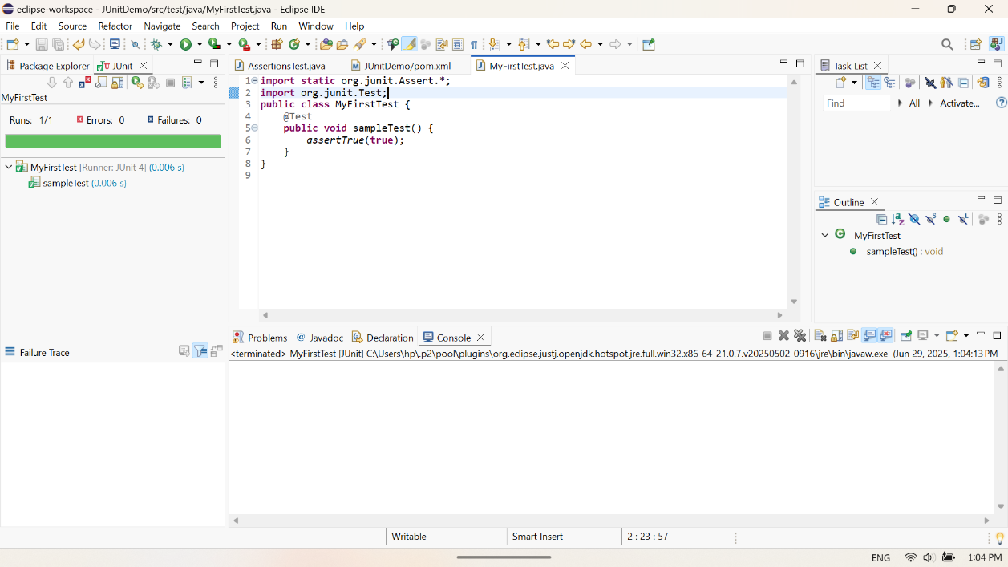

Exercise 3: Assertions in JUnit:

Write tests using various JUnit assertions.

**import** **static** org.junit.Assert.*;

**import** org.junit.Test;

**public** **class** AssertionsTest {

@Test

**public** **void** testAssertions() {

*assertEquals*(5, 2 + 3);

*assertTrue*(5 > 3);

*assertFalse*(5 < 3);

*assertNull*(**null**);

*assertNotNull*(**new** Object());

}

}

**Output:**

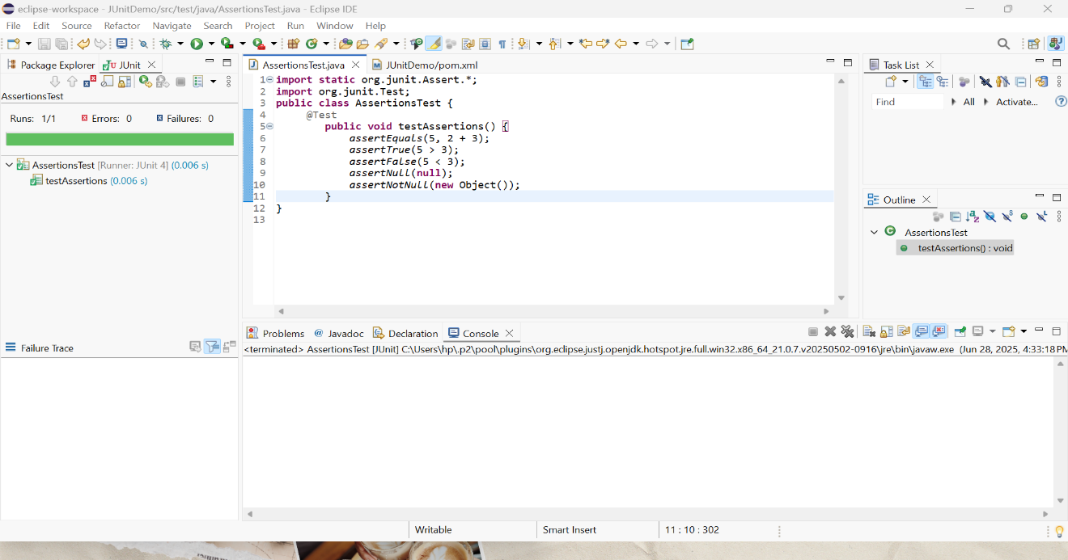

Exercise 4:Arrange-Act-Assert(AAA) Pattern,Test Fixtures,Setup and Teardown Methods in Junit

Calculator.java

**public** **class** Calculator {

**public** **int** add(**int** a, **int** b) {

**return** a + b;

}

**public** **int** subtract(**int** a, **int** b) {

**return** a - b;

}

}

CalculatorTest.java

**import** org.junit.Before;

**import** org.junit.After;

**import** org.junit.Test;

**import** **static** org.junit.Assert.*;

**public** **class** CalculatorTest {

**private** Calculator calc;

@Before

**public** **void** setUp() {

// Arrange: Setup before each test

calc = **new** Calculator();

System.***out***.println("Setup done");

}

@After

**public** **void** tearDown() {

// Cleanup after each test

calc = **null**;

System.***out***.println("Teardown done");

}

@Test

**public** **void** testAddition() {

// Act

**int** result = calc.add(2, 3);

// Assert

*assertEquals*(5, result);

}

@Test

**public** **void** testSubtraction() {

**int** result = calc.subtract(10, 4);

*assertEquals*(6, result);

}

}

**Output:**

