Department of
Artificial Intelligence & Machine Learning
B.Tech III Semester
Academic Year2026-2027
Data Base Management Systems (25B11CS001)

Capstone Stone Project Documentation

ADITYA UNIVERSITY
Surampalem, Kakinada District
Andhra Pradesh-533437

SOFTWARE MANAGEMENT SYSTEM
A DBMS Capstone Project Report submitted in partial fulfillment of the requirements for the award of the degree of

BACHELOR OF TECHNOLOGY
in

ARTIFICIAL INTELLIGENCE AND MACHINE LEARNING

Submitted By

G. ROHITH REDDY (25B11AI388)
J. SAHITHI (25B11AI417)
J. DEVI (25B11AI422)
J. MOMITHA (25B11AI441)

Under the esteemed guidance of

Mrs G. L. NARASAMBA VANGURI

Assistant Professor


DEPARTMENT OF ARTIFICIAL INTELLIGENCE AND MACHINE LEARNING

ADITYA UNIVERSITY
(Formerly Aditya Engineering College (A))
Aditya Nagar, ADB Road, Surampalem, Andhra Pradesh, India

2026 – 2027


Aditya Nagar, ADB Road, Surampalem, Andhra Pradesh, India
DEPARTMENT OF ARTIFICIAL INTELLIGENCE AND MACHINE LEARNING

CERTIFICATE

This is to certify that the DBMS Capstone Project report entitled “Bank Account Management System” is being submitted by G. ROHITH REDDY (25B11AI388),J. SAHITHI (25B11AI417),J. DEVI (25B11AI422) and J. MOMITHA (25B11AI441) inpartial fulfillment of the requirements for the award of the B.Tech. degree in Artificial Intelligence and Machine Learning. The work documented in this report was carried out as part of the Capstone Project for the course Database Management Systems (2501IT05) during the academic year 2026–2027, and records the database design, implementation, and documentation undertaken by the team.

Project Guide
Head of the Department
Mrs G. L. NARASAMBA VANGURI (M.tech ph.D)
Dr. K. Naga Bhargavi, M. Tech, Ph.D.
Assistant professor Associate Professor & HOD

External Examiner

DECLARATION

We hereby declare that the DBMS Capstone Project entitled “SOFTWARE MANAGEMENT SYSTEM”
is a genuine work carried out by us. The database design, SQL implementation, queries and documentation presented in this report are our own work, completed under the guidance of Mr. T. Srinivasulu, Department of Artificial Intelligence and Machine Learning, Aditya University, Surampalem. We further declare that this work has not been submitted, in full or in part, for the award of any degree of this or any other educational institution.

Project Associates

Date: 6 october 2026
Place: Surampalem
G. ROHITH REDDY (25B11AI388)
J. SAHITHI (25B11AI417)
J. DEVI (25B11AI422)
J. MOMITHA (25B11AI441)

ACKNOWLEDGEMENT

It is with immense pleasure that we express our indebted gratitude to our project guide Mrs G. L. NARASAMBA VANGURI epartment of Artificial Intelligence and Machine Learning, who guided us throughout the capstone project. We are thankful for the constant encouragement and valuable suggestions received at every review stage.
We are grateful to Dr. K. Naga Bhargavi, Head of the Department, for inspiring us and for arranging the facilities and resources needed for this project.
We extend our sincere thanks to the Management, Dr. M. Sreenivasa Reddy, Deputy Pro-Chancellor, Dr. M. B. Srinivas, Vice-Chancellor, and Dr. A. Ramesh, Pro Vice-Chancellor (Engineering & Sciences), for providing an excellent academic environment.
Not to forget, we thank the Teaching and Non-Teaching Staff, our parents and our friends, who have directly or indirectly supported us in completing this project on time.

Project Associates

G. ROHITH REDDY (25B11AI388)
J. SAHITHI (25B11AI417)
J. DEVI (25B11AI422)
J. MOMITHA (25B11AI441)

ADITYA UNIVERSITY
Surampalem
Department of Computer Science and Engineering

DBMS CAPSTONE PROJECT


Project Documentation Report
Project Title: SOFTWARE MANGEMENT SYSTEM SSYSME ssssssysme sSYSTEM
Submitted by:
Course: Database Management System (DBMS) Course Code: DBMS
Faculty Coordinator:
Academic Year: 2026–27
Date of Submission: 14 September 2026
GitHub Repository Link: https://github.com/sahithijaldu/software-management-system

S.No | Student Name | Roll Number
1 | G.ROHITH REDDY | 25B11AI388
2 | J. SAHITHI | 25B11AI417
3 | J.DEVI | 25B11AI422
4 | J.MOMITHA | 25B11AI441

ABSTRACT

The Software Management System is a database application developed using DBMS concepts to store and manage software-related information in a centralized and organized manner. The system manages software name, version, category, developer, license, users, and installation details.
The project reduces manual work, avoids unnecessary duplication, and supports efficient insertion, updating, deletion, and retrieval of records. The design uses entities, relationships, relational schemas, primary keys, foreign keys, and SQL operations to maintain structured software data.
For implementation, a relational DBMS such as Oracle Database can be used. SQL supports data definition, manipulation, querying, validation, and reporting. Data cleaning in this project is handled through database constraints, validation rules, duplicate prevention, and SQL-based filtering/transformation rather than treating DBMS as a separate data-cleaning application.

TABLE OF CONTENTS

Chapter | Title | Page No.
 | Certificate | i
 | Declaration | ii
 | Acknowledgement | iii
 | Project Documentation Report | iv
1 | ABSTRACT | v
 | List of Figures | vii
 | List of Tables | vii
2 | INTRODUCTION | 1
 | 2.1 Background | 1
 | 2.2 Purpose of the Database | 1
3 | PROBLEM STATEMENT | 1
4 | OBJECTIVES | 1
5 | TOOLS & TECHNOLOGIES USED | 2
6 | DATABASE DESIGN | 2
 | 6.1 Identified Entities | 2
 | 6.2 Entity Attributes | 3
 | 6.3 ER Diagram | 4
 | 6.4 Relationships & Cardinality | 5
 | 6.5 Relational Database Schema | 5
 | 6.6 Normalization | 6
7 | DATABASE IMPLEMENTATION | 7
 | 7.1 DDL — Database and Table Creation | 7
 | 7.2 Sample Data — DML. | 8
 | 7.3 Constraints & Data Integrity | 9
 | 7.4 SQL Operations & Queries | 9
 | 7.5 Sample Outputs / Screenshots | 10
8 | MODULES & FUNCTIONALITIES | 12
9 | GITHUB REPOSITORY & TEAM RESPONSIBILITIES | 12
10 | ENHANCEMENTS & FUTURE IMPROVEMENTS | 13
11 | CONCLUSION | 13
12 | REFERENCES | 13
 | APPENDIX | 14
 | A. Complete SQL Script | 14
 | B. Additional Screenshots / Outputs | 14

LIST OF FIGURES
LIST OF TABLES

Figure No. | Title of the Figure | Page No.
6.3 | ER Diagram | 4
Figure 1 | Customer records / basic SELECT output | 12
Figure 2 | Active savings accounts / filtering output | 12
Figure 3 | Aggregate or GROUP BY output | 13
Figure 4 | Join or subquery output | 13

Table No. | Title of the Table | Page No.
5 | TOOLS & TECHNOLOGIES USED | 2
6.1 | Identified Entities | 2
6.2 | Entity Attributes | 2
6.4 | Relationships & Cardinality | 4
6.5 | Relational Database Schema | 4
7.2 | Sample Data — DML. | 10
7.3 | Constraints & Data Integrity | 10
7.4 | SQL Operations & Queries | 10
8 | MODULES & FUNCTIONALITIES | 14
9 | GITHUB REPOSITORY & TEAM RESPONSIBILITIES | 14

INTRODUCTION

Background

Managing software information manually becomes difficult as the number of software records increases. Organizations may need to track software names, versions, categories, developers, licenses, users and installation details. A relational database provides a systematic way to store these related records and retrieve them efficiently.
The Software Management System applies DBMS concepts to organize software-related information into separate but related tables. The design uses keys and relationships to reduce duplication and maintain consistency.
.

Purpose of the Database
The purpose of the database is to provide a centralized structure for maintaining software information. It allows users to add, update, delete and retrieve records while maintaining relationships among software, developers, categories, licenses, users and installations.

PROBLEM STATEMENT

Managing software information manually is time-consuming and can lead to data duplication, incorrect records and difficulty in tracking software details. It is also difficult to maintain information about software versions, categories, developers, licenses, installations and users in an organized manner.
Therefore, a centralized Software Management System is required to store and manage software-related data efficiently and provide quick access to accurate information.

OBJECTIVES

To develop a centralized database for managing software information.
To store software details in a structured and organized manner.
To reduce manual work and data duplSication.
To provide easy insert, update, delete and retrieve operations.
To maintain software license and installation details.
To establish proper relationships between software, users, developers and categories.
To ensure data accuracy and consistency using DBMS concepts.

TOOLS & TECHNOLOGIES USED

Category | Tool / Technology | Purpose
Database | Relational DBMS / SQL | Create and manage database tables and relationships
Query Language | SQL | DDL, DML, DQL and CRUD operations
Design | ER Diagram | Represent entities and relationships
Version Control | GitHub | Repository and team project management
Documentation | Microsoft Word | Project report preparation

DATABASE DESIGN

Identified Entities

S.No | Entity | Description
1 | Software | Stores software name, version, license, category and developer references.
2 | Developer | Stores developer name, email and contact details.
3 | Category | Stores software category name and description.
4 | License | Stores license type, dates and status.
5 | User | Stores user name, email, department and contact details.
6 | Installation | Stores software installation details for users and systems.

Entity Attributes

Entity | Attributes
Software | Software_ID, Software_Name, Version, License_ID, Category_ID, Developer_ID
Developer | Developer_ID, Developer_Name, Email, Contact
Category | Category_ID, Category_Name, Description
License | License_ID, License_Type, Start_Date, Expiry_Date, Status
User | User_ID, User_Name, Email, Department, Contact
Installation | Installation_ID, Software_ID, User_ID, Install_Date, System_Name, Status

ER Diagram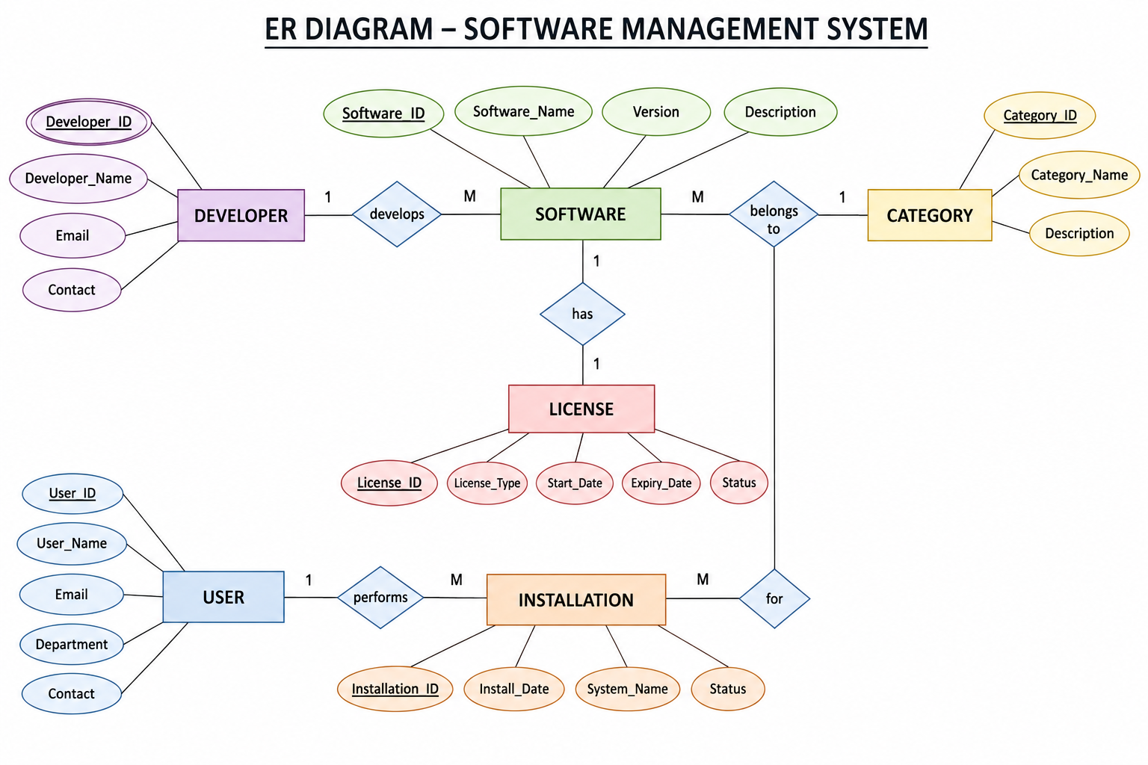

Relationships & Cardinality

Entity 1 | Relationship | Entity 2 | Cardinality
Developer | develops | Software | 1:N
Category | contains | Software | 1:N
License | is assigned to | Software | 1:N
User | has | Installation | 1:N
Software | has | Installation | 1:N

Relational Database Schema

Table | Schema
DEVELOPER | Developer(Developer_ID, Developer_Name, Email, Contact)
CATEGORY | Category(Category_ID, Category_Name, Description)
LICENSE | License(License_ID, License_Type, Start_Date, Expiry_Date, Status)
SOFTWARE | Software(Software_ID, Software_Name, Version, Developer_ID, Category_ID, License_ID)
USER | User(User_ID, User_Name, Email, Department, Contact)

Normalization

- Table | Primary Key | Foreign Keys
Developer | Developer_ID | —
Category | Category_ID | —
License | License_ID | —
Software | Software_ID | Developer_ID, Category_ID, License_ID
User | User_ID | —
Installation | Installation_ID | Software_ID, User_ID

A primary key uniquely identifies each record in a table. A foreign key is an attribute that refers to a primary key in another table, allowing related records to be connected and helping maintain referential integrity.

DATABASE IMPLEMENTATION

DDL — Database and Table Creation
,

CREATE TABLE Developer (
Developer_ID NUMBER PRIMARY KEY,
Developer_Name VARCHAR2(100) NOT NULL,
Email VARCHAR2(100) UNIQUE,
Contact VARCHAR2(20)
);
CREATE TABLE Category (
Category_ID NUMBER PRIMARY KEY,
Category_Name VARCHAR2(100) NOT NULL,
Description VARCHAR2(200)
);
CREATE TABLE License (
License_ID NUMBER PRIMARY KEY,
License_Type VARCHAR2(50) NOT NULL,
Start_Date DATE,
Expiry_Date DATE,
Status VARCHAR2(30)
);
CREATE TABLE Software (
Software_ID NUMBER PRIMARY KEY,
Software_Name VARCHAR2(100) NOT NULL,
Version VARCHAR2(30),
Developer_ID NUMBER,
Category_ID NUMBER,
License_ID NUMBER,
CONSTRAINT fk_software_developer
FOREIGN KEY (Developer_ID) REFERENCES Developer(Developer_ID),
CONSTRAINT fk_software_category
FOREIGN KEY (Category_ID) REFERENCES Category(Category_ID),
CONSTRAINT fk_software_license
FOREIGN KEY (License_ID) REFERENCES License(License_ID)
);
CREATE TABLE App_User (
User_ID NUMBER PRIMARY KEY,
User_Name VARCHAR2(100) NOT NULL,
Email VARCHAR2(100) UNIQUE,
Department VARCHAR2(100),
Contact VARCHAR2(20)
);
CREATE TABLE Installation (
Installation_ID NUMBER PRIMARY KEY,
Software_ID NUMBER NOT NULL,
User_ID NUMBER NOT NULL,
Install_Date DATE,
System_Name VARCHAR2(100),
Status VARCHAR2(30),
CONSTRAINT fk_install_software
FOREIGN KEY (Software_ID) REFERENCES Software(Software_ID),
CONSTRAINT fk_install_user
FOREIGN KEY (User_ID) REFERENCES App_User(User_ID)

Sample Data — DML.

Table | Example Information Stored
Software | Software name, version and references to developer/category/license
Developer | Developer name, email and contact
Category | Category name and description
License | License type, start date, expiry date and status
User | User name, email, department and contact
Installation | Software, user, install date, system name and status

Constraints & Data Integrity

Operation | Meaning | Application in Project
DDL | Data Definition Language | Create and modify database tables and constraints
DML | Data Manipulation Language | Insert, update and delete software-related records
DQL | Data Query Language | Retrieve and analyze stored software information using SELECT

SQL Operations & Queries
.
CRUD Operation | Purpose | Example Use
Create | Add new records | Insert a new software record
Read | Retrieve records | Display software by category or developer
Update | Modify records | Update software version or license status
Delete | Remove records | Delete an obsolete software record

Sample Outputs / Screenshots

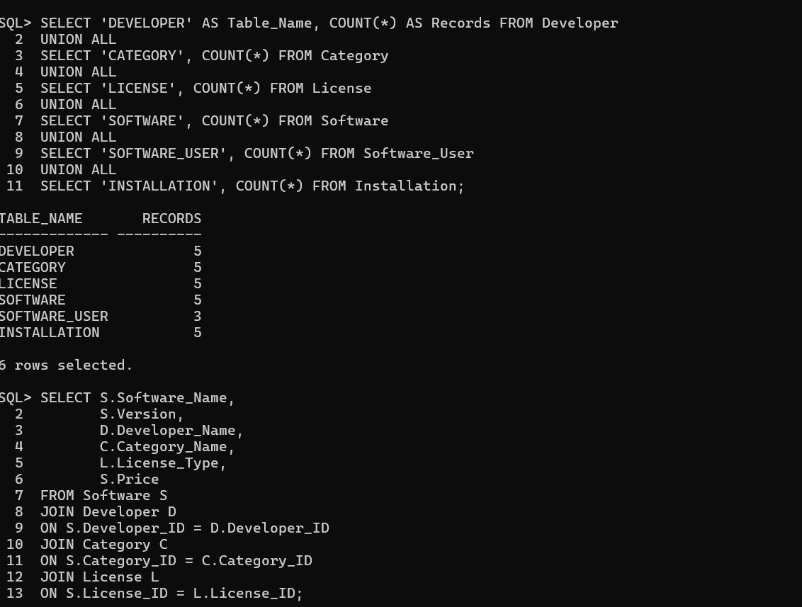

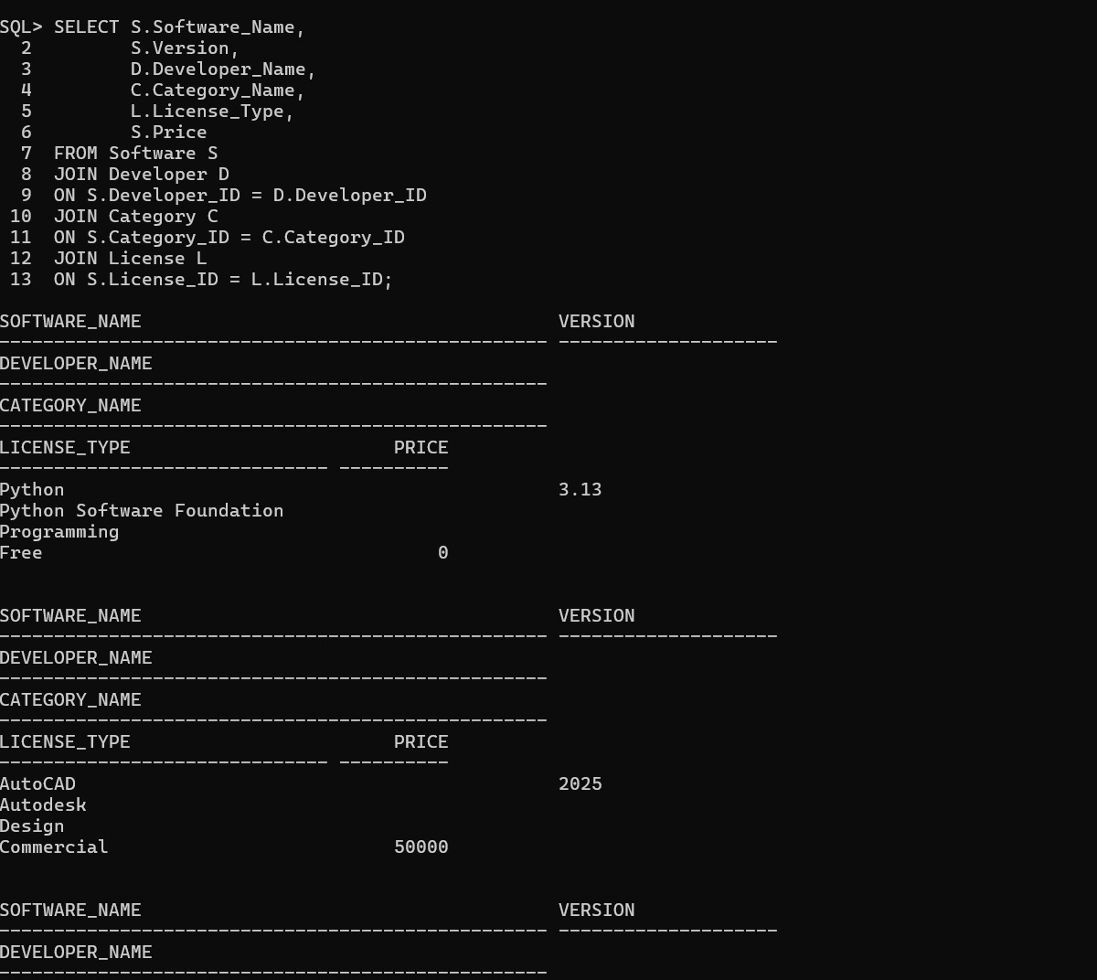


MODULES & FUNCTIONALITIES

Module | Functionality
Software Management | Stores software name, version and related identifiers.
Developer Management | Maintains developer information.
Category Management | Maintains categories and descriptions.
License Management | Maintains license type, dates and status.
User Management | Maintains user information.
Installation Management | Tracks software installations, systems, users and status.

GITHUB REPOSITORY & TEAM RESPONSIBILITIES
Repository Link: https://github.com/sahithijaldu/software-management-system

Student Name | Roll Number | Role / Responsibility | Contribution Status
GROHITH REDDY | 25B11AI388 | Wrote DDL scripts (tables, keys, constraints) | Completed
J.SAHITHI | 25B11AI417 | Designed ER diagram & relational schema | Completed
J.DEVI | 25B11AI422 | Wrote CRUD, Join & Aggregate queries | Completed
J.MOMITHA | 25B11AI441 | Compiled documentation & screenshots | Completed

ENHANCEMENTS & FUTURE IMPROVEMENTS
Add a user-friendly front-end interface for software management.
Introduce authentication and role-based access.
Add reporting and dashboard features.
Add automated license-expiry notifications.
Add audit logging for software record changes.
Use stored procedures or triggers where appropriate.
Add indexing for frequently searched software attributes.
. These are proposed future improvements. The uploaded presentation does not establish that all of these features are already implemented

CONCLUSION

The Software Management System provides a structured and organized approach to managing software-related information using DBMS concepts. It models software, developers, categories, licenses, users and installations as related entities. The relational schema, primary keys, foreign keys, SQL operations and CRUD concepts provide a foundation for efficient storage, retrieval and maintenance of software records.
.

REFERENCES

Project presentation: Software Management System — DBMS Capstone Project
.
Aditya University DBMS Capstone Project documentation structure used as the reference format.

SQL and relational database concepts used in the project presentation

APPENDIX

Complete SQL Script
The final SQL implementation is supplied through the uploaded project files:

    - ddl.sql — database table definitions, keys, foreign keys, and constraints.
    - dml.sql — sample data for all six tables.
    - queries.sql — representative SQL operations and analytical queries.
Repository: https://github.com/gopipeddinti1986-oss/Bank-Account-Management-System.git

Additional Screenshots / Outputs
Additional evidence can include SQL execution screenshots showing table creation, sample data, customer/account retrieval, balance updates, aggregate results, joins, GROUP BY/HAVING results, and subquery outputs. No execution screenshots were included in the uploaded source files, so this section is intentionally left for the team to add its actual screenshots.

