**Austo Motor Company**

**Analysts are required to explore data and reflect on the insights. Clear writing skill is an integral part of a good report. Note that the explanations must be such that readers with minimum knowledge of analytics can grasp the insight.**

**Austo Motor Company is a leading car manufacturer specializing in SUV, Sedan, and Hatchback models. In its recent board meeting, members raised concerns about the marketing campaign’s efficiency. The board decides to rope in an analytics professional to improve the existing campaign.**

**LET’S UNDERSTAND ABOUT GIVEN DATA:**

**By observing the Austo Motor Company data set,**

* **We have 1581 rows and 14 columns which include categorical and numerical data as follows:**

**Categorical Data:**

1. Gender
2. Profession
3. Marital_status
4. Education
5. Personal_loan
6. House_loan
7. Partner_working
8. Make

Numerical Data:

1. Age
2. No_of_Dependents
3. Salary
4. Partner_salary
5. Total_Salary
6. Price

**BASIC OBSERVATIONS FROM UNDERSTANDING:**

* After an overview of the data, no duplicate values are present.

That is no data repeated in the given data.

* Few values in the gender should be renamed to make the data more meaningful.

['Male', 'Femal', 'Female', nan, 'Femle']

The above is the list of values in the column gender. These spelling mistakes are to be

corrected to the following list ['Male', 'Female'].

* There are some null values in the Gender, Partner_salary.

In the below table, we can find the total number of null values in the give data.

Gender has 53 null values and Partner Salary has 106 null values which are to be rectified and bring to 0 null values.

|  |  |
| --- | --- |
| Age | 0 |
| Gender | 53 |
| Profession | 0 |
| Marital_status | 0 |
| Education | 0 |
| No_of_Dependents | 0 |
| Personal_loan | 0 |
| House_loan | 0 |
| Partner_working | 0 |
| Salary | 0 |
| Partner_salary | 106 |
| Total_salary | 0 |
| Price | 0 |
| Make | 0 |

**LET’S GET AN IDEA OF ALL THE INDIVIDUAL FEATURES OF THE DATA:**

1. **MAKE :**

There are three different varieties of Make – SUV, Sedan, Hatchback

If we observe the above Pie chart of Make,

* Sedan has more demand with 44.40%
* Hatchback comes next with 36.81%
* SUV has the least demand among the three varieties with 18.79%

1. **AGE:**

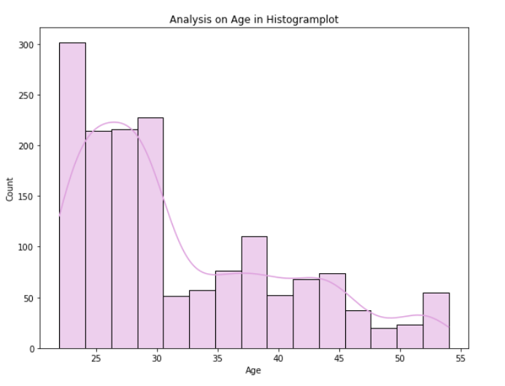

By observing the above histogram of the age column, we can say that the range of age is 22 – 54, where the median lies at 29.

That is most of the purchases are made by the age group around 29 to 31.

1. **GENDER:**

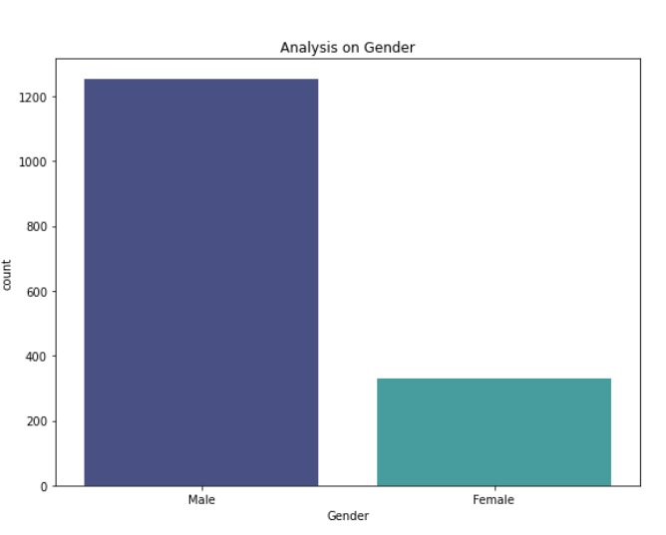

From the above bar graph, we can say most males are purchasing automobiles.

So, we must focus on females. Advertise in such a way that females have special benefits in purchasing the automobiles.

1. **SALARY:**

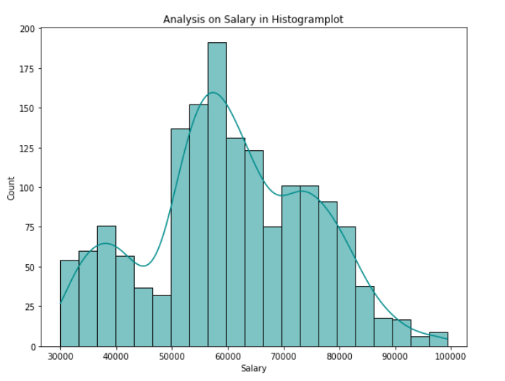

People with a salary range of 50,000 to 68,000 are more likely interested.

From this, we might think,

People with lower salaries might be interested in lower price cars.

People with higher salaries might be looking for cars with more features.

1. **PRICE:**

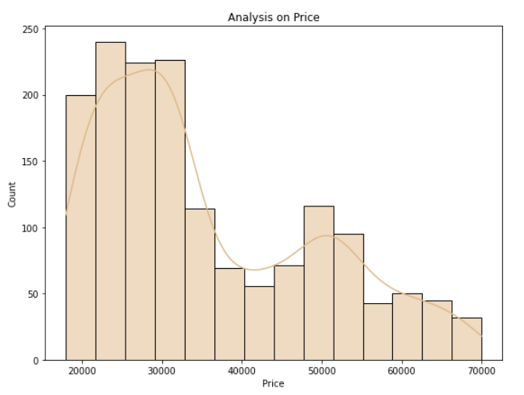

The price range is flexible from 18,000 to 70,000. There are cars with different price ranges to select from low to high.

People can select according to their requirement and budget.

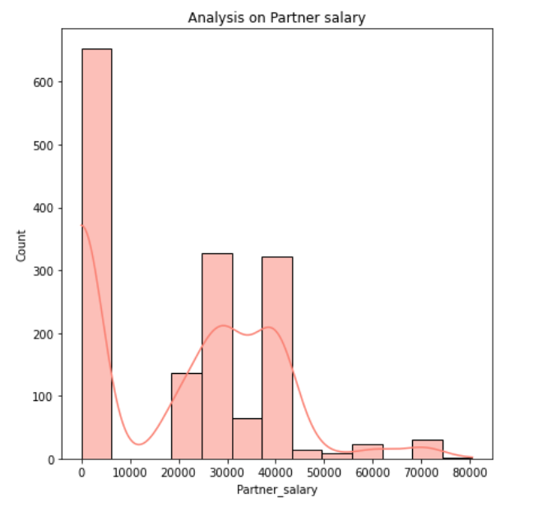**Lets go through other variables:**

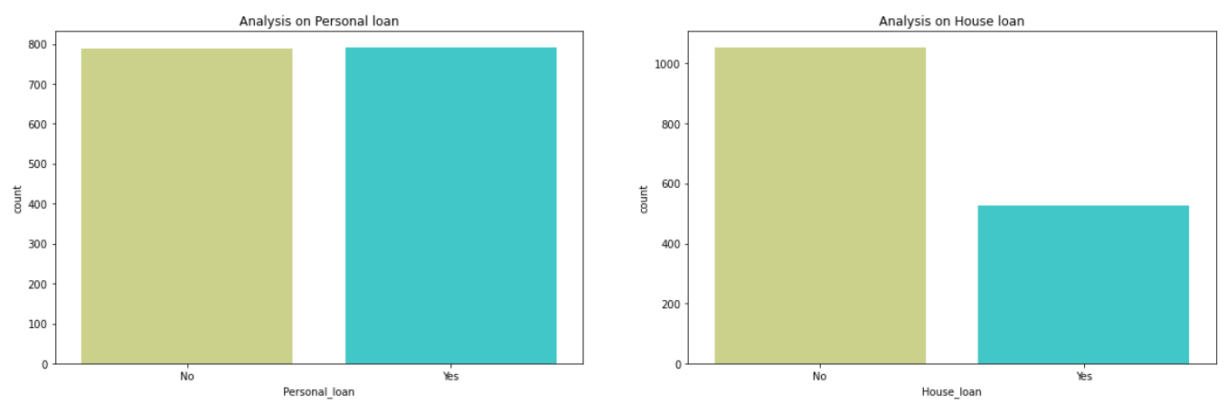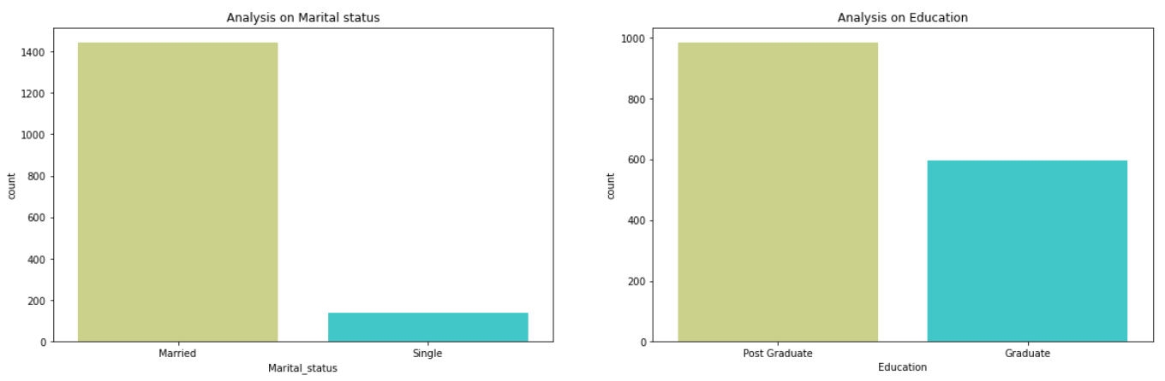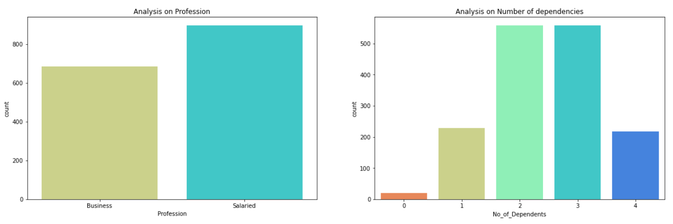

**Insights from the Univariate Analysis:**

1. By observing the histogram of partner salary, we can find a large bar at 0. This says that there are few non-working partners.

The partner’s salary ranges from 0 to 80,000.

1. Salaried people are a lot more interested in purchasing cars than business people.

To attract the business profession public, we can advertise in such a way that car is helpful in the business for them. This could help in increasing sales by people from business profession.

1. Married people are mostly preferring to purchase than singles.
2. People who pursued higher education or post-graduation is likely to purchase more than graduate people.
3. We cannot get any analysis through a personal loan, people with and without personal loan have purchased with almost equal count.
4. People with no house loan is more interested to buy car.
5. By analyzising number of dependencies graph, 2 and 3 dependencies are purchasing more.

**BI-VARIATE ANALYSIS:**

1. 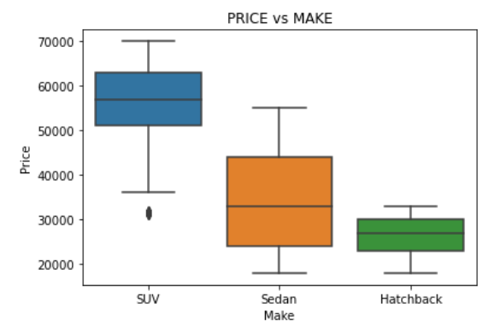**PRICE vs MAKE:**

**Insights:**

1. Comparing the price and make gives the price range of each make.
2. Here we have three different makes – SUV, Sedan, Hatchback.
3. The price range of an SUV starts from 31,000 to 70,000
4. The price range of a Sedan starts from 18,000 to 55,000
5. The price range of Hatchback starts from 18,000 to 33,000
6. Among the three models, Hatchback has least median that is it has a lower price range.
7. From the univariate analysis on Make, we understood that the highest purchased model is Sedan, the next is Hatchback, and the least is SUV.
8. As the price of SUVs is high the purchase count is also low.
9. Even though the Hatchback price range is low, the purchase count lies next to Sedan.
10. So we can consider Sedan the most preferred by people as the price is from lowest 18,000 to highest 55,000 which is not too high.
11. We could see an outlier in the price of SUV, as there is a model with a price of 31,000 and the next model starts from 51,000.
12. 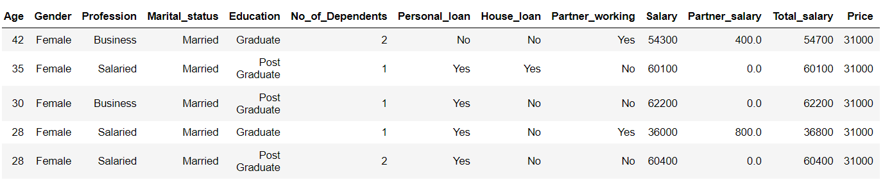One point to be noted in this outlier or at a model with price 31,000 is that this model is preferred by females.
13. **MAKE vs AGE**

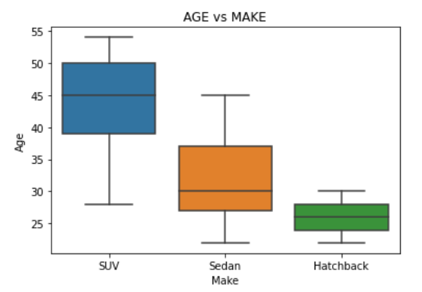

**Insights:**

1. Comparing the age and make, we can estimate which age group is interested in buying which model.
2. Hatchback cars are only used by the age group of 22 to 30.
3. From the age 30 to 45 people are preferring Sedans or SUVs.
4. SUV is the most selected car for the age group above 46.
5. If we could observe from the age 22 to 30, the public mostly prefers Hatchback and Sedan with more count that is more purchases of cars are by this age group than other age people.
6. Hatchback purchase count is above 60 in the age group of 22 to 28.
7. In ages 29 and 30, it is above 49 which is less count.
8. Sedan purchase is above 25 in the age group of 22 - 27.
9. People between the age of 28, 29, and 30 are more likely to be interested in Sedan.
10. In this case, the purchase count of Sedan is above 55.
11. Purchases of SUVs are observed from the people whose age from 28, with a very low purchase count which is less than 6.
12. From the age of 34, we could say the purchase count has increased more than the above age group but there is a pulse (increase and decrease of purchase count).
13. We have already observed the Price and Make comparison where we understood that Hatchback has a lower price range than others.
14. In Age and Make comparison, we found 22 to 30 age group is preferring Hatchback.
15. From two observations, as Hatchback price is low people at 22 to 30 age group might be preferring it.
16. Let us later check the age and salary to get more clarity.
17. 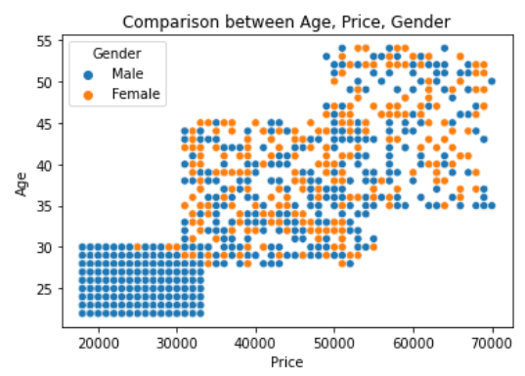**MAKE vs GENDER**

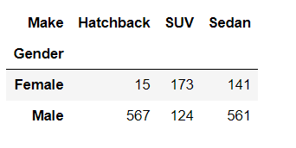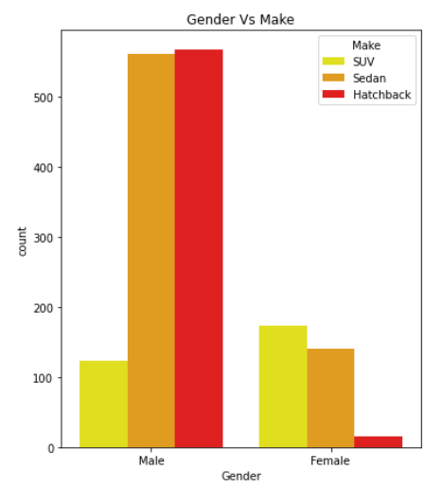

**Insights:**

1. From the bar graph and table, there is a lot of difference when comparing Make and Gender.
2. Females are not more into purchasing.
3. By comparison, females are preferring SUVs more than Sedan.
4. Female’s least preference is Hatchback.
5. Males are preferring Hatchback and Sedan more than SUVs.
6. We should concentrate on sales by female customers.
7. This can be done by giving offers, especially to females.
8. Also by advertising the safety for females by using automobiles.
9. Comparison between Age, Price, Gender graph clearly says, upto a certain age female are not purchasing.
10. **MAKE vs SALARY and MAKE vs PARTNER SALARY:**

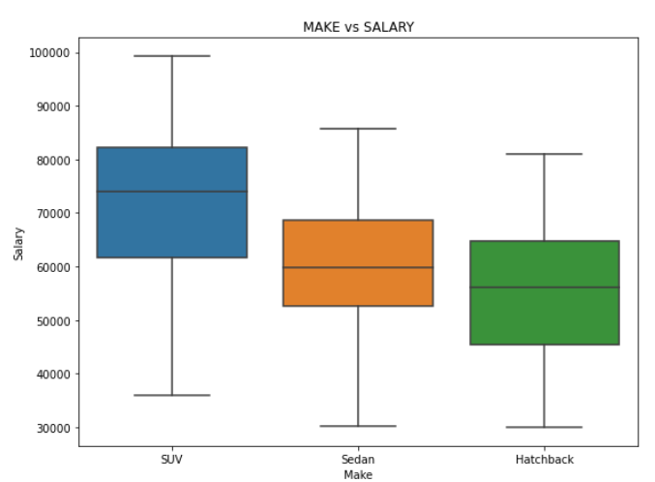

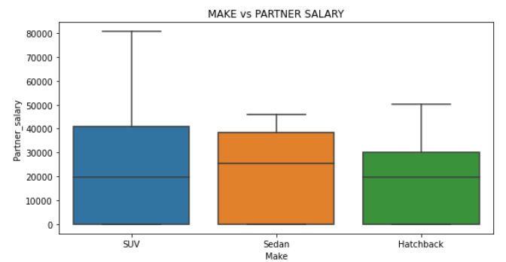

**Insights:**

1. People with high salaries tend to purchase a model with a high price from the compassion between Make and Salary
2. Here SUV is a high price as we have already observed.
3. So people with high salaries are more likely to buy SUVs, the next is Sedan and then Hatchback.
4. The positions are the same are their order of price (Make vs Price)
5. If the partner’s salary is high people are showing interest in SUVs but there is not much difference between SUVs and Sedans.
6. Median of Sedan is high, that is people are purchasing more price Sedan model that SUV.
7. Hatchback and SUV median are at almost same level, that is people are buying Hatchback and SUV at price range around 20,000.
8. 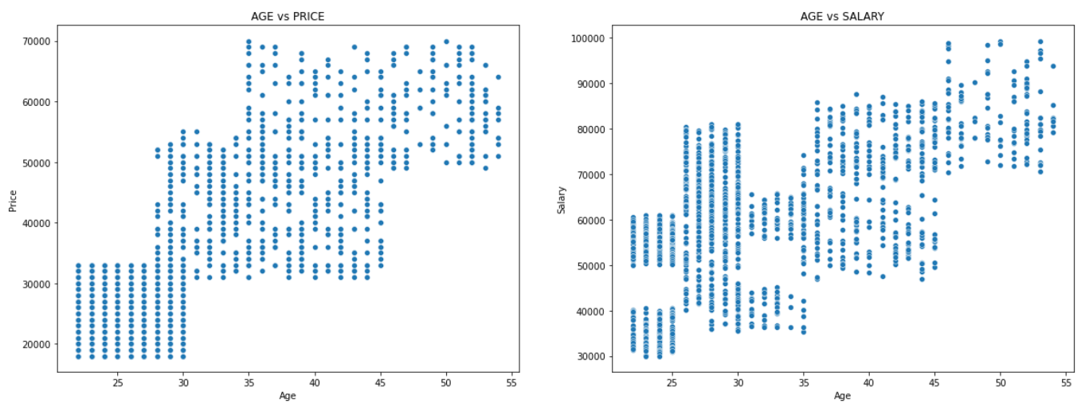**AGE VS PRICE AND AGE VS SALARY**

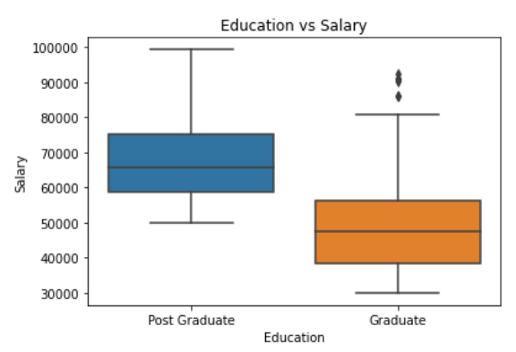

1. From the above graphs, we could conclude that as Higher the education level, higher the salary and higher the purchase price.
2. Age vs Price is clearly colinear. As people age increases, their purchase price increases.

**E. Employees working on the existing marketing campaign have made the following remarks. Based on the data and your analysis state whether you agree or disagree with their observations. Justify your answer Based on the data available.**

**E1) Steve Roger says “Men prefer SUV by a large margin, compared to the women”**

**E2) Ned Stark believes that a salaried person is more likely to buy a Sedan.**

**E3) Sheldon Cooper does not believe any of them; he claims that a salaried male is an easier target for a SUV sale over a Sedan Sale.**

**Solutions:**

**E1) Steve Roger says “Men prefer SUV by a large margin, compared to the women”**

I would not agree with the Steve Roger statement as Women prefer SUV by a large scale than Men.

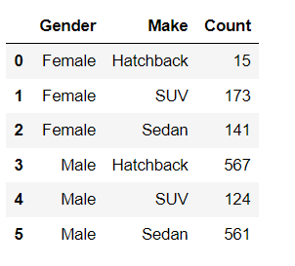Below table is the justification for the answer. We could see the count of the purchases made by men and women for each make.

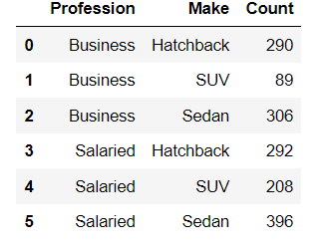**E2) Ned Stark believes that a salaried person is more likely to buy a Sedan.**

**I agree with the Ned Stark statement, Salaried person is more likely to buy a Sedan.**

**From the above table, the count of salaried person to buy Sedan is greater than other Make.**

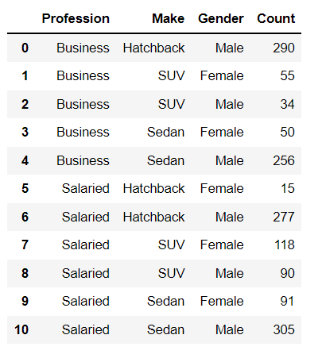**E3) Sheldon Cooper does not believe any of them; he claims that a salaried male is an easier target for a SUV sale over a Sedan Sale.**

Salaried men are not more likely to buy SUV. They are a lot more interested in Sedan, the next is Hatchback.

Salaried men purchasing SUV is least among other two Makes.

So, I do not agree with Sheldon Cooper.

**F. From the given data, comment on the amount spent on purchasing automobiles across the following categories. Comment on how a Business can utilize the results from this exercise. Give justification along with presenting metrics/charts used for arriving at the conclusions.**

**Give justification along with presenting metrics/charts used for arriving at the conclusions.**

**F1) Gender**

**F2) Personal_loan**

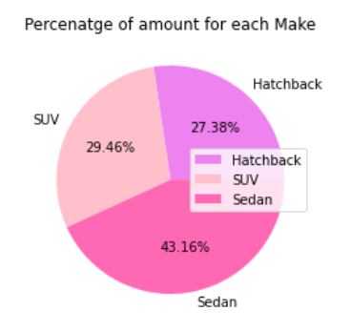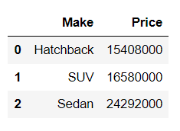**Amount spent on purchasing each Make:**

The Amount spend on Sedan is Far greater than SUV and Hatchback with 2,42,92,000.

The amount spend on SUV is 1,65,80,000.

The amount spend on Hatchback is 1,54,08,000.

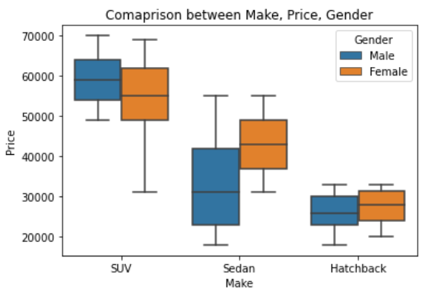**Total amount of purchase from each Gender on each Make:**

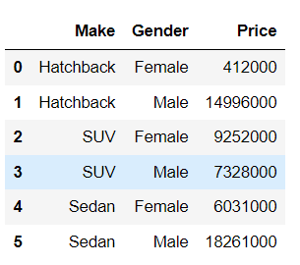Women spent more on SUV with total amount of 92,52,000.

Men spend most on Sedan with 1,82,61,000.

**G. From the current data set comment if having a working partner leads to the purchase of a higher-priced car.**

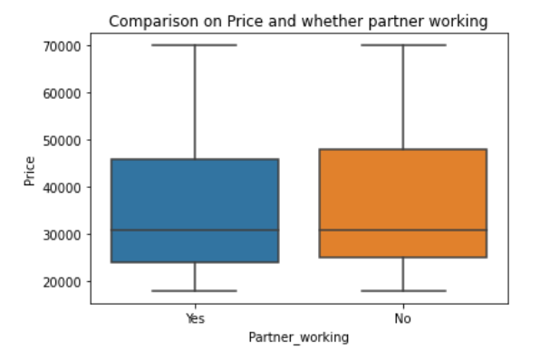

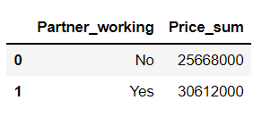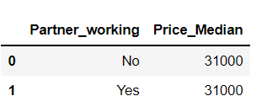

If we observe the Comparison of price and partner working graph, there not much difference can be found.

Although the box at no is higher, the median for both partners working or not of price is same that is in both the cases price spend is almost similar.

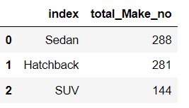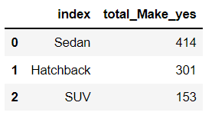*Let’s check for high priced car*:

As we know SUV is high priced car, by observing above table is partner is working, purchasing count of SUV is high.

Not only SUV but also count of purchasing cars is high if partner is working.