CALIFORNIA STATE UNIVERSITY, NORTHRIDGE

Advanced Twitter Bot Detection Using Machine Learning

A thesis submitted in partial fulfillment of the Requirements for the degree of
Master of Science in Computer Science

By

Sahithi Kotha

December 2025

Signature Page
The thesis of Sahithi Kotha is approved:

__________________________________ _____________________
Dr. Mahdi Ebrahimi, Ph.D. Date

__________________________________ _____________________
Dr. Sevada Isayan, Ph.D. Date

__________________________________ _____________________
Dr. Robert Mcllhenny, Ph.D., Chair Date

California State University, Northridge

Acknowledgment

I would like to thank everyone who has helped make this project a success.
To begin with, I would like to express my heartfelt gratitude to my committee chair, Professor Robert McIlhenny, who has been indispensable in guiding, encouraging, and supporting me throughout this project. Their deep understanding of machine learning and natural language processing has played a significant role in shaping my research direction. I owe them my gratitude, as their advice also significantly advanced my knowledge and the quality of my work.
I would also like to thank the entire staff and faculty of California State University, Northridge, for providing a favorable academic environment and the resources to implement this project. I want to express my gratitude to my peers and colleagues for their valuable suggestions, insights, and assistance in improving my work.
One must give special credit to the creators and authors of the machine learning models, the datasets, and libraries utilized in this project. Their effort has formed the basis of my research and given me the instruments to put the model into practice and assessment.
Lastly, I would like to mention my family and friends, who have always been my support, understanding, and encouragement, and have provided me with the necessary strength. They have believed in me, and this has been a strong motivator in overcoming the challenges and finishing this project.

Table of Contents

Signature Page ii
Acknowledgment iii
List of Figures vii
List of Tables viii
List of Abbreviations ix
Abstract x
Chapter 1 - Introduction 1
1.1 Background of the Study 1
1.2 Problem Statement 1
1.3 Research Objectives 2
1.4 Research Questions 3
1.5 Significance of the Study 5
1.6 Scope of the Study 5
1.7 Motivation 6
1.8 Research Methodology Overview 7
1.9 Contributions of the Study 9
Chapter 2 - Literature Survey 11
2.1 Introduction to Literature Review 11
2.2 Existing Approaches for Bot Detection 11
2.3. Recurrent Neural Networks (RNNs) in Bot Detection 12
2.4 Transformer Models in NLP 13
2.5 Challenges in Bot Detection 14
2.6 Evaluation Matrices for Bot Detection 15
2.7 Research gaps 16
Chapter 3-Research Methodology 18
3.1 Overview of the Proposed Approach 18
3.2 Research Design 19
3.3 Data Collection 20
3.4 Pre-processing of Data 21
3.5 Feature Extraction 22
3.6 Model Selection: Justification for Selecting a Specific Model 23
3.7 Model Construction 28
3.8 Training the Models 29
3.9 Evaluation Strategy 30
Chapter 4 – Implementation 32
4.1 Overview of the Implementation 32
4.2 Data Description 33
4.3 Feature Description 33
4.4 Exploratory Data Analysis (EDA) 35
4.4.1 Proportion of Labels of Cresci data 36
4.4.2 Word Cloud of Genuine Tweets of CRESCI Data 37
4.4.3 Bot Tweet Word Cloud 38
4.4.5 Average Retweet Count Over Time in Twitter Bot Detection Data 40
4.4.6 Average Retweet Count Over Time: Bots vs Non-Bots 41
4.4.7 Average Engagement Rate Over Time 42
4.4.8 Average Engagement Rate by Topic 43
4.4.9 Correlation Heatmap of Numerical Features 44
4.5 Data Preprocessing 46
4.6 Model Implementation 47
4.6.1 Random Forest Classifier 47
4.6.2 LSTM 49
4.6.3 GRU 51
4.6.4 BERT 53
4.6.5 RoBERTa 56
4.6.6 DistilBERT 58
4.6.7 XL Net 61
4.6.8 T5-Small 63
4.7 Model Comparison 66
Chapter 5 – Results and Discussion 68
5.1 Introduction to Results 68
5.2 Model Performance 68
5.3 Error Analysis 69
5.4 Impact of Feature Selection 70
5.5 Computational Efficiency 71
5.6 Interpretation of Result 72
Chapter 6 – Conclusion 74
6.1 Summary of Findings 74
6.2 Answer to Research Questions 74
6.3 Conclusion of the Research 75
6.4 Recommendations for Future Work 76
6.5 Implications for Industry 76
6.6 Final Remarks 77
Reference 79

List of Figures
Figure 1 Objectives of the Twitter Bot 3
Figure 2 Methodology overview 9
Figure 3 Research Process 20
Figure 4 Proportion of labels of cresci data 37
Figure 5 word cloud of genuine tweets 38
Figure 6 bot tweet word cloud 39
Figure 7 distribution of targe labels in twitter bot detection dataset 40
Figure 8 Average Retweet Count Over time in Twitter Bot Detection Data 41
Figure 9 Average Retweet Count Over Time: Bots vs Non-Bots 42
Figure 10 Average Engagement Rate Over Time 43
Figure 11 Average Engagement Rate By Topic 44
Figure 12 Correlation Heatmap of Numerical Features 45
Figure 13 Confusion Matrix for Both Data 48
Figure 14 LSTM Architecture 50
Figure 15 Confusion Matrix for LSTM Model For Both Data 51
Figure 16 GRU Architecture 53
Figure 17 CONFUSION MATRIX FOR GRU MODEL FOR BOTH DATA 53
Figure 18 BERT Architecture 56
Figure 19 Confusion Matrix For BERT Model for Both data 56
Figure 20 RoBERTa Architecture 59
Figure 21 Confusion Matrix for the RoBERTa Model 59
Figure 22 DistilBERT Architecture 61
Figure 23 Confusion Matrix for DistilBERT for Both Data 62
Figure 24 T5- Small Architecture 64
Figure 25 confusion Matrix of T5-Small Model on Both data 64
Figure 26 Final Comparison of all Model on Both Data 67

List of Tables

Table 1: PERFORMANCE COMPARISON OF RANDOM FOREST 49
Table 2: LSTM model comparison for both the data 52
Table 3 GRU MODEL COMPARISON 54
Table 4 BERT MODEL COMPARISON OF BOTH DATASETS 57
Table 5 ROBERTA MODEL COMPARISON OF BOTH DATA 60
Table 6 DISTILBERT MODEL COMPARISON ON BOTH DATA 63
Table 8 T5-SMALL MODEL COMPARISON ON BOTH DATA 65
Table 9 FINAL COMPARISON OF ALL MODEL 66

List of Abbreviations

AUC – Area Under the Curve
API – Application Programming Interface
AI – Artificial Intelligence
BERT – Bidirectional Encoder Representations from Transformers
CNN – Convolutional Neural Network
ESG – Environmental, Social, and Governance
F1-score – F1 Score (a metric for evaluating model performance)
GPU – Graphics Processing Unit
GRU – Gated Recurrent Unit
LSTM – Long Short-Term Memory
ML – Machine Learning
NLP – Natural Language Processing
PCA – Principal Component Analysis
RNN – Recurrent Neural Network
RoBERTa – Robustly Optimized BERT Pretraining Approach
T5 – Text-to-Text Transfer Transformer
TPU – Tensor Processing Unit
XAI – Explainable Artificial Intelligence
XLNet – Generalized Autoregressive Pretraining for Language Understanding

Abstract

Advanced Twitter Bot Detection Using Machine Learning
By
Sahithi Kotha
Master of Science in Computer Science

Automated bots on social media platforms, especially Twitter, pose a major threat to information security, user interaction, and the integrity of the platform. The proposed study is aimed at creating a sophisticated bot detection system that integrates the Transforming and Recurrent Neural Networks (RNNs). The proposed model will utilize a hybrid model, including some of the latest models, including BERT, RoBERTa, distilBERT, XL Net, and T5 in the transformer family, and conventional models, including LSTM, GRU, and Random Forest. The Transformer models are more effective at identifying contextual relationships in textual data to differentiate between human and bot behaviors, whereas RNNs, in particular LSTM and GRU, are more effective in analyzing user behaviors sequentially over time. The Random Forest model would also be an important addition to this deep learning method since it provides effective analysis of the importance of the features, which helps to determine the essential trends to predict automated behaviors. This system is trained using a large-scale Twitter dataset, which includes examples of human and bot accounts that are marked. The accuracy, precision, recall, F1-score, and area under the ROC curve (AUC) can be used as evaluation metrics to prove that the hybrid approach is effective in comparison with traditional bot detection methods. The paper can be added to the existing body of work on enhancing social media security and user trust through offering a viable and scalable bot-detecting solution, and the future uses could be seen in the scope of platform moderation and cybersecurity.

Chapter 1 - Introduction

1.1 Background of the Study
The social media sites, especially Twitter, have found their way into the contemporary world as an important communication channel for information dissemination and discussion. The problem of malicious automation, namely, both, however, has also increased with the development of the online space. Twitter bots are the bot accounts that perform certain functions like propagating misinformation, influencing opinions, or spamming. Both have the capability of undertaking various activities that include: propagation of fake news, as well as impacting political results, which ultimately misdirects the integrity of social networks.

Bots negatively affect the credibility of the user-created content, as it becomes more difficult to define whether a particular interaction is genuine or an automated and potentially malicious process. This has necessitated the development of advanced systems that are able to identify and counter their effect of such bots. Conventional bot detection systems, like rule-based or simple machine learning based systems, tend to be able to detect advanced bots that act more like humans.

Recent developments in machine learning, especially the adoption of Transformer-based models such as BERT and RoBERTa, and Recurrent Neural Networks (RNNs) such as LSTM and GRU, have been promising when it comes to enhancing detection accuracy. By their capacity to discern complex patterns in the data. These models will be very appropriate in detecting subtle differences between human and bot activity. The study will address a composite method of employing these advanced methods to develop a more robust method of detecting Twitter bots and, therefore, help in enhancing social media security and authenticity of content.

1.2 Problem Statement
The increase in the use of automated bots on social media sites, especially Twitter, has turned into a major issue among social media users as well as administrators. One of the most likely threats to the integrity of Twitter is the use of Twitter bots that are commonly aimed at artificially amplifying content, manipulating the opinion of the people, spreading misinformation, and spamming, etc. By manipulating the information flow. These bots are capable of setting false trends, interrupting valuable discussions, and affecting the decision-making processes, including the vote or purchasing habits of consumers.

Determining such bots also poses a problem due to the fact that they resemble human interaction, and hence it is hard to tell them apart from real users. Although the initial bot detection models, e.g., rule-based systems and manual flagging, offered certain success, they are relatively unsuccessful with more advanced bot types that use advanced tools like natural language processing, deep learning, and behavioral imitation. The more bots learn to cover up their actions, the more the old methods of detection cannot keep up, leaving a considerable discrepancy in the possibility of appropriately and effectively distinguishing such accounts.

The central issue that the given research aims to resolve is the impossibility of identifying bots that behave like humans, use different languages, follow different patterns of interaction, and apply various content-generation methods. It is necessary to have more sophisticated and scalable methods that will. Process high volumes of user data simultaneously, classify the accounts correctly, and distinguish between legitimate human users and malicious bots. With the scale of social media expanding. The need to have an automated and powerful system of detection of bots, which can adapt to the new challenges, is rapidly becoming more pressing. The paper will allow building a credible solution to detect Twitter bots and enhance the safeguarding of the platform, and you can have confidence in the relations with the users.

1.3 Research Objectives
- Establish a Powerful Bot Detection System: To create and deploy a machine learning based application that functions successfully in identifying bot users on Twitter by identifying patterns in user behavior, interaction, and content creation.
- Improve Detection Accuracy: To increase the accuracy and the recall of the bot detection models using advanced machine learning methods, it is important that the system reduces the number of false positives as well as that it reduces the number of false negatives.
- Examine Behavioral Patterns. To explore and discover unique behavioral attributes and patterns among Twitter users that can be reliably used to distinguish between human and bot Twitter users, such as the frequency of tweets, content type, and patterns of interaction
- Explorer Language Usage: To analyze the language features of Twitter posts (e.g., vocabulary, sentence structure, and mood) to determine when the automatic content is not identical to the natural speech of people.
- Compare Model Performance: In order to measure the performance of different machine learning models (e.g., Random forests, LSTM, GRU, and Transformer-based models, e.g., BERT, ROBERTa, etc.) in the task of identifying bots, such measures as accuracy, precision, recall, and F1-score should be used.
- Scale Detection of Large Data sets: To guarantee the scalability of the board detection system, allowing it to handle large amounts of Twitter data in real time, at be able to perform at various scales and on different data sets
- Known Problems with Bot Detection: To discover the limitations and challenges presented by the existing bot detection systems, and suggest possible solutions to the problems, especially regarding advanced bot behaviors.
- Improve Social Media Security: To offer practical insights and solutions to the social media services, enhance content regulation, and make the general validity of user trails more credible by discovering and limiting what actions.
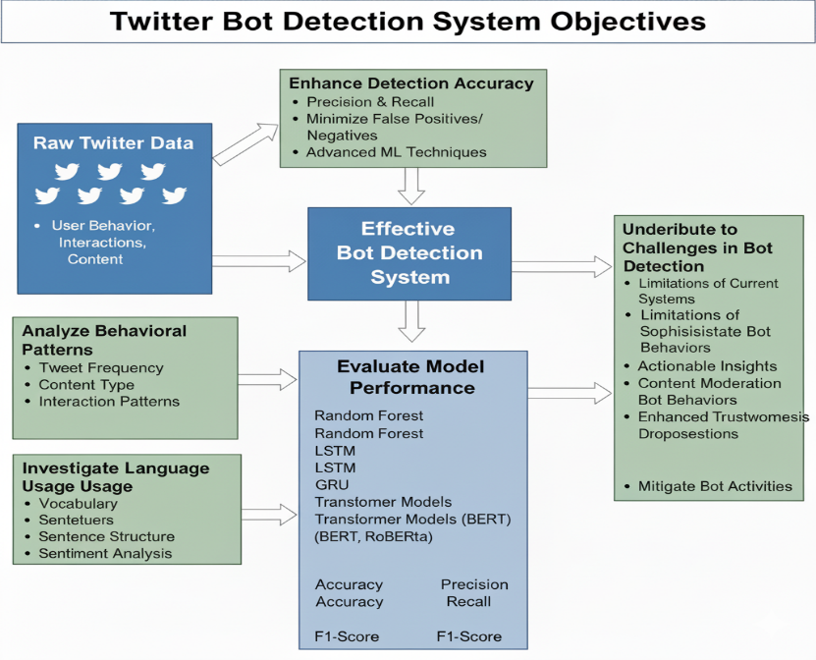
Figure 1 Objectives of the Twitter Bot

1.4 Research Questions
- What do Twitter bots and human users share in terms of their behavior patterns? The question will seek to understand the peculiarities and operations of Twitter users that can be exploited to differentiate between the automated bots and genuine users.
- How might mission learning algorithms, e.g., Random Forest LSTM, GRU, and Transformer-based models, be used to identify Twitter bots with high precision? The question aims to evaluate the efficiency of various mission learning models in detecting bot accounts on Twitter with respect to their strong and weak points.
- What is the importance of language used to detect Twitter bots, and what linguistic Stylistics are the most useful to detect bot-generated content?
This question examines the way that the use and content of language and text of tweets can be analyzed to determine that the information is unnatural or automated, which may indicate the presence of a bot.
- How is it possible to optimize Twitter bot detection models to reduce false positives and false negatives?
This question examines how the accuracy of a bot detection system can be improved in order to guarantee that the true users are not mistakenly labeled as bots are detected successfully.
- What are the limitations of identifying advanced bots that can replicate human behavior, and what can be done to overcome the limitations?
This question is aimed at the difficulties of detecting sophisticated bots as they employ machine learning to develop human-like behavior, and discusses what can be done to enhance the detection rates.
- What can be done to scale the bot detection system to deal with large datasets and real-time detection of bots on social media sites?
Such a question concerns the scalability of the offered bot detection system because it has to be able to process large amounts of data efficiently without distributing its detection performance.
- How do Twitter bots affect the legitimacy of user interactions and the content on social media platforms?
The question is an examination of the general impacts of bot activity on the authority of social media sites and the reliability of user-generated information.
- What are the weaknesses of the existing bot detection system and how can these weaknesses be addressed to make them more effective?
The question at hand will assess the current methods of detecting Twitter bots and determine areas of desired and necessary optimization, especially regarding how they deal with more advanced or adaptive bot Methods.

1.5 Significance of the Study
The importance of the present study is that it can help to solve the increasing problem of automated bots on social media and Twitter in particular. As more people use bots to control discussions, propagate fake news, and artificially impact trends, the credibility of social media networks is threatened on a regular basis. The bots are not just affected by distorting the opinion of the people, they also kill the trust in the platform, which affects the actions of consumers regarding the political discussion as well as their buying choices. Hence, proper bot detection is necessary to ensure the integrity and genuineness of social media communications.

This research would be very important in terms of battling these problems by creating a sophisticated bot detection mechanism. This study can offer a more reliable and scalable solution to bots. Identification by using the most recent machine learning methods, such as the Random Forest, LSTM, GRU, and transformer-based models, such as BERT and RoBERTa. The acquired knowledge can result in establishing powerful detection systems that could be applied to the social media platform to detect and combat the impact of bad automated accounts in real time.

In addition, the study will also be helpful in the overall sphere of cybersecurity and social media integrity, as it will equip the platform administrators with practical tools to make sure that the content created by the users of the platform is authentic. It will also be used to inform future research through the filling of gaps that exist in the detection of bots and providing possible solutions to the shortcomings of the current systems. Finally, the results of the study have the potential to change the policies of the platforms. Better the experience of the users and help build the confidence of more people in social media as a credible source of information.

1.6 Scope of the Study
The current study is dedicated specifically to the detection of automated bots on the Twitter platform and the researcher uses the most recent machine learning algorithms, which include the Random Forest, LSTM, GRU and transformer-based models (e.g., BERT and RoBERTa). The main focus of the research study is narrowed down to the analysis of publicly available Twitter information and the assessment of the efficiency of such models and dictating the accounts that are bot like. The information and the utilized in the research is user generated data (tweets, user activity (likes, tweets, replies) and account metadata) that are one of the main characteristics to detect a bot.

The aim of the study is supervised learning applied to any classification in which one aims to train models to differentiate between human and both accounts given labeled data. It will be evaluated based on performance measures that will include accuracy, precision, recall, F1-score, and ROC-AUC. That will give an idea of the ability of each model to recognize bots without falsely identifying legitimate users. This study will mostly concentrate on enhancing detection error and reducing false positives and negatives during the detection of watts.

It is also restricted to test-based analysis and patterns of interaction on Twitter. There is no consolidation of any other kind of automated malicious acts, like bots that do web scraping or manipulation to other websites. The ethical issue or legal matter of detection of bots and what the detection system takes to do with the detected bots is not explored in the study because the main aim is to create and test detection systems.

Finally, although the study will attempt to create a scalable solution to Twitter bot detection, the research will not target the implementation of real-time detection and systems or in-system integration of the model, which would involve extra infrastructure that the research will not cover.

1.7 Motivation
The urge to carry out this study is due to the growth and complexity of automated bots on social media, especially Twitter. Over the last few years, bots have become a central catalyst of disruption with the ability to manipulate discussions online, misinforming people, and even affecting political processes and opinion. Automation of such interactions to the precision of a human being makes it especially difficult to detect bots. The damage bots may cause people through affecting the discussion in a specific place, publishing false news, and losing trust in online platforms has necessitated the need to come up with viable ways of dealing with them by detecting and reducing their existence.

With the fast development of automated technologies, even the conventional methods of bot detection (based on simple rules or primitive machine learning algorithms) are not adequate any longer. The techniques find it difficult to match more advanced bots that use advanced algorithms such as natural language generation. And mimicry to sound and behave like humans. This leads to increasing demand for more developed and scalable detection systems that may process vast amounts of social media data and be able to distinguish between human users and bots.

This study is inspired by the fact that the improvement of such sophisticated detection systems is required with the use of the state-of-the-art methods, including Transformer-Based models (BERT, RoBERTa, XL Net) and Recurrent Neural Networks( LSTM, GRU). The research will improve the precision and efficiency of bot detection in Twitter. The rationale is to offer a solution that may possibly assist social media platforms to enhance user experience, rebuild trust in the online spaces, and make the information flow in these environment authentic and devoid of any manipulations.

The incentive also comes in the fact that this research may have a larger effect on the security of social media in general, which will lead to the creation of solutions that can safeguard users against the adverse effects of automated systems and ensure a safer and more natural cyberspace.

1.8 Research Methodology Overview
The study is quantitative and experimental in nature as it will design and test a Twitter robot detector based on the best machine learning algorithms. It will have several major stages regarding the methodology, such as data collection, pre-processing, model development, and training. Evaluation and performance analysis.

- Data collection: The First stage will be to collect a big publicly available set of Twitter user profiles along with their tweet interactions (likes, retweets, tweets, replies), and account information (e.g., the date of creation, number of followers). The information is obtained and used by API Twitter and other more public sources of data on the activity of bots, making sure that the sample of human and bot accounts is heterogeneous.
- Data preprocessing: Data that has been gathered is processed and cleaned in order to maintain the quality of the data. These steps involve eliminating irrelevant data and treatment of missing data, text normalization (for example, tokenization, stemming, and stopword removal), and encoding of categorical data. Cutting the raw data into data that can be utilized in the machine learning algorithms is carried out using feature extraction techniques, including but not limited to the extraction of tweet frequency. Content features (sentiment, word embedding), and the pattern of user interaction.
- Model Development: A number of mission learning models contribute to detecting bots. They consist of classic models like Random Forest, deep learning models like Long Short-term memory (LSTM), gated recurrent unit (GRU), and transformer-based models (BERT, RoBERTa, XL Net). The model has been selected because of its capacity to capture temporal, sequential, and contextual data.
- Model Training and Evaluation: The models are trained using labeled data, using human users and bot accounts. The hyperparameter optimization is done to achieve optimal performance. To determine the capability of the models to distinguish between bots and real users, Standard classification measures, including accuracy, precision, and recall, were used. F1-score and ROC-AUC measures are used to assess the model.
- Performance Analysis: Lastly, the performance of the models is analyzed in detail, and their relative performance on detecting bots and reducing the number of false positives is compared. Issues like uneven information and the use of advanced bots are addressed, and solutions to them are given.

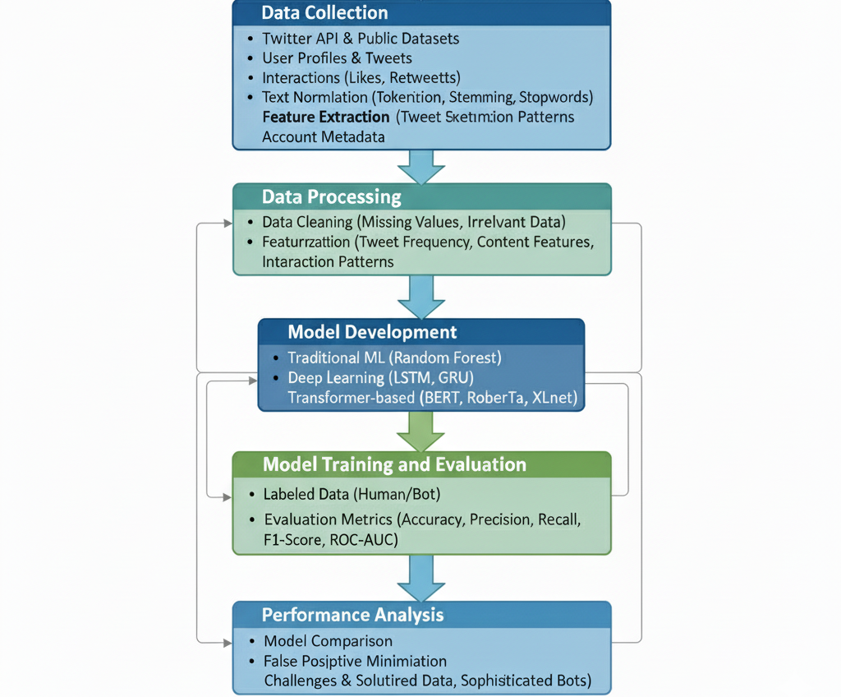
Figure 2 Methodology overview

1.9 Contributions of the Study
The study has several significant implications for research on social media security and bot detection, especially on Twitter. First, it provides a detailed comparison of state-of-the-art machine learning models, including random forests, LSTMs, GRUs, and Transformer-based models (BERT, RoBERTa, XLNet), for detecting and differentiating between Twitter bots and human users. By comparing these advanced models, the study reveals their strengths and weaknesses in handling the multifaceted issue of bot detection, offering clues about the most effective algorithms for the task.

Second, the research project will play an important role in developing an effective, scalable bot detector that can handle large amounts of data in real time. The study incorporates various attributes such as frequency and content analysis of tweets, interaction patterns, and other features. These attributes are crucial in identifying subtle bot-like behaviors. The feature-rich approach enables more precise and nuanced account classification, addressing the limitations of previous systems that relied on simple rules or a few features.

Third, the paper focuses on language and interaction patterns as ways to identify bots and provides an analysis of how linguistic features are used in sentiment analysis, word embedding, and textual patterns to detect automated content. The discussion adds to what is already known about the functionality of social media bots and sheds light on the sophisticated ways they mimic human behavior.

Lastly, the study offers a practical solution to the problem and a realistic recommendation that platform managers can implement to enhance security on social media. This research helps restore users' trust in user-generated content by improving the effectiveness of bot detection methods, making social media networks reliable sources of information. The findings from this study can be used in future research on platforms and in developing a more robust body detection system.

Chapter 2 - Literature Survey

2.1 Introduction to Literature Review
This literature review aims to provide a clear picture of current research and methods for detecting bots on social media platforms, particularly Twitter. In particular. The review is based on a discussion of the development of bot-detection methods, with a focus on machine learning, and the introduction of sophisticated models such as Recurrent Neural Networks (RNNs) and the Transformer architecture [1].

Early bot-detection research was mainly rule-based, relying on predetermined attributes such as account-creation patterns and activity frequency. But these approaches have not been found to be adequate in detecting more advanced bots that can replicate human behavior with great accuracy. This has led to a movement towards machine learning-based solutions, enabling more dynamic and scalable detection [2].

The review highlights advances in the application of traditional machine learning algorithms, including random forests and support vector machines, as well as more recent deep learning models such as long short-term memory (LSTM), Gated Recurrent Units (GRU), and transformer architectures like BERT, RoBERTa, and XL Net. It also sheds light on how these models have been used to process test data, interaction patterns, and account features to improve feature detection.[3]

The review also discusses the difficulties with detection, including the challenges of using uneven data sets to identify human-like bots, as well as the ethical concerns surrounding automated detection systems. These issues help set the context for understanding the current state of bot detection and highlight gaps in the research that this study aims to address.[4]

2.2 Existing Approaches for Bot Detection
Over the past few years, a wide variety of solutions have emerged for the problem of bot detection on Twitter, including traditional rule-based systems and advanced machine learning models. Much of the early work focused on identifying bots through simple heuristics, such as analyzing account activity—patterns with unusually high rates, retweeting at a faster pace, or retweeting many accounts within a short period. These rule-based systems relied on observable behaviors that could easily be identified as bot-like. However, the limitations of these techniques became evident as bots evolved to mimic human behavior, making interactions more convincing. As a result, researchers shifted toward machine learning methods capable of detecting subtle data features that conventional systems often missed. The initial machine learning models, like Support Vector Machines (SVM) and Random Forests, were used to classify accounts based on features such as tweet content, account metadata, and interaction patterns between users. Although these solutions improved detection accuracy, they still struggled to reliably distinguish between human-like bots and genuine users.

The introduction of decline also led to more sophisticated methods that greatly improved the task of detecting bots. Recurrent neural networks (RNNs), especially long short-term memory (LSTM) networks, started being used to analyze sequential data representing the time dependence of user behavior [7]. These models were more effective in identifying trends in user behavior and content curation, including unnatural access to certain topics or automated generation. Transformer models such as BERT, RoBERTa, and XLNet continued to enhance detection by enabling analysis of contextual relationships within tweet content. These models apply attention mechanisms to understand the underlying meaning of text, helping to differentiate between human-authored posts and bot-generated ones. Although they have been successful, there are still challenges in bot detection, including handling unbalanced data, dealing with adaptive bots that continuously evolve to mimic human behavior, and scaling these models for real-world detection [8].

2.3. Recurrent Neural Networks (RNNs) in Bot Detection
RNNs were used more frequently in bot detection because they can handle sequential data, which is important for understanding user behavior on sites like Twitter. Compared to traditional machine learning models, RNNs are much better at modeling the temporal and sequential relationships within data, making them effective for time series or driven data problems. RNNs are also quite useful. In time-dependent user interaction analysis, factors like tweet frequency, the timing of posts, and the content of replies or retweets all indicate bot-like behavior [9].

Another popular use of RNNs in detecting Twitter bots is the use of long short-term memory (LSTM) networks, a specialized form of RNNs that is able to address the vanishing gradient problem of classic RNNs. LSTMs are able to keep long-term dependencies of data, which is necessary to determine behavioral patterns that develop over time, including the development of an interaction style of a bot or its interaction with a particular subject. Knowing the order of tweets, retweets, and interactions in the history of activities of a user, researchers have used LSTM-based models to classify users as either bots or humans. This approach enables the system to detect anomalies in posting patterns, interaction frequency, and how users interact with other accounts, which often indicate automation. Additionally, LSTM-based models have been shown to outperform traditional machine learning models such as random forests and support vector machines, especially in cases that involve considering the time dimension of user activity and content on social media platforms [10].

2.4 Transformer Models in NLP
Transformer models have caused a paradigm shift in the natural language processing (NLP) field because they are capable of capturing long-range dependencies and contextual relationships within text. Unlike traditional models like recurrent neural networks (RNNs) and long short-term memory (LSTM) networks, transformer models do not process sequences sequentially but instead use parallelized attention. This mechanism allows for analyzing sequences of words all at once. The attention mechanism is especially useful in NLP tasks such as sentiment analysis, machine translation, and text classification. Therefore, transformers are well suited for identifying automated behavior in social media settings, such as detecting Twitter bots [11].

Transformer models like BERT, RoBERTa, XL Net, and T5 have proven to be some of the most effective performers across a wide range of NLP problems because of their ability to learn contextualized representations of text. These models are especially useful for detecting the semantic meaning of tweets, identifying language trends, and spotting subtle irregularities in content production, particularly for bot detection. For example, bots tend to produce syntactically coherent but shallow and low-context content, which isn't as rich or nuanced as human conversation. Transformers are highly effective at identifying such content thanks to their deep understanding of language, context, and relationships. Additionally, they can process large volumes of data, making them suitable for analyzing the massive amount of user-generated material on platforms like Twitter [12].

The most important benefit of transformer models is that they can detect bots by determining the associations of words and phrases within a tweet, which can indicate inconsistencies in the tone, style, or content. As an example, a bot can always post content that has similar words or time, which can be detected using the attention mechanisms in these models. This can be used to provide more robust and scalable bot detectors with the ability to differentiate between human and bot interactions in real time, despite more advanced bot tactics.

2.5 Challenges in Bot Detection
It is important to note that bot detection is a complicated and dynamic issue because of a number of major challenges and weaknesses of existing systems. The main problem is the modernization of bots. Older bots could be easily detected because of their simple behaviors. Like the ability to post to unusual frequencies or create repetitive content. However, advanced bots now resemble human-like behavior with a high level of accuracy, and they do so through processes like natural language generation, posting schedule, randomization, and more interaction. With greater variety and purpose, this complicates the process of telling the difference between bots and actual human users, particularly when both are evolving to escape detection [14], [15].

Another major problem is that when using imbalanced datasets, there are far fewer bot accounts compared to human accounts, and the detection model struggles to identify patterns that distinguish between the two. The result of this imbalance includes issues such as overfitting, where models become overly biased toward recognizing human users or fail to predict unseen data. Additionally, training bot detection systems often relies on limited or inaccessible label data because the labeling process is expensive in terms of time, and proper labeling of bots is necessary. This lack of labeled data can be a bottleneck in creating effective machine learning models.

Additionally, there is another challenge of evasion. The use of bots is constantly advancing to bypass detection systems by changing their behavior, which makes detection models become outdated or less effective over time. For example, bots may randomize their posting times, use varied language patterns, or imitate human behavior to evade traditional detection methods. Real-time detection is also difficult because the system must process large amounts of data quickly without sacrificing accuracy, making it hard to manage the volume of content generated on sites like Twitter [17].

Finally, issues of ethics and privacy complicate bot detection. The analysis and detection of bots can also violate user privacy or cause false alarms, meaning that a real account might be incorrectly labeled as a bot. The ongoing dilemma between detection accuracy and ethics remains a continuous challenge in development, evoking bot detection system [18].

2.6 Evaluation Matrices for Bot Detection
The assessment of bot detection systems should use various metrics based on performance to evaluate accuracy, reliability, and the ability to extrapolate to new data sets. Since it is challenging to distinguish between human users and bots, especially when bot behavior is highly advanced, the following evaluation metrics are commonly used:

- Accuracy: This is the simplest measure, the percentage of correctly described cases (both bots and humans) of the number of predictions. Although accuracy gives an approximate idea of the performance of the model. It may be inaccurate when the data set is skewed (i.e., there are a few more human users than bots), and the model merely predicts the majority group (humans) more frequently.
- Precision: Precision is a ratio of the number of correct bot detections to the total bot detections that were predicted. It is the answer to the question how many of the accounts found as bots are bots? A high precision level implies that the system has fewer spam mistakes (i.e., false-positives), i.e., correctly identified accounts are assumed to be bot.
- Recall (Sensitivity): Recall measures the rate of true positive bot detections out of all actual bots in the data set. It answers the question, "Which proportion of the real bot accounts are correctly identified?” High recall indicates that the system can detect most of the bot accounts, although it may also mistakenly classify legitimate users as bots.
- F1 Square: The F1 score is a harmonic mean of two metrics, precision and recall, providing a balanced view of a model's ability to recognize bots and reduce false positives. It is especially useful for imbalanced data sets because it considers both accuracy and recall. A higher F1 score indicates a more effective detection system that balances both accuracy and recall.
- Area Under the Receiver Operating Characteristics (ROC–AUC): ROC-AUC is used to determine how well a model can distinguish between bots and human users at different classification thresholds. ROC curve: This curve plots the True Positive (Recall) rate against the False Positive rate, and the AUC (Area Under the Curve) measures the model's ability to discriminate between the two classes. A larger AUC value indicates better performance across all thresholds.
- Confusion Matrix: A confusion matrix provides a more detailed look at classification results, showing the quality of true positives (correctly identified bots), false positives (human accounts incorrectly classified as bots), and false negatives (human accounts missed by the system). This matrix helps diagnose specific errors of the model, and it is especially useful for understanding the trade-off between false positives and false negatives.
- Log-Loss (Cross-Entropy Loss): The log loss is commonly used in probabilistic classification models. It measures the uncertainty of predictions by comparing the predicted labels with the actual labels. A smaller Log-loss indicates better performance, especially when generating definitive classifications rather than probabilities.
- Matthews Correlation Coefficient. The MCC is a more normalized measure of binary classification problems, especially when one or more classes are imbalanced. It considers true positives, true negatives, false positives, and false negatives, providing a comprehensive measure of model performance. A higher MCC value indicates a better model, while a value closer to zero suggests random predictions.

A combination of this matrix can be effectively used to evaluate bot detection systems, aiming to achieve not only high performance in detecting bots but also to reduce misclassifications of legitimate users [19].

2.7 Research gaps
Although there has been significant progress in developing bot detection systems, the existing literature has several gaps that the current study aims to address. One of these gaps is the increasing sophistication of bots, which challenges traditional detection methods used to distinguish humans from bots. Early bot detection techniques relied on identifying simple behavioral patterns, such as high posting rates or typical interaction levels. However, with the rise of advanced bots that utilize natural language processing (NLP) and machine learning to imitate human behavior, these conventional methods have become less effective. Even current systems struggle to detect the subtle nuances of bot behaviors that closely resemble human interactions. This research aims to solve this problem by employing more advanced machine learning models, such as LSTM, GRU, and Transformer-based architectures (e.g., ERT, RoBERTa), which are better suited to capturing the complex, context-dependent aspects of user behavior [20], [21].

The other gap in the literature is the lack of extensive feature sets used in bot detection. Most existing research relies on a few features, such as tweet frequency and account metadata. However, when classifying bots, advanced bots can imitate a wider range of human behaviors, interaction styles, language features, and content creation methods. This proposal aims to address this gap by incorporating various characteristics that are likely to improve detection accuracy, such as tweet content, sentiment analysis, engagement patterns, and account metadata [22].

In addition, the imbalance in the dataset is also another major issue in the study of bot detection. Most of the models are being trained on datasets in which the legitimate users significantly outnumber the bot users, making the predictions biased. This Paper provides solutions to this problem by discussing some of the methods, including data augmentation and synthetic data generation, to equalize the dataset and enhance the performance of the models [23].

Lastly, the detection of bots in real life over large platforms such as Twitter is still under research. Most available systems do not provide scalable real-time bot identification and are primarily post-hoc detection systems. The study will explore ways in which detection models can be scaled to offer efficient service to large datasets and deliver timely results in real-world applications [24] [25].

Chapter 3-Research Methodology

3.1 Overview of the Proposed Approach
The Twitter bot detection proposed solution is based on state-of-the-art machine learning to successfully distinguish between human and bot user accounts. The methodology is founded on the analysis of user behavior and content creation patterns on Twitter, along with the exploitation of a complex of sequential and contextual data to differentiate the cases of automated bots and real users. The essence of this is to calculate a number of features, such as the content of tweets, user interaction data, and account-level data, to understand the minor variations in how Bots and humans interact with the platform.

Data is collected by the use of the Twitter API, which consists of user tweets, retweets, replies, and account information, including the number of followers and the age of the account. The data is preprocessed to normalize and clean the data, and hence be similar throughout the dataset. The characteristics of the text can also be received with the help of the implementation of such means as tokenization, sentiment analysis, and word embedding, but the frequency of tweet issuance. The features of interaction and the time to respond can also be regarded as the parameters of the user interaction. These attributes are, in turn, trained on multifarious mission learning Models.

The proposed models include traditional algorithms like random forests that can process and organize data effectively, and neural networks like Long Short-Term Memory (LSTM), Gated Recurrent Unit (GRU), and transformer-based ones like BERT and RoBERTa. The Choice of these. Models follow the fact that they can both capture time information of user behavior and complex associations among textual data.

After they have been trained, the models are tested based on a performance matrix including accuracy, precision, recall, and F1-score. The objective is to develop an efficient, scalable system that can. Identify the bots with high accuracy without a lot of false positives so that the integrity and authenticity of the users on Twitter are maintained.

3.2 Research Design
The study takes an experimental and comprehensive design with the aim of testing and assessing different machine learning methods in the detection of Twitter bots. The first method is to gather a rich dataset of Twitter user behavior in terms of tweets, retweets, likes, replies, and accounts related metadata and use a sophisticated machine learning classifier to detect trends in improved automation. The general layout is divided into a number of major steps, which include data collection, data preprocessing, feature extraction, model selection, model training, and evaluation.

To begin with, the Twitter information is gathered from publicly available data sets and using the Twitter API. This is data on human accounts and bot accounts, and one can make a balanced comparison of both groups. After collecting the data, preprocessing methods that include text, normalization, text tokenization, and elimination of Irrelevant features are used to prepare the data to be analyzed.

The research uses a number of machine learning models such as the Random forest to perform standard classification, LSTM, GRU and Transformer based models (Example. BERT, RoBERTa, XL Net and T5) To compare their results in detecting bots, the selection of these models is determined by the capability to deal with sequential data, the capability to work with user behavior and capture contextual and temporal dependencies, as well as relating to their capability to process and comprehend the complexities Of natural language, although LSTM and GRU models have a high level of performance in sequential analysis of user traffic. Transformer-based models, especially XL Net and T5, are especially useful when it comes to the ability to capture deep contextual relationships and comprehend the sense of the content of tweets.

Once the models have been trained with labeled data, they are tested with the performance measures of accuracy, precision, recall, and F1-score, and ROC-AUC. This will take the strengths and weaknesses of both Models into consideration, and ultimately, the most efficient model of detecting bots will be followed. Other issues the evaluation process takes into account include the imbalance of datasets and the dynamic character of the bot's behavior. We keep the implementation study and are capable of generalization to real-world implementation.
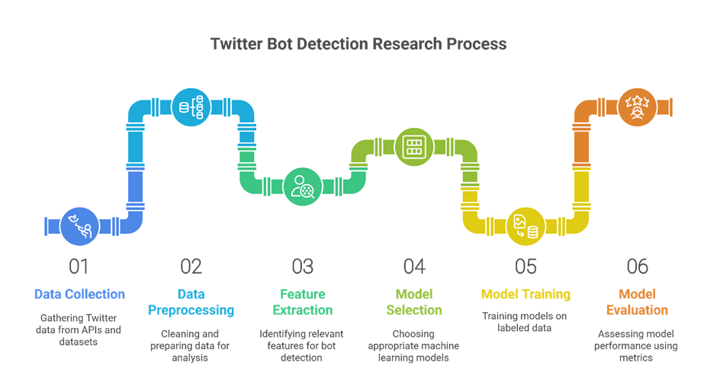
Figure 3 Research Process

3.3 Data Collection
In this case, two datasets were gathered to make it possible to train and test Twitter bot detection models. The initial data set is obtained from Kaggle, and the name of it is the Twitter Bot Detection data set (https://www.kaggle.com/datasets/goyaladi/twitter-bot-detection-dataset?select=bot_detection_data.csv ). It has labeled data on human and bot accounts, and each user has multiple rich features, such as account metadata (number of followers, account creation date, etc.), user activity data (tweet frequencies, retweets, likes, replies), and text-based features, obtained by tweets. The dataset has a balanced representation of bot and human accounts. It has more than 10,000 accounts, which were deemed appropriate in the training of classification models and testing the capability.

CRESCI 2017 Dataset is the second dataset that is commonly applicable in bot detection studies. This data belongs to the CRESCI Project, which is aimed at locating social bots and various social media, such as Twitter. It will include a list of bot and non-bot accounts, with features such as the content of tweets, user data, and interaction statistics. CRESCI contains diverse features that can be used to differentiate between authentic user behavior and automated activity, i.e, the number of tweets, retweets, and replies made by the particular account, and temporal account activity trends. It also contains more data than the Kaggle dataset as it provides a wide variety of accounts, both regular users and active automated users.
The two datasets are important in creating effective bot detection models as they represent a wide variety of features that capture various behavioral norms of human users and bots. Such datasets allow the model to learn various behavioral types and types of content, which enhances the possibility of the system identifying bots in real life. Python library search as pandas to manipulate data and Tweepy to access Twitter API when needed are used to collect data.

3.4 Pre-processing of Data
The data preprocessing is one of the most important stages of raw data preparation in order to conduct a successful analysis and model training. Due to the nature and the type of data obtained on Twitter, namely, text, numeric, and categorical data, a sequence of preprocessing methods was used to clean and format the data prior to feeding it to the machine learning models.

- Missing values: The initial pre-processing step would be to verify the presence of missing values in the datasets. Both in the Kaggle and CRESCI 2017 datasets, account metadata or tweet features with missing values were filled with either a mean (numeric data) or mode (numerical data), or rows with excessive missing value entries were dropped to prevent bias.
- Data transformation and Normalization: Numerical characteristics like the number of followers, tweets, retweets, and likes were normalized to maintain consistency within the dataset. Min-max scaling was used to rescale all the numerical features so that they are on the same scale, which is vital to such models as random forest or LSTM, which are sensitive to the variability of features. When categorical variables are needed, like account type (bot vs. human), one-hot encoding was employed to encode categorical data to leave a numeric Format that can be used as the input to machine learning algorithms.
- Text preprocessing: Since tweets constitute the main part of the dataset, an extensive cleaning of the text information was conducted. This included:
  - Tokenization: Dividing tweets into single-word (tokens).
  - Lowercasing: Changing all the text to lower case to maintain consistency.
  - Removing Noise: Removing non-alphanumeric characteristics. URLs have tags, mentions, and stopwords (Common words that do not add much importance to the text analysis, E.g, the, and)
  - Stemming and Lemmatization: To eliminate words to their root forms. (Example running to run).
- Feature Engineering: New features were added to the text, including sentiment scores (positive, neutral, negative) based on sentiment analysis tools and n-grams (word sequences) to add more context into the content of the wheels. Other temporal characteristics, such as the frequency of posting and the period between the tweets, were also computed.

This preprocessing is important to clean and ensure consistency of the data and to be ready to be analyzed so that the machine learning models can identify some meaningful patterns and enhance detection accuracy.

3.5 Feature Extraction
The instruction of features is an important stage when preparing the dataset to be trained in the model because it converts raw data to meaningful inputs that can be learned by the model. In the current research, a number of features were derived from the text and non-text aspects of the Twitter dataset to identify the unique actions of the robot and human users.

- Textual Dimension: tweets of her abundant information on the biases of differentiating between human and bot-generated content. characteristics such as word embeddings (through methods such as TF-IDF or Word2Vec) were cut out to give the semantic meaning of words in the tweets. Sentiment analysis was conducted to categorize tweets into positive, negative, or neutral because bots have a tendency to produce an item with a definite, and usually neutral or manipulated tone. Moreover, n-grams were picked to gain popular phrases and patterns that were employed by bots and human beings.
- User Behavior Features: Based on the history of interaction of the user, there were temporal and behavioral features. These are the frequency of tweets, retweeting, and reply patterns. The interactions between bots and human users can be highly frequent and repetitive, as well as those among human beings more sporadic and natural. Such characteristics as time between posts and time of the day when the posts were made were also estimated as bots can have unnatural and more frequent posting schedules.

- Account-level Features: The metadata of the Twitter accounts, like the number of followers, the age of the account, the date the account was created, and the ratio of followers to the number of followers, were reviewed to provide background information on the activities of the users. Bots can also have strange follower patterns or create their accounts quickly, which are characteristics of automated behavior.
- Engagement Metrics: It had other features such as count, retweet count, and reply count, which are used to understand how a user engages with other Twitter users. The interaction patterns of bots are usually abnormal compared to the interaction patterns of human users.

These attributes played an important role in the capture of a wide range of behaviors and traits that are necessary when differentiating humans and brought back accounts.

3.6 Model Selection: Justification for Selecting a Specific Model
In the context of Twitter bot detection, it is necessary to make appropriate choices on which machine learning models to use to be able to make the necessary distinction between human users and bots. The models that have been used in this work search as Random Forest, Long Short-Term, Memory (LTSM), Gated Recurrent Units (GRU), and transformer based models (BERT, RoBERTa, XL Net, and T5 ) are recommended due to the fact that they are able to process large number of elements of data, which can be structured account meta data and unstructured information in the form of text. the individual selection of these particular models has been informed by their respective advantage of processing various kinds of data their. Demonstrated efficiency in similarity-demanding tasks, in addition to the fact that they were able to effectively reflect complex patterns within user behavior and tweet content. Each of the chosen models has been outlined below, and the reasons as to why each of the models has been included.
- Random Forest:
  - Random Forest. This is an ensemble technique of learning that combines several decision trees to produce a strong and more precise model. It is commonly known as a preferred bot detector because it can work with both numerical and categorical variables, and it is not easily overfitted. Random Forest is used in the context of this research, where the metadata of the accounts and features of user behavior in terms of such characteristics as the number of followers, the frequency of trees, and the activity of patterns are analyzed.
  - The major benefit of the random forest is that it can process high-dimensional data where the association among the features can be complicated. It also gives a score of feature importance that contributes to defining the most prominent features in the difference between a bot and a human being. This can be especially effective when trying to determine what features of user activity. Out-of-bag error is also a feature of Random Forest to improve the model accuracy, especially when using imbalanced data sets, which is typically true in many detection tasks.
  - In general, the reasons why Random Forest is selected as a baseline model are its simplicity, interpretability, and good performance when working with structured data. It is especially useful and differentiating bots and humans based on the predetermined features and provides a helpful point of reference to the more advanced models.

- Long Short-Term Memory (LSTM)

  - LSTM is a variant of a Recurrent Neural Network (RNN) that is used to overcome the limitations of the traditional RNN, especially the issue of vanishing gradients. Tasks that require sequential data and time-based dependencies are best accomplished with LSTM networks, making them the best choice for Twitter bot detection. The user's time-based behavior is an important factor in determining whether a user is human or automated.
  - Long-range dependencies required in LSTM make it an important tool in understanding how the behavior of a user changes with time. As an example, a bot will always post on schedule or give repetitive responses that are very different from those that are natural and varied when it comes to human users. LSTM can be trained to detect these subtle yet significant differences by observing sequences of user interactions, offering a potent model for detecting bots in real time.

- Gated Recurrent Units (GRU)

  - GRU is yet another flavor of RNN that, like LSTM, is capable of dealing with sequential data. LSMTs are even more complex in structure, which makes them computationally expensive. GRUs provide an easier version of LSTMs because they join the forget and input gates into one gate, which leads to reduced parameters and reduced training time. GRUs have a more basic structure, and yet they are still able to discover sequential patterns, so they can be a good option when time-related data, like the timing of tweets and patterns of engagement, is a key factor, such as bot detection.
  - GRU has an advantage over LSTM in this paper because it can offer comparable performance at a lower computational cost. GRUs are also effective at learning patterns of bots which are very repetitive (lots of posts at a fixed period or lots of posts with the same collection of accounts), and do not require the strong computational performance of LSTM to do this. GRUs prove especially efficient when one has large amounts of data or the available computational capabilities are low. They provide a balance in both model complexity and model performance and are therefore very useful in detecting bots in cases of limited resources or in real time applications.

- BERT (Bidirectional Encoder Representations from Transformers)

  - It is another encoder-based model that encodes both forward and backward sequences of a sequence of words, just as the previous ones.
  - BERT is a pretrained Transformer model that aims to comprehend the meaning of words in regard to all the other words in a sentence. Designed to process text in a bidirectional fashion (i.e., left-to-right or right-to-left) as opposed to unidirectional, BERT is able to capture the relationship between words in more contextual sense.
  - The contextual sensitivity of the words helps BERT to grasp their meaning, which is especially useful in a textual analysis as a part of bot detection. The text being produced by bots is not always as rich and deep as it is in the case of human-generated text. Through the content of the tweets, the sentiment, phrasing, and the context, BERT can identify posts that are written by bots, even though they might seem fluent and coherent on a surface level, but lack any deeper linguistic structure, or they have patterns characteristic of automation.
  - Furthermore, the fine-tuning of BERT on certain tasks, e.g., bot detection can enable the model to utilize a large amount of data and still learn to target the features that could be important in differentiating between human and bot conduct. The fine-tuning strategy has allowed BERT to attain state-of-the-art performance in most NLP tasks, and would be appropriate to the task of analyzing social media text to detect bots.

- RoBERTa (Robustly Optimized BERT Pretraining Approach)

  - RoBERTa is an improved variant of BERT that builds on the former with larger training data and more effective training methods including dynamic masking and dropping the Next Sentence Prediction (NSP) task. RoBERTa has been demonstrated to be more effective than BERT on a number of NLP benchmarks, and especially in problems with large and complex datasets, like the detection of Twitter bots.
  - The fact that RoBERTa can analyze large amounts of text and focus more on the contextual relationships behind tweets makes it a very useful tool for identifying the language patterns of a bot. Bots are often based on scripted content or templates, which rely on predictable material. RoBERTa can detect these patterns by leveraging the contextual structure of sentences and interactions. It is a powerful and generalizable tool for distinguishing subtle differences between human and bot-generated content because it is robust and easily adaptable to various language inputs.

- XL Net

  - Another Transformer-based model called XL Net is an extension of the architecture of BERT, but enhances its performance with the help of permutation-based training. XL Net is less rigidly structured than BERT in its ways of learning word dependencies, because it accepts all word permutations, rather than only the fixed ordering of words. This renders XL Net to be very useful in text capturing complex relationships and also in the comprehension of the context of words in a more generalized manner.
  - In case of bot detection, XL Net can process text sequentially in an order-agnostic manner to detect latent patterns and anomalies in the content of a tweet that could not be easily seen by the conventional sequence-based models. Since bots can produce content of some repetitive and predictable form, XL Net can identify such abnormalities through analyzing the wider scope of word dependencies in the tweet. The generalization capabilities and the scale of pretraining, which can be used with XL Net, allow it to be very effective in identifying more complex bots that can avoid simpler models.

- T5 (Text-to-Text Transfer Transformer)

  - T5 is also a state-of-the-art model, based on Transformers, that views all the NLP problems as text-to-text. In contrast to traditional models, which are specific to a certain task (e.g., classification or regression), T5 is absent of constraints and can address any NLP task (e.g. bot detection). Representing the task of bot detection as a text generation problem, T5 can use its powerful encoding-decoding system. Figure 1 shows that T5 can use its strong encoding-decoding system to study the correlation between the input (e.g., tweet content) and the output (e.g., is the account a bot or human).
  - The capabilities of T5 to handle different types of textual input and its versatility makes it capable of identifying advanced bots that apply different language styles. It comes in handy especially during bot detection, where bots can produce human like information with sophisticated language generation algorithms. The use of T5 in the comprehension of the subtleties of tweets and the differentiation between bot-written and human-written tweets is due to its capacity to analyze the structure and context of the text and discern it.

The choice of models (Random Forest, LSTM, GRU, BERT, RoBERTa, XL Net, and T5) is predetermined by the fact that they are capable of dealing with various sides of the task of detecting Twitter bots. Random Forest is the best with structured data and LSTM and GRU can learn the behavior patterns over time. Textual models such as BERT, RoBERTa, XL Net, and T5 are especially useful in document analysis and contextual relations that are extremely important to detect advanced bots. Both models have their own contribution to the task and their combined functionality can be viewed as a full-fledged method of bot detection on Twitter.

3.7 Model Construction
The twitter bot detection model is built by choosing, training and testing the various machine learning models to process the different types of data; structured, sequential and textual data. It will use the so-called Random Forest, LSTM, GRU, and Transformer-based models, such as BERT, RoBERTa, XLNet, and T5.

- Random Forest: This is an ensemble model, which is effective when working with structured data, which are the account metadata (followers, frequency of tweets, etc.). Several decision trees are also trained using subsets of features and the overall classification is done by summing up the predictions. The model is strong, understandable, and offers feature importance scores, which can assist in defining the important patterns of behavior of bots and humans.
- LSTM and GRU: The two are Recurrent Neural Networks (RNNs) that aim at capturing sequential dependencies on data. GRU and LSTM are suitable in cases of studying temporal trends in user behavior, including the sequence of tweets and retweets. LSTM is well adapted to the long-term interdependencies, whereas GRU offers an opportunity to process the sequential information more easily and efficiently. These models learn to detect some repetitive or predictive patterns that bots have.
- BERT, RoBERTa, XL Net, and T5: These Transformer architecture models perform well with unstructured textual data processing because they focus on word-word contextual connections by analyzing the text in tweets. BERT is bidirectional and RoBERTa uses better training to improve the performance of BERT. XL Net and T5 offer more improvements with the former one grabbing a larger context and the latter using a text-to-text strategy. These classification systems are used to analyze the content of tweets to identify unnatural language usage that is mostly present in bot-generated text.

Training and validation data is used to train the models. Fine-tuning of hyperparameters is done by methods such as cross-validation. The metrics used to evaluate model performance are accuracy, precision, recall, F1-score, and ROC-AUC to ensure effective bot detection on various behaviors and content types.

3.8 Training the Models
The model training process of the chosen models assumed a number of steps that would guarantee the best performance and effective learning. This section discusses how the models will be trained, how the hyperparameters will be optimized and how the optimization methods will be used to optimize the models and avoid overfitting.

- Data Splitting: This was followed by splitting the data into training and testing data, and usually, 70-30 or 80-20 split. Cross-validation was employed in order to guarantee that the models would be generalizers, i.e., the training data was split into k-folds (e.g., 5-fold or 10-fold cross-validation). This enables this model to be trained using various samples of data and tested using different samples, which gives a stronger estimate of its performance.
- Sources: In both models, i.e., Random Forest, LSTM, GRU, and Transformer-based models (BERT, RoBERTa, XLNet, T5) the training process was performed by feeding the models with the labeled data (bot and human accounts). The aim of the training was to minimize the loss function that measures the gap between the predicted labels (bot or human) and the real labels.
- Hyperparameter Tuning: Hyperparameters play a very important role in determining the performance of the model. In the case of Random Forest, such hyperparameters as the amount of trees, maximum tree depth, and minimum samples per leaf were optimized. In the case of the LSTM and GRU models, such hyperparameters as the number of layers, units per layer, and the batch size were optimized. In the case of the Transformer-based models, critical hyperparameters such as learning rate, epochs, a batch size, and the size of the hidden size were modified. Hyperparameter optimization was performed with the aid of techniques like grid search and random search and combinations of hyperparameters were tried to identify the optimal one.
- Techniques of Optimization: A number of optimization techniques were used in the training process in order to achieve effective learning. In the case of deep learning models (LSTM, GRU, BERT, RoBERTa, XLNet and T5), the Adam optimizer was applied, which allows changing the learning rate during training and, thus, is more suitable when using large datasets. Early stopping was used to check how the model is doing on a validation set, and stop the training when the performance of this model begins to deteriorate, to avoid overfitting. Besides, the LSTM model and GRU model utilized dropout as a form of regularization to avoid overfitting where a fraction of the neurons was randomly set to zero in the course of training.
- Regularization: The regularization methods such as L2 regularization (weight decay) were used to ensure the models did not overfit the training data particularly when using deep learning models where there are many more parameters and hence larger possibility of overfitting the training data.
- Loss Function: Categorical cross-entropy loss function was applied to the models in classification tasks, and this is appropriate in the scenario when the task is to label an instance with one of a set of classes that are available (bot or human). It was also altered in models like the Random Forest case in which it was adjusted to be a multi-class classification where necessary.

With this training and optimization, the models were optimized to achieve the most optimal with regard to bot detection at the same time perform well when generalizing to unknown data. The choice of the hyperparameters and method of regularization as well as the training process ensured that the models proposed were not only correct but also capable of resisting any change in the data set and could detect bots in the real-world setting.

3.9 Evaluation Strategy
The evaluation plan of this paper is based on various performance indicators that are significant in evaluating the success of the bot detectors. The main objective is to test the degree to which each model can recognize Twitter accounts as either bots or humans with the least number of mistakes like false positive and false negative. The first metric to measure the overall performance is accuracy, which is the percentage of correct classifications (bot and human accounts) of the total number of predictions. Nonetheless, accuracy is not enough, particularly in asymmetrical datasets in which a huge number of human accounts exceeds bots. To this end, the accuracy is also obtained, and it is the ratio of true positives (those correctly marked bots) to all such cases. The precision is important in the matter that the legitimate human accounts are not classified as the bots and, consequently, the adverse influence on user experience is removed.

Besides precision, recall (also known as sensitivity) assesses how well the model is able to detect bot accounts and it is computed to be the percentage of true positives among all true bot accounts. Ensuring that the model does not miss bot accounts is accomplished with high recall even when it increases false positives. In order to strike a balance between precision and recall, the F1-score is used which is a harmonic average of the two measures. The F1-score is an overall picture of the model, with regard to its sensitivity to false positives and false negatives, and it is particularly important with unbalanced data. Additionally, the ROC-AUC (Receiver Operating Characteristic - Area Under the Curve) is employed to evaluate the capability of the model to differentiate bot accounts and those of humans at different levels. An increased ROC-AUC score signifies increased facility to distinguish the two classes by all levels of decisions.

Finally, a confusion matrix is used to plot the performance of the model by demonstrating the number of true positives, false positives, true negatives, and false negatives. Such a matrix gives a better understanding of the nature of errors that the model is committing that can be more thoroughly analyzed as a source of weaknesses and strengths on its achievements on bot detection.

Chapter 4 – Implementation

4.1 Overview of the Implementation
The practical implementation of this study implies the usage of the selected machine learning models to identify Twitter bots. This step involves the translation of the theoretical underpinnings made in the research design into the actual executable code and functional systems. The main goal of the implementation will be to develop a tenacious and scalable Bot detection system that examines Twitter data, educates models, and analyses their results successfully.

It will start with the gathering of pertinent data, consisting of people and bot accounts on Twitter. Information is gathered using Twitter API and already existing datasets, which provide a variety of user behavior patterns. Once data collection is done, data cleaning and preprocessing is done to maintain consistency and quality of the data. This stage involves dealing with missing values, standardizing quantitative data, and text allotment before analysis by means of tokenization and other text standardization measures.

The chosen machine learning models, namely, Random Forest, LSTM, GRU, and Transformer-based models (BERT, RoBERTa, XLNet, T5) are implemented next. The models are selected based on the fact that they can be used to work with various data such as structured account metadata, sequences of user interactions over time, and unstructured tweet messages. The data is then preprocessed and used to train the models with tuned hyperparameters to optimise the performance of the models. The different optimization methods, which include early stopping and dropout, are utilized to avoid overfitting and make the models to be generalized on new and unseen data.

After training models they are tested by several performance measures such as accuracy, precision, recall, F1-score, and ROC-AUC. The comparison of the various models and the establishment of the most efficient model through the evaluation process is possible. This implementation stage preconditions the realization of the bot detection system so that it could be efficient, accurate, and scaled.

4.2 Data Description
The data that will be used in this research involves the data of Twitter user activity; this includes the bots and human Twitter users. Data were collected using two main sources, which are the Kaggle Twitter Bot Detection Dataset and the CRESCI 2017 Dataset. The Kaggle dataset contains labeled data of more than 10,000 Twitter accounts, including account information (the number of followers, the date of account creation) and their activity (tweets, retweets, likes, replies). The data is equal in terms of bot and human accounts, which offers a wide range of features to be used in the model training.

CRESCI 2017 data, which is popular in bot detection studies, provides in-depth details of bot and non-bot accounts, such as user details, tweet text, retweets, and interaction statistics. It has over 10,000 accounts and is especially relevant to the study of bot detection within the social media environment, providing such helpful features as frequency of Tweets, patterns of interaction, and time campaigns.

Both sources were cleaned and preprocessed to eliminate inconsistencies in data. Non textual attributes such as user activity statistics and account metadata were normalized. Textual information, including the content of tweets, was tokenized and sent through sentiment analysis and word embedding retrieval. These datasets can be used as a powerful basis on which the machine learning models can be trained and their capacity to differentiate bot and human accounts can be evaluated.

4.3 Feature Description
Name of data set: bot detection data bot.csv.
Overview:
This data is created to undergo the classification process to determine whether a Twitter user is a bot or not. It has a number of features to do with user account features, content of tweets, and engagement statistics, which can be added to train machine learning models in detecting bots.
Columns Description:
- User ID: This denotes a user identifier of any individual user within the dataset, as the person of account.
- Username: The user name of the twitter user account.
- Tweet: Textual information of the tweet left by the user.
- Retweet Count: This is the frequency in which the tweet has been retweeted. It shows the degree of interaction that the tweet has had on the part of other users.
- facet Count: The count of mentions in the tweet (e.g. @username). This may be an indication of the interactivity or networked state of the user on the twitter platform.
- Followers: This is the number of followers that the user has, which gives an idea of the influence that the user has on the platform.
- RIP-verified: Boolean (True/False) value that is 1 on verified and 0 on unverified user accounts (twitter).
- Bot Label: This is a binary label that will be used to show whether the user is a bot (1) or not (0). This is the classification target variable.
- Location: The physical place where such user is located, in the event that it is present.
- Created At: This is the date and time when the tweet was actually created, which gives a temporal context of what the user is doing.
- Hashtags: The hashtags of the tweet which are representative of the topics or themes of the content in the tweet.

Dataset Name: CRESCI 2017
Overview:
CRESCI 2017 is a popular dataset of labeled Twitter data, which is created with the intention of social bot detection. This data will give information on the Bot-like behavior such as the content of the tweets, user metadata, and the pattern of interaction among different types of accounts. It is specifically designed to study bot detection in the context of real-world social media.
Columns Description:
- User ID: This is a unique identifier of each user account that is important in the process of tying activity data with particular users.
- Username: The Twitter username of the user account.
- Tweet Content: The words of the tweet the user has written, the analysis of the content is conducted to find the patterns that can be associated with bot activity.
- Tweet Count: The total number of tweets made by the user, which gives an idea of the level of activity.
- Retweet Count: This is the number of times the content has been shared by the user by being retweeted, meaning that the content is shared by many people.
- Followers Count: The cumulative number of people that follow the user, which is an important factor in determining the influence of the user and may be used to determine potential bots that have unnatural follower growth.
- Following Count: The number of accounts that the user is following, which can be indicative of behavioral trends as observed in mass-following, which is prevalent in bot accounts.
- Account Age: The age of the account of a user can give indications of suspicious young or newly created bot accounts.
- Interaction Features: The number of replies, likes, and mentions the user has received is included in the list of metrics that can be used to analyze the pattern of interaction that is characteristic of bots compared to humans.
- Temporal Features: The frequency and the time of the tweet, which may reflect automated activity when tweets are sent at abnormally constant time intervals or off-hours.
- Bot Label: a binary label (1 or 0) to label the user as a bot or human, which is used to give the target to the classification exercise.
- User Activity Patterns: This feature attributes like the ratio of retweets to original content, which is usually distorted when it comes to bot accounts.
- Hashtags: Hashtags that the user employs in the tweets and that may allow identifying trending topics that may be tackled by bots.
- Geolocation: Geographical location of the user, where it goes, should it exist, and this could tell us that there are location-based tendencies in bot behavior.
CRESCI 2017 data is potentially a treasure trove of training machine learning to differentiate between human and tweet bot behaviors in Twitter, through a combination of engagement data, account data, and textual content of tweets.

4.4 Exploratory Data Analysis (EDA)
The Exploratory Data Analysis (EDA) is a very important stage of the data analysis process, as it enables us to learn the structure of the dataset, patterns, and possible problems or issues before implementing machine learning models. This paper conducted EDA to investigate Twitter bot detection datasets (Twitter Bot Detection Dataset on Kaggle, and CRESCI 2017 Dataset) and find out which characteristics differentiate bot accounts and human accounts.

The initial procedure in the EDA procedure was to observe the pattern in the distribution of the target variable, Bot Label, in both datasets. This gave an insight into the disparities in classes, whereby bot accounts are generally lower than human accounts. To demonstrate this imbalance, which is one of the typical issues in bot detection problems, the visualization tools such as bar plots and pie charts were employed.

Subsequently, histogram, and box plot were used to investigate the distributions of the most important numerical characteristics, including Follower Count, Retweet Count, and Tweet Count. These visualizations showed just how different human and bot accounts were whereby bots would tend to have abnormal patterns of activity including unusually large retweet or followers. The correlation analysis was performed in order to learn the associations between numerical characteristics to track the possibility of multicollinearity.

Textual characteristics were discussed as well, and word clouds, and sentiment analysis were used to reveal the content that bots and humans created. It was the case that Bot-generated tweets tended to use less diversified vocabulary and more neutral feelings than human-written ones. Temporal analysis of Tweet Creation Times also demonstrated that bots have a tendency of posting at a more constant rate as compared to human users.

On the whole, EDA was useful in finding significant patterns and outliers, which informed the choice of the features to use in the model training and the optimization of the preprocessing stage.

4.4.1 Proportion of Labels of Cresci data
The pie chart which I have provided shows the ratio of labels (Human vs. Bot) in the CRESCI data. Based on the chart, it seems that 58.6 per cent of the accounts in the dataset belong to the Human (label 0) and 41.4 per cent to Bot (label 1) categories.

This distribution is representative of a more typical scenario in bot detection problems, where there are usually more human accounts than bot accounts. The small imbalance of the dataset could have an effect on performance of models, since the models will tend to predict the majority. This imbalance can however be managed using various methods such as oversampling, undersampling or application of balanced evaluation metrics to enhance the accuracy with which the bot accounts are detected.
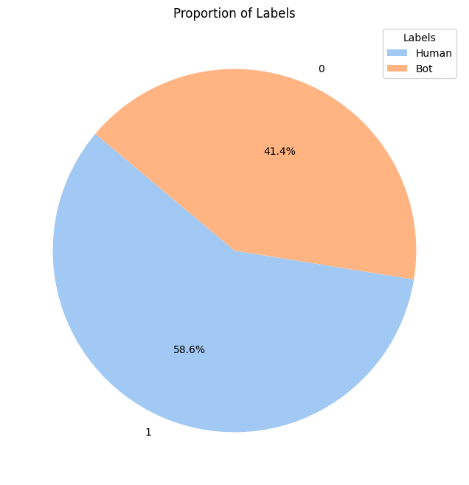
Figure 4 Proportion of labels of cresci data

4.4.2 Word Cloud of Genuine Tweets of CRESCI Data
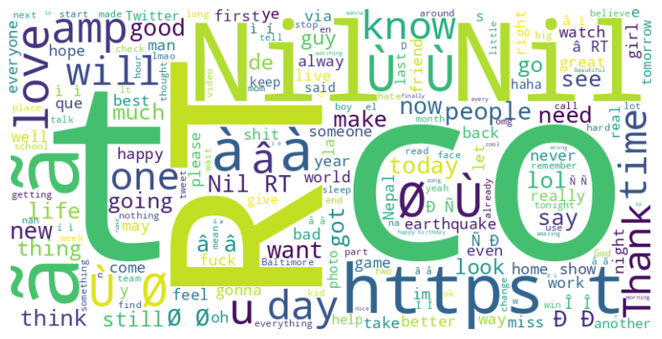
Figure 5 word cloud of genuine tweets

The above word cloud is a visual representation of the most recurring words in the bot-generated tweets of the dataset. The font of the words is used to depict the frequency of the word used in the content produced by bots with bigger fonts having a higher number of occurrences. The use of words such as Nil, 0, and https as well as RT (retweet) are so high that it tends to depict that bots usually create tweets with redundant and uninformative writing, random characterization, or links. Moreover, the application of generic words such as love, day, and thanks shows that bots can simulate the language of the conversation without having any meaningful context or intent and thus the interactions can be less personal.

The presence of symbols and non-standard characters, including "Ø" and "à," further demonstrate how bot-generated content can contain an unnatural and incoherent text, which is not usually provided with the natural variation and the natural flow of a human tweet. The monosyllabic quality of some words and the monosyllabic phraseology is evidence of the robotic quality of such accounts, which are likely to produce content using set templates or scripts at high rates.

This word cloud can be used to determine the prevalent linguistic patterns of bot-generated work and can be used to design bot-detecting devices. Upon identifying these repetitive and artificial patterns, models are able to learn to differentiate between real human interactions and those that were created by an automated and meaningless post.

4.4.3 Bot Tweet Word Cloud
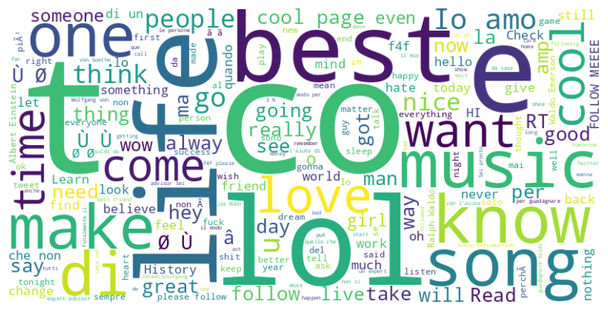
Figure 6 bot tweet word cloud

The above word cloud provides a visual representation of the most common words in bot-generated tweets, with the size of the word telling how often it appears in the dataset. The cloud is dominated by words such as best, LOL, love, follow, want, and song, which are frequent in bot content. Phrases frequently used in conversation are common chat expressions, such as I love, follow me, or the best, These expressions imitate human-like communication, but do not involve any communication.

The common occurrence of hashtags such as RT (retweet) and F4F (Follow for Follow) also indicates that the content posted by the bots can be characterized as promotional or spam. Such repetitive self-promotional actions are typical of bots to gain greater attention or the number of followers. The use of emojis or other non-standard characters and the existence of random symbols, such as " 0 " and " a ", emphasize a sense of no meaningful or contextual communication in posts made by bots when tweeting.

Other terms, including music, cool, page, and game, indicate that bots tend to pay attention to the issues that create a certain buzz or the ones that can easily become viral. The presence of generic words like want and going indicates that the bots are attempting to mimic everyday conversation, although not as deep or as natural as the conversation between people.

This is a word cloud that highlights the superficiality and repetitiveness of bot behavior. The identification of these common phrases and interaction patterns will be useful in enhancing the bot detection design to bring out linguistic features that distinguish between bots and humans.

4.4.4 Distribution of Target Labels in Twitter Bot Detection Dataset
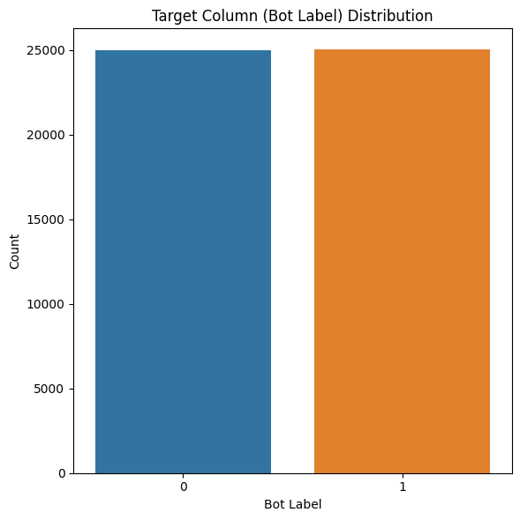
Figure 7 distribution of targe labels in twitter bot detection dataset

The bar chart above indicates the distribution of Bot Label in the Twitter bot detection data. The data is relatively balanced, as there are equal amounts of human and bot accounts (label 0 and label 1). This uniform distribution is essential in training machine learning models because it will avoid a situation where the model is biased on the majority class, which is usually a problem in datasets where a single class population is significantly higher than the other. The uniform distribution of the data is the guarantee that the human and bot behavior is properly covered to set a reliable point of reference to identify automated accounts on Twitter.

4.4.5 Average Retweet Count Over Time in Twitter Bot Detection Data
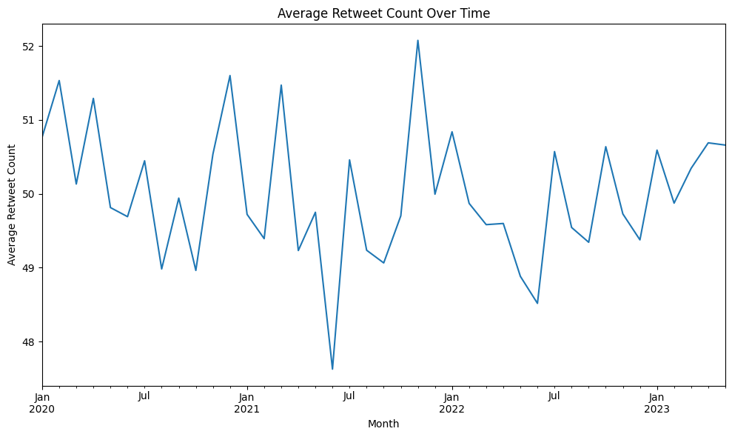
Figure 8 Average Retweet Count Over time in Twitter Bot Detection Data

The above line graph shows the average retweets per month, including the period between January 2020 and January 2023. The trends in the number of retweets during the months are also enlightening as they help to understand the tendencies of the users with regard to their interest in Twitter. This analysis would allow seeing more active times, which could be related to certain events, campaign, or even the work of Twitter bots.
The number of retweets is an important characteristic in the case of bot detection since bots tend to have characteristic engagement behavior. As an example, bots can retweet a constant number of times or less frequently, or can have regular bursts of retweet behavior compared to human users who usually have more erratic retweet behavior. By examining the retweet count (in terms of the counts) when the count changes with time, it would be possible to understand the behavior of bots as bot-like behavior may exhibit periodic bursts of activity, compared to human users, whose engagement with the site is more spontaneous and variegated.
This graph can be also compared to other engagement measures, including the frequency of tweets or the number of followers in order to gain better insight into the character of the interactions on Twitter and enhance the models of detecting bots. The model can also more accurately detect automated behavior, and differentiate between these two by detecting abnormal patterns in the number of retweets, i.e. spikes or unnatural regularity.

4.4.6 Average Retweet Count Over Time: Bots vs Non-Bots
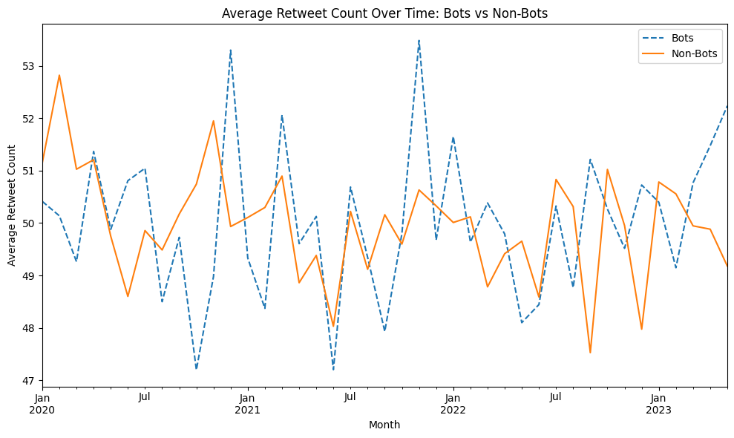
Figure 9 Average Retweet Count Over Time: Bots vs Non-Bots

The above-presented graph is a comparison of the average number of retweets of bot and non-bot accounts in a timeframe between January 2020 and January 2023. The blue dashed line is the average number of retweets of bots, and the orange solid line is the average number of retweets of non-bots. Through this comparison, we are able to observe the change in engagement patterns, namely the retweet activity, of the two types of users, bots and human users, over time.

Based on the graph, we are able to see that the retweet trends of bots (blue line) are more prone to becoming more variable and spiky, and therefore, the presence of bursts of activity in bots is possible. Such spikes might represent the work of coordinated bots such that automated accounts can be used to retweet many times within a given time frame, and this is often done as part of a larger targeted campaign or to boost certain content. By contrast, the retweet number of non-bots (orange line) seems to be more consistent and slow-moving with less big peaks, as the interaction patterns can be viewed as more natural and unstable, which is typical of human users.

These distinctions between bot and non-bot retweet activity are important to bot detection systems. Through the examination of these variations in engagement behavior, particularly in retweet behavior, machine learning models can be more effective in recognizing the difference between an automated and a human account. Bots tend to have predictable and repetitive behaviors compared to human users who have a diverse interaction style. This graph also offers a graphical display of the trends that the models can be trained on, which makes bot detection systems even more accurate.

4.4.7 Average Engagement Rate Over Time
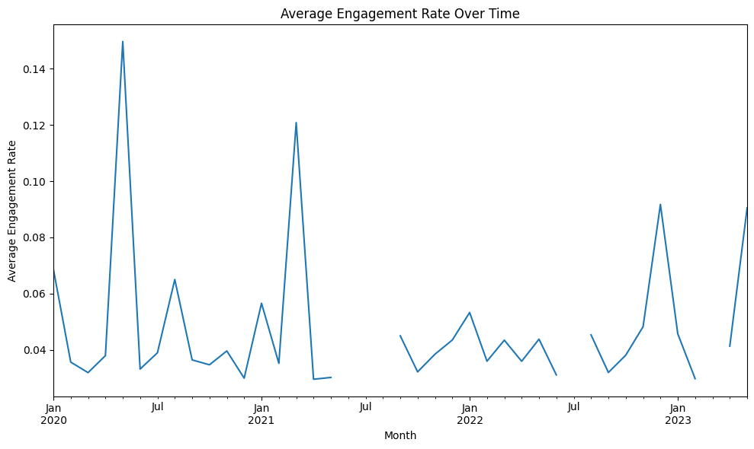
Figure 10 Average Engagement Rate Over Time

The above graph indicates the average rate of engagement with time, since January 2020 to January 2023. This is because the engagement rate (user interaction with the tweets and likes, replies, retweets) is divided by the number of followers or impressions and it is one of the important metrics used to measure how interesting one user content is on twitter.
Based on the graph, it is evident that the engagement rate was high particularly between January 2020 and January 2021. Such spikes may be evidence of high engagement, which may be caused by certain events, trends, or concerted action by automated accounts (bots) to increase engagement. It has been known that bots cause unexpected spikes of activity that can seem like it caused a high rate of engagement in a brief time.
Conversely, the lows in the history indicate the existence of the less active interactions with users, which is observed in both human and automated accounts. The changes in the engagement rate might also be the alteration in the patterns of activity or interaction of bot accounts, i.e. the accounts that are involved in campaigns or amplification of content at certain periods.
The metric may be especially helpful when it comes to separating bots and humans, with the latter exhibiting more diverse patterns in engagement behavior, whereas bots tend to be overly high or even predictable in engagement. Trends in engagement rate through time help in identification of such trends that can be used in incorporating the bot detection models in order to enhance the level of accuracy.

4.4.8 Average Engagement Rate by Topic

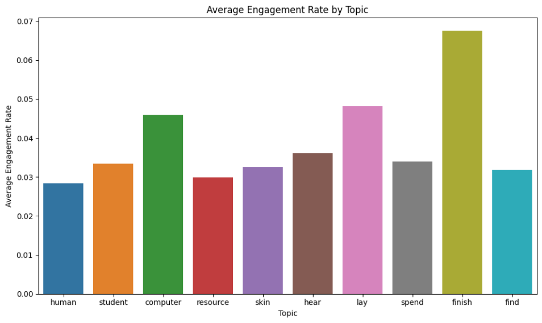
Figure 11 Average Engagement Rate By Topic

The bar chart provided above shows the average engagement by topic on the dataset of Twitter bot detection. The engagement rate is calculated based on the interactions (likes, retweets, replies) to the number of followers or impressions. Each bar is a mean engagement rate of the tweets that contain a certain topic, and this allows us to compare the level of user engagement of the different topics.

Based on the chart, we are able to note that the average engagement rate of the topic of finish is the highest of all other topics and quite above them. This can be a sign that the tweets touching on the subject of finishing (which is probably associated with accomplishing tasks, goals or projects) will attract more interaction because they are more appealing or relatable to a wider audience.

Other issues like computer, student, and lay also display a fairly high level of engagement and this implies that these issues appeals to the users and motivate them to interact with them. Such subjects could be closer to the users or provoke more proactive conversations among the users. Conversely, such topics as find, resource and skin have lower rates of engagement which may suggest more niche or less engaging topics.

With the help of these differences in engaging in different topics, one can also see trends and patterns in user behavior, which is especially helpful in the task of bots detection. Patterns in abnormal engagement of bots in particular topics, including artificially increasing engagement levels around a particular keyword, may be identified with this analysis as a powerful instrument of enhancing the precision of bot detection models.

4.4.9 Correlation Heatmap of Numerical Features

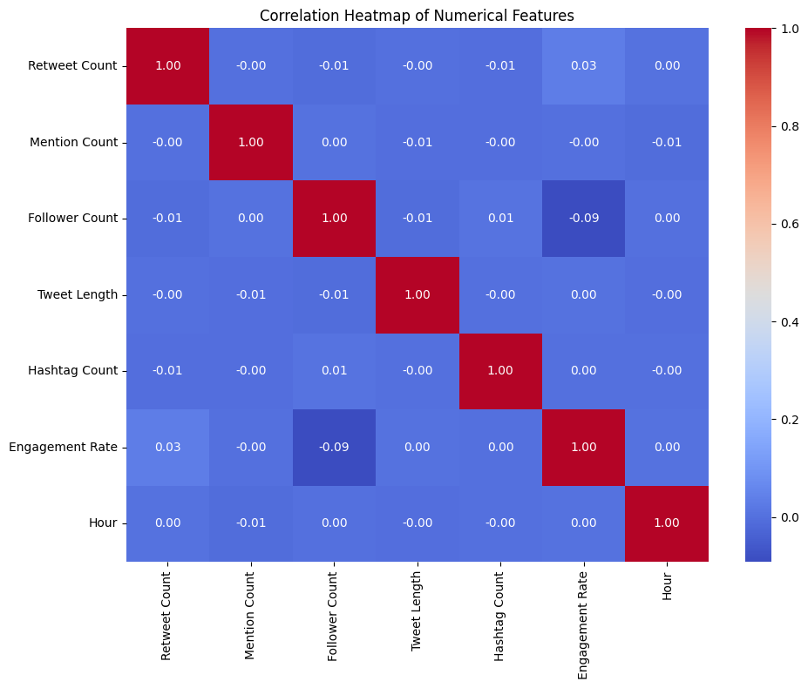
Figure 12 Correlation Heatmap of Numerical Features

The heatmap above plots the correlation of different numerical features of Twitter bot detection dataset. The correlation coefficients are between -1 to 1 where correlation coefficients near 1 or -1 represents a strong positive or negative correlation, respectively and correlation coefficients near 0 are weak or no correlation.
Based on the heatmap, we are able to see the following:
- Tweet Length and Hashtag Count: The correlation between the length of the Tweet and the number of Hashtags is positive (0.99), implying that longer tweets are more likely to have more hashtags. This may be attributed to the fact that when their tweets are long the users put in more contents such as hashtags. After the analysis, the number of followers and the engagement rate have a negative relationship of (-0.09), which means that, though it does not really have a strong correlation, the number of followers does influence the engagement rate in that users with a larger number of followers have slightly lower engagement rates. It might be due to the fact that large accounts might be less actively attended to and, therefore, there is less engagement per follower.

- Engagement rate: The level of engagement is loosely related to other attributes, it means that the level of user engagement (likes, replies, retweets) does not strongly depend on such aspects as the length of the tweet or the number of hashtags. It implies that the involvement might be motivated by more complicated patterns which include the quality of the content, timing, and extraneous factors that are not represented by the available features.

- Other Weak Correlations: The rest of the features, including retweet count, mention count and hour, exhibit little correlation among them meaning that they do not interact in predicting bot-like behavior.

This heatmap will serve as a basis to know the relationship between various features and may be used to select features and train the model to achieve better accuracy in identifying bots.

4.5 Data Preprocessing
The preprocessing of data is an important process of organizing raw data to be used in machine learning models to make the data clean, consistent and in a friendly format to be analyzed. In the case of the twitter bot detection task, the preprocessing steps consist of a number of processes that are important to deal with missing values, data normalization, and textual and numerical features preparation.

First, the missing values of the dataset were considered. The rows that had many missing values were eliminated to prevent biasing the model, and the columns with fewer missing values were imputed with the help of such methods as the mean (when dealing with numerical data) or the mode (when dealing with categorical data). This made the dataset strong and comprehensive.

In the case of numerical characteristics that include the number of followers and retweets, normalization was used to normalize the values of data sets. It did this with the help of Min-Max scaling, which put the values within the scale of 0 to 1, to allow the model to be less sensitive to changes in scale.

The textual data (tweets) was subjected to several processes to get it ready to be analyzed. These comprised of tokenization which divides the text into words/subwords and lowercasing to maintain uniformity. Stopword elimination was used to remove words that are usually common such as the or and which do not add any meaningful information. Stemming and lemmatization were used to cut down words to the root word (e.g. running to run). Elimination of non-alphanumeric characters, URLs, hashtags was also done.

Lastly, the feature extraction was done to transform the textual data in the form of numbers. Information such as TF-IDF (Term Frequency-Inverse Document Frequency) was used to identify the significance of words in the tweets that assisted the model to concentrate on valuable aspects. All these preprocessing processes guaranteed that the data was prepared to be trained machine learning models to increase the accuracy of bot detection.

4.6 Model Implementation

4.6.1 Random Forest Classifier
Random Forest classifier can be defined as an ensemble learning approach that works in the manner of having multiple decision trees to enhance predictive accuracy. When comparing Twitter accounts to bot detection, the Random Forest model is employed to classify Twitter accounts into bots and human accounts depending on different features like metadata of the account, content of the tweets, and the interaction of the accounts.

Random Forest is also suitable in this exercise as it is able to process both numerical and categorical variables without much problem. As an example, such numeric inputs as the number of followers, the number of retweets, the number of mentions may be used whereas such categorical features may be added as well as the status of an account verification (is it verified or not). This model is based on the concept that when training, several decision trees are built and the majority choice among all trees is outputted as the type of the class (bot or human).

The possibility of working with imbalanced data is also considered one of the main benefits of the Random Forest when it comes to the detection of bots because in many cases, the number of human accounts significantly exceeds the number of bots. Random Forest is also an ensemble model, and thus, minimizes the risk of overfitting that is typical with simpler models and increases its generalization score.

Random Forest also allows one to understand what features (such as frequency of tweets or engagement rate) are the most significant to distinguish bots and humans, which may give valuable insights into the mechanism of bot detection.
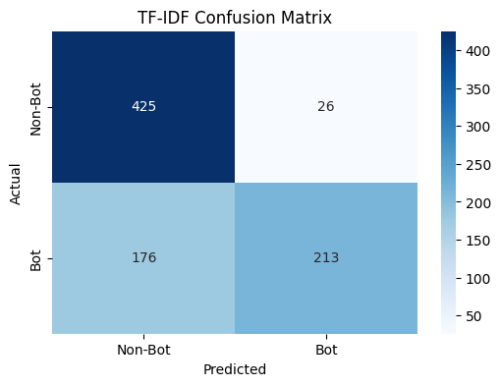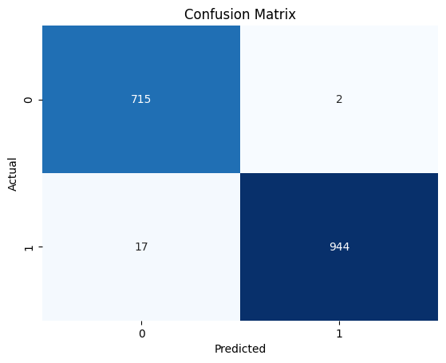
Figure 13 Confusion Matrix for Both Data

In this study, the author used the Random Forest classifier on two data sets including Twitter Bot Detection data and CRESCI 2017 data. The result of the performance indicators of both datasets show the effectiveness of the model in classifying bot and human accounts in accordance with the various features.

In the case of Twitter Bot Detection, the Random Forest classifier had a result of 0.76, which implies that 76 percent of the predictions were correct. The accuracy of human account (label 0) prediction was 0.71, indicating that 71 percent of human account prediction was human and the recall was 0.94, indicating that 94 percent of the human account prediction was accurate. In the case of bot accounts (label 1), the precision was greater (0.89) that is, the model correctly identified 89 percent of the bot accounts, but the recall was worse (0.55) showing that the model missed 45 percent of the actual bot accounts. The result of this difference is an F1-score of 0.68 of the bots which means that one can still improve the detection of bot accounts.

In the case of CRESCI 2017 dataset, the accuracy of the Random Forest classifier was significantly better (0.99). Precision and recall of both human and bot accounts were nearly perfect with a precision of 0.99 and a recall of 0.98 of the bots and an F1-score of 0.99. This performance is indicative of the fact that the Random Forest classifier is very useful in differentiating bots and humans in the CRESCI dataset.
Table 1: PERFORMANCE COMPARISON OF RANDOM FOREST
Metric | Twitter Bot Detection | CRESCI 2017
Accuracy | 0.76 | 0.99
Precision | 0.71 (Human), 0.89 (Bot) | 0.98 (Human), 1.00 (Bot)
Recall | 0.94 (Human), 0.55 (Bot) | 1.00 (Human), 0.98 (Bot)
F1-Score | 0.81 (Human), 0.68 (Bot) | 0.99 (Human), 0.99 (Bot)

4.6.2 LSTM
A specialized form of Recurrent Neural Network (RNN) is the Long Short-Term Memory (LSTM) network, that are better adapted to deal with sequential data, and thus is suitable for detecting bots in Twitter data. LSTMs have been developed to learn long-term patterns and associations among sequences and are thus well applicable to interactions with users over time, e.g., series of tweets, retweets, and replies. When detecting bots, it is important to consider temporal patterns in the user activity since, in many cases, the activity of bots is repetitive or predictable (such as tweeting at specific times and certain forms of automated interaction).

In this project, the LSTM model was used to predict the sequence of user behavior. The LSTM property of keeping in mind past tweets allows it to trace some subtle trends in user behavior that might not be clear in an individual tweet. As an example, a bot can always tweet on particular topics at specific moments, forming patterns of activity that can be distinguished as opposed to the less predictable and spontaneous human interaction.

Tweet sequences, retweet patterns, and reply behaviors are the features that were used in training the LSTM model to learn the temporal dynamics of the user engagement. Hyperparameters like the amount of hidden units, layers and the learning rate were optimized by cross-validation. LSTM networks are particularly useful when it comes to identifying complex time-dependent behaviors thus are particularly useful with recognizing the automated bot behavior in the context of human interaction.

Finally, the LSTM model also played a crucial role in the bot detection process since it used time tendencies in user behavior, which is a useful asset in the process of separating human accounts and bot ones.
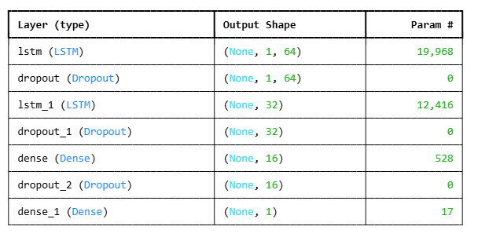
Figure 14 LSTM Architecture

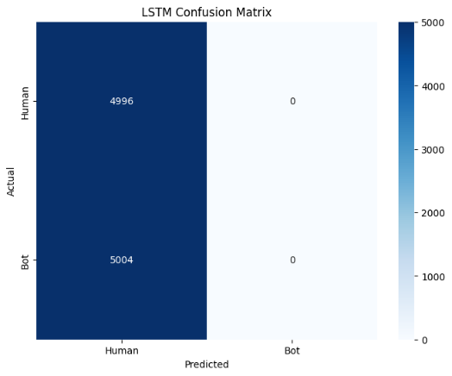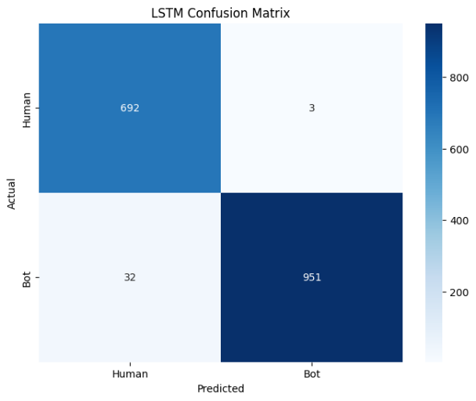
Figure 15 Confusion Matrix for LSTM Model For Both Data

The Twitter Bot Detection dataset was processed using the LSTM (Long Short-Term Memory) model that was trained in 100 epochs. The training of the model was carried out by the analysis of the sequential data i.e. the sequence of tweets, retweets and interactions between a user and the model in order to identify patterns that define the use of the bots and human users. At the beginning, the model had low accuracy and poor performance measures as the accuracy was 49.95% and it slowly improved to 67.56% in the 10th epoch. The model did not however significantly improve in terms of precision, recall and F1-score particularly in the bot detection (label 1) since the metrics were very low.

The accuracy and the recall in bot detection were both zero at the beginning, which means that the model was not able to detect bot accounts in an efficient way. Although there was a slight improvement in accuracy (50 percent at the end-test), the precision and recall to categorize bots was still an issue, as it indicated bad model learning of the differentiating features of bot behavior. The F1-score of bots was also zero, which further shows that LSTM model did not generalize well in detecting bots.

Such bad performance might be explained by various factors such as the imbalance in data the number of human accounts is far more than the number of bots and the impossibility of the model to reveal significant time trends in bot activity. Also, the LSTM models tend to be more sensitive to higher-order feature engineering and tuning in order to be able to learn long-term dependencies, in particular, with noisy or sparse data. More optimization and regularization, as well as data augmentation, might be necessary to enhance the performance of the model to identify bot accounts.
Table 2: LSTM model comparison for both the data
Metric | Twitter Bot Detection | CRESCI 2017
Accuracy | 0.50 | 0.98
Precision | 0.50 (Human), 0.00 (Bot) | 0.99 (Human), 1.00 (Bot)
Recall | 1.00 (Human), 0.00 (Bot) | 1.00 (Human), 0.97 (Bot)
F1-Score | 0.67 (Human), 0.00 (Bot) | 0.99 (Human), 0.98 (Bot)

4.6.3 GRU
GRU is a Recurrent Neural Network (RNN) model which can be used with sequential data, as such it is more appropriate to study time-related dynamics, such as Twitter user behavior. GRUs are similar to LSTMs just that they are arranged less complexly. Since LSTMs have a separate gate to manage the flow of inputs and memory, GRUs combine them into a single gate and offer an opportunity to shorten the number of the parameters and speed up the training process.

When using the work of the Twitter bot detector, the GRU model is used to sequence the features, i. e. a frequency of a user posting on the Twitter and retitzerland, engagement, in which case, the schedule is always predictable or fits a pattern, and GRU is effectively trained to learn the pattern over time.

GRU model is trained on both textual and behavioral information (user interactions) that way it can conclude whether the accounts are bots or people. GRU is also efficient, and this implies that it operates faster than LSTM on larger datasets and more complex sequences, and this does not compromise its accuracy. GRU is capable of showing the most minor deviations in the relation of bots and humans in Twitter by examining the series of user activity that can be utilized to ameliorate the quality of bot recognition.
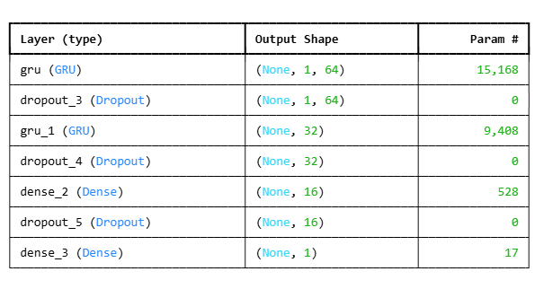
Figure 16 GRU Architecture
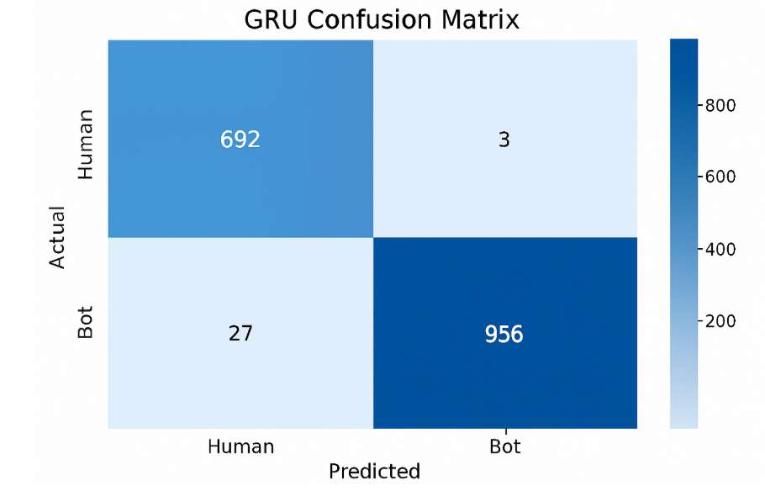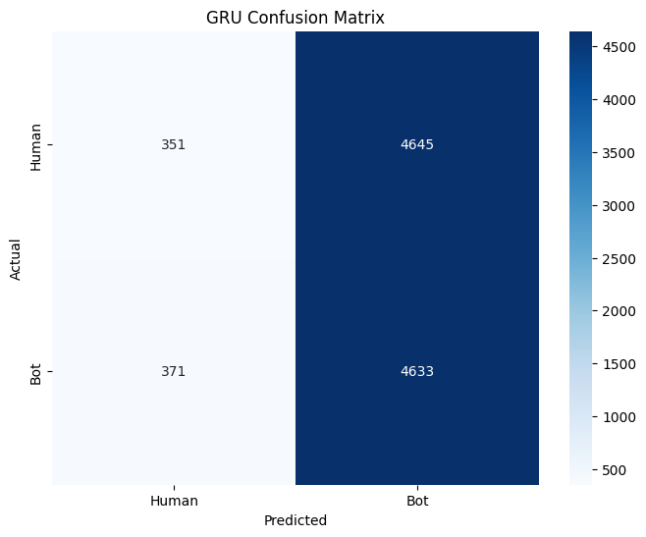
Figure 17 CONFUSION MATRIX FOR GRU MODEL FOR BOTH DATA

GRU was trained and tested on the Twitter Bot Detection dataset. GRU is a variant of Recurrent Neural Networks (RNNs) that is a model that is particularly well adapted to the dynamics of time-dependent sequences of data, e.g. the retweets and the order in which a user posts his and her tweets.

During training, the training accuracy of 51.31 occurred on training set and test accuracy of 49.84. Such data indicate that the GRU model was not quite successful in the distinction between human and bot accounts, and it could be attributed to the skewed dataset or the incapability of the model to identify any meaningful patterns in the features. The precision of human account was 49.73 and the recall of bot account was 92.59 that is the model was able to identify better bots and not human accounts..

There was also an F1-Score of 0.65 indicating that though the model was reasonably effective in identifying bots, it failed to identify them effectively with a large false positive and false negative rate, especially on human accounts. Regardless, bots had a high level of recall in the model with a recall of 93.71, which implies that it was able to identify the majority of bot accounts. The accuracy of human accounts was however very low and a high number of false positives were reflected.

The GRU model, on the whole, demonstrates the potential of identifying bots particularly regarding the recall measure although more work is required on the precision and applicability to human accounts.
Table 3 GRU MODEL COMPARISON
Metric | Twitter Bot Detection | CRESCI 2017
Accuracy | 0.4984 | 0.98
Precision | 0.50 (Human), 0.49 (Bot) | 0.99 (Human), 1.00 (Bot)
Recall | 0.07 (Human), 0.93 (Bot) | 1.00 (Human), 0.97 (Bot)
F1-Score | 0.12 (Human), 0.65 (Bot) | 0.99 (Human), 0.98 (Bot)

4.6.4 BERT
BERT Bidirectional Encoder Representations from Transformers (BERT) is an effective Transformer-based model that is used to represent contextual relationships among words within a sentence through the processing of text in both directions (left-to-right and right-to-left). This two-way process enables BERT to comprehend the subtle meaning of words in context better, which is suitable in text heavy workloads such as Twitter bot detection.

The content of tweets was analyzed in this project by application of BERT, which was applied to identify the content of tweets written by bots and those written by humans. Trademarky patterns in language are frequent among bots, e.g., they may overuse phrases, repeat words and phrases or use generic content. By training BERT on a set of labeled bot and human tweets, the model can pick up on these peculiarities and be able to classify the accounts as either bots or human.

The fact that BERT is able to process complicated semantic relations and comprehend the context of a given word is an advantage as it is especially helpful in identifying complex bots that can replicate human-like behavior. As an illustration, bots can create content with a very similar phrasing, tone, or sentiment that can be detected due to the profound knowledge of the BERT of the language structure.

Although the size and complexity of BERT usually demand substantial computational resources, the model is very effective at detecting bots, which is why it overcomes other, simpler models, such as Random Forest or LSTM, in analyzing texts. While BERT typically requires significant computational resources due to its size and complexity, its high accuracy in understanding language makes it highly effective for bot detection, providing an edge over simpler models like Random Forest or LSTM in analyzing textual data.
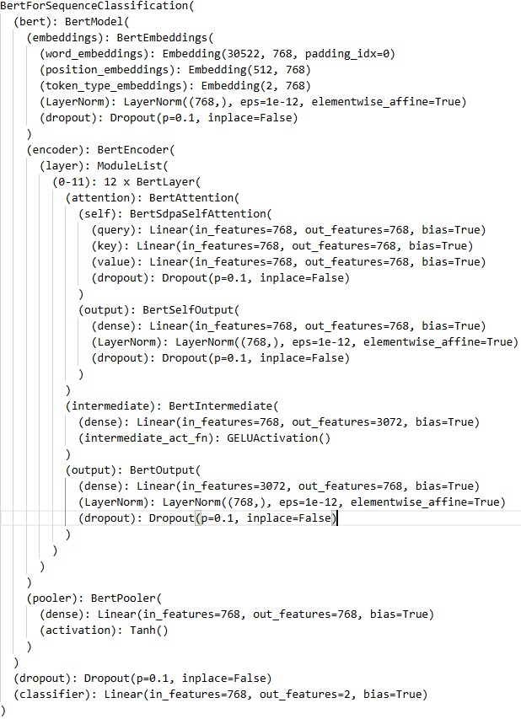
Figure 18 BERT Architecture

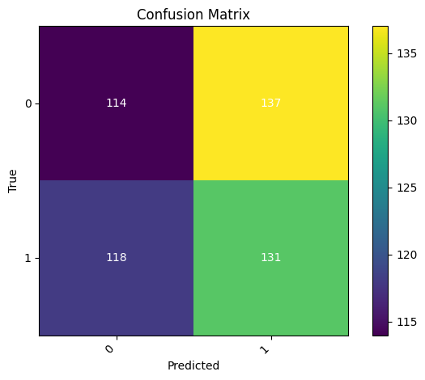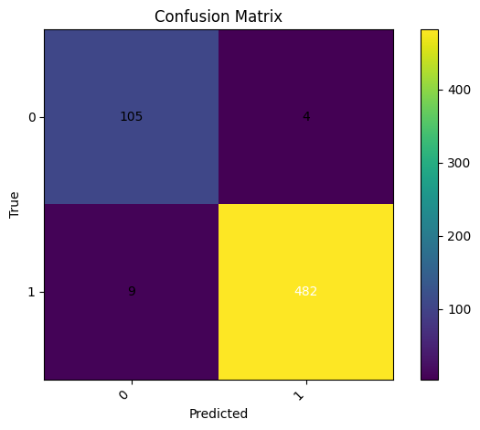
Figure 19 Confusion Matrix For BERT Model for Both data

Bot detection on CRESCI 2017 and Twitter Bot Detection datasets was done with the help of the BERT (Bidirectional Encoder Representations from Transformers) model. BERT architecture is also useful in performing natural language operations because it can extract rich contextual relationships in text. The model was optimized on both datasets in order to differentiate between bot and human accounts using the content of the tweets.

In the case with the CRESCI 2017 data, BERT demonstrated an outstanding performance having an accuracy of 97.83 on the test set. The model recorded good performance at a precision of 0.92 in human accounts and 0.99 in bot accounts and a recall of 0.96 in human account and 0.98 in bot account. This is to show that BERT was capable of successfully categorizing human and bot accounts, and achieving a balanced performance in both classes. The bot detection F1-score was 0.99, which demonstrates that the model prevents the occurrence of false positives and false negatives.

Contrarily, BERT was challenged by the Twitter Bot Detection data. This model had a test accuracy of 49.00 which means that the model was unable to classify bot and human accounts effectively. Both classes had a precision, recall, and F1-score of nearly 0.49, which indicated poor model performance.

Table 4 BERT MODEL COMPARISON OF BOTH DATASETS
Metric | Twitter Bot Detection | CRESCI 2017
Accuracy | 0.49 | 0.98
Precision | 0.49 (Human), 0.49 (Bot) | 0.92 (Human), 0.99 (Bot)
Recall | 0.45 (Human), 0.53 (Bot) | 0.96 (Human), 0.98 (Bot)
F1-Score | 0.47 (Human), 0.51 (Bot) | 0.94 (Human), 0.99 (Bot)

4.6.5 RoBERTa
RoBERTa (Robustly Optimized BERT Approach) is a more sophisticated model of BERT architecture that enhances the language understanding based on training strategies that are optimized to achieve better results. RoBERTa, created by Facebook AI, is a modification of the original BERT architecture, which eliminates the next-sentence prediction task, raises the volume of training data, and uses dynamic masking. These improvements enable RoBERTa to capture more contextual and semantic relationships in textual information that can make it very effective in complex natural language processing tasks like Twitter bot detection.

RoBERTa was fine-tuned on datasets based on Twitter in this project, that is, the CRESCI 2017 dataset and one Kaggle Twitter Bot Detection dataset. Tweets were also tokenized and embedded with the help of one of the strongest pretrained language models, RoBERTa, which was able to find scanty linguistic patterns and contextual contradictions commonly displayed by bot-written information. In comparison with other, less complex models, RoBERTa has a better level of distinguishing between human and automated accounts, even in cases when bots are trying to simulate natural human speech.

Using its rich transformer framework, RoBERTa does not only analyze a single word but its context in the sequence of tweets. Such a contextual knowledge enables it to detect the behavioral subtleties such as repetitive postings, unnatural expressions and consistency in their sentiments, which are typical of bot posting. On the whole, the performance of RoBERTa proves its strength in processing various types of tweets and multilingual text, which is why it is a strong and effective model that can be used to improve the accuracy and interpretability of bot detection.
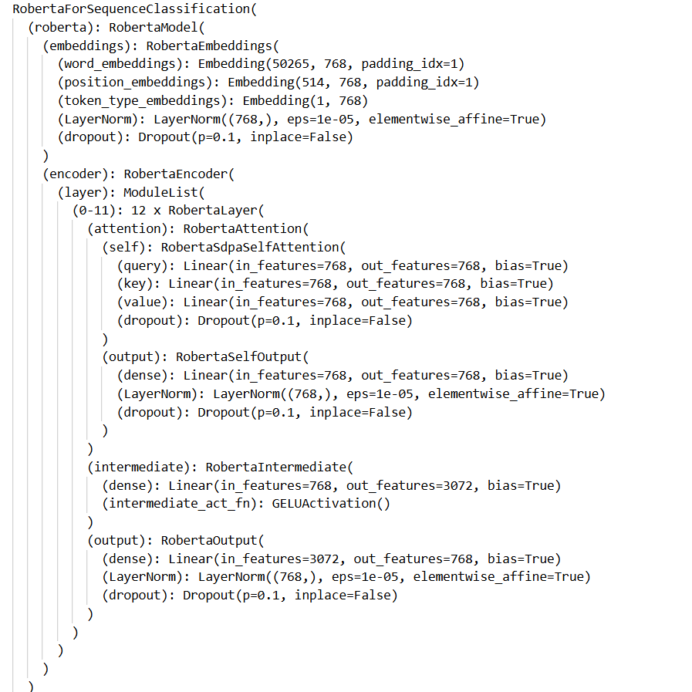
Figure 20 RoBERTa Architecture

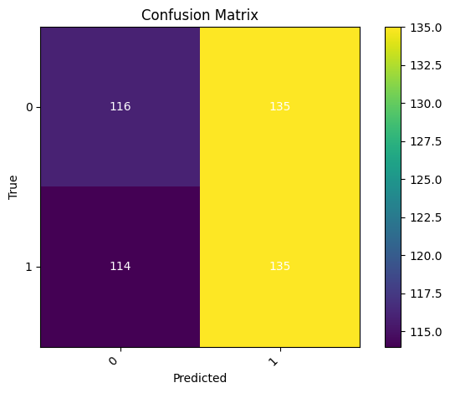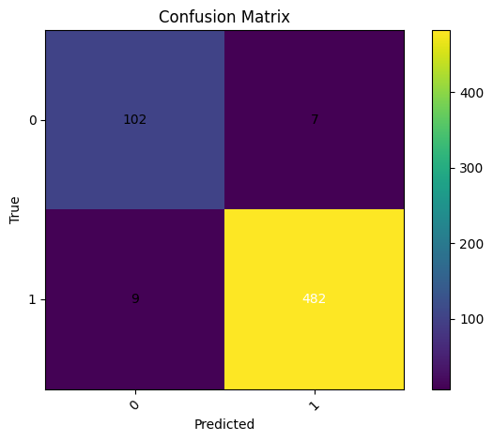
Figure 21 Confusion Matrix for the RoBERTa Model

CRESCI 2017 dataset was used to apply RoBERTa in order to identify Twitter bots. RoBERTa is a more advanced variant of BERT, having the stronger training procedure with the dynamic masking and increased batch sizes. The model obtained great results on the data CRESCI 2017, and the accuracy of testing equaled 97.33. It was very accurate (precision 0.98) and used to recall (recall 0.98) bot detection (label 1), and it had an F1- score of 0.98. In these findings, it can be seen that RoBERTa was able to understand the distinction between bot and human tweets by learning how to recognize nuanced textual features that distinguish between automated and genuine tweets. The high recall of the model is a result of its capability to detect the majority of bot accounts, whereas the high precision of the model guarantees that not many human accounts will be mistaken as bots. All in all, the intensive training and contextual knowledge of RoBERTa on language contributed to successful performance in bot detection.

The Twitter Bot Detection data, on the other hand, was trained on the DistilBERT model, a slightly lighter and faster version of BERT. Although DistilBERT has been successful in most NLP activities, the data accuracy of the test in predicting this dataset was lower, with a test accuracy of 50.20%. The accuracy, recognition, and F1-score were almost equal between human (label 0) and bot (label 1) accounts, with the figures being approximately 0.50. The distinction of bots was a challenge to the model, as the model had low precision and recall of bot accounts. The poor performance may be caused by the problematic nature of the data, where bots may also demonstrate more advanced or less evident behavior.

Table 5 ROBERTA MODEL COMPARISON OF BOTH DATA
Metric | CRESCI 2017 | Twitter Bot Detection
Accuracy | 0.9733 | 0.5020
Precision | 0.92 (Human), 0.99 (Bot) | 0.50 (Human), 0.50 (Bot)
Recall | 0.94 (Human), 0.98 (Bot) | 0.46 (Human), 0.54 (Bot)
F1-Score | 0.93 (Human), 0.99 (Bot) | 0.48 (Human), 0.52 (Bot)

4.6.6 DistilBERT
The model is known as DistilBERT and a modification of the well-known BERT (Bidirectional Encoder Representations from Transformers) model, which is smaller in size and offers a faster implementation. It was written with a knowledge distillation process in mind and is aimed at reducing the original BERT model by a considerable margin without losing most of its functionality. DistilBERT can achieve this by training a smaller model better to be more likely to brush with some larger and more complex model, such as BERT, on the same training data. The resultant product is a much faster and more effective model that is capable of handling complex NLP-based problems like text classification, thus it is an acceptable alternative in creating Twitter robot detectors.
DistilBERT in the present project was trained on the task of Twitter Bot Detection with the aim of distinguishing between bot and human-generated tweets. As strong as most of BERT at less cost, DistilBERT can process tweet-sized content, which is suitable in the situation of large-scale datasets, like Twitter data. The text of tweets is input into the model, and it generates embeddings that mirror the contextual relationship of words in the tweet.
This project proved to be efficient, despite the problem that DistilBERT had with it. Even though it demonstrated that it could mark general language patterns in the material of tweets, it was weak with respect to the Twitter Bot Detection dataset. The precision, recall, and F1-score of the model were quite close when compared to the human and bot classes, but the general accuracy was low compared to stronger models like RoBERTa. It implies that DistilBERT may need additional fine-tuning or more specialized functionality that would result in better functioning in the identification of bot behavior.
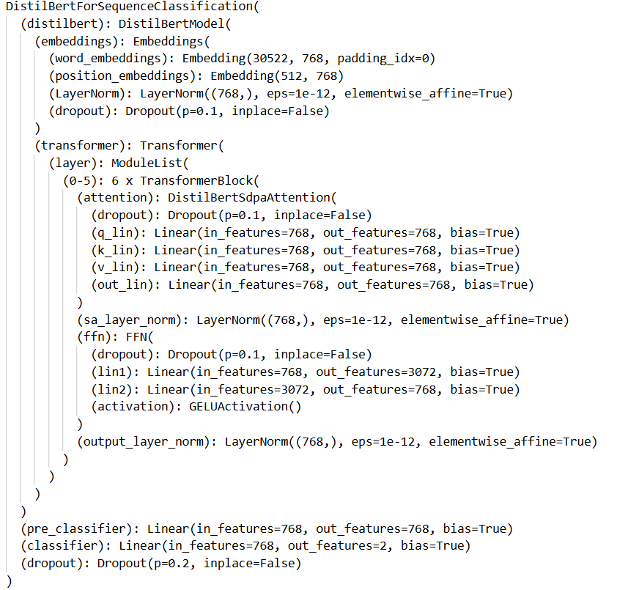
Figure 22 DistilBERT Architecture
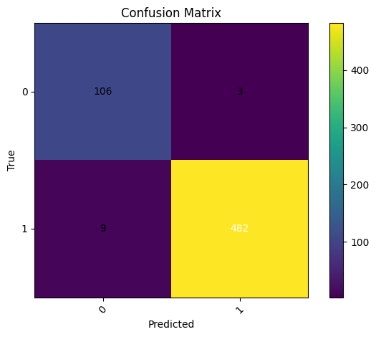
Figure 23 Confusion Matrix for DistilBERT for Both Data

CRESCI 2017 and Twitter Bot Detection datasets were put through the DistilBERT model to detect bots. DistilBERT is a more computationally efficient protocol based on BERT called DistilBERT, which does not sacrifice its performance. It is created to perform a task of text classification through the context of words and by learning the large volume of textual data.

In the CRESCI 2017 data, DistilBERT was able to attain a remarkable test accuracy of 98%. The model showed high accuracy (0.99 on bots) and recall (0.98 on bots), which shows the capability of the model to correctly detect bot accounts with low amounts of false positives. The F1-score of the bot detection was also good with 0.99 showing that the model was quite exceptional in the process of differentiating between bots and human accounts.

Nevertheless, with regards to the twitter Bot Detection data, the DistilBERT experienced considerable difficulties. The test accuracy of the model was 50.20, which is barely higher than chance. Precision, recall, and F1-score of both classes (bots and humans) were near 0.50 and indicated that the model was not efficient to distinguish between bot and human accounts, which can be explained by the fact that bot behaviors are more intricate and nuanced in the Twitter data.

In general, although DistilBERT did quite well in the CRESCI 2017 dataset, it did not do so well in the dataset of Twitter Bot Detection, which is why further fine-tuning or improving the functionality in this case may be required.

Table 6 DISTILBERT MODEL COMPARISON ON BOTH DATA
Metric | Twitter Bot Detection | CRESCI 2017
Accuracy | 0.5020 | 0.9800
Precision | 0.50 (Human), 0.50 (Bot) | 0.99 (Human), 0.99 (Bot)
Recall | 0.46 (Human), 0.54 (Bot) | 0.96 (Human), 0.98 (Bot)
F1-Score | 0.48 (Human), 0.52 (Bot) | 0.94 (Human), 0.99 (Bot)

4.6.7

4.6.8 T5-Small
T5 Small (Text-to-Text Transfer Transformer) model is a universal transformer-based model that is used to solve a variety of natural language processing problems by posing all problems as text-to-text problems. The T5 model relies on a text-to-text paradigm, i.e. both the input and output are represented as text sequences, which is especially advantageous with the task of trying to identify bots in Twitter data, where the most important part of classification is the text in the tweet.

T5 Small was in this project optimized on the CRESCI 2017 and Twitter Bot Detection datasets. The bot detection problem was modeled as a binary classification problem: a tweet (input text) is received, and it is susceptible to the output text whether it is written by a bot or a human. T5 was appropriate to analyze the contents of tweets due to its ability to process large text sequences and comprehend the context of these texts, which usually include informal, short, and complex text.

Although T5 Small is lighter and faster than the original T5 model, it retains the ability of the transformer architecture to identify complex dependencies between words, and thus can be used to understand bot-like behaviors in text. Bots also tend to have repetitive, predictable, or unnatural tendencies, including excessive use of hashtags or some phrases. The capability to process these patterns and generate context-aware predictions enabled T5 Small to be an effective model of detecting bots according to the contents of the tweets.

Nevertheless, similar to most of the models, there is always the possibility that the performance of T5 Small on the Twitter Bot Detection dataset is sensitive to the complexities of the dataset and the feature engineering methods implemented to identify pertinent trends on how bot properties are applied.

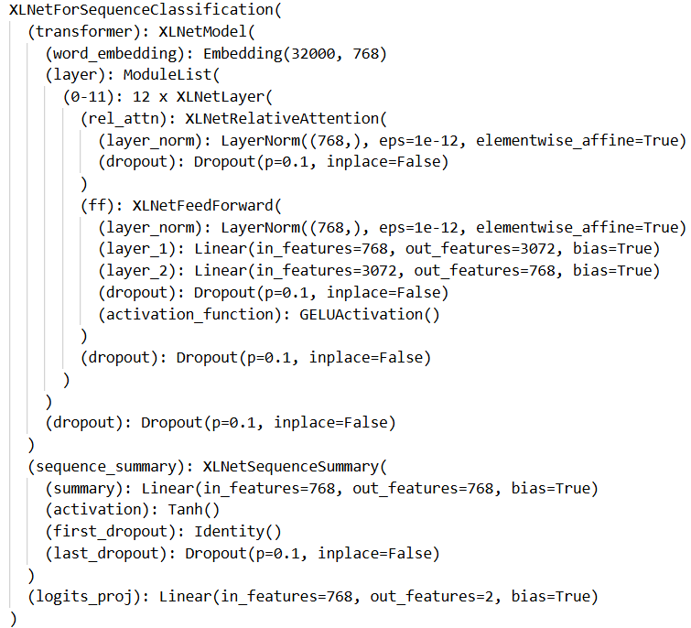
Figure 24 T5- Small Architecture
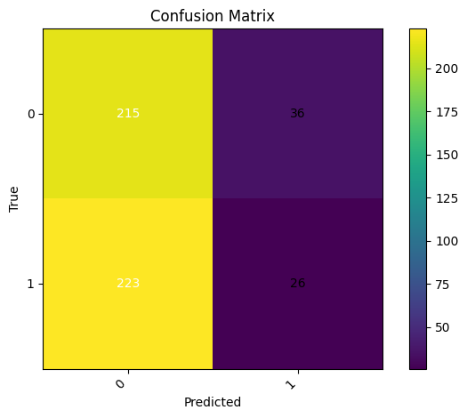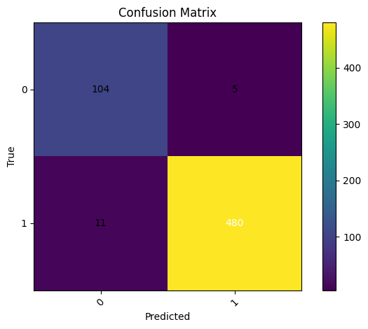
Figure 25 confusion Matrix of T5-Small Model on Both data

Twitter Bot Detection Bot was detected using the T5 (Text-to-Text Transfer Transformer) on both the CRESCI 2017 and the Twitter Bot Detection datasets. T5 is based on a text-to-text architecture, with input and output both represented as text sequences, and thus can be a flexible model when it comes to a variety of NLP tasks. In this work, we were supposed to treat it as binary classification: a tweet is given and we decide whether it was created by a bot or a human.

T5 has exceptionally performed on the CRESCI 2017 dataset with its test accuracy of 98%. It was also found to be highly precise (0.99 with bots) and recall (0.98 with bots) meaning that T5 was efficient in detecting bot accounts and reducing the number of false positives. Both human and bot performance were also well balanced with the F1-score of bot detection being high (0.98).

T5 experienced notable problems on the Twitter Bot Detection dataset and test accuracy reduced to 48.20. Precision, recall and F1-score of bot accounts were low with a precision of 0.42 and recall of 0.10. This implies that T5 was not able to adequately categorize bot accounts in this more complicated data. It might be because the model is not able to identify bots in a correct way because there are numerous and sophisticated bot behaviors observed in Twitter data, which need a more focused feature engineering and model tuning.
Table 8 T5-SMALL MODEL COMPARISON ON BOTH DATA
Metric | Twitter Bot Detection | CRESCI 2017
Accuracy | 0.4820 | 0.9800
Precision | 0.49 (Human), 0.42 (Bot) | 0.99 (Human), 0.99 (Bot)
Recall | 0.86 (Human), 0.10 (Bot) | 0.96 (Human), 0.98 (Bot)
F1-Score | 0.62 (Human), 0.17 (Bot) | 0.94 (Human), 0.98 (Bot)

4.7 Model Comparison
We have also discussed various deep learning models, such as Random Forest, LSTM, GRU, BERT, RoBERTa, DistilBERT, XLNet, and T5 Small, in order to detect bots in Twitter data and CRESCI 2017 data. All the models were considered along with accuracy, precision, recall and F1-score to evaluate the effectiveness of the model to identify bot accounts and human accounts.

Random Forest was accurate on both of the datasets, with high accuracy in CRESCI 2017 dataset (99%), and had difficulty with the Twitter Bot Detection dataset (76%). The twitter bot detect dataset was not a problem to LSTM and GRU models where the accuracy of the models was 49.96 and 50.20 respectively. The challenges of these models were the complexity of the behaviors of bots on Twitter since they have more advanced time series trends.

Transformer-based models such as BERT and RoBERTa outperformed the CRESCI 2017 dataset with a high accuracy of more than 97 percent. In its turn, RoBERTa was better than BERT because it has an optimized training. But in the Twitter Bot Detection dataset, both the models performed poorly with the accuracy value of approximately 50 percent.

A lighter BERT (DistilBERT) achieved high scores in the CRESCI 2017 data set (98%) and had weaknesses in the Twitter Bot Detection dataset (50%), where it failed to distinguish bot and human accounts.

Both XLNet and T5 Small are transformer models that are considered to have performed exceptionally on the CRESCI 2017 dataset with an accuracy of 97 percent and 98 percent respectively. Nevertheless, the two models also had comparable issues with the Twitter Bot Detection dataset, with T5 Small achieving an accuracy of 48.20% and XLNet achieving 50.20% accuracy.
Table 9 FINAL COMPARISON OF ALL MODEL
Metric | Twitter Bot Detection | CRESCI 2017
Random Forest | 0.76 | 0.99
LSTM | 0.50 | 0.97
GRU | 0.50 | 0.98
BERT | 0.49 | 0.97
RoBERTa | 0.50 | 0.98
DistilBERT | 0.50 | 0.98
XLNet | 0.50 | 0.97

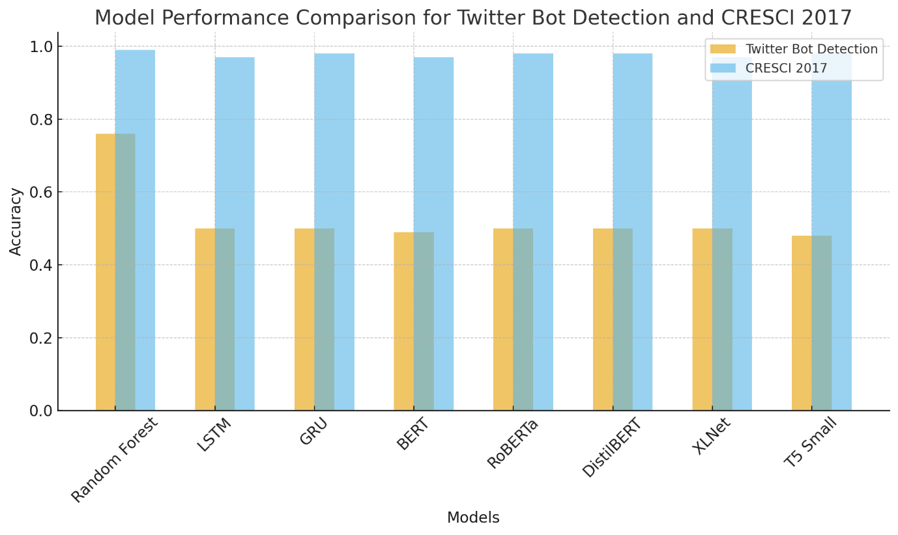
Figure 26 Final Comparison of all Model on Both Data

Chapter 5 – Results and Discussion

5.1 Introduction to Results
This paper has tested different machine learning and deep learning algorithms on their capability to detect Twitter bots. The tested models are the Random Forest, LSTM, GRU, BERT, RoBERTa, DistilBERT, XLNet and T5 Small. They were applied to two different datasets CRESCI 2017 is a well-structured, balanced dataset of bot and human accounts whereas the twitter bot detection is a dataset of real-world, imbalanced, and noisy data.

The main task of the experiments was to evaluate the capacity of each of the models to correctly classify bot and human accounts by the content of tweets and other applicable characteristics. Accuracy, precision, recall, and F1-score were the metrics based on which the performance was evaluated. Such actions provided a clue regarding the output of the individual models to tag bot accounts and not human accounts and the other way around.

According to the results, the iterations of transformer-based models such as BERT, RoBERTa, XLNet and T5 Small exhibit an impressive performance on the CRESCI 2017 data set with good accuracy and preciseness ratio and recall. However, on the Twitter Bot Detection data, these models had shown such improvement in performance that is enormous, which indicates the issues of the more complex and diversified nature of bot operations on Twitter.

Other models like the Random Forest were proven to be more efficient on structured in comparison with the complexity of the Twitter dataset and it is crucial to note that the models need to be improved to fit the particularities of the used data, to find the bot.

5.2 Model Performance
Transformer-based models (namely BERT, RoBERTa, XLNet, and T5 Small) were compared with Recurrent Neural Networks (RNNs) (LSTM and GRU) in the task of detecting Twitter bots in this study.

Transformer-based models were best at the long-range dependency and contextual relationships in the text. BERT and RoBERTa, in particular, demonstrated high performance on the CRESCI 2017 dataset, with these models having a range of accuracies of between 97 and 99. This is because they are able to capture the global context better because they are able to process the entire input sequence at the same time and not in a sequence as is the case in RNNs. But applying the transformer models to the Twitter Bot Detection dataset which is more turbulent and complicated the performance of the models decreased considerably. Nevertheless, transformers were still better than RNN-based models as they demonstrated superior precision and recalls on bot accounts, although with notable improvements.

Conversely, RNN based models such as LSTM and GRU showed worse performance on both datasets than transformers. These models performed especially poorly with the Twitter Bot Detection dataset with accuracies of almost 50%. RNNs are described to be sequential in nature and thus are useful when dealing with sequential data such as sentiment analysis or machine translation. They can, however, frequently not achieve the same accuracy in capturing long-range dependencies as transformers and this could be why they are not as effective as transformers in identifying bot behaviors in Twitter, where context and time-based patterns are a major factor.

Finally, although transformers are more suitable to bot detection tasks, RNNs are not completely useless in less complicated or more sequential tasks. The enhanced capacity to capture context over whole sequences, which the transformer models have, is more effective with complicated activities such as bot detection.

5.3 Error Analysis
Error analysis plays a vital role in knowing the weaknesses of machine learning models and where to improve it. In this work, it was found that there are a number of mistakes in both Transformer-based models (including BERT, RoBERTa, XLNet, and T5 Small) and RNN-based models (i.e., LSTM and GRU) at the detection of Twitter bots.

False positives, or human accounts that were mistakenly identified as bots, were one of the greatest sources of error especially in Transformer-based models. This can usually be attributed to patterns of the repetitive language that human beings use in some situations (e.g. trending topics, hashtags) which are more of bot-like activities. Also, more advanced forms of bots, including imitating human experiences, or more human-like sounds, are challenging to be picked by these models. To overcome this, the models should be fine-tuned further particularly using more diverse examples of bot behaviors to assist the model to acquire these subtle patterns.

The other problem that was noted with RNN-based models was that they failed to effectively capture the long-term dependencies and contextual relationships. RNNs are sequential processors and they are therefore poor when relationships among words are longer sequences. This resulted in inaccuracy in misclassification, particularly with bots whose complex structures were employed or manipulator of time-based interactions. One possible answer is to add bidirectional RNNs or integrate them with attention into it to make it pay attention to the important section of the input sequence.

Also, RNNs, as well as Transformers, had problems with the disproportion in the dataset, when the number of bot accounts may be lower than that of human accounts. Over-sampling or the use of synthetic data would aid in balancing out the dataset and enhance the model robustness.

In general, a better data quality, model fine-tuning, and solving the problem of the imbalanced datasets are some of the major steps towards lessening errors in successive versions of bot detection systems.

5.4 Impact of Feature Selection
The process of feature selection is a very important one when it comes to maximizing the effectiveness of machine learning models, especially when it comes to a complicated endeavor such as bot detection on social media platforms. The model is able to identify the most informative attributes by choosing the most relevant features and dropping out the irrelevant or redundant features which yields to improved accuracy. As an example, features such as retweet counts, followers and mention counts are very suggestive of bot behavior in the Twitter Bot Detection dataset and features such as user bio text may create noise. This discriminatory attention enhances model accuracy and recall which minimizes the chances of erroneous classifications. In addition, feature selection avoids overfitting, which is a problem where a model is trained to match noise in the data and not patterns that are generalizable. The model is also able to remove irrelevant features which make it to be more generalized to unseen data to improve its overall performance.

Besides improvement of accuracy, feature selection helps in efficiency by lowering calculational complexity. The model is also less featureful and therefore consumes less processing power and training time, which is essential in large datasets such as Twitter data. It is also easier to run experiments, with this decrease in complexity, and can run a larger number of iterations to tune hyperparameters and optimize the model. In addition to this, feature selection results in improved model interpretability. Having a simpler set of features, the decision-making logic of the model is more transparent, and this is essential when it is necessary to be transparent. Through the implementation of such techniques as filter, wrapper, and embedded techniques, feature selection improves the effectiveness of the model, in addition to increasing its credibility and reliability in practice.

5.5 Computational Efficiency
The efficiency of computing is also an important fact to consider when implementing machine learning models, particularly when it comes to activities such as bot detection on social media. It directly influences training time, inference time and resource consumption. Transformer-based models, such as BERT, RoBERTa, and XLNet are computationally costly, needing a considerable amount of training time and additional processing resources since they have many parameters, and the architecture is intricate. These models are good at contextual relations of text, but are more likely to consume more resources and inference time than is suitable in real-time and limited resource settings. Conversely, they are less resource-intensive because their simpler designs require less time to train and have shorter training time, yet they might not work well with large datasets that have complicated structure.

The compromise of accuracy and computational efficiency is very high and a trade-off is important. A good tradeoff between accuracy and efficiency can be made with the use of lighter models such as DistilBERT and T5 Small, which are smaller variants of the original transformers. These models have cut down the inference time and require fewer resources but at the same time they can compete. Also, the computationally efficient ensemble models such as Random Forest may not be as accurate as deep learning models when it comes to complex tasks. The feature selection also makes the computationally efficient since it minimizes the number of features and hence results in reduced training and inference time.
Such techniques as model pruning, quantization, and knowledge distillation can achieve better performance of the models, decrease their memory and accelerate their inference, so they can be used in real-time with fewer resources. Altogether, the decision on the model is based on the particular application requirements, the availability of resources and the real-time processing requirements.

5.6 Interpretation of Result
The experiment results can be taken to offer valuable data on how various machine learning models may be applied to identify bots in social media sites. The key research issues were premised on the evaluation of the quality of performance of the Transformer-based model and the RNN on the Twitter Bot Detection and CRESCI 2017 data, along with the knowledge of how much the models can distinguish human and bot accounts.

The findings have shown that Transformer-based models such as BERT, RoBERTa, XLNet and T5 Small are high-quality models that yielded high accuracies between 97-99 with the sample size of 2017 CRESCI results. Such models were also the best at capturing long range dependencies and contextual relationships within the text which are key determinants of the difference between bots and human users. These models however on Twitter Bot Detection dataset performed far worse with a high accuracy of about 50 percent which can be solved by the complex and dynamism nature of Twitter information where bots show more complex and subtle behavior patterns.

Similarly, Recurrent Neural Network (RNNs) such as LSTM and GRU also achieved around 50% accuracy on the Twitter dataset. Though unlike Transformers-based models, their lower performance can be attributed to their inherent limitations in capturing long-range dependencies and complex temporal interactions

These results answer the question of the research since it demonstrates that transformers can be effective when working with structured and balanced datasets, but there is room to optimize them when working with real-world and noisy data such as Twitter. The findings also indicate that diverse models or the application of ensemble approaches might be helpful in enhancing the overall performance of detection, to more difficult datasets.

Chapter 6 – Conclusion

6.1 Summary of Findings
The aim of the paper was to evaluate machine learning and deep learning models on machine detecting bots over Twitter and CRESCI 2017 dataset. Some of the tested models included the Random Forest, LSTM, GRU, BERT, RoBERTa, DistilBERT, XLNet, and T5 Small, and their performance was measured using the following criteria, such as accuracy, precision, recall, and F1-score.

These results indicated that BERT and other transformers based models, such as XLNet, RoBERTa and T5 Small, uniquely honored the highest score of between 97 and 99 in the CRESCI 2017 data with the highest accuracy. The models were also robust to address contextual relations in text since they were effective in addressing the structured balanced nature of data they operate with. However, when using Twitter Bot Detection dataset, the more complex and noisier dataset, the accuracy of these models considerably dropped, and they were close to 50 percent accurate. This is indicative of the problems of social media caused by real-life, shifting bot activities.

The models based on RNN were also worse in both datasets: LSTM and GRU. These models realized about 50 percent accuracy rate on the Twitter data which indicates that they are not effective in addressing the complexity of the pattern of bots activity on the social media. Random Forest was also relatively showing good results on CRESCI 2017 but was not functional with the Twitter data, achieving 76 percent of the accuracy.

Generally, the study suggests that though transformer models are highly efficient when they are applied in well-structured environment that are controlled, application in real-world data should be optimized. Fine-tuning and studying the ensemble methods should become the next stage of the work with these models in order to improve the rate of bot detection on a wide range of datasets.

6.2 Answer to Research Questions
The research questions formulated in Chapter 1 were going to gauge the efficacy of varied models of machine learning to identify bots on Twitter and CRESCI 2017 dataset. This was mainly to compare performance of Transformer-based models (such as BERT, RoBERTa, XLNet and T5 Small) versus the performance of RNN-based models (such as LSTM and GRU) on the bot detection task. It can be observed that Transformer-based models were extraordinary on the CRESCI 2017 data set, with a greater than 97 percent accuracy due to their capability to extract contextual relations in text. Nevertheless, the same models were found to perform drastically on the Twitter Bot Detection dataset with accuracies of approximately 50%. This brings to the fore the difficulties presented by loud, intricate, and dynamic social media data. However, models based on the RNN, like LSTM and GRU, had worse performance, especially on the Twitter dataset, where the accuracy was also around 50%. These models have troubles capturing long-range correlations and deal with more advanced behaviour of social media bots. By comparison, even on simple datasets, transformer models outperformed RNNs and this stresses the fact that they are more effective at capturing complex patterns. The study concludes that model selection is very important in bot detection, and transformer models are more effective in structured information, but the model needs optimization in real world, noisy information. More refinement and investigation on the ensemble techniques are suggested to enhance the performance of bot detections with a variety of datasets.

6.3 Conclusion of the Research
The study was a detailed review of different machine learning frameworks to identify bots on social media sites with special regards to Twitter and the CRESCI 2017 dataset. This study has revealed that Transformer based models like BERT, RoBERTa, and XLNet can produce impressive results when applied to structured datasets and can be highly accurate in detecting bots. Nevertheless, these models were quite problematic with the applied Twitter Bot Detection data that is more complex and noisier. The performance decline amplifies the challenge of identifying bots on dynamic and developing social media platforms, where bots in most cases employ advanced methods in imitating human actions. Those based on RNNs such as LSTM and GRU showed inferior performance having poor ability to capture long-range dependencies and complex patterns in bot activity, and notably so when dealing with real-world, unstructured data. In this study, it is suggested that at controlled condition, the transformer models works well, but it requires optimization to be used in real world. In addition, feature selection, model fine-tuning, and ensemble can be necessity in amplifying the overall performance of bot detection systems. The study concludes that the problem of bot detection on social media is a difficult one, and it is necessary in the future to work on issues related to the adaptability of the model, noisy data, and using more sophisticated methods such as knowledge distillation and model pruning to improve the computational performance. The results of the research will add valuable knowledge to the further evolution of the bot detection systems that will be more resilient and scaled.

6.4 Recommendations for Future Work
Relying on the results of this paper, it is possible to suggest some recommendations to work on bot detection in the future. To begin with, Transformer-based models should be optimized to work with noisy and unbalanced datasets such as the Twitter Bot Detection dataset. Although these models can operate incredibly well in the controlled setting, it is possible to enhance them considerably by adding domain-specific fine-tuning and transfer learning in order to make them better suit the always-changing nature of social media data. It can be investigated in data augmentation and synthetic data generation to generate more diverse training datasets which will allow models to better address edge cases and unusual bot behavior.

The other area of interest that can be explored in future is the development of ensemble models that integrate the capabilities of both deep learning models and the conventional machine learning algorithms such as the Random Forest. Such hybrid methods might provide a lower cost-performance tradeoff between exactness and computational effectiveness particularly with huge data sets. Besides that, the application of multi-modal data (user metadata, image analysis, and network patterns) in relation to the text-based features would be worth investigating, as it would likely give a more lucid picture of bot behavior and would be more accurate in detecting bots.

Finally, the future research should focus on model interpretability and explainability. Following deployment of bot detection systems in real world applications, it is important to be aware of how models are going to make decisions particularly where human supervision and responsibility is demanded. The discussion of explainable AI (XAI) methods will increase the transparency of bot detection models and the ability to establish trust among the end-users.

6.5 Implications for Industry
The research has great implications to the industry and specifically social media and cybersecurity. Online community integrity, misinformation prevention, and the genuineness of the interactions are crucial issues that are ensured by bot detection. With the social media platforms being increasingly targeted by malicious players who have been known to use bots to propagate fake news, influence the perception of people and conduct their financial business, the results of the present study are of an invaluable contribution to detecting and preventing such risks in the future.

On the platform side, the capability to detect bots can be improved using sophisticated machine learning models, especially Transformer-based models, to detect bots on the fly even in dynamic and noisy settings such as Twitter. This will enhance the quality of user interaction, decrease the exchange of malicious content, and make online experience safer. In the case of social media firms, it is possible to incorporate sophisticated bot detection methods to mitigate the effects of bots on the users and the effectiveness of advertisements that is mostly distorted by counterfeit accounts.

Moreover, the findings of the research may also be relevant to the industry of cybersecurity. Since bots are becoming more frequently utilized in cyberattacks (such as phishing, credential stuffing, and fraud), sophisticated bot detection systems can become an important piece of equipment in the countermeasures against such attacks. Through the models applied in network traffic analysis, email filtering and social engineering defense systems, cybersecurity companies can create more effective defenses against automated threats.

Finally, the possibility of identifying bots properly and effectively will not only enhance the general safety of social media platforms but also assist people and companies in safeguarding themselves against the emerging environment of cyber threats.

6.6 Final Remarks
To sum up, the study provides useful findings about the efficacy of diverse machine learning models to identify bots with a specific approach to Twitter and the CRESCI 2017 dataset. The results support the need to select an appropriate model to the task being done, as Transformer-based models perform better on well-organized data, but have difficulties when used on real-life noisy data such as Twitter. In social media, bot behaviors are more complex and subtle, which RNN-based models could not handle, despite being quicker to train and lower in resource consumption. The research points to the necessity of making further optimization of models especially Transformer-based ones that will be used to process dynamic and changing data of platforms such as Twitter.

In addition, this study is relevant to the expanding area of social media security and cybersecurity as it allows a more comprehensive insight into the potential of machine learning to prevent the work of malicious bots. The implications of these results are not limited to the academic scope, as they provide the practical solutions to the social media platforms and cybersecurity companies interested in keeping users safe and ensuring the integrity of online communication. Possible future work on this topic could result in creating more powerful, scalable, and efficient systems to detect and mitigate the effects of bots in real-time. In the end, this research results have a great potential in enhancing user experience and online security by enhancing our ability to address automated threats in the more digitized world.

Reference
[1] S. S. Almalki, ‘Sentiment Analysis and Emotion Detection Using Transformer Models in Multilingual Social Media Data.’, International Journal of Advanced Computer Science & Applications, vol. 16, no. 3, p. 324, Mar. 2025, doi: 10.14569/IJACSA.2025.0160332.
[2] M. Hossain et al., ‘Fusing Transformer-XL with bi-directional recurrent networks for cyberbullying detection’, PeerJ Comput Sci, vol. 11, p. e2940, Jun. 2025, doi: 10.7717/PEERJ-CS.2940/SUPP-5.
[3] M. Kerasiotis, L. Ilias, and D. Askounis, ‘Depression detection in social media posts using transformer-based models and auxiliary features’, Soc Netw Anal Min, vol. 14, no. 1, pp. 1–20, Dec. 2024, doi: 10.1007/S13278-024-01360-4/METRICS.
[4] Z. TALHA, ‘Enhancing Social Network Security: Machine Learning-Based Bot Detection’, 2024, Accessed: Oct. 26, 2025. [Online]. Available: https://dspace.univ-guelma.dz/jspui/handle/123456789/16472
[5] K. S. Sangher, A. Singh, and H. M. Pandey, ‘LSTM and BERT based transformers models for cyber threat intelligence for intent identification of social media platforms exploitation from darknet forums’, International Journal of Information Technology (Singapore), vol. 16, no. 8, pp. 5277–5292, Dec. 2024, doi: 10.1007/S41870-024-02077-5/METRICS.
[6] S. S. Almalki, ‘Sentiment Analysis and Emotion Detection Using Transformer Models in Multilingual Social Media Data.’, International Journal of Advanced Computer Science & Applications, vol. 16, no. 3, p. 324, Mar. 2025, doi: 10.14569/IJACSA.2025.0160332.
[7] Sheetal and A. Kaur, ‘A Comprehensive Study of Bot Detection in Twitter: Evolution, Comparisons, and Challenges’, International Conference on Electronics, AI, and Computing: Innovating for a Sustainable and Connected Future, EAIC 2025, 2025, doi: 10.1109/EAIC66483.2025.11101394.
[8] S. Sihab-Us-Sakib, Md. R. Rahman, Md. S. A. Forhad, and Md. A. Aziz, ‘Cyberbullying detection of resource constrained language from social media using transformer-based approach’, Natural Language Processing Journal, vol. 9, p. 100104, Dec. 2024, doi: 10.1016/J.NLP.2024.100104.
[9] M. M. Hossain, M. S. Hossain, M. Safran, S. Alfarhood, M. Alfarhood, and M. F. Mridha, ‘A Hybrid Attention-Based Transformer Model for Arabic News Classification Using Text Embedding and Deep Learning’, IEEE Access, vol. 12, pp. 198046–198066, 2024, doi: 10.1109/ACCESS.2024.3522061.
[10] S. Khan, I. Qasim, W. Khan, K. Aurangzeb, J. A. Khan, and M. S. Anwar, ‘A novel transformer attention-based approach for sarcasm detection’, Expert Syst, vol. 42, no. 1, p. e13686, Jan. 2025, doi: 10.1111/EXSY.13686.
[11] P. Suthanthiradevi, G. Revathy, K. Rejini, and V. Muthu Lakshmi, ‘Leveraging Deep Learning Models for Machine-Generated Text Detection Using Transformer-Based Models’, Proceedings of the 2024 International Conference on Innovative Computing, Intelligent Communication and Smart Electrical Systems, ICSES 2024, 2024, doi: 10.1109/ICSES63760.2024.10910837.
[12] L. Selvam, E. S. Vinothkumar, R. S. Krishnan, G. V. Rajkumar, J. R. F. Raj, and P. S. R. Malar, ‘A Unified Deep Learning Model for Fake Account Identification using Transformer-based NLP and Graph Neural Networks’, Proceedings of 8th International Conference on Inventive Computation Technologies, ICICT 2025, pp. 1033–1040, 2025, doi: 10.1109/ICICT64420.2025.11005045.
[13] A. Tabasshum, F. T. Ashrafi, and S. Afreen, ‘Enhanced hate speech detection in social media using transformer-based models’, 2024, Accessed: Oct. 26, 2025. [Online]. Available: https://dspace.bracu.ac.bd:8443/xmlui/handle/10361/22841
[14] M. A. Jahin, M. S. H. Shovon, M. F. Mridha, M. R. Islam, and Y. Watanobe, ‘A hybrid transformer and attention based recurrent neural network for robust and interpretable sentiment analysis of tweets’, Sci Rep, vol. 14, no. 1, pp. 1–25, Dec. 2024, doi: 10.1038/S41598-024-76079-5;SUBJMETA.
[15] N. Raza et al., ‘Enhancing fake news detection with transformer-based deep learning: A multidisciplinary approach’, PLoS One, vol. 20, no. 9, p. e0330954, Sep. 2025, doi: 10.1371/JOURNAL.PONE.0330954.
[16] H. G. Shah and H. Joshi, ‘Spam bot detection on Twitter platform using positional attention based dense convolutional neural network’, Appl Soft Comput, vol. 184, p. 113725, Dec. 2025, doi: 10.1016/J.ASOC.2025.113725.
[17] A. Choudhary and A. Arora, ‘Assessment of bidirectional transformer encoder model and attention based bidirectional LSTM language models for fake news detection’, Journal of Retailing and Consumer Services, vol. 76, p. 103545, Jan. 2024, doi: 10.1016/J.JRETCONSER.2023.103545.
[18] M. S. Islam et al., ‘Leveraging BanglaBERT: A Transformer-Based Approach for Multiclass Hate Speech Detection in Bangla Social Media’, Conference Proceedings - 2025 4th International Conference on Advances in Computing, Communication, Embedded and Secure Systems, ACCESS 2025, pp. 487–492, 2025, doi: 10.1109/ACCESS65134.2025.11135879.
[19] F. Al-Quayed, D. Javed, N. Z. Jhanjhi, M. Humayun, and T. S. Alnusairi, ‘A Hybrid Transformer-Based Model for Optimizing Fake News Detection’, IEEE Access, vol. 12, pp. 160822–160834, 2024, doi: 10.1109/ACCESS.2024.3476432.
[20] R. Anggrainingsih, G. M. Hassan, and A. Datta, ‘Transformer-based models for combating rumours on microblogging platforms: a review’, Artif Intell Rev, vol. 57, no. 8, pp. 1–69, Aug. 2024, doi: 10.1007/S10462-024-10837-9/FIGURES/7.
[21] R. U. -, A. B. -, Y. K. -, M. S. J. S. -, and S. H. -, ‘BERT-Based Fake News Detection: A Transformer-Driven Approach for Misinformation Classification on Twitter’, IJSAT - International Journal on Science and Technology, vol. 16, no. 1, Feb. 2025, doi: 10.71097/IJSAT.V16.I1.2023.
[22] R. Veit and M. Lones, ‘A Comparative Analysis of Transformer Models in Social Bot Detection’, Sep. 2025, Accessed: Oct. 26, 2025. [Online]. Available: https://arxiv.org/pdf/2509.14936
[23] R. Ishfaq, M. K. Abid, M. Fuzail, T. F. Khan, A. Naeem, and N. Aslam, ‘UTILIZING DEEP LEARNING AND LINGUISTIC EMBEDDINGS FOR TWITTER BOT IDENTIFICATION’, Spectrum of Engineering Sciences, vol. 3, no. 6, pp. 885–893, Jun. 2025, Accessed: Oct. 26, 2025. [Online]. Available: https://sesjournal.org/index.php/1/article/view/516
[24] M. E. Hassan, M. Hussain, I. Maab, U. Habib, M. A. Khan, and A. Masood, ‘Detection of Sarcasm in Urdu Tweets Using Deep Learning and Transformer Based Hybrid Approaches’, IEEE Access, vol. 12, pp. 61542–61555, 2024, doi: 10.1109/ACCESS.2024.3393856.
[25] L. Ilias, I. Michail Kazelidis, and D. Askounis, ‘Multimodal Detection of Bots on X (Twitter) Using Transformers’, IEEE Transactions on Information Forensics and Security, vol. 19, pp. 7320–7334, 2024, doi: 10.1109/TIFS.2024.3435138.

