GIT Branching Assignment 2

Objective: Commit HTML, CSS & JavaScript assignments into GIT.

SECTION-1 (HTML assignments) - Steps to follow:

1. First take a backup of your assignments & projects. This is required because due to incorrect GIT operation you may lose your files. 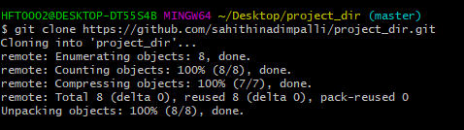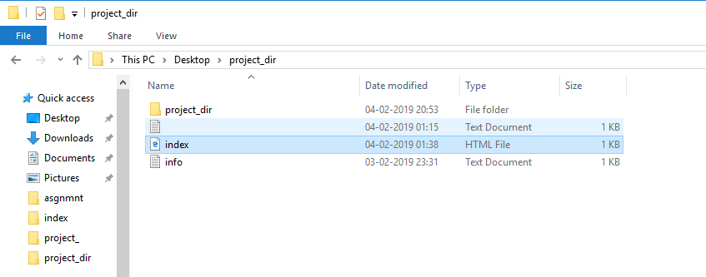
2. Create an empty directory ‘Assignments’ & cd to ‘Assignments’. 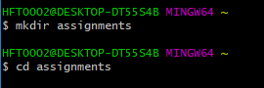
3. Create a file README.txt inside ‘Assignments’ & write few lines about the contents of ‘Assignments’ folder. 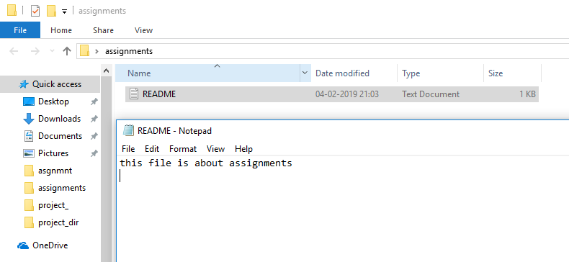
4. Commit README.txt file. 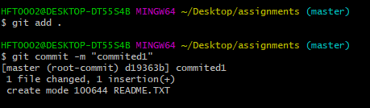
5. Now create a new branch ‘html-assignments’. C:\Users\HFT0002\Desktop\asignmnt2\5.PNG
6. Switch to ‘html-assignments’ branch. C:\Users\HFT0002\Desktop\asignmnt2\6.PNG
7. Copy all HTML assignments inside ‘Assignments’ folder. 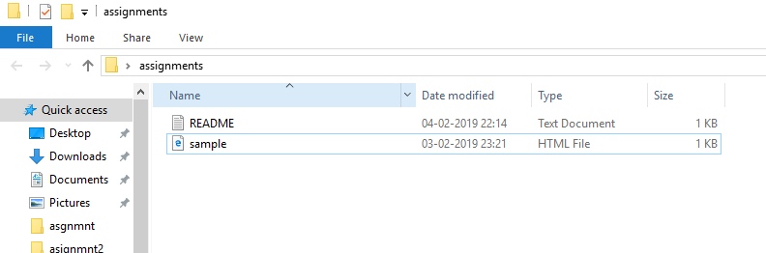
8. Commit HTML assignments into ‘html-assignments’ branch. C:\Users\HFT0002\Desktop\asignmnt2\8.PNG
9. Make minor changes into few files belonging to ‘html-assignments’ branch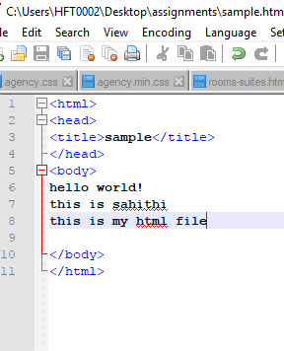.
10. Commit those changed files. 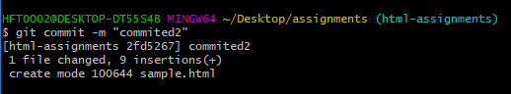
11. Switch to master branch. 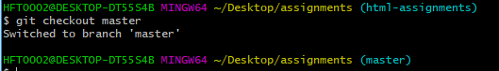
12. Make minor changes into README.txt file & commit those changes into master. 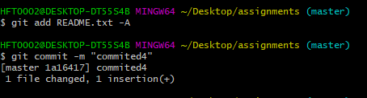
13. Again switch to ‘html-assignments’ branch. 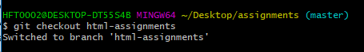
14. Make minor changes into few files belonging to ‘html-assignments’ branch. 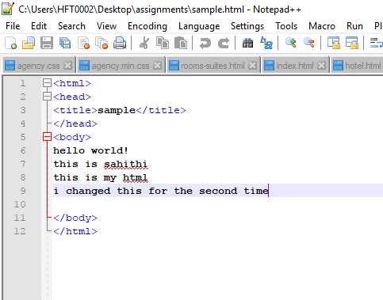
15. Commit those changes. 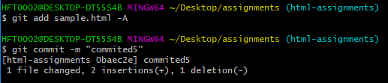
16. Switch to master. C:\Users\HFT0002\Desktop\asignmnt2\16.PNG
17. Merge ‘html-assignments’ branch into master. Confirm all html assignments are shown in master. 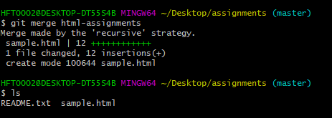
18. Finally delete the ‘html-assignments’ branch. C:\Users\HFT0002\Desktop\asignmnt2\18.PNG

SECTION-2 - (CSS assignments) Steps to follow:

1. Create a new branch ‘css-assignments’. C:\Users\HFT0002\Desktop\asignmnt2\sec 2.1.PNG
2. Switch to ‘css-assignments’ branch. C:\Users\HFT0002\Desktop\asignmnt2\sec 2.2.PNG
3. Copy all CSS assignments inside ‘Assignments’ folder. 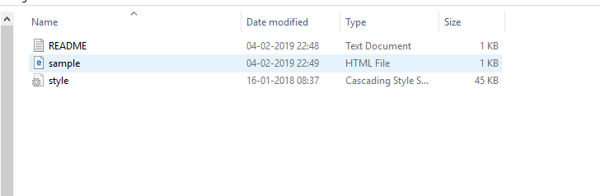
4. Commit CSS assignments into ‘css-assignments’ branch. C:\Users\HFT0002\Desktop\asignmnt2\sec 2.4.PNG
5. Make minor changes into README.txt file on line 1 belonging to ‘css-assignments’ branch. 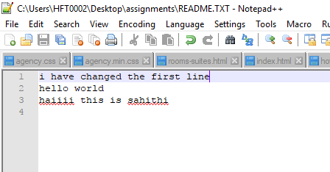
6. Commit those changed files. 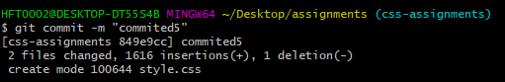
7. Switch to master branch. 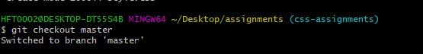
8. Make minor changes into README.txt file on line 3 & commit those changes into master. 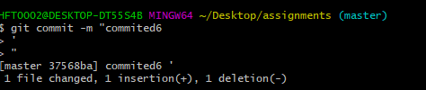
9. Again switch to ‘css-assignments’ branch. 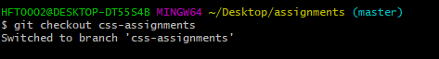
10. Make minor changes into few files belonging to ‘css-assignments’ branch. 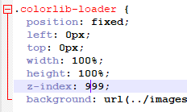
11. Commit those changes. C:\Users\HFT0002\Desktop\asignmnt2\sec 2.11.PNG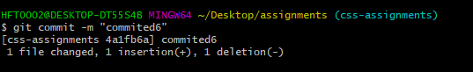
12. Switch to master. C:\Users\HFT0002\Desktop\asignmnt2\sec 2.12.PNG
13. Merge ‘css-assignments’ branch into master. Confirm all css assignments are shown in master. 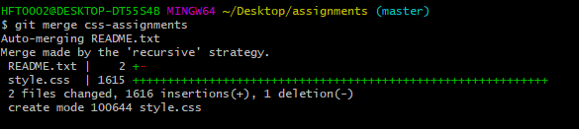
14. Finally delete the ‘css-assignments’ branch. C:\Users\HFT0002\Desktop\asignmnt2\sec 2.14.PNG

SECTION-3 - (JavaScript assignments) Steps to follow:

1. Create a new branch ‘js-assignments’. C:\Users\HFT0002\Desktop\asignmnt2\sec 3.1.PNG
2. Switch to ‘js-assignments’ branch. C:\Users\HFT0002\Desktop\asignmnt2\sec 3.2.PNG
3. Copy all JavaScript assignments inside ‘Assignments’ folder. 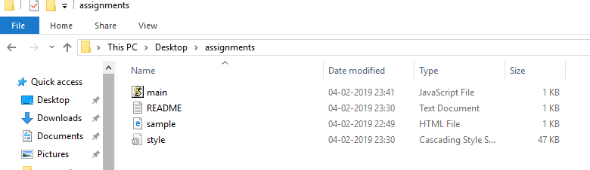
4. Commit JavaScript assignments into ‘js-assignments’ branch. 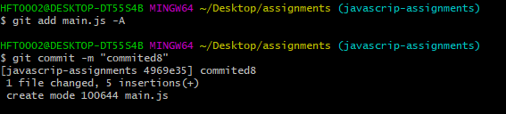
5. Make minor changes into README.txt file on line 1 belonging to ‘js-assignments’ branch. 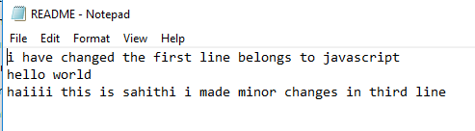
6. Commit those changed files. 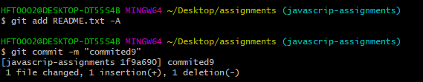
7. Switch to master branch. C:\Users\HFT0002\Desktop\asignmnt2\sec 3.7.PNG
8. Make minor changes into README.txt file on line 1 & commit those changes into master. 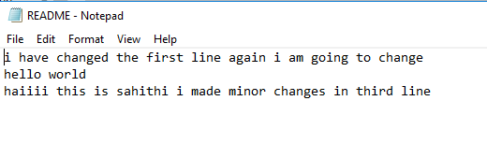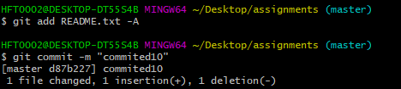
9. Again switch to ‘js-assignments’ branch. 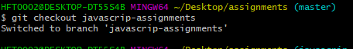
10. Make minor changes into few files belonging to ‘js-assignments’ branch. 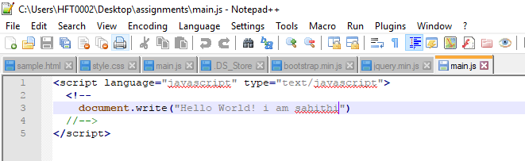
11. Commit those changes. 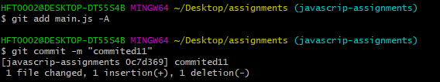
12. Switch to master. C:\Users\HFT0002\Desktop\asignmnt2\sec 3.12.PNG
13. Merge ‘js-assignments’ branch into master. Confirm all JavaScript assignments are shown in master. 
14. Finally delete the ‘js-assignments’ branch. C:\Users\HFT0002\Desktop\asignmnt2\sec 3.14.PNG