**Module: 1**

1.) Assume that you are a software developer and you are applying for a job at XYZ company. The job description says that developers with years of experience between 3 to 20 can only apply for the particular designation.

What is the conditional statement to subscribe the candidates for the job based on their years of experience in relation with the above given requirements in Python?

1. if(year > 3 and year > 20)
2. if(year > 3 and year < 20)
3. if(year > 3 && year , 20)
4. if(year < 3 and year > 20)

Module – Python; Topic – Conditional Statements

2.) Which of the following cannot be used as an identifier in Python Programming Language?

1. nonlocal_
2. _nonlocal_
3. nonlocal
4. nonlocal_1

Module – Python; Topic – Identifiers in Python

3.) Which of the following value has complex data type in python?

1. 54J+h
2. 54o
3. 56j
4. 52J*j

Module – Python; Topic – Datatypes

4.) Consider a developer was developing a program using python. In that program the developer is displaying the square of even numbers within a given number range. The range starts with 78 ends with 89. The number 89 should also be processed in the program.

1. For i in 78.90:  
   if (%2 = = 0);  
   print(“”2)  
   else  
   print(i)
2. For i in range (78, 89)  
   if (%2 = = 0);  
   print(i”2)  
   else  
   print(i)
3. For i in range (78, 90)  
   if (%2 = = 0);  
   print(i”2)  
   else  
   print(i)
4. For i in range (78, 89)  
   if (%2 = = 0);  
   print(i”2)  
   else  
   print(i)

Module – Python; Topic – Loops and range function

5.) A developer was creating a python code. In that python code, the developer wants to create a method “Time _convert” to convert a given input number into hours and minutes.

What is the code statement in python to define the method “Time convert” with the above given requirements?

1. Function Time_convert(int num)  
   //code
2. def Time_convert(num);  
   //code
3. def Time_convert for num ()  
   //code
4. function Time_convert(float num)  
   //code

Module – Python; Topic – Functions

6.) Consider the student is working on a python in that program. In that program, the student has to display the all elements stored of an array. Refer the array details.

Array name. “color”

Array Elements:

* Blue
* Green
* Pink
* Black
* Yellow

What is the code snippet to execute the program based on the above given scenario?

1. for c= color

print(c)

1. for c as color

print(c)

1. for c = color

print(c)

1. for c in color

print(c)

Module – Python; Topic – Loops

7.) Which of the following is the web framework is used to develop an application server quickly using python programming language?

1. .NET
2. Spring
3. Flask
4. Node PY

Module – Python; Topic – Web Framework

8.) Consider the given string :

String_str = ‘ Data science 5 ‘

What is the code statement in python to convert the given string into upper case and display the result by removing the extra while space in the front and back of the string?

1. print(String_str.remove(), ConvertToUpper())
2. print(String_str.remove(),upper())
3. print(strip(string_str), ConvertToUpper(String_str))
4. print(String_str.strip().Upper())

Module – Python; Topic – String Functions

9.) Refer the given output image:

Input elements are given in the following order.

* “Dog”
* “Cat”
* “Lion”
* “Tiger”

Which of the following data type is used to store the above given data in a single variable and the elements are scrambled when displayed?

(‘Cat’, ‘Lion’, ‘Dog’, ‘Tiger’)

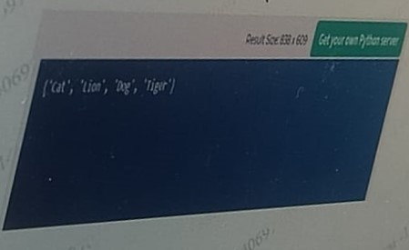

1. Dictionary
2. Set
3. List
4. Tufle

Module – Python; Topic – Collection Data types

10.) Consider a student is developing a program using Python. The Program build displays the various arithmetic operators available in Python. Refer the given variable ‘X’.

X = 78

Which of the following operator is used to find the cube of the value stored in the variable ‘X’?

1. X//3
2. 3**X
3. X**3
4. X—3

Module – Python; Topic – Operators

11.) Refer the given code blocks

Block 1:

class Person:

Block 2:

def myfunc(self):

print(“Name” + self.name)

Block 3:

def_init_(obj, name, age):

obj.name = name

obj.age = age

Block 4:

p1 = Person(“Jacob”, 34)

p1.myfunc()

Rearrange the given block of codes to buildan executable python program

1. Class Person:  
     
   p1 = Person(“Jacob”,34)  
   p1.myfunc)  
     
   def myfunc(self);

Print(“Name” self.name)  
  
def_init_(obj, name, age);

Obj,name = name  
obj,age = age

1. Class Person:  
     
   def_init_(obj, name, age);  
   obj.name = name  
   obj.age = age  
     
   def myfunc(self);  
   print(“Name”+self.name)  
     
   p1 = Person(“Jacob”, 34)  
   p1.myfunc()

Module – Python; Topic – OOPs

**MODULE: 2**

1.) Observe the two given columns:  
Column A is the data frame property  
Column B is the description  
Match the data frame property with its appropriate python description:

|  |  |
| --- | --- |
| **Column A** | **Colum B** |
| shape | Finds Variable Correlations |
| head() | Details of Missing value |
| describe() | Display all Columns and rows |
| info() | Display Top five rows |
| corr() | View Statistical summary of data |

Module – Data Analysis; Topic – Pandas

2.) Consider a developer has collected some data. In order to understand more about the collected data, the developer wants to analyse the collected data. The developer is using descriptive statistics to analyse the data.  
In Descriptive statistics, Univariate analysis is done in order to analyse a particular variable

What are the measures that are used to perform a univariate analysis in descriptive statistics?

1. Measure of central Tendency – Mean, Median, Mode  
   Measure of dispersion – range, Variance, Standard Deviations
2. Measure of central Limit derivation – Range, Variance, Standard Deviations  
   Measure of spread – Mean, Median, Mode
3. Measure of central Limit derivation – Mean, variance, Mode  
   Measure of dispersion – Range, Median, Standard, Deviations
4. Measure of central Tendency – Mean, variance, Mode  
   Measure of dispersion – Range, Median, Standard, Deviations

Module – Data Analysis; Topic – Univariate Analysis - Descriptive Statistics

3.) Consider to table with columns “x” and “z”. Which of the following library in python is used to find the correlations between the columns “x” and “z”?

1. NumPy
2. SciPy
3. Pandas
4. TensorFlow

Module – Data Analysis; Topic – Pandas

4.) Refer the image given below   
What is the keyword to create the given plot with Matplotlib in Python?

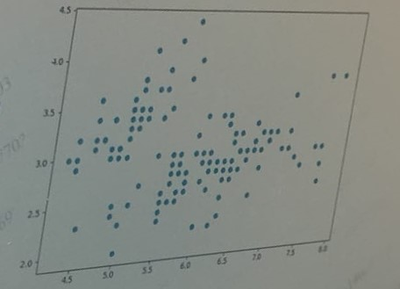

1. Vchfguj
2. Chfhy
3. Vhcfhc
4. Vchch

Module – Data Analysis; Topic – Data Visualizations using Matplotlib

5.) Consider a developer was working with python programming language. The developer wants to draw a distributed plot using a library which is built on the top of matplotlib in python.

What are the code statements to import the required library and the draw the plot given in the above scenario in python?

1. Import seabom as sb

Sd.distplot(…)

1. Import pandas as sb

Sd.distplot( …)

1. Import numpy as sb  
   sd.dist(…)
2. Import matplotlib as sb  
   sd.dist(…)

Module – Data Analysis; Topic – Data Visualizations using Matplotlib

6.) What is the command statement to install the powerful numerical processing library in Juypter python?

1. $ pip install numlib
2. ! install numlib
3. ! pip install numpy
4. Pip install numpy

Module – Data Analysis; Topic – Numpy

7.) A financial department employee was computing some financial data of ZYX company. Refer the data attained by the financial department employee.

LPA of 3 employees in ZYX company:

Employee1 = 1,00,000  
Employee2 = 3,00,000  
Employee3 = 2,00,000

What is the LPA central value based on the given LPA of three employees working in a company ZYX?

1. 300000
2. 100000
3. 200000
4. 150000

Module – Data Analysis; Topic – Univariate Analysis - Descriptive Statistics

Module: 3

1.) A student was working on Central Limit Theorem, while learning Data Science. In the central Limit Theorem an interval estimate can be created.

Which of the following value is used to estimate the confidence level while computing the interval estimation?

1. Mean
2. z-score
3. c-score
4. t-score

Module – Advance Statistics; Topic – Probability Distributions

2.) Consider a student wants to conduct a study to know the average count of apple iPhone users in India. Because of time and cost constraint the student can perform the study on only people 15,000 people. So the sample population of the study is 15,000.  
What is the symbol that can be used to represent the mean of the total population and the sample population?

1. µ, X_
2. µ,
3. $,µ
4. µ, X

Module – Advance Statistics; Topic – Inferential statistics (Hypothesis testing)

3.) Observe the Given plot whose width is defined using standard deviation :

In data science, which of the following symmetric plot of data is plotted in the given image?

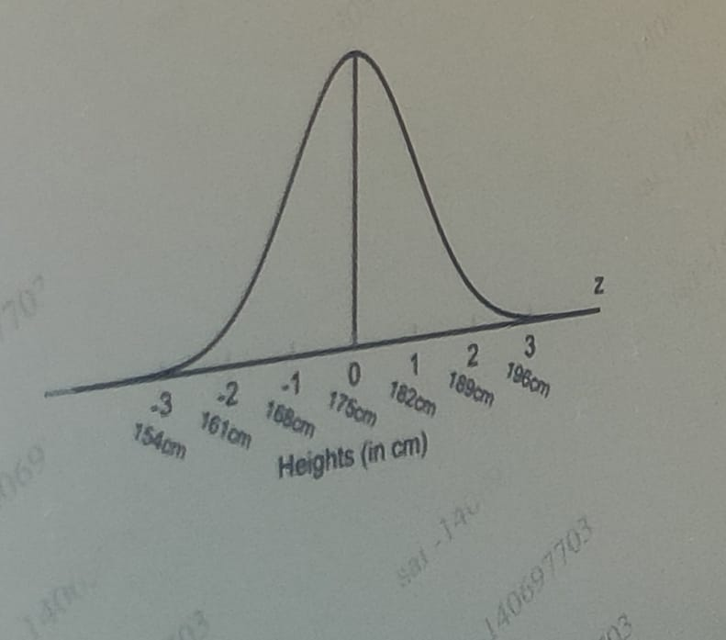

1. Uniform Distribution
2. Gaussian distribution
3. Bernoulli Distribution
4. Binomial distribution

Module – Advance Statistics; Topic – Probability Distributions

4.) Which of the following Probability distribution can be computed using a discrete random variable?

1. Uniform Distribution
2. Plot Distribution
3. Bernoulli Distribution
4. Normal Distribution

Module – Advance Statistics; Topic – Probability Distributions

5.) Which of the following study in data science has to be undertaken to know the uncertainty that may occur while working with data?

1. Occurance
2. Chi square
3. Probability
4. Plot

Module – Advance Statistics; Topic – Probability

Module: 4

1.) Assume a client is working on the artificial intelligence and machine learning. The client is also exploring all the algorithms in machine learning to understand which type of algorithm has to be applied on the data that has been collected.

Which of the following is an iterative algorithm in machine learning that can be used to optimize a function?

1. Gradient Descent
2. Decision tree
3. Logistic regression
4. KNN algorithm

Module – Machine Learning; Topic – Optimizers

2.) Consider a data science student was working with the artificial intelligence and machine learning. The student has collected few data and is looking for the appropriate machine language technique to work on the data.

Which following Machine Learning technique is applied if the data collected consists of a target variable?

1. Supervised Machine Learning
2. Reinforcement Machine Learning
3. Non- Supervised Machine Learning
4. Natural Machine Learning

Module – Machine Learning; Topic – Types of Machine Learning

3.) Consider a developer was collecting some data. The developer wants to perform a supervised machine learning technique to solve the classification problems, Based on the collected data, the developer is opting for the Decision tree algorithm.

To work with this machine learning algorithm the developer has located the data and the test train x_train and y_train are created.  
What is the code snipped in machine learning to fit on the given x_train and y_train in Decision tree?

1. From sklearn.tree import Decision Tree

Classifier = Decision TreeClassifier(max_depth = 3)  
fitclaasfier(x_train, x_train)

1. from sklearn.tree import Decision TreeClssifier  
   classifier = Decision TreeClassifier(max_depth = 3)  
   classifier.fit(x_train,y_train)
2. from sklearn import Decision TreeClassifier  
   classifier = Decision TreeClassifier(max_depth = 3)  
   fit.classifier(ytrain,y_train)
3. from sklearn.tree import Decision TreeClassifier  
   classifier = Decision TreeClassifier(max_depth = 3)  
   fit.classifier(y_train,y_train)

Module – Machine Learning; Topic – Supervised Learning algorithms – Decision Trees

4.) Consider a developer was collecting some students data in a CSV format in “data.csv” file. After the collection of data the developer wants to apply the K Nearest Neighbour algorithm of machine learning to solve the classification problems of the collect data. In order to perform the algorithm, the data is loaded using python pandas.

The data column headers are “Age Height, Weight, BMI”.

What is the code statement to identify the input data in the data frame ‘df’ which is created by reading the file “data csv” using python pandas?

1. df.{[‘Age’,[Height’],[‘Weight’],[‘BMI’]}
2. df{[‘Age’,’Height’,’Weight’,’BMI’]}
3. df.[‘Age’,’Height’,’Weight’,BMI’]
4. df{[Age],Height,[Weight,BMI]}

Module – Machine Learning; Topic – Data Understanding

5.) Consider a developer is collecting the details of 30,000 Airtel customers. This data is collected along with the details like Customer name, address, connection number, Internet plan adopted, Start and end date of the plan, monthly Payment of the plan, Due date, Payment paid dates, penalty amounts and default payment as per prediction. All these data are stored in a file “dat.csv” as the data are in CSV format.

1. What is the code snipped to load the csv data in machine learning and the code statement that is used to find the number of defaulters based on the given data using python?
2. What is the code statement in python to import the package necessary to build a stacking ensemble model?
3. a.) Import pandas as pd  
   df = pd.read_csv(‘data.csv’)  
   df[‘defaulted’].value_counts(normalize = True)

b.) from sklearn.ensemble import stackingClassifier

1. a.) Import pandas as pd  
   df = pd.read_csv(‘data_csv’)  
   df[‘defaulted’].value(normalize=False)  
     
   b.) from sklearn.ensemble import stackingClassifier
2. a.) Import pandas as pd  
   df = pd_read_csv(‘data.csv’)  
   df[‘defaulted].value_counts(normalize=false)  
     
   b.) Import sklearn.ensemble from stackingClassifier

Module – Machine Learning; Topic – Ensemble techniques

6.) Consider a developer is working with machine learning. A machine learning requires a major mathematical skill which is linear algebra. Many machine learning language data set are in the form of Matrix.  
Which of the following study cannot be defined using linear algebra that is the mathematical foundation for machine learning?

1. Dot Product
2. Vectors
3. Mapping
4. Schemes

Module – Machine Learning; Topic – Linear Algebra

Module: 5

1.) Tokens (words) are generated in the process. “Bag of words”, after preprocessing multiple sentences in the dataset. What are those tokens used for?

1. Calculating the frequency of each token.
2. Calculating the importance of each token.
3. Calculating the usability of each token
4. Calculating the total number of tokens.

Module – Deep Learning; Topic – NLP

2.) When purchasing a phone online, the website includes a picture of the phone, its features, and user reviews, Which pipeline in deep learning handles the picture portion?

1. Image Vision Pipeline
2. Computer Vision Pipeline
3. Natural Language Processing Pipeline
4. Natural Language Understanding Pipeline

Module – Deep Learning; Topic – Computer Vision

3.) What are the two main inputs to an ANN?

1. Text and Frequency
2. Image and Text
3. Text and Numbers
4. Images and Numbers

Module – Deep Learning; Topic – ANN

4.) Consider that there is a picture, and the picture’s edges and boundaries need to be determined using the edge detection method. What will be the initial task to be performed?

1. Decrease the sharpness of the image.
2. Increase the exposure of the image.
3. Convert the image to a black and white image.
4. Convert the image to a grey scale image.

Module – Deep Learning; Topic – Computer Vision

5.) What happens when there’s a negligible change in the node weights in a neural network?

1. The accuracy of the model becomes ().
2. The accuracy of the model does improves.
3. The accuracy of the model becomes 1.
4. The accuracy of the model does not improve.

Module – Deep Learning; Topic – ANN

6.) The data has been preprocessed, and natural language understanding has been applied to the preprocessed data. What happens in the next stage of natural language processing (NLP)?

1. Natural Language Generation.
2. Natural Language Optimization.
3. Natural Language Creation.
4. Natural Language Reduction.

Module – Deep Learning; Topic – NLP

7.) In the given image, the most prominent features of the feature map are select. What is the image 2 called as?

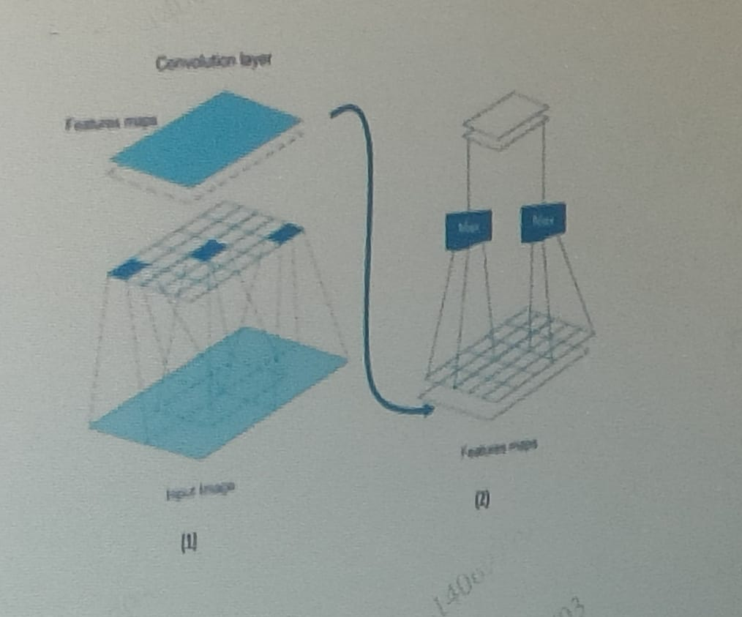

1. Max pooling layer
2. Map Layer
3. Features layer
4. Pooling Layer

Module – Deep Learning; Topic – CNN