A CASE-STUDY BASED REPORT
ON
Explainable Machine Learning for Predicting and Understanding Employee Attrition Using IBM HR Analytics Data
submitted in partial fulfilment of the requirements for the Course
MACHINE LEARNING
BACHELOR OF TECHNOLOGY
in
A.Y.: 2026-27
by
Bhavana. D Roll No. 2520030242
Sahithi. P Roll No. 2520030262
Under the Esteemed guidance of
Dr.Y.Lakshmi Prasanna
Asst.Professor, Dept. of CS&IT




INDEX
Abstract 3
1. Introduction 4
1.1 Background 4
1.2 Motivation for the Project 4
1.3 Overview of the Work Carried Out 4
1.4 Scope and Responsible-Use Statement 5
2. Problem Statement 6
2.1 Case-Study Scenario 6
2.2 Central Case-Study Question 6
2.3 Formal Problem Definition 6
2.4 Objectives that Guide the Study 6
2.5 Assumptions and Limitations 6
3. Dataset and Exploratory Data Analysis 8
3.1 About the Dataset 8
3.2 Purpose of EDA 8
3.3 Preparation Steps Actually Performed 8
3.4 EDA Exploration – Implementation 8
3.5 Summary of EDA Findings 10
4. Algorithm Selection and Implementation 12
4.1 Why These Two Models 12
4.2 Implementation 12
4.3 Results 13
4.4 Explainability with SHAP 15
4.5 Interpretation for HR Decision-Making 16
5. Conclusion 18
References 19

Abstract
Employee attrition imposes recruitment costs, loss of institutional knowledge and reduced productivity on organisations. This case study predicts employee attrition on the IBM HR Analytics dataset (1,470 employees, 35 attributes, 16.1% of whom left) and explains the predictions so that HR teams can act on them. Two supervised models, Logistic Regression and Random Forest, were trained on a stratified 80/20 split using class-weighting to handle the 84:16 class imbalance. Because missing a leaver is costlier than a false alarm, the evaluation emphasises recall alongside accuracy, precision, F1-score and ROC-AUC.
On the held-out test set, Logistic Regression identified 29 of 47 leavers (recall 0.62, ROC-AUC 0.80), whereas Random Forest at the default 0.5 threshold had higher accuracy (0.83) but recalled only 14 of 47 leavers (recall 0.30, ROC-AUC 0.77); lowering its decision threshold trades precision for recall. SHAP values computed on the Random Forest show that overtime, age, stock-option level, monthly income, tenure and years with the current manager are the strongest drivers of predicted attrition risk, both across the workforce and for individual employees.
The study shows how predictive modelling combined with explainable AI can support transparent, evidence-based retention decisions, and it is explicit about the limits of the approach: a small number of leavers in the test set, a public dataset of uncertain realism, and the fact that model explanations describe associations rather than causes.

1. Introduction

1.1 Background
Employee attrition is the loss of employees from an organisation through resignation, retirement or termination. When skilled staff leave, the organisation pays for replacement hiring and training, loses knowledge that was never documented, and often sees team morale and productivity dip. Traditional HR practice is reactive: exit interviews and turnover reports describe attrition only after it has happened.
Machine learning (ML) allows a proactive approach. A classifier trained on historical records can estimate, for each current employee, the probability of leaving, so that HR can prioritise conversations and interventions. The IBM HR Analytics Employee Attrition & Performance dataset has become a standard benchmark for this task, and recent studies on it compare linear, tree-based and boosting models and increasingly add explainable AI. For example, Alyousef et al. [1] report that on this dataset a logistic regression model gave a better F1-score and recall than Random Forest and XGBoost, and Ansari et al. [2] combine XGBoost with SHAP in an HR information system. Raza et al. [4] and Chung et al. [5] show that ensemble methods can score highly on accuracy, while Varkiani et al. [6] and Mohiuddin et al. [3] stress that predictions are only useful to HR when their reasons can be inspected.
SHAP (SHapley Additive exPlanations) [9] is a game-theoretic method that assigns every feature a contribution to each individual prediction; for tree ensembles it can be computed efficiently [10]. It provides both global importance (which factors matter across the workforce) and local explanations (why this employee was flagged).

1.2 Motivation for the Project
Two gaps motivated this work. First, many attrition studies report accuracy, which is misleading when only about one employee in six leaves: in our test set a model that always predicts "stays" would already reach 84.0% accuracy while finding no leavers at all. Recall and ROC-AUC are the more honest measures. Second, a risk score without reasons is hard for HR managers to trust or use. We therefore wanted a simple and transparent pipeline that (i) compares an interpretable baseline with a stronger non-linear model, (ii) evaluates them on metrics that reflect business cost, and (iii) explains the better-suited model with SHAP at both global and individual level.

1.3 Overview of the Work Carried Out
The work was carried out end-to-end in Python (pandas, scikit-learn, SHAP, matplotlib) on the IBM HR Analytics dataset:
- Loaded the 1,470 × 35 dataset, verified there are no missing values or duplicate rows, and removed four non-informative columns (three constants and an ID).
- Performed exploratory data analysis (class balance, attrition rate by categorical and ordinal factors, distributions of income, tenure and commute, correlations).
- One-hot encoded categorical variables (44 model features), created a stratified 80/20 train–test split and standardised features for Logistic Regression.
- Trained Logistic Regression and a Random Forest with balanced class weights; evaluated them with 5-fold cross-validated ROC-AUC on the training set and with accuracy, precision, recall, F1 and ROC-AUC on the test set.
- Applied SHAP TreeExplainer to the Random Forest for global importance, direction-of-effect plots and one individual explanation, and translated the drivers into HR retention actions.

1.4 Scope and Responsible-Use Statement
Scope. The study covers binary classification (leaves / stays) and post-hoc explanation using one public dataset and two models. It does not cover time-to-event (survival) modelling, causal inference, or deployment.
Responsible use. The dataset is published on Kaggle [12], where it is described as a fictional dataset created by IBM data scientists, so results should not be assumed to transfer to any real organisation without re-validation on local data. The models are intended as decision support for HR, not as automated decision makers: no hiring, firing, pay or promotion decision should be taken on a model score alone. Some influential features (age, marital status) are personal characteristics; they help explain historical patterns but must not be used to single out or disadvantage employees. Retention actions should target modifiable factors such as workload, pay and career growth. SHAP values describe how the model uses features, not why people actually leave, so they should open a conversation rather than conclude it.

2. Problem Statement

2.1 Case-Study Scenario
A mid-sized company with roughly 1,500 employees across Research & Development, Sales and Human Resources notices that about one in six employees leaves, and that departures cluster in certain roles. The HR head wants a data-driven early-warning view: which current employees are most at risk, what is driving that risk, and where retention effort will be best spent. Because the output will influence conversations with real people, HR also requires that every flagged case can be explained in plain terms.

2.2 Central Case-Study Question
Can employee attrition be predicted with useful recall from routine HR data, and can the model's predictions be explained well enough, globally and for individual employees, to guide targeted and fair retention strategies?

2.3 Formal Problem Definition
Let x ∈ ℝ^d (d = 44 after encoding) be the feature vector of an employee and y ∈ {0,1} the label (1 = left). Given training data D = {(x_i, y_i)}, learn a classifier f(x) = P(y = 1 | x) and a decision rule ŷ = 1[f(x) ≥ τ] that maximises recall on the minority class at an acceptable precision, with ROC-AUC used to assess ranking quality independent of τ. For explanation, compute Shapley values φ_j(x) for each feature j such that f(x) = φ_0 + Σ_j φ_j(x), where φ_0 is the average model output; a positive φ_j pushes the prediction towards "leaves".

2.4 Objectives that Guide the Study
- O1 – Data: prepare the IBM HR Analytics dataset (1,470 employees, 35 attributes) and understand attrition patterns through EDA.
- O2 – Models: implement and compare Logistic Regression and Random Forest classifiers for attrition prediction.
- O3 – Evaluation: evaluate with accuracy, precision, recall, F1-score and ROC-AUC, giving particular attention to recall for the "leaves" class.
- O4 – Explainability: apply SHAP to the Random Forest to identify global and individual drivers of attrition risk and translate them into actionable HR recommendations.

2.5 Assumptions and Limitations
- The dataset is a single, static snapshot; it has no time dimension, so we cannot say when someone left or model changes over time.
- The label "Attrition" is assumed to be correct and not to distinguish voluntary from involuntary exits.
- The test set contains only 47 leavers, so each metric has wide uncertainty; a different random split can change recall by several percentage points.
- Hyper-parameters were set to sensible fixed values and not exhaustively tuned; no resampling (SMOTE/ADASYN) was used, class weights were used instead.
- The decision threshold analysis in Section 4.3 is a sensitivity study on the test set, not a tuned final threshold.
- Correlated features (for example JobLevel and MonthlyIncome, r = 0.95) share SHAP credit, so individual feature rankings should be read with care.
- SHAP explanations show model behaviour, not causation, and the data come from a fictional dataset.

3. Dataset and Exploratory Data Analysis

3.1 About the Dataset
The IBM HR Analytics Employee Attrition & Performance dataset [12] contains 1,470 employee records with 35 attributes and no missing values. The target, Attrition, is "Yes" for 237 employees (16.1%) and "No" for 1,233 (83.9%). The attributes fall into the groups shown in Table 1.
Group | Attributes (examples)
Demographics | Age (18–60), Gender, MaritalStatus, Education, EducationField, DistanceFromHome
Job & organisation | Department, JobRole, JobLevel, BusinessTravel, OverTime, StockOptionLevel
Compensation | MonthlyIncome (1,009–19,999), DailyRate, HourlyRate, MonthlyRate, PercentSalaryHike
Experience & tenure | TotalWorkingYears, YearsAtCompany, YearsInCurrentRole, YearsSinceLastPromotion, YearsWithCurrManager, NumCompaniesWorked
Satisfaction & performance | JobSatisfaction, EnvironmentSatisfaction, RelationshipSatisfaction, WorkLifeBalance, JobInvolvement, PerformanceRating, TrainingTimesLastYear
Constants / identifiers | EmployeeCount, Over18, StandardHours (constant); EmployeeNumber (ID)

Table 1: Attribute groups in the IBM HR Analytics dataset

3.2 Purpose of EDA
EDA was used to (a) quantify the class imbalance and therefore justify recall-oriented evaluation, (b) discover which factors differ most between leavers and stayers, which gives expectations to compare SHAP results against, (c) detect redundant or uninformative columns, and (d) decide on encoding and scaling.

3.3 Preparation Steps Actually Performed
- Integrity checks: 0 missing values; 0 duplicate rows; EmployeeNumber is unique.
- Dropped columns: EmployeeCount, Over18, StandardHours (single value in every row) and EmployeeNumber (identifier) – leaving 30 predictors.
- Target encoding: Attrition Yes → 1, No → 0.
- Categorical encoding: one-hot encoding with drop_first=True for BusinessTravel, Department, EducationField, Gender, JobRole, MaritalStatus and OverTime, giving 44 model features.
- Split: stratified 80/20 train–test split (random_state = 42): 1176 training rows (190 leavers) and 294 test rows (47 leavers).
- Scaling: StandardScaler fitted on the training set only and applied to the test set; used for Logistic Regression only (Random Forest is scale-invariant).
- Imbalance handling: class_weight="balanced" in both models; no synthetic oversampling, which avoids any risk of leakage into the test set.

3.4 EDA Exploration – Implementation
The following code loads the data, checks quality and produces the figures used below.
import pandas as pd, seaborn as sns, matplotlib.pyplot as plt
df = pd.read_csv("WA_Fn-UseC_-HR-Employee-Attrition.csv")
print(df.shape, df.isna().sum().sum(), df.duplicated().sum()) # (1470, 35) 0 0
print(df["Attrition"].value_counts(normalize=True)) # No 0.839 / Yes 0.161
df["y"] = (df["Attrition"] == "Yes").astype(int)

# attrition rate (%) by factor
for col in ["OverTime", "JobSatisfaction", "WorkLifeBalance", "JobRole"]:
print(df.groupby(col)["y"].mean().mul(100).round(1))

# distributions and correlations
sns.boxplot(data=df, x="Attrition", y="MonthlyIncome")
corr = df.select_dtypes("number").corr()["y"].sort_values()

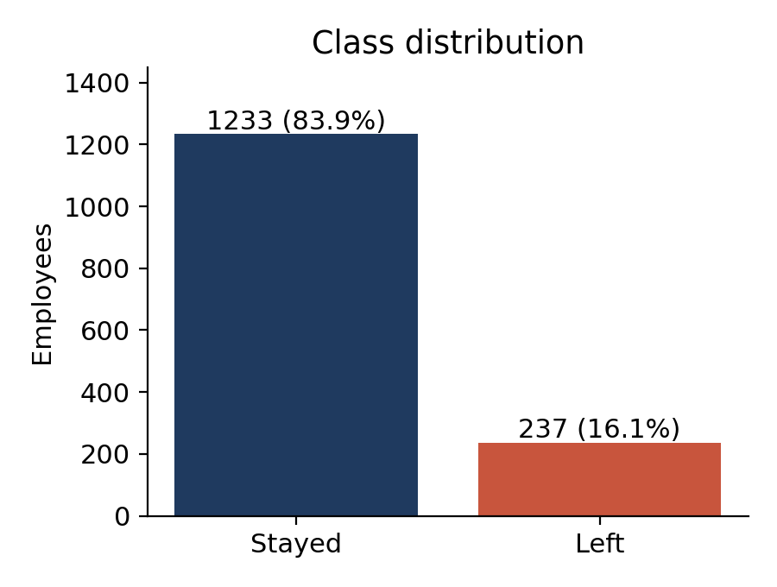
Figure 1: Class distribution – 237 of 1,470 employees (16.1%) left
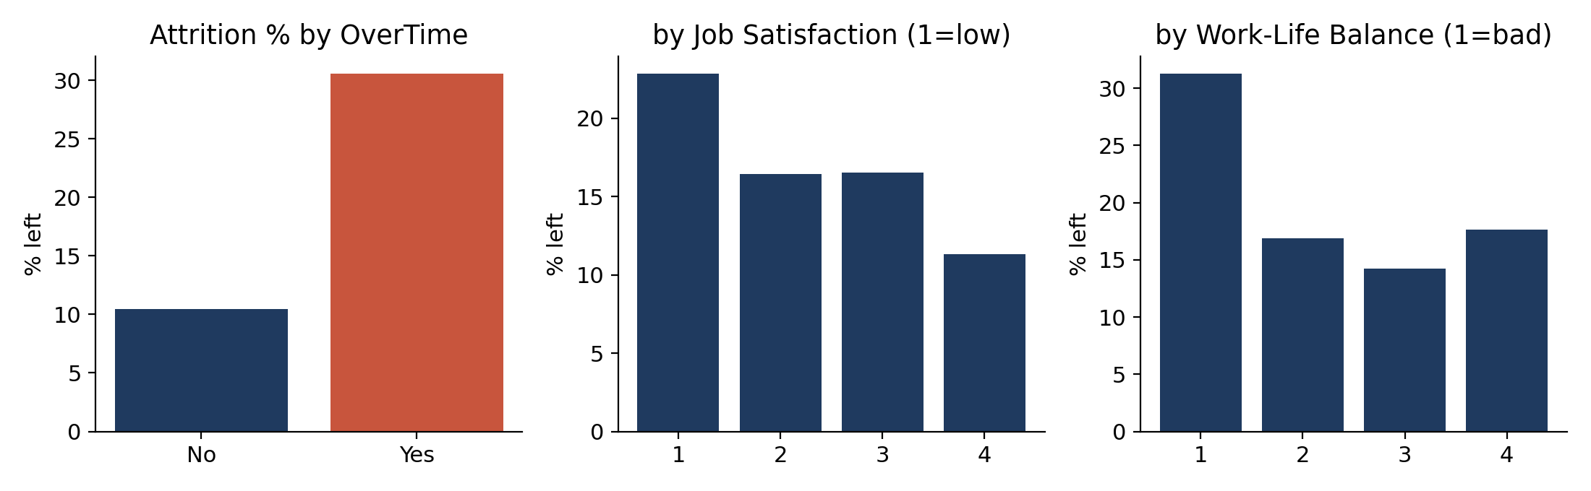
Figure 2: Attrition rate by overtime, job satisfaction and work-life balance
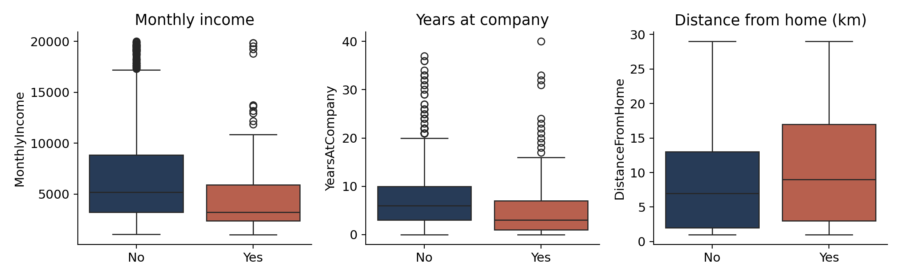
Figure 3: Monthly income, years at company and distance from home by attrition status
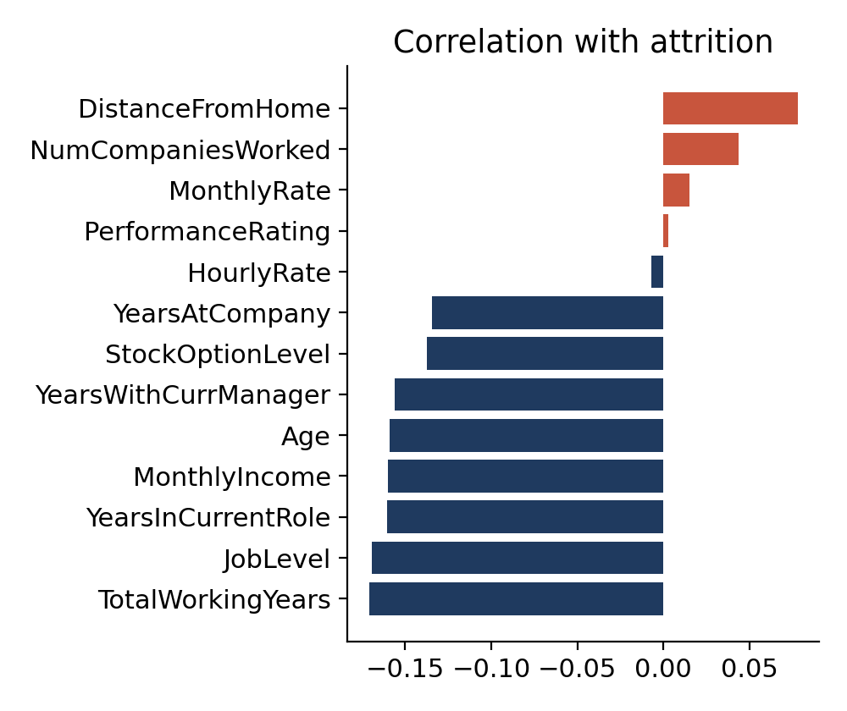
Figure 4: Correlation of numeric features with attrition (point-biserial)

3.5 Summary of EDA Findings
Factor | Observation | Attrition rate / value
Class balance | Strong imbalance | 16.1% left (237 of 1,470)
OverTime | Overtime workers leave about three times as often | 30.5% (Yes) vs 10.4% (No)
JobSatisfaction | Lowest satisfaction group has the highest attrition | 22.8% (level 1) vs 11.3% (level 4)
WorkLifeBalance | "Bad" balance is the highest-risk group (80 employees) | 31.2% (level 1) vs 14.2–17.6% (levels 2–4)
JobRole | Sales Representatives and Laboratory Technicians highest | 39.8% and 23.9%; Research Director 2.5%
BusinessTravel | Frequent travellers leave more | 24.9% (frequent) vs 8.0% (none)
MaritalStatus | Single employees leave more | 25.5% (single) vs 12.5% (married)
StockOptionLevel | No stock options → higher attrition | 24.4% (level 0) vs 9.4% (level 1)
MonthlyIncome | Leavers earn less (median) | 3,202 vs 5,204
YearsAtCompany | Leavers are earlier in tenure (median) | 3 vs 6 years
Age | Leavers are younger (mean) | 33.6 vs 37.6 years
DistanceFromHome | Leavers live slightly farther (mean) | 10.6 vs 8.9 km

Table 2: Key EDA findings (computed from the full dataset)
Three further observations affect modelling. Experience-related variables (TotalWorkingYears, JobLevel, YearsInCurrentRole, MonthlyIncome, Age) all correlate negatively with attrition at about −0.16 to −0.17, so no single numeric variable is strongly predictive and a multivariate model is needed. JobLevel and MonthlyIncome are highly correlated (r = 0.95), which warns that their importance will be shared. Finally, several of the small groups behind the high rates (for example 80 employees with the lowest work-life balance, 83 Sales Representatives) are small, so those percentages are indicative rather than precise.

4. Algorithm Selection and Implementation

4.1 Why These Two Models
Logistic Regression (LR) models log-odds as a linear combination of the features, P(y=1|x) = 1 / (1 + e^−(β0 + βᵀx)). Its coefficients are directly readable (a positive coefficient raises predicted risk), it trains in milliseconds and it is hard to overfit, which makes it the natural interpretable baseline.
Random Forest (RF) [11] averages many decision trees trained on bootstrap samples and random feature subsets. It captures non-linear effects and interactions (for example, overtime mattering more for junior staff) without manual feature engineering and is robust to scale and outliers. Its drawback is opacity, which SHAP addresses. Tree-based SHAP also has an exact, fast algorithm [10], which is why SHAP was applied to RF rather than LR.
Gradient-boosting models (XGBoost, LightGBM) are common in the literature [1], [2], [7], but were left out of scope so that the comparison stays clear: a transparent linear model versus a non-linear ensemble.

4.2 Implementation
from sklearn.model_selection import train_test_split, StratifiedKFold, cross_val_score
from sklearn.preprocessing import StandardScaler
from sklearn.linear_model import LogisticRegression
from sklearn.ensemble import RandomForestClassifier
import shap

X = pd.get_dummies(df.drop(columns=["Attrition","y","EmployeeCount",
"Over18","StandardHours","EmployeeNumber"]), drop_first=True).astype(float)
y = df["y"]
Xtr, Xte, ytr, yte = train_test_split(X, y, test_size=0.2,
stratify=y, random_state=42)
sc = StandardScaler().fit(Xtr)

lr = LogisticRegression(max_iter=2000, class_weight="balanced", random_state=42)
rf = RandomForestClassifier(n_estimators=300, max_depth=8, min_samples_leaf=3,
class_weight="balanced", random_state=42, n_jobs=-1)

skf = StratifiedKFold(5, shuffle=True, random_state=42)
cv_lr = cross_val_score(lr, sc.transform(Xtr), ytr, cv=skf, scoring="roc_auc").mean()
cv_rf = cross_val_score(rf, Xtr, ytr, cv=skf, scoring="roc_auc").mean()

lr.fit(sc.transform(Xtr), ytr); rf.fit(Xtr, ytr)
p_lr = lr.predict_proba(sc.transform(Xte))[:, 1]
p_rf = rf.predict_proba(Xte)[:, 1]

explainer = shap.TreeExplainer(rf)
sv = explainer.shap_values(Xte) # class-1 contributions
shap.summary_plot(sv, Xte, max_display=10)

Table 3 lists the settings. Hyper-parameters were chosen as reasonable fixed values (moderate tree depth and minimum leaf size to limit overfitting) rather than by a search, which is noted as a limitation.
Setting | Logistic Regression | Random Forest
Input | 44 standardised features | 44 raw (one-hot) features
Key parameters | max_iter = 2000, L2 penalty (default) | 300 trees, max_depth = 8, min_samples_leaf = 3
Imbalance | class_weight = "balanced" | class_weight = "balanced"
Decision threshold | 0.5 | 0.5 (sensitivity study in 4.3)
Random seed | 42 | 42

Table 3: Model configuration

4.3 Results
Five-fold stratified cross-validated ROC-AUC on the training set was 0.827 for Logistic Regression and 0.796 for Random Forest. Test-set results are in Table 4.
Model | Accuracy | Precision | Recall | F1-score | ROC-AUC
Logistic Regression | 0.752 | 0.345 | 0.617 | 0.443 | 0.798
Random Forest (τ = 0.5) | 0.833 | 0.467 | 0.298 | 0.364 | 0.774

Table 4: Test-set performance (n = 294, 47 leavers). Always predicting "stays" would give accuracy 0.840, recall 0
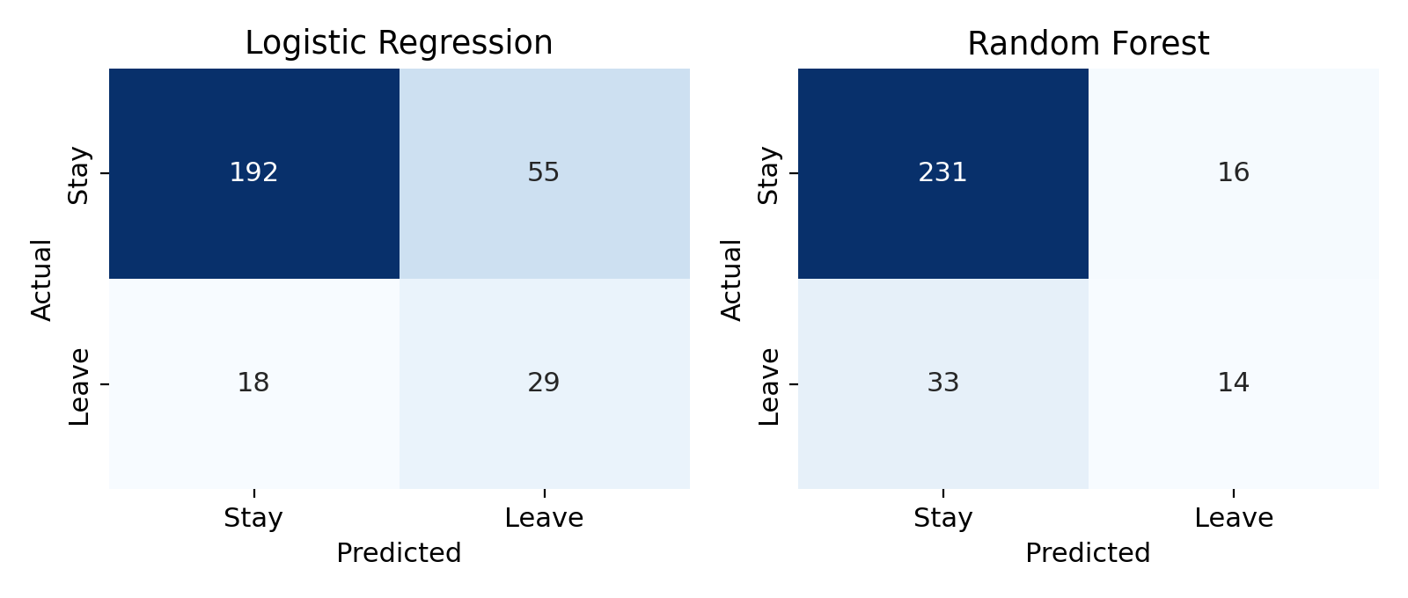
Figure 5: Confusion matrices on the test set
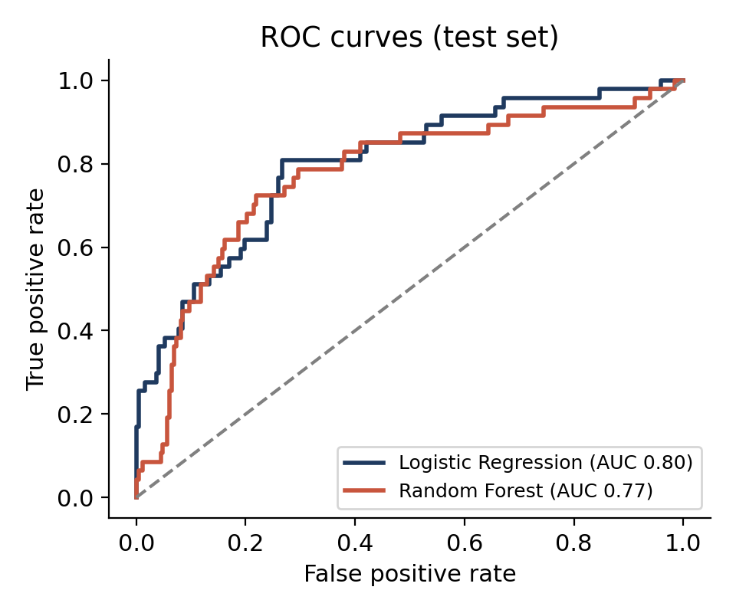
Figure 6: ROC curves of the two models on the test set
Reading the results. Random Forest has the higher accuracy (0.833 vs 0.752) but this is mostly because it predicts "stays" more often; it catches 14 of 47 leavers and misses 33. Logistic Regression catches 29 of 47 (recall 0.617) at the cost of 55 false alarms against 16 for Random Forest. It also has the better F1-score and ROC-AUC on both cross-validation and the test set. Under the recall priority set in the objectives, the linear baseline therefore performs better than the more complex model at the default threshold. This agrees with the pattern reported on the same dataset by Alyousef et al. [1], whose logistic regression reached recall 0.638 and F1 0.504 against 0.383 and 0.429 for Random Forest; our figures are close, although the splits differ.
Threshold sensitivity (Random Forest). Random Forest outputs probabilities, so its poor recall at 0.5 is partly a threshold effect. Table 5 shows that lowering the threshold raises recall substantially.
Threshold τ | Recall | Precision | F1-score
0.5 | 0.298 | 0.467 | 0.364
0.4 | 0.532 | 0.417 | 0.467
0.3 | 0.723 | 0.366 | 0.486
0.25 | 0.830 | 0.279 | 0.417

Table 5: Random Forest at different decision thresholds (test set; illustrative, not a tuned final choice)
At τ = 0.30, Random Forest reaches recall 0.72 with precision 0.37, i.e. roughly one flagged employee in three actually leaves. Because these thresholds were examined on the test set, the numbers are optimistic; in practice τ should be chosen on validation data using the relative cost of a missed leaver versus an unnecessary retention conversation.
Logistic Regression coefficients. The strongest positive (risk-raising) standardised coefficients were JobRole = Laboratory Technician (+0.81), OverTime = Yes (+0.77), BusinessTravel = Travel_Frequently (+0.72), JobLevel (+0.65) and JobRole = Sales Representative (+0.53). The strongest negative ones were TotalWorkingYears (−0.66), EducationField = Life Sciences (−0.51), YearsWithCurrManager (−0.46) and EnvironmentSatisfaction (−0.43). The positive JobLevel coefficient, which contradicts the negative raw correlation, is a symptom of its 0.95 correlation with MonthlyIncome, a reminder that individual coefficients are unstable under collinearity.

4.4 Explainability with SHAP
SHAP was applied to the Random Forest on the test set. Figure 7 ranks features by mean absolute SHAP value (global importance) and Figure 8 shows the direction of each effect: each dot is an employee, red means a high feature value and a position to the right means higher predicted risk.
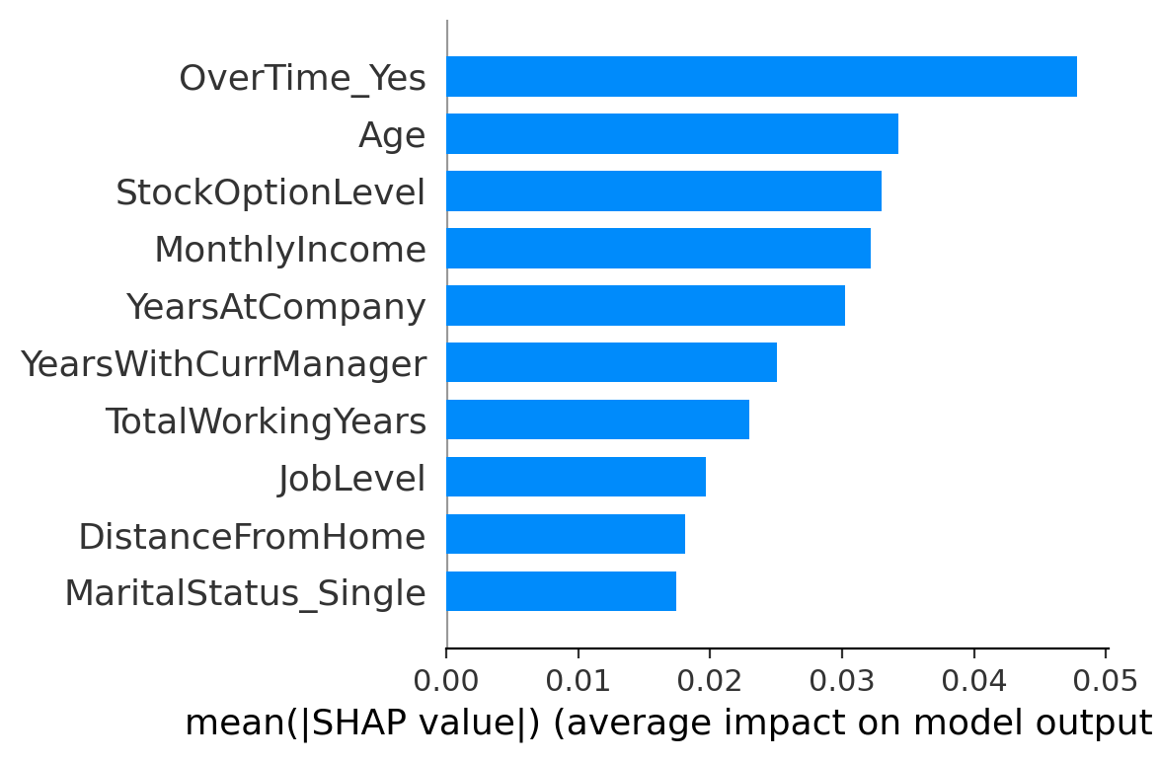
Figure 7: Global importance – mean |SHAP value| (top 10 features)
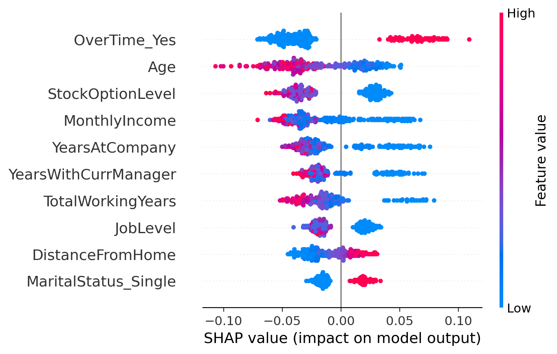
Figure 8: SHAP summary (beeswarm) plot for the Random Forest
Global findings. The ten most influential features by mean |SHAP| were OverTime = Yes, Age, StockOptionLevel, MonthlyIncome, YearsAtCompany, YearsWithCurrManager, TotalWorkingYears, JobLevel, DistanceFromHome and MaritalStatus = Single. Working overtime pushes predicted risk up for every employee who does it; low age, low tenure, low income, few total working years and no stock options push risk up; a long distance from home raises risk modestly. These agree with the EDA in Table 2. The built-in Random Forest impurity importance ranks MonthlyIncome, Age, TotalWorkingYears, YearsAtCompany and OverTime highest, i.e. a similar set but a different order, which is expected because impurity importance favours continuous variables with many split points.
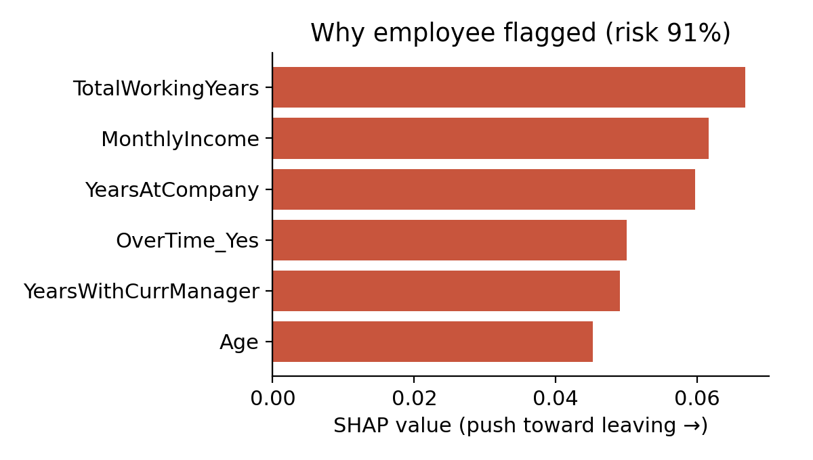
Figure 9: Local explanation for the highest-risk employee in the test set
Individual example. The employee with the highest predicted risk in the test set (91%; this person did leave) is explained in Figure 9: only 1 total working year and 1 year at the company, a monthly income of 2,121, working overtime, 0 years with the current manager and age 19 all push the prediction up. For HR this reads as a very junior, low-paid, overloaded newcomer, which suggests a concrete conversation about workload, pay progression and onboarding support rather than a generic retention offer.

4.5 Interpretation for HR Decision-Making
Driver (SHAP / EDA) | Evidence | Possible retention action
Overtime | Top SHAP feature; 30.5% vs 10.4% attrition | Monitor and cap sustained overtime; rebalance workload or add capacity in affected teams
Low income / early career | Low MonthlyIncome, few years of experience raise risk | Review pay progression for early-career staff; clear grade-to-pay path
Short tenure and new manager | Low YearsAtCompany and YearsWithCurrManager raise risk | Structured onboarding, buddy scheme, early manager check-ins in first 12 months
No stock options | 24.4% vs 9.4% attrition | Consider equity or long-term incentive schemes for at-risk groups
Frequent travel / long commute | 24.9% attrition for frequent travellers; distance has a positive SHAP effect | Travel rotation, remote or hybrid options
High-risk roles | Sales Representative 39.8%, Laboratory Technician 23.9% | Role-specific retention review (targets, career ladder, tooling)

Table 6: Translating model drivers into actions
Age and marital status appear among the influential features but are not actionable and are sensitive; they should be treated as context for the model, not as grounds for any decision about an individual.

5. Conclusion
This case study built an explainable attrition-prediction pipeline on the IBM HR Analytics dataset. EDA showed that attrition is imbalanced (16.1%) and concentrated among overtime workers, low-satisfaction and low-work-life-balance employees, frequent travellers, early-career and lower-paid staff, and certain roles. Logistic Regression and Random Forest were compared on metrics that reflect the cost of missed leavers: Logistic Regression had the better recall (0.62), F1 (0.44) and ROC-AUC (0.80) at the default threshold, while Random Forest had the higher accuracy (0.83) but missed most leavers until its threshold was lowered. SHAP on the Random Forest identified overtime, age, stock options, income, tenure and time with the current manager as the leading drivers and produced individual explanations that map to practical HR actions.
The main limitations are the small number of leavers in the test set, the single train–test split, the fixed (untuned) hyper-parameters, the fictional nature of the data and the associative nature of SHAP. Future scope: repeated cross-validation or bootstrapped confidence intervals, threshold selection on validation data using a cost matrix, gradient-boosting models, a fairness audit across gender, age and marital status, and a simple dashboard that shows an employee's risk score with its SHAP explanation to HR users.

References
[1] M. I. Alyousef, H. W. Khan and M. U. Sattar, "A hybrid predictive model for employee turnover: Integrating ensemble learning and feature-driven insights from IBM HR Analytics," Information, vol. 17, no. 2, Art. 208, 2026, doi: 10.3390/info17020208.
[2] M. E. Ansari, M. T. R. Tarafder, A. Chowdhury, N. N. Rimi, N. Akter and K. R. Ahmed, "An AI-driven management information system for employee attrition prediction: Enhancing human agency through XGBoost and explainable AI," Computers, vol. 15, no. 7, Art. 400, 2026, doi: 10.3390/computers15070400.
[3] K. Mohiuddin, M. A. Alam, M. M. Alam, P. Welke, M. Martin, J. Lehmann and S. Vahdati, "Retention is all you need," in Proc. 32nd ACM Int. Conf. Information and Knowledge Management (CIKM), 2023, pp. 4752–4758, doi: 10.1145/3583780.3615497.
[4] A. Raza, K. Munir, M. Almutairi, F. Younas and M. M. S. Fareed, "Predicting employee attrition using machine learning approaches," Appl. Sci., vol. 12, no. 13, Art. 6424, 2022, doi: 10.3390/app12136424.
[5] D. Chung, J. Yun, J. Lee and Y. Jeon, "Predictive model of employee attrition based on stacking ensemble learning," Expert Syst. Appl., vol. 215, Art. 119364, 2023, doi: 10.1016/j.eswa.2022.119364.
[6] S. M. Varkiani, F. Pattarin, T. Fabbri and G. Fantoni, "Predicting employee attrition and explaining its determinants," Expert Syst. Appl., vol. 272, Art. 126575, 2025, doi: 10.1016/j.eswa.2025.126575.
[7] H. Talebi, A. K. Bardsiri and V. K. Bardsiri, "Developing a hybrid machine learning model for employee turnover prediction: Integrating LightGBM and genetic algorithms," J. Open Innov. Technol. Mark. Complex., vol. 11, Art. 100557, 2025, doi: 10.1016/j.joitmc.2025.100557.
[8] M. Elhosseini, "Integrating machine learning and explainable AI for employee attrition prediction in HR analytics," Zayed University Scholars, 2026. [Online]. Available: https://zuscholars.zu.ac.ae/works/7853
[9] S. M. Lundberg and S.-I. Lee, "A unified approach to interpreting model predictions," in Advances in Neural Information Processing Systems 30 (NeurIPS), 2017, pp. 4765–4774.
[10] S. M. Lundberg et al., "From local explanations to global understanding with explainable AI for trees," Nature Mach. Intell., vol. 2, pp. 56–67, 2020.
[11] L. Breiman, "Random forests," Mach. Learn., vol. 45, no. 1, pp. 5–32, 2001.
[12] Pavan Subhash, "IBM HR Analytics Employee Attrition & Performance," Kaggle dataset. [Online]. Available: https://www.kaggle.com/datasets/pavansubhasht/ibm-hr-analytics-attrition-dataset
[13] F. Pedregosa et al., "Scikit-learn: Machine learning in Python," J. Mach. Learn. Res., vol. 12, pp. 2825–2830, 2011.
Signature of the Team members
Bhavana. D (2520030242)
Sahithi. P (2520030262)

