**1.Screenshots of webpage:**

**Home Page - index.html**

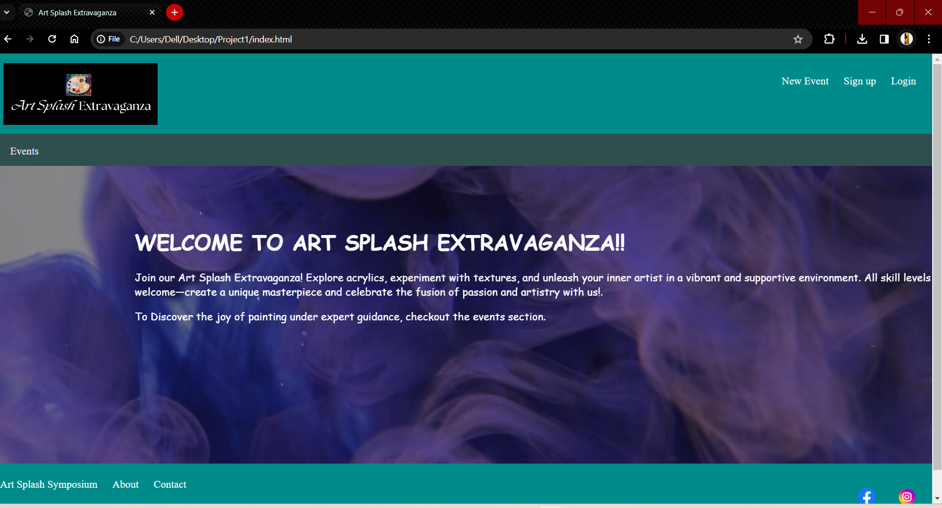

**Events Page – events.html**

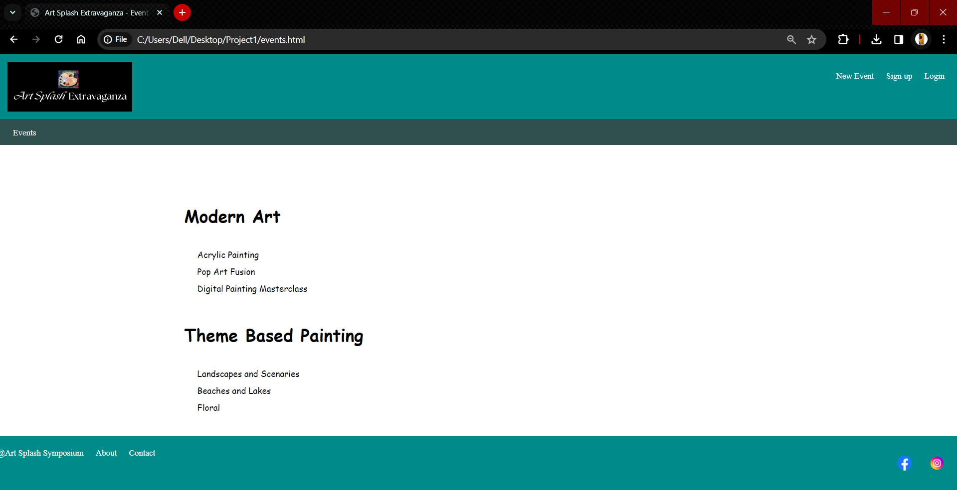

**Event Detail Page – event.html**

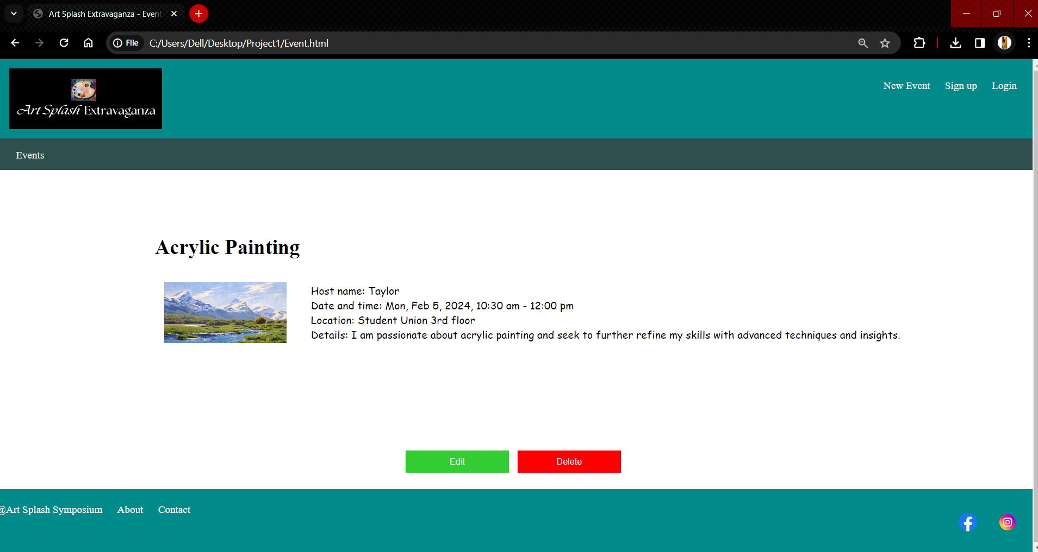

**New Event Page – newEvent.html**

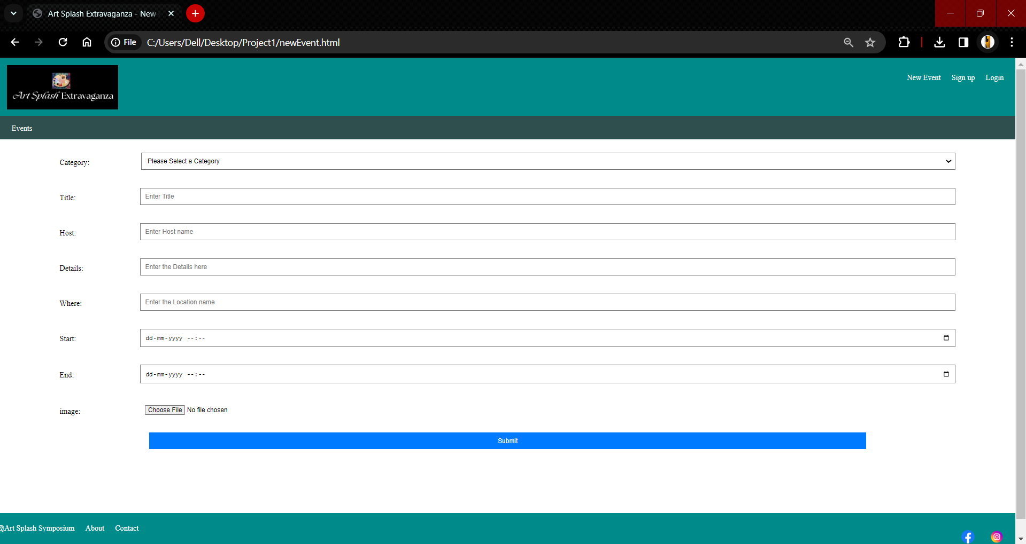

**2. Explanation of additional features, if any.**

Did not add any additional features. The Website has been designed as per the instructions.

**3. Explanation of status, stopping point, and issues if incomplete.**

The webpage is completely developed as per requirements. There was no stopping point nor facing any issues at any stage.

**4. Discuss the easy and challenging parts of the assignment. How did you overcome all or some of**

**the challenges?**

Completing the tasks was straightforward, yet the sole challenge arose during the alignment of elements. To overcome this hurdle, I experimented with various CSS properties and sought potential solutions online, ultimately achieving the desired alignment by the project's conclusion.

Report Submitted By

**Vamsi Krishna Tanagala  
Sahithipriya Gattu**