**PROJECT TOPIC: Restaurant website (Froy )**

**TEAM MEMBERS:**

19011P0523

19011P0528

19011M2115

19011M2116

19011M2218

**DESCRIPTION:**

It is a website for a restaurant called Froy Bistro. Web pages included in this website are Homepage,

contact us page, Login page, Menu page, Reservation page, Order online page, About us page. Each web

page has its own functionality.

• **Homepage**: This gives the basic view of the restaurant. It provides links to other web pages.

• **Contact us page**: This provides the contact information of the restaurant.

• **Login page**: A user can login to avail offers, or reserve a table.

• **Menu page**: This page holds information about the menu of the restaurant.

• **Reservation page**: Users can refer to this page to reserve a table.

• **About us page**: This page provides with information of the restaurant.

**ABSTRACT:**

This website is designed for a restaurant - FROY . This helps the users to view information about the restaurant. Users can login and reserve a table if needed and can also check out the menu.Users can also give a response to the restaurant using contact form.

**Front-end Technologies used:**

HTML

CSS

JavaScript

**Back-end Technologies used:**

JSP

JavaScript

Servlets

**Database :**

MySQL

**STATIC PAGES:**

1. Home page
2. Login page
3. Sign up page
4. Menu page
5. Reserve table page
6. Contact Us page
7. **HOME PAGE:**

<!**DOCTYPE** html>

<**html**>

<**link** href=*"https://fonts.googleapis.com/css2?family=Open+Sans:wght@300&family=Pacifico&family=Titillium+Web:wght@200&display=swap"* rel=*"stylesheet"*>

<**link** rel=*"stylesheet"* type=*"text/css"* href=*"style.css"*>

<**head**>

<**meta** charset=*"UTF-8"*>

<**meta** name=*"viewport"* content=*"width=device-width, initial-scale=1.0"*>

<**title**>Froy.com</**title**>

<</**head**>

<**body**>

<**section** class=*"first"*>

<**div** class=*"firstd"*>

<**header** class=*"head"*>

<**img** id=*"logo"* src=*"images/canvas.png"* >

<**nav** class=*"navbar"*>

<**ul** type=*"none"*>

<**li**><**a** href=*"index.jsp"*>Home</**a**></**li**>

<**li**><**a** href=*"#second"*>About Us</**a**></**li**>

<**li**><**a** href=*"menu.jsp"*>Menu</**a**></**li**>

<**li**><**a** href=*"contact.jsp"*>Contact Us</**a**></**li**>

<**li**><**a** href=*"logout"*>Logout</**a**></**li**>

<**li**><**a** href=*"details2.jsp"* style="font-size:*10px*"><%= session.getAttribute("name") %></**a**></**li**>

</**ul**>

</**nav**>

</**header**>

<**div** class=*"res"*>

<**button** onclick="location.href='Reserve.jsp'" type=*"button"*><**b**>Reserve a table</**b**>

</**button**>

</**div**>

<**div** class=*"welcome"*>

<**h1**>FROY</**h1**>

<**p**>

Delight in every bite

</**p**>

</**div**>

</**div**>

</**section**>

<**section** id=*"second"* class=*"about"*>

<**div** class=*"second"*>

<**center**>

<**img** id=*"logo2"* src=*"images/logo2.png"*>

<**p** class=*"aboutp"*>Froy specializes in delicious food featuring fresh ingredients and masterful preparation by the Froy culinary team. Whether you are ordering a multi-course meal or grabbing a drink and pizza at the bar, Froy's lively, casual yet upscale atmosphere makes it perfect for dining with friends, family, clients and business associates.<**br**> <**br**>

Froy combines flavors & inspiration from the Far East & the West to create what we think is the best! Home to the original (recipe), we specialize in pizzas, as well as handmade appetizers, sandwiches, salads, and gluten friendly, vegetarian, & vegan selections. Feel free to indulge in a tiki drink or craft beer with our fantastic unique cuisine. Cheers!

</**p**>

<**article** id=*"cc-slider"*>

<**input** checked=*"checked"* name=*"cc-slider"* id=*"slide1"* type=*"radio"*>

<**input** name=*"cc-slider"* id=*"slide2"* type=*"radio"*>

<**input** name=*"cc-slider"* id=*"slide3"* type=*"radio"*>

<**input** name=*"cc-slider"* id=*"slide4"* type=*"radio"*>

<**input** name=*"cc-slider"* id=*"slide5"* type=*"radio"*>

<**div** id=*"cc-slides"*>

<**div** id=*"overflow"*>

<**div** class=*"inner"*>

<**article**>

<**img** src=*"https://www.brabbu.com/en/news-events/wp-content/uploads/2015/11/L_Amico-top-10-best-restaurants-nyc.jpg"*>

</**article**>

<**article**>

<**img** src=*"https://media.architecturaldigest.com/photos/5637972e7a4c7a362e06640d/master/w_1600,c_limit/lamico-new-york-02.jpg"*> </**article**>

<**article**>

<**img** src=*"https://media.architecturaldigest.com/photos/5637972c7a4c7a362e066407/master/w_1600,c_limit/lamico-new-york-03.jpg"*>

</**article**>

<**article**>

<**img** src=*"https://media.architecturaldigest.com/photos/5637972ca6f997a353b88217/master/w_1600,c_limit/lamico-new-york-04.jpg"*>

</**article**>

<**article**>

<**img** src=*"https://hospitalitysnapshots.com/wp-content/uploads/sites/3/2019/05/lamico_5d8e9df29cf07.jpg"*>

</**article**>

</**div**>

<**script**>

w3.slideshow = **function** (sel, ms, func) {

**var** i, ss, x = w3.getElements(sel), l = x.length;

ss = {};

ss.current = 1;

ss.x = x;

ss.ondisplaychange = func;

**if** (!isNaN(ms) || ms == 0) {

ss.milliseconds = ms;

} **else** {

ss.milliseconds = 1000;

}

ss.start = **function**() {

ss.display(ss.current)

**if** (ss.ondisplaychange) {ss.ondisplaychange();}

**if** (ss.milliseconds > 0) {

window.clearTimeout(ss.timeout);

ss.timeout = window.setTimeout(ss.next, ss.milliseconds);

}

};

ss.next = **function**() {

ss.current += 1;

**if** (ss.current > ss.x.length) {ss.current = 1;}

ss.start();

};

ss.previous = **function**() {

ss.current -= 1;

**if** (ss.current < 1) {ss.current = ss.x.length;}

ss.start();

};

ss.display = **function** (n) {

w3.styleElements(ss.x, "display", "none");

w3.styleElement(ss.x[n - 1], "display", "block");

}

ss.start();

**return** ss;

};

</**script**>

</**div**>

</**div**>

<**div** id=*"controls"*>

<**label** for=*"slide1"*></**label**>

<**label** for=*"slide2"*></**label**>

<**label** for=*"slide3"*></**label**>

<**label** for=*"slide4"*></**label**>

<**label** for=*"slide5"*></**label**>

</**div**>

</**article**>

</**center**>

</**div**>

</**section**>

<**section** id=*"third"* class=*"contact"*>

<**img** id=*"con"* src=*"https://cdn.cnn.com/cnnnext/dam/assets/200120161356-cnn-worlds-best-new-restaurants---madera---simon-brown-photography-1-1-full-169.jpg"* >

<**script** src=*"https://kit.fontawesome.com/f5d7e640d9.js"* crossorigin=*"anonymous"*></**script**>

<**div** class=*"new"*>

<**div** class=*"content"*>

<**h2**> Contact Us </**h2**>

<**p**> Thank you for your interest in our restaurant.For further information please do contact us via email or phone .</**p**>

</**div**>

<**div** class=*"container"*>

<**div** class=*"contactinfo"*>

<**div** class=*"box1"* >

<**div** class=*"icon"*><**i** class=*"fa-solid fa-location-dot"*></**i**></**div**>

<**div** class=*"text"*>

<**h3**>Address</**h3**>

<**p**>Jubliee Hills Road No 36,<**br**>Hyderabad,Telangana,<**br**>500033</**p**>

</**div**>

</**div**>

<**div** class=*"box2"*>

<**div** class=*"icon"*><**i** class=*"fa-solid fa-phone"*></**i**></**div**>

<**div** class=*"text"*>

<**h3**>Phone</**h3**>

<**p**> +91 6127970164 </**p**>

</**div**>

</**div**>

<**div** class=*"box3"*>

<**div** class=*"icon"*><**i** class=*"fa-solid fa-envelope"*></**i**></**div**>

<**div** class=*"text"*>

<**h3**>Email</**h3**>

<**p**>FroyContactUs@gmail.com</**p**>

</**div**>

</**div**>

<**div** id=*"place"*>

<**iframe** src=*"https://www.google.com/maps/embed?pb=!1m18!1m12!1m3!1d3806.547558309475!2d78.40325131479695!3d17.43348738805104!2m3!1f0!2f0!3f0!3m2!1i1024!2i768!4f13.1!3m3!1m2!1s0x3bcb91463b7ebb4b%3A0x16a4ba4ed2262687!2sRd%20Number%2036%2C%20Jubilee%20Hills%2C%20Hyderabad%2C%20Telangana%20500033!5e0!3m2!1sen!2sin!4v1654000861349!5m2!1sen!2sin"* width=*"400"* height=*"300"* style="border:*0*;" allowfullscreen=*""* loading=*"lazy"* referrerpolicy=*"no-referrer-when-downgrade"*></**iframe**>

</**div**>

</**div**>

</**div**>

</**section**>

</**body**>

</**html**>

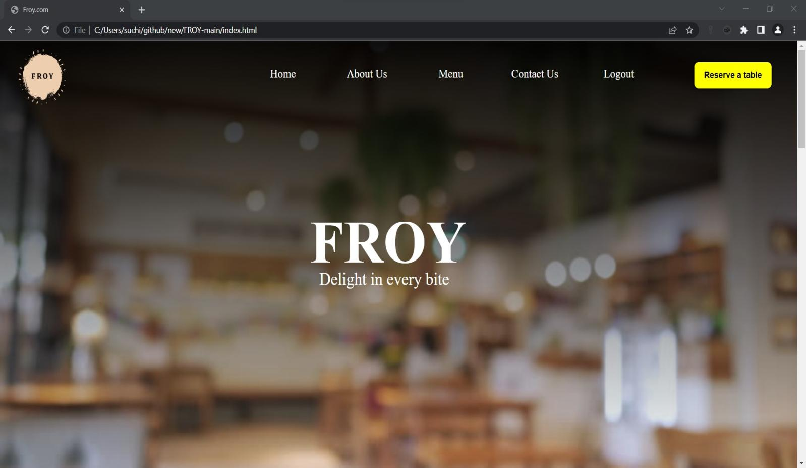

1. **LOGIN PAGE:**

<!**DOCTYPE** html>

<**html**>

<**head**>

<**link** href=*"https://fonts.googleapis.com/css2?family=Open+Sans:wght@300&family=Pacifico&family=Titillium+Web:wght@200&display=swap"* rel=*"stylesheet"*>

<**style**>

*{

padding: *0*;

margin:*0*;

font-family: *Tapestry*;

}

body{

min-height: *100vh*;

margin: *0px*;

padding: *0px*;

background-image: *linear-gradient(rgba(0,0,0,0.95),rgba(0,0,0,0)),url("https://media.gettyimages.com/videos/tilt-down-blur-restaurant-for-background-video-id1273433362?s=640x640")*;

background-size: *cover*;

background-repeat: *no-repeat*;

}

display-flex, .display-flex, .display-flex-center, .signup-content, .signin-content, .social-login, .socials {

display: *flex*;

display: *-webkit-flex*; }

/* @extend list-type-ulli; */

list-type-ulli, .socials {

list-style-type: *none*;

margin: *0*;

padding: *0*; }

img {

max-width: *100%*;

height: *auto*; }

figure {

margin: *0*; }

p {

margin-bottom: *0px*;

font-size: *15px*;

color: *#777*; }

h2 {

line-height: *1.66*;

margin: *0*;

padding: *0*;

font-weight: *bold*;

color: *#222*;

font-family: *Poppins*;

font-size: *36px*; }

.main {

background: *#f8f8f8*;

padding: *50px 0*; }

.clear {

clear: *both*; }

.container {

width: *500px*;

background: *#fff*;

margin: *0 auto*;

box-shadow: *0px 15px 16.83px 0.17px rgba(0, 0, 0, 0.05)*;

-moz-box-shadow: *0px 15px 16.83px 0.17px rgba(0, 0, 0, 0.05)*;

-webkit-box-shadow: *0px 15px 16.83px 0.17px rgba(0, 0, 0, 0.05)*;

-o-box-shadow: *0px 15px 16.83px 0.17px rgba(0, 0, 0, 0.05)*;

-ms-box-shadow: *0px 15px 16.83px 0.17px rgba(0, 0, 0, 0.05)*;

border-radius: *20px*;

-moz-border-radius: *20px*;

-webkit-border-radius: *20px*;

-o-border-radius: *20px*;

-ms-border-radius: *20px*;

position: *relative*;

top:*140px*;

height:}

.display-flex {

justify-content: *space-between*;

-moz-justify-content: *space-between*;

-webkit-justify-content: *space-between*;

-o-justify-content: *space-between*;

-ms-justify-content: *space-between*;

align-items: *center*;

-moz-align-items: *center*;

-webkit-align-items: *center*;

-o-align-items: *center*;

-ms-align-items: *center*; }

.display-flex-center {

justify-content: *center*;

-moz-justify-content: *center*;

-webkit-justify-content: *center*;

-o-justify-content: *center*;

-ms-justify-content: *center*;

align-items: *center*;

-moz-align-items: *center*;

-webkit-align-items: *center*;

-o-align-items: *center*;

-ms-align-items: *center*; }

.position-center {

position: *absolute*;

top: *50%*;

left: *50%*;

transform: *translate(-50%, -50%)*;

-moz-transform: *translate(-50%, -50%)*;

-webkit-transform: *translate(-50%, -50%)*;

-o-transform: *translate(-50%, -50%)*;

-ms-transform: *translate(-50%, -50%)*; }

.signup {

margin-bottom: *30px*; }

.signup-content {

padding: *50px 0*;

}

.signup-form, .signin-form {

width: *50%*;

overflow: *hidden*; }

.form-title {

margin-bottom: *33px*; }

.form-submit {

display: *inline-block*;

background: *#6dabe4*;

color: *#fff*;

border-bottom: *none*;

width: *auto*;

padding: *15px 39px*;

border-radius: *5px*;

-moz-border-radius: *5px*;

-webkit-border-radius: *5px*;

-o-border-radius: *5px*;

-ms-border-radius: *5px*;

margin-top: *25px*;

cursor: *pointer*; }

.form-submit:hover {

background: *#4292dc*; }

#signin {

margin-top: *16px*; }

.signup-image-link {

font-size: *14px*;

color: *#222*;

display: *block*;

text-align: *center*;

position : *relative*;

right: *23px*;

}

.term-service {

font-size: *13px*;

color: *#222*; }

.signup-form , .signin-form {

margin-left: *75px*;

margin-right: *75px*;

padding-left: *34px*;

position: *relative*;

right: *50px*;

}

.register-form {

width: *100%*; }

.form-group {

position: *relative*;

margin-bottom: *25px*;

overflow: *hidden*; }

.form-group:last-child {

margin-bottom: *0px*; }

.navbar{

width: *auto*;

float: *right*;

border: *none*;

height: *70px*;

padding: *15px*;

}

.navbar ul li{

width: *150px*;

float: *left*;

margin: *25px auto*;

text-align: *center*;

padding: *5px*;

position: *relative*;

left:*-67%*;

}

.navbar ul li a{

text-decoration: *none*;

color: *white*;

font-size: *20px*;

padding: *2px*;

}

.navbar ul li a:hover{

color: *white*;

text-decoration: *underline*;

}

</**style**>

</**head**>

<**body**>

<**section** class=*"newsec"*>

<**div** class=*"newclass"*>

<**nav** class=*"navbar"*>

<**ul** type=*"none"*>

<**li**><**a** href=*"index.jsp"*>Home</**a**></**li**>

<**li**><**a** href=*"menu.jsp"*>Menu</**a**></**li**>

<**li**><**a** href=*"login.jsp"*>Login</**a**></**li**>

<**li**><**a** href=*"contact.jsp"*>Contact Us</**a**></**li**>

</**ul**>

</**nav**>

<**div** class=*"container"*>

<**div** class=*"signin-content"*>

<**div** class=*"signin-form"*>

<**h2** class=*"form-title"*>Sign in</**h2**>

<**form** method=*"post"* action=*"login"* class=*"register-form"*

id=*"login-form"*>

<**div** class=*"form-group"*>

<**label** for=*"email"*><**i**

class=*"zmdi zmdi-account material-icons-name"*></**i**></**label**> <**input**

type=*"email"* name=*"email"* id=*"email"*

placeholder=*"Your email"* required=*"required"* />

</**div**>

<**div** class=*"form-group"*>

<**label** for=*"password"*><**i** class=*"zmdi zmdi-lock"*></**i**></**label**> <**input**

type=*"password"* name=*"password"* id=*"password"*

placeholder=*"Password"* required=*"required"*/>

</**div**>

<**div** class=*"form-group"*>

<**input** type=*"checkbox"* name=*"remember-me"* id=*"remember-me"*

class=*"agree-term"* /> <**label** for=*"remember-me"*

class=*"label-agree-term"*><**span**><**span**></**span**></**span**>Remember

me</**label**>

</**div**>

<**div** class=*"form-group form-button"*>

<**input** type=*"submit"* name=*"signin"* id=*"signin"*

class=*"form-submit"* value=*"Log in"* />

</**div**>

<**div** class=*"reglink"*>

<**a** href=*"signin.jsp"* class=*"signup-image-link"*>Create an

account</**a**>

</**div**>

</**form**>

</**div**>

</**div**>

</**div**>

</**div**>

</**section**>

</**body**>

</**html**>

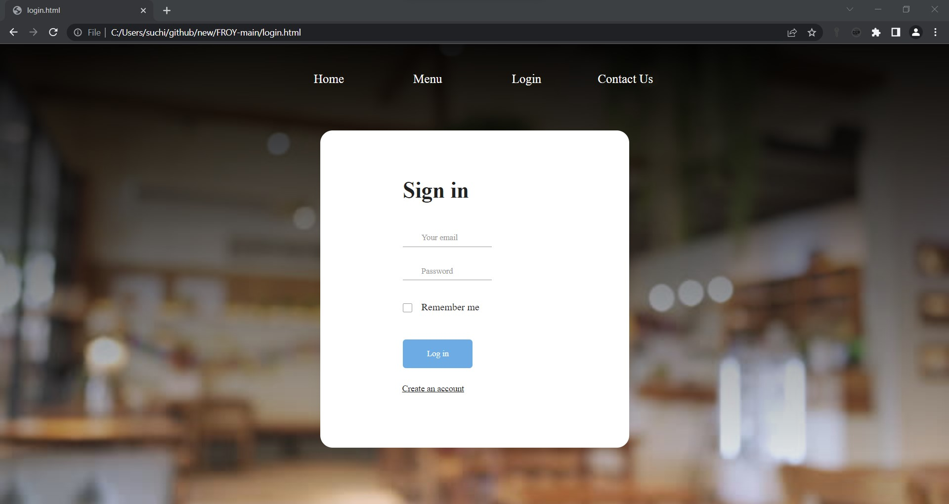

1. **SIGNUP PAGE:**

<!**DOCTYPE** html>

<**link** href=*"https://fonts.googleapis.com/css2?family=Open+Sans:wght@300&family=Pacifico&family=Titillium+Web:wght@200&display=swap"* rel=*"stylesheet"*>

<**html**>

<**head**>

<**style**>

*{

padding: *0*;

margin:*0*;

font-family: *Tapestry*;

}

body{

min-height: *100vh*;

background-image: *linear-gradient(rgba(0,0,0,0.95),rgba(0,0,0,0)),url("https://media.gettyimages.com/videos/tilt-down-blur-restaurant-for-background-video-id1273433362?s=640x640")*;

background-size: *cover*;

background-repeat: *no-repeat*;

}

img {

max-width: *100%*;

height: *auto*; }

figure {

margin: *0*; }

p {

margin-bottom: *0px*;

font-size: *15px*;

color: *#777*; }

h2 {

line-height: *1.66*;

margin: *0*;

padding: *0*;

font-weight: *bold*;

color: *#222*;

font-family: *Poppins*;

font-size: *36px*; }

.main {

background: *#f8f8f8*;

padding: *50px 0*; }

.clear {

clear: *both*; }

.container {

width: *500px*;

background: *#fff*;

margin: *0 auto*;

box-shadow: *0px 15px 16.83px 0.17px rgba(0, 0, 0, 0.05)*;

-moz-box-shadow: *0px 15px 16.83px 0.17px rgba(0, 0, 0, 0.05)*;

-webkit-box-shadow: *0px 15px 16.83px 0.17px rgba(0, 0, 0, 0.05)*;

-o-box-shadow: *0px 15px 16.83px 0.17px rgba(0, 0, 0, 0.05)*;

-ms-box-shadow: *0px 15px 16.83px 0.17px rgba(0, 0, 0, 0.05)*;

border-radius: *20px*;

-moz-border-radius: *20px*;

-webkit-border-radius: *20px*;

-o-border-radius: *20px*;

-ms-border-radius: *20px*;

position: *relative*;

top: *140px*;

}

.display-flex {

justify-content: *space-between*;

-moz-justify-content: *space-between*;

-webkit-justify-content: *space-between*;

-o-justify-content: *space-between*;

-ms-justify-content: *space-between*;

align-items: *center*;

-moz-align-items: *center*;

-webkit-align-items: *center*;

-o-align-items: *center*;

-ms-align-items: *center*; }

.display-flex-center {

justify-content: *center*;

-moz-justify-content: *center*;

-webkit-justify-content: *center*;

-o-justify-content: *center*;

-ms-justify-content: *center*;

align-items: *center*;

-moz-align-items: *center*;

-webkit-align-items: *center*;

-o-align-items: *center*;

-ms-align-items: *center*; }

.position-center {

position: *absolute*;

top: *50%*;

left: *50%*;

transform: *translate(-50%, -50%)*;

-moz-transform: *translate(-50%, -50%)*;

-webkit-transform: *translate(-50%, -50%)*;

-o-transform: *translate(-50%, -50%)*;

-ms-transform: *translate(-50%, -50%)*; }

.signup {

margin-bottom: *30px*; }

.signup-content {

padding: *50px 0*; }

.signup-form, .signup-image, .signin-form, .signin-image {

width: *50%*;

overflow: *hidden*; }

.signup-image {

margin: *0 55px*; }

.form-title {

margin-bottom: *33px*; }

.signup-image {

margin-top: *30px*;

margin-right:*50px*; }

figure {

margin-bottom: *50px*;

text-align: *center*; }

.form-submit {

display: *inline-block*;

background: *#6dabe4*;

color: *#fff*;

border-bottom: *none*;

width: *auto*;

padding: *15px 39px*;

border-radius: *5px*;

-moz-border-radius: *5px*;

-webkit-border-radius: *5px*;

-o-border-radius: *5px*;

-ms-border-radius: *5px*;

margin-top: *25px*;

cursor: *pointer*;

position: *relative*;

right: *25px*;}

.form-submit:hover {

background: *#4292dc*;

}

#signin {

margin-top: *16px*; }

.signup-image-link {

font-size: *14px*;

color: *#222*;

display: *block*;

text-align: *center*;

position: *relative*;

right: *10px*;}

.term-service {

font-size: *13px*;

color: *#222*; }

.signup-form {

margin-left: *75px*;

margin-right: *75px*;

padding-left: *34px*; }

.register-form {

width: *100%*; }

.form-group {

position: *relative*;

margin-bottom: *25px*;

overflow: *hidden*; }

.form-group:last-child {

margin-bottom: *0px*; }

input {

width: *100%*;

display: *block*;

border: *none*;

border-bottom: *1px solid #999*;

padding: *6px 30px*;

font-family: *Poppins*;

box-sizing: *border-box*; }

input::-webkit-input-placeholder {

color: *#999*; }

input::-moz-placeholder {

color: *#999*; }

input:-ms-input-placeholder {

color: *#999*; }

input:-moz-placeholder {

color: *#999*; }

input:focus {

border-bottom: *1px solid #222*; }

input:focus::-webkit-input-placeholder {

color: *#222*; }

input:focus::-moz-placeholder {

color: *#222*; }

input:focus:-ms-input-placeholder {

color: *#222*; }

input:focus:-moz-placeholder {

color: *#222*; }

input[type=checkbox]:not(old) {

width: *2em*;

margin: *0*;

padding: *0*;

font-size: *1em*;

display: *none*; }

input[type=checkbox]:not(old) + label {

display: *inline-block*;

line-height: *1.5em*;

margin-top: *6px*; }

.navbar{

width: *auto*;

float: *right*;

border: *none*;

height: *70px*;

padding: *15px*;

}

.navbar ul li{

width: *150px*;

float: *left*;

margin: *25px auto*;

text-align: *center*;

padding: *5px*;

position: *relative*;

left:*-67%*;

}

.navbar ul li a{

text-decoration: *none*;

color: *white*;

font-size: *20px*;

padding: *2px*;

}

.navbar ul li a:hover{

color: *white*;

text-decoration: *underline*;

}

#signup{

margin-left: *25px*;

margin-right: *25px*;

}

.logo{

position: *relative*;

bottom: *300px*;

border-radius: *5px*;

left: *250px*;

background-color: *black*;

width:*250px*;

height:*250px*;

border-radius: *50%*;

}

#image{

position: *relative*;

width:*370px*;

height:*300px*;

right: *73px*;

bottom: *30px*;

}

</**style**>

</**head**>

<**body**>

<**section**>

<**div** class=*"newsign"*>

<**header**>

<**nav** class=*"navbar"*>

<**ul** type=*"none"*>

<**li**><**a** href=*"index.jsp"*>Home</**a**></**li**>

<**li**><**a** href=*"menu.jsp"*>Menu</**a**></**li**>

<**li**><**a** href=*"login.jsp"*>Login</**a**></**li**>

<**li**><**a** href=*"contact.jsp"*>Contact Us</**a**></**li**>

</**ul**>

</**nav**>

</**header**>

<**div** class=*"logo"*>

<**img** id=*"image"* src=*"images\canvas.png"* >

</**div**>

<**div** class=*"container"*>

<**div** class=*"signup-content"*>

<**div** class=*"signup-form"*>

<**h2** class=*"form-title"*>Sign up</**h2**>

<**form** method=*"post"* action=*"signin"* class=*"register-form"*

id=*"register-form"*>

<**div** class=*"form-group"*>

<**label** for=*"email"*><**i** class=*"zmdi zmdi-email"*></**i**></**label**> <**input**

type=*"email"* name=*"email"* id=*"email"* placeholder=*"Your Email"* required=*"required"*/>

</**div**>

<**div** class=*"form-group"*>

<**label** for=*"pass"*><**i** class=*"zmdi zmdi-lock"*></**i**></**label**> <**input**

type=*"password"* name=*"password"* id=*"pass"* placeholder=*"Password"* required=*"required"*/>

</**div**>

<**div** class=*"form-group"*>

<**label** for=*"re-pass"*><**i** class=*"zmdi zmdi-lock-outline"*></**i**></**label**>

<**input** type=*"password"* name=*"re_pass"* id=*"re_pass"*

placeholder=*"Repeat your password"* required=*"required"* />

</**div**>

<**div** class=*"form-group form-button"*>

<**input** type=*"submit"* name=*"signup"* id=*"signup"*

class=*"form-submit"* value=*"Register"* />

</**div**>

</**form**>

</**div**>

<**div** class=*"signup-image"*>

<**a** href=*"login.jsp"* class=*"signup-image-link"*>I am already

member</**a**>

</**div**>

</**div**>

</**div**>

</**div**>

</**section**>

</**body**>

</**html**>

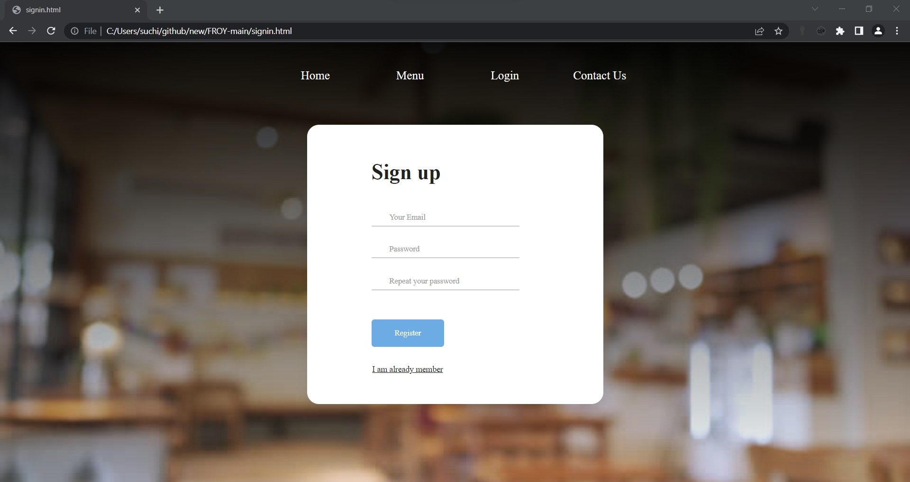

1. **MENU PAGE**

<**html**>

<**head**>

<**style**>

* {

padding: *0px*;

margin: *0px*;

}

.hrcRestaurantMenu2Widget1323330 {

color: *#000*;

line-height: *normal*;

margin: *20px auto*;

padding: *0 15px*

}

.hrcRestaurantMenu2Widget1323330 sup {

left: *.1em*;

top: *-.4em*

}

.hrcRestaurantMenu2Widget1323330 li:before {

display: *none*

}

.hrcRestaurantMenu2Widget1323330 .menuLink {

text-align: *center*

}

.hrcRestaurantMenu2Widget1323330 .menuLink a {

background-color: *#c82540*;

border: *1px solid #c82540*;

-webkit-transition: *all .5s ease*;

transition: *all .5s ease*

}

.hrcRestaurantMenu2Widget1323330 .menuLink a:focus,

.hrcRestaurantMenu2Widget1323330 .menuLink a:hover {

background-color: *#000*;

border: *1px solid #000*

}

.hrcRestaurantMenu2Widget1323330 .menuLink.visible-xs {

margin: *20px auto*

}

.hrcRestaurantMenu2Widget1323330 .menuLink.visible-xs a {

display: *block*

}

.hrcRestaurantMenu2Widget1323330 .menuLink.visible-xs a:not(:last-child) {

margin-bottom: *3px*

}

.hrcRestaurantMenu2Widget1323330 .menuLink.visible-sm {

margin: *10px auto 30px*;

text-align: *center*

}

.hrcRestaurantMenu2Widget1323330 .menuLink.hidden-xs.hidden-sm {

margin: *30px auto 0*

}

.hrcRestaurantMenu2Widget1323330 .menuLink.hidden-xs.hidden-sm a {

margin-bottom: *5px*

}

.hrcRestaurantMenu2Widget1323330 .languagesMenu {

margin-bottom: *20px*;

position: *relative*;

text-align: *center*

}

.hrcRestaurantMenu2Widget1323330 .languagesMenu button {

background-color: *#c82540*;

border: *none*;

color: *#fff*;

padding: *10px*;

text-align: *center*;

width: *100%*

}

.hrcRestaurantMenu2Widget1323330 .languagesMenu .fas.fa-comments {

margin-right: *10px*

}

.hrcRestaurantMenu2Widget1323330 .languagesMenu .fas.fa-caret-down {

margin-left: *10px*

}

.hrcRestaurantMenu2Widget1323330 .languagesMenu .dropdown-menu {

background-color: *#000*;

border: *none*;

border-radius: *0*;

margin-top: *0*;

padding-left: *0 !important*;

text-align: *center*;

top: *42px*;

width: *100%*

}

.hrcRestaurantMenu2Widget1323330 .languagesMenu .dropdown-menu>li>a {

color: *#fff*;

padding: *10px*;

text-transform: *uppercase*

}

.hrcRestaurantMenu2Widget1323330 .languagesMenu .dropdown-menu>li>a:focus,

.hrcRestaurantMenu2Widget1323330 .languagesMenu .dropdown-menu>li>a:hover {

background-color: *#000*;

color: *#f9b200*

}

.hrcRestaurantMenu2Widget1323330 .languagesNavPill,

.hrcRestaurantMenu2Widget1323330 .languagesNavPill .dropdown-menu {

width: *150px*

}

.hrcRestaurantMenu2Widget1323330 .languagesNavPill {

background-color: *#fff*;

border-radius: *0*;

c82540 color: *#000*;

cursor: *pointer*;

padding: *10px 15px*

}

.hrcRestaurantMenu2Widget1323330 .languagesNavPill:focus,

.hrcRestaurantMenu2Widget1323330 .languagesNavPill:hover {

background-color: *#c82540*;

border-color: *#c82540*;

color: *#fff*

}

.hrcRestaurantMenu2Widget1323330 .languagesNavPill .fas {

margin-left: *10px*

}

.hrcRestaurantMenu2Widget1323330 .languagesNavPill .dropdown-menu {

background-color: *#c82540*;

border: *none*;

border-radius: *0*;

box-shadow: *none*;

color: *#fff*;

margin-top: *0*;

margin-left: *-2px*;

min-width: *0*;

padding-left: *4px !important*

}

.hrcRestaurantMenu2Widget1323330 .languagesNavPill .dropdown-menu li {

margin: *0*;

width: *100%*

}

.hrcRestaurantMenu2Widget1323330 .languagesNavPill .dropdown-menu>.active>a {

background-color: *transparent*;

color: *#E6DBD9*

}

.hrcRestaurantMenu2Widget1323330 .languagesNavPill .dropdown-menu a {

color: *#fff*;

padding: *10px 15px*

}

.hrcRestaurantMenu2Widget1323330 .languagesNavPill .dropdown-menu>.active>a:focus,

.hrcRestaurantMenu2Widget1323330 .languagesNavPill .dropdown-menu>.active>a:hover {

color: *#fff*

}

.hrcRestaurantMenu2Widget1323330 .languagesNavPill .dropdown-menu a:focus,

.hrcRestaurantMenu2Widget1323330 .languagesNavPill .dropdown-menu a:hover {

background-color: *transparent*;

color: *#E6DBD9*

}

.hrcRestaurantMenu2Widget1323330 .panel-group .panel+.panel {

margin-top: *0*

}

.hrcRestaurantMenu2Widget1323330 .panel-heading {

background-color: *#fff*;

padding: *0*

}

.hrcRestaurantMenu2Widget1323330 .panel-default {

border: *2px solid #000*;

border-bottom: *1px*;

border-radius: *0*

}

.hrcRestaurantMenu2Widget1323330 .panel-default:last-child {

border-bottom: *2px solid #000*

}

.hrcRestaurantMenu2Widget1323330 .panel-title {

font-weight: *800*;

text-align: *center*

}

.hrcRestaurantMenu2Widget1323330 .panel-title>a {

display: *block*;

padding: *10px 15px*;

text-decoration: *none*

}

.hrcRestaurantMenu2Widget1323330 .panel-title>a:hover,

.hrcRestaurantMenu2Widget1323330 .panel-title>a.js-tabcollapse-panel-heading {

background-color: *#c82540*;

color: *#fff*

}

.hrcRestaurantMenu2Widget1323330 .panel-title>a.js-tabcollapse-panel-heading.collapsed {

background-color: *#fff*;

color: *#000*

}

.hrcRestaurantMenu2Widget1323330 .panel-default>.panel-heading+.panel-collapse>.panel-body {

border-top: *2px solid #000*

}

.hrcRestaurantMenu2Widget1323330 .nav-pills {

margin: *30px auto 20px*;

padding: *0 10px*;

text-align: *center*;

position: *relative*;

top: *-55px*;

}

.hrcRestaurantMenu2Widget1323330 .nav-pills li {

display: *inline-block*;

float: *none*;

font-weight: *850*;

margin: *0 5px 15px*;

text-transform: *uppercase*

}

.hrcRestaurantMenu2Widget1323330 .nav-pills>li>a {

background-color: *#fff*;

border-radius: *0*;

color: *#000*;

text-decoration: *none*;

-webkit-transition: *all .5s ease*;

transition: *all .5s ease*

}

.hrcRestaurantMenu2Widget1323330 .nav-pills>li>a:hover

{

background-color: *grey*;

border-color: *black*;

color: *black*;

-webkit-transition: *all .5s ease*;

transition: *all .5s ease*

}

.hrcRestaurantMenu2Widget1323330 h2 {

color: *#c82540*;

font-family: *'Oswald', sans-serif*;

font-size: *2rem*;

font-weight: *700*;

letter-spacing: *2px*;

margin-top: *0*

}

.hrcRestaurantMenu2Widget1323330 .submenuGroup {

margin-top: *50px*

}

.hrcRestaurantMenu2Widget1323330 .menuItemList {

list-style-type: *none*;

margin-top: *50px*;

padding-left: *0 !important*

}

.hrcRestaurantMenu2Widget1323330 .menuItemList li:not(:first-child) {

margin-top: *30px*

}

.hrcRestaurantMenu2Widget1323330 .menuItemList li h4 {

font-size: *1.1rem*;

font-weight: *800*;

margin-bottom: *5px*

}

.hrcRestaurantMenu2Widget1323330 .menuItemList li div {

font-weight: *400*

}

.hrcRestaurantMenu2Widget1323330 .tabDisclaimer {

font-size: *0.85rem*;

line-height: *1.8*;

margin: *30px auto 0*

}

.hrcRestaurantMenu2Widget1323330 li.newItemYes {

position: *relative*

}

.hrcRestaurantMenu2Widget1323330 li.newItemYes:before {

display: *block*;

content: *url('https://www.hardrockcafe.com/files/5282/menuNew.png') !important*;

position: *absolute*;

left: *-22px*;

top: *-7px*

}

.hrcRestaurantMenu2Widget1323330 .featuredItem {

text-align: *center*

}

.hrcRestaurantMenu2Widget1323330 .featuredItem:not(.TabFeaturedItem1) {

margin-top: *30px*

}

.hrcRestaurantMenu2Widget1323330 .featuredItemContent {

border: *4px solid #c82540*;

font-weight: *400*;

margin: *30px auto 0*;

padding: *20px*

}

.hrcRestaurantMenu2Widget1323330 .featuredItemContent h3 {

font-size: *1.5rem*;

font-weight: *900*;

margin: *0*

}

.hrcRestaurantMenu2Widget1323330 .featuredItemContent>div {

margin-top: *10px*

}

.hrcRestaurantMenu2Widget1323330 .addtlInfo {

border: *4px solid #c82540*;

font-weight: *400*;

margin: *30px auto 0*;

padding: *20px*

}

.hrcRestaurantMenu2Widget1323330 .addtlInfoHeading {

color: *#c82540*;

font-family: *'Nunito Sans', sans-serif*;

font-style: *italic*;

font-weight: *700*;

margin-top: *0*;

text-transform: *none*

}

.hrcRestaurantMenu2Widget1323330 .addtlInfoContent {}

.hrcRestaurantMenu2Widget1323330 .panel-body {}

.hrcRestaurantMenu2Widget1323330 .panel-body a {

color: *#c82540*

}

.hrcRestaurantMenu2Widget1323330 .tab-content {

background-position: *50% 50%*;

background-size: *cover*;

color: *#000*;

padding: *30px*

}

.hrcRestaurantMenu2Widget1323330 .tab-pane {

background-color: *#fff*;

padding: *50px*

}

.hrcRestaurantMenu2Widget1323330 .tab-pane a {

color: *#c82540*

}

@media (min-width:768px) {}

@media (min-width:992px) {

.hrcRestaurantMenu2Widget1323330 .nav-pills>li.active>a:hover {

background-color: *#fff*;

border-color: *#000*;

color: *#000*

}

.hrcRestaurantMenu2Widget1323330 h2 {

font-size: *3.5rem*

}

.hrcRestaurantMenu2Widget1323330 .submenuGroup {

margin-top: *0*

}

.hrcRestaurantMenu2Widget1323330 .submenuGroup:not(.TabMenuItem1) {

margin-top: *100px*

}

}

@media (min-width:1200px) {

.hrcRestaurantMenu2Widget1323330 h2 {

font-size: *4rem*

}

}

@media (min-width:1400px) {

.hrcRestaurantMenu2Widget1323330 h2 {

font-size: *5rem*

}

}

</**style**>

</**head**>

<**body**>

<**button** onclick="topFunction()" id=*"myBtn"* title=*"Go to top"*>Top</**button**>

<**style**>

#myBtn {

display: *none*;

position: *fixed*;

bottom: *20px*;

right: *30px*;

z-index: *99*;

font-size: *18px*;

border: *none*;

outline: *none*;

background-color: *#a86868*;

color: *white*;

cursor: *pointer*;

padding: *15px*;

border-radius: *4px*;

}

#myBtn:hover {

background-color: *#555*;

}

</**style**>

<**script**>

**var** mybutton = document.getElementById("myBtn");

window.onscroll = **function**() {scrollFunction()};

**function** scrollFunction() {

**if** (document.body.scrollTop > 20 || document.documentElement.scrollTop > 20) {

mybutton.style.display = "block";

} **else** {

mybutton.style.display = "none";

}

}

**function** topFunction() {

document.body.scrollTop = 0;

document.documentElement.scrollTop = 0;

}

</**script**>

<**div** id=*"hero"* style="margin-top: *87px*;">

<**div** id=*"headerImg"*>

<**div** id=*"vizHeroImage31Widget805803"* class=*"customWidget vizHeroImage31Widget pageWidgetId805803"*>

<**style**>

.vizHeroImage31Widget805803 div.hero-image {

background-size: *cover*;

background-repeat: *no-repeat*;

height: *0px padding*:*0px*;

position: *relative*;

top: *-100px*;

}

.vizHeroImage31Widget805803 .hero-image {

position: *relative*

}

.vizHeroImage31Widget805803 .hero-fade {

display: *none*

}

</**style**>

<**div** class=*"vizHeroImage31Widget805803 fullViewportHero"*>

<**div** class=*"hero-image"* style="height: *600.5px*;">

<**div** class=*"hero-fade"*></**div**>

<**nav** class=*"navbar"*>

<**ul** type=*"none"*>

<**li**><**a** href=*"index.jsp"*>Home</**a**></**li**>

<**li**><**a** href=*"menu.jsp"*>Menu</**a**></**li**>

<**li**><**a** href=*"logout"*>Logout</**a**></**li**>

<**li**><**a** href=*"contact.jsp"*>Contact Us</**a**></**li**>

</**ul**>

</**nav**>

<**style**>

.navbar {

width: *auto*;

float: *right*;

border: *none*;

height: *70px*;

padding: *15px*;

position: *relative*;

top: *13px*;

left: *-60px*;

}

.navbar ul li {

width: *150px*;

float: *left*;

margin: *25px auto*;

text-align: *center*;

padding: *5px*;

position: *relative*;

right: *350px*;

}

.navbar ul li a {

text-decoration: *none*;

color: *white*;

font-size: *20px*;

padding: *2px*;

}

.navbar ul li a:hover {

color: *white*;

text-decoration: *underline*;

}

</**style**>

<**style**>

#vizHeroImage31Widget805803 div.hero-image {

background-image: *linear-gradient(rgba(0, 0, 0, 0.65), rgba(0, 0, 0, 0)), url('https://hospitalitysnapshots.com/wp-content/uploads/sites/3/2019/05/lamico_5d8e9df29cf07.jpg')*;

background-position: *50% 70%*

}

@media (min-width:768px) {

#vizHeroImage31Widget805803 div.hero-image {

background-image: *linear-gradient(rgba(0, 0, 0, 0.65), rgba(0, 0, 0, 0)), url('https://hospitalitysnapshots.com/wp-content/uploads/sites/3/2019/05/lamico_5d8e9df29cf07.jpg')*;

background-position: *50% 70%*

}

}

@media (min-width:992px) {

#vizHeroImage31Widget805803 div.hero-image {

background-image: *linear-gradient(rgba(0, 0, 0, 0.65), rgba(0, 0, 0, 0)), url('https://hospitalitysnapshots.com/wp-content/uploads/sites/3/2019/05/lamico_5d8e9df29cf07.jpg')*;

background-position: *50% 70%*

}

</**style**>

<**div** class=*"visible carousel-caption"*>

<**h3**><**span** class=*"bgOuter"*><**span** class=*"bgInner"*><**span** class=*"bgInner2"*>Menu</**span**></**span**></**span**></**h3**>

</**div**>

<**style**>

@media (min-width: 768px) {

#hero .slideCaption,

#hero .carousel-caption {

right: *5%*;

left: *5%*;

}

}

#hero .slideCaption,

#hero .carousel-caption {

right: *8%*;

left: *8%*;

}

#hero .slideCaption,

#hero .carousel-caption {

right: *8%*;

left: *8%*;

}

@media screen and (min-width: 768px) .carousel-caption {

right: 20%;

left: 20%;

padding-bottom: 30px;

}

.carousel-caption {

position: *absolute*;

right: *15%*;

bottom: *20px*;

left: *15%*;

z-index: *10*;

padding-top: *20px*;

padding-bottom: *20px*;

color: *#fff*;

text-align: *center*;

text-shadow: *0 1px 2px rgb(0 0 0 / 60%)*;

}

#hero .carousel-caption h3 {

font-size: *2.7rem*;

margin: *0*;

text-align: *center*;

text-transform: *uppercase*;

}

#hero .visible.carousel-caption .bgInner {

background: *url(https://www.hardrockcafe.com/files/templates/1732/bannerBg.jpg) 50% 50% / cover*;

display: *inline-block*;

}

</**style**>

</**div**>

</**div**>

<**script**>

**function** ApplyHeight() {

**function** heightCalc() {

$fullViewport = **true**;

$iHeight = $(window).height() - ($('header').height() + ($(window).height() * .25));

}

**function** heightCalcFalse() {

$fullViewport = **false**;

$iWidth = $('body').width();

}

**var** $fullViewport;

**var** $iHeight;

**var** $iWidth;

heightCalc();

**if** ($fullViewport == **true**) {

$(".vizHeroImage31Widget805803 .hero-image").height($iHeight);

$(".vizHeroImage31Widget805803").addClass('fullViewportHero');

}

$(window).on('resize', **function**() {

**if** ($fullViewport == **true**) {

heightCalc();

$(".vizHeroImage31Widget805803 .hero-image").height($iHeight);

}

});

}

$(**function**() {

ApplyHeight();

});

</**script**>

</**div**>

</**div**>

</**div**>

<**div** class=*"hrcRestaurantMenu2Widget1323330"*>

<**ul** class=*"nav nav-pills nav-left hidden-xs"* role=*"tablist"* id=*"hrcRestaurantMenu2Widget1323330Nav"*>

<**li** class=*"enabledSection"* role=*"presentation"*><**a** href=*"#Tab1"* aria-controls=*"home"* role=*"tab"* data-toggle=*"tab"* aria-expanded=*"false"*>Burgers</**a**></**li**>

<**li** class=*"enabledSection"* role=*"presentation"*><**a** href=*"#Tab2"* aria-controls=*"home"* role=*"tab"* data-toggle=*"tab"* aria-expanded=*"false"*> Starters </**a**></**li**>

<**li** class=*"enabledSection"* role=*"presentation"*><**a** href=*"#Tab3"* aria-controls=*"home"* role=*"tab"* data-toggle=*"tab"* aria-expanded=*"false"*>Sandwiches</**a**></**li**>

<**li** class=*"enabledSection"* role=*"presentation"*><**a** href=*"#Tab4"* aria-controls=*"home"* role=*"tab"* data-toggle=*"tab"*>Salads &amp; Bowls</**a**></**li**>

<**li** class=*"enabledSection"* role=*"presentation"*><**a** href=*"#Tab6"* aria-controls=*"home"* role=*"tab"* data-toggle=*"tab"*>Desserts</**a**></**li**>

<**li** class=*"enabledSection"* role=*"presentation"*><**a** href=*"#Tab8"* aria-controls=*"home"* role=*"tab"* data-toggle=*"tab"* aria-expanded=*"true"*>Beverages</**a**></**li**>

</**ul**>

<**div** class=*"panel-group visible-xs"* id=*"hrcRestaurantMenu2Widget1323330Nav-accordion"*></**div**>

<**div** class=*"tab-content hidden-xs animated fadeIn"* data-originalsrc=*"https://www.hardrockcafe.com/files/5282/menuBg02.jpg"* style="background-image: *url(&quot;https://www.hardrockcafe.com/files/5282/menuBg02.jpg&quot;)*;">

<**div** role=*"tabpanel"* class=*"tab-pane fade enabledSection Tab1"* id=*"Tab1"*>

<**div** class=*"row"*>

<**div** class=*"col-xs-12 col-md-5 featuredItems"*>

<**div** class=*"visible-xs visible-sm"*>

<**center**>

<**h2** class=*"visible-sm"*> Burgers</**h2**>

<**p**> Burgers are served with a fresh toasted brioche bun and seasoned fries.</**p**>

</**center**>

</**div**>

<**div** class=*"featuredItem TabFeaturedItem1 TabFeaturedItemLast"*><**img** alt=*"Legendary Burger and Fries "* class=*"featuredItemImg"* data-originalsrc=*"https://www.hardrockcafe.com/files/5282/Burger-1-061.jpg"*

src=*"https://www.hardrockcafe.com/files/5282/Burger-1-061.jpg"* title=*"Original Legendary Burger"*>

<**div** class=*"featuredItemContent"*><**h3**>ORIGINAL LEGENDARY BURGER</**h3**><**div**><**em**>The burger that started it all!</**em**><**br**> Fresh steak burger, with Applewood bacon, Tillamook cheddar cheese, crispy onion ring, leaf lettuce and vine-ripened tomato, served with our signature steak sauce on the side.</**div**></**div**>

<**script**>

$(**function**() {

$('.hrcRestaurantMenu2Widget1323330 [href="#Tab1"]').on('show.bs.tab', **function**() {

$('.hrcRestaurantMenu2Widget1323330 .Tab1 .TabFeaturedItem1 .featuredItemImg').attr('src', $('.hrcRestaurantMenu2Widget1323330 .Tab1 .TabFeaturedItem1 .featuredItemImg').attr('data-originalsrc'));

});

});

</**script**>

</**div**>

</**div**>

<**div** class=*"col-xs-10 col-xs-push-1 col-md-6 col-md-push-1 menuItems"*>

<**div** class=*"submenuGroup TabMenuItem1"*>

<**ul** class=*"menuItemList"*>

<**li** class=*"TabMenuItemItem1 newItemNo"*>

<**h4**>BBQ BACON CHEESEBURGER</**h4**>

<**div**>Fresh steak burger, seasoned and seared with a signature spice blend, topped with house-made barbecue sauce, crispy shoestring onions, Tillamook cheddar cheese, Applewood bacon, leaf lettuce and vine-ripened tomato, served

with

our signature steak sauce on the side.</**div**>

</**li**>

<**li** class=*"TabMenuItemItem2 newItemNo"*>

<**h4**>THE BIG CHEESEBURGER</**h4**>

<**div**>Three slices of Tillamook cheddar cheese melted on our fresh steak burger with leaf lettuce, vine-ripened tomato and red onion, served with our signature steak sauce on the side.</**div**>

</**li**>

<**li** class=*"TabMenuItemItem3 newItemNo"*>

<**h4**>DOUBLE-DECKER DOUBLE CHEESEBURGER</**h4**>

<**div**><**em**>A tribute to our 1971 âDown Home Double Burgerâ</**em**><**br**> Two stacked steak burgers with American cheese, mayonnaise, leaf lettuce, vine-ripened tomato and red onion, served with our signature steak sauce on the side.*</**div**>

</**li**>

<**li** class=*"TabMenuItemItem4 newItemNo"*>

<**h4**>THE IMPOSSIBLE BURGER</**h4**>

<**div**>100% plant-based vegan patty, topped with Tillamook cheddar cheese and a crispy onion ring, served with leaf lettuce and vine-ripened tomato.<**br**><**small**><**em**>Vegan/vegetarian burgers vary in locations around the

world.</**em**></**small**>

</**div**>

</**li**>

<**li** class=*"TabMenuItemItem5 newItemNo"*>

<**h4**>MOVING MOUNTAINS BURGER</**h4**>

<**div**>100% plant-based vegan patty, topped with cheddar cheese and a crispy onion ring, served with leaf lettuce and vine-ripened tomato.</**div**>

</**li**>

<**li** class=*"TabMenuItemItem6 newItemNo"*>

<**h4**>SURF &amp; TURF BURGER</**h4**>

<**div**>Our signature steak burger topped with Spicy Shrimp on a bed of spicy slaw, served with our signature steak sauce on the side.</**div**>

</**li**>

</**ul**>

</**div**>

<**div** class=*"submenuGroup TabMenuItem2 TabMenuItemLast"*>

<**h2**><**center**>Smashed &amp; Stacked</**center**></**h2**>

<**ul** class=*"menuItemList"*>

<**li** class=*"TabMenuItemItem1 newItemNo"*>

<**h4**>COUNTRY BURGER</**h4**>

<**div**>Two smashed &amp; stacked burgers seasoned and seared medium-well, with American cheese, leaf lettuce, vine-ripened tomato, red onion, pickles, house-made burger sauce and served with a side of sweet relish.</**div**>

</**li**>

<**li** class=*"TabMenuItemItem2 newItemNo"*>

<**h4**>SWISS MUSHROOM BURGER</**h4**>

<**div**>Two smashed &amp; stacked burgers seasoned and seared medium-well, with Swiss cheese, sautÃ©ed mushrooms, leaf lettuce, vine-ripened tomato, and Dijon mayonnaise.</**div**>

</**li**>

<**li** class=*"TabMenuItemItem3 TabMenuItemItemLast newItemNo"*>

<**h4**>SPICY DIABLO BURGER</**h4**>

<**div**>Two smashed &amp; stacked burgers seasoned and seared medium-well, with Monterey Jack cheese, pickled jalapeÃ±os, leaf lettuce, vine-ripened tomato, and spicy mayonnaise.</**div**>

</**li**>

</**ul**>

</**div**>

</**div**>

</**div**>

</**div**>

<**div** role=*"tabpanel"* class=*"tab-pane fade enabledSection Tab2"* id=*"Tab2"*>

<**div** class=*"row"*>

<**div** class=*"col-xs-12 col-md-5 featuredItems"*>

<**div** class=*"visible-xs visible-sm"*>

<**center**>

<**h2** class=*"visible-sm"*>Starters </**h2**>

<**p**>Flavor, spice and an extra helping of attitude. That's worth celebrating.</**p**>

</**center**>

</**div**>

<**div** class=*"featuredItem TabFeaturedItem1"*><**img** alt=*"Nachos"* class=*"featuredItemImg"* data-originalsrc=*"https://www.hardrockcafe.com/files/5282/Nachos_No_Protein-20.jpg"*

src=*"https://www.hardrockcafe.com/files/5282/Nachos_No_Protein-20.jpg"* title=*"Classic Nachos"*>

<**div** class=*"featuredItemContent"*>

<**h3**>Classic Nachos</**h3**>

<**div**>Crisp tortilla chips layered with ranch-style beans and a four-cheese sauce blend, topped with fresh pico de gallo, spicy jalapeÃ±os, melted cheddar and Monterey Jack cheese, pickled red onions and scallions, served with sour

cream on

the side. <**strong**>Add Guacamole, Grilled Chicken, or Grilled Steak for an additional charge.</**strong**></**div**>

</**div**>

<**script**>

$(**function**() {

$('.hrcRestaurantMenu2Widget1323330 [href="#Tab2"]').on('show.bs.tab', **function**() {

$('.hrcRestaurantMenu2Widget1323330 .Tab2 .TabFeaturedItem1 .featuredItemImg').attr('src', $('.hrcRestaurantMenu2Widget1323330 .Tab2 .TabFeaturedItem1 .featuredItemImg').attr('data-originalsrc'));

});

});

</**script**>

</**div**>

<**div** class=*"featuredItem TabFeaturedItem2 TabFeaturedItemLast"*><**img** alt=*"Spicy Shrimp Menu Item at Hard Rock Cafe"* class=*"featuredItemImg"* data-originalsrc=*"https://www.hardrockcafe.com/files/5282/Dynamite-Shrimp-32.jpg"*

src=*"https://www.hardrockcafe.com/files/5282/Dynamite-Shrimp-32.jpg"* title=*"One Night in Bangkok Spicy Shrimp"*>

<**div** class=*"featuredItemContent"*>

<**h3**>Spicy Shrimp</**h3**>

<**div**>Crispy shrimp, tossed in a creamy, spicy sauce, topped with scallions, served on a bed of coleslaw.</**div**>

</**div**>

<**script**>

$(**function**() {

$('.hrcRestaurantMenu2Widget1323330 [href="#Tab2"]').on('show.bs.tab', **function**() {

$('.hrcRestaurantMenu2Widget1323330 .Tab2 .TabFeaturedItem2 .featuredItemImg').attr('src', $('.hrcRestaurantMenu2Widget1323330 .Tab2 .TabFeaturedItem2 .featuredItemImg').attr('data-originalsrc'));

});

});

</**script**>

</**div**>

</**div**>

<**div** class=*"col-xs-10 col-xs-push-1 col-md-6 col-md-push-1 menuItems"*>

<**div** class=*"submenuGroup TabMenuItem1 TabMenuItemLast"*>

<**ul** class=*"menuItemList"*>

<**li** class=*"TabMenuItemItem1 newItemNo"*>

<**h4**>THREE-CHEESE &amp; ROMA TOMATO FLATBREAD</**h4**>

<**div**>A blend of Mozzarella, Parmesan and Romano cheeses, topped with Roma tomatoes and fresh basil, drizzled with cilantro pesto. </**div**>

</**li**>

<**li** class=*"TabMenuItemItem2 newItemNo"*>

<**h4**>SOUTHWEST CHICKEN FLATBREAD</**h4**>

<**div**>Grilled fresh chicken, avocado, melted Italian cheeses, fresh pico de gallo, diced red peppers and scallions, finished with guacamole ranch. </**div**>

</**li**>

<**li** class=*"TabMenuItemItem3 newItemNo"*>

<**h4**>PEPPERONI FLATBREAD</**h4**>

<**div**>Melted Mozzarella, Parmesan and Romano cheeses, layered with sliced pepperoni and traditional pizza sauce, topped with a sprinkle of grated Romano cheese.

</**div**>

</**li**>

<**li** class=*"TabMenuItemItem4 newItemNo"*>

<**h4**>WINGS</**h4**>

<**div**>Our signature slow-roasted jumbo wings tossed with your choice of classic buffalo, sweet &amp; spicy tangy, or house-made barbecue sauce, served with celery and blue cheese dressing.</**div**>

</**li**>

<**li** class=*"TabMenuItemItem5 newItemNo"*>

<**h4**>BONELESS BODACIOUS WINGS</**h4**>

<**div**>Our crispy Tupelo Chicken Tenders tossed with your choice of classic buffalo, sweet &amp; spicy tangy, or house-made barbecue sauce, served with celery and blue cheese dressing.</**div**>

</**li**>

<**li** class=*"TabMenuItemItem6 newItemNo"*>

<**h4**>ALL-AMERICAN SLIDERS</**h4**>

<**div**>Three mini-burgers with melted American cheese, crispy onion ring and creamy coleslaw on a toasted brioche bun.</**div**>

</**li**>

<**li** class=*"TabMenuItemItem7 newItemNo"*>

<**h4**>CUBAN SLIDERS</**h4**>

<**div**>Three mini-burgers with melted Swiss cheese, Dijon mayonnaise, hand-pulled smoked pork and sliced pickle.</**div**>

</**li**>

<**li** class=*"TabMenuItemItem8 TabMenuItemItemLast newItemNo"*>

<**h4**>BRUSCHETTA</**h4**>

<**div**>Balsamic-marinated Roma tomatoes and fresh basil topped with Romano cheese. Served with toasted artisan bread drizzled with basil oil and a side of shaved Parmesan cheese.</**div**>

</**li**>

</**ul**>

</**div**>

</**div**>

</**div**>

</**div**>

<**div** role=*"tabpanel"* class=*"tab-pane fade enabledSection Tab3"* id=*"Tab3"*>

<**div** class=*"row"*>

<**div** class=*"col-xs-12 col-md-5 featuredItems"*>

<**div** class=*"visible-xs visible-sm"*>

<**center**>

<**h2** class=*"visible-sm"*>Sandwiches</**h2**>

<**p**>Served with seasoned fries or upgrade to Cheese Fries with Applewood Bacon.</**p**>

</**center**>

</**div**>

<**div** class=*"featuredItem TabFeaturedItem1 TabFeaturedItemLast"*>

<**img** alt=*"BBQ Pulled Pork Sandwich"* class=*"featuredItemImg"* data-originalsrc=*"https://www.hardrockcafe.com/files/5282/BBQ_Pulled_Pork-60.jpg"* src=*"https://www.hardrockcafe.com/files/5282/BBQ_Pulled_Pork-60.jpg"*>

<**div** class=*"featuredItemContent"*>

<**h3**>BBQ PULLED CHICKEN SANDIWCH</**h3**>

<**div**>Hand-pulled smoked pork with our house-made barbecue sauce, served on a toasted fresh brioche bun with coleslaw and pickles.</**div**>

</**div**>

<**script**>

$(**function**() {

$('.hrcRestaurantMenu2Widget1323330 [href="#Tab3"]').on('show.bs.tab', **function**() {

$('.hrcRestaurantMenu2Widget1323330 .Tab3 .TabFeaturedItem1 .featuredItemImg').attr('src', $('.hrcRestaurantMenu2Widget1323330 .Tab3 .TabFeaturedItem1 .featuredItemImg').attr('data-originalsrc'));

});

});

</**script**>

</**div**>

</**div**>

<**div** class=*"col-xs-10 col-xs-push-1 col-md-6 col-md-push-1 menuItems"*>

<**div** class=*"submenuGroup TabMenuItem1 TabMenuItemLast"*>

<**ul** class=*"menuItemList"*>

<**li** class=*"TabMenuItemItem1 newItemNo"*>

<**h4**>GRILLED CHICKEN SANDWICH</**h4**>

<**div**>Grilled fresh chicken with melted Monterey Jack cheese, Applewood bacon, leaf lettuce and vine-ripened tomato, served on a toasted fresh brioche bun with honey mustard sauce.</**div**>

</**li**>

<**li** class=*"TabMenuItemItem2 TabMenuItemItemLast newItemNo"*>

<**h4**>FRIED CHICKEN SANDWICH</**h4**>

<**div**>Crispy buttermilk-marinated chicken breast with leaf lettuce, vine-ripened tomato and ranch dressing, served on a toasted fresh brioche bun. <**br**><**em**>Spice it up with our classic buffalo sauce upon request! </**em**></**div**>

</**li**>

</**ul**>

</**div**>

</**div**>

</**div**>

</**div**>

<**div** role=*"tabpanel"* class=*"tab-pane fade enabledSection Tab4"* id=*"Tab4"*>

<**div** class=*"row"*>

<**div** class=*"col-xs-12 col-md-5 featuredItems"*>

<**div** class=*"visible-xs visible-sm"*>

<**h2** class=*"visible-sm"*>Salads &amp; Bowls</**h2**>

</**div**>

<**div** class=*"featuredItem TabFeaturedItem1 TabFeaturedItemLast"*><**img** alt=*"STEAK SALAD"* class=*"featuredItemImg"* data-originalsrc=*"https://www.hardrockcafe.com/files/5282/Steak-Salad-044.jpg"*

src=*"https://www.hardrockcafe.com/files/5282/Steak-Salad-044.jpg"* title=*"STEAK SALAD"*>

<**div** class=*"featuredItemContent"*>

<**h3**>STEAK SALAD</**h3**>

<**div**>8oz grilled steak on a bed of fresh mixed greens tossed in a blue cheese vinaigrette, with pickled red onions, red peppers and Roma tomatoes, finished with crispy shoestring onions and blue cheese crumbles.</**div**>

</**div**>

<**script**>

$(**function**() {

$('.hrcRestaurantMenu2Widget1323330 [href="#Tab4"]').on('show.bs.tab', **function**() {

$('.hrcRestaurantMenu2Widget1323330 .Tab4 .TabFeaturedItem1 .featuredItemImg').attr('src', $('.hrcRestaurantMenu2Widget1323330 .Tab4 .TabFeaturedItem1 .featuredItemImg').attr('data-originalsrc'));

});

});

</**script**>

</**div**>

</**div**>

<**div** class=*"col-xs-10 col-xs-push-1 col-md-6 col-md-push-1 menuItems"*>

<**div** class=*"submenuGroup TabMenuItem1 TabMenuItemLast"*>

<**ul** class=*"menuItemList"*>

<**li** class=*"TabMenuItemItem1 newItemNo"*>

<**h4**>GRILLED CHICKEN CAESAR SALAD</**h4**>

<**div**>Fresh chicken breast grilled and sliced, with fresh romaine tossed in a classic Caesar dressing, topped with Parmesan crisps, croutons and shaved Parmesan cheese. <**b**>Substitute Grilled Salmon for an additional charge.</**b**></**div**>

</**li**>

<**li** class=*"TabMenuItemItem2 newItemNo"*>

<**h4**>GRILLED SALMON NOODLE BOWL</**h4**>

<**div**>Ramen noodles tossed in a sesame-soy dressing over a bed of mixed greens topped with edamame, julienned carrots, red peppers, cabbage, and scallions, served with grilled Norwegian salmon.</**div**>

</**li**>

<**li** class=*"TabMenuItemItem3 TabMenuItemItemLast newItemNo"*>

<**h4**>SOUTHWESTERN CHICKEN BOWL</**h4**>

<**div**>Fajita-spiced chicken, quinoa corn salad, pico de gallo, seasoned black beans and red cabbage served on mixed greens tossed in a guacamole ranch dressing.</**div**>

</**li**>

</**ul**>

</**div**>

</**div**>

</**div**>

</**div**>

<**div** role=*"tabpanel"* class=*"tab-pane fade enabledSection Tab6"* id=*"Tab6"*>

<**div** class=*"row"*>

<**div** class=*"col-xs-12 col-md-5 featuredItems"*>

<**div** class=*"visible-xs visible-sm"*>

<**h2** class=*"visible-sm"*>

<**center**>Desserts</**center**>

</**h2**>

</**div**>

<**div** class=*"featuredItem TabFeaturedItem1 TabFeaturedItemLast"*><**img** alt=*"Hot Fudge Brownie"* class=*"featuredItemImg"* data-originalsrc=*"https://www.hardrockcafe.com/files/5282/Hot_fudge_sunday_4.jpg"*

src=*"https://www.hardrockcafe.com/files/5282/Hot_fudge_sunday_4.jpg"* title=*"Hot Fudge Brownie"*>

<**div** class=*"featuredItemContent"*>

<**h3**>HOT FUDGE BROWNIE</**h3**>

<**div**>Warm chocolate brownie topped with vanilla bean ice cream, hot fudge, chocolate sprinkles, fresh whipped cream and a cherry.</**div**>

</**div**>

<**script**>

$(**function**() {

$('.hrcRestaurantMenu2Widget1323330 [href="#Tab6"]').on('show.bs.tab', **function**() {

$('.hrcRestaurantMenu2Widget1323330 .Tab6 .TabFeaturedItem1 .featuredItemImg').attr('src', $('.hrcRestaurantMenu2Widget1323330 .Tab6 .TabFeaturedItem1 .featuredItemImg').attr('data-originalsrc'));

});

});

</**script**>

</**div**>

</**div**>

<**div** class=*"col-xs-10 col-xs-push-1 col-md-6 col-md-push-1 menuItems"*>

<**div** class=*"submenuGroup TabMenuItem1 TabMenuItemLast"*>

<**ul** class=*"menuItemList"*>

<**li** class=*"TabMenuItemItem1 newItemNo"*>

<**h4**>NEW YORK CHEESECAKE</**h4**>

<**div**>Rich and creamy NY-style cheesecake served with a fresh strawberry sauce and fresh whipped cream.</**div**>

</**li**>

<**li** class=*"TabMenuItemItem2 newItemNo"*>

<**h4**>HOMEMADE APPLE COBBLER</**h4**>

<**div**>Old-fashioned apple cobbler with warm Granny Smith apples, baked until golden brown and topped with vanilla bean ice cream and caramel sauce.</**div**>

</**li**>

<**li** class=*"TabMenuItemItem3 newItemNo"*>

<**h4**>ICE CREAM</**h4**>

<**div**>Choose from Madagascar vanilla bean or rich chocolate.</**div**>

</**li**>

<**li** class=*"TabMenuItemItem4 TabMenuItemItemLast newItemNo"*>

<**h4**>DINER-STYLE MILKSHAKES</**h4**>

<**div**>Your choice of Madagascar vanilla bean or rich chocolate ice cream blended thick and finished with fresh whipped cream.</**div**>

</**li**>

</**ul**>

</**div**>

</**div**>

</**div**>

</**div**>

<**div** role=*"tabpanel"* class=*"tab-pane fade enabledSection Tab8 TabLast active in"* id=*"Tab8"*>

<**div** class=*"row"*>

<**div** class=*"col-xs-12 col-md-5 featuredItems"*>

<**div** class=*"visible-xs visible-sm"*>

<**h2** class=*"visible-sm"*><**span** class=*"visible-sm"*>

<**center**>Beverages</**center**>

</**span**></**h2**>

</**div**>

<**div** class=*"featuredItem TabFeaturedItem1 TabFeaturedItemLast"*><**img** alt=*"Hurricane Alcoholic Beverage"* class=*"featuredItemImg"* data-originalsrc=*"https://www.hardrockcafe.com/files/5282/Hurricane-04.jpg"*

src=*"https://www.hardrockcafe.com/files/5282/Hurricane-04.jpg"* title=*"Hurricane"*>

<**div** class=*"featuredItemContent"*>

<**h3**>Hurricane</**h3**>

<**div**><**em**>Our signature cocktail and a 1940s New Orleans classic! </**em**><**br**>Bacardi Superior Rum, a blend of orange, mango, pineapple juice and grenadine, finished with a float of Bacardi Black Rum and Amaretto. Include your own

collectible

glass for an additional charge.</**div**>

</**div**>

<**script**>

$(**function**() {

$('.hrcRestaurantMenu2Widget1323330 [href="#Tab8"]').on('show.bs.tab', **function**() {

$('.hrcRestaurantMenu2Widget1323330 .Tab8 .TabFeaturedItem1 .featuredItemImg').attr('src', $('.hrcRestaurantMenu2Widget1323330 .Tab8 .TabFeaturedItem1 .featuredItemImg').attr('data-originalsrc'));

});

});

</**script**>

</**div**>

</**div**>

<**div** class=*"col-xs-10 col-xs-push-1 col-md-6 col-md-push-1 menuItems"*>

<**div** class=*"submenuGroup TabMenuItem1"*>

<**ul** class=*"menuItemList"*>

<**li** class=*"TabMenuItemItem1 newItemNo"*>

<**h4**>Classic Caribbean Mojito</**h4**>

<**div**><**em**>A treasured favorite with a little extra jazz!</**em**><**br**>Bacardi Superior Rum, fresh mint, lime juice and sparkling soda, with a premium Bacardi AÃ±ejo Cuatro floater and a powdered sugar sprinkle.</**div**>

</**li**>

<**li** class=*"TabMenuItemItem2 newItemNo"*>

<**h4**>Rockin' Fresh Rita</**h4**>

<**div**>Milagro Silver Tequila, fresh lime juice and agave nectar, finished with our signature sweet and savory rim. <**strong**>Upgrade to PatrÃ³n Silver Tequila for an additional charge.</**strong**></**div**>

</**li**>

<**li** class=*"TabMenuItemItem3 newItemNo"*>

<**h4**>Blackberry Sparkling Sangria</**h4**>

<**div**>A signature blend of red wine, the fresh flavors of blackberries, cranberry juice and squeeze of orange, topped with bubbly Riondo Prosecco.</**div**>

</**li**>

<**li** class=*"TabMenuItemItem4 TabMenuItemItemLast newItemNo"*>

<**h4**>Ultimate Long Island Iced Tea</**h4**>

<**div**>Tito's Handmade Vodka, Bombay Sapphire Gin, Sailor Jerry Spiced Rum, Cointreau Orange Liqueur, house-made sour mix finished with a splash of Coca-Cola<**sup**>Â®</**sup**>. </**div**>

</**li**>

</**ul**>

</**div**>

</**div**>

</**div**>

</**div**>

</**div**>

</**div**>

</**body**>

</**html**>

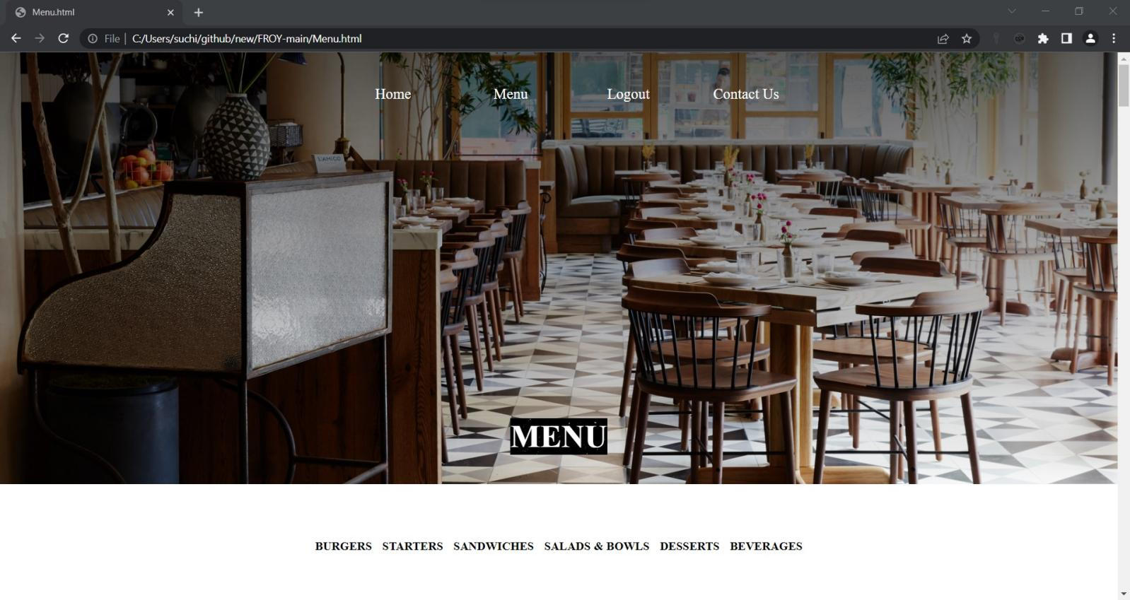

1. **RESERVE TABLE PAGE:**

<!**DOCTYPE** html>

<**link** href=*"https://fonts.googleapis.com/css2?family=Open+Sans:wght@300&family=Pacifico&family=Titillium+Web:wght@200&display=swap"* rel=*"stylesheet"* >

<**html**>

<**head**>

<**meta** charset=*"utf-8"*>

<**meta** http-equiv=*"X-UA-Compatible"* content=*"IE=edge"*>

<**title**>Reservation Form</**title**>

<**meta** name=*"viewport"* content=*"width=device-width, initial-scale=1"*>

<**link** rel=*"stylesheet"* href=*"main.css"*>

<**link** rel=*"stylesheet"* href=*"fonts/material-icon/css/material-design-iconic-font.min.css"*>

<**style**>

@import *url('https://fonts.googleapis.com/css2?family=Poppins:wght@300;500;700&display=swap')*;

*{

box-sizing: *border-box*;

padding: *0*;

margin: *0*;

}

body{

font-family: *'Poppins', sans-serif*;

margin: *0px*;

}

.banner{

min-height: *100vh*;

background: *linear-gradient(rgba(0, 0, 0, 0.5), rgba(0, 0, 0, 0.5)), url("https://media.gettyimages.com/videos/tilt-down-blur-restaurant-for-background-video-id1273433362?s=640x640") center/cover no-repeat*;

display: *flex*;

flex-direction: *column*;

justify-content: *center*;

align-items: *center*;

color: *#fff*;

padding-bottom: *20px*;

}

.card-container{

display: *grid*;

grid-template-columns: *420px 420px*;

}

.card-img{

background: *url("https://restaurantindia.s3.ap-south-1.amazonaws.com/s3fs-public/content9723.jpg") center/cover no-repeat*;

}

.banner h2{

padding-bottom: *40px*;

margin-bottom: *20px*;

}

.card-content{

background: *#fff*;

height: *330px*;

}

.card-content h3{

text-align: *center*;

color: *#000*;

padding: *25px 0 10px 0*;

font-size: *26px*;

font-weight: *500*;

}

.form-row{

display: *flex*;

width: *90%*;

margin: *0 auto*;

}

form select, form input{

display: *block*;

width: *100%*;

margin: *15px 12px*;

padding: *5px*;

font-size: *15px*;

font-family: *'Poppins', sans-serif*;

outline: *none*;

border: *none*;

border-bottom: *1px solid #eee*;

font-weight: *300*;

}

form input[type = text], form input[type = number], form input::placeholder, select{

}

form input[type = submit]{

color: *#fff*;

background: *#f2745f*;

padding: *12px 0*;

border-radius: *4px*;

cursor: *pointer*;

}

form input[type = submit]:hover{

opacity: *0.9*;

}

@media(max-width: 992px){

.card-container{

grid-template-columns: *100%*;

width: *100vw*;

}

.card-img{

height: *330px*;

}

}

.navbar{

width: *auto*;

float: *right*;

border: *none*;

height: *70px*;

padding: *15px*;

font-family: *Tapestry*;

}

.navbar ul li{

width: *150px*;

float: *left*;

margin: *25px auto*;

text-align: *center*;

padding: *5px*;

position: *relative*;

right: *20px*;

top:*-100px*;

}

.navbar ul li a{

text-decoration: *none*;

color: *white*;

font-size: *20px*;

padding: *2px*;

}

.navbar ul li a:hover{

color: *white*;

text-decoration: *underline*;

}

#start{

position:*relative*;

right:*5px*;}

</**style**>

</**head**>

<**body**>

<**section** class = *"banner"*>

<**header**>

<**nav** class=*"navbar"*>

<**ul** type=*"none"*>

<**li**><**a** href=*"index.jsp"*>Home</**a**></**li**>

<**li**><**a** href=*"menu.jsp"*>Menu</**a**></**li**>

<**li**><**a** href=*"logout"*>Logout</**a**></**li**>

<**li**><**a** href=*"contact.jsp"*>Contact Us</**a**></**li**>

</**ul**>

</**nav**>

</**header**>

<**h2**>BOOK YOUR TABLE NOW</**h2**>

<**div** class = *"card-container"*>

<**div** class = *"card-img"*>

<!-- image here -->

</**div**>

<**div** class = *"card-content"*>

<**h3**>Reservation</**h3**>

<**form** method=*"post"* action=*"reserve"*>

<**div** class = *"form-row"*>

<**input** type=*"date"* id=*"start"* name=*"date"*

min=*"2000-01-01"* max=*"2900-12-31"* required=*"required"*>

<**input** type=*"time"* id=*"appt"* name=*"hours"* required=*"required"*>

</**div**>

<**div** class = *"form-row"*>

<**input** type = *"text"* name=*"cname"* placeholder=*"Full Name"* required=*"required"*>

<**input** type = *"text"* name=*"number"* placeholder=*"Phone Number"* required=*"required"*>

</**div**>

<**div** class = *"form-row"*>

<**input** type = *"number"* name=*"guests"* placeholder=*"How Many Persons?"* min = *"1"* required=*"required"*>

<**input** type = *"submit"* name=*"submit"* value = *"BOOK TABLE"* required=*"required"*>

</**div**>

</**form**>

</**div**>

</**div**>

</**section**>

</**body**>

</**html**>

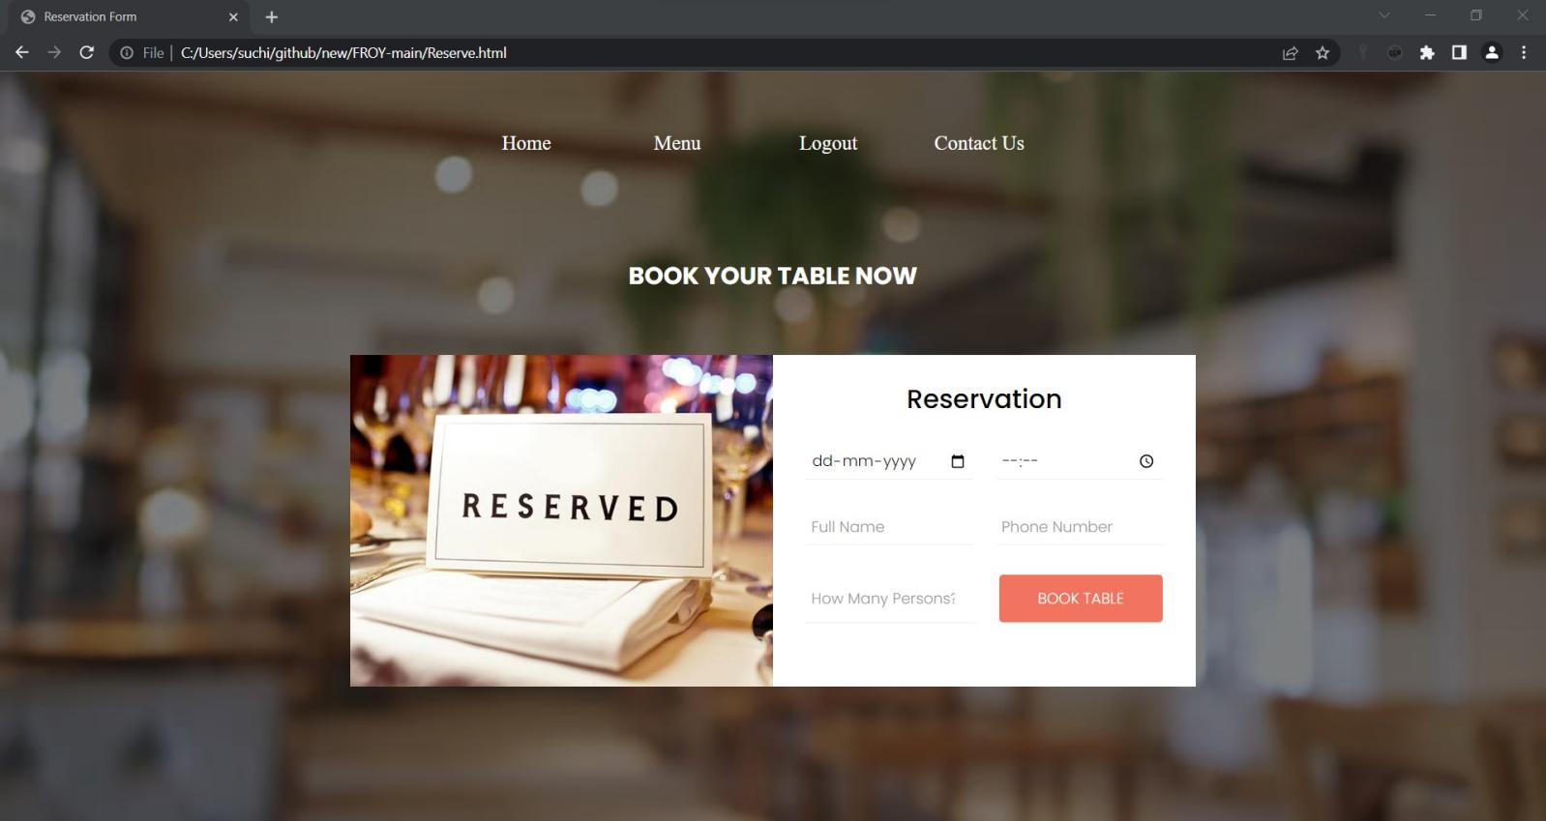

1. **CONTACT US PAGE :**

<!**DOCTYPE** html>

<**html**>

<**head**>

<**style**>

*{

padding: *0px*;

margin:*0px*;

}

.contact {

position: *relative*;

padding: *0px*;

margin: *0px*

*align-items*: *center*;

height: *auto*;

background-image: *url('https://img.freepik.com/free-photo/abstract-dark-blue-grunge-texture-with-scratches-spots-old-cement-plaster-wall-background_150101-2005.jpg')*;

color: *white*;

background-size:*cover*;

}

.container {

width:*auto*;

padding: *20px 20px*;

position: *relative*;

}

.container .contactInfo

{

width:*50%*;

display: *flex*;

flex-direction: *row*;

}

.container .conatactInfo .box{

position: *absolute*;

display:*flex*;

}

.container .contactInfo .box1 .icon{

width: *50px*;

height: *50px*;

position: *relative*;

font-size: *26px*;

top:*80px*;

}

.container .contactInfo .box1 .text{

text-align: *left*;

width: *150px*;

position: *relative*;

left: *43px*;

top: *25px*;

}

.container .contactInfo .box2 .icon{

width: *50px*;

height: *50px*;

position: *relative*;

font-size: *26px*;

top: *80px*;

left:*150px*;

}

.container .contactInfo .box2 .text{

text-align: *left*;

width: *150px*;

position: *relative*;

left: *200px*;

top:*25px*;

}

.container .contactInfo .box3 .icon{

width: *50px*;

height: *50px*;

position: *relative*;

font-size: *26px*;

top: *80px*;

left:*300px*;

}

.container .contactInfo .box3 .text{

text-align: *left*;

width: *150px*;

position: *relative*;

left: *352px*;

top: *25px*;}

#place{

position: *relative*;

left: *440px*;

bottom: *10px*;

}

.first{

background:*linear-gradient(rgba(0,0,0,0.7), rgba(0,0,0,0.5)), url('https://cdn.cnn.com/cnnnext/dam/assets/200120161356-cnn-worlds-best-new-restaurants---madera---simon-brown-photography-1-1-full-169.jpg')*;

background-image: *cover*;

height:*710px*;

color: *white*;

}

.inside-contact{

width:*500px*;

height: *80%*;

position: *relative*;

top: *130px*;

left:*800px*;

}

}

.inside-contact h2{

text-transform:*uppercase*;

text-align:*center*;

margin-top:*50px*;

padding-top: *5px*;

}

.inside-contact h3{

text-align:*center*;

font-size:*16px*;

color:*#0085e2*;

margin: *10px*;

}

.inside-contact input, .inside-contact textarea{

width:*80%*;

background-color:*rgba(255,255,255,0.9)*;

border:*1px solid rgba(0,0,0,0.48)*;

padding:*5px 10px*;

margin: *15px*;

}

.inside-contact p{

padding-left:*15px*;

}

.logo{

position: *relative*;

bottom: *300px*;

border-radius: *5px*;

left: *250px*;

background-color: *black*;

width:*250px*;

height:*250px*;

border-radius: *50%*;

}

#image{

position: *relative*;

width:*370px*;

height:*300px*;

right: *73px*;

bottom: *30px*;

}

.navbar{

width: *auto*;

float: *right*;

border: *none*;

height: *70px*;

position: *relative*;

top:*15px*;

}

.navbar ul li{

width: *150px*;

float: *left*;

margin: *25px auto*;

text-align: *center*;

padding: *5px*;

position: *relative*;

left:*-67%*;

}

.navbar ul li a{

text-decoration: *none*;

color: *white*;

font-size: *20px*;

padding: *2px*;

}

.navbar ul li a:hover{

color: *white*;

text-decoration: *underline*;

}

.new{

padding-left:*80px*;

}

#cont{

position: *relative*;

left:*140px*;

}

#btn_send{

background: *yellow*;

}

</**style**>

</**head**>

<**body**>

<**section** class=*"first"*>

<**nav** class=*"navbar"*>

<**ul** type=*"none"*>

<**li**><**a** href=*"index.jsp"*>Home</**a**></**li**>

<**li**><**a** href=*"menu.jsp"*>Menu</**a**></**li**>

<**li**><**a** href=*"logout"*>Logout</**a**></**li**>

<**li**><**a** href=*"contact.jsp"*>Contact Us</**a**></**li**>

</**ul**>

</**nav**>

<**div** class=*"inside-contact"*>

<**span** id=*"cont"*>

<**h2**>Contact Us</**h2**></**span**>

<**h3**>

<**span** id=*"confirm"*>

</**h3**>

<**form** id=*"contact-form"* method=*"post"* action=*"contact"*>

<**p**>Name *</**p**>

<**input** id=*"txt_name"* name=*"name"* type=*"text"* Required=*"required"*>

<**p**>Email *</**p**>

<**input** id=*"txt_email"* name=*"email"* type=*"email"* Required=*"required"*>

<**p**>Phone *</**p**>

<**input** id=*"txt-phone"* "type=*"text"* name=*"PhoneNumber"* pattern=*"[7-9]{1}[0-9]{9}"*

title=*"Phone number with 7-9 and remaining 9 digit with 0-9"*>

<**p**>Message *</**p**>

<**textarea** id=*"txt_message"* name=*"textarea"* rows=*"4"* cols=*"20"* Required=*"required"* ></**textarea**>

<**input** type=*"submit"* class=*"contact-form"* id=*"btn_send"* value=*"SEND"*>

</**form**>

</**div**>

<**div** class=*"logo"*>

<**img** id=*"image"* src=*"images\canvas.png"* >

</**div**>

</**section**>

<**section** class=*"contact"*>

<**script** src=*"https://kit.fontawesome.com/f5d7e640d9.js"* crossorigin=*"anonymous"*></**script**>

<**div** class=*"new"*>

<**div** class=*"container"*>

<**div** class=*"contactinfo"*>

<**div** class=*"box1"* >

<**div** class=*"icon"*><**i** class=*"fa-solid fa-location-dot"*></**i**></**div**>

<**div** class=*"text"*>

<**h3**>Address</**h3**>

<**p**>Jubliee Hills Road No 36,<**br**>Hyderabad,Telangana,<**br**>500033</**p**>

</**div**>

</**div**>

<**div** class=*"box2"*>

<**div** class=*"icon"*><**i** class=*"fa-solid fa-phone"*></**i**></**div**>

<**div** class=*"text"*>

<**h3**>Phone</**h3**>

<**p**> +91 6127970164 </**p**>

</**div**>

</**div**>

<**div** class=*"box3"*>

<**div** class=*"icon"*><**i** class=*"fa-solid fa-envelope"*></**i**></**div**>

<**div** class=*"text"*>

<**h3**>Email</**h3**>

<**p**>FroyContactUs@gmail.com</**p**>

</**div**>

</**div**>

<**div** id=*"place"*>

<**iframe** src=*"https://www.google.com/maps/embed?pb=!1m18!1m12!1m3!1d3806.547558309475!2d78.40325131479695!3d17.43348738805104!2m3!1f0!2f0!3f0!3m2!1i1024!2i768!4f13.1!3m3!1m2!1s0x3bcb91463b7ebb4b%3A0x16a4ba4ed2262687!2sRd%20Number%2036%2C%20Jubilee%20Hills%2C%20Hyderabad%2C%20Telangana%20500033!5e0!3m2!1sen!2sin!4v1654000861349!5m2!1sen!2sin"* width=*"400"* height=*"300"* style="border:*0*;" allowfullscreen=*""* loading=*"lazy"* referrerpolicy=*"no-referrer-when-downgrade"*></**iframe**>

</**div**>

</**div**>

</**div**>

</**div**>

</**section**>

</**body**>

</**html**>

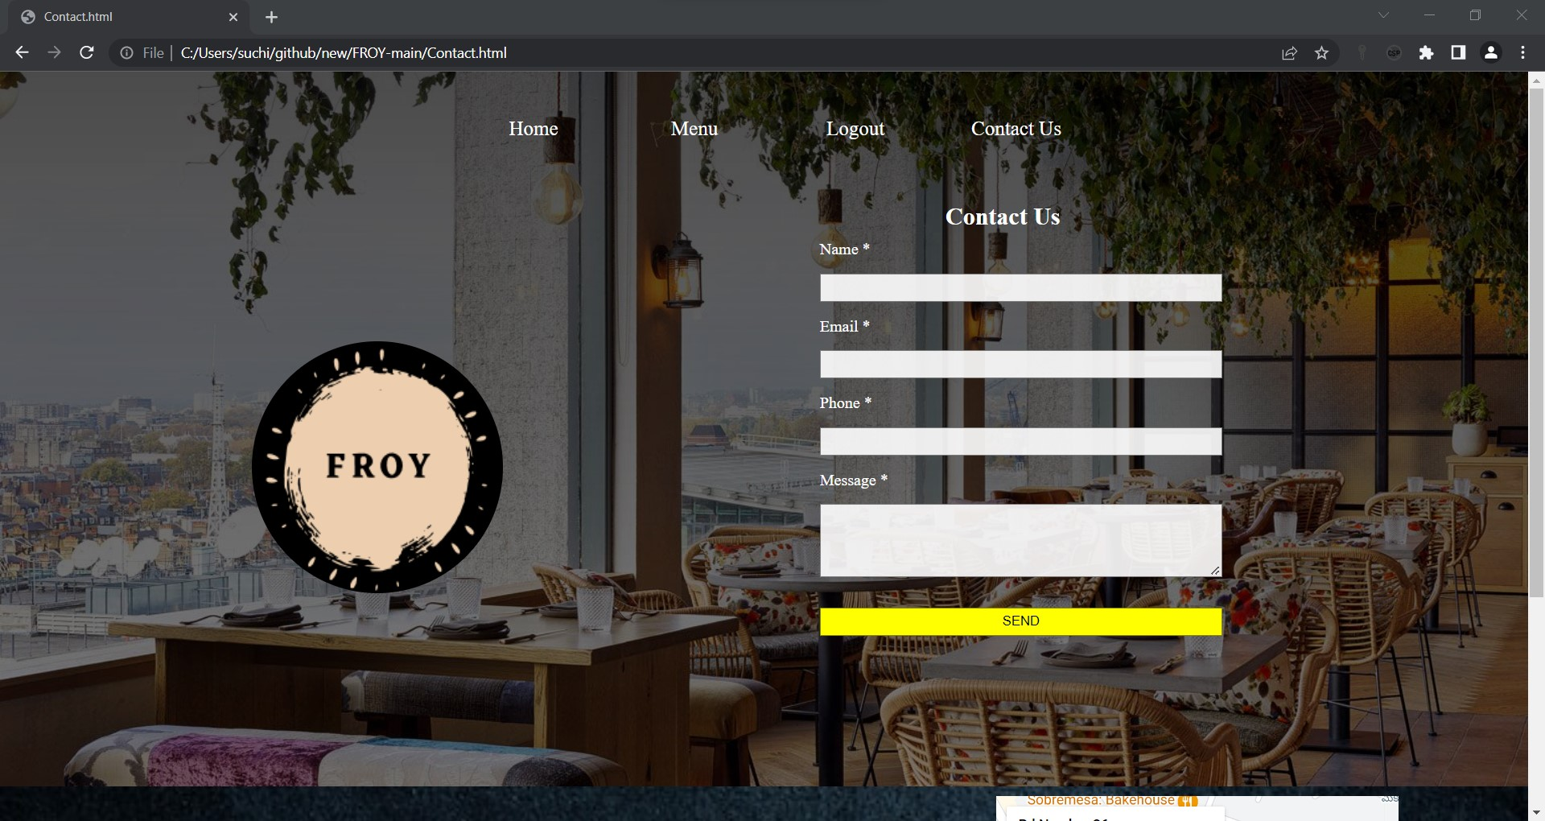

**DYNAMIC PAGES :**

1. Index.jsp page
2. Login.jsp page
3. Signin.jsp page
4. Login.java page
5. SigninServlet.java page
6. Reserve.jsp
7. Reservetable.java
8. Menu.jsp
9. Contact.jsp
10. Contact.java
11. Details.jsp
12. Logout.java
13. **index.jsp page**

<%

if(session.getAttribute("name")==null){

response.sendRedirect("login.jsp");

}

%>

<!**DOCTYPE** html>

<**html**>

<**link** href=*"https://fonts.googleapis.com/css2?family=Open+Sans:wght@300&family=Pacifico&family=Titillium+Web:wght@200&display=swap"* rel=*"stylesheet"*>

<**link** rel=*"stylesheet"* type=*"text/css"* href=*"style.css"*>

<**head**>

<**meta** charset=*"UTF-8"*>

<**meta** name=*"viewport"* content=*"width=device-width, initial-scale=1.0"*>

<**title**>Froy.com</**title**>

</**head**>

<**body**>

<**section** class=*"first"*>

<**div** class=*"firstd"*>

<**header** class=*"head"*>

<**img** id=*"logo"* src=*"images/canvas.png"* >

<**nav** class=*"navbar"*>

<**ul** type=*"none"*>

<**li**><**a** href=*"index.jsp"*>Home</**a**></**li**>

<**li**><**a** href=*"#second"*>About Us</**a**></**li**>

<**li**><**a** href=*"menu.jsp"*>Menu</**a**></**li**>

<**li**><**a** href=*"contact.jsp"*>Contact Us</**a**></**li**>

<**li**><**a** href=*"logout"*>Logout</**a**></**li**>

<**li**><**a** href=*"details2.jsp"* style="font-size:*10px*"><%= session.getAttribute("name") %></**a**></**li**>

</**ul**>

</**nav**>

</**header**>

<**div** class=*"res"*>

<**button** onclick="location.href='Reserve.jsp'" type=*"button"*><**b**>Reserve a table</**b**>

</**button**>

</**div**>

<**div** class=*"welcome"*>

<**h1**>FROY</**h1**>

<**p**>

Delight in every bite

</**p**>

</**div**>

</**div**>

</**section**>

<**section** id=*"second"* class=*"about"*>

<**div** class=*"second"*>

<**center**>

<**img** id=*"logo2"* src=*"images/logo2.png"*>

<**p** class=*"aboutp"*>Froy specializes in delicious food featuring fresh ingredients and masterful preparation by the Froy culinary team. Whether you are ordering a multi-course meal or grabbing a drink and pizza at the bar, Froy's lively, casual yet upscale atmosphere makes it perfect for dining with friends, family, clients and business associates.<**br**> <**br**>

Froy combines flavors & inspiration from the Far East & the West to create what we think is the best! Home to the original (recipe), we specialize in pizzas, as well as handmade appetizers, sandwiches, salads, and gluten friendly, vegetarian, & vegan selections. Feel free to indulge in a tiki drink or craft beer with our fantastic unique cuisine. Cheers!

</**p**>

<**article** id=*"cc-slider"*>

<**input** checked=*"checked"* name=*"cc-slider"* id=*"slide1"* type=*"radio"*>

<**input** name=*"cc-slider"* id=*"slide2"* type=*"radio"*>

<**input** name=*"cc-slider"* id=*"slide3"* type=*"radio"*>

<**input** name=*"cc-slider"* id=*"slide4"* type=*"radio"*>

<**input** name=*"cc-slider"* id=*"slide5"* type=*"radio"*>

<**div** id=*"cc-slides"*>

<**div** id=*"overflow"*>

<**div** class=*"inner"*>

<**article**>

<**img** src=*"https://www.brabbu.com/en/news-events/wp-content/uploads/2015/11/L_Amico-top-10-best-restaurants-nyc.jpg"*>

</**article**>

<**article**>

<**img** src=*"https://media.architecturaldigest.com/photos/5637972e7a4c7a362e06640d/master/w_1600,c_limit/lamico-new-york-02.jpg"*> </**article**>

<**article**>

<**img** src=*"https://media.architecturaldigest.com/photos/5637972c7a4c7a362e066407/master/w_1600,c_limit/lamico-new-york-03.jpg"*>

</**article**>

<**article**>

<**img** src=*"https://media.architecturaldigest.com/photos/5637972ca6f997a353b88217/master/w_1600,c_limit/lamico-new-york-04.jpg"*>

</**article**>

<**article**>

<**img** src=*"https://hospitalitysnapshots.com/wp-content/uploads/sites/3/2019/05/lamico_5d8e9df29cf07.jpg"*>

</**article**>

</**div**>

<**script**>

w3.slideshow = **function** (sel, ms, func) {

**var** i, ss, x = w3.getElements(sel), l = x.length;

ss = {};

ss.current = 1;

ss.x = x;

ss.ondisplaychange = func;

**if** (!isNaN(ms) || ms == 0) {

ss.milliseconds = ms;

} **else** {

ss.milliseconds = 1000;

}

ss.start = **function**() {

ss.display(ss.current)

**if** (ss.ondisplaychange) {ss.ondisplaychange();}

**if** (ss.milliseconds > 0) {

window.clearTimeout(ss.timeout);

ss.timeout = window.setTimeout(ss.next, ss.milliseconds);

}

};

ss.next = **function**() {

ss.current += 1;

**if** (ss.current > ss.x.length) {ss.current = 1;}

ss.start();

};

ss.previous = **function**() {

ss.current -= 1;

**if** (ss.current < 1) {ss.current = ss.x.length;}

ss.start();

};

ss.display = **function** (n) {

w3.styleElements(ss.x, "display", "none");

w3.styleElement(ss.x[n - 1], "display", "block");

}

ss.start();

**return** ss;

};

</**script**>

</**div**>

</**div**>

<**div** id=*"controls"*>

<**label** for=*"slide1"*></**label**>

<**label** for=*"slide2"*></**label**>

<**label** for=*"slide3"*></**label**>

<**label** for=*"slide4"*></**label**>

<**label** for=*"slide5"*></**label**>

</**div**>

</**article**>

</**center**>

</**div**>

</**section**>

<**section** id=*"third"* class=*"contact"*>

<**img** id=*"con"* src=*"https://cdn.cnn.com/cnnnext/dam/assets/200120161356-cnn-worlds-best-new-restaurants---madera---simon-brown-photography-1-1-full-169.jpg"* >

<**script** src=*"https://kit.fontawesome.com/f5d7e640d9.js"* crossorigin=*"anonymous"*></**script**>

<**div** class=*"new"*>

<**div** class=*"content"*>

<**h2**> Contact Us </**h2**>

<**p**> Thank you for your interest in our restaurant.For further information please do contact us via email or phone .</**p**>

</**div**>

<**div** class=*"container"*>

<**div** class=*"contactinfo"*>

<**div** class=*"box1"* >

<**div** class=*"icon"*><**i** class=*"fa-solid fa-location-dot"*></**i**></**div**>

<**div** class=*"text"*>

<**h3**>Address</**h3**>

<**p**>Jubliee Hills Road No 36,<**br**>Hyderabad,Telangana,<**br**>500033</**p**>

</**div**>

</**div**>

<**div** class=*"box2"*>

<**div** class=*"icon"*><**i** class=*"fa-solid fa-phone"*></**i**></**div**>

<**div** class=*"text"*>

<**h3**>Phone</**h3**>

<**p**> +91 6127970164 </**p**>

</**div**>

</**div**>

<**div** class=*"box3"*>

<**div** class=*"icon"*><**i** class=*"fa-solid fa-envelope"*></**i**></**div**>

<**div** class=*"text"*>

<**h3**>Email</**h3**>

<**p**>FroyContactUs@gmail.com</**p**>

</**div**>

</**div**>

<**div** id=*"place"*>

<**iframe** src=*"https://www.google.com/maps/embed?pb=!1m18!1m12!1m3!1d3806.547558309475!2d78.40325131479695!3d17.43348738805104!2m3!1f0!2f0!3f0!3m2!1i1024!2i768!4f13.1!3m3!1m2!1s0x3bcb91463b7ebb4b%3A0x16a4ba4ed2262687!2sRd%20Number%2036%2C%20Jubilee%20Hills%2C%20Hyderabad%2C%20Telangana%20500033!5e0!3m2!1sen!2sin!4v1654000861349!5m2!1sen!2sin"* width=*"400"* height=*"300"* style="border:*0*;" allowfullscreen=*""* loading=*"lazy"* referrerpolicy=*"no-referrer-when-downgrade"*></**iframe**>

</**div**>

</**div**>

</**div**>

</**section**>

</**body**>

</**html**>

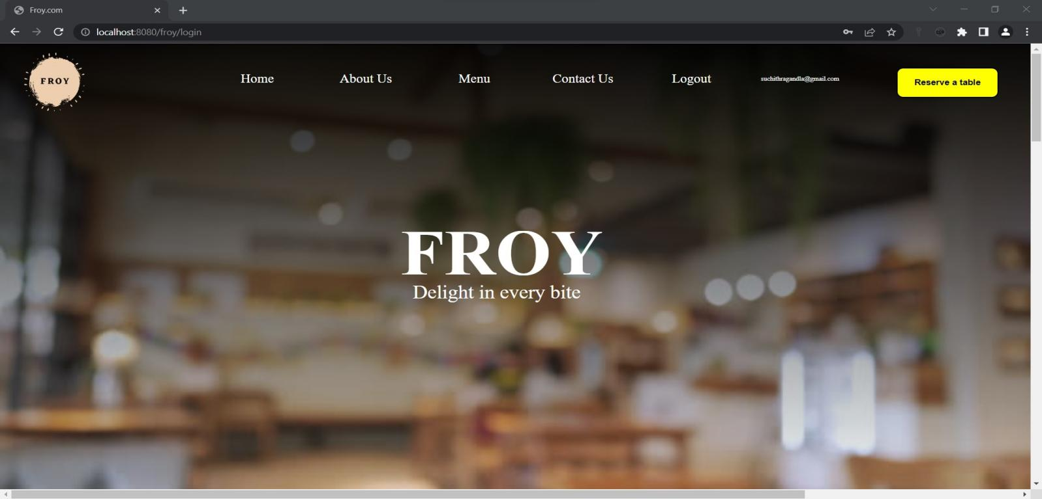

1. **login.jsp page:**

<!**DOCTYPE** html>

<**html**>

<**head**>

<**link** href=*"https://fonts.googleapis.com/css2?family=Open+Sans:wght@300&family=Pacifico&family=Titillium+Web:wght@200&display=swap"* rel=*"stylesheet"*>

<**link** rel=*"stylesheet"* href=*"fonts/material-icon/css/material-design-iconic-font.min.css"*>

<**style**>

*{

padding: *0*;

margin:*0*;

font-family: *Tapestry*;

}

body{

min-height: *100vh*;

margin: *0px*;

padding: *0px*;

background-image: *linear-gradient(rgba(0,0,0,0.95),rgba(0,0,0,0)),url("https://media.gettyimages.com/videos/tilt-down-blur-restaurant-for-background-video-id1273433362?s=640x640")*;

background-size: *cover*;

background-repeat: *no-repeat*;

}

display-flex, .display-flex, .display-flex-center, .signup-content, .signin-content, .social-login, .socials {

display: *flex*;

display: *-webkit-flex*; }

img {

max-width: *100%*;

height: *auto*; }

figure {

margin: *0*; }

p {

margin-bottom: *0px*;

font-size: *15px*;

color: *#777*; }

h2 {

line-height: *1.66*;

margin: *0*;

padding: *0*;

font-weight: *bold*;

color: *#222*;

font-family: *Poppins*;

font-size: *36px*; }

.main {

background: *#f8f8f8*;

padding: *50px 0*; }

.clear {

clear: *both*; }

.container {

width: *500px*;

background: *#fff*;

margin: *0 auto*;

box-shadow: *0px 15px 16.83px 0.17px rgba(0, 0, 0, 0.05)*;

-moz-box-shadow: *0px 15px 16.83px 0.17px rgba(0, 0, 0, 0.05)*;

-webkit-box-shadow: *0px 15px 16.83px 0.17px rgba(0, 0, 0, 0.05)*;

-o-box-shadow: *0px 15px 16.83px 0.17px rgba(0, 0, 0, 0.05)*;

-ms-box-shadow: *0px 15px 16.83px 0.17px rgba(0, 0, 0, 0.05)*;

border-radius: *20px*;

-moz-border-radius: *20px*;

-webkit-border-radius: *20px*;

-o-border-radius: *20px*;

-ms-border-radius: *20px*;

position: *relative*;

top:*140px*;

height:}

.display-flex {

justify-content: *space-between*;

-moz-justify-content: *space-between*;

-webkit-justify-content: *space-between*;

-o-justify-content: *space-between*;

-ms-justify-content: *space-between*;

align-items: *center*;

-moz-align-items: *center*;

-webkit-align-items: *center*;

-o-align-items: *center*;

-ms-align-items: *center*; }

.display-flex-center {

justify-content: *center*;

-moz-justify-content: *center*;

-webkit-justify-content: *center*;

-o-justify-content: *center*;

-ms-justify-content: *center*;

align-items: *center*;

-moz-align-items: *center*;

-webkit-align-items: *center*;

-o-align-items: *center*;

-ms-align-items: *center*; }

.position-center {

position: *absolute*;

top: *50%*;

left: *50%*;

transform: *translate(-50%, -50%)*;

-moz-transform: *translate(-50%, -50%)*;

-webkit-transform: *translate(-50%, -50%)*;

-o-transform: *translate(-50%, -50%)*;

-ms-transform: *translate(-50%, -50%)*; }

.signup {

margin-bottom: *30px*; }

.signup-content {

padding: *50px 0*;

}

.signup-form, .signin-form {

width: *50%*;

overflow: *hidden*; }

.form-title {

margin-bottom: *33px*; }

.form-submit {

display: *inline-block*;

background: *#6dabe4*;

color: *#fff*;

border-bottom: *none*;

width: *auto*;

padding: *15px 39px*;

border-radius: *5px*;

-moz-border-radius: *5px*;

-webkit-border-radius: *5px*;

-o-border-radius: *5px*;

-ms-border-radius: *5px*;

margin-top: *25px*;

cursor: *pointer*; }

.form-submit:hover {

background: *#4292dc*; }

#signin {

margin-top: *16px*; }

.signup-image-link {

font-size: *14px*;

color: *#222*;

display: *block*;

text-align: *center*;

position : *relative*;

right: *23px*;

}

.term-service {

font-size: *13px*;

color: *#222*; }

.signup-form , .signin-form {

margin-left: *75px*;

margin-right: *75px*;

padding-left: *34px*;

position: *relative*;

right: *50px*;

}

.register-form {

width: *100%*; }

.form-group {

position: *relative*;

margin-bottom: *25px*;

overflow: *hidden*; }

.form-group:last-child {

margin-bottom: *0px*; }

.signup-form {

margin-left: *0px*;

margin-right: *0px*;

padding-left: *0px*;

/* box-sizing: border-box; */

padding: *0 30px*;

}

.signup-form, .signin-form {

width: *auto*; }

.social-login {

justify-content: *center*;

-moz-justify-content: *center*;

-webkit-justify-content: *center*;

-o-justify-content: *center*;

-ms-justify-content: *center*; }

.form-button {

text-align: *center*; }

.signin-form {

order: *1*;

-moz-order: *1*;

-webkit-order: *1*;

-o-order: *1*;

-ms-order: *1*;

margin-right: *0px*;

margin-left: *0px*;

padding: *0 30px*; }

.form-title {

text-align: *center*; } }

@media screen and (max-width: 400px) {

.social-login {

flex-direction: *column*;

-moz-flex-direction: *column*;

-webkit-flex-direction: *column*;

-o-flex-direction: *column*;

-ms-flex-direction: *column*; }

.social-label {

margin-right: *0px*;

margin-bottom: *10px*; } }

.navbar{

width: *auto*;

float: *right*;

border: *none*;

height: *70px*;

padding: *15px*;

}

.navbar ul li{

width: *150px*;

float: *left*;

margin: *25px auto*;

text-align: *center*;

padding: *5px*;

position: *relative*;

left:*-67%*;

}

.navbar ul li a{

text-decoration: *none*;

color: *white*;

font-size: *20px*;

padding: *2px*;

}

.navbar ul li a:hover{

color: *white*;

text-decoration: *underline*;

}

</**style**>

</**head**>

<**body**>

<**section** class=*"newsec"*>

<**input** type=*"hidden"* id=*"status"* value="<%= request.getAttribute("status") %>">

<**div** class=*"newclass"*>

<**nav** class=*"navbar"*>

<**ul** type=*"none"*>

<**li**><**a** href=*"index.jsp"*>Home</**a**></**li**>

<**li**><**a** href=*"menu.jsp"*>Menu</**a**></**li**>

<**li**><**a** href=*"login.jsp"*>Login</**a**></**li**>

<**li**><**a** href=*"contact.jsp"*>Contact Us</**a**></**li**>

</**ul**>

</**nav**>

<**div** class=*"container"*>

<**div** class=*"signin-content"*>

<**div** class=*"signin-form"*>

<**h2** class=*"form-title"*>Sign in</**h2**>

<**form** method=*"post"* action=*"login"* class=*"register-form"*

id=*"login-form"*>

<**div** class=*"form-group"*>

<**label** for=*"email"*><**i**

class=*"zmdi zmdi-account material-icons-name"*></**i**></**label**> <**input**

type=*"email"* name=*"email"* id=*"email"*

placeholder=*"Your email"* required=*"required"* />

</**div**>

<**div** class=*"form-group"*>

<**label** for=*"password"*><**i** class=*"zmdi zmdi-lock"*></**i**></**label**> <**input**

type=*"password"* name=*"password"* id=*"password"*

placeholder=*"Password"* required=*"required"*/>

</**div**>

<**div** class=*"form-group"*>

<**input** type=*"checkbox"* name=*"remember-me"* id=*"remember-me"*

class=*"agree-term"* /> <**label** for=*"remember-me"*

class=*"label-agree-term"*><**span**><**span**></**span**></**span**>Remember

me</**label**>

</**div**>

<**div** class=*"form-group form-button"*>

<**input** type=*"submit"* name=*"signin"* id=*"signin"*

class=*"form-submit"* value=*"Log in"* />

</**div**>

<**div** class=*"reglink"*>

<**a** href=*"signin.jsp"* class=*"signup-image-link"*>Create an

account</**a**>

</**div**>

</**form**>

</**div**>

</**div**>

</**div**>

</**div**>

</**section**>

<**script** src=*"vendor/jquery/jquery.min.js"*></**script**>

<**script** src=*"js/main.js"*></**script**>

<**script** src=*"https://unpkg.com/sweetalert/dist/sweetalert.min.js"*></**script**>

<**link** rel=*"stylesheet"* href=*"alert/dist/sweetalert.css"*>

<**script** type=*"text/javascript"*>

**var** status = document.getElementById("status").value;

**if**(status == "failed"){

swal("Sorry", "Wrong email or password","failed");

}

**if**(status == "invalidEmail"){

swal("Sorry", "please enter email","failed");

}

**if**(status == "invalidPwd"){

swal("Sorry", "please enter password","failed");

}

</**script**>

</**body**>

</**html**>



1. login.java page:

package com.uniquedeveloper.signup;

import java.io.*;

import jakarta.servlet.*;

import jakarta.servlet.annotation.WebServlet;

import jakarta.servlet.http.*;

import java.sql.Connection;

import java.sql.DriverManager;

import java.sql.PreparedStatement;

import java.sql.ResultSet;

*@WebServlet*("/login")

public class login extends HttpServlet {

private static final long ***serialVersionUID*** = 1L;

protected void doPost(HttpServletRequest request, HttpServletResponse response)

throws ServletException, IOException {

String uemail = request.getParameter("email");

String upwd = request.getParameter("password");

HttpSession session = request.getSession();

RequestDispatcher dispatcher = null;

if(uemail == null || uemail.equals("")) {

request.setAttribute("status","invalidEmail");

dispatcher = request.getRequestDispatcher("login.jsp");

dispatcher.forward(request, response);

}

if(upwd == null || upwd.equals("")) {

request.setAttribute("status","invalidPwd");

dispatcher = request.getRequestDispatcher("login.jsp");

dispatcher.forward(request, response);

}

try {

Class.*forName*("com.mysql.jdbc.Driver");

Connection con = DriverManager.*getConnection*("jdbc:mysql://localhost:3306/signin","root","suchithra");

PreparedStatement pst = con.prepareStatement("select * from users where uemail = ? and upwd = ?");

pst.setString(1, uemail);

pst.setString(2, upwd);

ResultSet rs = pst.executeQuery();

if (rs.next()) {

session.setAttribute("name",rs.getString("uemail"));

dispatcher = request.getRequestDispatcher("index.jsp");

}else {

request.setAttribute("status","failed");

dispatcher = request.getRequestDispatcher("login.jsp");

}

dispatcher.forward(request, response);

}catch ( Exception e )

{

e.printStackTrace();}}}

New user:

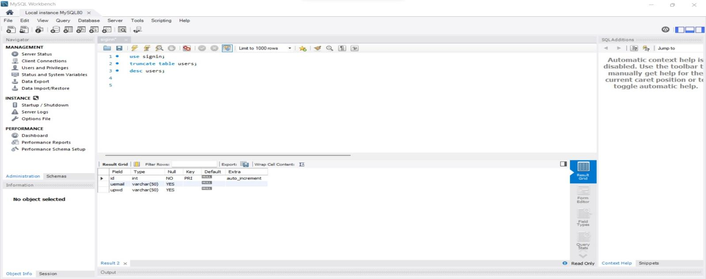

1. **signin.jsp page:**

<!**DOCTYPE** html>

<**link** href=*"https://fonts.googleapis.com/css2?family=Open+Sans:wght@300&family=Pacifico&family=Titillium+Web:wght@200&display=swap"* rel=*"stylesheet"*>

<**link** rel=*"stylesheet"* href=*"fonts/material-icon/css/material-design-iconic-font.min.css"*>

<**html**>

<**head**>

<**style**>

*{

padding: *0*;

margin:*0*;

font-family: *Tapestry*;

}

body{

min-height: *100vh*;

background-image: *linear-gradient(rgba(0,0,0,0.95),rgba(0,0,0,0)),url("https://media.gettyimages.com/videos/tilt-down-blur-restaurant-for-background-video-id1273433362?s=640x640")*;

background-size: *cover*;

background-repeat: *no-repeat*;

}

.container {

width: *500px*;

background: *#fff*;

margin: *0 auto*;

box-shadow: *0px 15px 16.83px 0.17px rgba(0, 0, 0, 0.05)*;

-moz-box-shadow: *0px 15px 16.83px 0.17px rgba(0, 0, 0, 0.05)*;

-webkit-box-shadow: *0px 15px 16.83px 0.17px rgba(0, 0, 0, 0.05)*;

-o-box-shadow: *0px 15px 16.83px 0.17px rgba(0, 0, 0, 0.05)*;

-ms-box-shadow: *0px 15px 16.83px 0.17px rgba(0, 0, 0, 0.05)*;

border-radius: *20px*;

-moz-border-radius: *20px*;

-webkit-border-radius: *20px*;

-o-border-radius: *20px*;

-ms-border-radius: *20px*;

position: *relative*;

top: *140px*;

}

.display-flex {

justify-content: *space-between*;

-moz-justify-content: *space-between*;

-webkit-justify-content: *space-between*;

-o-justify-content: *space-between*;

-ms-justify-content: *space-between*;

align-items: *center*;

-moz-align-items: *center*;

-webkit-align-items: *center*;

-o-align-items: *center*;

-ms-align-items: *center*; }

.display-flex-center {

justify-content: *center*;

-moz-justify-content: *center*;

-webkit-justify-content: *center*;

-o-justify-content: *center*;

-ms-justify-content: *center*;

align-items: *center*;

-moz-align-items: *center*;

-webkit-align-items: *center*;

-o-align-items: *center*;

-ms-align-items: *center*; }

.position-center {

position: *absolute*;

top: *50%*;

left: *50%*;

transform: *translate(-50%, -50%)*;

-moz-transform: *translate(-50%, -50%)*;

-webkit-transform: *translate(-50%, -50%)*;

-o-transform: *translate(-50%, -50%)*;

-ms-transform: *translate(-50%, -50%)*; }

.signup {

margin-bottom: *30px*; }

.signup-content {

padding: *50px 0*; }

.signup-form, .signup-image, .signin-form, .signin-image {

width: *50%*;

overflow: *hidden*; }

.signup-image {

margin: *0 55px*; }

.form-title {

margin-bottom: *33px*; }

.signup-image {

margin-top: *30px*;

margin-right:*50px*; }

figure {

margin-bottom: *50px*;

text-align: *center*; }

.form-submit {

display: *inline-block*;

background: *#6dabe4*;

color: *#fff*;

border-bottom: *none*;

width: *auto*;

padding: *15px 39px*;

border-radius: *5px*;

-moz-border-radius: *5px*;

-webkit-border-radius: *5px*;

-o-border-radius: *5px*;

-ms-border-radius: *5px*;

margin-top: *25px*;

cursor: *pointer*;

position: *relative*;

right: *25px*;}

.form-submit:hover {

background: *#4292dc*;

}

#signin {

margin-top: *16px*; }

.signup-image-link {

font-size: *14px*;

color: *#222*;

display: *block*;

text-align: *center*;

position: *relative*;

right: *10px*;}

.term-service {

font-size: *13px*;

color: *#222*; }

.signup-form {

margin-left: *75px*;

margin-right: *75px*;

padding-left: *34px*; }

.register-form {

width: *100%*; }

.form-group {

position: *relative*;

margin-bottom: *25px*;

overflow: *hidden*; }

.form-group:last-child {

margin-bottom: *0px*; }

input {

width: *100%*;

display: *block*;

border: *none*;

border-bottom: *1px solid #999*;

padding: *6px 30px*;

font-family: *Poppins*;

box-sizing: *border-box*; }

input::-webkit-input-placeholder {

color: *#999*; }

input::-moz-placeholder {

color: *#999*; }

input:-ms-input-placeholder {

color: *#999*; }

input:-moz-placeholder {

color: *#999*; }

input:focus {

border-bottom: *1px solid #222*; }

input:focus::-webkit-input-placeholder {

color: *#222*; }

input:focus::-moz-placeholder {

color: *#222*; }

input:focus:-ms-input-placeholder {

color: *#222*; }

input:focus:-moz-placeholder {

color: *#222*; }

input[type=checkbox]:not(old) {

width: *2em*;

margin: *0*;

padding: *0*;

font-size: *1em*;

display: *none*; }

input[type=checkbox]:not(old) + label {

display: *inline-block*;

line-height: *1.5em*;

margin-top: *6px*; }

input[type=checkbox]:not(old) + label > span {

display: *inline-block*;

width: *13px*;

height: *13px*;

margin-right: *15px*;

margin-bottom: *3px*;

border: *1px solid #999*;

border-radius: *2px*;

-moz-border-radius: *2px*;

-webkit-border-radius: *2px*;

-o-border-radius: *2px*;

-ms-border-radius: *2px*;

background: *white*;

background-image: *-moz-linear-gradient(white, white)*;

background-image: *-ms-linear-gradient(white, white)*;

background-image: *-o-linear-gradient(white, white)*;

background-image: *-webkit-linear-gradient(white, white)*;

background-image: *linear-gradient(white, white)*;

vertical-align: *bottom*; }

input[type=checkbox]:not(old):checked + label > span {

background-image: *-moz-linear-gradient(white, white)*;

background-image: *-ms-linear-gradient(white, white)*;

background-image: *-o-linear-gradient(white, white)*;

background-image: *-webkit-linear-gradient(white, white)*;

background-image: *linear-gradient(white, white)*; }

input[type=checkbox]:not(old):checked + label > span:before {

content: *'\f26b'*;

display: *block*;

color: *#222*;

font-size: *11px*;

line-height: *1.2*;

text-align: *center*;

font-family: *'Material-Design-Iconic-Font'*;

font-weight: *bold*; }

.agree-term {

display: *inline-block*;

width: *auto*; }

label {

position: *absolute*;

left: *0*;

top: *50%*;

transform: *translateY(-50%)*;

-moz-transform: *translateY(-50%)*;

-webkit-transform: *translateY(-50%)*;

-o-transform: *translateY(-50%)*;

-ms-transform: *translateY(-50%)*;

color: *#222*; }

.label-has-error {

top: *22%*; }

label.error {

position: *relative*;

background: *url("../images/unchecked.gif") no-repeat*;

background-position-y: *3px*;

padding-left: *20px*;

display: *block*;

margin-top: *20px*; }

label.valid {

display: *block*;

position: *absolute*;

right: *0*;

left: *auto*;

margin-top: *-6px*;

width: *20px*;

height: *20px*;

background: *transparent*; }

label.valid:after {

font-family: *'Material-Design-Iconic-Font'*;

content: *'\f269'*;

width: *100%*;

height: *100%*;

position: *absolute*;

/* right: 0; */

font-size: *16px*;

color: *green*; }

.label-agree-term {

position: *relative*;

top: *0%*;

transform: *translateY(0)*;

-moz-transform: *translateY(0)*;

-webkit-transform: *translateY(0)*;

-o-transform: *translateY(0)*;

-ms-transform: *translateY(0)*; }

.material-icons-name {

font-size: *18px*; }

.signin-content {

padding-top: *67px*;

padding-bottom: *87px*; }

.social-login {

align-items: *center*;

-moz-align-items: *center*;

-webkit-align-items: *center*;

-o-align-items: *center*;

-ms-align-items: *center*;

margin-top: *80px*; }

.social-label {

display: *inline-block*;

margin-right: *15px*; }

.socials li {

padding: *5px*; }

.socials li:last-child {

margin-right: *0px*; }

.socials li a {

text-decoration: *none*; }

.socials li a i {

width: *30px*;

height: *30px*;

color: *#fff*;

font-size: *14px*;

border-radius: *5px*;

-moz-border-radius: *5px*;

-webkit-border-radius: *5px*;

-o-border-radius: *5px*;

-ms-border-radius: *5px*;

transform: *translateZ(0)*;

-moz-transform: *translateZ(0)*;

-webkit-transform: *translateZ(0)*;

-o-transform: *translateZ(0)*;

-ms-transform: *translateZ(0)*;

-webkit-transition-duration: *0.3s*;

transition-duration: *0.3s*;

-webkit-transition-property: *transform*;

transition-property: *transform*;

-webkit-transition-timing-function: *ease-out*;

transition-timing-function: *ease-out*; }

.socials li:hover a i {

-webkit-transform: *scale(1.3) translateZ(0)*;

transform: *scale(1.3) translateZ(0)*; }

.zmdi-facebook {

background: *#3b5998*; }

.zmdi-twitter {

background: *#1da0f2*; }

.zmdi-google {

background: *#e72734*; }

.signin-form {

margin-right: *90px*;

margin-left: *80px*; }

.signin-image {

margin-left: *110px*;

margin-right: *0px*;

margin-top: *10px*; }

@media screen and (max-width: 1200px) {

.container {

width: *calc( 100%* - *30px)*;

max-width: *100%*; } }

@media screen and (min-width: 1024px) {

.container {

max-width: *1200px*; } }

@media screen and (max-width: 768px) {

.signup-content, .signin-content {

flex-direction: *column*;

-moz-flex-direction: *column*;

-webkit-flex-direction: *column*;

-o-flex-direction: *column*;

-ms-flex-direction: *column*;

justify-content: *center*;

-moz-justify-content: *center*;

-webkit-justify-content: *center*;

-o-justify-content: *center*;

-ms-justify-content: *center*; }

.signup-form {

margin-left: *0px*;

margin-right: *0px*;

padding-left: *0px*;

/* box-sizing: border-box; */

padding: *0 30px*; }

.signin-image {

margin-left: *0px*;

margin-right: *0px*;

margin-top: *50px*;

order: *2*;

-moz-order: *2*;

-webkit-order: *2*;

-o-order: *2*;

-ms-order: *2*;

position: *relative*;

right: *5px*;}

.signup-form, .signup-image, .signin-form, .signin-image {

width: *auto*; }

.social-login {

justify-content: *center*;

-moz-justify-content: *center*;

-webkit-justify-content: *center*;

-o-justify-content: *center*;

-ms-justify-content: *center*; }

.form-button {

text-align: *center*; }

.signin-form {

order: *1*;

-moz-order: *1*;

-webkit-order: *1*;

-o-order: *1*;

-ms-order: *1*;

margin-right: *0px*;

margin-left: *0px*;

padding: *0 30px*; }

.form-title {

text-align: *center*; } }

@media screen and (max-width: 400px) {

.social-login {

flex-direction: *column*;

-moz-flex-direction: *column*;

-webkit-flex-direction: *column*;

-o-flex-direction: *column*;

-ms-flex-direction: *column*; }

.social-label {

margin-right: *0px*;

margin-bottom: *10px*; } }

/*# sourceMappingURL=style.css.map */

.navbar{

width: *auto*;

float: *right*;

border: *none*;

height: *70px*;

padding: *15px*;

}

.navbar ul li{

width: *150px*;

float: *left*;

margin: *25px auto*;

text-align: *center*;

padding: *5px*;

position: *relative*;

left:*-67%*;

}

.navbar ul li a{

text-decoration: *none*;

color: *white*;

font-size: *20px*;

padding: *2px*;

}

.navbar ul li a:hover{

color: *white*;

text-decoration: *underline*;

}

#signup{

margin-left: *25px*;

margin-right: *25px*;

}

.logo{

position: *relative*;

bottom: *300px*;

border-radius: *5px*;

left: *250px*;

background-color: *black*;

width:*250px*;

height:*250px*;

border-radius: *50%*;

}

#image{

position: *relative*;

width:*370px*;

height:*300px*;

right: *73px*;

bottom: *30px*;

}

</**style**>

</**head**>

<**body**>

<**section**>

<**input** type=*"hidden"* id=*"status"* value=*"*<%= request.getAttribute("status") %>*"*>

<**div** class=*"newsign"*>

<**header**>

<**nav** class=*"navbar"*>

<**ul** type=*"none"*>

<**li**><**a** href=*"index.jsp"*>Home</**a**></**li**>

<**li**><**a** href=*"menu.jsp"*>Menu</**a**></**li**>

<**li**><**a** href=*"login.jsp"*>Login</**a**></**li**>

<**li**><**a** href=*"contact.jsp"*>Contact Us</**a**></**li**>

</**ul**>

</**nav**>

</**header**>

<**div** class=*"logo"*>

<**img** id=*"image"* src=*"images\canvas.png"* >

</**div**>

<**div** class=*"container"*>

<**div** class=*"signup-content"*>

<**div** class=*"signup-form"*>

<**h2** class=*"form-title"*>Sign up</**h2**>

<**form** method=*"post"* action=*"signin"* class=*"register-form"*

id=*"register-form"*>

<**div** class=*"form-group"*>

<**label** for=*"email"*><**i** class=*"zmdi zmdi-email"*></**i**></**label**> <**input**

type=*"email"* name=*"email"* id=*"email"* placeholder=*"Your Email"* required=*"required"*/>

</**div**>

<**div** class=*"form-group"*>

<**label** for=*"pass"*><**i** class=*"zmdi zmdi-lock"*></**i**></**label**> <**input**

type=*"password"* name=*"password"* id=*"pass"* placeholder=*"Password"* required=*"required"*/>

</**div**>

<**div** class=*"form-group"*>

<**label** for=*"re-pass"*><**i** class=*"zmdi zmdi-lock-outline"*></**i**></**label**>

<**input** type=*"password"* name=*"re_pass"* id=*"re_pass"*

placeholder=*"Repeat your password"* required=*"required"* />

</**div**>

<**div** class=*"form-group form-button"*>

<**input** type=*"submit"* name=*"signup"* id=*"signup"*

class=*"form-submit"* value=*"Register"* />

</**div**>

</**form**>

</**div**>

<**div** class=*"signup-image"*>

<**a** href=*"login.jsp"* class=*"signup-image-link"*>I am already

member</**a**>

</**div**>

</**div**>

</**div**>

</**div**>

</**section**>

<**script** src=*"vendor/jquery/jquery.min.js"*></**script**>

<**script** src=*"js/main1.js"*></**script**>

<**script** src=*"https://unpkg.com/sweetalert/dist/sweetalert.min.js"*></**script**>

<**link** rel=*"stylesheet"* href=*"alert/dist/sweetalert.css"*>

<**script** type=*"text/javascript"*>

**var** status = document.getElementById("status").value;

**if**(status == "success"){

swal("Congrats", "Account Created Successfully","success");

}

**if**(status == "invalidEmail"){

swal("sorry", "Please enter email","error");

}

**if**(status == "invalidPwd"){

swal("sorry", "Please enter password","error");

}

**if**(status == "invalidConfirmPwd"){

swal("sorry", "Password do not match","error");

}

</**script**>

</**body**>

</**html**>



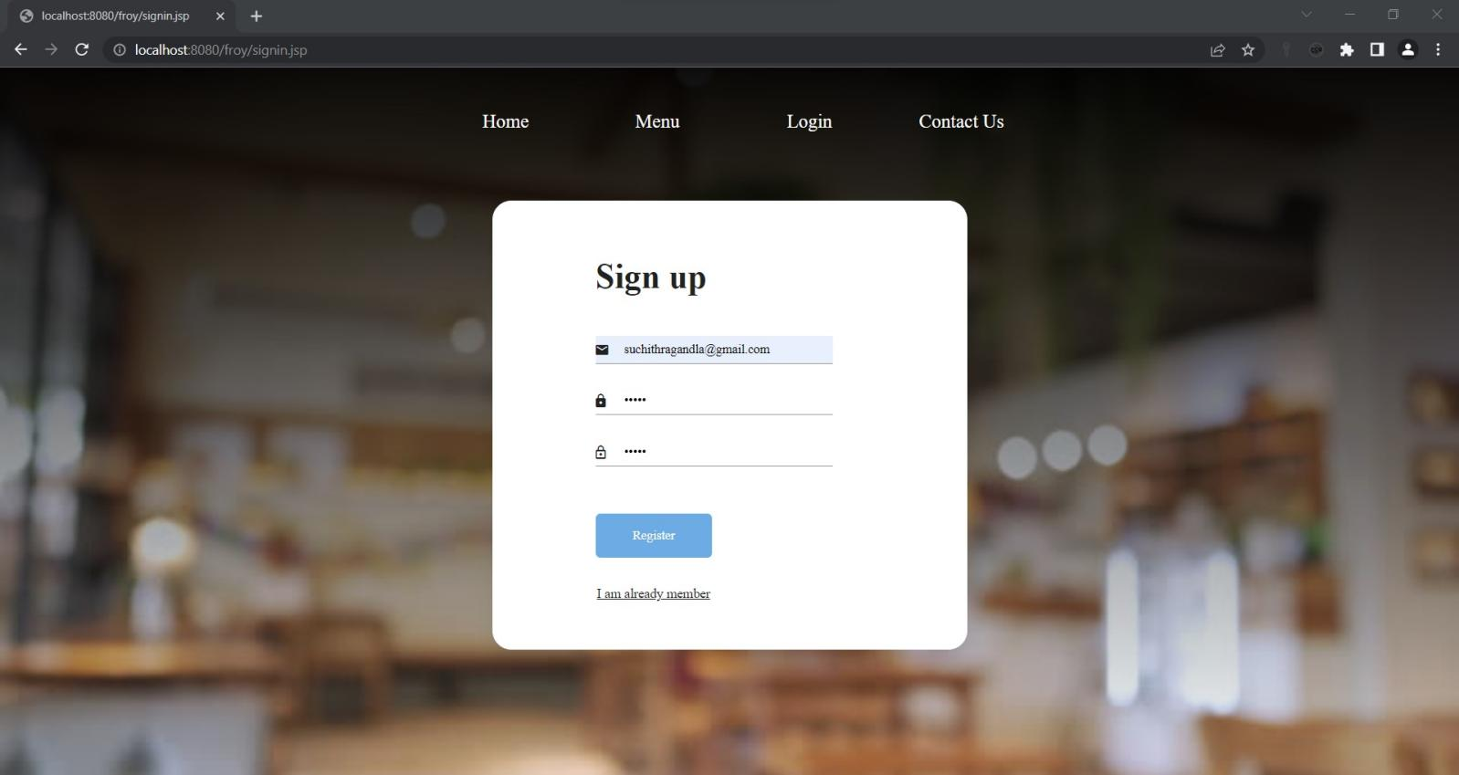

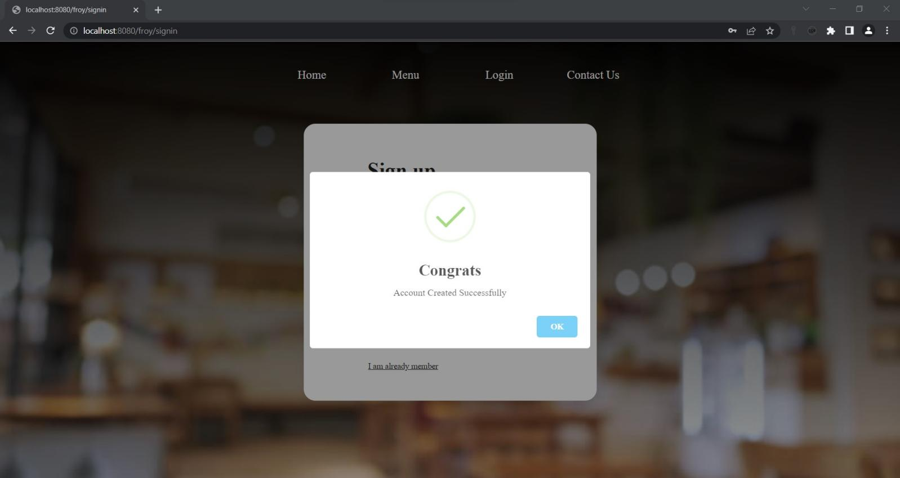

1. **SigninServlet.java page:**

package com.uniquedeveloper.signup;

import java.io.*;

import jakarta.servlet.*;

import jakarta.servlet.annotation.WebServlet;

import jakarta.servlet.http.*;

import java.sql.Connection;

import java.sql.DriverManager;

import java.sql.PreparedStatement;

import java.sql.SQLException;

*@WebServlet*("/signin")

public class SigninServlet extends HttpServlet {

private static final long ***serialVersionUID*** = 1L;

protected void doPost(HttpServletRequest request, HttpServletResponse response)

throws ServletException, IOException {

String uemail = request.getParameter("email");

String upwd = request.getParameter("password");

String Reupwd = request.getParameter("re_pass");

RequestDispatcher dispatcher = null;

Connection con = null;

if(uemail == null || uemail.equals("")) {

request.setAttribute("status","invalidEmail");

dispatcher = request.getRequestDispatcher("signin.jsp");

dispatcher.forward(request, response);

}

if(upwd == null || upwd.equals("")) {

request.setAttribute("status","invalidPwd");

dispatcher = request.getRequestDispatcher("signin.jsp");

dispatcher.forward(request, response);

}

if(Reupwd == null || !upwd.equals(Reupwd)) {

request.setAttribute("status","invalidConfirmPwd");

dispatcher = request.getRequestDispatcher("signin.jsp");

dispatcher.forward(request, response);

}

try {

Class.*forName*("com.mysql.cj.jdbc.Driver");

con = DriverManager.*getConnection*("jdbc:mysql://localhost:3306/signin","root","suchithra");

PreparedStatement pst = con.prepareStatement("insert into users(uemail,upwd) values(?,?)");

pst.setString(1,uemail);

pst.setString(2, upwd);

int rowCount = pst.executeUpdate();

dispatcher = request.getRequestDispatcher("signin.jsp");

if (rowCount >0) {

request.setAttribute("status", "success");

}else {

request.setAttribute("status", "failed");

}

dispatcher.forward(request, response);

}catch(Exception e) {

e.printStackTrace();

}finally {

try {

con.close();

}catch (SQLException e) {

e.printStackTrace();

}}}}

**After signup:**

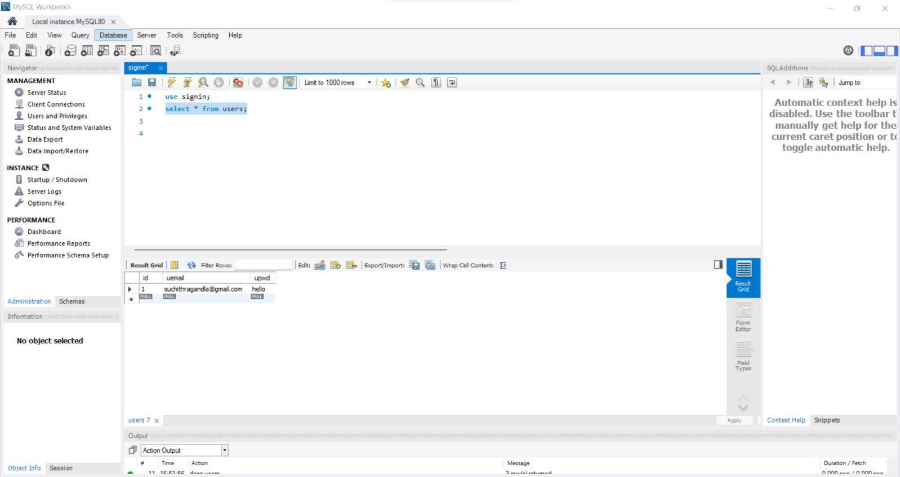

1. **reserve.jsp page:**

<**link** rel=*"stylesheet"* href=*"fonts/material-icon/css/material-design-iconic-font.min.css"*>

<!**DOCTYPE** html>

<**link** href=*"https://fonts.googleapis.com/css2?family=Open+Sans:wght@300&family=Pacifico&family=Titillium+Web:wght@200&display=swap"* rel=*"stylesheet"* >

<**html**>

<**head**>

<**meta** charset=*"utf-8"*>

<**meta** http-equiv=*"X-UA-Compatible"* content=*"IE=edge"*>

<**title**>Reservation Form</**title**>

<**meta** name=*"viewport"* content=*"width=device-width, initial-scale=1"*>

<**link** rel=*"stylesheet"* href=*"main.css"*>

<**link** rel=*"stylesheet"* href=*"fonts/material-icon/css/material-design-iconic-font.min.css"*>

<**style**>

@import *url('https://fonts.googleapis.com/css2?family=Poppins:wght@300;500;700&display=swap')*;

*{

box-sizing: *border-box*;

padding: *0*;

margin: *0*;

}

body{

font-family: *'Poppins', sans-serif*;

margin: *0px*;

}

.banner{

min-height: *100vh*;

background: *linear-gradient(rgba(0, 0, 0, 0.5), rgba(0, 0, 0, 0.5)), url("https://media.gettyimages.com/videos/tilt-down-blur-restaurant-for-background-video-id1273433362?s=640x640") center/cover no-repeat*;

display: *flex*;

flex-direction: *column*;

justify-content: *center*;

align-items: *center*;

color: *#fff*;

padding-bottom: *20px*;

}

.card-container{

display: *grid*;

grid-template-columns: *420px 420px*;

}

.card-img{

background: *url("https://restaurantindia.s3.ap-south-1.amazonaws.com/s3fs-public/content9723.jpg") center/cover no-repeat*;

}

.banner h2{

padding-bottom: *40px*;

margin-bottom: *20px*;

}

.card-content{

background: *#fff*;

height: *330px*;

}

.card-content h3{

text-align: *center*;

color: *#000*;

padding: *25px 0 10px 0*;

font-size: *26px*;

font-weight: *500*;

}

.form-row{

display: *flex*;

width: *90%*;

margin: *0 auto*;

}

form select, form input{

display: *block*;

width: *100%*;

margin: *15px 12px*;

padding: *5px*;

font-size: *15px*;

font-family: *'Poppins', sans-serif*;

outline: *none*;

border: *none*;

border-bottom: *1px solid #eee*;

font-weight: *300*;

}

form input[type = text], form input[type = number], form input::placeholder, select{

}

form input[type = submit]{

color: *#fff*;

background: *#f2745f*;

padding: *12px 0*;

border-radius: *4px*;

cursor: *pointer*;

}

form input[type = submit]:hover{

opacity: *0.9*;

}

@media(max-width: 992px){

.card-container{

grid-template-columns: *100%*;

width: *100vw*;

}

.card-img{

height: *330px*;

}

}

.navbar{

width: *auto*;

float: *right*;

border: *none*;

height: *70px*;

padding: *15px*;

font-family: *Tapestry*;

}

.navbar ul li{

width: *150px*;

float: *left*;

margin: *25px auto*;

text-align: *center*;

padding: *5px*;

position: *relative*;

right: *20px*;

top:*-100px*;

}

.navbar ul li a{

text-decoration: *none*;

color: *white*;

font-size: *20px*;

padding: *2px*;

}

.navbar ul li a:hover{

color: *white*;

text-decoration: *underline*;

}

#start{

position:*relative*;

right:*5px*;}

</**style**>

</**head**>

<**body**>

<**section** class = *"banner"*>

<**input** type=*"hidden"* id=*"status"* value="<%= request.getAttribute("status") %>">

<**header**>

<**nav** class=*"navbar"*>

<**ul** type=*"none"*>

<**li**><**a** href=*"index.jsp"*>Home</**a**></**li**>

<**li**><**a** href=*"menu.jsp"*>Menu</**a**></**li**>

<**li**><**a** href=*"logout"*>Logout</**a**></**li**>

<**li**><**a** href=*"contact.jsp"*>Contact Us</**a**></**li**>

</**ul**>

</**nav**>

</**header**>

<**h2**>BOOK YOUR TABLE NOW</**h2**>

<**div** class = *"card-container"*>

<**div** class = *"card-img"*>

<!-- image here -->

</**div**>

<**div** class = *"card-content"*>

<**h3**>Reservation</**h3**>

<**form** method=*"post"* action=*"reserve"*>

<**div** class = *"form-row"*>

<**input** type=*"date"* id=*"start"* name=*"date"*

min=*"2000-01-01"* max=*"2900-12-31"* required=*"required"*>

<**input** type=*"time"* id=*"appt"* name=*"hours"* required=*"required"*>

</**div**>

<**div** class = *"form-row"*>

<**input** type = *"text"* name=*"cname"* placeholder=*"Full Name"* required=*"required"*>

<**input** type = *"text"* name=*"number"* placeholder=*"Phone Number"* required=*"required"*>

</**div**>

<**div** class = *"form-row"*>

<**input** type = *"number"* name=*"guests"* placeholder=*"How Many Persons?"* min = *"1"* required=*"required"*>

<**input** type = *"submit"* name=*"submit"* value = *"BOOK TABLE"* required=*"required"*>

</**div**>

</**form**>

</**div**>

</**div**>

</**section**>

<**script** src=*"vendor/jquery/jquery.min.js"*></**script**>

<**script** src=*"js/main1.js"*></**script**>

<**script** src=*"https://unpkg.com/sweetalert/dist/sweetalert.min.js"*></**script**>

<**link** rel=*"stylesheet"* href=*"alert/dist/sweetalert.css"*>

<**script** type=*"text/javascript"*>

**var** status = document.getElementById("status").value;

**if**(status == "success"){

swal("Congrats", "Table reserved successfully","success");

}

**if**(status == "Givedate"){

swal("sorry", "Please enter date","error");

}

**if**(status == "Givehour"){

swal("sorry", "Please enter hour","error");

}

**if**(status == "invalidname"){

swal("sorry", "Please enter name","error");

}

**if**(status == "invalidnum"){

swal("sorry", "Please enter number","error");

}

**if**(status == "Givepersons"){

swal("sorry", "Please enter no of persons","error");

}

</**script**>

</**body**>

</**html**>

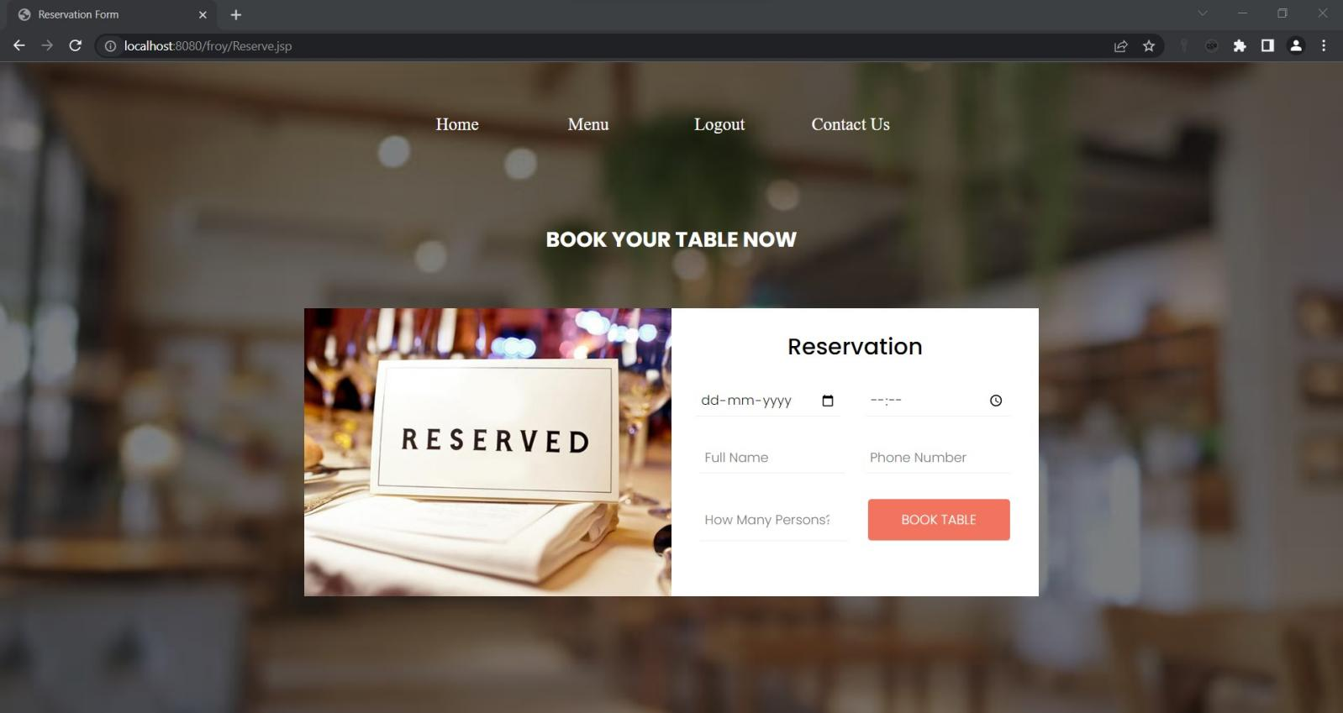

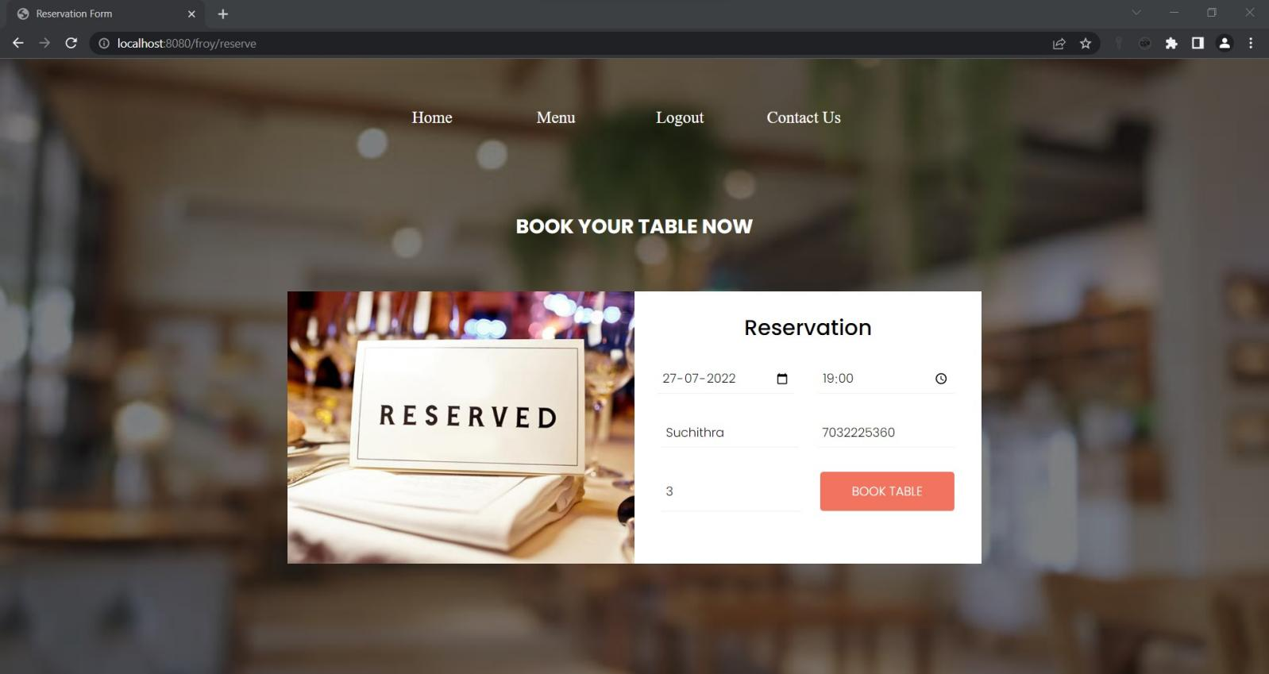

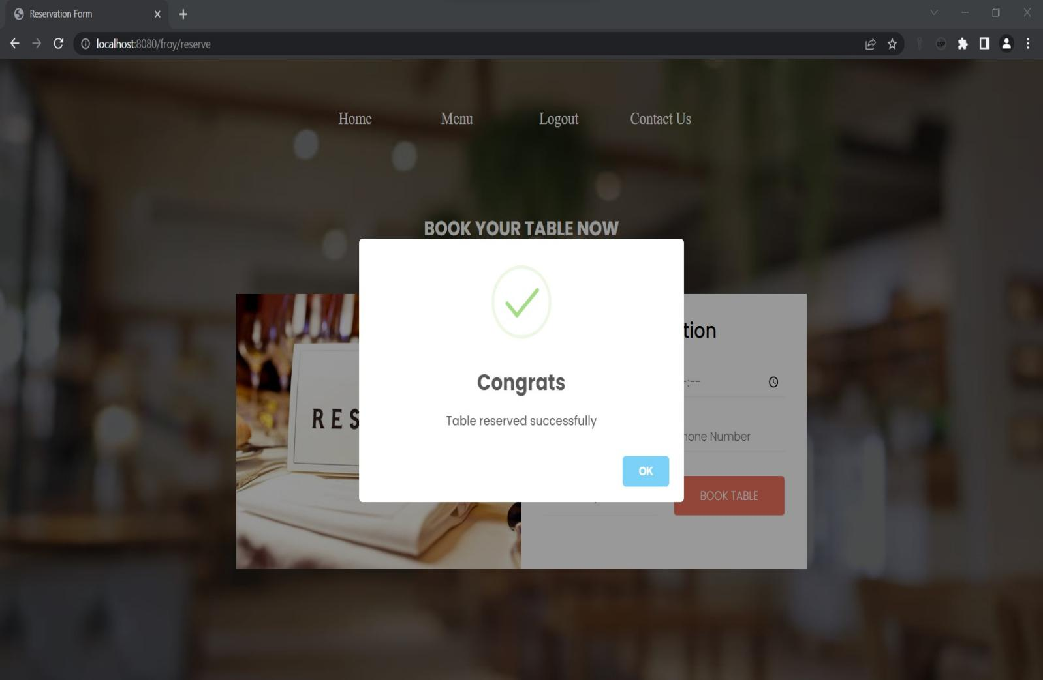

1. **reservetable.java page:**

package com.uniquedeveloper.signup;

import jakarta.servlet.RequestDispatcher;

import jakarta.servlet.ServletException;

import jakarta.servlet.annotation.WebServlet;

import jakarta.servlet.http.HttpServlet;

import jakarta.servlet.http.HttpServletRequest;

import jakarta.servlet.http.HttpServletResponse;

import java.io.IOException;

import java.sql.Connection;

import java.sql.DriverManager;

import java.sql.PreparedStatement;

import java.sql.SQLException;

@WebServlet("/reserve")

public class reservetable extends HttpServlet {

private static final long serialVersionUID = 1L;

protected void doPost(HttpServletRequest request, HttpServletResponse response)

throws ServletException, IOException {

String udate = request.getParameter("date");

String uhour = request.getParameter("hours");

String uname = request.getParameter("cname");

String uphonenum = request.getParameter("number");

String upersons = request.getParameter("guests");

RequestDispatcher dispatcher = null;

Connection con = null;

if(udate == null || udate.equals("")) {

request.setAttribute("status","Givedate");

dispatcher = request.getRequestDispatcher("Reserve.jsp");

dispatcher.forward(request, response);

}

if(uhour == null || uhour.equals("")) {

request.setAttribute("status","Givehour");

dispatcher = request.getRequestDispatcher("Reserve.jsp");

dispatcher.forward(request, response);

}

if(uname == null || uname.equals("")) {

request.setAttribute("status","invalidname");

dispatcher = request.getRequestDispatcher("Reserve.jsp");

dispatcher.forward(request, response);

}

if(uphonenum == null || uphonenum.equals("")) {

request.setAttribute("status","invalidnum");

dispatcher = request.getRequestDispatcher("Reserve.jsp");

dispatcher.forward(request, response);

}

if(upersons == null || upersons.equals("")) {

request.setAttribute("status","Givepersons");

dispatcher = request.getRequestDispatcher("Reserve.jsp");

dispatcher.forward(request, response);

}

try {

Class.forName("com.mysql.cj.jdbc.Driver");

con = DriverManager.getConnection("jdbc:mysql://localhost:3306/signin","root","suchithra");

PreparedStatement pst = con.prepareStatement("insert into reservetable(udate,uhour,uname,uphonenum,upersons) values(?,?,?,?,?)");

pst.setString(1,udate);

pst.setString(2, uhour);

pst.setString(3, uname);

pst.setString(4, uphonenum);

pst.setString(5, upersons);

int rowCount = pst.executeUpdate();

dispatcher = request.getRequestDispatcher("Reserve.jsp");

if (rowCount >0) {

request.setAttribute("status", "success");

}else {

request.setAttribute("status", "failed");

}

dispatcher.forward(request, response);

}catch(Exception e) {

e.printStackTrace();

}finally {

try {

con.close();

}catch (SQLException e) {

e.printStackTrace();

}

}

}}

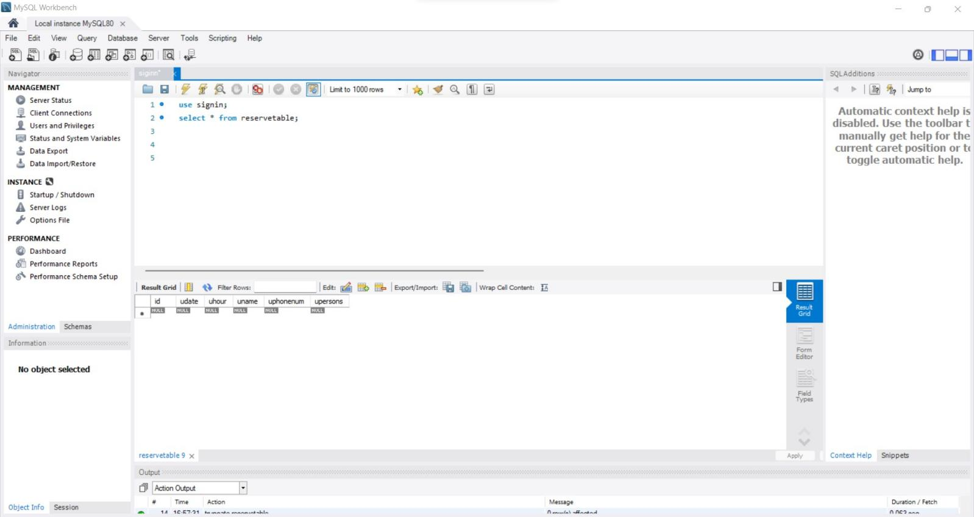

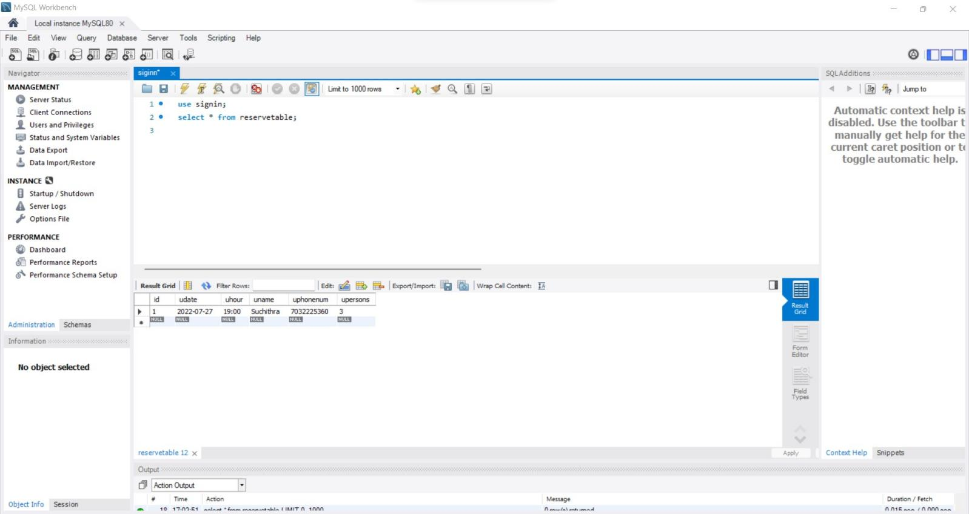

1. **menu.jsp page:**

<%

if(session.getAttribute("name")==null){

response.sendRedirect("login.jsp");

}

%>

<**html**>

<**head**>

<**style**>

* {

padding: *0px*;

margin: *0px*;

}

.hrcRestaurantMenu2Widget1323330 {

color: *#000*;

line-height: *normal*;

margin: *20px auto*;

padding: *0 15px*

}

.hrcRestaurantMenu2Widget1323330 sup {

left: *.1em*;

top: *-.4em*

}

.hrcRestaurantMenu2Widget1323330 li:before {

display: *none*

}

.hrcRestaurantMenu2Widget1323330 .menuLink {

text-align: *center*

}

.hrcRestaurantMenu2Widget1323330 .menuLink a {

background-color: *#c82540*;

border: *1px solid #c82540*;

-webkit-transition: *all .5s ease*;

transition: *all .5s ease*

}

.hrcRestaurantMenu2Widget1323330 .menuLink a:focus,

.hrcRestaurantMenu2Widget1323330 .menuLink a:hover {

background-color: *#000*;

border: *1px solid #000*

}

.hrcRestaurantMenu2Widget1323330 .menuLink.visible-xs {

margin: *20px auto*

}

.hrcRestaurantMenu2Widget1323330 .menuLink.visible-xs a {

display: *block*

}

.hrcRestaurantMenu2Widget1323330 .menuLink.visible-xs a:not(:last-child) {

margin-bottom: *3px*

}

.hrcRestaurantMenu2Widget1323330 .menuLink.visible-sm {

margin: *10px auto 30px*;

text-align: *center*

}

.hrcRestaurantMenu2Widget1323330 .menuLink.hidden-xs.hidden-sm {

margin: *30px auto 0*

}

.hrcRestaurantMenu2Widget1323330 .menuLink.hidden-xs.hidden-sm a {

margin-bottom: *5px*

}

.hrcRestaurantMenu2Widget1323330 .languagesMenu {

margin-bottom: *20px*;

position: *relative*;

text-align: *center*

}

.hrcRestaurantMenu2Widget1323330 .languagesMenu button {

background-color: *#c82540*;

border: *none*;

color: *#fff*;

padding: *10px*;

text-align: *center*;

width: *100%*

}

.hrcRestaurantMenu2Widget1323330 .languagesMenu .fas.fa-comments {

margin-right: *10px*

}

.hrcRestaurantMenu2Widget1323330 .languagesMenu .fas.fa-caret-down {

margin-left: *10px*

}

.hrcRestaurantMenu2Widget1323330 .languagesMenu .dropdown-menu {

background-color: *#000*;

border: *none*;

border-radius: *0*;

margin-top: *0*;

padding-left: *0 !important*;

text-align: *center*;

top: *42px*;

width: *100%*

}

.hrcRestaurantMenu2Widget1323330 .languagesMenu .dropdown-menu>li>a {

color: *#fff*;

padding: *10px*;

text-transform: *uppercase*

}

.hrcRestaurantMenu2Widget1323330 .languagesMenu .dropdown-menu>li>a:focus,

.hrcRestaurantMenu2Widget1323330 .languagesMenu .dropdown-menu>li>a:hover {

background-color: *#000*;

color: *#f9b200*

}

.hrcRestaurantMenu2Widget1323330 .languagesNavPill,

.hrcRestaurantMenu2Widget1323330 .languagesNavPill .dropdown-menu {

width: *150px*

}

.hrcRestaurantMenu2Widget1323330 .languagesNavPill {

background-color: *#fff*;

border-radius: *0*;

c82540 color: *#000*;

cursor: *pointer*;

padding: *10px 15px*

}

.hrcRestaurantMenu2Widget1323330 .languagesNavPill:focus,

.hrcRestaurantMenu2Widget1323330 .languagesNavPill:hover {

background-color: *#c82540*;

border-color: *#c82540*;

color: *#fff*

}

.hrcRestaurantMenu2Widget1323330 .languagesNavPill .fas {

margin-left: *10px*

}

.hrcRestaurantMenu2Widget1323330 .languagesNavPill .dropdown-menu {

background-color: *#c82540*;

border: *none*;

border-radius: *0*;

box-shadow: *none*;

color: *#fff*;

margin-top: *0*;

margin-left: *-2px*;

min-width: *0*;

padding-left: *4px !important*

}

.hrcRestaurantMenu2Widget1323330 .languagesNavPill .dropdown-menu li {

margin: *0*;

width: *100%*

}

.hrcRestaurantMenu2Widget1323330 .languagesNavPill .dropdown-menu>.active>a {

background-color: *transparent*;

color: *#E6DBD9*

}

.hrcRestaurantMenu2Widget1323330 .languagesNavPill .dropdown-menu a {

color: *#fff*;

padding: *10px 15px*

}

.hrcRestaurantMenu2Widget1323330 .languagesNavPill .dropdown-menu>.active>a:focus,

.hrcRestaurantMenu2Widget1323330 .languagesNavPill .dropdown-menu>.active>a:hover {

color: *#fff*

}

.hrcRestaurantMenu2Widget1323330 .languagesNavPill .dropdown-menu a:focus,

.hrcRestaurantMenu2Widget1323330 .languagesNavPill .dropdown-menu a:hover {

background-color: *transparent*;

color: *#E6DBD9*

}

.hrcRestaurantMenu2Widget1323330 .panel-group .panel+.panel {

margin-top: *0*

}

.hrcRestaurantMenu2Widget1323330 .panel-heading {

background-color: *#fff*;

padding: *0*

}

.hrcRestaurantMenu2Widget1323330 .panel-default {

border: *2px solid #000*;

border-bottom: *1px*;

border-radius: *0*

}

.hrcRestaurantMenu2Widget1323330 .panel-default:last-child {

border-bottom: *2px solid #000*

}

.hrcRestaurantMenu2Widget1323330 .panel-title {

font-weight: *800*;

text-align: *center*

}

.hrcRestaurantMenu2Widget1323330 .panel-title>a {

display: *block*;

padding: *10px 15px*;

text-decoration: *none*

}

.hrcRestaurantMenu2Widget1323330 .panel-title>a:hover,

.hrcRestaurantMenu2Widget1323330 .panel-title>a.js-tabcollapse-panel-heading {

background-color: *#c82540*;

color: *#fff*

}

.hrcRestaurantMenu2Widget1323330 .panel-title>a.js-tabcollapse-panel-heading.collapsed {

background-color: *#fff*;

color: *#000*

}

.hrcRestaurantMenu2Widget1323330 .panel-default>.panel-heading+.panel-collapse>.panel-body {

border-top: *2px solid #000*

}

.hrcRestaurantMenu2Widget1323330 .nav-pills {

margin: *30px auto 20px*;

padding: *0 10px*;

text-align: *center*;

position: *relative*;

top: *-55px*;

}

.hrcRestaurantMenu2Widget1323330 .nav-pills li {

display: *inline-block*;

float: *none*;

font-weight: *850*;

margin: *0 5px 15px*;

text-transform: *uppercase*

}

.hrcRestaurantMenu2Widget1323330 .nav-pills>li>a {

background-color: *#fff*;

border-radius: *0*;

color: *#000*;

text-decoration: *none*;

-webkit-transition: *all .5s ease*;

transition: *all .5s ease*

}

.hrcRestaurantMenu2Widget1323330 .nav-pills>li>a:hover

{

background-color: *grey*;

border-color: *black*;

color: *black*;

-webkit-transition: *all .5s ease*;

transition: *all .5s ease*

}

.hrcRestaurantMenu2Widget1323330 h2 {

color: *#c82540*;

font-family: *'Oswald', sans-serif*;

font-size: *2rem*;

font-weight: *700*;

letter-spacing: *2px*;

margin-top: *0*

}

.hrcRestaurantMenu2Widget1323330 .submenuGroup {

margin-top: *50px*

}

.hrcRestaurantMenu2Widget1323330 .menuItemList {

list-style-type: *none*;

margin-top: *50px*;

padding-left: *0 !important*

}

.hrcRestaurantMenu2Widget1323330 .menuItemList li:not(:first-child) {

margin-top: *30px*

}

.hrcRestaurantMenu2Widget1323330 .menuItemList li h4 {

font-size: *1.1rem*;

font-weight: *800*;

margin-bottom: *5px*

}

.hrcRestaurantMenu2Widget1323330 .menuItemList li div {

font-weight: *400*

}

.hrcRestaurantMenu2Widget1323330 .tabDisclaimer {

font-size: *0.85rem*;

line-height: *1.8*;

margin: *30px auto 0*

}

.hrcRestaurantMenu2Widget1323330 li.newItemYes {

position: *relative*

}

.hrcRestaurantMenu2Widget1323330 li.newItemYes:before {

display: *block*;

content: *url('https://www.hardrockcafe.com/files/5282/menuNew.png') !important*;

position: *absolute*;

left: *-22px*;

top: *-7px*

}

.hrcRestaurantMenu2Widget1323330 .featuredItem {

text-align: *center*

}

.hrcRestaurantMenu2Widget1323330 .featuredItem:not(.TabFeaturedItem1) {

margin-top: *30px*

}

.hrcRestaurantMenu2Widget1323330 .featuredItemContent {

border: *4px solid #c82540*;

font-weight: *400*;

margin: *30px auto 0*;

padding: *20px*

}

.hrcRestaurantMenu2Widget1323330 .featuredItemContent h3 {

font-size: *1.5rem*;

font-weight: *900*;

margin: *0*

}

.hrcRestaurantMenu2Widget1323330 .featuredItemContent>div {

margin-top: *10px*

}

.hrcRestaurantMenu2Widget1323330 .addtlInfo {

border: *4px solid #c82540*;

font-weight: *400*;

margin: *30px auto 0*;

padding: *20px*

}

.hrcRestaurantMenu2Widget1323330 .addtlInfoHeading {

color: *#c82540*;

font-family: *'Nunito Sans', sans-serif*;

font-style: *italic*;

font-weight: *700*;

margin-top: *0*;

text-transform: *none*

}

.hrcRestaurantMenu2Widget1323330 .addtlInfoContent {}

.hrcRestaurantMenu2Widget1323330 .panel-body {}

.hrcRestaurantMenu2Widget1323330 .panel-body a {

color: *#c82540*

}

.hrcRestaurantMenu2Widget1323330 .tab-content {

background-position: *50% 50%*;

background-size: *cover*;

color: *#000*;

padding: *30px*

}

.hrcRestaurantMenu2Widget1323330 .tab-pane {

background-color: *#fff*;

padding: *50px*

}

.hrcRestaurantMenu2Widget1323330 .tab-pane a {

color: *#c82540*

}

@media (min-width:768px) {}

@media (min-width:992px) {

.hrcRestaurantMenu2Widget1323330 .nav-pills>li.active>a:hover {

background-color: *#fff*;

border-color: *#000*;

color: *#000*

}

.hrcRestaurantMenu2Widget1323330 h2 {

font-size: *3.5rem*

}

.hrcRestaurantMenu2Widget1323330 .submenuGroup {

margin-top: *0*

}

.hrcRestaurantMenu2Widget1323330 .submenuGroup:not(.TabMenuItem1) {

margin-top: *100px*

}

}

@media (min-width:1200px) {

.hrcRestaurantMenu2Widget1323330 h2 {

font-size: *4rem*

}

}

@media (min-width:1400px) {

.hrcRestaurantMenu2Widget1323330 h2 {

font-size: *5rem*

}

}

</**style**>

</**head**>

<**body**>

<**button** onclick="topFunction()" id=*"myBtn"* title=*"Go to top"*>Top</**button**>

<**style**>

#myBtn {

display: *none*;

position: *fixed*;

bottom: *20px*;

right: *30px*;

z-index: *99*;

font-size: *18px*;

border: *none*;

outline: *none*;

background-color: *#a86868*;

color: *white*;

cursor: *pointer*;

padding: *15px*;

border-radius: *4px*;

}

#myBtn:hover {

background-color: *#555*;

}

</**style**>

<**script**>

**var** mybutton = document.getElementById("myBtn");

window.onscroll = **function**() {scrollFunction()};

**function** scrollFunction() {

**if** (document.body.scrollTop > 20 || document.documentElement.scrollTop > 20) {

mybutton.style.display = "block";

} **else** {

mybutton.style.display = "none";

}

}

**function** topFunction() {

document.body.scrollTop = 0;

document.documentElement.scrollTop = 0;

}

</**script**>

<**div** id=*"hero"* style="margin-top: *87px*;">

<**div** id=*"headerImg"*>

<**div** id=*"vizHeroImage31Widget805803"* class=*"customWidget vizHeroImage31Widget pageWidgetId805803"*>

<**style**>

.vizHeroImage31Widget805803 div.hero-image {

background-size: *cover*;

background-repeat: *no-repeat*;

height: *0px padding*:*0px*;

position: *relative*;

top: *-100px*;

}

.vizHeroImage31Widget805803 .hero-image {

position: *relative*

}

.vizHeroImage31Widget805803 .hero-fade {

display: *none*

}

</**style**>

<**div** class=*"vizHeroImage31Widget805803 fullViewportHero"*>

<**div** class=*"hero-image"* style="height: *600.5px*;">

<**div** class=*"hero-fade"*></**div**>

<**nav** class=*"navbar"*>

<**ul** type=*"none"*>

<**li**><**a** href=*"index.jsp"*>Home</**a**></**li**>

<**li**><**a** href=*"menu.jsp"*>Menu</**a**></**li**>

<**li**><**a** href=*"logout"*>Logout</**a**></**li**>

<**li**><**a** href=*"contact.jsp"*>Contact Us</**a**></**li**>

</**ul**>

</**nav**>

<**style**>

.navbar {

width: *auto*;

float: *right*;

border: *none*;

height: *70px*;

padding: *15px*;

position: *relative*;

top: *13px*;

left: *-60px*;

}

.navbar ul li {

width: *150px*;

float: *left*;

margin: *25px auto*;

text-align: *center*;

padding: *5px*;

position: *relative*;

right: *350px*;

}

.navbar ul li a {

text-decoration: *none*;

color: *white*;

font-size: *20px*;

padding: *2px*;

}

.navbar ul li a:hover {

color: *white*;

text-decoration: *underline*;

}

</**style**>

<**style**>

#vizHeroImage31Widget805803 div.hero-image {

background-image: *linear-gradient(rgba(0, 0, 0, 0.65), rgba(0, 0, 0, 0)), url('https://hospitalitysnapshots.com/wp-content/uploads/sites/3/2019/05/lamico_5d8e9df29cf07.jpg')*;

background-position: *50% 70%*

}

@media (min-width:768px) {

#vizHeroImage31Widget805803 div.hero-image {

background-image: *linear-gradient(rgba(0, 0, 0, 0.65), rgba(0, 0, 0, 0)), url('https://hospitalitysnapshots.com/wp-content/uploads/sites/3/2019/05/lamico_5d8e9df29cf07.jpg')*;

background-position: *50% 70%*

}

}

@media (min-width:992px) {

#vizHeroImage31Widget805803 div.hero-image {

background-image: *linear-gradient(rgba(0, 0, 0, 0.65), rgba(0, 0, 0, 0)), url('https://hospitalitysnapshots.com/wp-content/uploads/sites/3/2019/05/lamico_5d8e9df29cf07.jpg')*;

background-position: *50% 70%*

}

</**style**>

<**div** class=*"visible carousel-caption"*>

<**h3**><**span** class=*"bgOuter"*><**span** class=*"bgInner"*><**span** class=*"bgInner2"*>Menu</**span**></**span**></**span**></**h3**>

</**div**>

<**style**>

@media (min-width: 768px) {

#hero .slideCaption,

#hero .carousel-caption {

right: *5%*;

left: *5%*;

}

}

#hero .slideCaption,

#hero .carousel-caption {

right: *8%*;

left: *8%*;

}

#hero .slideCaption,

#hero .carousel-caption {

right: *8%*;

left: *8%*;

}

@media screen and (min-width: 768px) .carousel-caption {

right: 20%;

left: 20%;

padding-bottom: 30px;

}

.carousel-caption {

position: *absolute*;

right: *15%*;

bottom: *20px*;

left: *15%*;

z-index: *10*;

padding-top: *20px*;

padding-bottom: *20px*;

color: *#fff*;

text-align: *center*;

text-shadow: *0 1px 2px rgb(0 0 0 / 60%)*;

}

#hero .carousel-caption h3 {

font-size: *2.7rem*;

margin: *0*;

text-align: *center*;

text-transform: *uppercase*;

}

#hero .visible.carousel-caption .bgInner {

background: *url(https://www.hardrockcafe.com/files/templates/1732/bannerBg.jpg) 50% 50% / cover*;

display: *inline-block*;

}

</**style**>

</**div**>

</**div**>

<**script**>

**function** ApplyHeight() {

**function** heightCalc() {

$fullViewport = **true**;

$iHeight = $(window).height() - ($('header').height() + ($(window).height() * .25));

}

**function** heightCalcFalse() {

$fullViewport = **false**;

$iWidth = $('body').width();

}

**var** $fullViewport;

**var** $iHeight;

**var** $iWidth;

heightCalc();

**if** ($fullViewport == **true**) {

$(".vizHeroImage31Widget805803 .hero-image").height($iHeight);

$(".vizHeroImage31Widget805803").addClass('fullViewportHero');

}

$(window).on('resize', **function**() {

**if** ($fullViewport == **true**) {

heightCalc();

$(".vizHeroImage31Widget805803 .hero-image").height($iHeight);

}

});

}

$(**function**() {

ApplyHeight();

});

</**script**>

</**div**>

</**div**>

</**div**>

<**div** class=*"hrcRestaurantMenu2Widget1323330"*>

<**ul** class=*"nav nav-pills nav-left hidden-xs"* role=*"tablist"* id=*"hrcRestaurantMenu2Widget1323330Nav"*>

<**li** class=*"enabledSection"* role=*"presentation"*><**a** href=*"#Tab1"* aria-controls=*"home"* role=*"tab"* data-toggle=*"tab"* aria-expanded=*"false"*>Burgers</**a**></**li**>

<**li** class=*"enabledSection"* role=*"presentation"*><**a** href=*"#Tab2"* aria-controls=*"home"* role=*"tab"* data-toggle=*"tab"* aria-expanded=*"false"*> Starters </**a**></**li**>

<**li** class=*"enabledSection"* role=*"presentation"*><**a** href=*"#Tab3"* aria-controls=*"home"* role=*"tab"* data-toggle=*"tab"* aria-expanded=*"false"*>Sandwiches</**a**></**li**>

<**li** class=*"enabledSection"* role=*"presentation"*><**a** href=*"#Tab4"* aria-controls=*"home"* role=*"tab"* data-toggle=*"tab"*>Salads &amp; Bowls</**a**></**li**>

<**li** class=*"enabledSection"* role=*"presentation"*><**a** href=*"#Tab6"* aria-controls=*"home"* role=*"tab"* data-toggle=*"tab"*>Desserts</**a**></**li**>

<**li** class=*"enabledSection"* role=*"presentation"*><**a** href=*"#Tab8"* aria-controls=*"home"* role=*"tab"* data-toggle=*"tab"* aria-expanded=*"true"*>Beverages</**a**></**li**>

</**ul**>

<**div** class=*"panel-group visible-xs"* id=*"hrcRestaurantMenu2Widget1323330Nav-accordion"*></**div**>

<**div** class=*"tab-content hidden-xs animated fadeIn"* data-originalsrc=*"https://www.hardrockcafe.com/files/5282/menuBg02.jpg"* style="background-image: *url(&quot;https://www.hardrockcafe.com/files/5282/menuBg02.jpg&quot;)*;">

<**div** role=*"tabpanel"* class=*"tab-pane fade enabledSection Tab1"* id=*"Tab1"*>

<**div** class=*"row"*>

<**div** class=*"col-xs-12 col-md-5 featuredItems"*>

<**div** class=*"visible-xs visible-sm"*>

<**center**>

<**h2** class=*"visible-sm"*> Burgers</**h2**>

<**p**> Burgers are served with a fresh toasted brioche bun and seasoned fries.</**p**>

</**center**>

</**div**>

<**div** class=*"featuredItem TabFeaturedItem1 TabFeaturedItemLast"*><**img** alt=*"Legendary Burger and Fries "* class=*"featuredItemImg"* data-originalsrc=*"https://www.hardrockcafe.com/files/5282/Burger-1-061.jpg"*

src=*"https://www.hardrockcafe.com/files/5282/Burger-1-061.jpg"* title=*"Original Legendary Burger"*>

<**div** class=*"featuredItemContent"*><**h3**>ORIGINAL LEGENDARY BURGER</**h3**><**div**><**em**>The burger that started it all!</**em**><**br**> Fresh steak burger, with Applewood bacon, Tillamook cheddar cheese, crispy onion ring, leaf lettuce and vine-ripened tomato, served with our signature steak sauce on the side.</**div**></**div**>

<**script**>

$(**function**() {

$('.hrcRestaurantMenu2Widget1323330 [href="#Tab1"]').on('show.bs.tab', **function**() {

$('.hrcRestaurantMenu2Widget1323330 .Tab1 .TabFeaturedItem1 .featuredItemImg').attr('src', $('.hrcRestaurantMenu2Widget1323330 .Tab1 .TabFeaturedItem1 .featuredItemImg').attr('data-originalsrc'));

});

});

</**script**>

</**div**>

</**div**>

<**div** class=*"col-xs-10 col-xs-push-1 col-md-6 col-md-push-1 menuItems"*>

<**div** class=*"submenuGroup TabMenuItem1"*>

<**ul** class=*"menuItemList"*>

<**li** class=*"TabMenuItemItem1 newItemNo"*>

<**h4**>BBQ BACON CHEESEBURGER</**h4**>

<**div**>Fresh steak burger, seasoned and seared with a signature spice blend, topped with house-made barbecue sauce, crispy shoestring onions, Tillamook cheddar cheese, Applewood bacon, leaf lettuce and vine-ripened tomato, served

with

our signature steak sauce on the side.</**div**>

</**li**>

<**li** class=*"TabMenuItemItem2 newItemNo"*>

<**h4**>THE BIG CHEESEBURGER</**h4**>

<**div**>Three slices of Tillamook cheddar cheese melted on our fresh steak burger with leaf lettuce, vine-ripened tomato and red onion, served with our signature steak sauce on the side.</**div**>

</**li**>

<**li** class=*"TabMenuItemItem3 newItemNo"*>

<**h4**>DOUBLE-DECKER DOUBLE CHEESEBURGER</**h4**>

<**div**><**em**>A tribute to our 1971 âDown Home Double Burgerâ</**em**><**br**> Two stacked steak burgers with American cheese, mayonnaise, leaf lettuce, vine-ripened tomato and red onion, served with our signature steak sauce on the side.*</**div**>

</**li**>

<**li** class=*"TabMenuItemItem4 newItemNo"*>

<**h4**>THE IMPOSSIBLE BURGER</**h4**>

<**div**>100% plant-based vegan patty, topped with Tillamook cheddar cheese and a crispy onion ring, served with leaf lettuce and vine-ripened tomato.<**br**><**small**><**em**>Vegan/vegetarian burgers vary in locations around the

world.</**em**></**small**>

</**div**>

</**li**>

<**li** class=*"TabMenuItemItem5 newItemNo"*>

<**h4**>MOVING MOUNTAINS BURGER</**h4**>

<**div**>100% plant-based vegan patty, topped with cheddar cheese and a crispy onion ring, served with leaf lettuce and vine-ripened tomato.</**div**>

</**li**>

<**li** class=*"TabMenuItemItem6 newItemNo"*>

<**h4**>SURF &amp; TURF BURGER</**h4**>

<**div**>Our signature steak burger topped with Spicy Shrimp on a bed of spicy slaw, served with our signature steak sauce on the side.</**div**>

</**li**>

</**ul**>

</**div**>

<**div** class=*"submenuGroup TabMenuItem2 TabMenuItemLast"*>

<**h2**><**center**>Smashed &amp; Stacked</**center**></**h2**>

<**ul** class=*"menuItemList"*>

<**li** class=*"TabMenuItemItem1 newItemNo"*>

<**h4**>COUNTRY BURGER</**h4**>

<**div**>Two smashed &amp; stacked burgers seasoned and seared medium-well, with American cheese, leaf lettuce, vine-ripened tomato, red onion, pickles, house-made burger sauce and served with a side of sweet relish.</**div**>

</**li**>

<**li** class=*"TabMenuItemItem2 newItemNo"*>

<**h4**>SWISS MUSHROOM BURGER</**h4**>

<**div**>Two smashed &amp; stacked burgers seasoned and seared medium-well, with Swiss cheese, sautÃ©ed mushrooms, leaf lettuce, vine-ripened tomato, and Dijon mayonnaise.</**div**>

</**li**>

<**li** class=*"TabMenuItemItem3 TabMenuItemItemLast newItemNo"*>

<**h4**>SPICY DIABLO BURGER</**h4**>

<**div**>Two smashed &amp; stacked burgers seasoned and seared medium-well, with Monterey Jack cheese, pickled jalapeÃ±os, leaf lettuce, vine-ripened tomato, and spicy mayonnaise.</**div**>

</**li**>

</**ul**>

</**div**>

</**div**>

</**div**>

</**div**>

<**div** role=*"tabpanel"* class=*"tab-pane fade enabledSection Tab2"* id=*"Tab2"*>

<**div** class=*"row"*>

<**div** class=*"col-xs-12 col-md-5 featuredItems"*>

<**div** class=*"visible-xs visible-sm"*>

<**center**>

<**h2** class=*"visible-sm"*>Starters </**h2**>

<**p**>Flavor, spice and an extra helping of attitude. That's worth celebrating.</**p**>

</**center**>

</**div**>

<**div** class=*"featuredItem TabFeaturedItem1"*><**img** alt=*"Nachos"* class=*"featuredItemImg"* data-originalsrc=*"https://www.hardrockcafe.com/files/5282/Nachos_No_Protein-20.jpg"*

src=*"https://www.hardrockcafe.com/files/5282/Nachos_No_Protein-20.jpg"* title=*"Classic Nachos"*>

<**div** class=*"featuredItemContent"*>

<**h3**>Classic Nachos</**h3**>

<**div**>Crisp tortilla chips layered with ranch-style beans and a four-cheese sauce blend, topped with fresh pico de gallo, spicy jalapeÃ±os, melted cheddar and Monterey Jack cheese, pickled red onions and scallions, served with sour

cream on

the side. <**strong**>Add Guacamole, Grilled Chicken, or Grilled Steak for an additional charge.</**strong**></**div**>

</**div**>

<**script**>

$(**function**() {

$('.hrcRestaurantMenu2Widget1323330 [href="#Tab2"]').on('show.bs.tab', **function**() {

$('.hrcRestaurantMenu2Widget1323330 .Tab2 .TabFeaturedItem1 .featuredItemImg').attr('src', $('.hrcRestaurantMenu2Widget1323330 .Tab2 .TabFeaturedItem1 .featuredItemImg').attr('data-originalsrc'));

});

});

</**script**>

</**div**>

<**div** class=*"featuredItem TabFeaturedItem2 TabFeaturedItemLast"*><**img** alt=*"Spicy Shrimp Menu Item at Hard Rock Cafe"* class=*"featuredItemImg"* data-originalsrc=*"https://www.hardrockcafe.com/files/5282/Dynamite-Shrimp-32.jpg"*

src=*"https://www.hardrockcafe.com/files/5282/Dynamite-Shrimp-32.jpg"* title=*"One Night in Bangkok Spicy Shrimp"*>

<**div** class=*"featuredItemContent"*>

<**h3**>Spicy Shrimp</**h3**>

<**div**>Crispy shrimp, tossed in a creamy, spicy sauce, topped with scallions, served on a bed of coleslaw.</**div**>

</**div**>

<**script**>

$(**function**() {

$('.hrcRestaurantMenu2Widget1323330 [href="#Tab2"]').on('show.bs.tab', **function**() {

$('.hrcRestaurantMenu2Widget1323330 .Tab2 .TabFeaturedItem2 .featuredItemImg').attr('src', $('.hrcRestaurantMenu2Widget1323330 .Tab2 .TabFeaturedItem2 .featuredItemImg').attr('data-originalsrc'));

});

});

</**script**>

</**div**>

</**div**>

<**div** class=*"col-xs-10 col-xs-push-1 col-md-6 col-md-push-1 menuItems"*>

<**div** class=*"submenuGroup TabMenuItem1 TabMenuItemLast"*>

<**ul** class=*"menuItemList"*>

<**li** class=*"TabMenuItemItem1 newItemNo"*>

<**h4**>THREE-CHEESE &amp; ROMA TOMATO FLATBREAD</**h4**>

<**div**>A blend of Mozzarella, Parmesan and Romano cheeses, topped with Roma tomatoes and fresh basil, drizzled with cilantro pesto. </**div**>

</**li**>

<**li** class=*"TabMenuItemItem2 newItemNo"*>

<**h4**>SOUTHWEST CHICKEN FLATBREAD</**h4**>

<**div**>Grilled fresh chicken, avocado, melted Italian cheeses, fresh pico de gallo, diced red peppers and scallions, finished with guacamole ranch. </**div**>

</**li**>

<**li** class=*"TabMenuItemItem3 newItemNo"*>

<**h4**>PEPPERONI FLATBREAD</**h4**>

<**div**>Melted Mozzarella, Parmesan and Romano cheeses, layered with sliced pepperoni and traditional pizza sauce, topped with a sprinkle of grated Romano cheese.

</**div**>

</**li**>

<**li** class=*"TabMenuItemItem4 newItemNo"*>

<**h4**>WINGS</**h4**>

<**div**>Our signature slow-roasted jumbo wings tossed with your choice of classic buffalo, sweet &amp; spicy tangy, or house-made barbecue sauce, served with celery and blue cheese dressing.</**div**>

</**li**>

<**li** class=*"TabMenuItemItem5 newItemNo"*>

<**h4**>BONELESS BODACIOUS WINGS</**h4**>

<**div**>Our crispy Tupelo Chicken Tenders tossed with your choice of classic buffalo, sweet &amp; spicy tangy, or house-made barbecue sauce, served with celery and blue cheese dressing.</**div**>

</**li**>

<**li** class=*"TabMenuItemItem6 newItemNo"*>

<**h4**>ALL-AMERICAN SLIDERS</**h4**>

<**div**>Three mini-burgers with melted American cheese, crispy onion ring and creamy coleslaw on a toasted brioche bun.</**div**>

</**li**>

<**li** class=*"TabMenuItemItem7 newItemNo"*>

<**h4**>CUBAN SLIDERS</**h4**>

<**div**>Three mini-burgers with melted Swiss cheese, Dijon mayonnaise, hand-pulled smoked pork and sliced pickle.</**div**>

</**li**>

<**li** class=*"TabMenuItemItem8 TabMenuItemItemLast newItemNo"*>

<**h4**>BRUSCHETTA</**h4**>

<**div**>Balsamic-marinated Roma tomatoes and fresh basil topped with Romano cheese. Served with toasted artisan bread drizzled with basil oil and a side of shaved Parmesan cheese.</**div**>

</**li**>

</**ul**>

</**div**>

</**div**>

</**div**>

</**div**>

<**div** role=*"tabpanel"* class=*"tab-pane fade enabledSection Tab3"* id=*"Tab3"*>

<**div** class=*"row"*>

<**div** class=*"col-xs-12 col-md-5 featuredItems"*>

<**div** class=*"visible-xs visible-sm"*>

<**center**>

<**h2** class=*"visible-sm"*>Sandwiches</**h2**>

<**p**>Served with seasoned fries or upgrade to Cheese Fries with Applewood Bacon.</**p**>

</**center**>

</**div**>

<**div** class=*"featuredItem TabFeaturedItem1 TabFeaturedItemLast"*>

<**img** alt=*"BBQ Pulled Pork Sandwich"* class=*"featuredItemImg"* data-originalsrc=*"https://www.hardrockcafe.com/files/5282/BBQ_Pulled_Pork-60.jpg"* src=*"https://www.hardrockcafe.com/files/5282/BBQ_Pulled_Pork-60.jpg"*>

<**div** class=*"featuredItemContent"*>

<**h3**>BBQ PULLED CHICKEN SANDIWCH</**h3**>

<**div**>Hand-pulled smoked pork with our house-made barbecue sauce, served on a toasted fresh brioche bun with coleslaw and pickles.</**div**>

</**div**>

<**script**>

$(**function**() {

$('.hrcRestaurantMenu2Widget1323330 [href="#Tab3"]').on('show.bs.tab', **function**() {

$('.hrcRestaurantMenu2Widget1323330 .Tab3 .TabFeaturedItem1 .featuredItemImg').attr('src', $('.hrcRestaurantMenu2Widget1323330 .Tab3 .TabFeaturedItem1 .featuredItemImg').attr('data-originalsrc'));

});

});

</**script**>

</**div**>

</**div**>

<**div** class=*"col-xs-10 col-xs-push-1 col-md-6 col-md-push-1 menuItems"*>

<**div** class=*"submenuGroup TabMenuItem1 TabMenuItemLast"*>

<**ul** class=*"menuItemList"*>

<**li** class=*"TabMenuItemItem1 newItemNo"*>

<**h4**>GRILLED CHICKEN SANDWICH</**h4**>

<**div**>Grilled fresh chicken with melted Monterey Jack cheese, Applewood bacon, leaf lettuce and vine-ripened tomato, served on a toasted fresh brioche bun with honey mustard sauce.</**div**>

</**li**>

<**li** class=*"TabMenuItemItem2 TabMenuItemItemLast newItemNo"*>

<**h4**>FRIED CHICKEN SANDWICH</**h4**>

<**div**>Crispy buttermilk-marinated chicken breast with leaf lettuce, vine-ripened tomato and ranch dressing, served on a toasted fresh brioche bun. <**br**><**em**>Spice it up with our classic buffalo sauce upon request! </**em**></**div**>

</**li**>

</**ul**>

</**div**>

</**div**>

</**div**>

</**div**>

<**div** role=*"tabpanel"* class=*"tab-pane fade enabledSection Tab4"* id=*"Tab4"*>

<**div** class=*"row"*>

<**div** class=*"col-xs-12 col-md-5 featuredItems"*>

<**div** class=*"visible-xs visible-sm"*>

<**h2** class=*"visible-sm"*>Salads &amp; Bowls</**h2**>

</**div**>

<**div** class=*"featuredItem TabFeaturedItem1 TabFeaturedItemLast"*><**img** alt=*"STEAK SALAD"* class=*"featuredItemImg"* data-originalsrc=*"https://www.hardrockcafe.com/files/5282/Steak-Salad-044.jpg"*

src=*"https://www.hardrockcafe.com/files/5282/Steak-Salad-044.jpg"* title=*"STEAK SALAD"*>

<**div** class=*"featuredItemContent"*>

<**h3**>STEAK SALAD</**h3**>

<**div**>8oz grilled steak on a bed of fresh mixed greens tossed in a blue cheese vinaigrette, with pickled red onions, red peppers and Roma tomatoes, finished with crispy shoestring onions and blue cheese crumbles.</**div**>

</**div**>

<**script**>

$(**function**() {

$('.hrcRestaurantMenu2Widget1323330 [href="#Tab4"]').on('show.bs.tab', **function**() {

$('.hrcRestaurantMenu2Widget1323330 .Tab4 .TabFeaturedItem1 .featuredItemImg').attr('src', $('.hrcRestaurantMenu2Widget1323330 .Tab4 .TabFeaturedItem1 .featuredItemImg').attr('data-originalsrc'));

});

});

</**script**>

</**div**>

</**div**>

<**div** class=*"col-xs-10 col-xs-push-1 col-md-6 col-md-push-1 menuItems"*>

<**div** class=*"submenuGroup TabMenuItem1 TabMenuItemLast"*>

<**ul** class=*"menuItemList"*>

<**li** class=*"TabMenuItemItem1 newItemNo"*>

<**h4**>GRILLED CHICKEN CAESAR SALAD</**h4**>

<**div**>Fresh chicken breast grilled and sliced, with fresh romaine tossed in a classic Caesar dressing, topped with Parmesan crisps, croutons and shaved Parmesan cheese. <**b**>Substitute Grilled Salmon for an additional charge.</**b**></**div**>

</**li**>

<**li** class=*"TabMenuItemItem2 newItemNo"*>

<**h4**>GRILLED SALMON NOODLE BOWL</**h4**>

<**div**>Ramen noodles tossed in a sesame-soy dressing over a bed of mixed greens topped with edamame, julienned carrots, red peppers, cabbage, and scallions, served with grilled Norwegian salmon.</**div**>

</**li**>

<**li** class=*"TabMenuItemItem3 TabMenuItemItemLast newItemNo"*>

<**h4**>SOUTHWESTERN CHICKEN BOWL</**h4**>

<**div**>Fajita-spiced chicken, quinoa corn salad, pico de gallo, seasoned black beans and red cabbage served on mixed greens tossed in a guacamole ranch dressing.</**div**>

</**li**>

</**ul**>

</**div**>

</**div**>

</**div**>

</**div**>

<**div** role=*"tabpanel"* class=*"tab-pane fade enabledSection Tab6"* id=*"Tab6"*>

<**div** class=*"row"*>

<**div** class=*"col-xs-12 col-md-5 featuredItems"*>

<**div** class=*"visible-xs visible-sm"*>

<**h2** class=*"visible-sm"*>

<**center**>Desserts</**center**>

</**h2**>

</**div**>

<**div** class=*"featuredItem TabFeaturedItem1 TabFeaturedItemLast"*><**img** alt=*"Hot Fudge Brownie"* class=*"featuredItemImg"* data-originalsrc=*"https://www.hardrockcafe.com/files/5282/Hot_fudge_sunday_4.jpg"*

src=*"https://www.hardrockcafe.com/files/5282/Hot_fudge_sunday_4.jpg"* title=*"Hot Fudge Brownie"*>

<**div** class=*"featuredItemContent"*>

<**h3**>HOT FUDGE BROWNIE</**h3**>

<**div**>Warm chocolate brownie topped with vanilla bean ice cream, hot fudge, chocolate sprinkles, fresh whipped cream and a cherry.</**div**>

</**div**>

<**script**>

$(**function**() {

$('.hrcRestaurantMenu2Widget1323330 [href="#Tab6"]').on('show.bs.tab', **function**() {

$('.hrcRestaurantMenu2Widget1323330 .Tab6 .TabFeaturedItem1 .featuredItemImg').attr('src', $('.hrcRestaurantMenu2Widget1323330 .Tab6 .TabFeaturedItem1 .featuredItemImg').attr('data-originalsrc'));

});

});

</**script**>

</**div**>

</**div**>

<**div** class=*"col-xs-10 col-xs-push-1 col-md-6 col-md-push-1 menuItems"*>

<**div** class=*"submenuGroup TabMenuItem1 TabMenuItemLast"*>

<**ul** class=*"menuItemList"*>

<**li** class=*"TabMenuItemItem1 newItemNo"*>

<**h4**>NEW YORK CHEESECAKE</**h4**>

<**div**>Rich and creamy NY-style cheesecake served with a fresh strawberry sauce and fresh whipped cream.</**div**>

</**li**>

<**li** class=*"TabMenuItemItem2 newItemNo"*>

<**h4**>HOMEMADE APPLE COBBLER</**h4**>

<**div**>Old-fashioned apple cobbler with warm Granny Smith apples, baked until golden brown and topped with vanilla bean ice cream and caramel sauce.</**div**>

</**li**>

<**li** class=*"TabMenuItemItem3 newItemNo"*>

<**h4**>ICE CREAM</**h4**>

<**div**>Choose from Madagascar vanilla bean or rich chocolate.</**div**>

</**li**>

<**li** class=*"TabMenuItemItem4 TabMenuItemItemLast newItemNo"*>

<**h4**>DINER-STYLE MILKSHAKES</**h4**>

<**div**>Your choice of Madagascar vanilla bean or rich chocolate ice cream blended thick and finished with fresh whipped cream.</**div**>

</**li**>

</**ul**>

</**div**>

</**div**>

</**div**>

</**div**>

<**div** role=*"tabpanel"* class=*"tab-pane fade enabledSection Tab8 TabLast active in"* id=*"Tab8"*>

<**div** class=*"row"*>

<**div** class=*"col-xs-12 col-md-5 featuredItems"*>

<**div** class=*"visible-xs visible-sm"*>

<**h2** class=*"visible-sm"*><**span** class=*"visible-sm"*>

<**center**>Beverages</**center**>

</**span**></**h2**>

</**div**>

<**div** class=*"featuredItem TabFeaturedItem1 TabFeaturedItemLast"*><**img** alt=*"Hurricane Alcoholic Beverage"* class=*"featuredItemImg"* data-originalsrc=*"https://www.hardrockcafe.com/files/5282/Hurricane-04.jpg"*

src=*"https://www.hardrockcafe.com/files/5282/Hurricane-04.jpg"* title=*"Hurricane"*>

<**div** class=*"featuredItemContent"*>

<**h3**>Hurricane</**h3**>

<**div**><**em**>Our signature cocktail and a 1940s New Orleans classic! </**em**><**br**>Bacardi Superior Rum, a blend of orange, mango, pineapple juice and grenadine, finished with a float of Bacardi Black Rum and Amaretto. Include your own

collectible

glass for an additional charge.</**div**>

</**div**>

<**script**>

$(**function**() {

$('.hrcRestaurantMenu2Widget1323330 [href="#Tab8"]').on('show.bs.tab', **function**() {

$('.hrcRestaurantMenu2Widget1323330 .Tab8 .TabFeaturedItem1 .featuredItemImg').attr('src', $('.hrcRestaurantMenu2Widget1323330 .Tab8 .TabFeaturedItem1 .featuredItemImg').attr('data-originalsrc'));

});

});

</**script**>

</**div**>

</**div**>

<**div** class=*"col-xs-10 col-xs-push-1 col-md-6 col-md-push-1 menuItems"*>

<**div** class=*"submenuGroup TabMenuItem1"*>

<**ul** class=*"menuItemList"*>

<**li** class=*"TabMenuItemItem1 newItemNo"*>

<**h4**>Classic Caribbean Mojito</**h4**>

<**div**><**em**>A treasured favorite with a little extra jazz!</**em**><**br**>Bacardi Superior Rum, fresh mint, lime juice and sparkling soda, with a premium Bacardi AÃ±ejo Cuatro floater and a powdered sugar sprinkle.</**div**>

</**li**>

<**li** class=*"TabMenuItemItem2 newItemNo"*>

<**h4**>Rockin' Fresh Rita</**h4**>

<**div**>Milagro Silver Tequila, fresh lime juice and agave nectar, finished with our signature sweet and savory rim. <**strong**>Upgrade to PatrÃ³n Silver Tequila for an additional charge.</**strong**></**div**>

</**li**>

<**li** class=*"TabMenuItemItem3 newItemNo"*>

<**h4**>Blackberry Sparkling Sangria</**h4**>

<**div**>A signature blend of red wine, the fresh flavors of blackberries, cranberry juice and squeeze of orange, topped with bubbly Riondo Prosecco.</**div**>

</**li**>

<**li** class=*"TabMenuItemItem4 TabMenuItemItemLast newItemNo"*>

<**h4**>Ultimate Long Island Iced Tea</**h4**>

<**div**>Tito's Handmade Vodka, Bombay Sapphire Gin, Sailor Jerry Spiced Rum, Cointreau Orange Liqueur, house-made sour mix finished with a splash of Coca-Cola<**sup**>Â®</**sup**>. </**div**>

</**li**>

</**ul**>

</**div**>

</**div**>

</**div**>

</**div**>

</**div**>

</**div**>

</**body**>

</**html**>

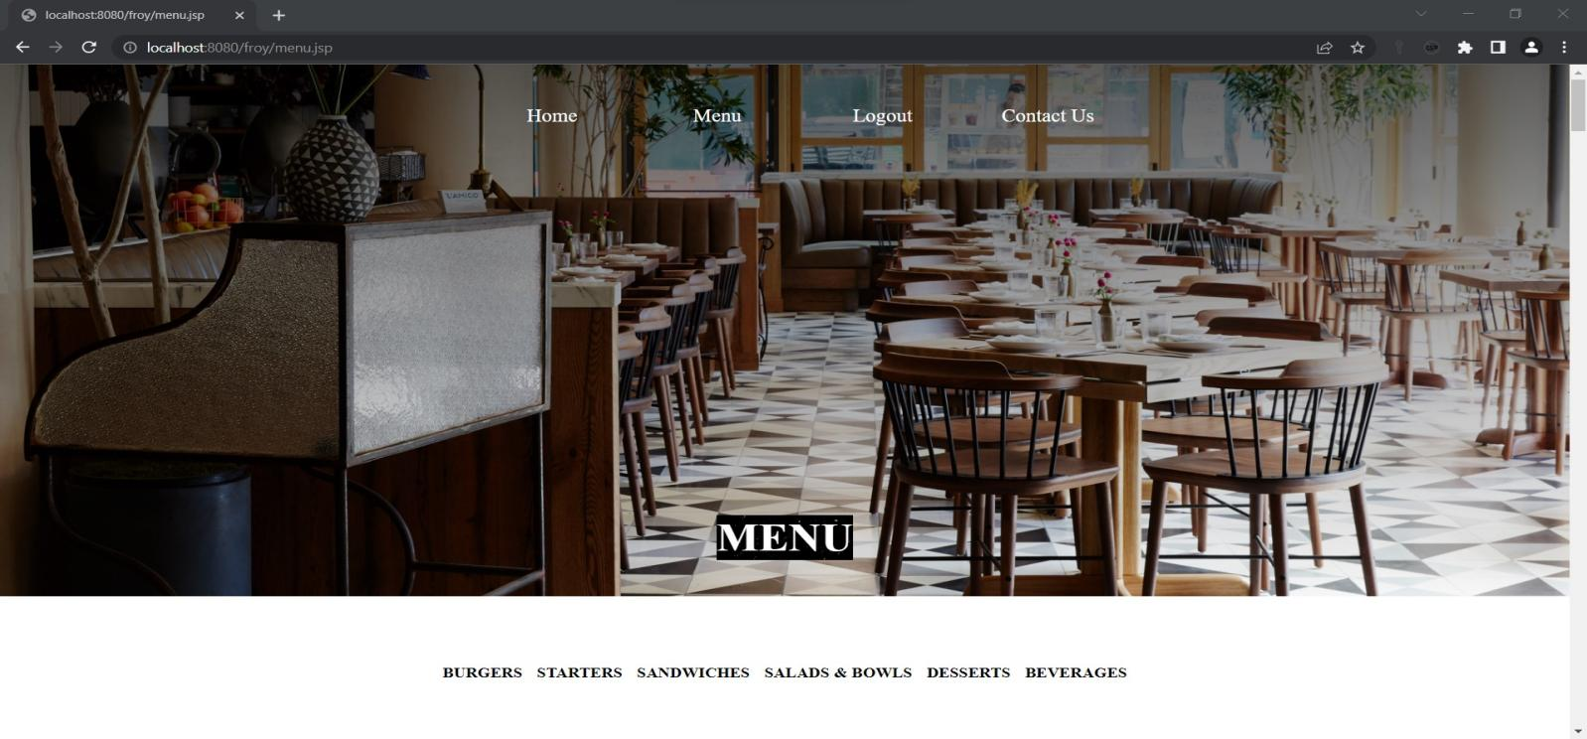

1. **contact.jsp page:**

<%

if(session.getAttribute("name")==null){

response.sendRedirect("login.jsp");

}

%>

<**link** rel=*"stylesheet"* href=*"fonts/material-icon/css/material-design-iconic-font.min.css"*>

<!**DOCTYPE** html>

<**html**>

<**head**>

<**style**>

*{

padding: *0px*;

margin:*0px*;

}

.contact {

position: *relative*;

padding: *0px*;

margin: *0px*

*align-items*: *center*;

height: *auto*;

background-image: *url('https://img.freepik.com/free-photo/abstract-dark-blue-grunge-texture-with-scratches-spots-old-cement-plaster-wall-background_150101-2005.jpg')*;

color: *white*;

background-size:*cover*;

}

.container {

width:*auto*;

padding: *20px 20px*;

position: *relative*;

}

.container .contactInfo

{

width:*50%*;

display: *flex*;

flex-direction: *row*;

}

.container .conatactInfo .box{

position: *absolute*;

display:*flex*;

}

.container .contactInfo .box1 .icon{

width: *50px*;

height: *50px*;

position: *relative*;

font-size: *26px*;

top:*80px*;

}

.container .contactInfo .box1 .text{

text-align: *left*;

width: *150px*;

position: *relative*;

left: *43px*;

top: *25px*;

}

.container .contactInfo .box2 .icon{

width: *50px*;

height: *50px*;

position: *relative*;

font-size: *26px*;

top: *80px*;

left:*150px*;

}

.container .contactInfo .box2 .text{

text-align: *left*;

width: *150px*;

position: *relative*;

left: *200px*;

top:*25px*;

}

.container .contactInfo .box3 .icon{

width: *50px*;

height: *50px*;

position: *relative*;

font-size: *26px*;

top: *80px*;

left:*300px*;

}

.container .contactInfo .box3 .text{

text-align: *left*;

width: *150px*;

position: *relative*;

left: *352px*;

top: *25px*;}

#place{

position: *relative*;

left: *440px*;

bottom: *10px*;

}

.first{

background:*linear-gradient(rgba(0,0,0,0.7), rgba(0,0,0,0.5)), url('https://cdn.cnn.com/cnnnext/dam/assets/200120161356-cnn-worlds-best-new-restaurants---madera---simon-brown-photography-1-1-full-169.jpg')*;

background-image: *cover*;

height:*710px*;

color: *white*;

}

.inside-contact{

width:*500px*;

height: *80%*;

position: *relative*;

top: *130px*;

left:*800px*;

}

}

.inside-contact h2{

text-transform:*uppercase*;

text-align:*center*;

margin-top:*50px*;

padding-top: *5px*;

}

.inside-contact h3{

text-align:*center*;

font-size:*16px*;

color:*#0085e2*;

margin: *10px*;

}

.inside-contact input, .inside-contact textarea{

width:*80%*;

background-color:*rgba(255,255,255,0.9)*;

border:*1px solid rgba(0,0,0,0.48)*;

padding:*5px 10px*;

margin: *15px*;

}

.inside-contact p{

padding-left:*15px*;

}

.logo{

position: *relative*;

bottom: *300px*;

border-radius: *5px*;

left: *250px*;

background-color: *black*;

width:*250px*;

height:*250px*;

border-radius: *50%*;

}

#image{

position: *relative*;

width:*370px*;

height:*300px*;

right: *73px*;

bottom: *30px*;

}

.navbar{

width: *auto*;

float: *right*;

border: *none*;

height: *70px*;

position: *relative*;

top:*15px*;

}

.navbar ul li{

width: *150px*;

float: *left*;

margin: *25px auto*;

text-align: *center*;

padding: *5px*;

position: *relative*;

left:*-67%*;

}

.navbar ul li a{

text-decoration: *none*;

color: *white*;

font-size: *20px*;

padding: *2px*;

}

.navbar ul li a:hover{

color: *white*;

text-decoration: *underline*;

}

.new{

padding-left:*80px*;

}

#cont{

position: *relative*;

left:*140px*;

}

#btn_send{

background: *yellow*;

}

</**style**>

</**head**>

<**body**>

<**section** class=*"first"*>

<**input** type=*"hidden"* id=*"status"* value=*"*<%= request.getAttribute("status") %>*"*>

<**nav** class=*"navbar"*>

<**ul** type=*"none"*>

<**li**><**a** href=*"index.jsp"*>Home</**a**></**li**>

<**li**><**a** href=*"menu.jsp"*>Menu</**a**></**li**>

<**li**><**a** href=*"logout"*>Logout</**a**></**li**>

<**li**><**a** href=*"contact.jsp"*>Contact Us</**a**></**li**>

</**ul**>

</**nav**>

<**div** class=*"inside-contact"*>

<**span** id=*"cont"*>

<**h2**>Contact Us</**h2**></**span**>

<**h3**>

<**span** id=*"confirm"*>

</**h3**>

<**form** id=*"contact-form"* method=*"post"* action=*"contact"*>

<**p**>Name *</**p**>

<**input** id=*"txt_name"* name=*"name"* type=*"text"* Required=*"required"*>

<**p**>Email *</**p**>

<**input** id=*"txt_email"* name=*"email"* type=*"email"* Required=*"required"*>

<**p**>Phone *</**p**>

<**input** id=*"txt-phone"* "type=*"text"* name=*"PhoneNumber"* pattern=*"[7-9]{1}[0-9]{9}"*

title=*"Phone number with 7-9 and remaining 9 digit with 0-9"*>

<**p**>Message *</**p**>

<**textarea** id=*"txt_message"* name=*"textarea"* rows=*"4"* cols=*"20"* Required=*"required"* ></**textarea**>

<**input** type=*"submit"* class=*"contact-form"* id=*"btn_send"* value=*"SEND"*>

</**form**>

</**div**>

<**div** class=*"logo"*>

<**img** id=*"image"* src=*"images\canvas.png"* >

</**div**>

</**section**>

<**section** class=*"contact"*>

<**script** src=*"https://kit.fontawesome.com/f5d7e640d9.js"* crossorigin=*"anonymous"*></**script**>

<**div** class=*"new"*>

<**div** class=*"container"*>

<**div** class=*"contactinfo"*>

<**div** class=*"box1"* >

<**div** class=*"icon"*><**i** class=*"fa-solid fa-location-dot"*></**i**></**div**>

<**div** class=*"text"*>

<**h3**>Address</**h3**>

<**p**>Jubliee Hills Road No 36,<**br**>Hyderabad,Telangana,<**br**>500033</**p**>

</**div**>

</**div**>

<**div** class=*"box2"*>

<**div** class=*"icon"*><**i** class=*"fa-solid fa-phone"*></**i**></**div**>

<**div** class=*"text"*>

<**h3**>Phone</**h3**>

<**p**> +91 6127970164 </**p**>

</**div**>

</**div**>

<**div** class=*"box3"*>

<**div** class=*"icon"*><**i** class=*"fa-solid fa-envelope"*></**i**></**div**>

<**div** class=*"text"*>

<**h3**>Email</**h3**>

<**p**>FroyContactUs@gmail.com</**p**>

</**div**>

</**div**>

<**div** id=*"place"*>

<**iframe** src=*"https://www.google.com/maps/embed?pb=!1m18!1m12!1m3!1d3806.547558309475!2d78.40325131479695!3d17.43348738805104!2m3!1f0!2f0!3f0!3m2!1i1024!2i768!4f13.1!3m3!1m2!1s0x3bcb91463b7ebb4b%3A0x16a4ba4ed2262687!2sRd%20Number%2036%2C%20Jubilee%20Hills%2C%20Hyderabad%2C%20Telangana%20500033!5e0!3m2!1sen!2sin!4v1654000861349!5m2!1sen!2sin"* width=*"400"* height=*"300"* style="border:*0*;" allowfullscreen=*""* loading=*"lazy"* referrerpolicy=*"no-referrer-when-downgrade"*></**iframe**>

</**div**>

</**div**>

</**div**>

</**div**>

</**section**>

<**script** src=*"vendor/jquery/jquery.min.js"*></**script**>

<**script** src=*"js/main1.js"*></**script**>

<**script** src=*"https://unpkg.com/sweetalert/dist/sweetalert.min.js"*></**script**>

<**link** rel=*"stylesheet"* href=*"alert/dist/sweetalert.css"*>

<**script** type=*"text/javascript"*>

**var** status = document.getElementById("status").value;

**if**(status == "success"){

swal( "Response submitted","success");

}

**if**(status == "invalidName"){

swal("sorry", "Please enter name","error");

}

**if**(status == "invalidEmail"){

swal("sorry", "Please enter email","error");

}

**if**(status == "invalidText"){

swal("sorry", "Please enter the message","error");

}

</**script**>

</**body**>

</**html**>



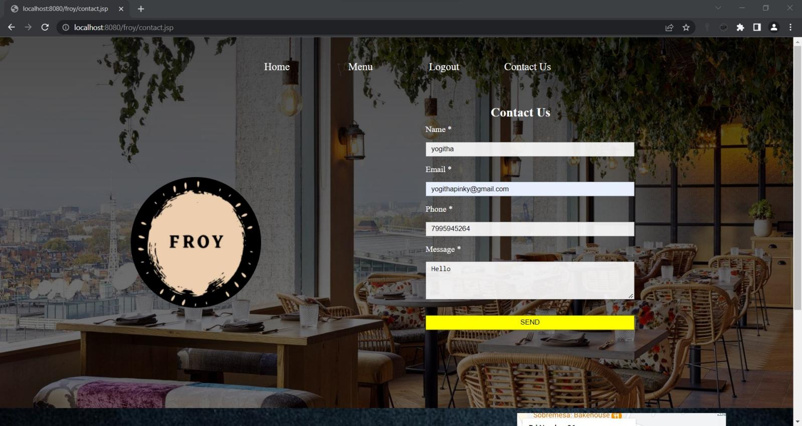

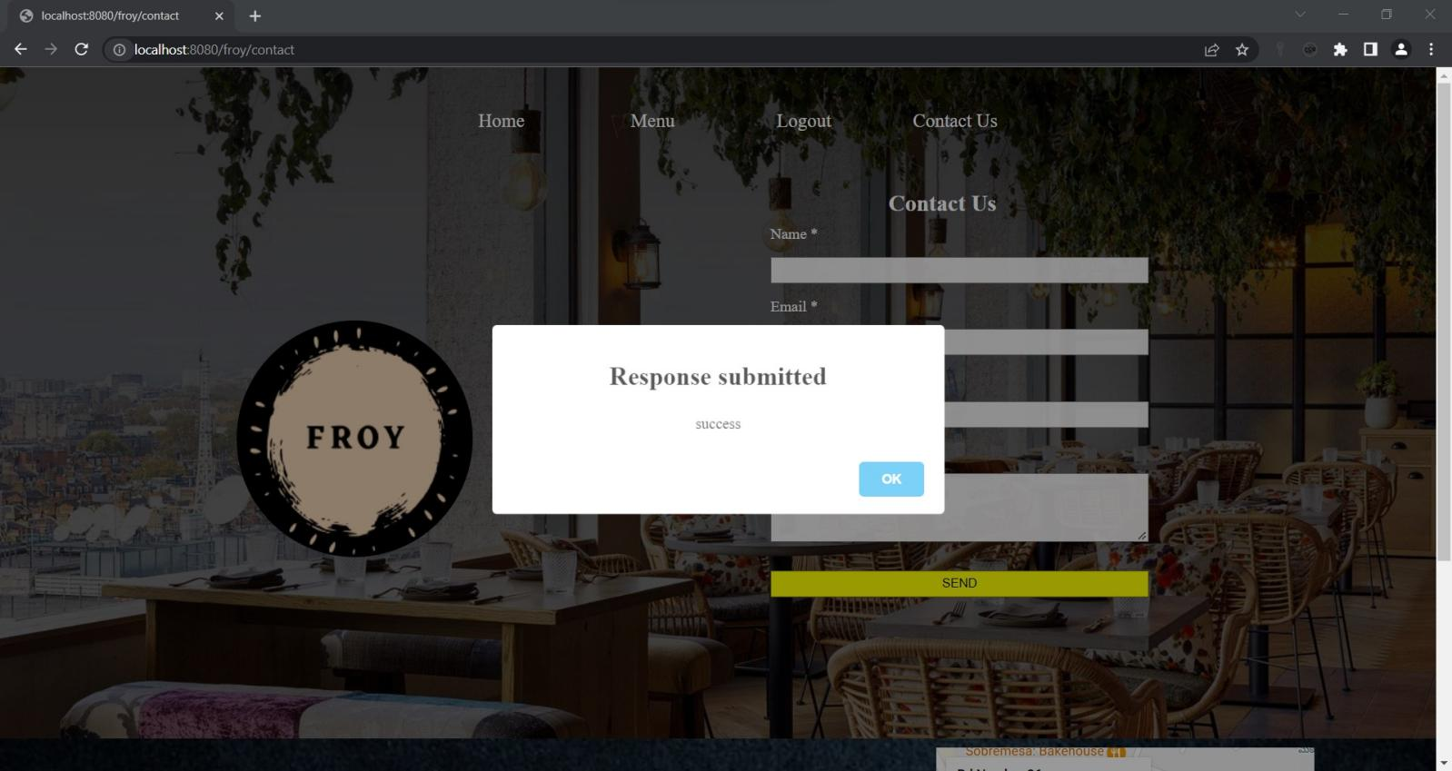

1. **contact.java**

package com.uniquedeveloper.signup;

import jakarta.servlet.RequestDispatcher;

import jakarta.servlet.ServletException;

import jakarta.servlet.annotation.WebServlet;

import jakarta.servlet.http.HttpServlet;

import jakarta.servlet.http.HttpServletRequest;

import jakarta.servlet.http.HttpServletResponse;

import java.io.IOException;

import java.sql.Connection;

import java.sql.DriverManager;

import java.sql.PreparedStatement;

import java.sql.SQLException;

*@WebServlet*("/contact")

public class contact extends HttpServlet {

private static final long ***serialVersionUID*** = 1L;

protected void doPost(HttpServletRequest request, HttpServletResponse response) throws ServletException, IOException {

String uname = request.getParameter("name");

String uemail = request.getParameter("email");

String uphonenumber = request.getParameter("PhoneNumber");

String utext = request.getParameter("textarea");

RequestDispatcher dispatcher = null;

Connection con = null;

if(uname == null || uname.equals("")) {

request.setAttribute("status","invalidName");

dispatcher = request.getRequestDispatcher("contact.jsp");

dispatcher.forward(request, response);

}

if(uemail == null || uemail.equals("")) {

request.setAttribute("status","invalidEmail");

dispatcher = request.getRequestDispatcher("contact.jsp");

dispatcher.forward(request, response);

}

if(utext == null || utext.equals("")) {

request.setAttribute("status","invalidText");

dispatcher = request.getRequestDispatcher("contact.jsp");

dispatcher.forward(request, response);

}

try {

Class.*forName*("com.mysql.cj.jdbc.Driver");

con = DriverManager.*getConnection*("jdbc:mysql://localhost:3306/signin","root","suchithra");

PreparedStatement pst = con.prepareStatement("insert into contactform(uname,uemail,uphonenumber,utext) values(?,?,?,?)");

pst.setString(1,uname);

pst.setString(2, uemail);

pst.setString(3, uphonenumber);

pst.setString(4, utext);

int rowCount = pst.executeUpdate();

dispatcher = request.getRequestDispatcher("contact.jsp");

if (rowCount >0) {

request.setAttribute("status", "success");

}else {

request.setAttribute("status", "failed");

}

dispatcher.forward(request, response);

}catch(Exception e) {

e.printStackTrace();

}finally {

try {

con.close();

}catch (SQLException e) {

e.printStackTrace();

}

}

}}

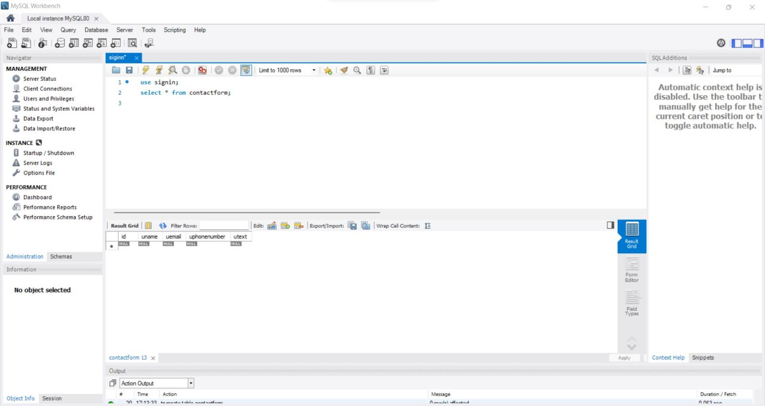

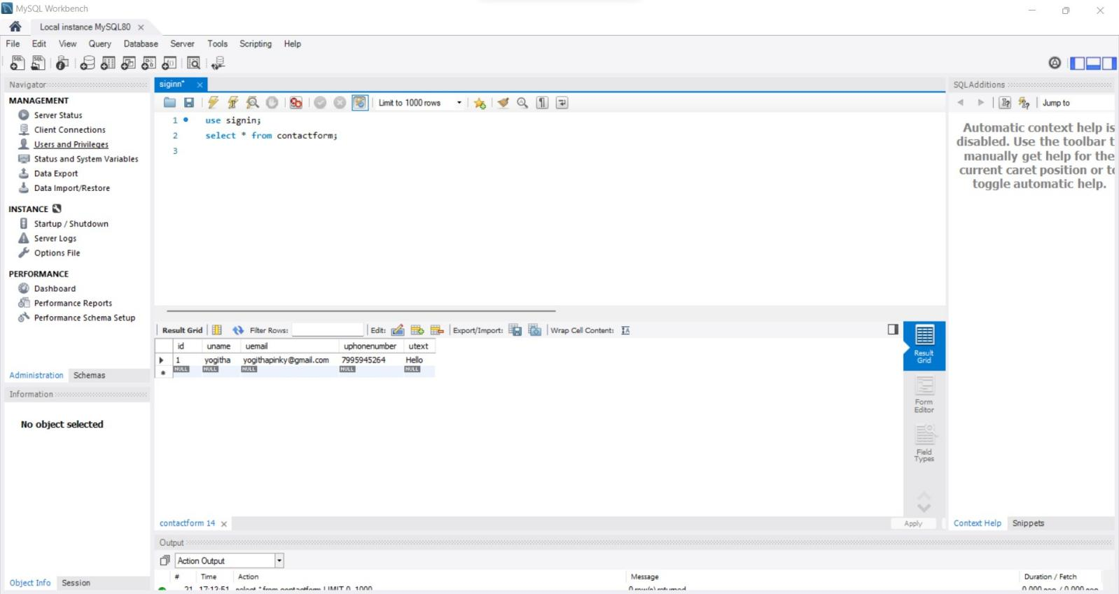

1. **details.jsp**

<%@**page** import=*"java.sql.Connection"*%>

<%@**page** import=*"java.sql.ResultSet"*%>

<%@**page** import=*"java.sql.Statement"*%>

<%@**page** import=*" java.io.*"*%>

<%@**page** import= *"jakarta.servlet.*"*%>

<%@**page** import=*"jakarta.servlet.annotation.WebServlet"*%>

<%@**page** import=*"jakarta.servlet.http.*"*%>

<%@**page** import=*"java.sql.Connection"*%>

<%@**page** import=*"java.sql.DriverManager"*%>

<%@**page** import= *"java.sql.PreparedStatement"*%>

<%@**page** import=*" java.sql.ResultSet"*%>

<!**DOCTYPE** html>

<**html**>

<**head**>

<**meta** name=*"viewport"* content=*"width=device-width, initial-scale=1"*>

<**link** rel=*"stylesheet"* href=*"fonts/material-icon/css/material-design-iconic-font.min.css"*>

</**head**>

<**style**>

@import *url('https://fonts.googleapis.com/css2?family=Poppins:wght@300;500;700&display=swap')*;

*{

box-sizing: *border-box*;

padding: *0*;

margin: *0*;

}

body{

font-family: *'Poppins', sans-serif*;

margin: *0px*;

}

.cell-1 {

border-collapse: *separate*;

border-spacing: *0 4em*;

background: *#fff*;

border-bottom: *5px solid transparent*;

/*background-color: gold;*/

background-clip: *padding-box*;

}

thead {

background: *#dddcdc*;

color: *black*;

fonr-size: *18px*;

}

th{

font-size: *18px*;}

tbody{

color:*black*;

}

.btn {

border: *2px solid black*;

background-color: *white*;

color: *black*;

padding: *8px 16px*;

font-size: *15px*;

cursor: *pointer*;

transition: *0.25s*;

border-radius: *20px*;

outline: *none*;

}

.edit_btn{

background-color: *gray*;

color: *white*;

padding: *8px 16px*;

font-size: *10px*;

cursor: *pointer*;

transition: *0.25s*;

outline: *none*;

border:*none*;

margin-left: *20px*;

border-radius: *20px*;

}

.success {

border-color: *#4CAF50*;

color: *green*;

}

.success:hover {

background-color: *#4CAF50*;

color: *white*;

}

.danger {

border-color: *#f44336*;

color: *red*;

}

.danger:hover {

background: *#f44336*;

color: *white*;

}

.ConfirmedLbl{

background-color: *MediumSeaGreen*;

color: *white*;

padding: *8px 16px*;

font-size: *15px*;

text-align: *center*;

}

.notfound{

top: *50%*;

left: *50%*;

position: *absolute*;

transform: *translate(-50%, -50%)*;

box-sizing: *border-box*;

padding: *70px 30px*;

}

.Alink{

text-decoration: *none*;

border: *none*;

outline: *none*;

height: *40px*;

background: *DodgerBlue*;

color: *#fff*;

font-size: *18px*;

border-radius: *20px*;

transition: *0.25s*;

padding: *8px 16px*;

}

.Alink:hover{

cursor: *pointer*;

background: *#ffc107*;

color: *#000*;

}

input{

border: *none*;

border-bottom: *1px solid darkgray*;

background: *transparent*;

outline: *none*;

height: *40px*;

color: *darkgray*;

font-size: *16px*;

transition: *0.25s*;

margin-left: *20px*;

}

.dbanner{

min-height: *100vh*;

background: *linear-gradient(rgba(0, 0, 0, 0.5), rgba(0, 0, 0, 0.5)), url("https://media.gettyimages.com/videos/tilt-down-blur-restaurant-for-background-video-id1273433362?s=640x640") center/cover no-repeat*;

display: *flex*;

flex-direction: *column*;

justify-content: *center*;

align-items: *center*;

color: *#fff*;

padding-bottom: *20px*;

}

.navbar{

width: *auto*;

float: *right*;

border: *none*;

height: *70px*;

padding: *15px*;

font-family: *Tapestry*;

}

.navbar ul li{

width: *150px*;

float: *left*;

margin: *25px auto*;

text-align: *center*;

padding: *5px*;

position: *relative*;

right: *20px*;

top:*-284px*;

}

.navbar ul li a{

text-decoration: *none*;

color: *white*;

font-size: *20px*;

padding: *2px*;

}

.navbar ul li a:hover{

color: *white*;

text-decoration: *underline*;

}

.dpage{

position : *relative*;

top: *-40px*;

font-size: *20px*;

}

</**style**>

<**body**>

<**section** class=*"dbanner"*>

<**header**>

<**nav** class=*"navbar"*>

<**ul** type=*"none"*>

<**li**><**a** href=*"index.jsp"*>Home</**a**></**li**>

<**li**><**a** href=*"menu.jsp"*>Menu</**a**></**li**>

<**li**><**a** href=*"logout"*>Logout</**a**></**li**>

<**li**><**a** href=*"contact.jsp"*>Contact Us</**a**></**li**>

</**ul**>

</**nav**>

</**header**>

<**div** class=*"dpage"*>

<**h3**>RESERVATION DETAILS</**h3**>

</**div**>

<**div** style="width: *100%*; min-height: *750px*;">

<**div** class=*"w3-container w3-margin-top"* id=*"rooms"*>

<**div** class=*"w3-row-padding w3-padding-16"*>

<%

try {

Statement statement = null;

ResultSet resultSet = null;

String Countrow="";

String CurrentUser = session.getAttribute("uname").toString();

Class.forName("com.mysql.jdbc.Driver");

Connection con = DriverManager.getConnection("jdbc:mysql://localhost:3306/signin","root","suchithra");

statement = con.createStatement();

String sql = "SELECT COUNT(id) FROM reservatable Where RequestMadeBy = '" + CurrentUser + "'";

resultSet = statement.executeQuery(sql);

while (resultSet.next()) {

Countrow = resultSet.getString(1);

if(Countrow.equals("0")){

%>

<**div** class=*"notfound"*>

<**center**><**img** alt=*"ntfound"* src=*"../images/ntfound.png"*>

<**h4**>No reservations found</**h4**>

</**div**>

<%

}

}

} catch (Exception e) {

e.printStackTrace();

}

%>

<%

try {

Class.forName("com.mysql.jdbc.Driver");

Connection con = DriverManager.getConnection("jdbc:mysql://localhost:3306/signin","root","suchithra");

String CurrentUser = session.getAttribute("uname").toString();

Statement statement = null;

ResultSet resultSet = null;

String sql = "SELECT * FROM rooms Where RequestMadeBy = '" + CurrentUser + "' ORDER BY dateNtime ASC";

resultSet = statement.executeQuery(sql);

while (resultSet.next()) {

%>

<**div** class=*"w3-third w3-margin-bottom"*>

<**div** class=*"w3-container w3-white"*>

<**table**>

<**tr**>

<**td**><**h3**>Reserve Id</**h3**></**td**>

<**td**><**label**

style="font-family: *monospace*; color: *gray*; border: *2px solid gray*; padding: *8px*;">

<%=resultSet.getString("id")%></**label**></**td**>

<**td**><**button** class=*"edit_btn"* onclick=*"hide_show_inputs(*<%=resultSet.getString("id")%>*)"* id=*"hide_show_inputs_btn_*<%=resultSet.getString("id")%>*"*>Edit</**button**></**td**>

</**tr**>

</**table**>

<**form** action=*"../UpdateMyRequest"* method=*"post"*>

<**ul**>

<**li**>Date

<**b** id=*"CheckIn_display_val_*<%=resultSet.getString("id")%>*"*><%=resultSet.getString("udate")%></**b**>

<**input** type=*"number"* name=*"Adults_update_input"* id=*"Adults_update_input_*<%=resultSet.getString("id")%>*"* required=*"required"* value=*'*<%=resultSet.getString("udate")%>*'* style="display: *none*;">

</**li**>

<**li**>Hour :

<**b** id=*"CheckIn_display_val_*<%=resultSet.getString("id")%>*"*><%=resultSet.getString("uhour")%></**b**>

<**input** type=*"number"* name=*"Kids_update_input"* id=*"Kids_update_input_*<%=resultSet.getString("id")%>*"* required=*"required"* value=*'*<%=resultSet.getString("uhour")%>*'* style="display: *none*;">

</**li**>

<**li**>Name:

<**b** id=*"CheckIn_display_val_*<%=resultSet.getString("id")%>*"*><%=resultSet.getString("uname")%></**b**>

<**input** type=*"date"* name=*"CheckIn_update_input"* id=*"CheckIn_update_input_*<%=resultSet.getString("id")%>*"* required=*"required"* value=*'*<%=resultSet.getString("uname")%>*'* style="display: *none*;">

</**li**>

<**li**>Phone Number :

<**b** id=*"CheckOut_display_val_*<%=resultSet.getString("id")%>*"*><%=resultSet.getString("uphonenum")%></**b**>

<**input** type=*"date"* name=*"CheckOut_update_input"* id=*"CheckOut_update_input_*<%=resultSet.getString("id")%>*"* required=*"required"* value=*'*<%=resultSet.getString("uphonenum")%>*'* style="display: *none*;">

</**li**>

<**li**>No Of Guests :

<**b** id=*"CheckOut_display_val_*<%=resultSet.getString("id")%>*"*><%=resultSet.getString("upersons")%></**b**>

<**input** type=*"date"* name=*"CheckOut_update_input"* id=*"CheckOut_update_input_*<%=resultSet.getString("id")%>*"* required=*"required"* value=*'*<%=resultSet.getString("upersons")%>*'* style="display: *none*;">

</**li**>

<%

if (resultSet.getString("Status").equals("1")) {

%>

</**ul**>

</**form**>

<**script** type=*"text/javascript"*>

document.getElementById("hide_show_inputs_btn_<%=resultSet.getString("id")%>").style.display ="none";

</**script**>

<**p** class=*"ConfirmedLbl"*>Confirmed</**p**>

<%

} else {

%>

<

<**input** style="display: *none*;" type=*"text"* name=*"req_id"*

value=*'*<%=resultSet.getString("id")%>*'*>

<**button** type=*"submit"* class=*"btn success"* id=*"save_btn_*<%=resultSet.getString("id")%>*"*

style="margin-left: *20px*; margin-bottom: *20px*; display: *none*;">Save</**button**>

</**form**>

<**form** action=*"../DeletRequestByUser"* method=*"post"*>

<**input** style="display: *none*;" type=*"text"* name=*"req_id"*

value=*'*<%=resultSet.getString("id")%>*'*>

<**button** type=*"submit"* class=*"btn danger"* id=*"delete_btn_*<%=resultSet.getString("id")%>*"*

style="margin-left: *20px*; margin-bottom: *20px*;">Delete</**button**>

</**form**>

<%

}

%>

</**div**>

</**div**>

<%

} catch (Exception e) {

e.printStackTrace();

}

%>

</**div**>

</**div**>

</**div**>

</**section**>

</**body**>

</**html**>

**User with no reservation :**

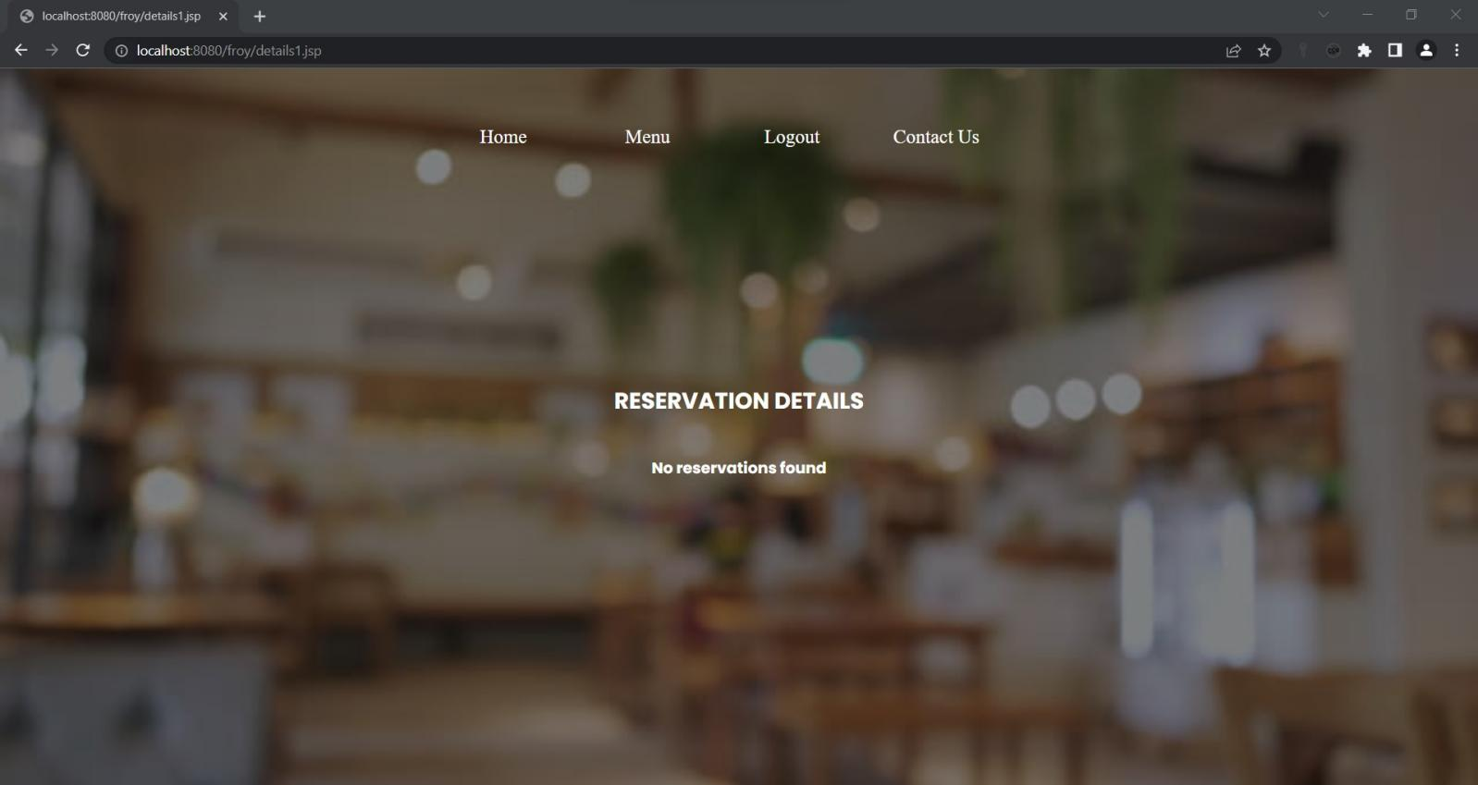

**User with reservations:**

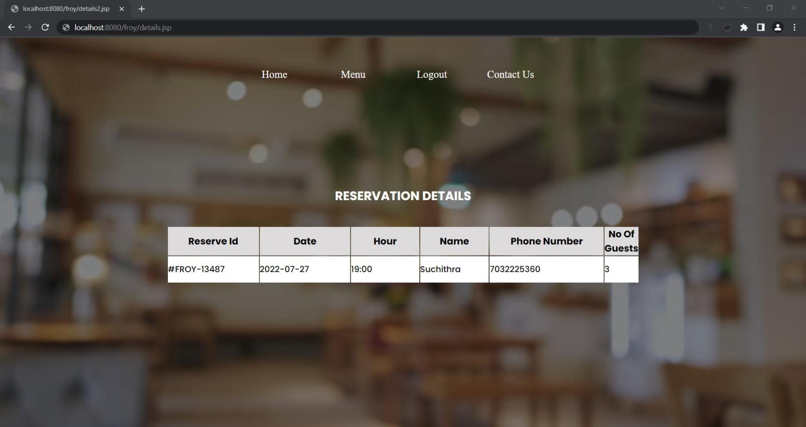

1. **logout.java**

package com.uniquedeveloper.signup;

import java.io.*;

import jakarta.servlet.*;

import jakarta.servlet.annotation.WebServlet;

import jakarta.servlet.http.*;

@WebServlet("/logout")

public class logout extends HttpServlet {

private static final long serialVersionUID = 1L;

protected void doGet(HttpServletRequest request, HttpServletResponse response)

throws ServletException, IOException {

HttpSession session = request.getSession();

session.invalidate();

response.sendRedirect("login.jsp");

}

}

PHP Programs

**1. Write a PHP script to print prime numbers between 1-50.**

<?php

for($i=2;$i<50;$i++)

{

$f = 0;

for($j=2;$j<$i;$j++)

{

if($i%$j==0)

{

$f++;

}

}

if($f==0)

{

echo "$i ";

}

}

?>

**Output :**

2 3 5 7 11 13 17 19 23 29 31 37 41 43 47

**2. PHP script to**

**a. Find the length of a string**

<?php

$str = "Musica project";

$len = 0;

$s = str_split($str);

while($s[$len])

{

$len++;

}

echo "The string has $len characters";

?>

**Output** :

The string has 14 characters

**b. Count no of words in a string.**

<?php

$str = "Musica project";

$len = 0;

$word = 1;

$s = str_split($str);

foreach($s as $i)

{

if ($i == ' ')

{

$word++; } }

echo "The string has $word words";

?>

**Output :**

The string has 2 words

**c. Reverse a string.**

<?php

$str = "Musica";

$word = " ";

for($i=strlen($str)-1;$i>=0;$i--)

{

$word[strlen($str)-1-$i] = $str[$i];

}

echo "Reverse of $str is $word";

?>

**Output:**

Reverse of Musica is acisuM

**d. Search for a specific string**

<?php

$str = "Musica project";

$find = "project";

for($i=0;$i<strlen($str)-strlen($find)+1;$i++)

{

$count = 0;

for($j=0;$j<strlen($find);$j++)

{

if($str[$i+$j] == $find[$j])

$count++;

else

break;

}

if($count == strlen($find))

{

echo "Word found in position $i";

break;

}

}

?>

**Output:**

Word found in position 7

**3. Write a PHP script to merge two arrays and sort them as numbers, in descending order**

<?php

$arr1 = [3, 1, 7];

$arr2 = [2, 5, 0, 11];

$len1 = count($arr1);

$len2 = count($arr2);

$len = $len1 + $len2;

for($i= $len1;$i<$len;$i++)

{

$arr1[$i] = $arr2[$i - $len1];

}

for($i=0;$i<$len;$i++)

{

for($j=0;$j<$len-$i-1;$j++)

{

if($arr1[$j] > $arr1[$j+1])

{

$t = $arr1[$j];

$arr1[$j] = $arr1[$j+1];

$arr1[$j+1] = $t;

}

}

}

echo "Sorted array is ";

for($i=0;$i<$len;$i++)

echo "$arr1[$i] ";

?>

**Output :**

Sorted array is 0 1 2 3 5 7 11

**4. Write a PHP script that reads data from one file and write into another file.**

<?php

$myfile = fopen("file1.txt","r");

$write = fopen("file2.txt","a");

while(!feof($myfile))

fwrite($write, fgets($myfile));

echo "Contents of file 1 copied into file 2"

?>

**Output:**

Contents of file 1 copied into file 2

XML Program

Create and save an XML document on the server, which contains 10 users information.

Write a program, which takes User Id as an input and returns the user details by taking the

user information from the XML document.

import javax.xml.parsers.*;

import org.w3c.dom.*;

import java.io.*;

import javax.servlet.http.*;

import javax.servlet.*;

import java.sql.*;

public class DOMDemo extends HttpServlet{

public void doPost(HttpServletRequest request, HttpServletResponse response)

throws ServletException, IOException{

String id = request.getParameter("UID");

PrintWriter out = response.getWriter();

response.setContentType("text/html");

DocumentBuilderFactory factory = DocumentBuilderFactory.newInstance();

DocumentBuilder builder = factory.newDocumentBuilder();

Document document = builder.parse(new File("C:\\Users\\bharg\\Desktop\\zoro\\web technologies\\XMLDOMP\\WEB-

INF\\employees.xml"))

out.println(document);

document.getDocumentElement().normalize();

out.println(document);

NodeList nList = document.getElementsByTagName("employee");

for(int i = 0;i<nList.getLength();i++){

Node node = nList.item(i);

if(node.getNodeType() == Node.ELEMENT_NODE){

Element eElement = (Element)node;

if(id.equals(eElement.getAttribute("id"))){

out.println("<h1>Emp Name:"+eElement.getElementsByTagName("name").item(0).getTextContent()+"</h1>");

out.println("<h1>Emp Last Name:"+eElement.getElementsByTagName("lastName").item(0).getTextContent()+"</h1>");

} } } } }

XML file :

<employees>

<employee id="111">

<firstName>Lokesh</firstName>

<lastName>Gupta</lastName>

<location>India</location>

</employee>

<employee id="222">

<firstName>Alex</firstName>

<lastName>Gussin</lastName>

<location>Russia</location>

</employee>

<employee id="333">

<firstName>David</firstName>

<lastName>Feezor</lastName>

<location>USA</location>

</employee>

</employees>