Assignment for Module 3

TABLES STRUCTURE

TABLES

- Employee
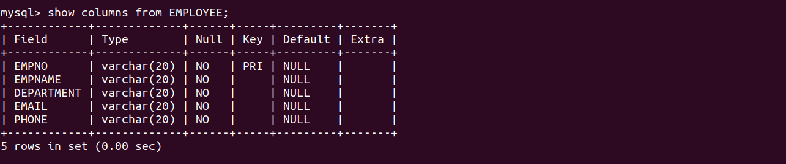

- ResourceTbl
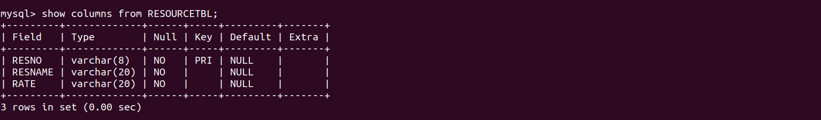

- EventRequest
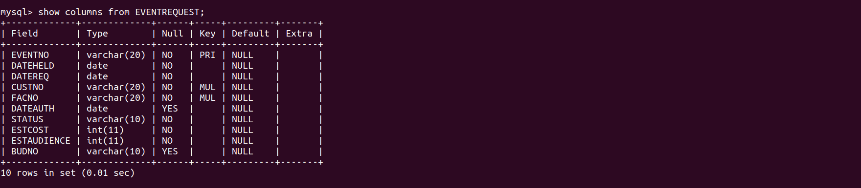
- EventPlan
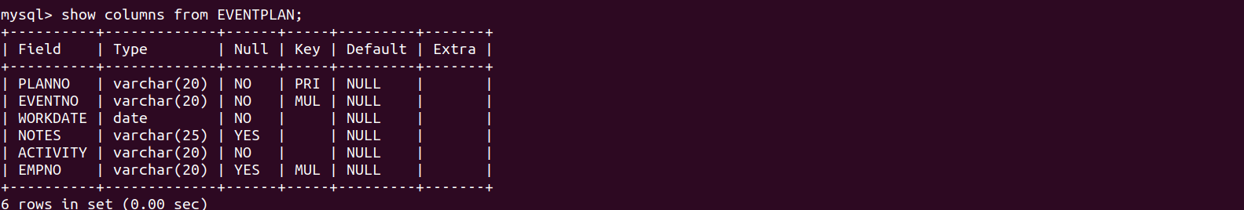

- EventPlanLine
