Sql-query assignment

1 ) Find out the PG-13 rated comedy movies. DO NOT use the film_list table.

select title , name from film

join film_category on film.film_id=film_category.film_id

join category on film_category.category_id=category.category_id

where name='comedy' and rating='PG-13';

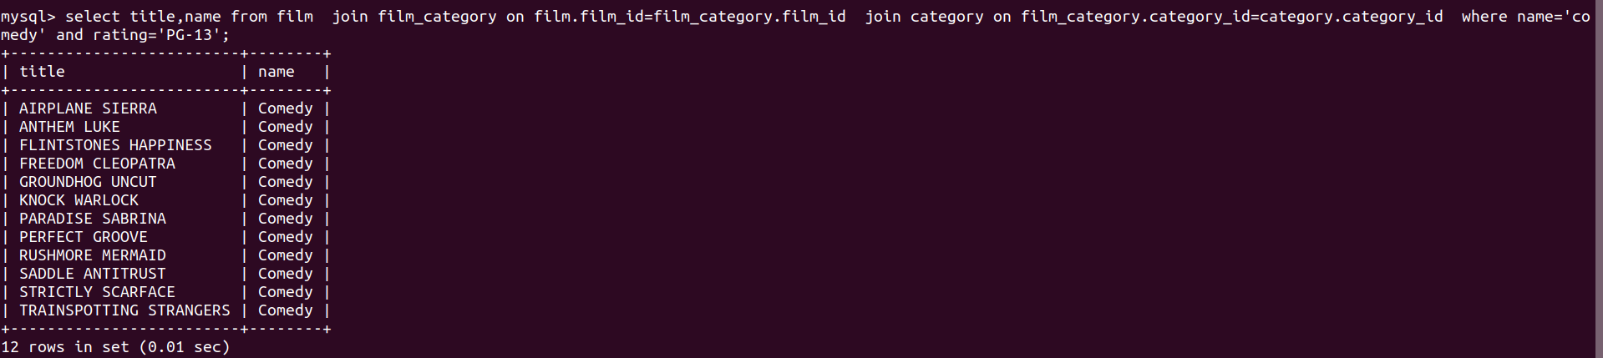

2)

select title,count(title) from film f join inventory i on f.film_id=i.film_id join rental r on r.inventory_id=i.inventory_id join film_category fc on fc.film_id=f.film_id join category c on c.category_id=fc.category_id where c.name='horror' group by title order by count(title) desc limit 3;

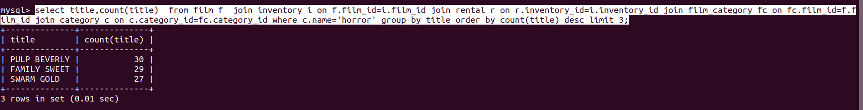`

3)Find out the list of customers from India who have rented sports movies.

select first_name,last_name,name,country from

customer cust join rental r on cust.customer_id=r.customer_id

join inventory i on i.inventory_id=r.inventory_id

join film_category fc on fc.film_id=i.film_id

join category c on c.category_id=fc.category_id

join address a on cust.address_id=a.address_id

join city on city.city_id=a.city_id

join country cty on cty.country_id = city.country_id

where country='india' and c.name='sports';

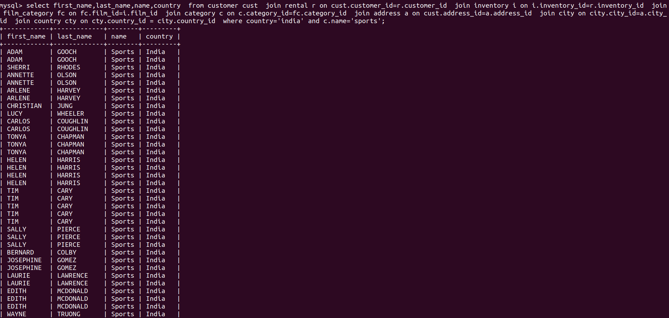



4) Find out the top 3 rented category of movies by “PATRICIA JOHNSON”.

select c.name ,count(c.name) as top_3_rented_categories from category c

join film_category fc on c.category_id=fc.category_id

join inventory i on i.film_id=fc.film_id

join customer cust on cust.store_id=i.store_id

where cust.first_name='PATRICIA' and cust.last_name='JOHNSON'

group by c.name order by count(c.name) desc limit 3;

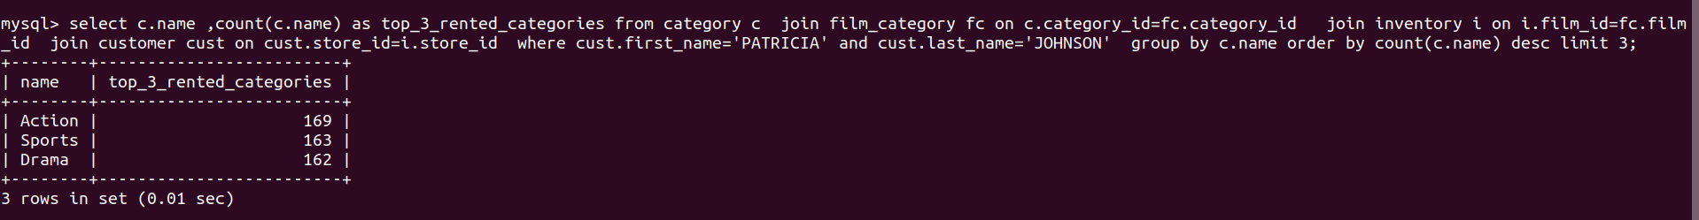

5).Find out the number of movies in which “SEAN WILLIAMS” acted.

select count(title) as number_of_movies from film f

join film_actor fa on f.film_id=fa.film_id

join actor on actor.actor_id=fa.actor_id

where actor.first_name='SEAN' and actor.last_name='WILLIAMS';

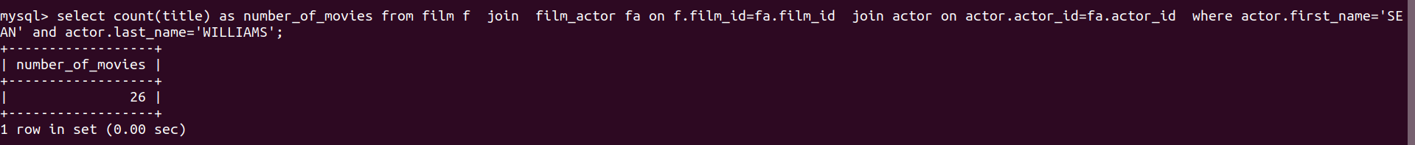

6) Find out the number of documentaries with deleted scenes.

select count(c.name) as number_of_documentaries_with_deleted_scenes from film f

join film_category fc on f.film_id=fc.film_id

join category c on c.category_id=fc.category_id

where c.name='documentary' and special_features like ‘deleted scenes%’;



7)Find out the number of sci-fi movies rented by the store managed by Jon Stephens

select count(c.name) as number_of_scifi_rented from category c

join film_category fc on c.category_id=fc.category_id

join inventory i on i.film_id=fc.film_id

join staff st on st.store_id=i.store_id

where st.first_name='JON' and st.last_name='STEPHENS'

and c.name='sci-fi';



8)

Find out the total sales from Animation movies.

select sum(amount) as total_sales_of_Animation from payment p

join rental r on p.rental_id=r.rental_id

join inventory i on i.inventory_id=r.inventory_id

join film_category fc on fc.film_id=i.film_id

join category c on c.category_id=fc.category_id

where cat.name='Animation';



9)Find out the top 3 rented category of movies by “PATRICIA JOHNSON”.

select c.name as top_3_rented_categories from category c

join film_category fc on c.category_id=fc.category_id

join inventory i on i.film_id=fc.film_id

join customer cust on cust.store_id=i.store_id

where cust.first_name='PATRICIA' and cust.last_name='JOHNSON'

group by c.name order by count(c.name) desc limit 3;



10) Find out the number of R rated movies rented by “SUSAN WILSON”.

select rating, count(rating) as total_R_rated_movies from film f join inventory i on i.film_id=f.film_id join customer cust on cust.store_id=i.store_id where cust.first_name='SUSAN' and cust.last_name='WILSON' and rating='r' group by rating;

