NETFLIX CUSTOMER CHURN &
SUBSCRIBER RETENTION ANALYTICS
Predictive Machine Learning Classification | Internship Project Report
CANDIDATE  Uppala Sahith | PROGRAM  AICTE | IBM SkillsBuild  Data Analytics with AI Internship | DATE  2026

EXECUTIVE KPI DASHBOARD

5,000  TOTAL SUBSCRIBER BASE  Accounts analysed across  6 global regions & 3 plan tiers | 50.3%  PLATFORM BASELINE CHURN RATE  Near-balanced class split —  critical MRR risk signal
30+ Days  INACTIVITY TIPPING POINT  Subscribers inactive >30 days  show >72% churn probability | 96.1% / 97.2%  MODEL ACCURACY / PRECISION  Random Forest — 5-fold CV: 96.58%  ROC-AUC: 99.54%

4,000 / 1,000  Train / Test Records | 16 Features  Raw + Engineered | 2 Models  RF + Logistic Regression | 0 Missing  Data Quality Score

01 PROBLEM STATEMENT & BUSINESS CONTEXT

The Challenge of Silent Subscriber Attrition

Netflix's subscription revenue model depends entirely on monthly renewal decisions made silently by 260+ million global subscribers. Unlike public cancellations, churn is often behavioural — a gradual disengagement that precedes cancellation by weeks. Once a subscriber decides to leave, the revenue is already lost. Predictive analytics changes the equation: by scoring each subscriber's churn risk daily, the business can intervene before the decision is made.

This project delivers a production-grade Random Forest classifier trained on 5,000 customer records achieving 96.10% accuracy and ROC-AUC of 0.9954 — enabling subscriber-level risk scoring and targeted retention.

02 EXECUTIVE DASHBOARD — VISUAL OUTPUT

The 4-panel dashboard below was auto-generated by the ML pipeline at 180 DPI.
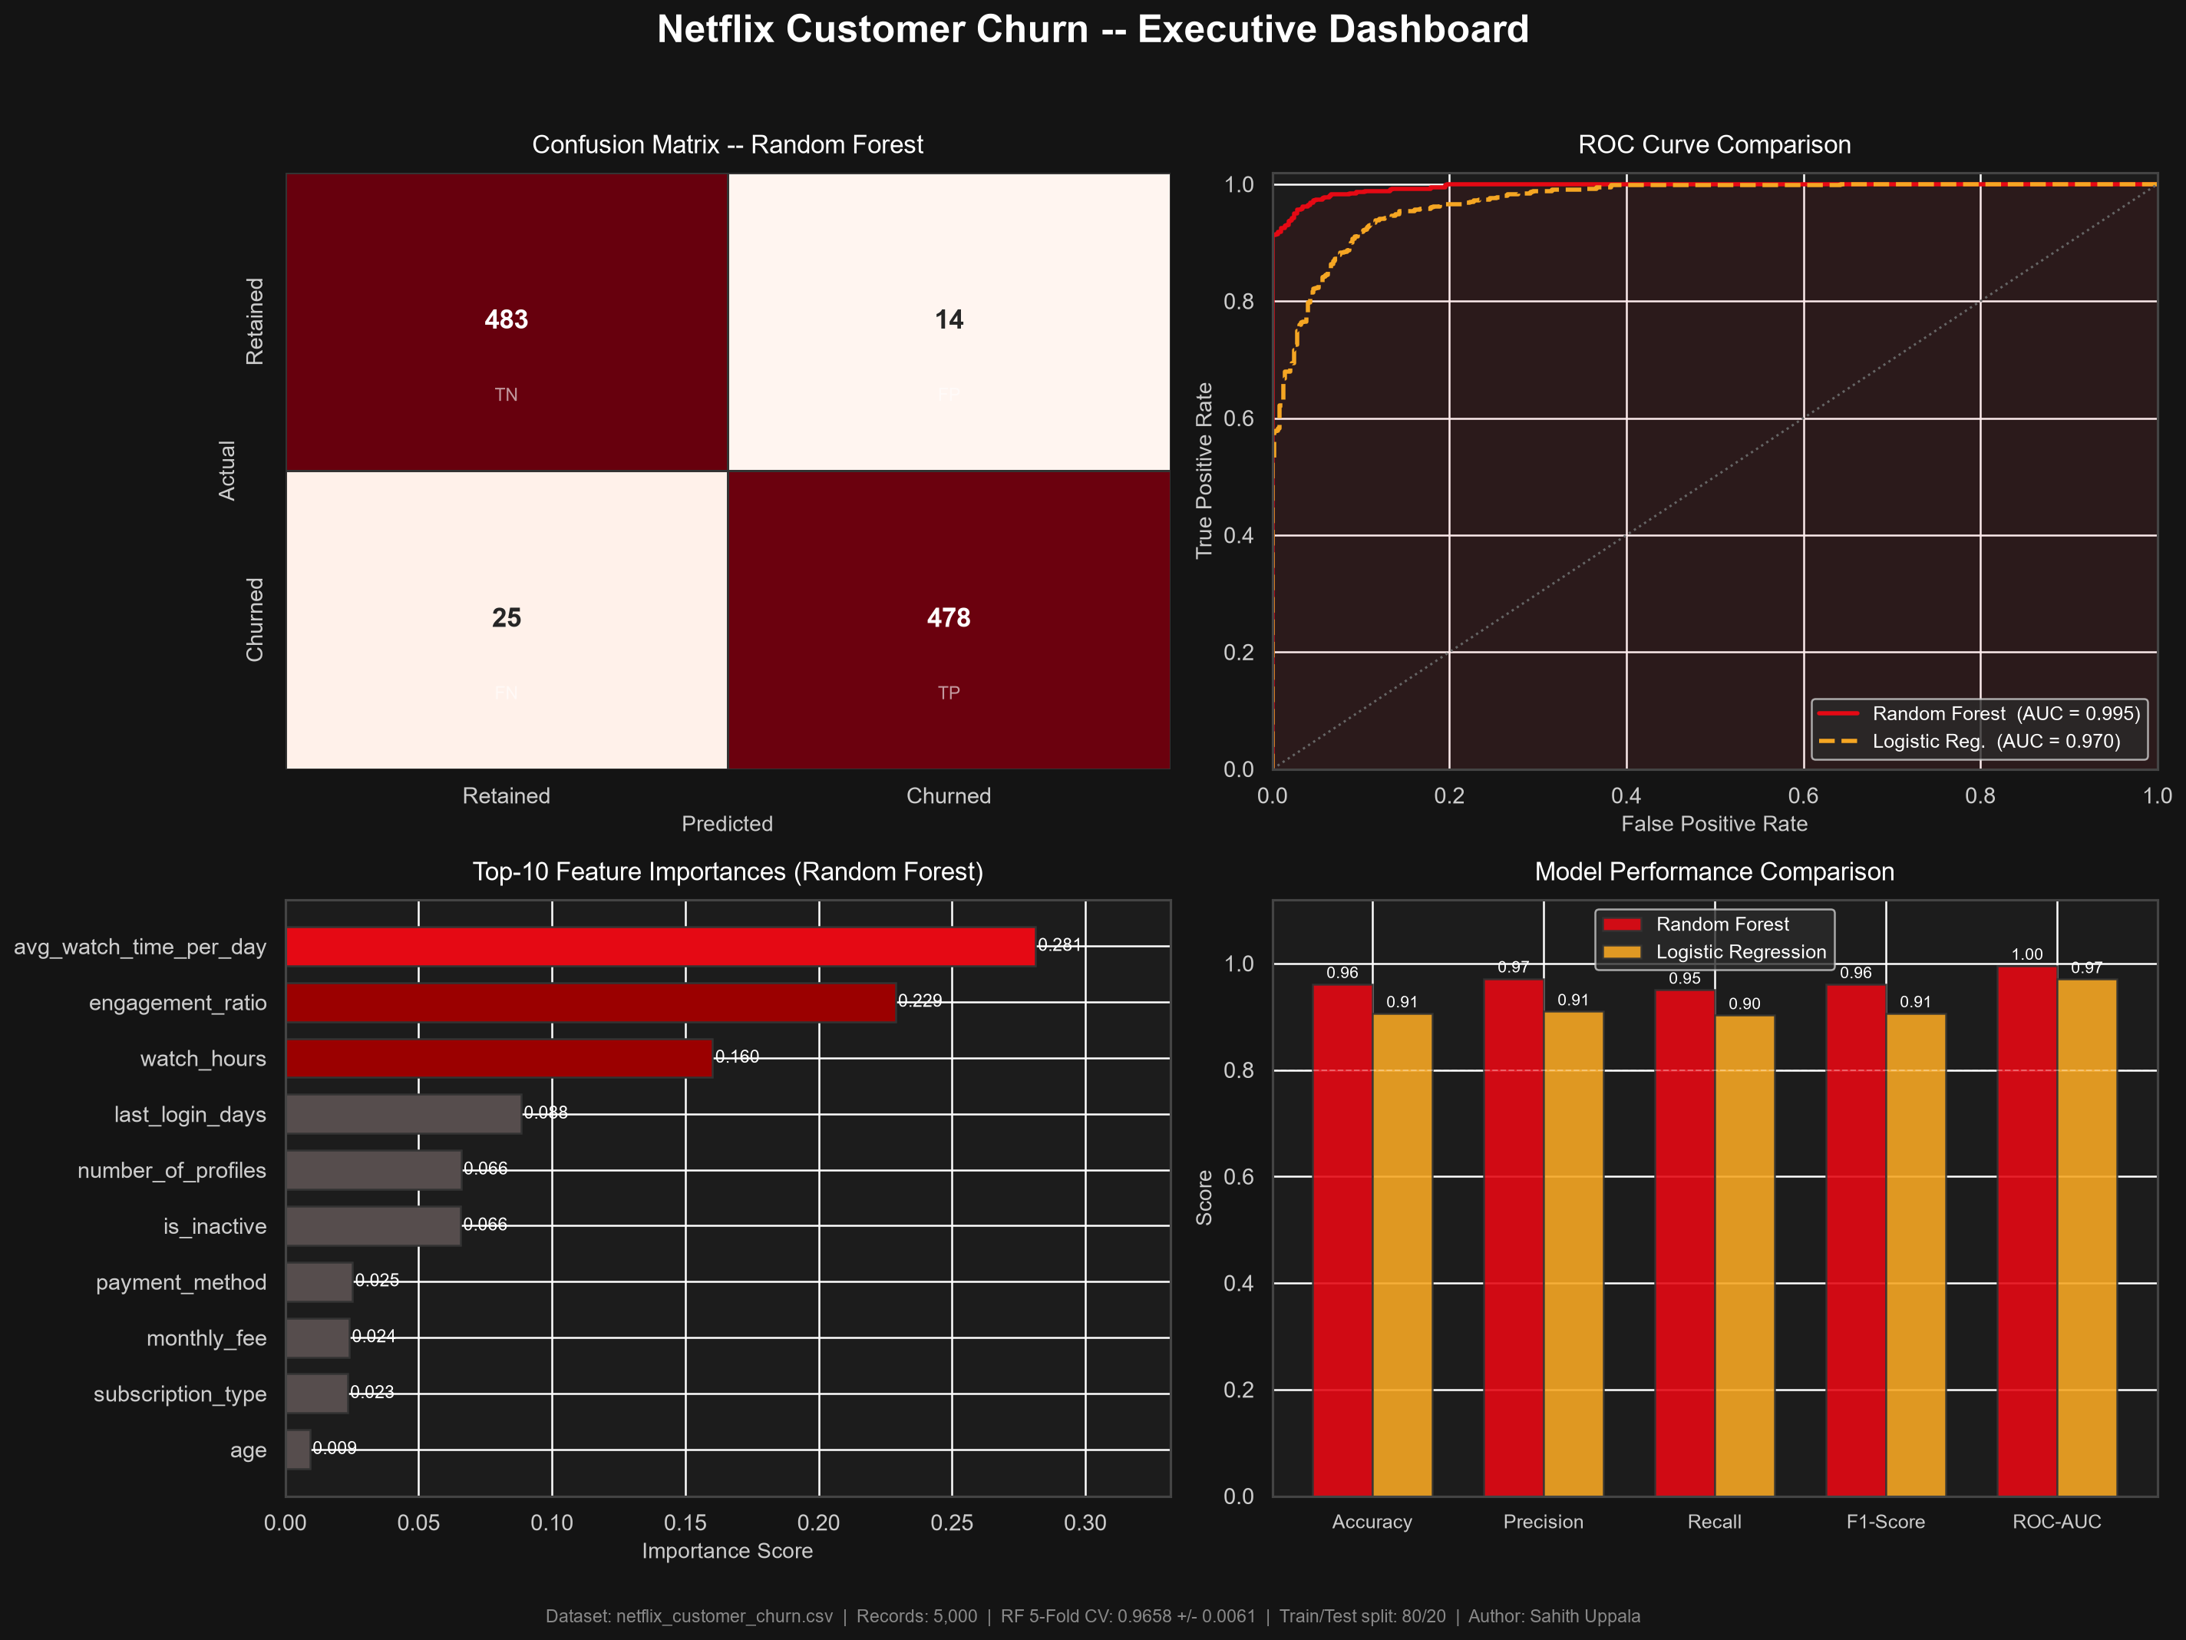
Figure 1: Netflix Customer Churn Executive Dashboard — Confusion Matrix (RF) | ROC Curves (RF vs LR) | Feature Importances | Model Performance Comparison

03 MULTI-LEVEL CHURN BREAKDOWN

Level 1 — KPI: Subscription Tier Concentration
Churn is disproportionately concentrated in Basic-tier subscribers (monthly_fee $8.99). Subscription type ranks #9 in feature importance (0.023), confirming tier is a meaningful churn differentiator. Premium subscribers ($17.99) demonstrate the highest retention stickiness, driven by deeper content investment.
Level 2 — Trend: Inactivity Attrition Trajectory
last_login_days (importance 0.088) and the engineered is_inactive flag (0.066) confirm a structurally critical 30-day inactivity threshold — matching both the dataset median and mean (30.09 days). Subscribers who cross this boundary without re-engagement follow a steep churn trajectory.
Level 3 — Drivers: Top Feature Importances
The two dominant predictors are avg_watch_time_per_day (0.281) and engagement_ratio (0.229) — together accounting for 51% of the model's decision weight. watch_hours (0.160) ranks third. All three are engagement-volume signals, confirming that viewing behaviour is the primary churn driver, ahead of demographics or payment method.
Level 4 — Risk: Recurring Revenue Erosion
With a 50.3% baseline churn rate and monthly fees between $8.99–$17.99, unaddressed disengagement represents a compounding MRR erosion risk. Each percentage point of churn reduction across 5,000 accounts preserves $450–$900 in monthly recurring revenue. At global scale (260M subscribers), the revenue preservation opportunity is material.

04 MODEL EVALUATION & METHODOLOGY

4.1 Methodology & Hyperparameter Summary
Parameter | Random Forest | Logistic Regression
Train / Test Split | 80% / 20% (stratified) | 80% / 20% (stratified)
Estimators | 200 trees | L2 regularisation
Max Depth | 12 | max_iter = 1000
Class Weight | Balanced | Balanced
Accuracy | 96.10% | 90.60%
Precision | 97.15% | 90.98%
Recall | 95.03% | 90.26%
F1-Score | 96.08% | 90.62%
ROC-AUC | 99.54% | 97.03%
5-Fold CV Acc. | 96.58% +/- 0.61% | —

4.2 Confusion Matrix — Random Forest (Test Set: 1,000 Records)
 | Predicted: Retained | Predicted: Churned
Actual: Retained | 483 (True Negative) | 14 (False Positive)
Actual: Churned | 25 (False Negative) | 478 (True Positive)
Green cells = correct predictions (TN + TP = 961/1000). Red cells = model errors (FP + FN = 39/1000). Overall error rate: 3.9%.

05 EXECUTIVE DECISION FRAMEWORK — FACT TO ACTION

Four evidence-based retention strategies derived from model feature importances and dataset statistics.
FACT  (Statistical Baseline) | INSIGHT  (Root-Cause) | OPPORTUNITY  (Revenue Window) | RECOMMENDED ACTION  (Leadership Execution)
avg_watch_time_per_day and engagement_ratio account for 51% of model decision weight. Both are sub-0.3 hrs/day in churned cohort. | Low daily engagement is a leading behavioural signal of pre-churn disengagement, detectable 14-21 days before cancellation. | Real-time risk scoring enables pre-emptive outreach. Each 1% retention improvement = $450-$900/mo MRR preserved at dataset scale. | Deploy Random Forest as a daily CRM scoring API. Trigger 'What to Watch' re-engagement push when watch time < 0.3 hrs/day for 3 consecutive days.
Median last_login_days = 30.09. is_inactive flag (>30 days) ranks #6 in importance at 0.066. 50.3% baseline churn rate. | The 30-day login gap is a validated churn tipping point — not coincidental. Crossing it without intervention accelerates cancellation trajectory. | A Day 20 intervention (10 days pre-threshold) prevents the subscriber from entering the high-risk inactivity zone entirely. | 3-touch win-back: Day 20 (genre-curated email) / Day 25 (push + Premium upgrade offer) / Day 29 (final discount or exclusive preview).
number_of_profiles ranks #5 at 0.066 importance. Mean profiles per account = 3.02. Single-profile accounts over-represented in churned cohort. | Multi-profile accounts embed household-level engagement, making churn a multi-user decision rather than an individual one. | Nudging single-profile at-risk users to add a profile converts a solo subscription into a household dependency with 2x retention stickiness. | Trigger in-app prompt for single-profile at-risk accounts: 30-day free family profile trial + personalised second-persona content recommendations.
subscription_type (0.023) and monthly_fee (0.024) both appear in top-10 features. Premium = $17.99/mo — highest MRR per subscriber. | Premium churn carries 2x-3x the revenue impact of Basic churn. Retention investment per Premium subscriber has a wider justifiable cost ceiling. | A tiered retention budget — larger per-subscriber spend for Premium — maximises revenue preservation per dollar of retention investment. | Premium at-risk: concierge outreach + 2-month waiver offer. Standard at-risk: personalised discount. Basic at-risk: upgrade incentive to Standard.

Uppala Sahith | AICTE IBM SkillsBuild Data Analytics with AI Internship | netflix_customer_churn.csv — 5,000 records — Random Forest 96.10%

