BACHELOR OF ENGINEERING
IN

CSE (Artificial Intelligence & Machine Learning)
Submitted by
K.Meghana 245323748037
T.Sahithya 245323748059

Under the guidance of

M Manohar Rao
Assistant/Associate Professor

NEIL GOGTE INSTITUTE OF TECHNOLOGY
Kachavanisingaram Village, Hyderabad, Telangana 500058.

Affiliated to Osmania University

2025 - 2026

BACHELOR OF ENGINEERING
IN

CSE (Artificial Intelligence & Machine Learning)

Submitted by
K.Meghana 245323748037
T.Sahithya 245323748059

Under the guidance of

M Manohar Rao
Assistant Professor

Department of CSE (Artificial Intelligence & Machine Learning)

NEIL GOGTE INSTITUTE OF TECHNOLOGY
Kachavanisingaram Village, Hyderabad, Telangana 500058.

2025 - 2026


CERTIFICATE

This is to certify that this is a Bonafide record of the project report titled Autonomous Multi-Agent DevOps & Productivity Platform which is being presented as project by K.Meghana, 245323748037, T.Sahithya, 245323748059, in partial fulfilment for the award of the Degree of Bachelor of Engineering in Computer Science affiliated to the Osmania University, Hyderabad.

Internal Guide Head of Department
M Manohar Rao Dr K Vinuthna Reddy
Assistant Professor Associate Professor

External Examiner



DECLARATION

We hereby declare that the results embodied in the dissertation Autonomous Multi-Agent DevOps & Productivity Platform has been carried myself during the academic year 2025-26 as a partial fulfilment of the award of the Bachelor of Engineering Degree in Computer Science from Osmania University. We have not submitted this report to any other university or organization for the award of any other degree.

K.Meghana 245323748037
T.Sahithya 245323748059

ACKNOWLEDGEMENT

We would like to thank our internal guide M Manohar Rao, Assistant Professor, for his/her technical guidance and constant encouragement.

We would like to thank Dr. CB. David Joel Kishore, Associate Professor, Project Co-ordinator, Neil Gogte Institute of Technology for having provided the freedom to use all the facilities available in the department and guidance and constant encouragement.

We would like to thank Dr K Vinuthna Reddy, Associate Professor and Head, Department of Computer Science, Neil Gogte Institute of Technology for having provided the freedom to use all the facilities available in the department, especially the laboratories and the library.

We are happy to express our deep sense of gratitude to the principal of the college Prof. R. Shyam Sunder, Neil Gogte Institute of Technology, for having provided us with adequate facilities to pursue our project.

We sincerely thank our seniors and all the teaching and non-teaching staff of the Department of Computer Science, for their timely suggestions, healthy criticism and motivation during this work.

Finally, we express our immense gratitude with pleasure to the other individuals who have either directly or indirectly contributed to our need at the right time for the development and success of this project work.

i

ABSTRACT

Modern software development requires multiple stages such as planning, coding, testing, deployment, and monitoring. These tasks are typically handled by different teams and tools, which can slow down the development cycle and increase operational complexity.

This project proposes an Autonomous Multi-Agent DevOps & Productivity Platform, an intelligent system where multiple AI agents collaborate to automate the complete software development lifecycle.

The platform uses Agentic AI, where each agent performs a specific responsibility such as requirement analysis, code generation, testing, deployment, and log monitoring. These agents communicate with each other to complete complex tasks like building APIs or deploying applications automatically. The system leverages Generative AI models for reasoning and decision-making, enabling agents to understand user goals and break them into executable steps.

To support fast communication and state management between agents, Redis is used as a memory store and caching layer. It allows agents to store intermediate outputs, task states, and shared information. Nginx acts as an API gateway that routes requests to different microservices efficiently and provides load balancing for scalability.

The backend is designed using a microservices architecture, where each AI agent and service operates independently but communicates through APIs and message queues. This architecture improves scalability, maintainability, and fault tolerance. The platform can automatically perform tasks such as generating backend APIs, deploying applications to cloud environments, analyzing logs, and suggesting fixes when errors occur.

Overall, this project demonstrates how Agentic AI can transform DevOps by enabling autonomous software development workflows, reducing manual effort and improving development speed.

ii

S.No. | Table. No. | Name of the Table | Page No
1 | Table 4.3 | Functional Requirements | 9
2 | Table 4.4 | Non-Functional Requirements | 10
3 | Table 4.5 | Dataset Requirements | 11
4 | Table 4.6 | Machine Learning Requirements | 11
5 | Table 5.2 | Module Description | 12
6 | Table 8.1 | Test Cases

iii

S.No. | Diagram. No. | Name of the Diagram | Page No
1 | Fig 5.1 | System Architecture Diagram | 12
2 | Fig 5.3.1 | Use Case Diagram | 13
3 | Fig 5.3.2 | Activity Diagram | 14
4 | Fig 5.3.3 | Class Diagram | 15
5 | Fig 5.3.4 | Sequence Diagram | 15

iv

S.No | Figure No. | Name of the Figure | Page No
1 | Fig | Sample Code Execution
2 | Fig | HomePage/User Interface
3 | Fig | Code Input Screen
4 | Fig | Code Explanation Output
5 | Fig | Bug Detection Output
6 | Fig | Fixed code Output
7 | Fig | Complexity Analysis Output
8 | Fig | Test Case Generation Output
9 | Fig 8. | Test Case Execution Result

v

CHAPTER NO | TITLE | PAGE NO
 | ACKNOWLEDGEMENT | i
 | ABSTRACT | ii
 | LIST OF TABLES | iii
 | LIST OF DIAGRAMS | iv
 | LIST OF FIGURES | v
1. | INTRODUCTION | 1
 | 1.1 Problem Statement | 1
 | 1.2 Motivation | 1
 | 1.3 Scope | 2
 | 1.4 Outline | 2
2. | LITERATURE SURVEY  2.1 Existing work | 3
 | 2.2 Gaps in Existing work | 4
3. | SYSTEM ANALYSIS  3.1 Existing System | 5
 | 3.2 Disadvantages of Existing System | 5
 | 3.3 Proposed System | 6
 | 3.4 Advantages of Proposed System | 6
 | 3.5 Limitations of Proposed System (Optional) | 7
4. | SOFTWARE REQUIREMENT SPECIFICATION  4.1 Overall Description  4.2 Operating Environment  4.3 Functional Requirement | 8  8  9
 | 4.4 Non-Functional Requirement | 10
 | 4.5 Dataset Requirements | 11
 | 4.6 Machine Learning Requirements | 11
5. | DESIGN  5.1 Proposed System Architecture | 12
 | 5.2 Module Description | 12
 | 5.3 UML Diagrams
 | - System Architecture Diagram | 12
 | - Use Case Diagram | 13
 | - Activity Diagram / Workflow Diagram | 14
 | - Class Diagram | 15
 | - Sequence Diagram | 15

- IMPLEMENTATION
  - Sample Code
- SCREEN SHOTS
7.1 | Login
7.2 | Output

- TESTING
  - Test Strategy
  - Test Cases
- RESULTS
- CONCLUSION & FUTURE SCOPE
- REFERENCES
- PAPER PUBLICATION DETAILS
(COPY OF PAPER PUBLISHED IN JOURNAL) (OPTIONAL)

INTRODUCTION
CHAPTER – 1

  - Problem Statement

Modern software development involves multiple stages such as planning, coding, testing, deployment, and monitoring. These tasks are usually handled by different tools and teams, which makes the development process slow and complex. Managing communication between these stages also becomes difficult, especially in large projects.
Developers often spend a lot of time switching between tools, fixing errors, and handling deployment issues. This increases manual effort and may lead to delays in delivering software. Even small mistakes in one stage can affect the entire workflow.
Therefore, there is a need for a system that can automate the complete development process and reduce human effort. This project focuses on developing an intelligent platform using Artificial Intelligence, where multiple agents work together to handle different stages of the software development lifecycle efficiently.
  - Motivation

The motivation for this project comes from the challenges faced in real-world software development and DevOps processes. Developers and organizations aim to build and deploy applications quickly, but the process often involves repetitive and time-consuming tasks.

With the advancement of Artificial Intelligence and automation, it is possible to design systems that can perform these tasks with minimal human intervention. Instead of manually managing each step, AI-based agents can collaborate and complete tasks such as code generation, testing, and deployment.

This project is motivated by the idea of simplifying the development workflow and improving productivity. It aims to reduce manual work, minimize errors, and speed up the overall software development process.
  - Scope
The motivation for this project comes from the challenges faced in real-world software development and DevOps processes. Developers and organizations aim to build and deploy applications quickly, but the process often involves repetitive and time-consuming tasks.
With the advancement of Artificial Intelligence and automation, it is possible to design systems that can perform these tasks with minimal human intervention. Instead of manually managing each step, AI-based agents can collaborate and complete tasks such as code generation, testing, and deployment.
This project is motivated by the idea of simplifying the development workflow and improving productivity. It aims to reduce manual work, minimize errors, and speed up the overall software development process.
  - Outline

This report is divided into different chapters to explain the project clearly. Chapter 1 gives an introduction to the project, including the problem statement, motivation, and scope.

Chapter 2 explains the literature survey and discusses existing systems. Chapter 3 covers system analysis. Chapter 4 describes the software requirements. Chapter 5 explains the design of the system. Chapter 6 presents the implementation details. Chapter 7 includes screenshots of the system. Chapter 8 explains the testing process. Chapter 9 shows the results, and Chapter 10 gives the conclusion and future scope of the project.

LITERATURE SURVEY
CHAPTER – 2

  - Existing Work
Recent research focuses on the concept of Agentic AI, where multiple AI agents collaborate to perform complex tasks. These agents are capable of understanding user requirements, breaking them into smaller tasks, and executing them step by step. Studies show that multi-agent systems can improve efficiency and reduce manual effort in software development workflows.
Large Language Models (LLMs) such as GPT-based models have also been widely used for code generation and automation. These models can generate code, suggest improvements, and assist developers in building applications. However, their performance depends on the quality of input and they may sometimes produce incorrect or incomplete outputs.
In practical applications, tools like GitHub Copilot, ChatGPT, and CI/CD platforms are commonly used in development environments. These tools help in speeding up development and automating certain tasks. Similarly, technologies like Docker and Kubernetes are used for deployment and scaling of applications, while tools like Jenkins support continuous integration and delivery.
Although these tools are powerful, they usually work independently and require manual integration. Developers still need to manage multiple systems for different stages of development, which increases complexity.
Overall, existing systems provide automation and support in different areas of software development, but they lack a unified approach where all tasks are handled together in an intelligent and coordinated manner.

  - Gaps in Existing Work
Despite the availability of various tools and technologies, there are several limitations in current systems. Most existing solutions focus on specific stages of the software development lifecycle, such as code generation, testing, or deployment, rather than providing a complete end-to-end solution.
Another major limitation is the lack of coordination between different tools. Developers often need to switch between multiple platforms to complete a single task, which increases time and effort. There is no centralized system that can manage all stages of development in an integrated way.
AI-based tools like code generators can produce useful outputs, but they are not fully autonomous. They still require human guidance and supervision. In some cases, the generated code may contain errors, and additional effort is needed to test and fix them.
Traditional DevOps tools are effective for automation, but they do not have intelligent decision-making capabilities. They follow predefined rules and cannot adapt dynamically to changing requirements or unexpected errors.
In addition, most systems do not provide real-time monitoring and automatic error resolution within the same platform. Developers must manually analyze logs and identify issues, which slows down the process.
Therefore, there is a need for an intelligent system that can integrate all stages of the software development lifecycle and automate them using collaborative AI agents. This project aims to address these gaps by developing a unified multi-agent platform that improves efficiency, reduces manual effort, and enhances productivity.

SYSTEM ANALYSIS
CHAPTER – 3

  - Existing System

Currently, software development and DevOps processes are carried out using a combination of different tools and platforms. Developers use code editors, version control systems, testing frameworks, and deployment tools separately to complete the software development lifecycle.
Traditional DevOps tools such as Jenkins, Docker, and Kubernetes are widely used for automation of tasks like building, testing, and deployment. These tools are effective in their specific areas but require manual configuration and integration. Developers need to manage multiple tools, which increases complexity.
In recent years, AI-based tools like ChatGPT and GitHub Copilot have been introduced to assist developers in generating code and suggesting improvements. These tools use Large Language Models to support coding tasks and reduce development time.
However, these systems work independently and are not fully integrated. They do not provide a unified platform that can handle the entire development lifecycle automatically. Most tools require human intervention at different stages and lack coordination between tasks.
Overall, the existing system supports software development and DevOps processes, but it lacks automation, integration, and intelligent coordination.

  - Disadvantages of existing system

The existing systems have several limitations that affect their efficiency and usability. One major disadvantage is the lack of integration. Developers need to use multiple tools for different tasks such as coding, testing, and deployment, which increases time and effort.
Another issue is the dependency on manual intervention. Even though automation tools are available, many steps still require human input, which slows down the development process. Existing AI-based tools can generate code, but they do not manage the complete workflow. They also depend heavily on user input, and incorrect input may lead to inaccurate results.
In addition, there is no proper communication between different tools, which makes it difficult to track the overall progress of the system. Error detection and resolution are also not fully automated, requiring developers to manually analyze and fix issues.
Overall, the existing system is not fully efficient and does not provide a complete automated solution.

  - Proposed system
The proposed system is an Autonomous Multi-Agent DevOps and Productivity Platform that uses Artificial Intelligence to automate the complete software development lifecycle. The system is based on the concept of Agentic AI, where multiple intelligent agents work together to perform different tasks. Each agent is responsible for a specific function such as requirement analysis, code generation, testing, deployment, and monitoring.
The user provides the requirement as input through a simple interface. The system analyzes the input and breaks it into smaller tasks using a planning agent. These tasks are then handled by different agents, which collaborate to generate code, test it, deploy the application, and monitor its performance.
The system uses Redis for managing shared data and communication between agents, and Nginx for routing requests efficiently. The microservices architecture ensures that each component works independently while maintaining coordination with others.
This approach makes the system more efficient and scalable, as it reduces manual effort and automates complex workflows.

3.4.Advantages of Proposed system
The proposed system offers several advantages compared to existing systems. It provides a complete solution by integrating all stages of the software development lifecycle into a single platform. This reduces the need to switch between multiple tools.

The system automates tasks such as code generation, testing, deployment, and monitoring, which saves time and reduces manual effort. The use of multiple AI agents improves efficiency, as each agent focuses on a specific task and collaborates with others. This leads to better performance and faster execution. The system also supports real-time monitoring and error detection, which helps in identifying and fixing issues quickly.
Overall, the proposed system improves productivity, reduces complexity, and provides a more efficient development process.
3.5 Limitation of proposed system
Although the proposed system provides several benefits, it also has some limitations. The system is mainly designed for basic and moderate use cases and may not handle highly complex or large-scale production systems effectively.
The performance of the system depends on the accuracy of AI models. In some cases, the generated code or decisions may not be fully correct. The system also requires proper configuration of tools like Redis and Nginx, which may be challenging for beginners. In addition, complete automation may not always be possible, and some level of human supervision is required to ensure correctness.
These limitations can be addressed in future improvements by enhancing the AI models and adding more advanced features.

SOFTWARE REQUIREMENTS SPECIFICATION

  - Overall Description
The proposed system is an AI-based platform designed to automate the software development lifecycle using multiple intelligent agents. The system takes user requirements as input and processes them through different modules such as task planning, code generation, testing, deployment, and monitoring.
CHAPTER – 4
The main goal of the system is to simplify and automate the development process by reducing manual effort. Each task is handled by a specific AI agent, which collaborates with other agents to complete the workflow efficiently. The system is capable of generating code, testing it, deploying applications, and monitoring system performance.
The platform is designed using a microservices architecture, where each component operates independently but communicates with others through APIs. Technologies like Redis are used for managing shared data and communication between agents, while Nginx is used for routing and load balancing.
The system is mainly intended for developers and learners who want to improve productivity and automate repetitive tasks. It follows an intelligent and semi-automated approach, where the system performs tasks and the user can monitor and verify the results. This makes the system more reliable and practical.
  - . Operating Environment Software Requirements
Operating System | : | Windows 10 / Windows 11 / Linux
Front End | : | Web Interface (React / Streamlit - optional)
Back End | : | Python (FastAPI / Flask)
Database / Cache | : | Redis
Server | : | Localhost / Cloud Server
Server Software | : | Uvicorn / Nginx
Development Tools | : | Visual Studio Code / PyCharm
Containerization | : | Docker (optional)

Hardware Requirements
Processor | : | Intel Core i3 or above (Minimum)
Speed | : | 2.0 GHz or higher
RAM | : | 4 GB (Minimum)
Hard Disk | : | 5 GB free space

4.3 Functional Requirements

Table 4.1: Functional Requirements

S.No | Requirement | Description
1 | Requirement Input | System accepts user requirements or project description as input
2 | Task Planning | System breaks user input into smaller tasks using Planner Agent
3 | Code Generation | Developer Agent generates code (APIs / backend) based on tasks
4 | Testing | Tester Agent generates and executes test cases
5 | Deployment | Deploy Agent deploys application using server or container
6 | Monitoring | Monitor Agent analyzes logs and system performance
7 | Error Detection & Fixing | Fix Agent identifies issues and suggests corrections
8 | Agent Communication | Agents communicate using shared memory(Redis)

4.4 Non-Functional Requirement

Table 4.2: Non-Functional Requirements

Category | Parameter | Requirement
Performance | Response Time | System should generate outputs within 3–5 seconds for normal inputs
Performance | Recovery Time | System should restart and resume within 30–60 seconds after failure
Performance | Capacity | System should support multiple users (10–20 concurrent users)
Performance | Resource Usage | System should efficiently use CPU and memory
Performance | Error Handling | System should handle invalid inputs without crashing
Safety | Data Safety | Task data and intermediate results should not be lost
Security | Data Privacy | User input and generated code should remain secure
Security | Secure Processing | Data should be processed safely between agents
Quality | Reliability | System should provide consistent and accurate outputs
Quality | Usability | System should be simple and user-friendly
Quality | Maintainability | System should be easy to update and maintain
Quality | Scalability | System should support future expansion and additional agents

4.5 Dataset Requirements

Table 4.3: Dataset Description

Parameter | Description
Number of Records | Small to medium dataset containing different types of software development tasks such as API creation, testing workflows, and deployment scenarios
Features/Attributes | Task-related features extracted from user input
Features/Attributes | Agent-specific attributes for planning, coding, testing, deployment, and monitoring
Features/Attributes | Structured representation of tasks for processing
Data Preprocessing | Input cleaning, task extraction from user requirements, and structuring into agent-readable format
Class Distribution | Includes different categories of tasks such as planning, coding, testing, deployment, and monitoring; balanced across all stages

4.6 Machine Learning Requirements

Table 4.6 Machine Learning Requirements

Parameter | Requirement
Problem Type | Task decomposition, code generation, and workflow automation using Agentic AI techniques
Proposed Algorithms | Large Language Models (LLMs), multi-agent frameworks, and prompt-based reasoning systems
Feature Engineering | Extraction of user requirements, task dependencies, system workflows, and execution steps
Evaluation Metrics | Accuracy of generated code, correctness of task execution, response time, and system reliability
Baseline Models | Single-agent LLM system for comparison with multi-agent collaborative approach

- DESIGN ANALYSIS
CHAPTER – 5

  - Proposed System Architecture

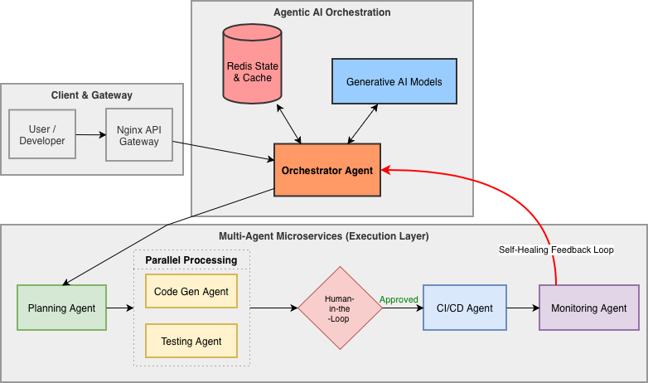
Fig 5.1 Architecture Diagram

  - Modular Description

The system is divided into several modules, each responsible for a specific task.

Module | Description
Code Input Mobile | Accepts source code input from the user through the interface
Backend Module | Handles requests and manages communication between frontend and processing modules
Code Processing Module | Parses and preprocesses the input code for analysis
Explanation Module | Generates a simple explanation of the code logic
Bug Detection Module | Identifies syntax and logical errors in the code
Code Fixing Module | Suggests corrected version of the code
Complexity Analysis Module | Analyzes the time complexity of the code
Test Case Generation Module | Generates test cases to validate the code
Output Module | Displays explanation, errors, fixed code, and test cases to the user
Table 5.2 Modular Description

  - UML Diagrams Description

5.3.1 Use Case Diagrams

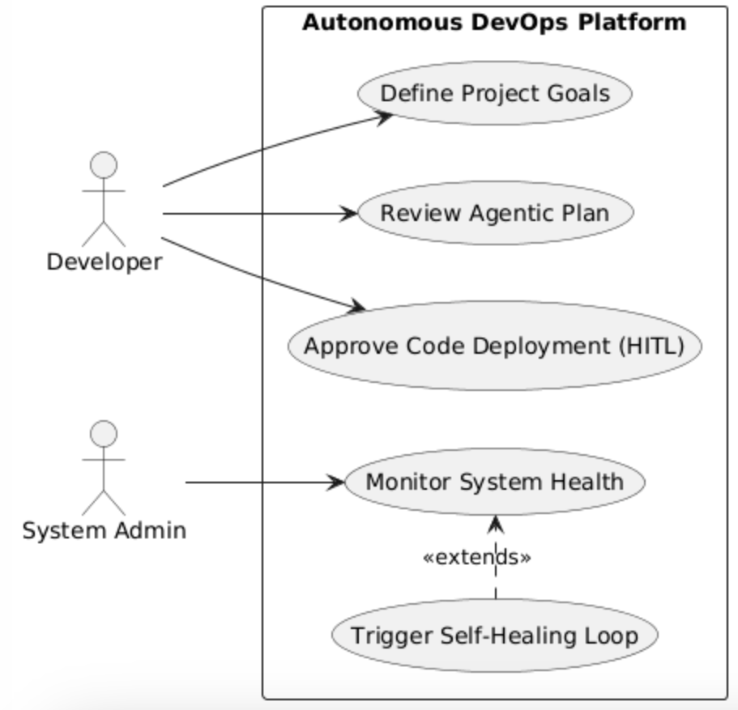

Fig 5.3.1: Use case diagram

5.3.2 Activity Diagram

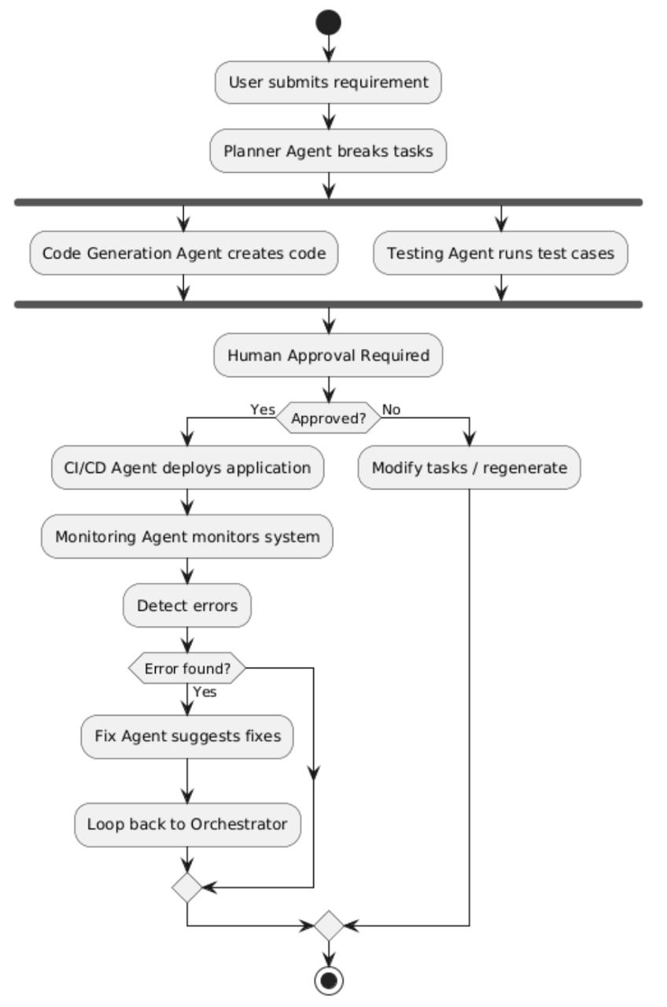
Fig 5.3.2: Activity Diagram

5.3.3 Class Diagram
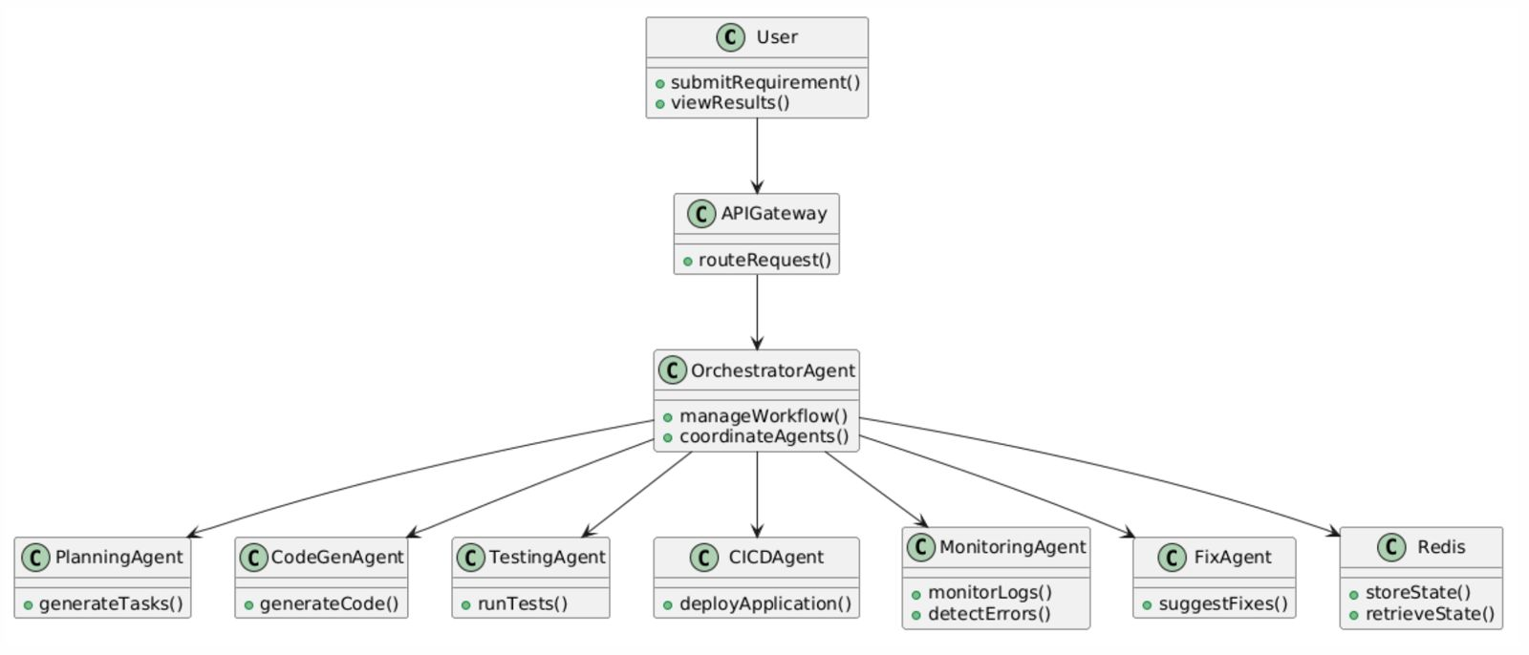
Fig 5.3.3: Class Diagram

5.3.4 Sequence Diagram
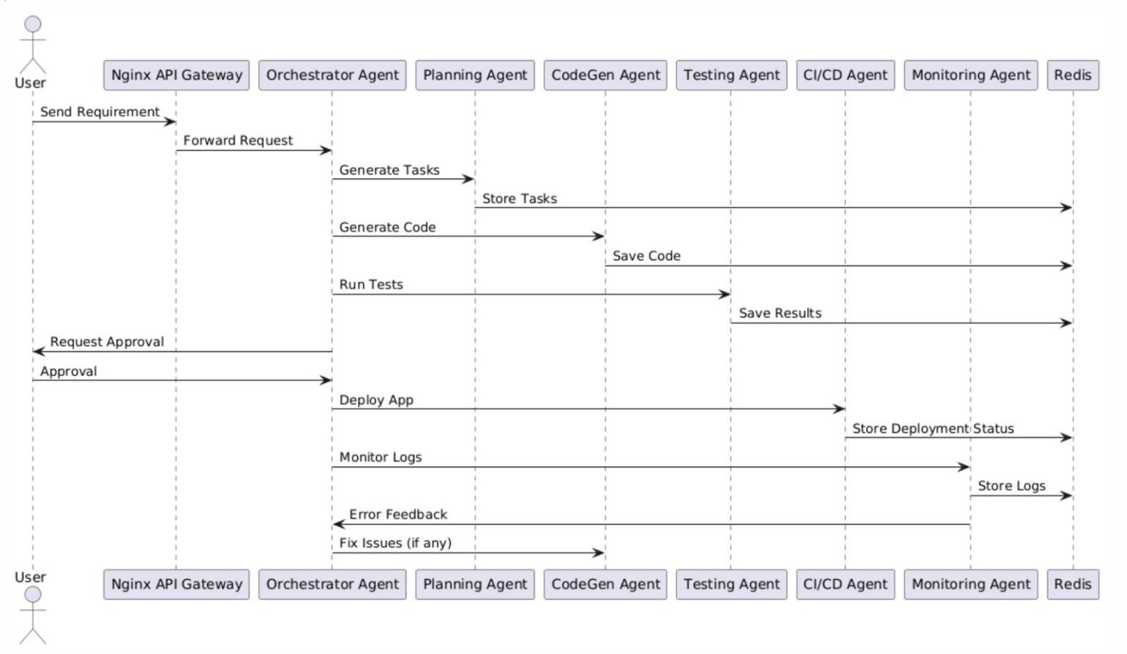Fig 5.3.4: Sequence Diagram

