Question 1

<!doctype html>

<html>

<head>

<meta charset="utf-8">

<title> NestedTables </title>

</head>

<body>

    <table border="5px" bordercolor = "red">

    <tr>

    <td >

        <table>

        <tr> <th colspan="2"> Nested Table 1 </th> </tr>

        <tr> <th> Column 1 </th> <th> Column 2 </th> </tr>

        <tr> <td> Our First Table </td>

        <td> Nested Within </td> </tr>

        </table>

        </td>

        <td >

            <table>

            <tr> <th > Nested Table 2 </th> </tr>

            <td>

              <ul>

                <li>List Object 1</li>

                <li>List Object 2</li>

                <li>List Object 3</li>

            </ul>

            </td>

            </table>

            </td>

    </tr>

    <tr>

        <td >

            <table>

            <tr> <th > Nested Table 3 </th> </tr>

            <tr> <th> <a href="">Nested Table</a> </th> <th> Demo Continued</th> </tr>

            </table>

            </td>

            <td >

                <table>

                <tr> <th colspan="2"> Nested Table 4 </th> </tr>

                <td>

                <image src='html.jpg'></image></td>

                </table>

                </td>

        </tr>

    </table>

Screenshots:

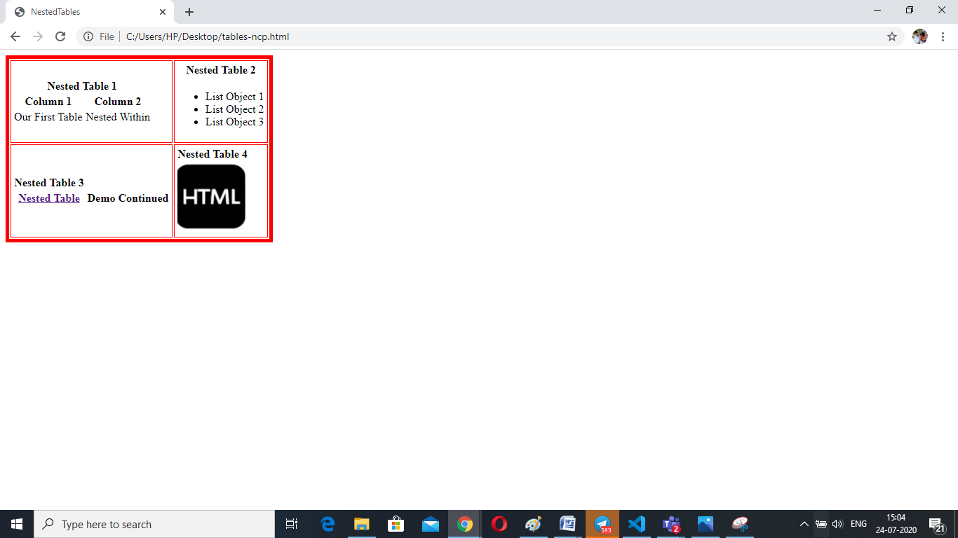

Question 2:

<!DOCTYPE html>

<html>

<body>

<h2>Basic HTML Table</h2>

<table border =1  style="width:100%; border-style:dotted">

  <tr style='background-color:green'>

    <td align=center colspan="12">Online  Time Table Slots</td>

  </tr>

  <tr style='background-color:orange'>

    <td>Dept</td>

    <td>CSE</td>

    <td>Semester</td>

    <td>VII</td>

    <td>Class</td>

    <td>B.Tech CSE</td>

    <td>Section</td>

    <td>D</td>

    <td>Class Advisor</td>

    <td>Mr Prathilothami</td>

    <td>Email id</td>

    <td>Prathilothami.edu</td>

  </tr>

  <tr>

    <th  align=center rowspan="2">Time/Day</th>

    <td>Slot 1</td>

    <td>Slot 2</td>

    <td>Slot 3</td>

    <td>Slot 4</td>

    <td  align=center rowspan ='8'>Lunch Break</td>

    <td>Slot 5</td>

    <td>Slot 6</td>

    <td>Slot 7</td>

    <td>Slot 8</td>

    <td>Slot 9</td>

    <td>Slot 10</td>

  </tr>

  <tr>

    <td>9.00:10.00</td>

    <td>10.00:11.00</td>

    <td>11.00:12.00</td>

    <td>12.00:13.00</td>

    <td>14.00:15.00</td>

    <td>15.00:16.00</td>

    <td>16.00:17.00</td>

    <td>17.00:18.00</td>

    <td>18.00:19.00</td>

    <td>19.00:20.00</td>

  </tr>

  <tr>

    <th>Monday</th>

    <td>15CSE402</td>

    <td></td>

    <td></td>

    <td></td>

    <td  align=center colspan ='2'>Elective Lab</td>

    <td></td>

    <td></td>

    <td>15CSE402</td>

    <td></td>

  </tr>

  <tr>

    <th>Tuesday</th>

    <td>15CSE401</td>

    <td>15CSE338</td>

    <td></td>

    <td>15CSE431</td>

    <td></td>

    <td></td>

    <td></td>

    <td></td>

    <td>15CSE401</td>

    <td></td>

  </tr>

  <tr>

    <th>Wedesday</th>

    <td>15CSE431</td>

    <td>15CSE401</td>

    <td></td>

    <td>15CSE402</td>

    <td  align=center colspan ='2'>Machine Learning</td>

    <td></td>

    <td></td>

    <td>15CSE431</td>

    <td></td>

  </tr>

  <tr>

    <th>Thurday</th>

    <td>15CSE338</td>

    <td></td>

    <td>Soft Skill</td>

    <td>15CSE376</td>

    <td ></td>

    <td></td>

    <td ></td>

    <td></td>

    <td>15CSE338</td>

    <td></td>

  </tr>

  <tr>

    <th>Friday</th>

    <td>15CSE376</td>

    <td>15CSE431</td>

    <td></td>

    <td>15CSE402</td>

    <td  align=center colspan='2'>Net Centric Programming</td>

    <td></td>

    <td ></td>

    <td>15CSE376</td>

    <td></td>

  </tr>

  <tr>

    <th>Saturday</th>

    <td>15CSE402</td>

    <td></td>

    <td>15CSE338</td>

    <td>15CSE401</td>

    <td></td>

    <td></td>

    <td></td>

    <td ></td>

    <td>15CSE343</td>

    <td></td>

  </tr>

</table>

</body>

</html>

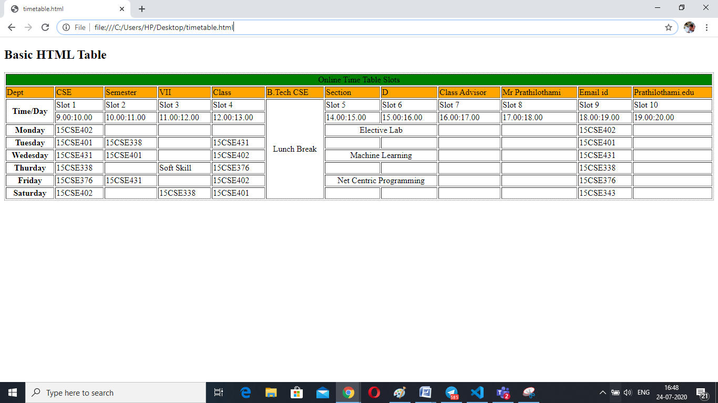

Question 3:

<!DOCTYPE html>

<html>

<body>

<h2>Image Maps</h2>

<img src="computer.jpg" alt="rectangle" usemap="#compmap" width="512" height="222">

<map name="compmap">

  <area shape="rect" coords="37,64,147,128" alt="rectangle 1" href="printer.html">

  <area shape="rect" coords="151,151,215,196" alt="rectangle 2" href="speaker.html">

  <area shape="rect" coords="223,166,425,181" alt="rectangle 3" href="keyboard.html">

  <area shape="rect" coords="346,189,397,196" alt="rectangle 4" href="mouse.html">

  <area shape="rect" coords="306,56,376,161" alt="rectangle 5" href="cpu.html">

  <area shape="rect" coords="170,33,295,141" alt="rectangle 6" href="monitor.html">

</map>

</body>

</html>

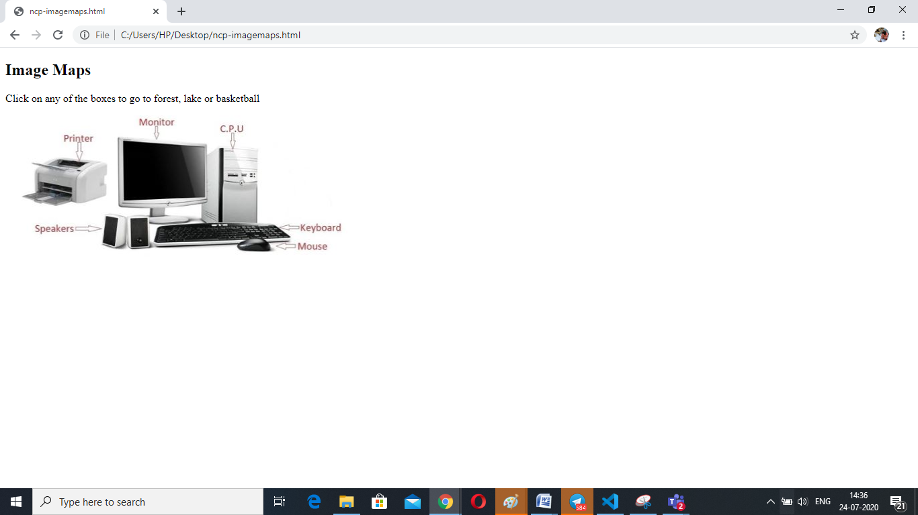

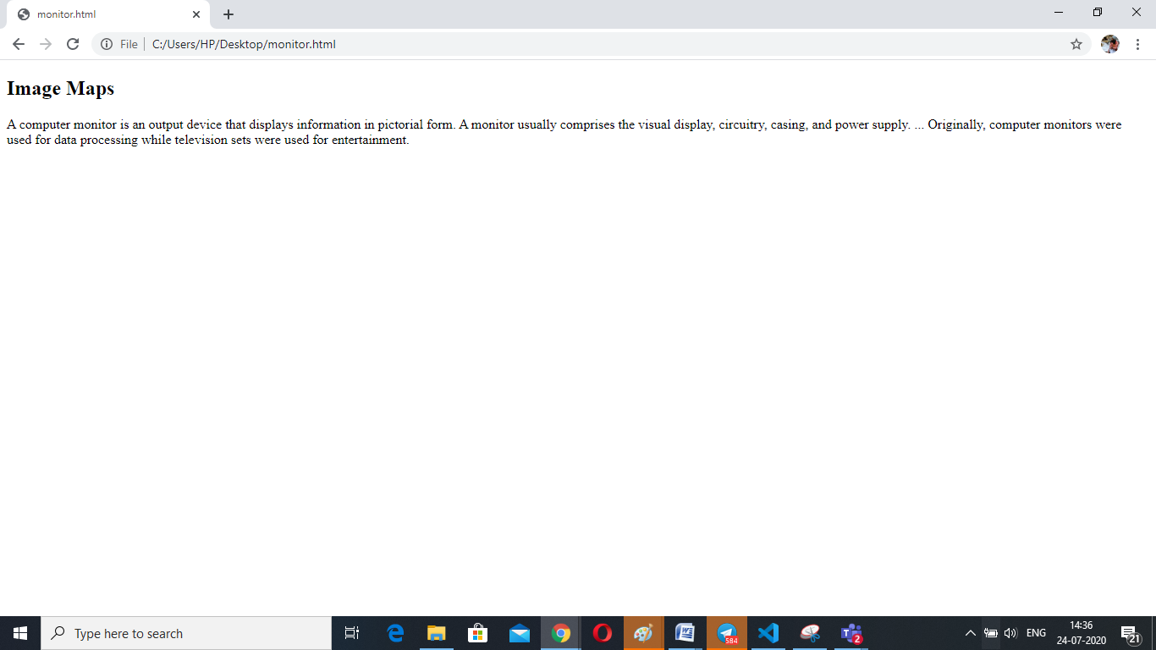

Question 4:

<!DOCTYPE html>

<html>

<head>

    <style>

        </style>

</head>

<body>

    <div>

        <fieldset style='border-style: solid;

       border-width: 5px;width: 100%;

        height:500px;border-color: slategrey'>

    <form method ='POST'>

        <table border=1>

            <tr>

                <td> <INPUT  TYPE="Radio" Name="id" Value="id">id</td>

                <td> <INPUT  TYPE="Radio" Name="pass" Value="pass">Passport</td>

                <td> <label for ='num' id="num" >Number</label>

                <input   style=' width:350px'  type ='text' , name='num'/></td>

                <td><label  align=right for ='papp' id="papp">Passport exp date</label>

                <input align=right  type ='date' , name='num'/> </td>

                <td><label for ='cnt' id="cnt">Passport Country</label>

                <select  name='cnt'>

                <option value='Value 1'>India</option>

                <option value='Value 2'>USA</option>

                <option value='Value 3'>London</option>

                </select>

                </td>

            </tr>

            </table>

            <table border=1>

                <tr>

                <td colspan="2">

                <label for ='title' id="title">Title</label>

                <select  name='title'>

                    <option value='Value 1'>Mr</option>

                    <option value='Value 2'>Mrs</option>

                    <option value='Value 3'>Miss</option>

                </select>

                </td>

                <td>

                <label for ='first' id="first">First Name</label>

                <input  type ='text' , name='first'/>

                </td>

                <td>

                <label for ='last' id="first">Last Name</label>

                <input   type ='text' , name='last'/>

                </td>

                </tr>

                <tr>

                <td colspan="2">

                <label for ='title' id="demo">Demo-Car ID</label>

                <input  type ='text' , name='demo'/>

                </td>

                <td>

                <label for ='card' id="card">Company Card no:</label>

                <input  type ='text' , name='card'/>

                </td>

                <td>

                <label for ='birth' id="birth">Birth Date</label>

                <input  type ='date' , name='birth'/>

                </td>

                </tr>

            </table>

            <table border=1>

            <tr>

             <td colspan=2>

             <label for ='lic' id="lic">License Country</label>

             <select  name='lic'>

                <option value='Value 1'>USA</option>

                <option value='Value 2'>UK</option>

                <option value='Value 3'>Germany</option>

             </select>

             </td>

             <td>

             <label for ='iss' id="iss">Issue  Date</label>

             <input  type ='date' , name='iss'/>

             </td>

             <td>

             <label for ='iata' id="iata">IATA</label>

             <input  type ='text' , name='iata', text-align="right"/>

             </td>

            </tr>

            <tr>

                <td colspan="2">

                <label for ='diss' id="diss">Driver license no.</label>

                <input  type ='text' , name='iss'/>

                </td>

                <td>

                <label for ='eiss' id="iss">Expiry Date</label>

                <input  type ='date' , name='eiss'/>

                </td>

                <td>

                <label for ='ddiss' id="ddiss">Phone 1</label>

                <input  type ='text' , name='ddiss',text-align="right"/>

                </td>

            </tr>

            <tr>

                <td colspan="3">

                <label for ='add' id="add">Address line1</label>

                <textarea name='add' , cols='30' rows ='1'></textarea>

                </td>

                <td>

                <label  style='text-align:right' for ='piata' id="piata">Phone 2</label>

<input  type ='text' , name='iata',text-align="right"/>

                </td>

            </tr>

            <tr>

                <td colspan="3">

                <label for ='add1' id="add">Address line2</label>

                <textarea name='add1' , cols='30' rows ='1'></textarea>

                </td>

                <td>

                <label  style='text-align:right' for ='piata' id="piata">Fax 1</label>

                <input  type ='text' , name='iata',text-align="right"/>

                </td>

            </tr>

            <tr>

                <td>

                <label for ='ddiss' id="ddiss">City/State</label>

                <input  type ='text' , name='ddiss'/>

                </td>

                <td>

                <label for ='ddiss' id="ddiss">Zip</label>

                <input  type ='text' , name='ddiss'/>

                </td>

                <td>

                <label for ='ddiss' id="ddiss">Country</label>

                <select  name='ddis'>

                    <option value='Value 1'>USA</option>

                    <option value='Value 2'>UK</option>

                    <option value='Value 3'>Germany</option>

                </select>

                </td>

                <td>

                <label for ='ddiss' id="ddiss">SMS Number</label>

                <input  type ='text' , name='ddiss'/>

                </td>

            </tr>

            </table>

            <table border=1>

            <tr>

                <td>

                <label for ='eiss' id="iss">Employer</label>

                <input  type ='date' , name='eiss'/>

                </td>

                <td>

                <label for ='eiss' id="iss">Customer Source Type</label>

                <select  name='eiss'>

                    <option value='Value 1'>Media</option>

                    <option value='Value 2'>UK</option>

                    <option value='Value 3'>Germany</option>

                </select>

                </td>

                <td>

                <label for ='eiss' id="iss">Email</label>

                <input  type ='text' , name='eiss'/>

                </td>

            </tr>

            <tr>

                <td colspan="2">

                <label for ='eiss' id="iss">Local Address</label>

                <input  type ='text' , name='eiss'/>

                </td>

                <td>

                <label for ='eiss' id="iss">Local Phone</label>

                <input  type ='text' , name='eiss'/>

                </td>

            </tr>

            </table>

                </form>

</div>

</body>

</html>

