Open aws account
Select EC2 instance
Click on launch instance
Select ubuntu os
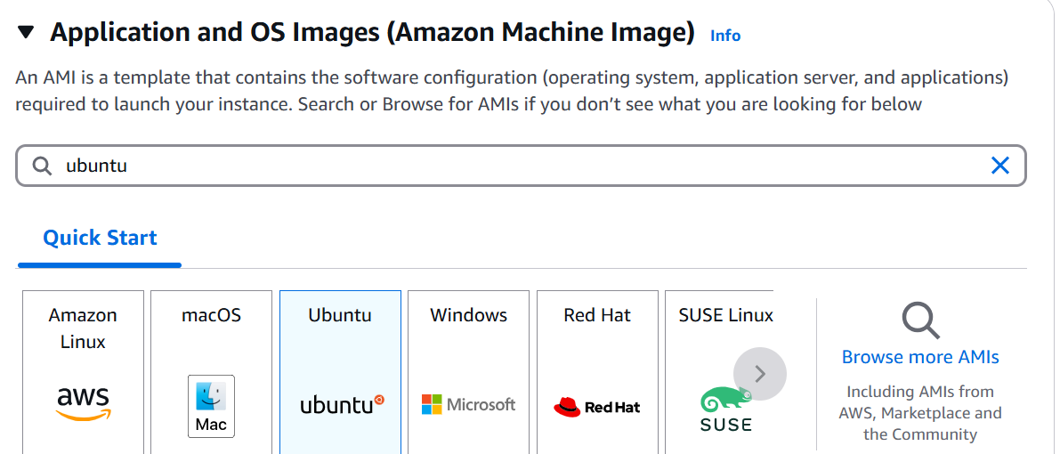
Select ubuntu free tier as amazoin image
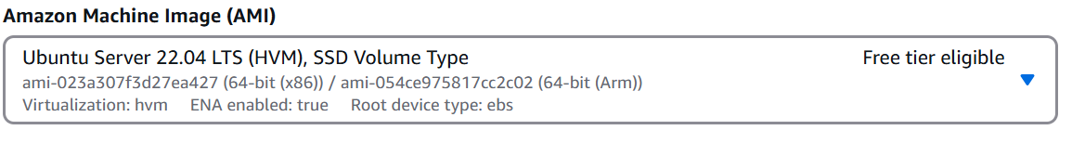
Select instance type t2.micro
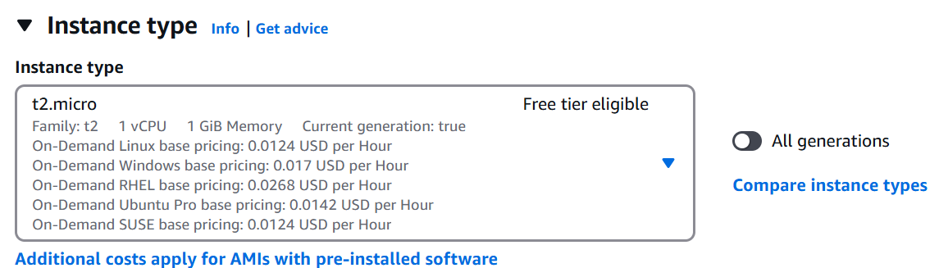

Create key pair
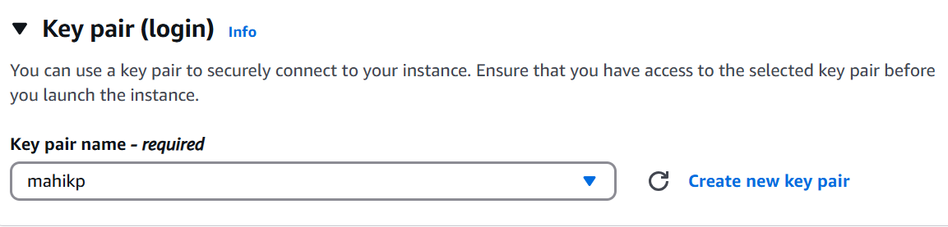

Network add the below rule
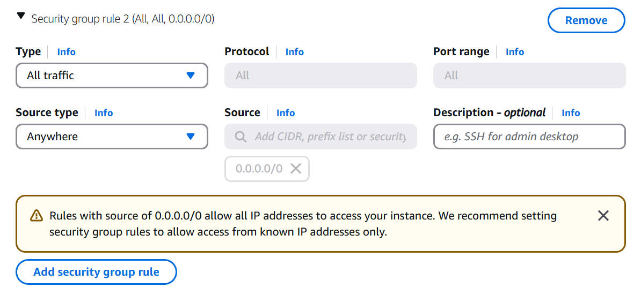

Goto the .pem file location from there open gitbash (before you need to download and install gitbash in your computer)

Goto aws click on the connect take the ssh id copy and paste in the gitbash
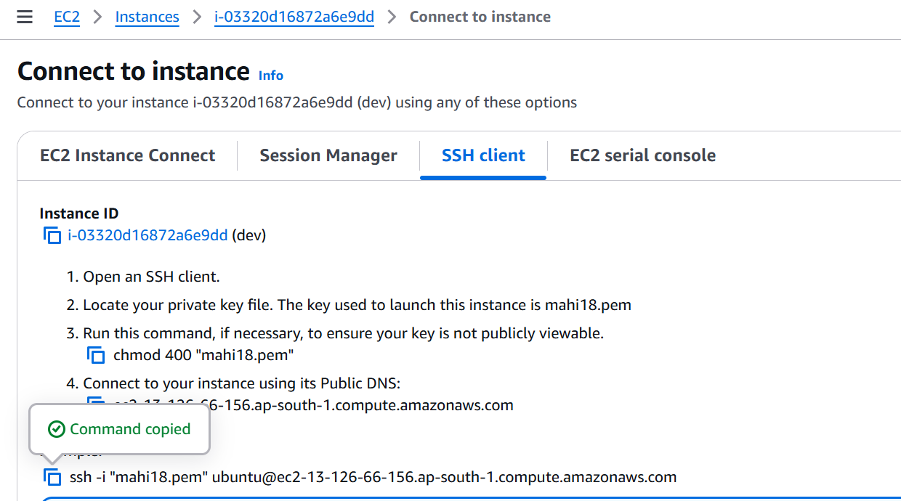

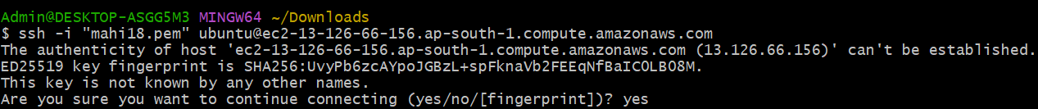

Now u need to install jenkins

First u need to update the apt repository

$ sudo apt update

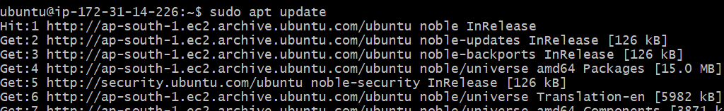

Install java

sudo apt install openjdk-21-jdk -y

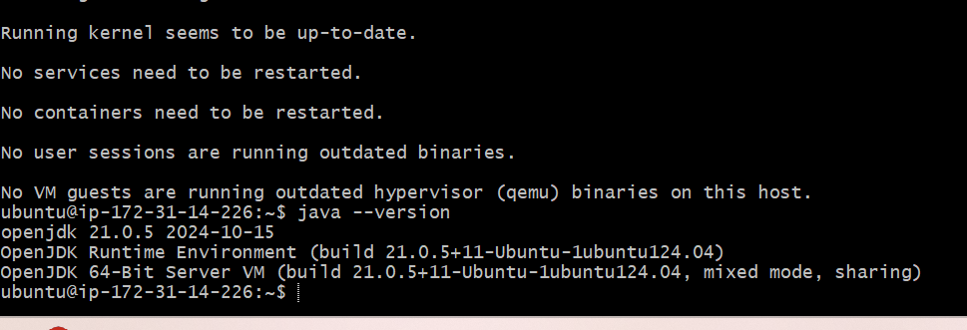

u need to install git and maven and check it
Sudo apt-get install -y git maven
git --version
mvn --version

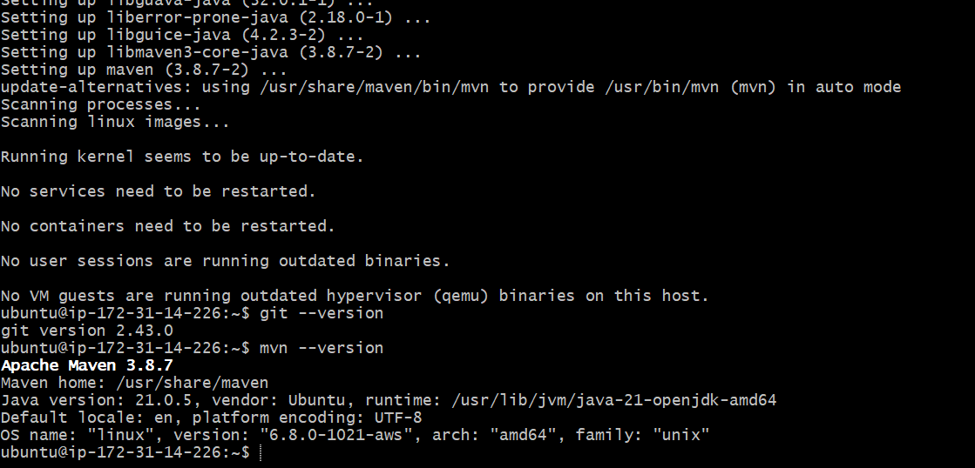

Open jenkin.io (Download and deploy) in browser and select the generic java package(.war)

Copy and paste link addrest

$wget linkaddress
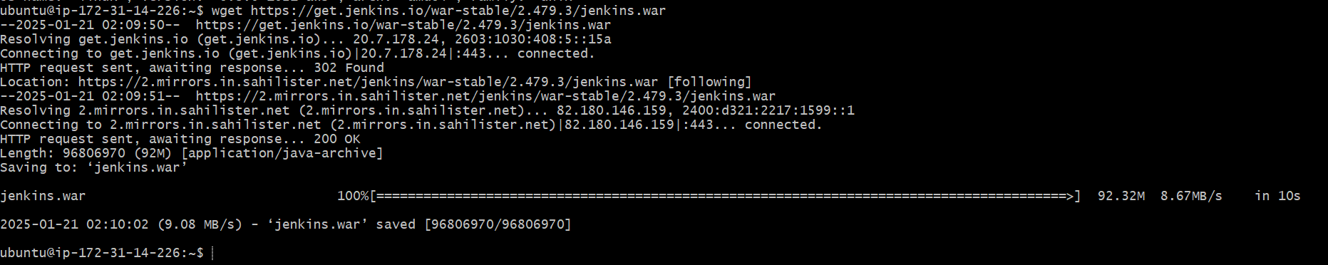

Start the jenkins services

$ java -jar jenkins.war

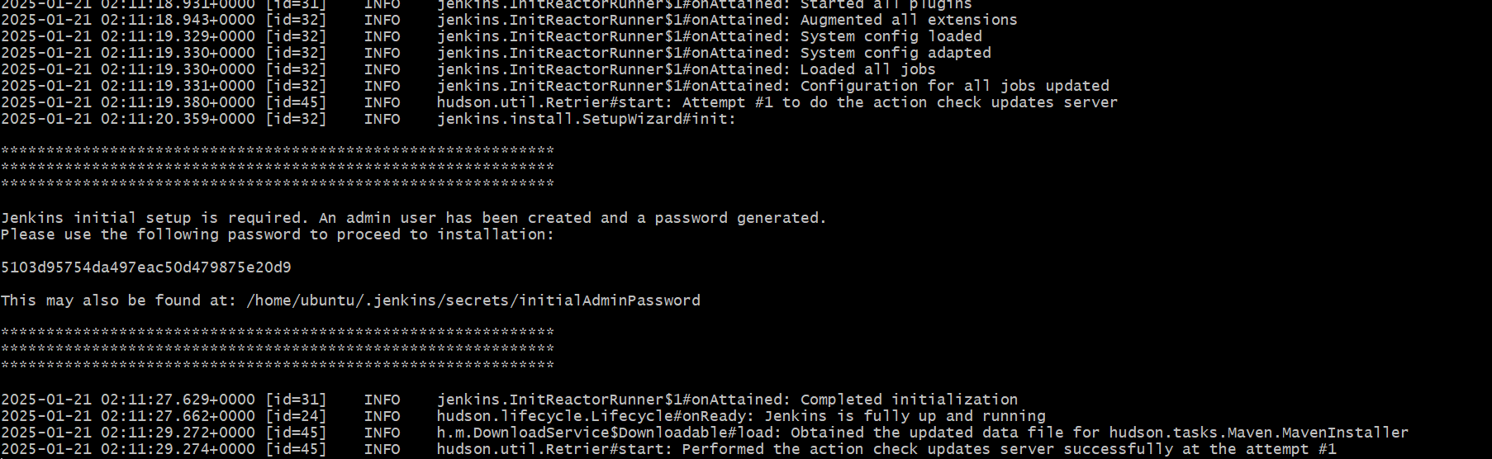

How can we access the jenkin

Take the public ip of dev server
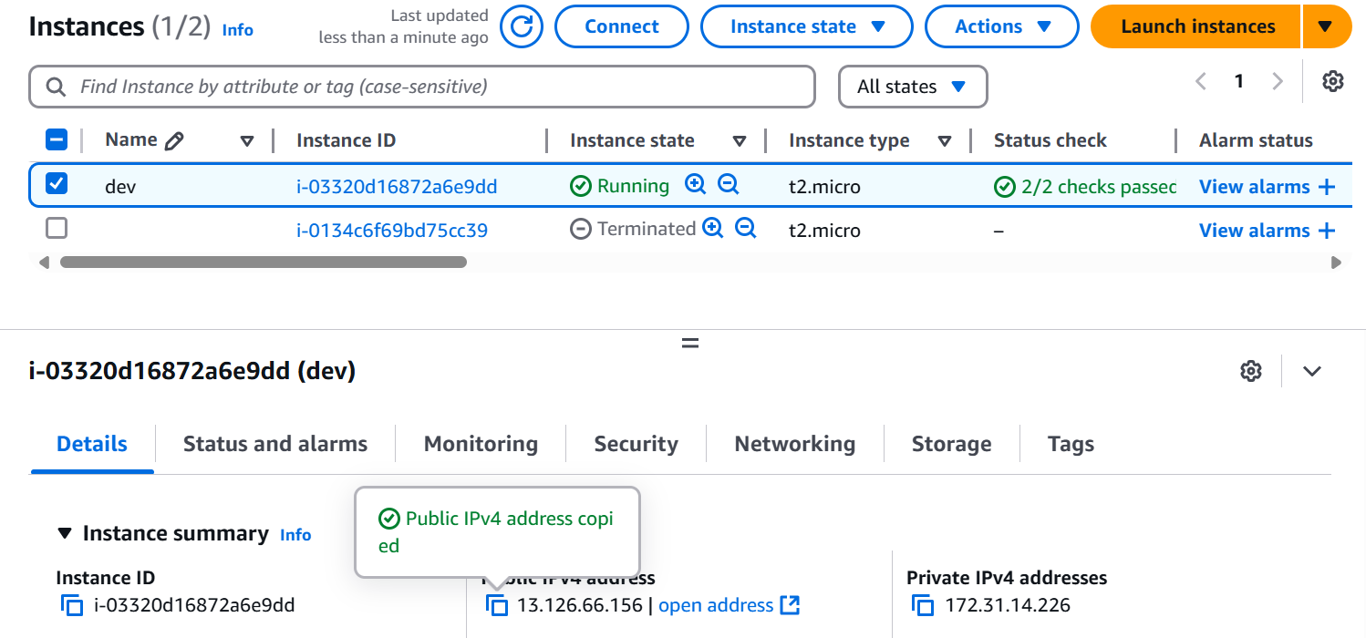
Copy and paste in the browser add 8080 as port number

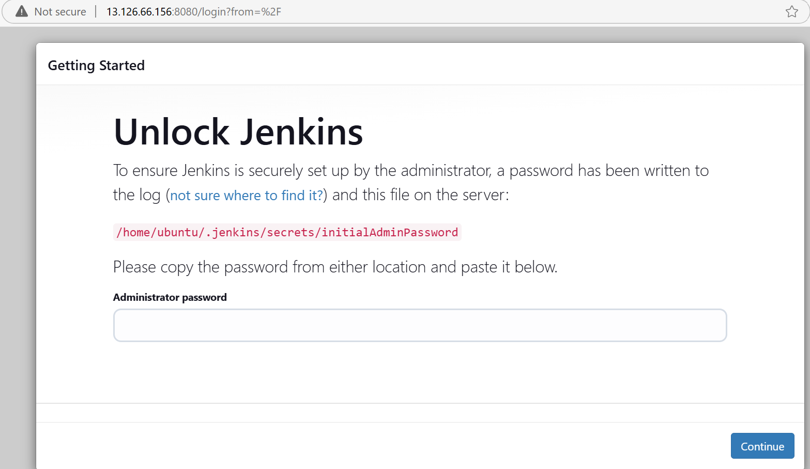

Unlock the jenkins with password which is present in the gitbash
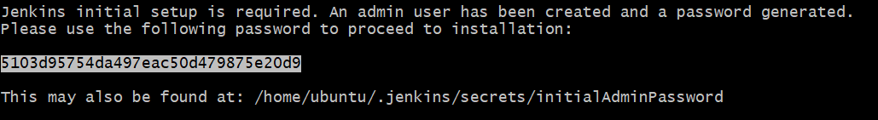

Select the install suggested pluggins
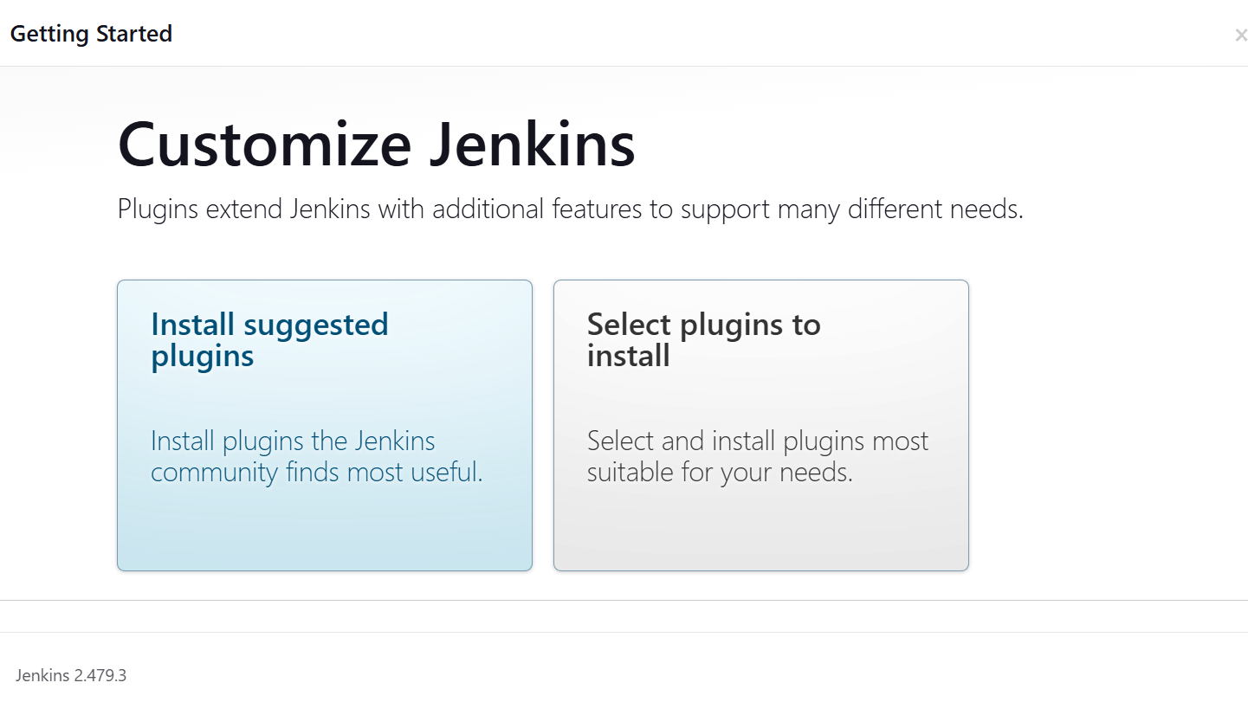

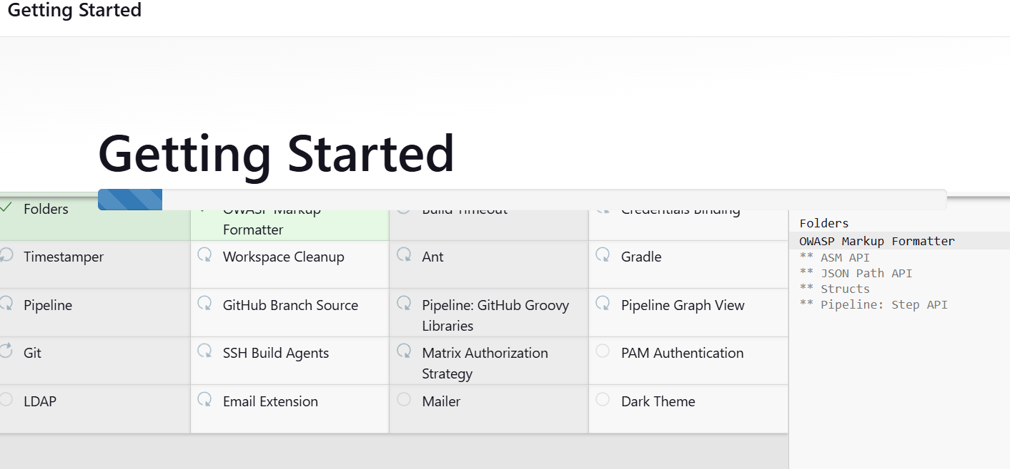

You can give all admin

Click on save and continue

Click on save and finish

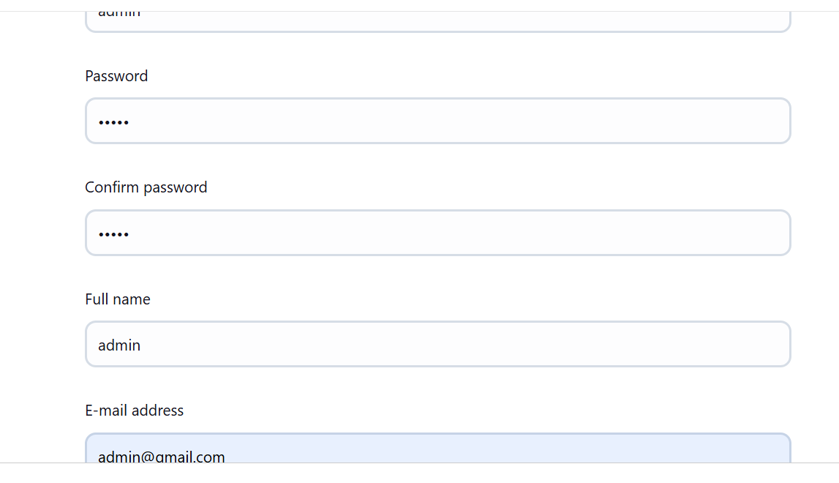

Your jenkins is ready

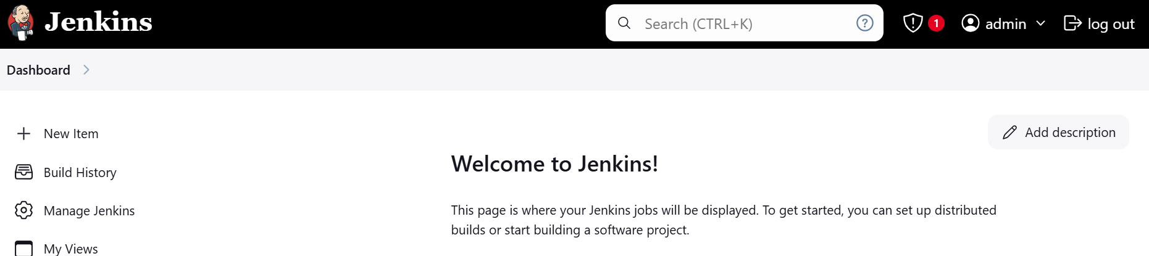

Note: don’t close the jenkins server

