**Question 1:**

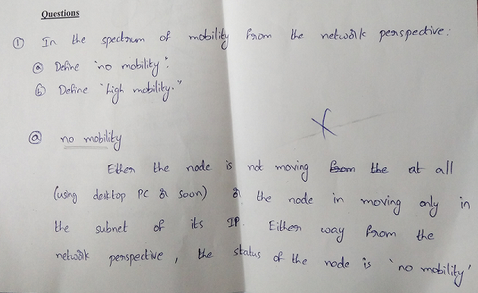

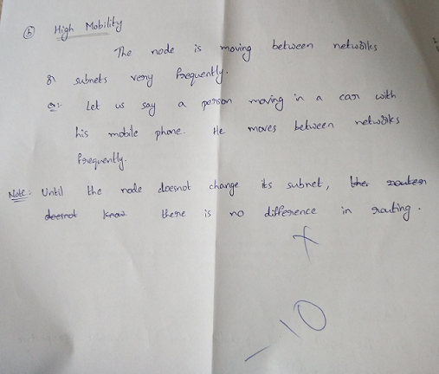

**Answer:**

No Mobility: - Mobile wireless user using same access point is considered as ‘no mobility’ from network perspective.

High Mobility :- Mobile user, passing through multiple access point while maintaining ongoing connections (like cellphone) is considered as ‘high mobility’.

**Question 2:**

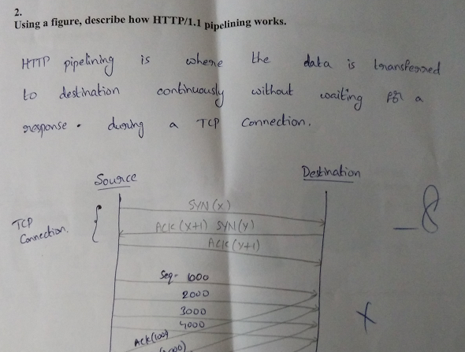

**Answer**

The HTTP pipelining feature allows requests to be issued asynchronously on a persistent connection. Requests must be processed in proper order.

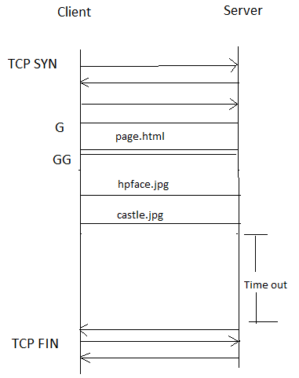

**Question 6:**

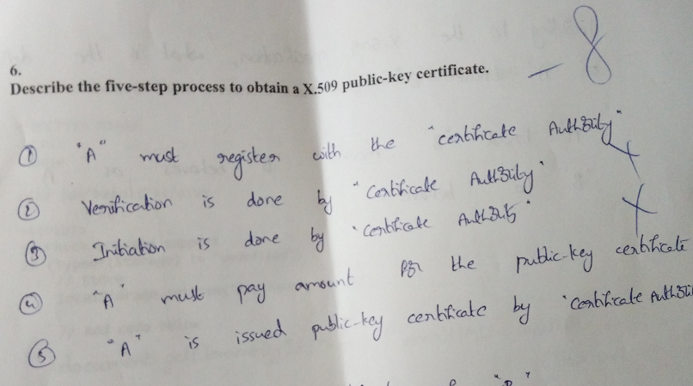

**Answer**

The five step process to obtain a X.509 public-key certificate is

1. Generate private and public keys

2. Gather name value pairs

3. Generate CSR

4. Submit CSR for CA to sign

5. Receive Certificate from CA

**Question 7b:**

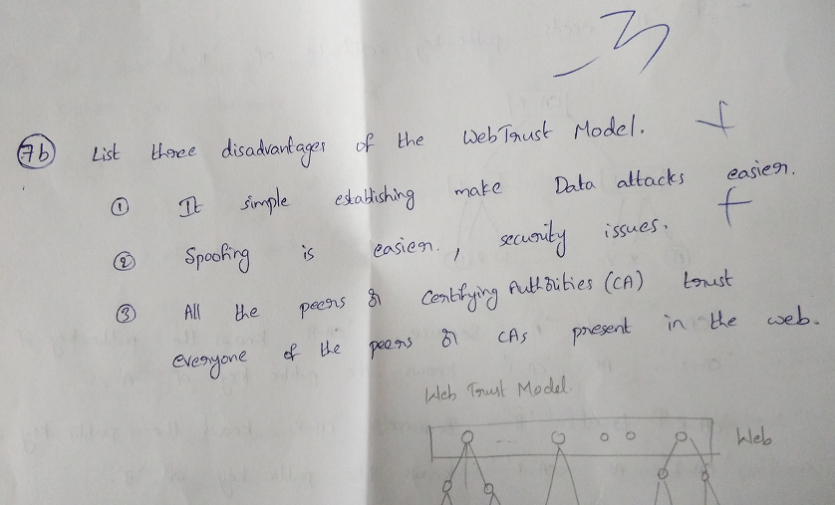

**Answer**

The three disadvantages of Web Trust Model are :-

1. Identifying spoofing with bad CA Certificate

2. Decentralized Trust management – user level management

3. Inability for Revocation – No CRL, OCSP

4. Distribution Problem