Exercise 1: Control Structures

TABLE :

CODE:

CREATE TABLE Customers (
CustomerID NUMBER PRIMARY KEY,
Name VARCHAR2(100),
Age NUMBER,
Balance NUMBER(10,2),
IsVIP VARCHAR2(5) DEFAULT 'FALSE'
);

CREATE TABLE Loans (
LoanID NUMBER PRIMARY KEY,
CustomerID NUMBER REFERENCES Customers(CustomerID),
InterestRate NUMBER(5,2),
DueDate DATE
);

INSERT INTO Customers VALUES (1, 'Alice', 65, 15000, 'FALSE');
INSERT INTO Customers VALUES (2, 'Bob', 45, 8000, 'FALSE');
INSERT INTO Customers VALUES (3, 'Charlie', 70, 11000, 'FALSE');
INSERT INTO Customers VALUES (4, 'Diana', 58, 9500, 'FALSE');

INSERT INTO Loans VALUES (101, 1, 7.5, SYSDATE + 15);
INSERT INTO Loans VALUES (102, 2, 6.8, SYSDATE + 40);
INSERT INTO Loans VALUES (103, 3, 8.2, SYSDATE + 10);
INSERT INTO Loans VALUES (104, 4, 7.0, SYSDATE + 5);

COMMIT;

TABLES :

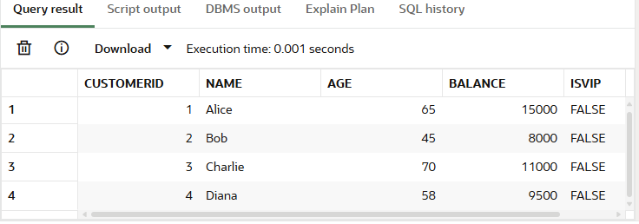

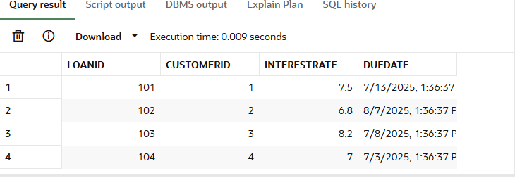

Scenario 1: The bank wants to apply a discount to loan interest rates for customers above 60 years old.

CODE:

BEGIN
FOR cust_rec IN (SELECT CustomerID FROM Customers WHERE Age > 60) LOOP
UPDATE Loans
SET InterestRate = InterestRate - 1
WHERE CustomerID = cust_rec.CustomerID;
END LOOP;

COMMIT;
END;

OUTPUT :

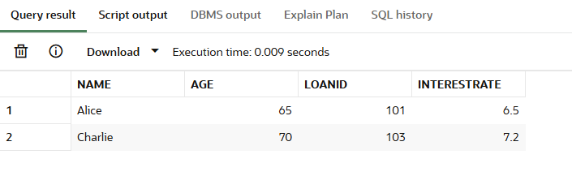

Scenario 2 : Promote Customers with Balance > $10,000

CODE :

BEGIN
FOR cust_rec IN (SELECT CustomerID FROM Customers WHERE Balance > 10000) LOOP
UPDATE Customers
SET IsVIP = 'TRUE'
WHERE CustomerID = cust_rec.CustomerID;
END LOOP;

COMMIT;
END;

OUTPUT :

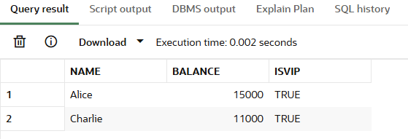

Scenario 3: Send Reminders for Loans Due in 30 Days

CODE :

BEGIN
FOR loan_rec IN (
SELECT L.LoanID, L.CustomerID, L.DueDate, C.Name
FROM Loans L
JOIN Customers C ON L.CustomerID = C.CustomerID
WHERE L.DueDate <= SYSDATE + 30
) LOOP
DBMS_OUTPUT.PUT_LINE('Reminder: Loan ' || loan_rec.LoanID ||
' for customer ' || loan_rec.Name ||
' is due on ' || TO_CHAR(loan_rec.DueDate, 'DD-MON-YYYY'));
END LOOP;
END;

OUTPUT :

