Exercise 3 : Stored Procedures

TABLES :

CODE :

CREATE TABLE Accounts (
AccountID NUMBER PRIMARY KEY,
CustomerID NUMBER,
AccountType VARCHAR2(20), -- 'Savings', 'Checking', etc.
Balance NUMBER(10, 2)
);

CREATE TABLE Employees (
EmployeeID NUMBER PRIMARY KEY,
Name VARCHAR2(100),
Department VARCHAR2(50),
Salary NUMBER(10, 2)
);

CREATE TABLE Transfers (
TransferID NUMBER GENERATED ALWAYS AS IDENTITY PRIMARY KEY,
FromAccount NUMBER,
ToAccount NUMBER,
Amount NUMBER(10, 2),
TransferDate DATE DEFAULT SYSDATE
);

TABLES OUTPUT :

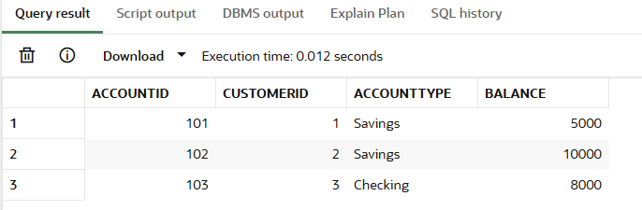

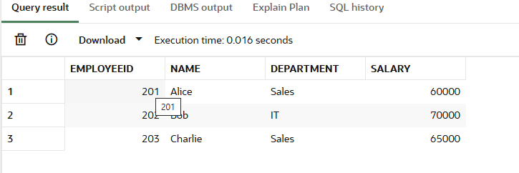

Scenario 1: Monthly Interest Processing

CODE :

CREATE OR REPLACE PROCEDURE ProcessMonthlyInterest IS
BEGIN
UPDATE Accounts
SET Balance = Balance * 1.01
WHERE AccountType = 'Savings';

COMMIT;
END;

EXEC ProcessMonthlyInterest;
SELECT * FROM Accounts;

OUTPUT :

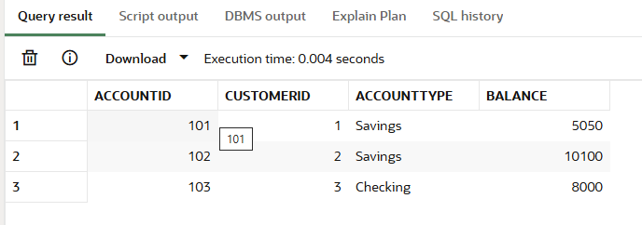

Scenario 2: Employee Bonus Update

CODE :
CREATE OR REPLACE PROCEDURE UpdateEmployeeBonus (
p_Department IN VARCHAR2,
p_BonusPercent IN NUMBER -- e.g. 10 for 10%
) IS
BEGIN
UPDATE Employees
SET Salary = Salary + (Salary * p_BonusPercent / 100)
WHERE Department = p_Department;

COMMIT;
END;

EXEC UpdateEmployeeBonus('Sales', 8);
SELECT * FROM Employees;

OUTPUT :

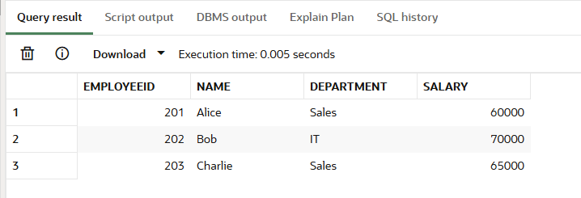

Scenario 3: Transfer Funds Between Accounts

CODE :

CREATE OR REPLACE PROCEDURE TransferFunds (
p_FromAccount IN NUMBER,
p_ToAccount IN NUMBER,
p_Amount IN NUMBER
) IS
v_FromBalance NUMBER;
BEGIN
-- Check balance of source account
SELECT Balance INTO v_FromBalance
FROM Accounts
WHERE AccountID = p_FromAccount
FOR UPDATE;

IF v_FromBalance < p_Amount THEN
RAISE_APPLICATION_ERROR(-20001, 'Insufficient funds in source account.');
END IF;

-- Deduct from source
UPDATE Accounts
SET Balance = Balance - p_Amount
WHERE AccountID = p_FromAccount;

-- Add to destination
UPDATE Accounts
SET Balance = Balance + p_Amount
WHERE AccountID = p_ToAccount;

-- Log transfer (optional)
INSERT INTO Transfers (FromAccount, ToAccount, Amount)
VALUES (p_FromAccount, p_ToAccount, p_Amount);

COMMIT;
END;

EXEC TransferFunds(101, 102, 500);
SELECT * FROM Transfers;

OUTPUT :

