Tribhuvan University
Institute of Science and Technology



Project Proposal
Of
LET’S FIND
Submitted To
Department Of Computer Science and Information Technology
Birat Kshitiz College, Biratnagar

In Partial Fulfillment of The Requirement for The Bachelors of Science in Computer Science and Information Technology
Submitted By
Rahul Majhi (27230/077)
Karan Pokhrel (27222/077)
Kuldip Shah (27224/077)

Date: 2081/05/07

TABLE OF CONTENTS
LIST OF FIGURES 3
CHAPTER 1: INTRODUCTION 4
1.1 Background 4
1.2 Problem Statement 4
1.3 Proposed Solution 5
1.4 Objective 5
1.5 Scopes 6
LIST OF ABBREVIATION 7
CHAPTER 2: SYSTEM ANALYSIS 8
2.1 Study of existing system 8
2.2 Requirement Analysis 8
2.2.1 Functional Requirements 8
CHAPTER 3: FEASIBILITY STUDY 9
3.1 Economic Feasibility 9
3.2 Technical Feasibility 9
3.3 Operational Feasibility 9
3.4 System Design and Development 10
3.4.1 Development Model 10
3.4.2 Flowchart for “LET’S FIND” 11
3.4.3 System Architecture 12
CHAPTER 4: IMPLEMENTATION TOOL 13
CHAPTER 5: CONCLUSION 15

LIST OF FIGURES
figure 1 : Iterative Waterfall Model 11
figure 2 :Flowchart for LET’S FIND 12
figure 3 : Use case Diagram For LET’S FIND 13
Figure 4 :Gantt Chart 16

CHAPTER 1: INTRODUCTION

1.1 Background
The world is gradually changing and people are getting busy day by day. There is no time for any kind of extra things like doing regular household things , such as cleaning , cooking, plumbing, etc , and even to find reliable co-workers for companies and large industries(eg: IT companies) So, in order to tackle such things one should know all works which is technically not possible. The cleanest way to handle it is to hire workers who are especially trained on particular works. LET’S FIND creates a platform for the certain purpose.

LET’S FIND is a website application developed with a view of changing the search of workers online instead physically. It solves the problem of hectic physical works where one should had to move from one place to other in search of labour or job by making it easy where one can search for job or worker online without moving even 1inch. It creates a platform where a company or person can create a profile and can seek for employees or jobs which can lead the life more easily and can save time.

1.2 Problem Statement
Before the advent of online platforms, the job-seeking and posting process was fraught with inefficiencies and limitations that created significant challenges for both job seekers and employers. Job seekers had to rely on traditional methods such as newspapers, bulletin boards, and word-of-mouth to find job opportunities, which were often limited in scope and accessibility. This approach made it difficult to discover a broad range of job openings, particularly for those seeking positions in different locations or industries. Additionally, the application process was cumbersome, requiring job seekers to manually prepare and submit paper resumes and cover letters, often resulting in delays and lost opportunities.

1.3 Proposed Solution
The proposed solution is a web-based application that provide a centralized, accessible, and streamlined solution that benefits both job seekers and employers. It offers a user friendly interface for the employers to post a job announcement with ease in handling the web application and for the job seekers to search job by sitting in a room to with our online portal where they can put their resume in their profile.

1.4 Objective
Major objectives behind developing LET’S FIND are:
- To develop a proper platform for the job or employee seekers.
- To minimize the time and effort for searching job physically by moving here and there instead search online sitting in a one corner of your house.
- To solve unemployment problem somehow.
- To make life easy where one can find solution (job and employee) in one click.

1.5 Scopes
It has following scopes:
- Can be helpful for the job seekers.
- Can create better opportunities for employment.
- Resume/CV management which allows job seekers to create and manage their resume/CVs and for employers to easily search and review candidate profiles.
- Offering communication tools for job seekers and employers to connect and discuss job opportunities, including chat or messaging features.

LIST OF ABBREVIATION

HTML Hypertext Markup Language
CSS Cascading Style Sheet
SQL Structured Query Language
PHP Hypertext Preprocessor

CHAPTER 2: SYSTEM ANALYSIS

2.1 Study of existing system
There are several employment opportunity applications over internet such as Merojob, Merorojgari, etc. but in terms of market popularity in Nepal, they are not quite heard and known. This shows their lack in meeting the user requirement as per the current situation of market in the country. One of the main focuses should be providing even smaller job to the people who need it without having degree or even not educated but most of the applications does not contain such matters in their application. So, the focus point is to make the LET’S FIND platform suitable for the market as per today’s need.

2.2 Requirement Analysis
A requirement is a singular documented physical or functional need that a particular design, product or process aims to satisfy. There are two types of requirements:
- Functional Requirements
- Non-functional Requirements

2.2.1 Functional Requirements
The functional requirements are the requirement that describes what system does i.e. the functioning or behavior of the system. The functional requirements of the LET’S FIND are:
- Login credentials
- User registration and Authentication
- Job posting
- Rating and Review
- Messaging and Notification
- Invoicing and Payments
- Reporting and Analysis
- Compliance and Regulation
- Add profile and edit

CHAPTER 3: FEASIBILITY STUDY
A feasibility study for LET’S FIND involves evaluating its economic, technical, and operational feasibility:

3.1 Economic Feasibility
The integration of traditional job seeking and recruitment system into online all in one platform where anyone or company can post or seek job oriented things and easily get benefited . From an economic perspective, online job seeking and recruitment platforms generally offer greater feasibility than traditional methods. They provide cost savings, increased efficiency, broader reach, and access to valuable data. However, the increased competition and potential impact on wages must be considered.
For most organizations and job seekers, the benefits of online platforms outweigh the costs, making them a more economically viable option in today's job market.

3.2 Technical Feasibility
online job seeking and recruitment platforms are technically feasible and offer significant advantages over traditional methods. These platforms leverage advancements in technology to provide scalable, accessible, and efficient solutions for both job seekers and employers.ability to scale, incorporate advanced technologies like AI, and provide a global, accessible, and secure environment makes them not only feasible but also the preferred choice in the modern job market. The continuous evolution of these platforms ensures they will remain at the forefront of job searching and recruitment.

3.3 Operational Feasibility
online job seeking and recruitment platforms are operationally more feasible than traditional methods. They offer superior efficiency, resource optimization, flexibility, scalability, and enhanced user experiences. The ability to reach a global audience and manage the entire recruitment process digitally ensures that these platforms are well-suited to the demands of modern job markets, making them a highly effective operational choice for both employers and job seekers.

3.4 System Design and Development
we can follow a structured approach and create various use cases diagrams to model the system's components, interactions, and behavior to design and develop online job seeking and recruitment system.

3.4.1 Development Model

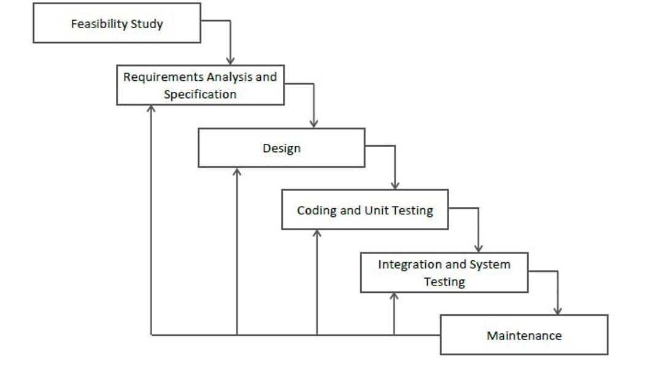
figure 1: Iterative Waterfall Model

3.4.2 Flowchart for “LET’S FIND”
Creating a flowchart for a LET’S FIND involves visually representing
the steps and decision points in the system's processes. Here's a of a flowchart for LET’S FIND :

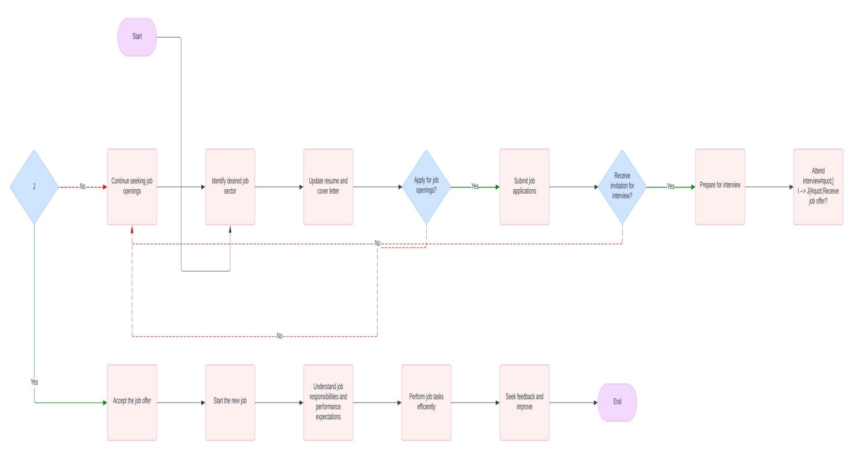figure 2:Flowchart for LET’S FIND

3.4.3 System Architecture

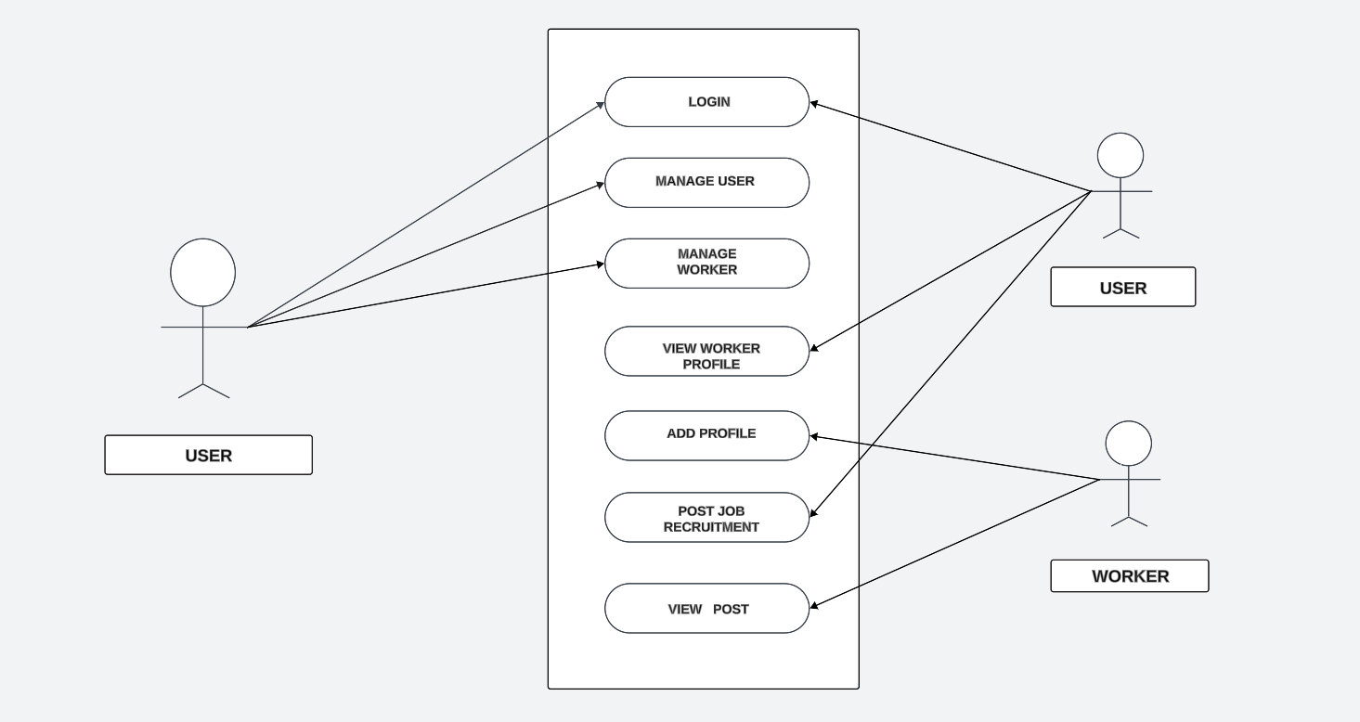
figure 3: Use case Diagram For LET’S FIND

CHAPTER 4: IMPLEMENTATION TOOL
To implement the system, various front end and back end developing tools are used as the implementation tools.

Front End Tools
Front-end converts the data to a graphical interface, through the use of various front end development tools so that users can view and interact with that data. Tools used to develop the front application of LET’S FIND are:
- HTML
- CSS
- JavaScript

HTML
Hypertext Markup Language (HTML) is the standard markup language for document, designed in a web browser. HTML provides a means to create structured document by denoting structural semantics for text such as headings, paragraph, lists, links, quotes and other items. It can be assumed as the skeleton of the front-end application.

CSS
Cascading Style Sheets (CSS) is a style sheet language used for describing the presentation of a document written in a markup language like HTML. It is responsible for the designing of the front-end application top enhances the user interface as it is designed to enable the separation of presentation and content, including layout, color and font.

JavaScript
JavaScript id lightweight, interrupted, pr just-in-time compiled programming language with first-class functions. While it is most well-known as the scripting language for Web pages, many non-browser environments also use it. It is client-side scripting language. It is used for validation and also to add extra functioning and to make the software responsive.

Back End Tools
Back-end refers to the server side of an application and everything that communicates between the database and the browser.
Tools used to develop the back-end application of LET’S FIND are:
- PHP
- MySQL

PHP
PHP is a web application framework with expressive and elegant syntax. It is accessible, powerful, and provides tools required for large, robust applications. In LET’S FIND , from database to the CRUD operation in the database is performed using PHP.

MySQL
MySQL is free and open-source relational database management system which is used by many database-driven web applications. The database of LET’S FIND is created using MySQL.

4.1 Gantt Chart For LET’S FIND

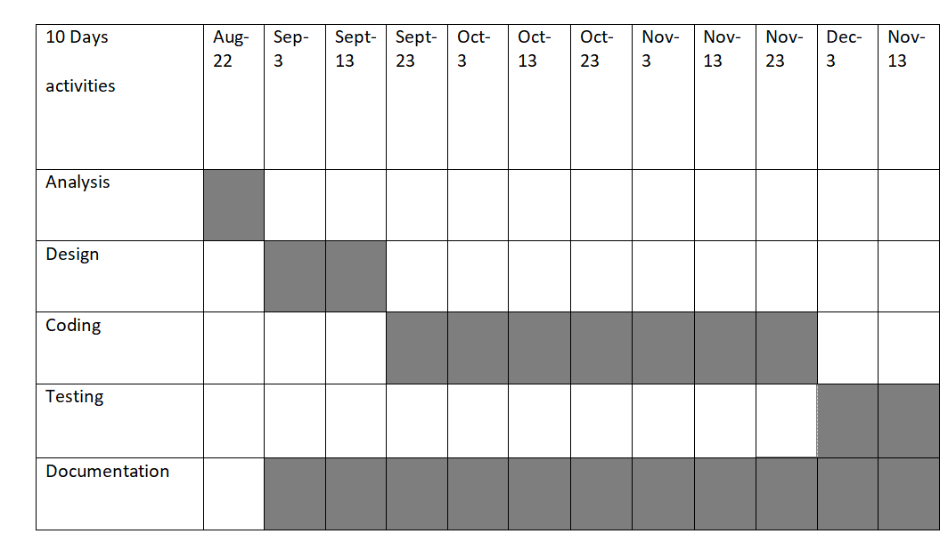Figure 4:Gantt Chart

CHAPTER 5: CONCLUSION
LET’S FIND is a web-based page developed using HTML, and CSS for its front end and PHP for its Back-end. This system is expected to be simple and efficient to use with high user interface. LET’S FIND is set to use more effectively. It should be able to work in almost all configurations.
The final outcome should comprise of the following features:
- Proper platform for job seekers
- User friendly interface
- Should be able to run on almost systems
- Helpful for the needy companies and peoples

