Assignment Cover Sheet

Qualification |  | Module Number and Title
HD in Computing and Software Engineering/ Network Technology and Cyber Security |  | CSE 4002  Fundamentals in Programming
Student Name & No. |  | Assessor
Thaslim Mohemmed Sahl  KD/HDCSE/CMU/74/22 |  | Ms. Dushyanthi Nisansala
Hand out date |  | Submission Date
2024/07/22 |  | 2024/08/28
Assessment type  Coursework | Duration/Length of  Assessment Type  3000 Words | Weighting of Assessment  100%

Learner declaration
I, Thaslim Mohemmed Sahl (KD/HDCSE/CMU/74/22),
certify that the work submitted for this assignment is my own and research sources are fully acknowledged.

Marks Awarded
First assessor
IV marks
Agreed grade
Signature of the assessor |  | Date

Turnitin Report
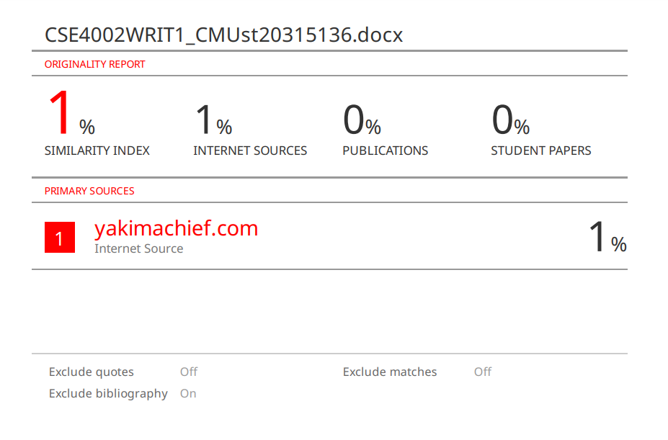

Feedback Form
International College of Business & Technology

Module : CSE 4002 WRIT1
Student : Thaslim Mohemmed Sahl (KD/HDCSE/CMU/74/22)
Assessor : Ms. Dushyanthi Nisansala
Assignment : Orichi-flora temperature system
Assessor Feedback:

Marks Awarded:

Table of Contents
Assignment Cover Sheet 1
Turnitin Report 2
Feedback Form 3
Table of Contents 4
Table of image 5
Acknowledgement 6
Executive summary. 6
Introduction 7
Task 1: 8
Main menu Flow chart 8
Store Temperature flow chart 9
Temperature fluctuation flow chart 10
Average Temperatures flow chart 11
Max and Min Temperature flow chart 12
Temperature Converter flow chart 13
Suitability flow chart 14
Task 3: 15
Introduction 15
Test plan: 15
Test case and test results : 16
Test case 1: 16
Test case2: 17
Test case3: 18
Test case4: 19
Test case5: 20
Test case6: 21
Test case7: 22
Testcase8: 23
Testcase9: 24
Testcase10: 25
Test case11: 26
User Acceptance testing (UAT) 27
UAT case ID1: 27
UAT case ID2: 27
UAT case ID3: 27
UAT case ID4: 28
Sample UAT questionnaire 28
Conclusions 28
Task2: 29
References 33

Table of image

Figure 1 Main menu 8
Figure 2 Store Temperature 9
Figure 3 Temperature fluctuation 10
Figure 4 Average Temperatures 11
Figure 5 MAX and MIN Temperature 12
Figure 6 Temperature converter 13
Figure 7 Suitability 14

Acknowledgement

I express my gratitude to Ms. Dushyanthi Nisansala, our lecturer for providing me with the opportunity to work on this assignment and for the insightful feedback and guidance provided at various stages.
I’m also deeply thankful to our seniors, classmates, and friends who offered their assistance and shared their perspectives, which greatly enriched the quality of our work.

Executive summary.

The below given assignment shows the main flow chart and modularized flowcharts in task 1. In task 2 it shows source code for the Orichi- flora temperature analysis system. Test cases and Test plan and UAT shown in the task 3.

Introduction

Orchi-flora Planters; developed a C++ application that is used in measuring and assessing the temperatures during the growing process of the orchids. Daily and average temperature and average temperature change will be recorded as well as the highest and lowest temperature will be determined and an acceptability of this frequency of temperature change according to the requirement of the orchids. The application will be of menu-driven type with user-friendly interface and in-built error controllers. It will also use data storage and modulation to further its effectiveness in preparing the data for analysis. This indicates that the application will undergo vigorous testing to determine it reliability in serving its purpose. This is so as to find out when the orchids should be grown. The program is to incorporate menu driven error handing compliant feature and will be user friendly.

Task 1:

Main menu Flow chart
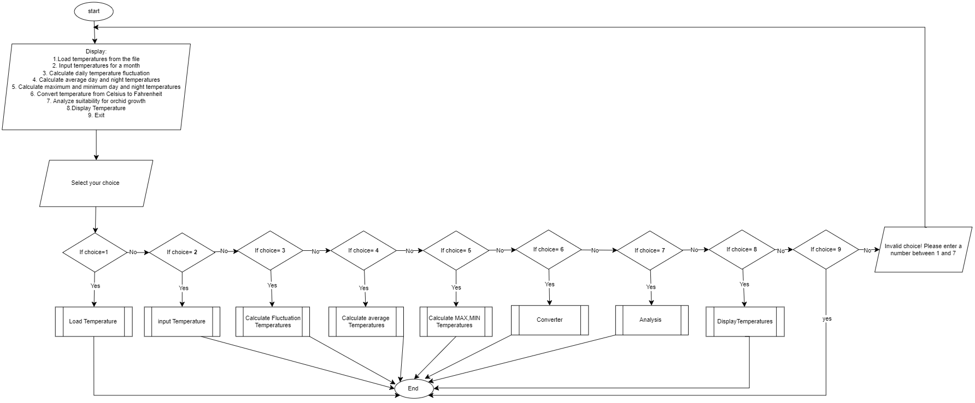
Figure 1 Main menu

Store Temperature flow chart
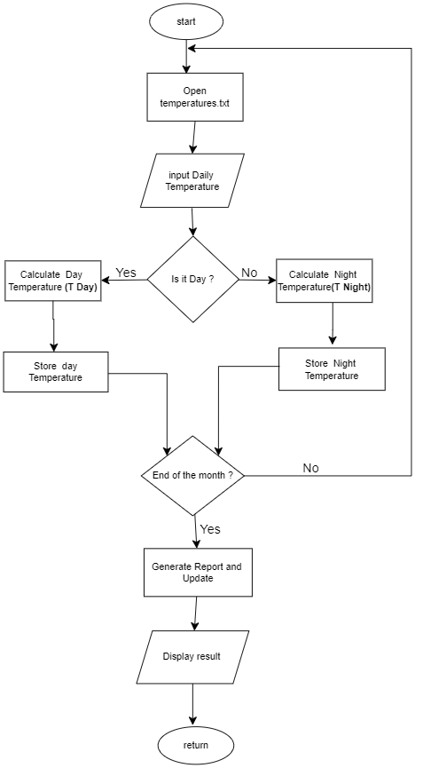
Figure 2 Store Temperature

Temperature fluctuation flow chart

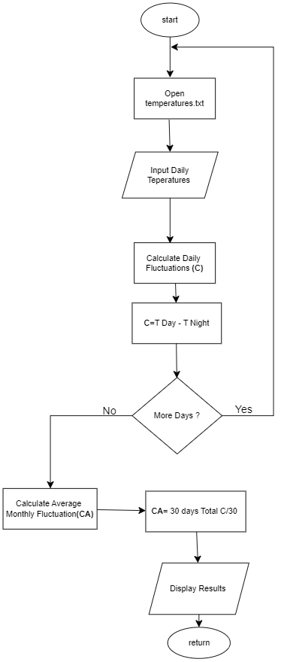
Figure 3 Temperature fluctuation

Average Temperatures flow chart
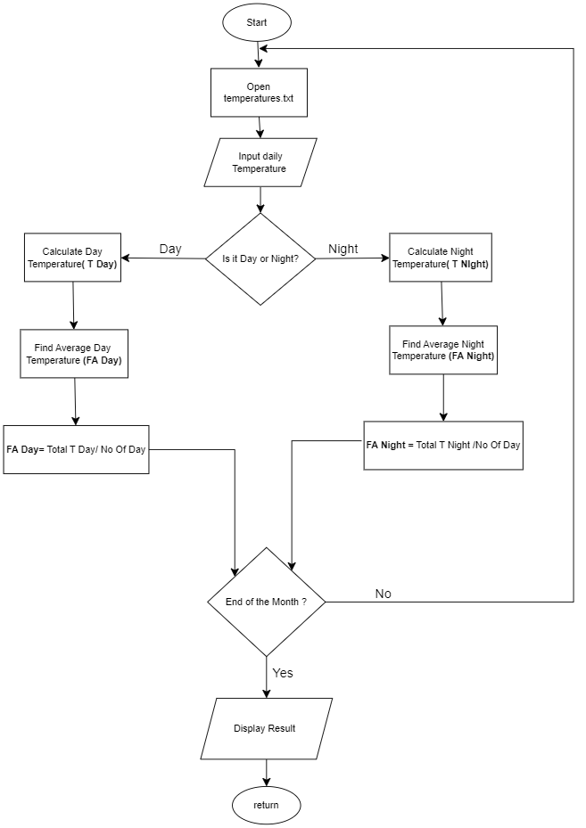
Figure 4 Average Temperatures

Max and Min Temperature flow chart

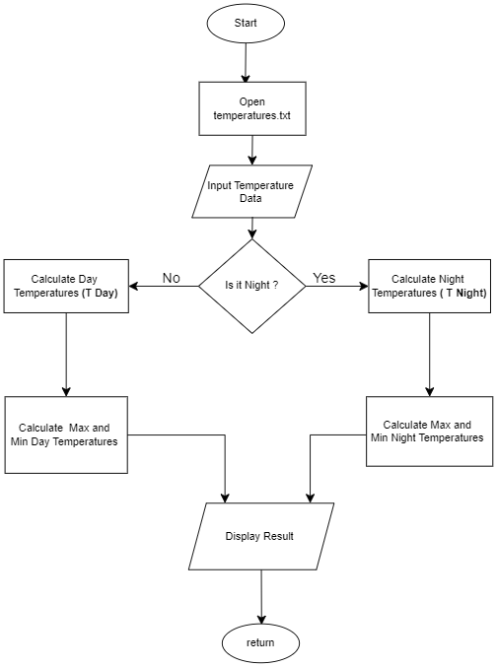
Figure 5 MAX and MIN Temperature

Temperature Converter flow chart
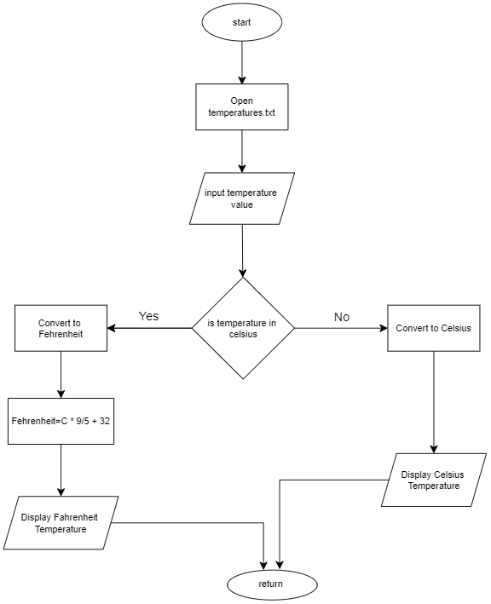
Figure 6 Temperature converter

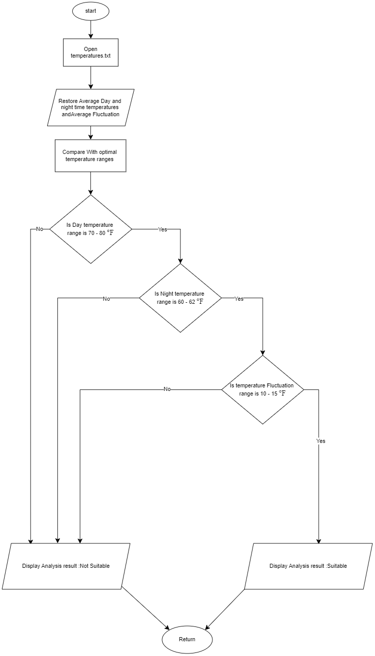
Suitability flow chart
Figure 7 Suitability

Task 3:

Introduction
The Orchid Temperature Analyzing System, designed to support Orchi-flora planters in optimizing orchid growth through temperature changes analysis, has a complete testing plan provided in this paper. The system computes essential data, records daily temperatures throughout the day and at night, and assesses if the environment is suitable for growing orchids. This testing strategy guarantees the accuracy, trustworthiness, and user-friendliness of every system function.

Test plan:
Bottom-up approach
the detailed testing methodology of orchid temperature Analyzing system is explained in this Bottom-Up Test plan which focus on the approach of testing individual modules before combining them to form final system. Before moving through the testing process the whole (system),the testing is conducted on the individual elemental components(functions) and then advanced integration test are carried out o ensure that all the units are right (simplilearn.com, 2024,11).

Objective
Make sure that the current and past daily temperature is stored and can be re called. Check that the system has capability to calculate averages, max ,min as well as temperature differences. Test the functioning of converting temperature. Check on the efficiency of the system to determine the right temperature for proper grow of the orchids. Make sure that the system meets users realistic need by conducting the user Acceptance Testing(UAT).

Scope
Every functional part of the system is covered by the test plan, including:
storing and regaining data computations using mathematics (averages, variations, maximum and minimum temperatures)Conversion of temperature An examination of suitability for orchid development.

Test case and test results :

Test case 1:

Requirements | Main menu
Tester | Developer
Scheduled date | 5/8/2024 | Date conducted | 5/8/2024
Input | Sample data | Expected results | Actual results
Valid |  | Access Granted | PASS
Invalid |  | Access Denied | FAIL

successful output
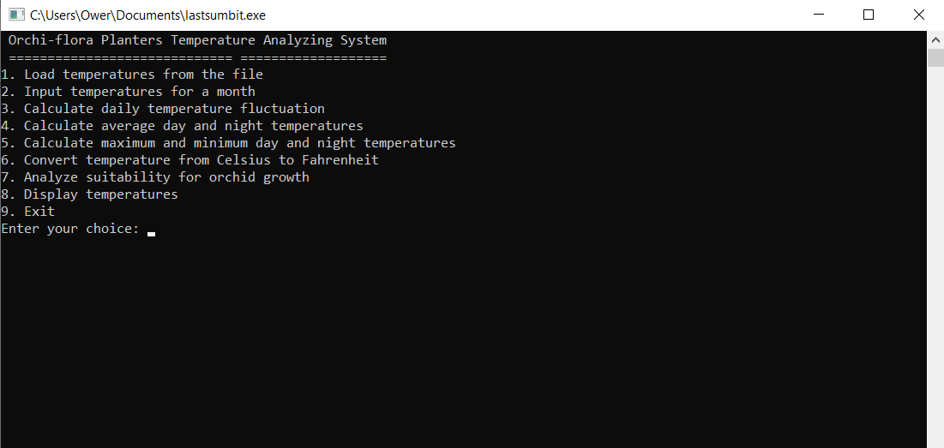

Test case2:

Requirements | Load temperature file
Tester | Developer
Scheduled date | 5/8/2024 | Date conducted | 5/8/2024
Input | Sample data | Expected results | Actual results
Valid | Existing file with temperature records | Successful message should appear | PASS
Invalid |  | Un Successful message should appear | FAIL

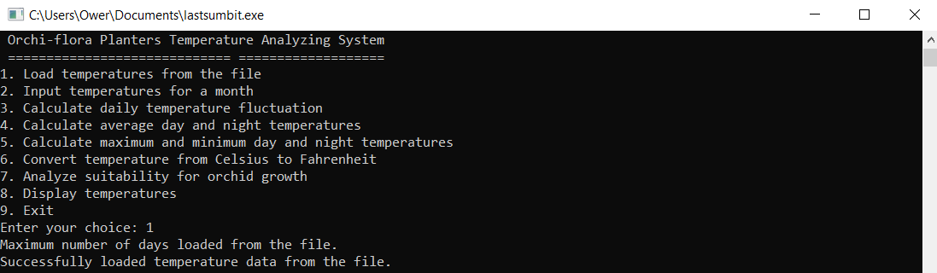
successful output

Test case3:

Requirements | Input Temperatures
Tester | Developer
Scheduled date | 5/8/2024 | Date conducted | 5/8/2024
Input | Sample data | Expected results | Actual results
Valid | Day:75°F ,  Night:60°F (for 30 days) | The system should save and confirm the entry | PASS
Invalid |  | The system shouldn’t save and confirm the entry | FAIL

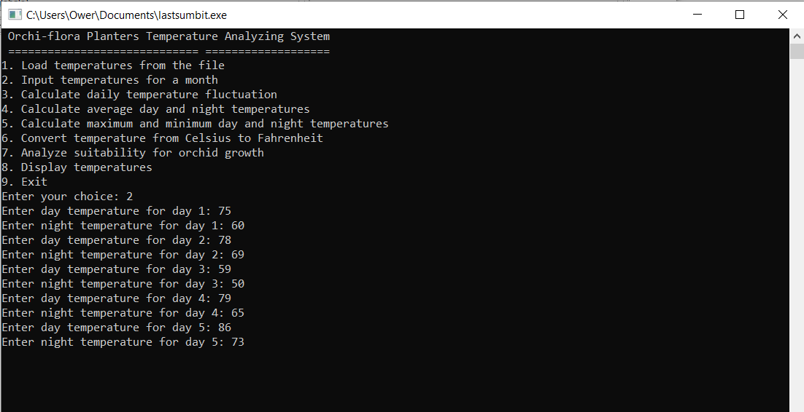
successful output

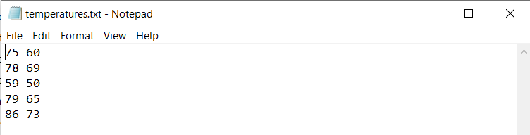

Test case4:

Requirements | Calculate daily Fluctuation
Tester | Developer
Scheduled date | 5/8/2024 | Date conducted | 5/8/2024
Input | Sample data | Expected results | Actual results
Valid | Day:75°F ,  Night:60°F | The system should calculate and display  Daily fluctuation | PASS
Invalid |  | The system shouldn’t calculate and display  Daily fluctuation | FAIL

Successful output
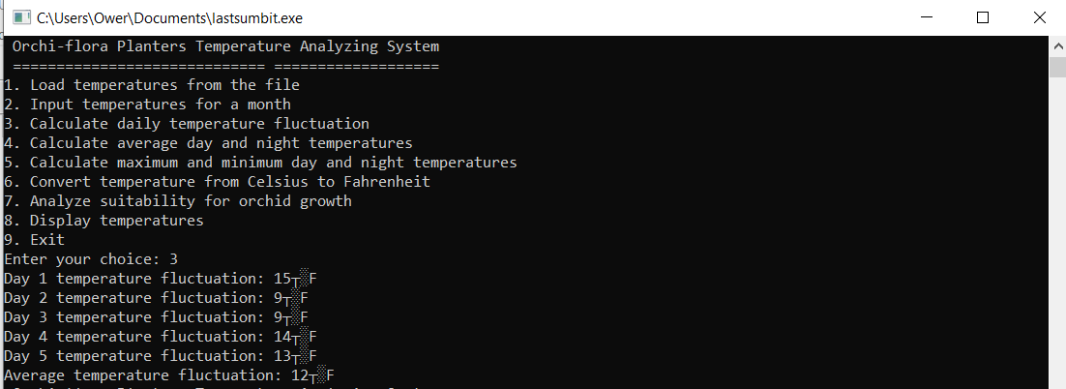

Test case5:

Requirements | Calculate average day and night temperature
Tester | Developer
Scheduled date | 5/8/2024 | Date conducted | 5/8/2024
Input | Sample data | Expected results | Actual results
Valid | Day:75°F ,  Night:60°F (for 30 days) | The system should display the average  Day and Night temperature | PASS
Invalid |  | The systemshouldn’t  display the average  Day and Night temperature | FAIL

Successful output
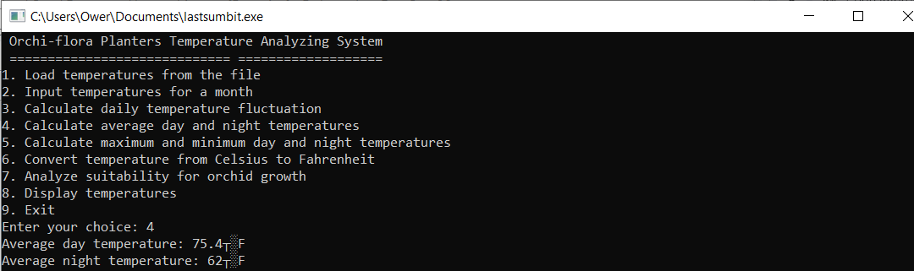

Test case6:

Requirements | Calculate MAX and MIN temperature
Tester | Developer
Scheduled date | 5/8/2024 | Date conducted | 5/8/2024
Input | Sample data | Expected results | Actual results
Valid | Day:75°F,  Night:60 °F (for 30 days) | The system should display the correct  MAX and MIN temperature | PASS
Invalid |  | The systemshouldn’t display the correct  MAX and MIN temperature | FAIL
Successful output
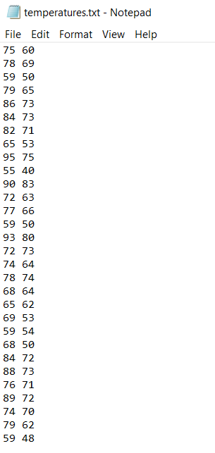
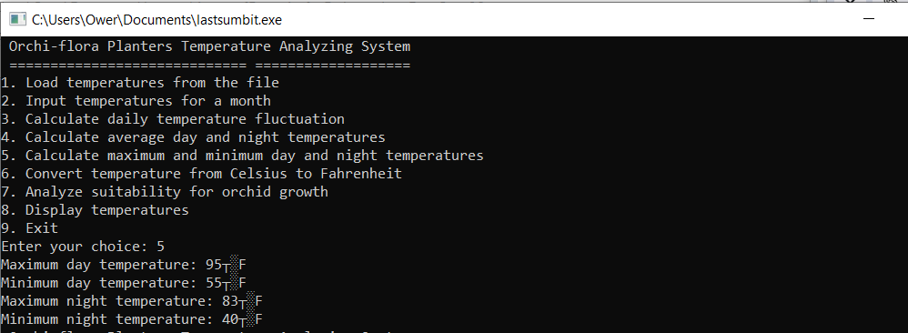

Test case7:

Requirements | Convert temperature
Tester | Developer
Scheduled date | 5/8/2024 | Date conducted | 5/8/2024
Input | Sample data | Expected results | Actual results
Valid | Boiling point:100°C  Freezing point:0 °C | The temperature should be converted and display accurately | PASS
Invalid |  | The temperature shouldn’t be converted and display accurately | FAIL

Successful output
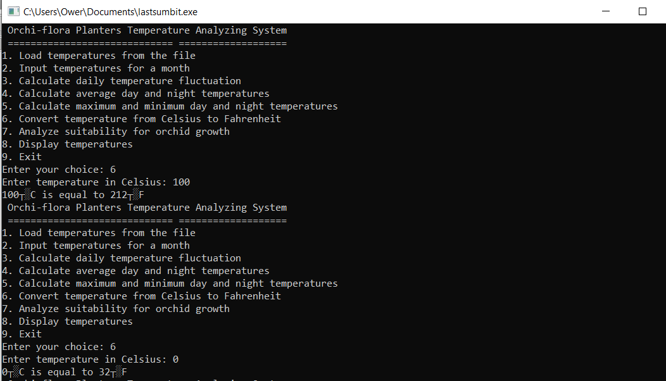

Testcase8:

Requirements | Analyze suitability
Tester | Developer
Scheduled date | 5/8/2024 | Date conducted | 5/8/2024
Input | Sample data | Expected results | Actual results
Valid | Day:75°F  Night:60°F(for 30 days) | The number of day that are ideal for orchid growth should display and accurately counted by system | PASS
Invalid |  | The number of day that are ideal for orchid growth shouldn’t display and accurately counted by system | FAIL

Successful output
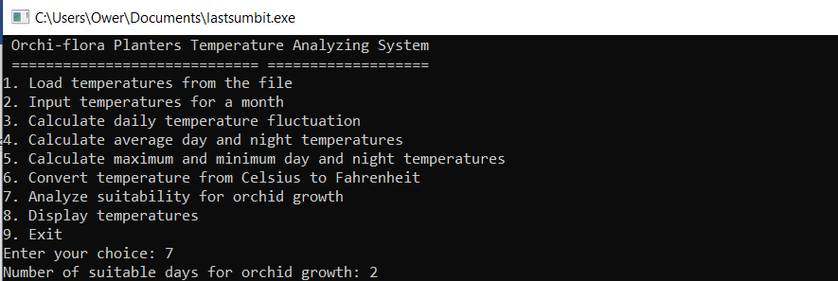

Testcase9:

Requirements | Display all recorded temperatures
Tester | Developer
Scheduled date | 5/8/2024 | Date conducted | 5/8/2024
Input | Sample data | Expected results | Actual results
Valid | Day:75°F  Night:60°F(for 30 days) | Every temperature recorded in memory should be shown by system | PASS
Invalid |  | Every temperature recorded in memory shouldn’t be shown by system | FAIL
Successful output
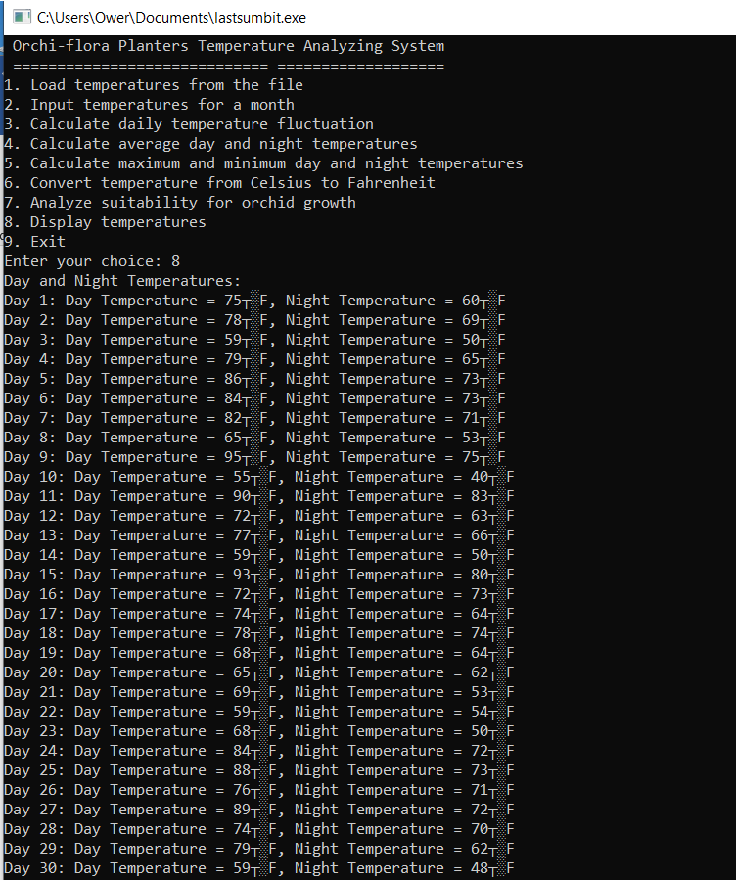

Testcase10:

Requirements | Exit the application
Tester | Developer
Scheduled date | 5/8/2024 | Date conducted | 5/8/2024
Input | Sample data | Expected results | Actual results
Valid | Select :9 | Data should be saved and the application should stop without any issues | PASS
Invalid | Select :10 | Invalid choice! please enter between 1 and 9 | FAIL

Successful output
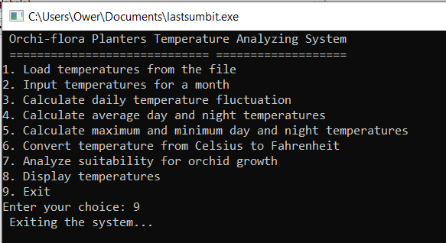
Unsuccessful output
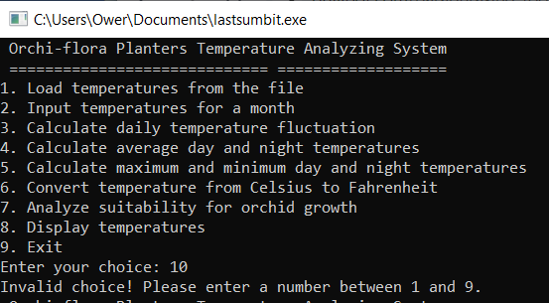

Test case11:

Requirements | Input exactly 30 days temperature
Tester | Developer
Scheduled date | 5/8/2024 | Date conducted | 5/8/2024
Input | Sample data | Expected results | Actual results
Valid | Day:75°F  Night:60°F(for 30 days) | The system need to record temperatures for exactly 30 days and stop accepting new data | PASS
Invalid |  | The system doesn’t need to record temperatures for exactly 30 days and stop accepting new data | FAIL

Successful output
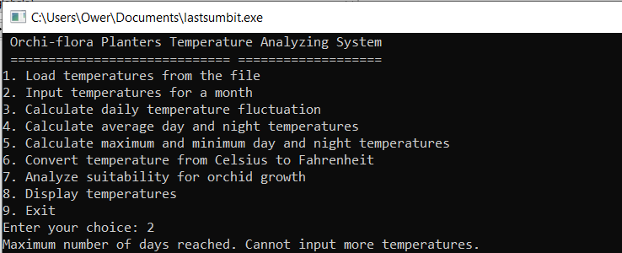

User Acceptance testing (UAT)

UAT case ID1:

Requirements | Load temperatures file
Tester | End-user
Scheduled date | 5/8/2024 | Date conducted | 5/8/2024
User actions | Expected results | Actual results | User feedback
Load temperature file is choose by user | The system load and display temperature correctly | PASS | The information loaded correctly and quickly
 |  | FAIL

UAT case ID2:

Requirements | Input temperatures for a month
Tester | End-user
Scheduled date | 5/8/2024 | Date conducted | 5/8/2024
User actions | Expected results | Actual results | User feedback
Enter temperatures for 30 days | After 30 days, the system stop accepting new temperature inputs and keeps all previous one | PASS | The system respond well and it was easy to enter data
 |  | FAIL

UAT case ID3:

Requirements | Analyze suitability for orchid growth
Tester | End-user
Scheduled date | 5/8/2024 | Date conducted | 5/8/2024
User actions | Expected results | Actual results | User feedback
Analyze suitability for orchid growth is selected user | Based on temperature range the system identifies the suitable days | PASS | The suitability analysis is clear and useful
 |  | FAIL

UAT case ID4:

Requirements | Convert temperature
Tester | End-user
Scheduled date | 5/8/2024 | Date conducted | 5/8/2024
User actions | Expected results | Actual results | User feedback
User enter temperature in Celsius and convert to Fahrenheit | Temperatures is convert by system accurately | PASS | Conversion work well and the result is display clearly
 |  | FAIL

Sample UAT questionnaire

- How much difficulty did the participants experience when using the system?
I / II / III / IV / V
- I
- How clear were the instructions and prompts given?
- Very clear
- Did the system respond as expected to your inputs ?
- Always
- How satisfied are you with the overall functionality?
- Very satisfied

Conclusions

- All functional and user acceptance test were successfully completed by the orichi-flora planters temperature analyzing system. The system is prepared for implementation, with a few small improvements recommended in response to user input. This system offers a detailed understanding of the testing procedure, guaranteeing that every aspect of the system is assessed and verified.

Task2:

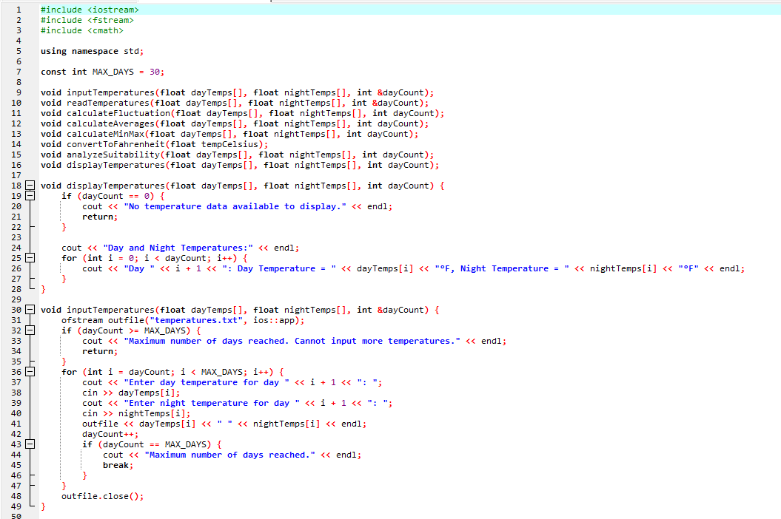

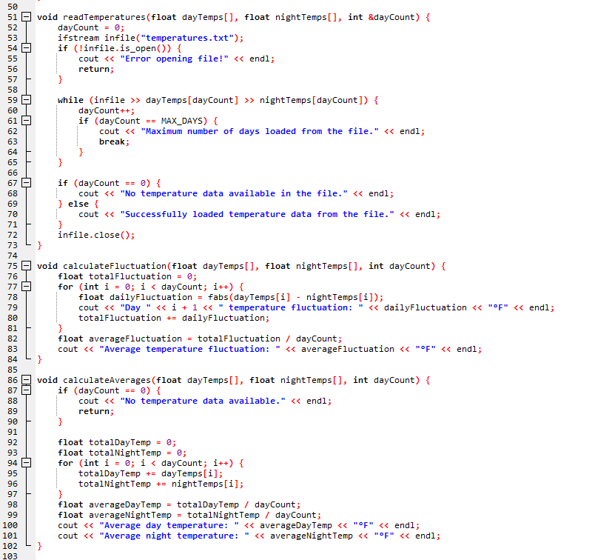

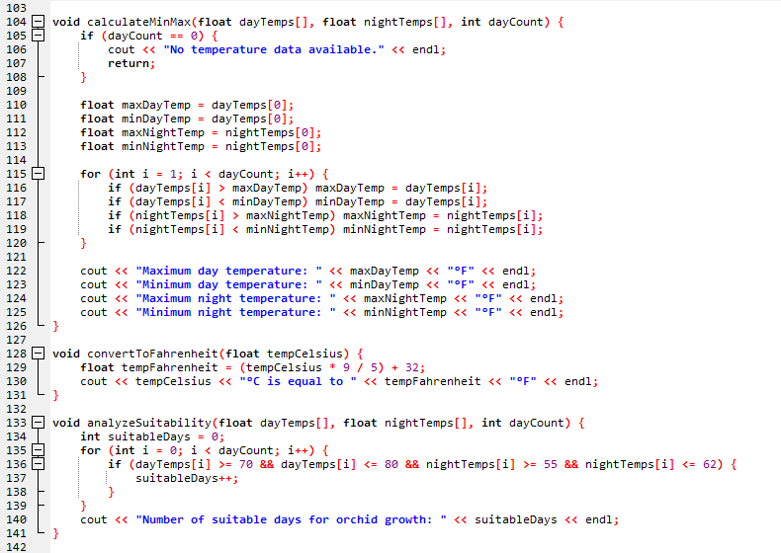

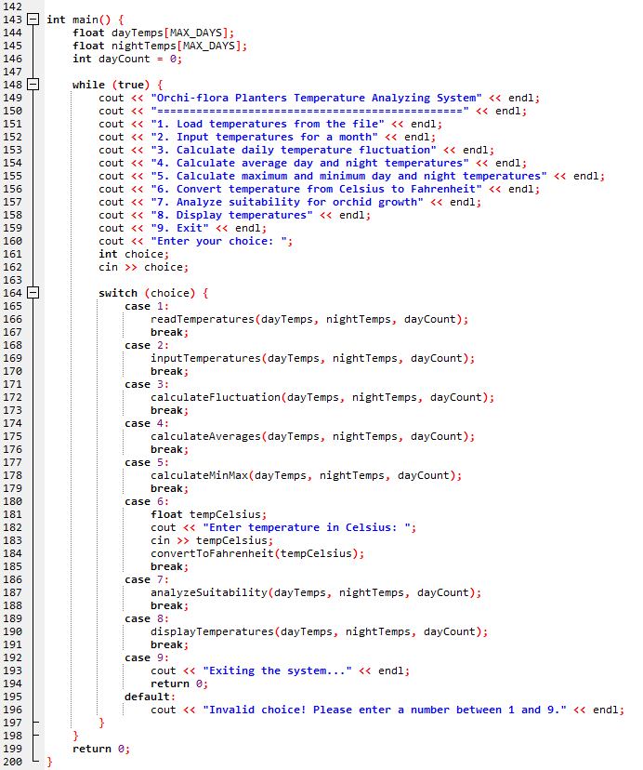
(Fadatare, n.d.)

NOTE: The error-free C++ software will be submitted in softcopy together with this document, which will be attached separately.

References
Fadatare, r., n.d. C++ Program to Convert Celsius to Fahrenheit and Vice-Versa. [Online]
Available at: https://www.javaguides.net/2023/08/cpp-program-to-convert-celsius-to-fahrenheit.html#google_vignette
[Accessed 24 august 2024].
simplilearn.com, 2024,11. Understanding Top-Down and Bottom-Up Management Approaches!. [Online]
Available at: https://www.simplilearn.com/top-down-approach-vs-bottom-up-approach-article#:~:text=What%20is%20the%20bottom%2Dup,employees%20in%20decision%2Dmaking%20processes.
[Accessed 25 august 2024].

